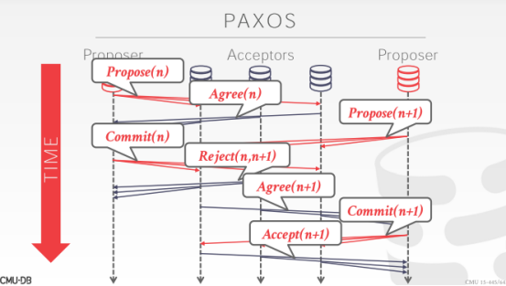

40:01 - 40:03
Yes What`s that

40:09 - 40:10
how would that work yeah
它是如何工作的
40.10-40.13
,so if one of these acceptors sees n+1
So，如果其中一个acceptor看到了n+1
40.13-40.15
,they have to reject n
它们就会去拒绝n
40:16 - 40:16
yeah

40:17 - 40:22
I think they cover Paxos in the distributed DBMS class,
我觉得他们在分布式DBMS课上介绍了Paxos
40.22-40.25
right the guys actually implement it
这货实际实现了Paxos
40:24 - 40:26
so I'm going through this very briefly,
So，我会简单带你们过下这个
40.26-40.32
just to show the distinction between two-phase commit and and Paxos that like
并向你们展示下两阶段提交和Paxos之间的区别
40:32 - 40:35
yeah the high level idea is the same
从高级层面来讲，它们的思想是相同的
40.35-40.40
except that under Paxos yeah you still get rejected in the second phase, and you have a majority have to agree
除了在Paxos中第二阶段时你必须获得多数派的同意，不然你的事务依然会被拒绝提交
40:42 - 40:45
so now her question is or her observation is
So，她的问题是，
40:45 - 40:52
it could not get started forever, if I just have two proposers clobbering each other by posing you know n+1 n+2 n+3
如果两个proposer互相讨价还价，一个提n+1，一个提n+2，以此类推，这样就永远没法开始执行
40:52 - 40:55
and everything just keeps getting rejected absolutely
所有事务就会都处于被拒绝的状态
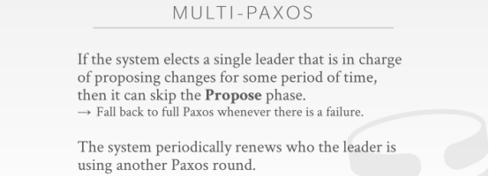

40:55 - 40:58
so the way you handle this is called multi-Paxos
So，我们处理这个问题的方式叫做multi-Paxos
40:58 - 41:00
so the idea with multi-Paxos is that
So，multi-Paxos的思路是
41.00-41.05
you select some node to become the leader for your Paxos group
你会选择某个节点作为一个Paxos group的leader
41:06 - 41:11
and then it's the sole node responsible for proposing changes to commit transactions
该节点负责提出修改以提交事务
41:12 - 41:19
they think of this it could delegate it or designate it as the almost like the coordinator or the middleware piece
他们觉得这个节点充当了协调器或者中间件的角色
41:19 - 41:23
that everybody has to go to determine whether they're allowed to commit or not
所有人都需要跑到它那里来确定是否允许它们提交事务
41:25 - 41:30
and you have a lease on being designated as a leader like you know some 60 seconds or so
当该节点被指定为一个leader时，它会有一个lease，时间长度可能是60秒之类
41:30 - 41:32
and then after that 60 seconds is up
当这60秒到了之后
41.32-41.34
you do a round of voting
你会进行一轮投票
41.34-41.39
, which is another round of Paxos to determine who the next leader is going to be
通过这一轮投票，我们来决定这个Paxos Group中的下一个leader是什么

41:41 - 41:43
and then once that that's resolved
接着，一旦选出了leader
41:43 - 41:50
then you go ahead and have you know that that new designated leader be the responsible for all for applying all the changes
那么这个新委派的leader就会负责去提交这些修改
41:50 - 41:52
so this avoids that that starving issue
So，这种方案避免了starving问题
41.52-41.56
because the leaders have been the only one proposing changes
因为只有leader才能对这些修改进行提案
41:58 - 41:58
yes
请讲
42:05 - 42:05
correct
没错
42.05-
so she's like isn't just moving the problem ,because now couldn't get starving for the leader election right
so 处理过程的前进不会再是问题，因为现在有leader选举制度的存在，我们不会再因为协调器角色的挂掉而要一直等它恢复了（知秋注：starving 问题）
42:10 - 42:12
So yeah we assume our nodes are friendly
So，我们假设我们的节点都是友好的
42:13 - 42:14
so we just have right in our database system
So，我们在我们的数据库系统中有这样的权力
42:15 - 42:18
you say all right well the after my lease is over
你表示：Well，当我的lease到期后
42:18 - 42:25
I'll try to be the only one to to ,you know vote myself or propose that I can be the new leader
我会试着给我自己投票来让我称为新的leader
42:25 - 42:27
how do you handle two guys clapping same time
你该怎样去处理俩proposer在同一时间互相讨价还价
42.27-42.29
yes ,but you serve back off
是的，退一步海阔天空即可
42:29 - 42:31
so I tried I got rejected
So，我试着这样做，但我被拒绝了
42.31-42.35
, so said to merely try to reject or merely try to propose it something new
在只是去尝试拒绝（reject ）或者只是尝试提议一些新的东西
42.35-42.36
maybe I'll wait 10 milliseconds
可能我会等待10毫秒
42:36 - 42:37
if I propose again
如果我再次进行提案
42.37-
I get rejected maybe I wait 20 just do it that way
我可能要等20ms才会去做拒绝动作
42:41 - 42:41
yes
请问
42:44 - 42:46
the question is how many proposers can you have
他的问题是，我们可以有多少个proposer
42:47 - 42:48
and then as you want
你想要多少就可以有多少
42:49 - 42:51
yeah algorithm doesn't say anything about limitation
算法中对此并没有任何限制
42.51-42.52
in practice
在实战中
42.52-42.55
it's like getting for it they'll call in a Paxos group
在一个Paxos Group中

42:56 - 43:00
you typically would have one under multi-Paxos to avoid this start starvation issue
使用multi-Paxos这种方案时，通常你只会有一个proposer，以避免这种starvation问题
43:01 - 43:05
if we cover spanner at the end of the semester of an system potpourri
如果我们在这学期最后介绍Potpourri的时候介绍Spanner的话
43.05-43.06
which every year we always do
实际上，我们每年都会去介绍下它
43:06 - 43:09
I'll show you how you can do Paxos with that
我会向你们展示如何在Spanner中使用Paxos
43:10 - 43:12
question over here okay
有问题吗？Ok
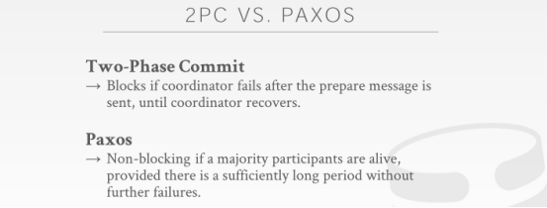

43:14 - 43:19
so the the main takeaway from this is that
So，我们从中主要学到的东西是
43.19-43.21
so with two-phase commit and paxos
So，对于两阶段提交和Paxos来说
43:21 - 43:23
you can both use them to commit transactions
这两种协议都可以用来提交事务
43:24 - 43:27
so to determine whether everyone agrees , we want to go ahead and commit transactions
So，以此来确定每个人是否同意我们去提交事务
43:28 - 43:28
in practice
在实战中
43.28-43.34
usually for distributed DBMSs that are local to each other
通常对于那些在本地的彼此相邻的分布式DBMS来说
43:34 - 43:36
like meaning, they're running under the same data center
我的意思是它们在同一个数据中心下运行
43.36-43.38
where they're not like you know or widespread geographic regions
它们并不是分区在全球的
43:39 - 43:41
two-phase commit it's what people mostly use,
人们最常使用的是两阶段锁
43.41-43.46
because the number of round trips could be less
因为这种来回发送信息的次数可能会更少
43:46 - 43:50
and you assume that maybe the nodes are going to be crash less often
并且你假设这些节点发生崩溃的频率也很低
43:50 -43:50
Okay

43.50-43.57
there's much extra failure scenario, you have to deal with failure handle code to deal with like, you know the coordinator goes down, participant goes down
你需要去处理一些额外的故障场景，比如：协调器崩掉了，或者参与者节点挂掉了
43:57 - 44:01
so it's you know even though it would be slightly faster than paxos
虽然，它的速度可能要比Paxos来得更快
44:01 - 44:06
it's still there's so much of your stuff you have to do to make sure that ,you don't the whole system doesn't go down and you don't lose data
你依然需要做些额外工作以确保整个系统不会挂掉，并且你也不会丢失数据
44:07 - 44:08
as I said before
我之前说过
44.08-44.13
the inventor of paxos Leslie Lamport and Jim Gray the guide have been two phase locking
Paxos的发明者是Leslie Lamport，两阶段锁的发明者则是Jim Gary
44:13 - 44:16
they had a paper in early 2000s before Jim disappeared
在Jim去世前，他们在2000年代早期的时候写了一篇paper
44:18 - 44:24
that showed that two phase commit is a degenerative case of two phase locking ,right
该paper表示，两阶段提交其实是两阶段锁的退化版本
44:24 - 44:28
sort of like I was talking to degenerative case of Paxos, right
抱歉，我说错了，两阶段提交是Paxos的退化版本
44:28 - 44:35
the the coordinator it's the same Paxos round of a voting, it's just everyone has agree rather than the majority
两阶段提交中的协调器和Paxos的投票其实是一回事，只是两阶段提交要让所有人同意才能提交事务，Paxos只需要大多数同意就可以提交事务
44:36 - 44:36
okay
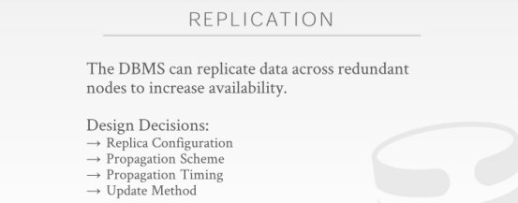

44:40 - 44:40
all Right

44.40-44.41！！！！！！！
so let's talk about replication now,
So，我们现在来讨论下replication
44.41-44.42
as I said in beginning
正如我一开始所说
44.42-44.50
most people don't need a sort of a partitioned distributed DBMS to handle the workload
大部分人并不需要对分布式DBMS进行分区以处理workload
大多数人不需要某种分区形式的分布式DBMS来处理workload
44:50 - 44:55
most the DBMS you play and count the real world while probably using , you know some kind of replication
你在平时所使用的大部分DBMS可能会去使用某种具备复制容错（replication）方式就足够了
44:55 - 44:57
and I would say that still counts as a distributed DBMS
其实我想说，这依然算是一种分布式DBMS
44:58 - 45:00
so the idea here it should be
So，这里的思路是
45.00-
a DBMS, replicated with the application is that
对于一个具备复制（replicated）能力的dbms，
45.03-45.06
we want to make multiple copies of every object
我们想去为每个对象制作多个副本
45.06-45.09
whether it's a page, or a tuple, a table whatever you want
不管这个对象是一个page还是一个tuple，或者是一个table
45:09 - 45:11
and store them on multiple nodes
并将它们保存在多个节点上
45.11-45.13
so that if one of those nodes goes down
So，如果一个节点挂掉了
45:13 - 45:15
we have a backup available for us
我们还有一个可供使用的备份
45:15 - 45:19
so we don't have to wait for the system to reboot and replay the log to put us back in the correct state
So，我们不需要等待系统重启并重新执行日志上的内容，以此来让我们到恢复正确的数据库状态
45:20 - 45:28
we could just failover using paxos to decide who to failover to, to determine what becomes that ,you know the new location for writing data
我们可以通过使用paxos来设计故障转移，以此决定在一个节点出故障时，启用哪个节点来作为一个新的用于接收数据写入的leader
45:29 - 45:33
so there's a bunch of design decisions we have to think about when we want to build our replication scheme
So，当我们想去构建我们的replication方案时，我们必须考虑一堆设计决策
45:33 - 45:35
so we'll go through each of these one by one
So，我们会逐个讲下这些东西
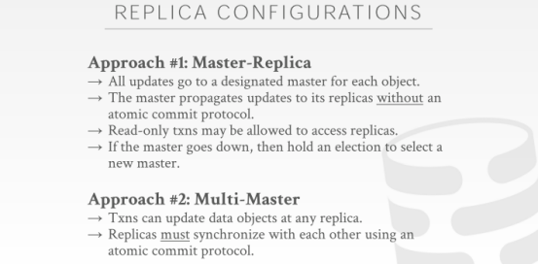

45:37 - 45:46
so the first issue is, what however after you can configure the replicas in the systems, and where do the reads and writes go to
对于第一条这个Master-Replica,是指你在系统中配置了一堆备机（replicas）后，你的读和写请求该落在哪台机器上
45:47 - 45:52
so the most common approach is used what is called master replicas replication
so 最常使用的方案就是主从复制（master replicas replication）
45:52 - 45:56
sometimes called leader-follower used to be called master-slave
有时候也叫 leader-follower，也可以称之为master-slave
45:56 - 45:58
But people try to avoid that term
但人们正在避免使用这俩词汇，你懂得
45:58 - 46:05
and the idea here is that there's some designated master for that form for a given object in the database
这里的思路是，在数据库中指定一个主节点
46:06 - 46:09
and all the writes are going to go to that master node
所有的写请求都会落到主节点上去
46:10 - 46:14
and the master node is then responsible for propagating those changes
主节点负责传播这些修改
46:14 - 46:16
The updates to its replicas
将这些修改落地到它的从节点（replicas）上去
46:19 - 46:23
and all the reads can go either to the master or some systems that can also go to the replicas
所有的读请求既可以落在master上，也可以落在replicas上
46:23 - 46:27
so you can offload the work you have to do in the massacres, the writes could be very expensive
这样，你在流量高峰期就可以降低你的工作压力，但写请求就可能付出很高的代价了
46:28 - 46:30
and so as I said if now the master goes down
so 如果现在master挂掉了
46:31 - 46:37
then we hold up axis around to do a leader election to determine, which replica becomes the new master ,and that's where all the writes go to
那我们就会去进行一场leader选举，以确定剩下的哪个replica可以成为新的master，这个新的master会是所有写请求的落脚点
46:37 - 46:37
question
请讲
46:41 - 46:44
this question is well this is a venture persistency, no we'll get there
他的问题是这会有持久化的风险，no，我们等会会说到这块儿的
46:46 - 46:52
do not necessarily, no no no not true,a few more slides
没必要，no no no 不对，在后面的ppt中会看到
46:54 - 47:04
okay the other approach is do multi-master ,where we have replicas stored in different machines ,and transactions are allowed to write to any of those replicas
ok，另一种方案是multi-master，我们在不同的机器中有多个副本（replica），事务可以被允许写入其中任何一个副本中
47:05 - 47:07
all right some sometimes called multi-home
有时候这也叫做multi-home
47:07 - 47:12
and then now that it's the replicas are responsible for determining
然后，现在，这些副本（replica）负责确定的是，
47:12 - 47:17
if you have two transactions that try to update the same thing, running the two different replicas
如果你有两个在尝试更新同一对象的事务，且基于对象，我们有运行了两个不同的副本
47:17 - 47:21
how do you actually coordinate from decide, which one should actually commit, which one should abort, how do you actually with conflicts
我们该怎样去彼此协作，谁应该去commit，谁应该中止（abort），该怎样去处理这种冲突
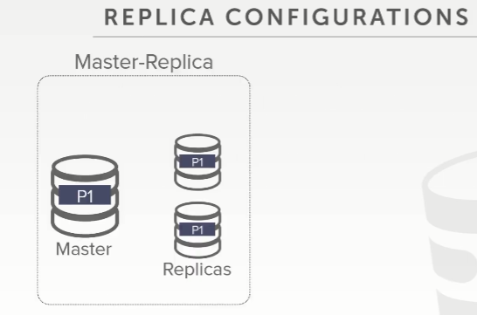

47:23 - 47:28
so let's look at these visual ease again master replicas, yeah you have a master node
so我们再来看下 master replicas，这里，你有一个master节点
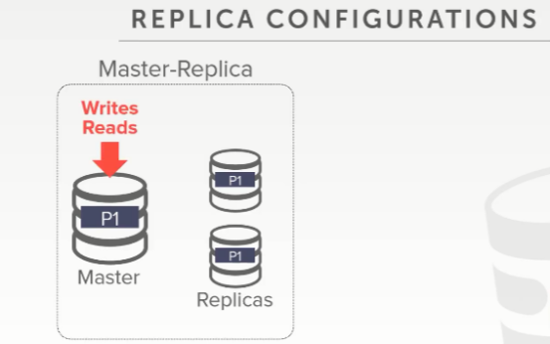

47:28 - 47:33
all your writes go to this guy and in some systems all the reads go here as well
你所有的写请求都会进入这个节点，在一些系统中，所有的读请求也会落在这里
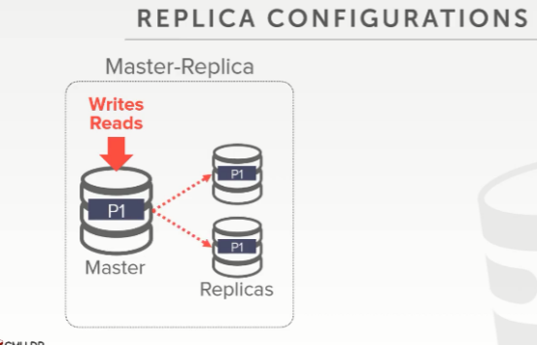

47:34 - 47:41
and then this just then propagates over the network the update information to it to its replicas so that can get applied
然后通过网络将修改信息进行传播并落地到它的replicas上

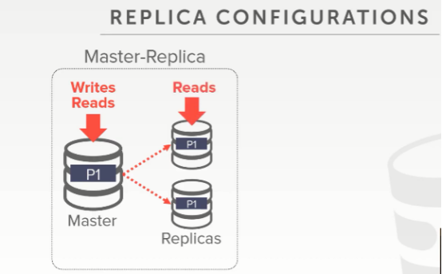

47:42 - 47:46
and for some systems again you can have the reads go to the replicas
对于一些系统来说，你可以将读请求落地在这些replicas上
47:46 - 47:49
so that you produce the amount of work you're doing on the front end
so 如果你这前端有大量的工作请求
47:49 - 47:54
so if your reads don't need to have the most up-to-date latest information
如果你的读请求不需要强调最新的数据信息
47:54 - 47:57
then you can all flow them to these other guys here
那你就可以将它们引导到这些节点身上
47:58 - 48:04
all right this is still be potentially consistent, by meaning like I can if I have snapshot isolation
这仍然可能是一致的，意思是，如果我具有快照隔离，
48:04 - 48:09
I can be guaranteed that I'm not seeing torn updates or partial updates from transactions still running on this guy here
我可以保证，我不会看到来自运行在这个节点上事务所造成的混乱或部分更新
48:09 - 48:14
so I still can guarantee the consistency are the data I'm reading on my replicas
我仍然可以保证我在replicas上读取的数据的一致性的
48:15 - 48:19
it just may be the case that I'm not seeing the little latest information that's on the master
因为我可能并没有看到master上最新的更新信息
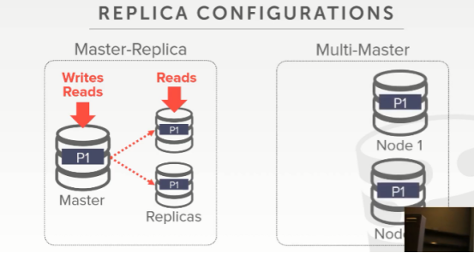

48:21 - 48:26
the multi-master approach is that again we have transactions can you read the writes to any copy of the data
对于multi-master方案，我们的事务，无论是读请求还是写请求，都可以落在任何一个数据副本（replicas）上
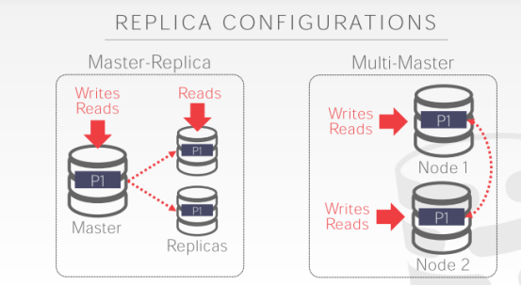

48:26 - 48:30
and then there's some procedure to resolve the conflict
不过需要通过一些方式来解决潜在的冲突
48:30 - 48:37
again using Paxos or two-phase committee to decide ,you know to have overlapping changes on these two replicas, what should be the latest version
再次，使用Paxos或两阶段提交来确定关于这两个replicas上的冲突修改，我们用的是最新的版本号这种方式
48:39 - 48:47
so just as a quick anecdote Facebook originally used to use this multi-master replica setup for their giant data center
就像Facebook最初为什么要将multi-master副本设置用于其大型数据中心，
48:47 - 48:50
right the main data center was I think you know in California
假如主数据中心在California
48:51 - 48:54
and then across the different around the world
然后在世界的不同地方
48:54 - 48:57
they would have replicas that would follower along, the
它们有很多replicas 作为该主数据中心的从机
48:57 - 49:02
you know the master and get updates to you know to propagate the changes, so that you can see things
当master更新后，它要将这些更新传播到这些从机上去
49:02 - 49:08
and the way they would fake it out to make it look like your changes happen real fast locally, like if you updated your timeline
他们通过伪造的方式，使你的修改看起来像是在本地快速发生，就像你在你这个时间点直接得到更新结果一样
49:09 - 49:13
they would store that as a cookie information in your browser
他们会将其作为Cookie信息存储在你的浏览器中
49:13 - 49:20
so that if you refresh the page you would see your update ,even though have may not been propagated to the to the replicas ,where you're reading your timeline from
如果你刷新页面，你会看到你的更新结果，尽管他们可能并没有传播到那些replicas中
49:20 - 49:24
right because it takes a bit of is late for the write to show up here ,and then pushed out to the replicas
因为要将写操作落地到这里是会有点延迟的，（知秋注：如果你读的话，那就是本地这个，那读的数据就和master的数据是不一致的，有些延时的）
49:25 - 49:29
and now probably five-six years ago now they do the multi-master set up
可能是在五到六年前，他们做了 multi-master方案的设置
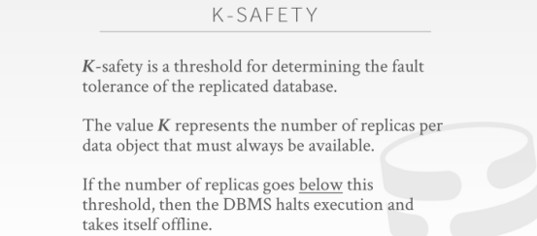

49:32 - 49:36
so an important concept in our with replicas yes
对于我们的replicas，有一个很重要的概念，请讲
49:42 - 49:47
you could react so there's a lot of pumpkin permission map this four years ago
在四年前，他们为此做了很多工作
49:47 - 49:50
so the way like if I write a post like you know in my timeline
so 它那会的方式，就好比如果当前我有一个post写请求提交到后台
49:50 - 49:54
if I refresh the page, and if I'm saying I'm in Brazil
如果我刷新下这个浏览器页面，如果当前我所在的区域在Brazil
49:54 - 49:58
and I'm reading Brazil my local data center has a replica of the master
接着，我就会将读请求发送到Brazil 本地的数据中心（它是master的一个从机）
49:58 - 50:04
so now if I refresh my page and come back, I wouldn't see my post, because it has been propagated from the master to the replica
so 现在，如果我刷新我的浏览器页面，在数据返回后，我并没有看到我的提交，因为它需要从master传播到replica
50:04 - 50:06
because there's always delay for this
因为这就是会产生延迟的
50:07 - 50:12
so people would then they want to avoid the issue of someone posting in their timeline hitting refresh
他们想要避免这种在当前时间点做修改提交所产生的刷新问题

50:12 - 50:15
and then thinking they're their post went missing, because now you're reading from this
然后，他们就会觉得他们的修改提交丢失了，因为你是从本地数据中心副本读取的数据
50:15 - 50:20
right so the way they would handle that is they would actually store ,what she wrote in your browser cookie
so，他们通过这种方式来处理那些实际存储到master上来，但没更新到本地数据中心产生的错位问题，即将post请求成功后，顺带将数据写到本地浏览器cookie 中
50:21 - 50:24
and then fill that in as if it was coming from the database
然后，这就会让人觉得，它是来自数据库中的数据一样
50:26 - 50:26
it's not

50:34 - 50:34
yes

50:35 - 50:38
if they quit their browser and assuming the cookies got blown away
如果他们把浏览器关了，假设cookies也消失了
50:39 - 50:47
and you cut but even better scenario, I make a change my time on this machine, and I have another machine next to it
有一个更好的场景例子，我在这台机器上将时间做了一个修改，它旁边我还有另一台机器
50:47 - 50:52
and I hit refresh on that machine, it would go to the replica database, down in Brazil it would not see your post
有个人在这台机器上更新了数据，这个人要去这个副本（replica）数据库读数据，这个副本数据库就在Brazil ，这个人不会看到你的提交
50:52 - 50:56
you know it'd be a couple hundred milliseconds before they actually got propagated
在数据传播到位之前，可能有100ms的延时
50:57 - 51:01
but they would say you know we'll still like to hit someone could hit refresh on the two machines they're exact same time
但他们（Facebook）说，我们还是想要在第一时间拿到它们在这两台机器上的更新（哪怕自己所在的本地数据中心有延时没有落地到位）
51:02 - 51:03
yes
请讲
51:12 - 51:16
Correct, question is is that in my scenario with Facebook
他的问题是这是不是就是类似于那个Facebook的场景，对的，确实是，
51:16 - 51:20
if the replicas Brazil ,this is in California , when I actually did the post does
如果备机副本是Brazil，这个是在California 的master，当我发出一个post请求
51:20 - 51:25
that mean the application server needs to communicate with the database back in California from Brazil, yes
这意味着， application server需要和在California 的数据库进行通信，数据读取应该从本地的Brazil数据中心查找
51:28 - 51:31
DBMS is that's a huge bottle absolutely and that's why they did the cookie thing to hide it
这就会成为DBMS一个很大的瓶颈，这也是为什么我们要做cookie中做这些事情来掩盖它
51:32 - 51:34
because doing this is hard
因为做这个Multi-Master太难了
51:35 - 51:40
right they had to build that and to get that write is not easy
他们不得不要去构建那种。。。要做到写操作落地到位太难了
51:41 - 51:41
yes

51:44 - 51:50
his question is receiving, again using the Facebook example, if someone comments on that post I will never see that
关于他的问题，我们这里再次使用Facebook 的这个例子，如果有些人对某条朋友圈发出的评论我并没有看到
51:50 - 51:54
no because again it's just the deal with you at the person writing the post
因为它就只是针对发出post写请求那个人来做的设定（写在他的cookie中，并不针对其他看的人）
51:54 - 52:01
if you hit refresh it would pull it from the cookie, so that you would think you got it from me from the master
如果你提交post请求刷新后，你会从cookie获取数据，这样，从你的脑子里，你会认为，你是从master处获取的数据
52:01 - 52:05
but you really got it from the replica, it fills in the missing information that knows it should exist for you
但其实你会从这个replica处获取数据，它（通过cookie这种方式）填补了你本应存在但却丢失的数据
52:05 - 52:09
eventually it the master will get propagated to the replica
最终master会将数据修改传播到这个replica 上
52:10 - 52:13
and then now if I do a refresh instead of coming at the cookie, I'll come from my replica
现在，如果我不通过cookie，来做一次刷新，我将从我的replica 上获取数据
52:14 - 52:18
so Zimmer and post my comment, it'll be a delay before I can see it
so 在我提交了我对某条动态的评论后，在我能看到该评论之前，我需要等一会
52:22 - 52:25
correct in the old system, yes, and the new system, yes, everything is
没错，在老系统，没问题，在新系统，没问题，都是如此
52:26 - 52:32
now we're getting the GPDR world which I don't wanna get into， like where can data actually live
现在，我们不想进入有GPDR 规范限制的国家，因为在这些国家，我们的数据实际该存放在哪里（注：GDPR ：《通用数据保护条例》，是在欧盟法律中对所有欧盟个人关于数据保护和隐私的规范，涉及了欧洲境外的个人数据出口。GDPR 主要目标为取回个人对于个人数据的控制，以及为了国际商务而简化在欧盟内的统一规范）
52:32 - 52:38
but in generally think of yes, like think of this is like Brazil America u.s.
但，基本来说，我觉得没问题，你可以把它们的所在地放在巴西，美国等这些地方
52:39 - 52:41
everyone has a complete copy in entire database
每个地方的数据中心都有整个数据库对应的完整副本
52:41 - 52:44
whether Facebook actually does that anymore I don't know
Facebook是否真的这样做了，我并不知道
52:45 - 52:50
again this big think of this as this is a good example of it's sort of like MP3 right
怎么来思考它呢，这里有一个很好的例子，拿MP3来讲，
52:50 - 52:56
MP3 take advantage of author humans of what we can proceed in audio
作为创作人员，利用MP3的优势，可以让我们在音频中进行处理
52:56 - 53:00
and they can compress down you know wavelengths that we can't see
他们可以压缩我们看不到的波长
53:00 - 53:05
by a throws away data that we humans are never going to be able to hear to compress the actual file
通过扔掉我们人类永远听不到的数据来压缩实际文件
53:05 - 53:07
so it's sort of like the same thing right
这和我们讨论的有点像同一件事
53:07 - 53:15
they know that if it takes me a hundred milliseconds to get a comment on my post, get from the master the replica
你知道，如果post提交的评论内容从master传播到replica ，最后我们从replica 上获取到需要100ms
53:16 - 53:20
who cares if it takes me a hundred milliseconds to see your comment about my stupid picture, right
你会在意这100ms间出现的评论么
53:21 - 53:25
the thing they were trying to avoid was someone posting ,and then immediately not seen what they posted
他们尝试做的就是屏蔽一些人的提交，没必要第一时间看到他们提交的评论
53:26 - 53:31
so that's why they were doing that cookie trick, but for everything else you do have to wait till gets propagated
so 这也是为什么他们要做的cookie策略，但对其他人来说，想要看到，你还得等待该修改内容传播到自己本地的数据中心副本上
53:31 - 53:34
and again if it's a hunter milliseconds to see a comment from your friend who cares
对于你的小伙伴来说，他们是不会在意这100ms的延时的
53:35 - 53:55
yes yes

54:00 - 54:05
yes so just repeat his comment like for this one I'm showing p1 the partition P1
so，再次重复下他的问题，这里，就好比是我此处展示的p1
54:05 - 54:07
and I'm assuming everyone has a complete copy of this
假设，每个数据中心都有一份关于它的完整的副本拷贝
54:07 - 54:12
but now you can think of like in a really large distributed DBMS with a lot of data
但，现在，你可以想象一下，你在一个拥有这大量数据的超级大的分布式DBMS中
54:13 - 54:16
I'm gonna maybe want to replicate p1 multiple times
我可能想要对p1复制很多次
54:16 - 54:18
so there be multiple copies of p1
so 那就会有多个p1的副本拷贝
54:19 - 54:26
and so maybe if all my data is down in if I'm down in Brazil, then I'll keep more copies of my data in Brazil
so 如果我为了防止在巴西的副本机器宕机而丢失了所有数据，那么我将在巴西设定更多数据副本
54:26 - 54:29
because I can update them more quickly if anybody's posting my comment Brazil
因为我想如果在巴西，有人提交了朋友圈动态评论，我能尽可能快的去更新它
54:29 - 54:35
now if anybody updates something in California ,that has to then get propagated down to Brazil ,so that when I refresh I can see it ,yes
如果有人更新了California 数据中心副本上的内容，然后它会将修改传播到巴西的主机副本上去，so，当我们刷新网页的时候，我们就可以看到它了
54:35 - 54:37
they handle all that
他们就是通过这种方式进将所有这些进行处理的
54:39 - 54:43
yeah the Facebook architecture actually means ,it's all based on MySQL at the end
Facebook 这种架构，它的底层，都是基于MySQL的
54:44 - 54:50
that is like the core storage engine of their giant distributed DBMS system is MySQL
这就像是，他们的这个巨型分布式DBMS系统的核心存储引擎是MySQL
54:50 - 54:54
they're getting rid of InnerDB and eventually replacing with RocksDB
他们扔掉了InnoDB，最终被RocksDB取代
54:55 - 55:01
but all the layers above that are sort of independent of what the actual underlying storage is,but the azure storage
但是上方的所有层都与实际底层存储无关，彼此独立的
55:01 - 55:05
doesn't look all that coordination stuff of like keeping the multi multi-master stuff in sync
但这看起来并没有像保持multi-master同步那样的协调能力
55:05 - 55:06
that's all written by Facebook
这都是由Facebook所写的
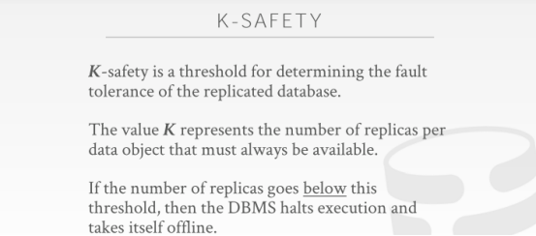

55:09 - 55:14
all right so an important property we care about in a replicated environment is this notion of K-safety
我们在复制环境中关心的一个重要属性就是这种K-safety的概念
55:14 - 55:21
and the idea here is just keeping track of the number of copies of an object you have to have in order for our system to remain online
这里的主要思路就是通过监控一个数据对象所对应的拷贝数量，来得知我们系统中存活的replica的数量
55:22 - 55:29
so I don't know whether K-safety is a standardized term , this is something that Mike Stonebreaker uses ,when describing verticaDB
我不知道K-safety是否是标准化术语，这是Mike Stonebreaker在描述verticaDB时使用的东西
55:29 - 55:32
and basically it's a human defined threshold to say
基本上这是一个人为定义的阈值
55:32 - 55:38
I need to have at least K copies of particular object at all time in my distributed DBMS , and if I ever go below that K
在我的分布式DBMS中，无论什么时候，我需要至少拥有K个特定对象的拷贝，如果少于K个
55:38 - 55:40
then I grind the system to a halt
我就会判定这个系统宕机了
55:40 - 55:47
and I stop until either I can bring up a new copy of that data, or you know Hughes or the human comes in and makes a correction
我就会停下来，直到一个关于此对象一个新的副本加入，或者人为来进行干预修正
55:48 - 55:54
the idea here is is that we want to avoid losing data ,so obviously I want my K-safety beat to be at least 1
这里的想法是，我们就是想要去避免丢失数据，so 很明显，我的K-safety 值至少为1
55:54 - 56:00
right because if I have if I lose one you know if I lose one node that has the only copy of that of a piece of data
因为如果这个1变为0了，也就是它对应的节点（唯一用有该数据拷贝的节点）挂掉了
56:00 - 56:05
then I'm screwed, now I could have false negatives or false positives for different queries, and my database is incorrect
然后我就搞砸了，现在对于不同的查询我可能会有假阴性或假阳性，而且我的数据库不正确（知秋注：节点数量不够，可能数据是老的，也可能查的数据是对的，但不符合阈值，判定还是错的）
56:06 - 56:12
so what this threshold actually depends on you know how paranoid you are about keeping things online
这个阈值实际上取决于你想保持多少个在线节点的取舍
56:13 - 56:21
and then you can also you know vary this by saying like in my example,what like I have more copy down in Brazil , maybe one copy up in up in and you know in the US
这就像我们这个例子，我在巴西有多个副本，可能我在美国就只有一个副本
56:21 - 56:25
because I want to make you know I care about keeping local copies down in Brazil
因为我想让你知道我更关心在巴西本地的副本
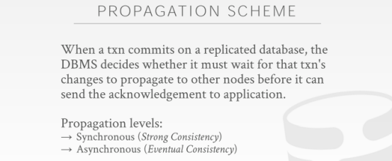

56:27 - 56:33
all right so now we want to get it what are we actually propagating, or how we're actually propagating our changes to have replicas
so 现在我们想知道的是我们实际是如何传播的，或者这么说，我们实际是怎么将我们的修改传播到这些replicas上的
56:34 - 56:39
and he sort of asked about this like does this mean we're doing eventual consistency, and I mention was no, you'll see why
他刚才问的关于这里的问题，就和我要做的最终一致性相关，我说了no，你会看到为什么
56:40 - 56:49
so the propagation scheme is when should we how long do we have to wait, or how many when should we tell the outside world that our transaction has committed
propagation（传播)方案是指，当 一个事务提交到一个具有复制能力的dmbs上，我们应该等待多长时间，或者我们应该何时告诉外界我们的事务提交已经完成
56:51 - 56:53
and this is somewhat independent of the two-phase commit stuff
这部分是独立于两阶段提交的
56:53 - 57:05
right this is saying like with my replicas, should I wait until the replica acknowledges that they got my change and have safety stored in a disk, before I tell the outside world that I've actually committed
这就是像是在说，在我向外界大声宣布我确实已经将事务提交之前，我是否应该等到replica给我返回的ack确认信息，即拿到我给它的修改信息，并安全的落地在磁盘中了

57:06 - 57:08
and in general the two approaches of using synchronous or asynchronous
通常，使用同步或异步的两种方案
57:09 - 57:16
synchronous will give you what's called strong consistency, which means I can guarantee that if I tell the outside world of my transaction has committed
同步将为我们提供所谓的强一致性，这意味着我可以保证，如果我告诉外界我的事务已经提交了
57:16 - 57:21
if I go read that data from any replicas, I'm guaranteed to see the changes of that turn action
如果我从这任何一个副本中读取数据，都可以保证看到这些修改
57:21 - 57:26
with eventual consistency, the idea is that the change will eventually get propagated to my replicas
对于最终一致性，要表达的是，修改最终将传播到我的副本中
57:27 - 57:33
so if I go if I hear back my transaction is committed, and I immediately go try to read it on a replica, I may not actually see it
如果我得知我的事务已提交的情况了，此时，我立即去尝试在某个replica上读取它，则实际上有可能看不到它
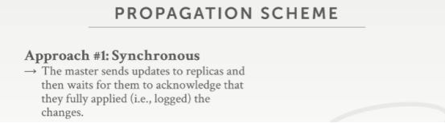

57:35 - 57:37
so again look at this visually
来看个图的
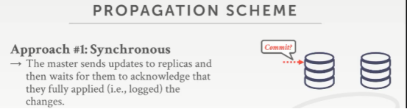

57:37 - 57:42
so with synchronous, we have say two nodes assuming we're doing a master replica set up
对于同步来说，我们有两个节点，假设我们做的是一个master-replica 方案设定
57:43 - 57:46
we say we want to commit on our master
我们想要在我们的master上来做提交（commit ）
57:46 - 57:57
and then we have to go to the replica, and say hey yeah we sent you a bunch of log messages or updates about this transaction made, go ahead and flush it

接着，我们必须将修改传播到replica上，然后对replica说，hey，我们向你发送了一些有关此事务的日志消息或更新，请将它刷出到你的磁盘中

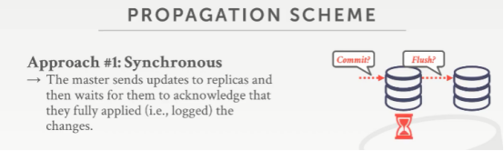

57:57 - 58:06
and then we pause and we wait until we hear a response back from our replicas, to say that our transaction has successfully been committed, and then it's durable, and disk
然后，我们停下来，等待，直到听到副本发出的响应，即我们的事务已成功提交（也就是日志落地了），然后就是持久化到磁盘
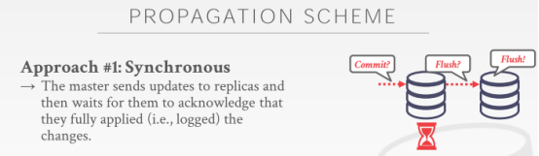

58:06 - 58:08
and then once it's done flushing
然后，一旦他结束数据刷盘，即持久化完毕

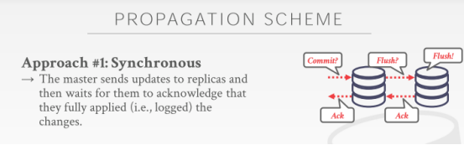

58:08 - 58:12
we send back the acknowledgment and at that point, we can tell the outside world, that we've committed
我们就返回ack确认信息，此时，我们可以告诉外界，我们的事务已经提交了
58:12 - 58:17
so again at this point here when we get back the ACK knowledge meant if we try to read whatever this thing modified
同样，在此时，即当我们拿到ack信息的时候，也就意味着如果我们尝试去任意一个replica上读取这个修改

58:18 - 58:25
we're guaranteed to see that change correct, you know see that the change we'd expect on both the master and any replicas
我们都能看到正确的数据，你会看到修改已经同时落地到master和所有的replica上了

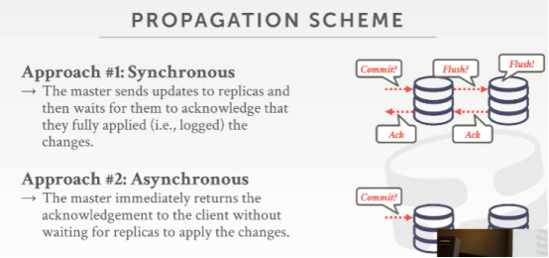

58:27 - 58:31
with asynchronous you don't wait for that response
对于异步来说，你不需要等待这种响应

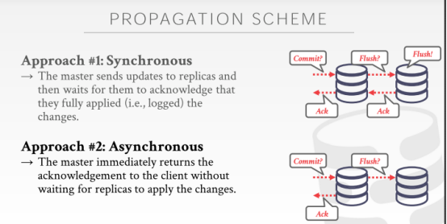

58:31 - 58:36
so I go ahead say I want to commit, then I say hey go but go ahead and flush the change
so 我会说我想要去commit，在master完事儿后，然后，我对replica说，hey，请将这些修改刷到你的本地磁盘
58:37 - 58:40
but then I can Neely come back into the application say my transaction has committed
然后，我就可以给前台应用程序说，我的事务已经提交了
58:42 - 58:47
and then now at some later point you know this thing with eventual get flushed
然后，在一段时间后，这个修改会最终刷出到replica的磁盘中去
58:47 - 58:52
but I don't really need to be told on the master ,be nice to know, but I technically I don't have to be told
但我不需要去告诉master，最好还是让它知道，但从技术上来讲，我没有必要去告诉它
58:54 - 59:04
so this is one of the good distinctions between distributed DBMS ,sorry that the traditional transactional relational DBMS and the NoSQL guys
传统的事务关系DBMS和那些NoSQL 很容易去选择适合自己的方案，

59:05 - 59:10
in the transactional DBMS, we don't wanna lose any data, we don't want to have any inconsistent reads
在事务型的DBMS中，我们不想丢失任何数据，我们不想有任何不一致的读取
59:10 - 59:13
so we would always do synchronous replication
so 我们将始终进行同步复制
59:13 - 59:16
denote the NoSQL guys would do this one here
NoSQL家伙会在这里做这个（异步复制）
59:17 - 59:21
because the idea is that eventually this thing I'll get propagated to my replicas
因为异步复制想法是，最终我会将这些修改传播到我的replicas中
59:21 - 59:27
and so maybe in the small window like 50 milliseconds, I can maybe get a stale read on my replica
也许在这50毫秒的窗口期中，你可能会在replica上读到过时的信息
59:27 - 59:28
that's who cares
但谁又会在意这些（知秋注：要注意nosql大多数的应用场景，比如最常见的redis，更多是作为缓存）
59:29 - 59:37
maybe it's a website of stupid cat food cat photos with comments, who cares you know I can't see the last 50 milliseconds of Cat Cat comments
也许它存储的是一个网站中对猫图片的评论数据，你会在意50ms内的没有更新到位的这些评论？
59:38 - 59:39
it's probably good enough
它可能足够好了
59:39 - 59:41
I have money certainly I want to use this
如果我有足够多的钱，我当然想要使用上面这个同步方案
59:42 - 59:44
because what could happen here
在这里可能会发生什么呢
59:44 - 59:48
I tell my transaction commits, I tell the outside world I committed
当我说我的事务提交了，我就告诉外界我事务提交了
59:49 - 59:51
but then this guy crashes and this guy crashes
但下面这种方案，这家伙（主）崩溃了，从也就崩溃了
59:51 - 59:57
and say this guy didn't flush anything to disk, and this guy didn't get the message yet or didn't apply it
也就是说，这家伙（主）不能将任何东西刷入到磁盘中了，然后这个从机就不能得到消息，也就不能落地修改了
59:57 - 59:59
now I want to come back my transactions gone
现在，我想返回信息，但我的事务已经没了

