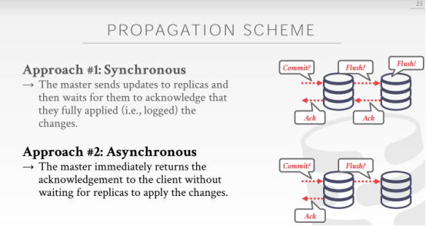

01:00:03 - 01:00:07
so as an aside come and I'll say that
顺便说一句，我会说
01:00:08 - 01:00:11
a lot of the NoSQL systems from 10 years ago
10年前的许多NoSQL系统
01:00:12 - 01:00:16
that all said we were a shoe SQL ,they were going to avoid joins ,avoid transactions
它们会避免join操作，避免事务
01:00:17 - 01:00:21
a majority of them have added transactions, the majority of them have added SQL and joins
其中大多数添加了事务，其中大多数添加了SQL和Join
01:00:22 - 01:00:29
right so it's not to say that certain aspects NoSQL systems are invalid
并不是说NoSQL系统的某些方面是不好的
01:00:29 - 01:00:33
there are certainly use cases like website we don't really need to have strong consistency
当然有像一些用例，比如有些网站，我们实际上并不需要很强的一致性
01:00:34 - 01:00:39
but in general I mean there's enough application out there ,where this matters a lot because you don't lose any data
但一般来说，有很多的应用程序，它们很介意这点，因为你不想丢失任何数据
01:00:43 - 01:00:48
so let's say like if I get this commit message here, and I immediately come back and say I acknowledgment
如果我在这里（ppt中下面这个异步图）收到此commit 消息，我立即返回并说我确认提交了
01:00:49 - 01:00:50
and I don't log anything here
我并不会在这里记录任何日志
01:00:51 - 01:00:53
actually, see the need I did log something right.
实际上，我需要在这里记录点日志么
01:00:54 - 01:00:55
say I log to disk that we commit this transaction
即，我在日志中说，我提交了这个事务
01:00:56 - 01:00:59
but now this machine catches on fire those disk milk-like
但现在这台机器（master）着火了
01:01:01 - 01:01:07
so now this guy crashes too, but he just crashed he comes back, he looks in this log
现在，这台机器（备机）也挂了，但他在挂了之后立马进行恢复，它会查看它的log
01:01:07 - 01:01:10
he didn't get the flush message, so that didn't show up in time
它没有发现flush记录，也就是没有可能落地了
01:01:10 - 01:01:15
so I told the outside world I committed, but this guy never solved the change and I crashed
我（master）已经告诉外界说我已经提交了，但这个备机并没有解决这个修改落地，它说它崩溃了
01:01:15 - 01:01:17
So I come back now the transactions gone
在我回过神来的时候，事务已经没了
01:01:22 - 01:01:25
in that if that's your bank account with that money transfer you're pissed
如果那是你转帐的银行帐户，你会很生气
01:01:26 - 01:01:26
all right

01:01:29 - 01:01:32
so it's up to the application to decide what trade-offs they want to make
so 这取决于应用程序要做哪种权衡了
01:01:32 - 01:01:36
do they care about alright are you super conservative and don't lose any data
就看你是不是超级保守，不想丢失任何数据
01:01:37 - 01:01:38
then synchronous replication is the way to go
那么就采用同步复制的方式
01:01:39 - 01:01:43
if you're okay with maybe losing the last ten five you know 50 milliseconds of data
如果你觉得丢失50ms的数据无伤大雅
01:01:44 - 01:01:45
And this is the way to go
那你就按照异步最终一致性的方式
01:01:48 - 01:01:48
Okay
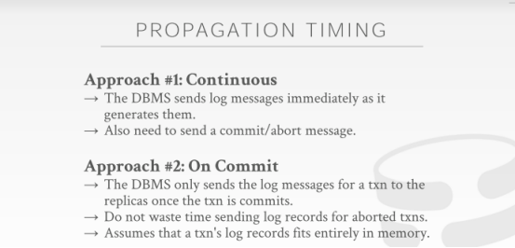

01:01:50 - 01:01:56
the next issue is when we actually send changes, oh and what do these changes actually look like
下一个问题是当我们实际发送修改时，这些修改实际上该是什么样的
01:01:58 - 01:02:06
so one approach is to have the master continuously send all the updates that transactions make as they occur
一种方法是让master服务器在事务发生时连续发送所有更新
01:02:07 - 01:02:11
think of this is like it's attached to the write-ahead log
这就像是它在追加修改到预写日志中
01:02:11 -01:02:14
so anytime I create a log record that I'm gonna put you know I want to write out the disk
每当我创建一条想要写出磁盘的日志记录时
01:02:14 - 01:02:18
I also send it out in the network to my replicas
我也会将其通过网络发送到我的replicas中
01:02:18 - 01:02:21
and they can start applying the changes as they come in
他们可以开始应用这些修改
01:02:21 - 01:02:24
of course this means now I only need to send a commit message
这意味着，我们现在不仅需要发送一个commit 消息
01:02:24 - 01:02:28
but I also need to send an abort message, just as they would if I'm replaying the write-ahead log
也需要钱发送一条abort信息，这样，如果我重演预写日志（write-ahead log）的时候就能用到了
01:02:28 - 01:02:31
because I need to know what changes I need to rollback
因为我需要知道哪些修改我需要去回滚
01:02:32 - 01:02:39
the other approach is to only send the log messages when the transaction actually goes into commit
另一种方法是仅在事务实际进行提交时才发送日志消息
01:02:39 - 01:02:44
so we just buffer all our log messages in memory on the master node
so 我们只是将所有日志消息缓存在主节点上的内存中
01:02:44 - 01:02:49
then we get abort who cares, we just drop it, we don't send anything over the network
然后我们发生了中止abort，谁会在意呢，我们就是放弃掉就好了，我们不会通过网络发送任何内容
01:02:49 - 01:02:55
if we go ahead and commit, then we push everything to our master, or sorry to our replicas
如果我们继续进行并提交，那么我们会将所有内容推送到replicas中
01:02:57 - 01:03:03
alright and the advantage of this one is that you're not wasting time sending log messages, that are gonna get aborted from transactions, they're gonna abort
这样做的好处是你不会浪费时间去发送日志消息，因为日志消息会被事务中止，它们会中止
01:03:04 - 01:03:08
but of course, this means now if I need it if I'm doing synchronous replication
当然，这意味着如果我正在执行同步复制，
01:03:08 - 01:03:13
and I need to wait until this guy acknowledges the replicas knowledge is that it's applied all this changes
我需要去等，直到replicas 去ack确认说它已经接受了所有的修改
01:03:13 - 01:03:16
then if I'm sending this huge batch of updates all at once
然后，如果我一次发送这一大批次的更新信息
01:03:16 - 01:03:19
I have to wait till they all get flushed, whereas in this one I can do it incrementally
我必须等到它们全部刷出到磁盘才行，在此过程中，我只能逐步进行
01:03:20 - 01:03:23
so far you know most systems will do the first one here
到目前为止，你知道大多数系统选择这里的第一个方案
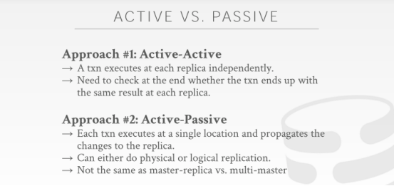

01:03:25 - 01:03:27
all right the last one is a bit more nuanced
最后一个东西其实有点微妙
01:03:29 - 01:03:31
but it's what

01:03:33 - 01:03:39
it's determining, what the changes were actually gonna apply to the system on our replicas
它是为了确定，我们实际该怎样将修改落地到我们的replica上
01:03:40 - 01:03:47
and so again in new databases a lot of times the terminology is vague or people use different things, or to describe different things
在数据库中，很多时候人们使用术语来表示不同的事物，或描述不同的事物
01:03:49 - 01:03:53
but I think active-passive versus active-active is standardized enough that this makes sense
我认为active-passive vs active-active之间的标准化足以表述到位了
01:03:53 - 01:03:55
I don't know what the textbook covers this
我不知道课本有没有涵盖这些
01:03:56 - 01:04:03
so think of this is like with active-active, the idea is that our transaction who's gonna run independently
so 对于这个active-active，它的核心是，我们的​​事务是彼此独立进行的
01:04:03 - 01:04:07
on on each of our replicas
在我们的每一个replicas 是彼此独立进行的
01:04:08 - 01:04:12
so say we have a transaction want to update for tuples
so，可以这么说，我们有一个事务，想要去更新这些tuples
01:04:12 - 01:04:16
we're gonna run that transaction on the master I run that transaction on the replicas
我们将在master服务器上运行该事务，我在replica上也运行着这个事务
01:04:16 - 01:04:20
or if we're doing multi-master again it runs on each copy of the node
或者，如果我们使用的是multi-master结构，这个事务会运行在每一个node副本上
01:04:20 - 01:04:26
and so they're gonna when they commit all we need to do determine whether we've committed correctly
他们在提交所有内容时需要去确定我们是否已正确提交
01:04:26 - 01:04:30
is that we use need to check to see whether they all produce the same result
我们需要检查它们是否都产生相同的结果
01:04:31 - 01:04:38
now this is not easy to do if you're doing a non-deterministic control scheme like two-phase locking
now，如果你正在执行诸如两阶段锁等这种具备不确定性控制的方案（因为要争抢），这就很不容易做了
01:04:38 - 01:04:41
and you know timestamp ordering all the things we talked about before
你知道的，我们之前有讨论的时间戳排序
01:04:41 - 01:04:49
because now you can be guaranteed that the transactions are running in the same order, on our two replicas without checking for every single query
因为现在你可以确保事务在我们的两个副本上以相同的顺序运行，而无需检查每个查询
01:04:50 - 01:04:55
so we talked about the partition timestamp ordering scheme, when Prashant talked that tell that lecture
so 我们有讨论过数据库分区时间戳排序方案（partition timestamp ordering scheme），这节课是Prashant讲的（Timestamp Ordering Concurrency Control那一讲）
01:04:55 - 01:05:04
in that case, you can use that for deterministic disjoint （subsets）and guarantee, that you know transactions run their operations in the exact same order on both sides
在这种情况下，你可以使用那些不相交的子集，并以此来保证事务在两边的副本分区上以完全相同的顺序运行

01:05:05 - 01:05:07
so active-active is not that common
active-active并不常见
01:05:08 - 01:05:12
because you have to do a better exercise a run exactly the same
因为你必须将精力花在如何更好地以完全相同的顺序运行事务
01:05:12 - 01:05:17
what is more common is active-passive where the transactions can execute on one location
更常见的是active-passive，每一个事务在一个单独的本地执行
01:05:17 - 01:05:19
the one master node
首先是在master节点上
01:05:19 - 01:05:22
and then they're gonna propagate their changes to the replicas
然后将修改传播到replica上
01:05:23 - 01:05:27
and these changes could either be like write-ahead log
这些修改的到replica的方式和预写式日志（write-ahead log）的方式很像（知秋注：具体前面有讲的）
01:05:27 - 01:05:34
you can either send out the physical updates to the actual tuples themselves or the bytes the low-low bytes we changed
你可以发送对实际tuples更新的物理结果（即我们修改结果的二进制字节码）
01:05:34 - 01:05:38
or we could also send out the SQL queries that they did, and just replay the single queries, and our replicas
或者你也可以发送SQL查询语句，这样，在我们的Replicas上面对每一条查询都重新执行一下就ok了
01:05:40 - 01:05:44
there's advantages of both of them just as we talked about before between you know for the recovery time
这两者都有他们自己的优点，我们之前在讲 recovery time的时候讨论过了
01:05:45 - 01:05:49
physical replication is usually the most common ,because all you're really doing is just sending up a lot the write ahead log just
物理复制往往最通用，因为你真正要做的就是发送大量的预写式日志
01:05:50 - 01:05:51
and then the replicas replay down
然后replicas重演日志就好了
01:05:53 - 01:05:55
so is this clear,yes
so 还有不明白的么，请讲
01:06:03 - 01:06:09
question is if you send the yeah ,his statement is yeah I actually would agree that
他的问题是，
01:06:09 - 01:06:17
a statement is if you're sending the SQL queries, isn't that the same thing as active-active
如果你发送了一statement 的sql查询，它们在active-active下会是一样的么
01:06:17 - 01:06:23
I'm thinking in terms of active-passive where I run the SQL query on the master
我想在active-passive情况下，这样我在master上运行一个sql 查询
01:06:23 - 01:06:26
and then the log message comes out as the SQL query
然后输出SQL查询时出现的日志消息
01:06:27 - 01:06:33
active-active in context of store procedures think of like , two transactions running in their entirety, independently on the two replicas
active-active在上下文的存储过程，即，两个事务各自独立分别完整地运行在两个replica上
01:06:34 - 01:06:40
but in your example yeah, this what I'm saying the terms are like nebulous, I would agree that would be active-active
但在你的问题中，这就是我说的这些术语所模糊的地方，我同意可以是active-active
01:06:40 - 01:06:45
even though it's done after like active-passive as I run it on the master
尽管我在master上使用的是 active-passive来运行这些sql
01:06:46 - 01:06:51
and then only after I run on the master, and then I sent to the replicas, but you could say alright I've run this query
只要在master执行后，我将二进制日志或者查询语句发送给replicas，但你可以说我已经执行了这个查询
01:06:51 - 01:06:57
and then right before you run it on the master, you send it over to the replicas, is that active-active mmm-hmm
这里，我可以在你在master上执行sql 语句之前，同时把它发送到replica上面，也就是用active-active方式
01:06:57 - 01:06:58
I would agree yes
我同意
01:07:01 - 01:07:06
alright um we have like eight minutes left
我们还剩八分钟
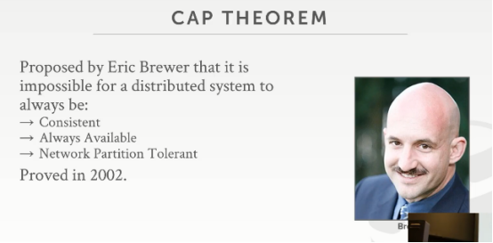

01:07:07 - 01:07:08
and this is like one of the hardest things
这是最难的一个知识点
01:07:09 - 01:07:11
let's roll the dice let's see we can do it okay
让我们掷把骰子，让我们看看是否可以hold住
01:07:12 - 01:07:17
so there's this thing called a cap theorem, that people apply for the distributed databases
这个东西叫做CAP定理，人们将它应用于分布式数据库
01:07:17 - 01:07:27
and this is a way to characterize and understand, what are the properties or guarantees ,that a distributed database can provide for you
通过它，可以知道分布式数据库为我们提供了哪些属性或保证
01:07:29 - 01:07:34
and it's broken up to three parts, consistency are consistent always available and Network partition tolerant
它分为三部分，一致性、始终可用、网络分区容错性
01:07:35 - 01:07:42
so this was originally posed as a conjecture by a Berkeley professor named Eric Brewer in the late 1990s
这最初是由1990年代末伯克利大学教授埃里克·布鲁尔（Eric Brewer）提出的
01:07:42 - 01:07:49
and then it was formally proved at MIT that this is actually correct this is a true theorem in 2002
然后在麻省理工学院正式证明这是正确的，这是2002年的一个真实定理
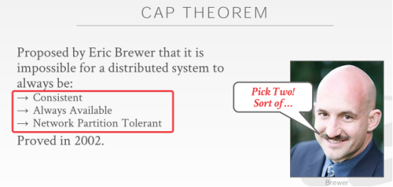

01:07:49 - 01:07:53
and the basic idea is that all these three things if you're going to have it distributed DBMS
基本的想法是，如果要使用分布式DBMS，对于这三件事，
01:07:54 - 01:07:57
you have to pick two of these you get two out of three
你需要完成这三者中的两个
01:07:58 - 01:08:04
right it's kind of like if you want it's like you know if you looking for a husband or a wife
这就好比，如果你正常找一个对象谈恋爱
01:08:05 - 01:08:09
you can pick someone's either smart good-looking or not crazy, but you can get me a two out of three of those things right
你可以选择某人的聪明帅气或老实，但你可以让我从这三个特征中选出两个来作为择偶标准
01:08:10 - 01:08:12
same thing for distributed databases
对分布式数据库来说是一个道理
01:08:12 - 01:08:13
So let's go footsies one by one
让我们一个个的来了解下
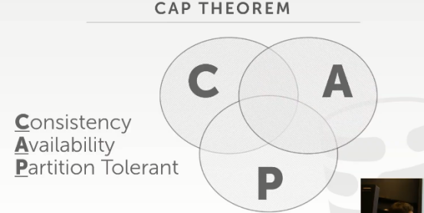

01:08:13 - 01:08:20
again the idea is that it's this sort of Venn diagram, where you have C A P, which you can never be in the middle of here
我们来看这个文森图，这就是CAP，这三者中间相交的这部分你永远不可能做到
01:08:20 - 01:08:22
you can never get a system has guarantees all these things
你永远找不到这样一个可以同时兼顾这三者的系统
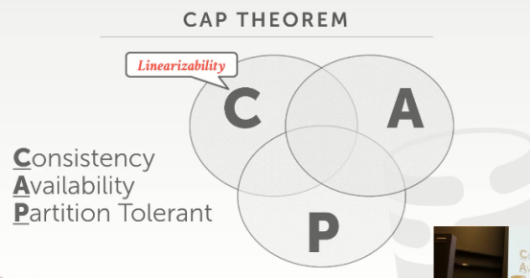

01:08:23 - 01:08:28
so the consistency just means linearizability thinking this is a stronger version of serializability
一致性就是指线性一致性，你可以把它想象成是可序列化的增强版本（知秋注：其实就是强一致性）
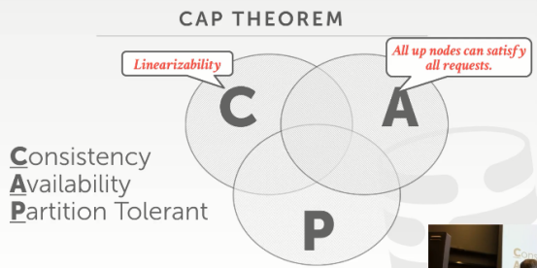

01:08:29 - 01:08:35
availability means that at any given time, we can access any node and get any data in our system
availability（可用性）是指在任意给定时间，我们可以访问任何节点并获取系统中的任何数据（知秋注:但是不保证获取的数据为最新数据）
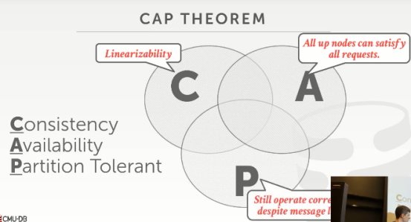

01:08:35 - 01:08:39
and then partition tolerant this means that if we start losing messages
分区容错性（Partition tolerance）意思是，如果我们有丢失消息
01:08:39 - 01:08:45
because the network goes down a machine goes down, that we can still process any response that we could ever want
因为可能会遇到网络故障，机器故障，在这种情况下，我们仍然可以处理并得到我们想要的任何响应
01:08:46 - 01:08:55
so the NoSQL guys, they are going to be AP, they're gonna try to provide availability and partition tolerance
so 对于NoSQL这些家伙们，他们走的都是AP路线，他们会尝试提供可用性和分区容错
01:08:56 - 01:08:59
in exchange for giving up consistency like, that's the eventual consistency thing
作为交换，它们放弃了强一致性，选择了最终一致性
01:08:59 - 01:09:04
like I can't guarantee that if I tell you I made your a ,I tell you that you're right it's exceeded,
就像我不能保证，如果我告诉你它执行了
01:09:04 - 01:09:06
that I guarantee that everyone's gonna see that right
我无法保证每个人都能看到正确的数据
01:09:07 - 01:09:11
in the sort of newSQL or the traditional transactional distributed of DBMS
在newSQL或传统的事务型分布式数据库
01:09:11 - 01:09:14
they're gonna try to do CP or CA
他们选择的要么是CP，要么是CA
01:09:15 - 01:09:20
and then their award if like I can't talk to a node rather than keep on running, I just shut the whole thing down
如果我不能和一个节点通信，与其继续运行，我要做的就是关闭整个事情
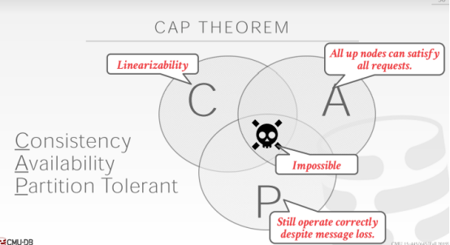

01:09:21 - 01:09:24
and in that case I give up I give up a bell Doty
看ppt中的骷髅头
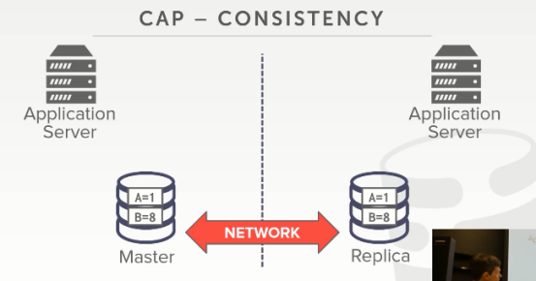

01:09:25 - 01:09:28
all right so let's go through these one by one ,I think we've covered most of these already
让我们一个接一个地讲解这些，我想我们已经涵盖了其中大多数
01:09:28 - 01:09:31
but just to show them visually to understand what they actually mean
这里通过例子来直观地展示它们，以了解它们的实际含义
01:09:32 - 01:09:37
so again with consistency, the idea is that, if we do a write on one machine that everyone should see that right
对于consistency，它的指的是，如果我们在一台机器上进行写操作，那么每个人都应该看到正确的
01:09:38 - 01:09:40
before we tell the outside world that are right it succeeded
即在我们告诉外界它成功之前
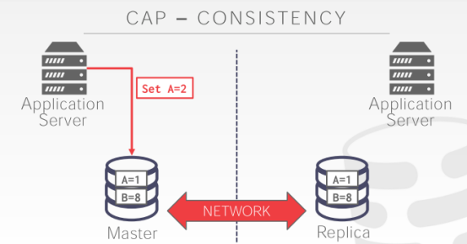

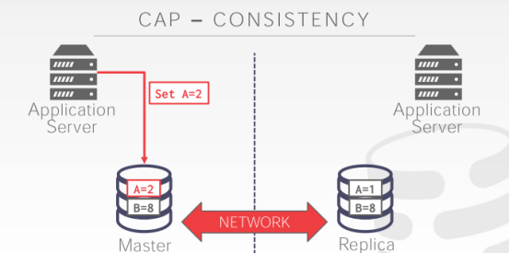

01:09:40 - 01:09:45
so our transaction is running on this application server here, it wants to set A=2
我们的事务正在此application server上运行，它想 set A=2

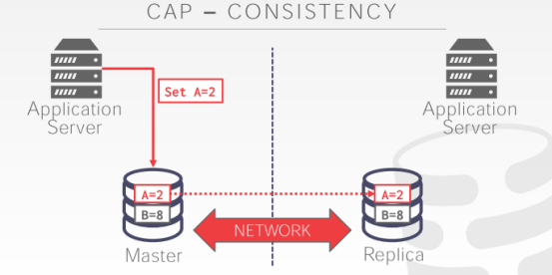

01:09:45 - 01:09:48
and then we're going to propagate that change to this replica
然后我们需要将该修改传播到这个replica上，
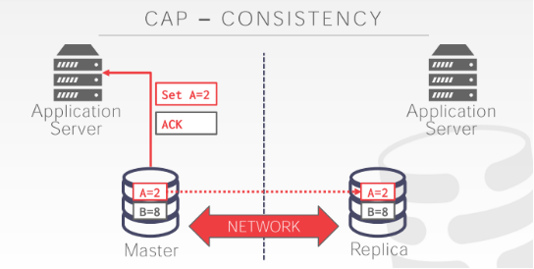

01:09:48 - 01:09:51
and then we can tell the outside world that we did acknowledge there right
然后我们告诉外界，我们做到了，即发出了ack
01:09:52 - 01:09:59
and at this point whether we read a on the replica or on the master will see A=2
此时，不管你访问的是replica还是master，你得到的结果都是A=2
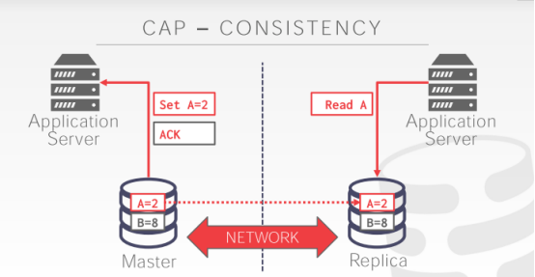

01:09:59 - 01:10:04
right so another application server can immediately see after this right has succeeded, I can see A=2
so 另一个 application server在此执行成功后，立即查看，看到的结果也是A=2

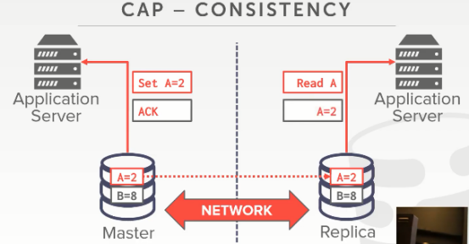

01:10:05 - 01:10:07
and I get back the correct response partition
我从分区上得到的相应结果是正确的
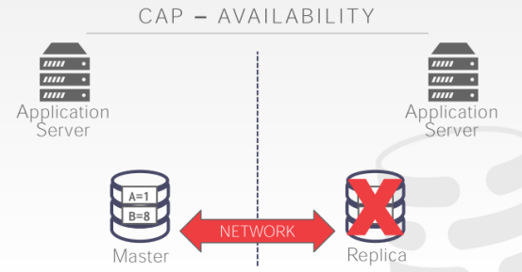

01:10:09 - 01:10:14
tolerance sorry availability says that if this replica it goes down
availability 是指，如果这个replica挂掉了
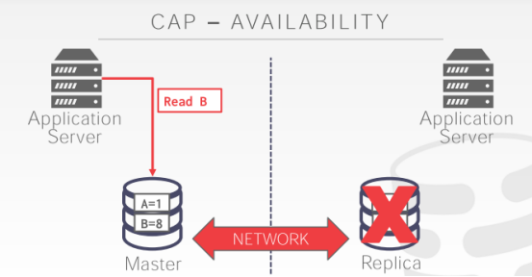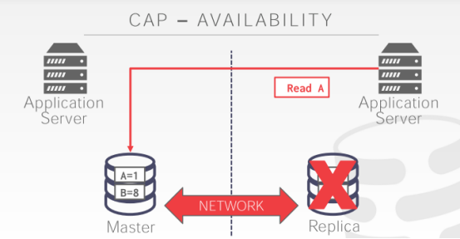

01:10:14 - 01:10:21
then either the mat this application server or this other application server can read and write to anything that at once here
无论这个 application server还是另一个 application server都能在master这里进行读和写
01:10:23 - 01:10:23
all right

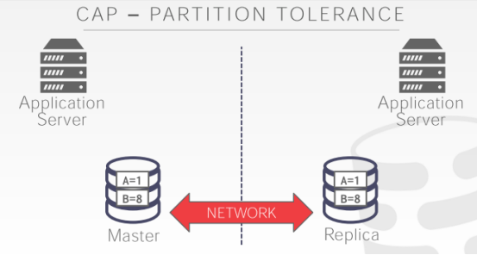

01:10:26 - 01:10:31
and then the last one is partition tolerance the idea here is that, say the network goes down
对于最后一个partition tolerance来说，它的主要思想是，如果这里的网络挂掉了
01:10:31 - 01:10:34
the network that I'm using to communicate between these two machines goes down
即用于这两台机器通信的网络GG了
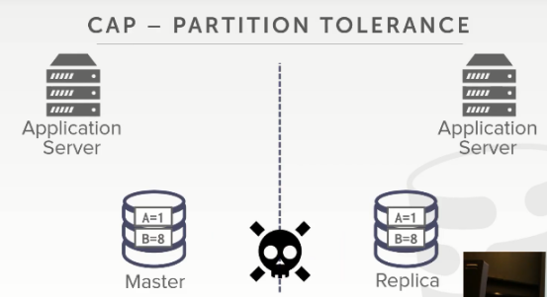

01:10:34 - 01:10:40
the machines don't go down, but it never goes down, or my messages my packets are getting lost in the network
但机器没有挂掉，我们的信息数据包在网络中丢失了
01:10:40 - 01:10:41
so now what's gonna happen here
so now 这会发生什么
01:10:42 - 01:10:45
well soon again before we had master replicas set up
在我们建立master replicas模式之前
01:10:45 - 01:10:49
and I said with master up like I set up, you run Paxos to decide who then who the master is
我说过，我们通过Paxos 来选举得到谁才是master
01:10:51 - 01:10:53
and then that's where all the updates are gonna go
然后，这就是接下来要做的事情，即选master
01:10:53 - 01:10:57
so at this point, there's that there's a network partition
此时，就会出现一个网络分区（脑裂了）
01:10:57 - 01:11:01
so these guys can't communicate, but they know they're so up like you know you're still alive
这些家伙无法通信，但是这些机器依然活得好好的

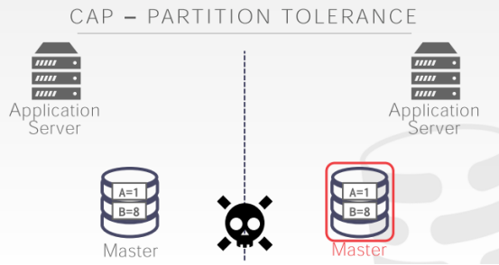

01:11:02 - 01:11:06
so now you run Paxos, and you find out oh I'm still alive now I'm the new master
现在你运行Paxos选举，这个家伙就会说，哈哈，我成了新的master了
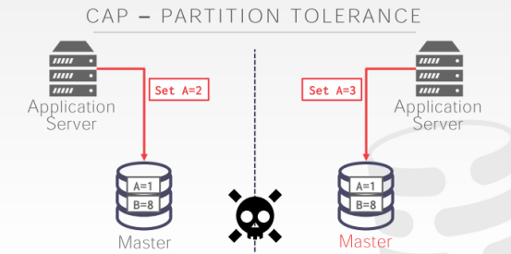

01:11:08 - 01:11:13
all right so now if my two application servers send at the exact same time updates to my database
如果这两个 application server同一时间发送了更新请求到我的数据库中
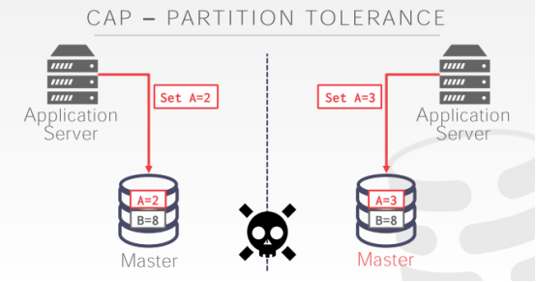

01:11:13 - 01:11:16
this guy's set A=2, this guy's set A=3
这个家伙做的是set A=2，这家伙做的是set A=3
01:11:16 - 01:11:22
both of these nodes think that their master because they ran packs those that was fine you know no one else about loaded us where the master
这俩节点都会以为它自己是master，他们可以接收并处理请求

01:11:22 - 01:11:25
so we said okay it's okay for me to go ahead and make this change
so 我们说，ok，对我来说我可以执行此修改
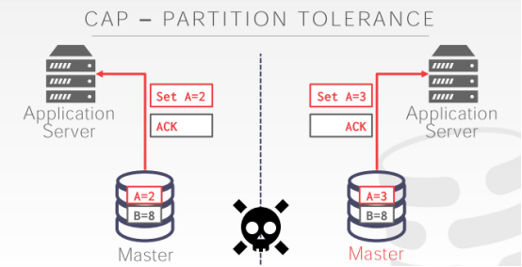

01:11:25 - 01:11:27
we send the acknowledgment that we made that change
在修改落地后，我向Application Server发出了ACK信息
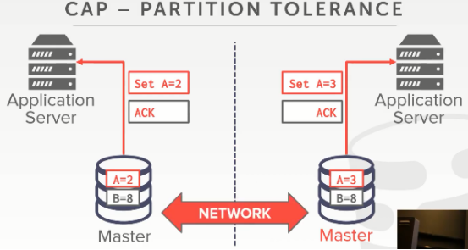

01:11:27 - 01:11:33
but now at some point, the network comes back, and I need to reconcile this change in synchronizing
现在，在这个点，网络恢复了，我需要对协调同步此更改
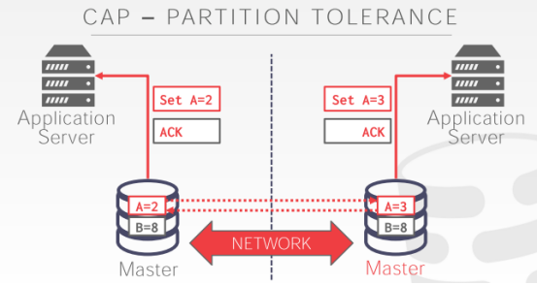

01:11:34 - 01:11:37
and now you're screwed, because now one guy set A=2, and this other guy set A=3
现在，你就懵圈了，因为这家伙set A=2，另一个家伙set A=3
01:11:37 - 01:11:40
and we told the outside world that those rights succeeded
我们都告诉外界我们落地成功了
01:11:42 - 01:11:43
so yes
请讲
01:11:49 - 01:11:53
so question is when you have CP you mM you can't really
so 他的问题是当你具有CP特性时，你不能。。。
01:11:56 - 01:11:56
take the back
再重复一下
01:11:58 - 01:12:00
yeah so this what I'm saying it's sort of
so 这就是我所说的
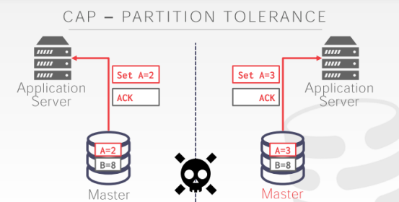

01:12:00 - 01:12:04
so what would CP look like, CP said what the network goes down
cp是指在网络挂了之后
01:12:05 - 01:12:10
I can't communicate these two nodes, what should I do
这俩节点无法通行了，我该怎么做
01:12:10 - 01:12:19
so if I'm doing like a K-safety thing, where I say, I need to have three copies of the data at all times
so 如果我做了诸如K-safety这样的事情，我会说，我需要一直存在关于此数据对象的三个副本
01:12:19 - 01:12:21
and say I have another node over here
也就是我在这里还有一个节点
01:12:22 - 01:12:28
so these two guys would you say hey we have at least two copies, we're fine, we do leader election, this guy says he's the master
这俩节点会说我们至少得有俩副本才行，我们来搞个选举吧，这家伙说它是master
01:12:29 - 01:12:31
so now anybody can do writes here and then that's fine
so 现在，每个人都可以在这里进行写操作，然后万事大吉
01:12:32 - 01:12:35
this guy over here say well K-safety is two
这家伙，会说，K-safety 是2
01:12:35 - 01:12:41
but I only have one, so I have to shut down, I can't run anything, so therefore I'm giving up availability
但只有我自己一个，so，我得shut down，我不能运行任何东西，因此我放弃了可用性
01:12:41 - 01:12:49
so in that case I can have I'm technically handling the partition in the network, by being not available on that side
在这个例子中，我可以通过技术手段来处理网络割裂，让那一边的机器不再可用
01:12:49 - 01:12:50
but this sides okay
但这边的机器是ok的
01:12:51 - 01:12:58
so this is called split-brain initiative systems like, I have two sides like two brain size the brain can't communicate, and they both think they're their king of the world
so这就是所谓的系统脑裂（split-brain），我这两遍边就像两个大脑，无法通信，它们都觉得他们是这个世界的王
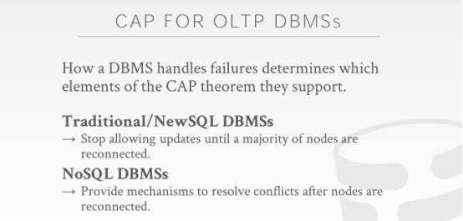

01:13:01 - 01:13:05
so again in a traditional transactional DBMS
so 在传统的事务型DBMS中
01:13:05 - 01:13:10
they basically stop the system when you realize you can't communicate with everyone
当你意识到你无法与所有人交流时，它们基本上会停止系统
01:13:11 - 01:13:14
right or if you have a majority then you say I'm the new master
如果你在一个绝大多数分区中，然后你会说，我是新的master
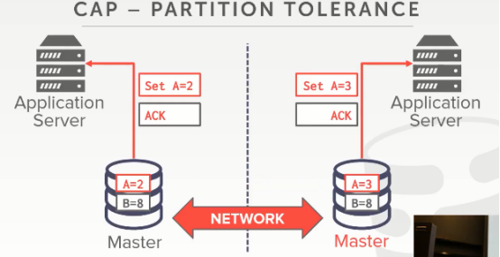

01:13:14 - 01:13:17
and so in this example here if say this guy came back up
在这个例子中，如果这个家伙归来了
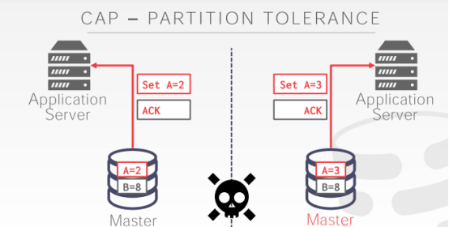

01:13:19 - 01:13:23
well assuming that seeming this guy if this guy was allowed to make changes
假设这个家伙可以进行修改
01:13:25 - 01:13:28
because it had its K-safety case a factor was enough
因为它的K-safety条件满足了
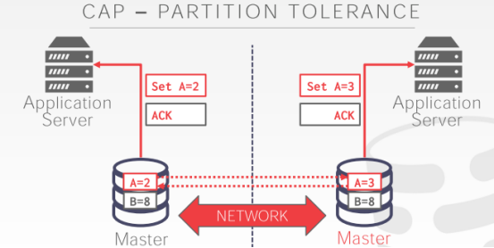

01:13:28 - 01:13:32
then when I came back, I would have to have a new human come in and resolved this change
当网络恢复后，我需要人工解决这个修改冲突的问题
01:13:32 - 01:13:36
we can't magically just do that in our system
我们不能很简单地在我们的系统中做到这一点
01:13:36 - 01:13:42
and in that case we again we stopped the world and we go offline until someone comes in and fixes us, yes
在那种情况下，我们再次全部停下来，然后离线，直到有人进来修复
01:13:49 - 01:13:49
yes

01:13:58 - 01:14:04
correct so his calm is how do I avoid the split-brain, well if your case safety factor is half the node plus one
他的问题我们该如何做才能避免脑裂（split-brain）,如果你的safety因子的大小为node数量的一半+1
01:14:04 - 01:14:06
that means that at least you're always guaranteed to have
也就是意味着至少你要一直保证的是
01:14:07 - 01:14:13
yeah only one side could be the master and the other guy fails, yes
只有一侧可以出现master，另一侧就失败咯
01:14:15 - 01:14:17
that's it there's no magic, right
这没什么可神奇的
01:14:19 - 01:14:22
and again so going back to the NoSQL guys
让我们的关注点回到NoSQL
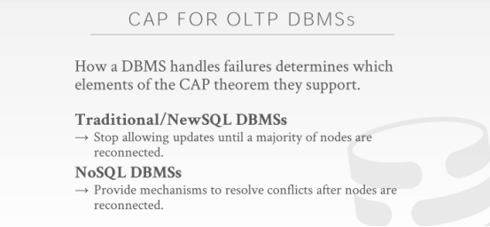

01:14:23 - 01:14:30
in their world again, they're dealing with like in it traditionally with dealing with like websites, that you want to have been online 24/7
在NoSQL 眼里，他们处理类似传统的网站，即你想让它们7*24在线
01:14:30 - 01:14:36
so in their world, they would rather have the system be available and still serve the request
在他们眼里，他们更喜欢让系统可用并一直提供请求服务
01:14:36 - 01:14:40
albeit maybe they're there they're slightly wrong or delayed in getting that all the changes
在获取所有的修改数据时，可能会有一点点数据上的错误或延时
01:14:40 - 01:14:43
but that was better than being completely online
但有些不适合这个场景
01:14:43 - 01:14:50
if you're dealing with money, and you can't, you don't want, I don't want to give out you know a million dollars to you that I don't have
如果你处理的是钱，你当然不想发生数据异常，你懂得，一百万美金可能就没了
01:14:50 - 01:14:52
and again a million dollars ever here from you know because I have a split-brain
一百万美金可能在这里，因为发生了脑裂，所以可能你看到的是美金消失了
01:14:53 - 01:14:56
in their role, they can't have that happen, so they'd rather take the whole thing down
在这种情况下，我们是不允许这种事情发生的，所以他们更倾向于直接让所有事情停下来
01:14:56 - 01:15:03
so I'm not saying one is better than another, I'm saying for certain application scenarios, one is preferred preferable
so 我没有说一个比另一个更好，我说的是在合适的情况下选择最适合的方案
01:15:06 - 01:15:11
but it's just sort of good understand like, when you start to design your distributed DBMS, what trade-offs are you actually making
在你开始设计你的分布式dmbs的时候，你要根据实际情况来做衡量选择的
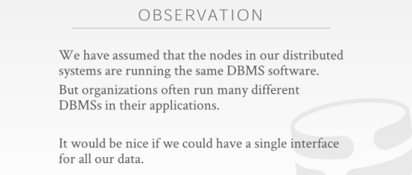

01:15:15 - 01:15:15
okay

01:15:17 - 01:15:20
so let's just finish out quickly about federated DB
So，让我们快速结束 异构联合数据库的内容
1.15.20-01:15:26
so the cap theorem again, it's include to be correct in the late 2000s some years ago
so，cap定理是在2000年后被证明是正确的

01:15:27 - 01:15:29
if you go Google the phrase like defeated cap theorem
如果你去Google一下cap 定理
01:15:29 - 01:15:34
there's a bunch of people making wild claims about, how their database is defeated a cap theorem
有一堆人大肆宣称，他们的数据库是如何如何打破了CAP定理
01:15:34 - 01:15:36
and they were presently put down as being stupid
他们是真的是够蠢的
01:15:37 - 01:15:41
its second you can't have it you distributed DBMS, you can have at your distributed DBMS, that can do everything
你无法让你的分布式DBMS面面俱到的
01:15:41 - 01:15:52
you can do a bunch of extra stuff to try to mitigate the bottleneck sort of the issues you would have, by having these various these, you know machine know down and things like that so redundancy

你可以做很多额外的事情来尝试降低瓶颈，例如，通过解决这些问题，比如，你知道机器已经崩溃了，那就对它进行冗余，来降低崩溃的瓶颈

01:15:52 - 01:15:58
so that you can you know reduce the likelihood of a network partition or things like that
So，你可以降低网络割裂或者其他类似事情发生的可能性
01:15:58 - 01:16:00
but in the end of the day, they're unavoidable
但最终，这些东西都是不可避免的
01:16:01 - 01:16:02
at some point, you're gonna run out of money
在某一时刻，你可能会烧光你手里所有的钱
1.16.02-1.16.03
or the system gonna get you slow
或者，系统可能会变慢
1.16.03-1.16.07
, and you're gonna become beholden to it
然后你就迷恋上这种调优了
01:16:07 - 01:16:08
all right

1.16.08-1.16.09
so let's just finish up quickly
So，我们快点结束吧
01:16:09 - 01:16:14
so I just want to briefly mention what a federated database is
So，我想简单提下什么是异构联合数据库
1.16.14-1.16.18
so that if you ever see one or think about building one
So，如果你曾经见过这种数据库或者想去构建这种数据库
01:16:18 - 01:16:19
you just know what it is
你需要知道它是什么样的
01:16:20 - 01:16:24
so in all this distributed DBMS, we talked about so far
So，在目前为止，在我们所讨论的分布式DBMS中
01:16:24 - 01:16:29
we have assumed that all the nodes are running the exact same DBMS software
我们假设所有节点运行着的是同一套DBMS软件
01:16:29 - 01:16:34
right it's in here it's distributed version of MySQL, distributed version of CockroachDB or whatever
它可以是分布式版的MySQL，也可以是分布式版的CockroachDB
01:16:35 - 01:16:38
but sometimes in some systems in sort of large organizations
但有时候，在某种大型组织所使用的系统中
01:16:39 - 01:16:46
you have these sort of applications that are using, you know this kind of DBMS, and then it's other applications using this other type of DBMS
你可能会遇上这种情况，即这种应用程序会使用这种DBMS，其他的应用程序则是由另一种DBMS
01:16:46 - 01:16:51
and they need a way to sort of do maybe transactions across all of them, do queries across all of them
它们需要通过某种方式在这些数据库之上执行事务，或者进行查询
01:16:51 - 01:16:53
so they appear as a single database instance
So，它们对外以一个数据库实例的形式出现
1.16.53-1.16.57
even though underneath the covers they're running completely different software
虽然在底层，它们运行的是完全不同的软件
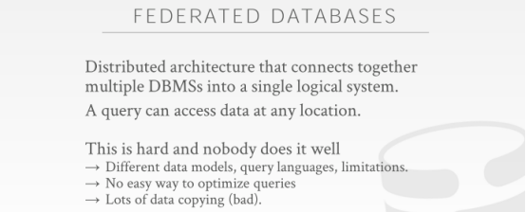

01:16:58 - 01:17:03
so this is what a federated database is designed to solve
So，这就是异构联合数据库被设计出来要去解决的问题

01:17:03 - 01:17:04
the idea is that
这里的思路是
1.17.04-1.17.07
we provide a single logical database instance
我们提供一个单个逻辑数据库实例
01:17:07 - 01:17:11
and we know how to take a single query on that single database instance
我们知道该如何在单个数据库实例上执行单个查询
01:17:11 - 01:17:14
and break it up into plan fragments
将这个查询拆分为计划碎片
1.17.14-1.17.17
that we can then possibly execute on the separate machines
这样我们就可以在单独的机器上执行这些任务
01:17:17 - 01:17:19
and we have a way to sort of put it all back together
我们会通过某种方式将这些执行结果组合在一起
01:17:19 - 01:17:23
so this was a big thing in the late 1980s early 1990s
So，这是1980年代末和1990年代初所出现的一个重要东西
01:17:24 - 01:17:26
right as companies and organizations got larger
当这些公司和组织的规模变得更大时
1.17.26-1.17.28
and there were more database deployments
它们就要部署更多的数据库
01:17:28 - 01:17:31
you think would it be great we had a single interface for all our databases
如果我们通过单独一个的接口来调用我们所有的数据库，你就会觉得这很棒
01:17:31 - 01:17:32
it didn't pan out
但这进展并不顺利
1.17.32-1.17.38
because you end up designing a system that has to do with the lowest common denominator of all your systems
因为你最终设计出来的系统必须能够做到实现你所有数据库系统的最小通用功能
01:17:38 - 01:17:39
all right

1.17.39-1.17.40
this system doesn't do the transaction
比如：这个系统不能执行事务
1.17.40-1.17.41
or this doesn't do these type of queries
或者，它不能执行这类查询
1.17.41-1.17.43
so we can't do that for other systems
So，我们也就不能在其他系统中做这些事情
01:17:44 - 01:17:44
all right

1.17.44-1.17.46
so again people try this, people still try this
So，人们依然在尝试探索这方面的东西
01:17:50 - 01:17:51
it's usually a bad idea
通常来讲，这是一个糟糕的想法
1.17.51-1.17.52
it's not gonna end well
人们依然在继续探索中
01:17:52 - 01:17:54
you do simple things
你可以做些简单的事情
1.17.54-1.17.54
but you know having this is beautiful all in the one federated databases, it's not gonna work
但你想将所有的功能都放入一个异构联合数据库中，这是不可行的
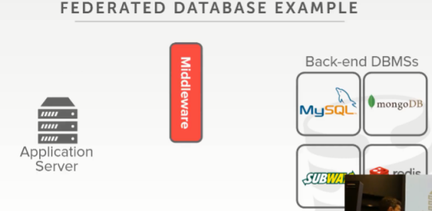

01:17:58 - 01:18:00
so again basic ideas like this
So，它的基本思想是这样的
1.18.00-*1.18.01
you have your application server
这里我们有一个应用程序服务器
01:18:01 - 01:18:04
you have your middleware system and your separate backend databases
接着，这里是我们的中间件系统，然后这里是我们的后端数据库
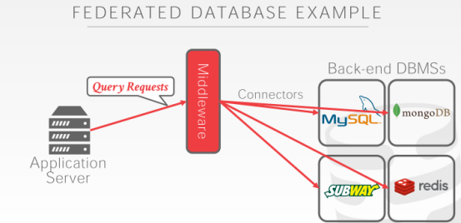

01:18:04 - 01:18:06
so single query goes to the middleware
So，我们会将查询请求发送到中间件这里
1.08.06-1.18.09
and then it recognizes what all these different systems can actually support
接着，中间件系统会意识到哪些不同的系统能支持处理这个查询
01:18:09 - 01:18:14
and so it rewrite the portion of the query that you want to run on these different machines for their different APIs
So，它会重写该查询中的部分内容，这样我们就能在不同的机器上使用不同的API对其进行处理
01:18:14 - 01:18:15
right so MySQL does SQL
So，MySQL使用的是SQL
1.18.15-1.18.18
MongoDB does JSON queries
MongoDB使用的是JSON查询
1.18.18-1.18.22
Redis does its own thing in the subway is whatever
Redis则是使用它自己的处理逻辑
01:18:23 - 01:18:23
alright

1.18.23-1.18.27
so it knows how to take all those queries break it up and run on those separate machines
So，它知道该如何将这些查询进行拆分，并在不同的机器上执行这些查询
01:18:28 - 01:18:29
and then you get back the result
然后，它们会将结果返回给我们

01:18:29 - 01:18:32
so these things are usually call connectors
So，这些东西通常叫做connectors
01:18:32 - 01:18:37
they have the ability to communicate with these different databases and pull them into the single system
它们有能力和这些不同的数据库进行通信，并将这些数据库放入一个系统中使用
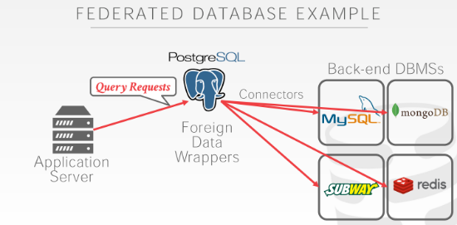

01:18:38 - 01:18:45
the one database that is the the best positioned to do a federated databases architecture is actually PostgreSQL
其中一种能做的最好的这种类型的异构联合数据库架构的DBMS就是PostgreSQL
01:18:46 - 01:18:48
so PostgreSQL has this thing called the foreign data wrappers
So，PostgreSQL有一种叫做Foreign Data Wrappers的东西
01:18:48 - 01:18:50
think of this is like an API
你可以将它想象为一种API
1.18.50-1.18.52
oh you can plug in different data sources
你可以将它用于不同的数据源上面
1.18.52-1.18.56
that are outside the normal PostgreSQL storage
对外展示的则是这种普通的PostgreSQL存储
01:18:56 - 01:19:01
so there's do foreign data wrappers for you know for Mongo and all these other systems
So，我们可以对Mongo和其他所有的数据库系统都使用这种foreign data wrapper
01:19:01 - 01:19:04
so I write all MySQL queries into PostgreSQL
So，我可以在PostgreSQL中编写MySQL查询语句
01:19:04 - 01:19:09
then the foreign-data wrapper knows how to go out to these individual systems, and suck the data in
foreign data wrapper知道该如何跑到这些数据库系统中，并往里面塞入数据
1.19.09-1.19.11
which I think is pretty cool
这点我觉得很Cool
01:19:11 - 01:19:11
okay

01:19:13 - 01:19:15
so any question about any of this
So，对此你们有任何问题吗？
1.19.15-1.19.17
as I said yes, in the back
后面那位，请讲
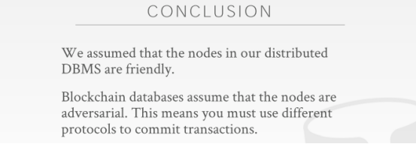

01:19:23 - 01:19:24
alright so question is
So，这里的问题是
1.19.24-1.19.29
can I recommend any distributed OLAP or OLTP system, OLAP
你要我推荐的是分布式OLAP系统，还是OLTP系统？是OLAP对吧
01:19:29 - 01:19:31
let's take this offline
我们课后再讲
1.19.31-1.19.32
because it's a complicated question
因为这是一个复杂的问题
1.19.32-1.19.33
depends on what are you trying to do,
这取决于你要试图做什么
1.19.33-1.19.35
what does your data look like
你的数据长什么样
1.19.35-1.19.37
, how much data do you have
以及你的数据量多大
01:19:37 - 01:19:39
do you want SQL or NoSQL
你想使用SQL还是NoSQL
01:19:42 - 01:19:42
why
为什么呢？
01:19:46 - 01:19:53
I mean there's like, you seen dbdb.io, there are 680 databases
你之前应该看过dbdb.io，上面有680多个数据库系统
1.19.53-
to some 260 whatever like

01:19:55 - 01:19:59
there's not gonna be this one magic thing that solves all the world's problems
这里面不存在那种能够解决世界上所有问题的数据库系统

