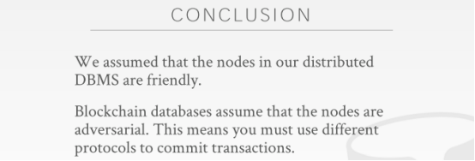

01:19:59 - 01:20:01
you have to look at your application requirements
你需要去结合你应用程序的实际需求
01:20:01 - 01:20:05
and end up making compromises about what you know ,what features you need ,what features you don't need
最后，你需要做出取舍，找出哪些是你需要的功能，哪些是你不需要的功能
01:20:05 - 01:20:07
how much money you will spend
以及你的预算是多少
01:20:08 - 01:20:08
right

01:20:13 - 01:20:15
so let's cover this next class
So，我们会在下节课的时候介绍这个
1.20.15-1.20.17
is a popular distributed OLAP DBMS will come at next class
我们会在下节课的时候介绍一个很流行的分布式OLAP DBMS
01:20:18 - 01:20:20
some popular distributed OLTP systems
对于那些流行的分布式OLTP系统来说
01:20:21 - 01:20:26
so all the the major vendors SQL server,DB2 and and Oracle
So，对于所有那些主流的数据库厂商（SQL Server、DB2以及Oracle）来说
01:20:26 - 01:20:29
they all have their own distributed DBMS
它们都有它们自己的分布式DBMS
01:20:29 - 01:20:29
all right
1.20.29-1.20.37
there's newer startups like Cockroach,TiDB , Yugabyte, Fauna ,Mongo's distributed
当然这里也有一些新兴的数据库初创企业，比如Cockroach、TiDB、Yugabyte、Fauna以及Mongo的分布式DBMS
01:20:37 - 01:20:40
right they all make you know they all have different trade-offs
它们在这上面都做了不同的权衡
01:20:41 - 01:20:45
well covered I'll list out some OLAP system next class and actually
我会在下节课的时候列出一些OLAP系统
01:20:46 - 01:20:47
let's talk let's talk offline
我们课后再去讨论
1.20.47-1.20.49
maybe there's some of your cover at the potpourri in the last class
我们可能会在最后一节课讨论Potpourri的时候介绍下
01:20:50 - 01:2050
all right

1.20.50-1.20.53
so again the main takeaway I saw from beginning is that
So，我们从本堂课学到的主要是
1.20.53-1.20.57
we assumed all our database nodes in our system are friendly
我们假设我们系统中所有的数据库节点都是可信的
01:20:57 - 01:21:00
that makes our life easier of how we do commits and transactions and Replication
这使我们在处理事务提交、事务以及Replication方面变得更为轻松
01:21:01 - 01:21:01
if they're not friendly
如果这些节点并不可信
1.21.01-1.21.03
then that's what the blockchain is
就拿区块链为例
1.21.03-1.21.05
and the blockchain worked
区块链的工作方式是
1.21.05-1.21.06
if they do to prove
如果它们要进行证明
1.21.06-1.21.07
that when we say commit transactions
当我们说要提交事务的时候
01:21:07 - 01:21:10
we want to commit a transaction ,that everybody actually committed transaction
当我们想提交事务的时候，所有人实际都已经提交了事务
01:21:11 - 01:21:14
and in case a Bitcoin that's all the hashing stuff they do with the Merkle trees
在比特币的例子中，他们使用的是Merkle tree来进行hash处理
01:21:15 - 01:21:15
okay
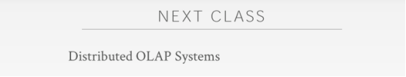

01:21:16 - 01:21:22
all right so Monday's class next week will be the last lecture on the distributed databases will cover distributed OLAP systems
下周一那节课是分布式数据库的最后一堂课，我们会去介绍分布式OLAP系统
01:21:22 - 01:21:26
I think that'll be the end of the material for the for the semester
我认为这是这学期我们最后要讲的内容
01:21:26 - 01:21:29
that'll be covered on the final
这在期末考试的时候也会有所涉及
1.21.29-1.21.31
on when we come back after Thanksgiving
当感恩节假期结束的时候
1.21.31-1.21.32
, that'll be the guest lecture from Oracle
Oracle的人会给我们进行一场客座演讲
01:21:33 - 01:21:35
and then the system potpourri in the final review, okay
Potpourri则是放在最后一节课
01:21:36 - 01:21:36
any questions
有任何问题吗
01:21:38 - 01:21:38
all right guys have good weekend see you
下周再见

