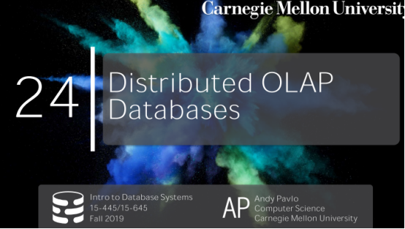

00:15 - 00:16
let's get started
我们开始吧
00:18 - 00:21
so DJ drop tables is not here today
So，DJ Drop Table今天并不在
00:21 - 00:26
he should be here next week ,he's a bit of cracking up here
他下周应该在，他遇上了点事
00:26 - 00:32
so his girlfriend's birthday this week ,and he blew off money last week in Vegas
So，这周是他女朋友生日，但他上周在拉斯维加斯把钱嚯嚯没了
00:32 - 00:38
so he lied and told her that he's going to visit his family for Thanksgiving
So，他对他女朋友撒谎说感恩节的时候要去见家人
00:38 - 00:39
so that's why he's gone this week
So，这就是他这周不在的原因
0.39-0.41
but that's just really get out of ruse of buying him a present
但这是他为了摆脱买礼物所耍的诡计
他为了不送女朋友礼物，真的是小精心
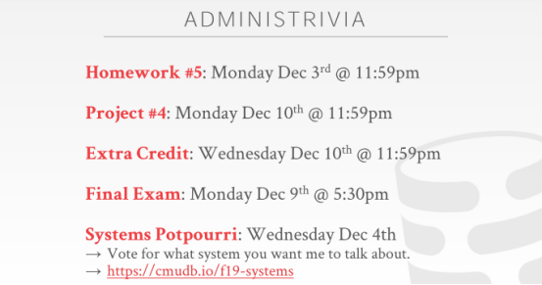

00:43 - 00:44
so he'll be back next week
So，他下周会回来
00:44 - 00:48
alright, so again just a reminder for what's on the docket for you guys
So，这里我要再次提醒下你们
00:48 - 00:52
homework 5 is due next week ,project 4 we do after that
Homework 5下周截止，Project 4则是在下下周截止
00:52 - 00:56
the extra credit for the feedback submission was last night
昨晚我们搞定了你们Extra Credit的反馈
00:57 - 01:01
some people emailed about about an error cuz some funky Unicode issue
有些人发邮件跟我说这里面有些因为Unicode而导致的错误
01:02 - 01:04
but everybody else should have submitted
但所有人应该都已经提交了你们的东西
01:04 - 01:06
the final exam will be on December 9th
期末考试应该是在12月9号
1.06-1.08
actually they announced the room
实际上，他们已经宣布了考试地点
1.08-1.09
but I haven't looked to see where it is
但我还没看它是在哪
1.09-1.11
that has anybody looked
有人知道是在哪里么
1.11-1.12
it doesn't matter
算了，这不重要
01:12 - 01:13
we'll figure it out
我们之后再看
01:14 - 01:19
and then for next week again, the Oracle talk will be on Monday
在下周一会有一场Oracle的演讲

01:19 - 01:23
the system Potpourri and the final review will be on on the Wednesday
System Potpourri以及期末复习我们会放在下周三
01:24 - 01:26
so we'll do the final review in the beginning
So，我们会在周三那节课先先进行期末复习
01:26 - 01:30
and then we'll do will cover three or four different database systems that you guys voted on
然后，我们会去介绍你们选出来的3到4个数据库系统
01:30 - 01:36
and I'll just sort of give you you know a ten minute over your what's interesting about it, why it's good ,why it's bad ,and so forth
我会花10分钟讲下你们感兴趣的那个数据库系统，我会说下它的优缺点等一系列东西
01:37 - 01:37
so if you haven't voted yet
So，如果你还没有投票
1.37-1.39
please please go in here and vote
那么就赶紧点这个网站进行投票
01:40 - 01:43
the numbers look similar to previous years
投票列表中数据库系统的数量和往年差不多
01:45 - 01:48
ah so again you can go look at the videos and last year to see what we're gonna discuss
So，你们可以去看下去年的视频，看看我们去年讨论了哪些东西
1.48-1.51
but go vote first then then go look it up
但你们还是先投票再看比较好
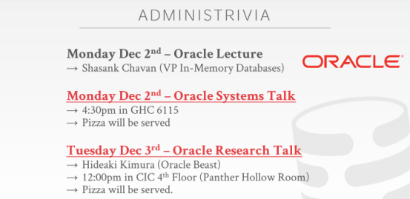

01:51 - 01:55
and as I said on Monday Tuesday next week our friends our Oracle are coming
我说过下周一周二的时候，我们Oracle的朋友会来我们这里给我们讲课
1.55-1.57
,and there's a gonna be three different talks
这里有3场不同的讲座
01:58 - 02:00
so on Monday class in here,
So，周一那场讲座就是在这里举行
2.00-2.06
they'll be will have Shashank Chavan talk about you know there's something his group is building
Shasank Chavan会讨论下他们那个组所构建的东西
02:07 - 02:08
again this is not a recruiting talk
这并不是招聘讲座
02:08 - 02:14
this is like a you know a scientific or or assistant discussion of what, they're building
这是一场科学性质或者研讨性质的讲座，内容是关于他们所构建的东西
02:14 - 02:18
and basically he'll use all the same key words and buzzwords, that I've used throughout the entire semester
简单来讲，他会使用我这学期所使用的关键字和术语
02:18 - 02:20
so you realize and I'm not not is making sure up

02:21 - 02:23
so he'll come and talk about their system
So，他会来讨论下他们所做的系统
2.23-2.28
, there's a more recruiting oriented systems talk will be Monday at 4:30 in in gates
周一下午四点半的时候，在GHC 6115那里会有一场招聘性质相关的数据库系统讲座
02:28 - 02:30
and that one will be pizza
这场讲座有披萨提供
02:30 - 02:36
and then a pure research talk would be on Tuesday December 3rd the following day at 12 p.m. and the CIC floor
在下周二的时候，我们会有一场纯研究性质的讲座
02:36 - 02:43
and so the Hideaki Kimura is as I mentioned on Piazza, I went to grad school with him
So，我之前在Piazzaa上提到Hideaki Kimura，我和他一起上的研究生
02:45 - 02:50
he's probably one of the most hardcore systems programmers ever met my life
他可能是我人生中所见到的一个很硬核的系统编程人员
02:50 - 02:52
he is also the most stubborn man that I've ever met in my life
他也是我人生中见过的最为固执的人
2.52-2.58
when we were building the first the first summer we were building H store
当年，我们在第一个暑假的时候，一起构建了HStore
02:58 - 03:01
he wanted we had to build our expression trees like for the where clauses
我们需要去构建用于处理where子句之类的表达式树
03:02 - 03:04
I had my way of doing it he had his way
我有我的方法，他有他的方法
03:04 - 03:06
we literally had a four-hour debate in my office
我们在我的办公室争论了4小时
3.06-3.09
just yelling at each other about, what to do and he just broke me down said to do it
我们互相争论该怎么做，他让我有点失望，他让我按照他的做
03:09 - 03:10
he was wrong
他的想法是错的
3.10-3.13
, and we removed what he did later on， my codes still there
我们之后移除了他做的那部分，我的代码被保留了下来
03:13 - 03:13
so I was right
So，我的想法是正确的
3.13-3.15
, but in general he's awesome
但总的来讲，他很棒
03:15 - 03:17
so he's gonna come talk about some

03:18 - 03:22 ！！！！！！
he's just come talk to the non-volatile memory stuff that they've been working on for the system
他会来讲下他们所负责系统中的非易失性内存(non-volatile memory)
03:22 - 03:23
because he's part of shashank group
因为他是Shasank组中的成员
3.23-3.27
so again if you're interested in doing internships or full-time positions with them
So，如果你想去他们那里实习或者全职工作
03:27 - 03:30
he will come and tell you the kind of things you could be working on, okay
他会来告诉你们，你们可以负责哪些东西
03:31 - 03:34
and I'll some reminders about all these things on Piazza
我会将这些东西放在Piazza上
03:34 - 03:35
any questions about any of these
对此你们有任何问题吗？
03:38 - 03:38
okay

3.38-3.44
and then I also make arrangers if you want to eat these guys one-on-one to talk about internships ,and full-time positions as well ,well
如果你们想要和他一对一讨论实习和全职工作方面的问题，我也会安排时间
03:44 - 03:45
I'll send that email
我会发邮件的
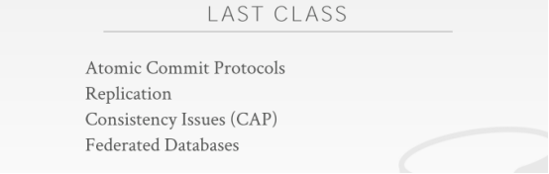

03:45 - 03:45
Okay

3.45-3.50
so last class was the second lecture we had on distributed databases
So，上节课是我们关于分布式数据库的第二节课
03:50 - 03:55
the first class are just defining what a distributed database system looks like from architecture standpoint
第一节课的时候，我们从架构层面定义了一个分布式数据库系统该是怎么样的
03:55 - 04:01
you know where's data relative to where the computers actually gonna run on it
即相对于机器来说，数据应该放在哪里
04:01 - 04:06
and then last class was all about talking about taking these distributed databases when you want to do transactions
上节课则是关于分布式数据库执行事务这块的内容
04:06 - 04:14
and making sure that we provide all the ACID guarantees, that we'd want on a single node system, but now doing this in a distribute environment
为了确保我们将在单节点数据库系统上所提供的ACID保证应用到分布式环境下
04:14 - 04:18
and we spend most of our time talking about the atomic commit protocol and replication
我们上节课花了大部分时间在讨论原子提交协议和replication上面
04:18 - 04:21
because again that's the hard part of apps you have in distributed database
因为这是分布式数据库中很难的一部分
4.21-4.21
when things are split up
当这些东西都被拆分开来的时候
04:22 - 04:25
and now you have transactions doing writes on a bunch of different nodes at the same time
你的事务就会在同一时间对不同节点上的数据执行写操作
04:25 - 04:26
how do you keep it all in sync
你如何让它们保持同步
4.26-4.28
how do you avoid losing data
以及，该怎么做才能避免丢失数据
4.28-4.31
,how do you have reads not see stale data ,if you care about those things
如果你在意这些东西的话，你该如何保证不读取到过时的数据
04:32 - 04:34
so for today class
So，在今天的课上
4.34-4.40
now we're going to sort up just leave alone or you know leave all the transaction stuff we talked about before
我们不会再去讨论我们之前讨论的事务相关内容
04:40 - 04:42
and now so I was talking about how to do analytics
今天我们要讨论的是如何进行数据分析
4.42-4.45
,where we're not doing a lot of writes,we're not doing transactions
我们不会去执行大量的写操作，也不会去执行事务
04:45 - 04:48
we're mostly going to be doing reads
我们大部分要做的还是执行读操作
我们要做的绝大多数操作都是读操作
04:48 - 04:55
but the amount of data we're going to be reading is much larger than what the OLTP transactions were doing from last class
但我们要读取的数据量要远比我们上节课执行事务时所读取的数据量大的多的多
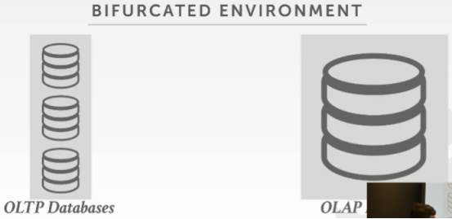

04:55 - 05:01
so I want to show what a sort of a typical set up would be in an analytical database
So，我想向你们展示下分析型数据库中的一种标准设置
05:01 - 05:04
and this doesn't necessarily have to be a distributed database
分析型数据库不一定就得是一个分布式数据库
05:04 - 05:06
but this is a common arrangement
但这是一种常见的安排
05:06 - 05:08
so on the front end you have your OLTP databases
So，在前端我们有一些OLTP数据库
5.08-5.13
,that this is where you're ingesting new information from the outside world
这是你从外界收集信息的地方
05:13 - 05:15
and this could be distributed could be single node
它可以是分布式的，也可以是单节点数据库系统
5.15-5.15
it doesn't matter
这都没关系
05:16 - 05:21
and then you want to get all the data from these front-end data silos into your back-end analytical database
接着，你想从这些前端data silos（数据孤岛）处获取数据，并放入后端分析型数据库中
5.21-5.23
sometimes called a data warehouse
有时这也叫做数据仓库
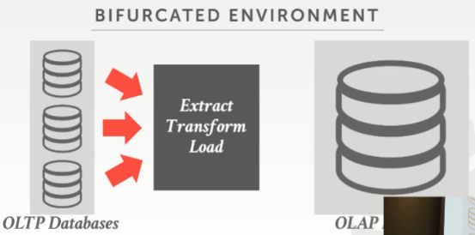

05:24 - 05:28
so there's this process called ETL extract transform the load
So，这个过程叫做ETL（提取、转换、加载）
05:28 - 05:33
so there are tools you can buy that do this we just write Python scripts or do whatever you do manually
So，你可以去购买这样的处理工具来处理这些数据，我们也可以写一些Python脚本来进行处理，或者你可以手动处理
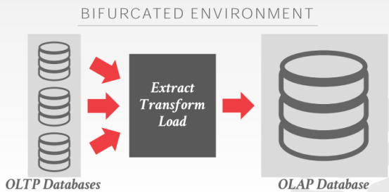

05:33 - 05:34
but the idea is that
但这里的思路是
5.34-5.38
to take all the data from these different front-end OLTP databases
我们先从前端所有不同的OLTP数据库中获取全部数据
05:38 - 05:43
and put it into a universal schema inside your data warehouse
接着，将这些数据放入你数据仓库的universal schema中进行处理
05:43 - 05:44
so for example
So，例如
5.44-5.46
let's say you have your front-end database
假设，你有一些前端OLTP数据库
5.46-5.50
, one application has that you know they all have different customers names
这些数据库中保存了不同的客户名
05:50 - 05:52
but this one has F name for the first name
但这个数据库中保存的是First name以F开头的用户信息
5.52-5.54
this one has first underscore name
这个数据库中保存的是以下划线_为开头的用户信息
05:54 - 05:57
so you can't just chuck that all into a single database
So，你不能直接将所有数据都放入一个数据库中
5.57-5.59
because the database doesn't know that F name equals first name
因为数据库并不知道它的First name是否以F开头
05:59 - 06:03
so this is where you do that cleanup process here in the ETL world
So，这就是你在ETL中数据清洗所要做的事情
06:04 - 06:06
so this is a very common setup right
So，这是一种非常常见的设置
06:06 - 06:08
if you're gonna build a startup
如果你要构建这样一种系统
6.08-6.09
you typically start with this
你通常就应该从这方面入手
6.09-6.11
because you need to get data first
因为你需要先获取数据
06:11 - 06:13
and then once you have a lot of data,
接着，一旦你拿到了大量数据
6.13-6.15
then you want to put it into your back-end data warehouse
然后，你会想将这些数据放入你的后端数据仓库中
06:16 - 06:16
and the idea is that
这里的思路是
6.16-6.18
we don't wanna do analytics on the front-end
我们不想在前端数据库中进行分析处理
6.18-6.20
because that's gonna slow down our transactions
因为这会降低我们事务执行的速度
06:20 - 06:22
so you can put this into our back-end data warehouse
So，你可以将这些业务放到我们的后端数据仓库中
06:23 - 06:24
so this is what we're focusing on today
So，这就是我们今天所关注的内容
6.24-6.25
how do we actually do this
我们实际该怎样做到这点
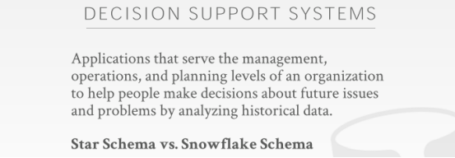

06:27 - 06:30
so I use the term OLAP
So，这里我使用了OLAP这一术语
6.30-6.32
online analytical processing
即在线分析处理
06:33 - 06:36
sometimes you'll see these types of systems referred to as a data warehouse
有时你们会将这类型系统叫做数据仓库
06:36- 06:40
or more traditionally sometimes they call it decision support systems DSS
或者，有时更传统的说法叫做决策支持系统（decision support systems DSS）
06:40 - 06:41
and again the idea is that
它的思想是
6.41-6.47 ！！！！
these are applications we're going to write now in our back-end data warehouse
这些是我们现在要在后端数据仓库中编写的应用程序
06:47- 06:50
That it's gonna analyze the data we have
它会对我们所拥有的数据进行分析
6.50-6.54
,that we've kept from the OLTP side extrapolate new information
这些数据是我们从OLTP数据库那里拿到的，并以此推断出新的信息
06:54 - 07:00
and then guide our decision-making processes for the business for the organization or for the OLTP allocations
然后用于对我们的组织业务或OLTP的分配的决策指导
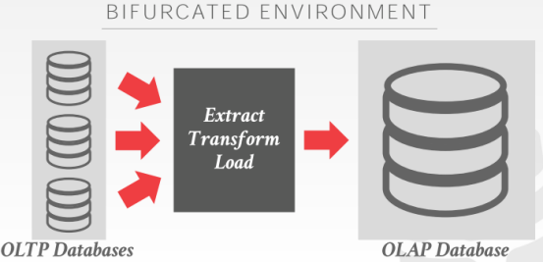

07:01 - 07:05
right so very common set up the one is they've always like to use is like zinga
我们最喜欢用来讲解的一个例子就是Zinga（一家社交游戏服务提供商）
07:05 - 07:08
zinga has all their stupid farmville games up here
假设，这里是Zinga他们推出的游戏Farmville
07:08 - 07:09
right these are OLTP databases
这是他们的OLTP数据库
7.09-7.11
for every click in the game
游戏中的每次点击

7.11-7.13
,that's another transaction or another update to the database
其实就是一个事务，会对对数据库进行更新
07:14 - 07:19
but then there's a shove all those clicks into the backend data warehouse
但接着，他们将所有的点击事件所产生的数据发送到后台数据仓库中
07:19 - 07:20
do some analysis on this
并对这些数据进行分析
7.20-7.27
at whether your decision support systems or machine learning to try to figure out some of, how to make you buy more stuff on the front end ,right
你的决策支持系统或者机器学习会去弄清楚如何让用户去购买更多的道具
07:28 - 07:33
like the the one example, I always heard was it's the candy crush game
我经常听到的一个例子就是Candy Crush（糖果传奇）这个游戏
07:33 - 07:35
if you played the candy crush game
如果你之前玩过糖果传奇
7.35-7.38
and so you get all these updates on the OLTP side
so，你会从OLTP一侧数据库中获取到所有这些更新
07:38 - 07:41
and then it's a you get a hard puzzle and you can't beat it, right
当你遇上难以通过的关卡时
07:42 - 07:43
and so you put the game down
你就会结束游戏
07:43 - 07:46
so they're gonna collect all this click stream to see how you played the game
So，他们就会去收集这些点击数据，以此来弄清楚你是怎么玩这游戏的
07:46 - 07:47
and then they'll learn that oh
然后，它们就可以学到这么一招
7.47-7.52
if you come back after not having played the game for like a day because you got frustrated
在你因为沮丧而很久不玩这游戏，然后在回归这游戏时

07:52 - 07:55
they make sure you they give you an easy puzzle that you can solve right away
他们为了确保你能够轻松通关，会给你降低难度
7.55-7.57
, so you get hooked again, right
So，你就会再度沉迷
07:57 - 07.58
and then keep playing it
并继续玩这游戏
7.58-7.59
,because they know if they give you a hard puzzle
因为他们知道，如果给你一个困难关卡
7.59-8.01
, you'll get frustrated and never come back ever again
你就会变得沮丧，并且不再玩这游戏了
08:02 - 08:04
right so that extrapolating that information that
So，他们就会提取出这样的信息
8.04-8.09
oh this is how I give you know the person, you know a game that they'll be able to beat
他们会给出你能够过关的关卡
08:09 - 08:11
you figure that out on this side
你会在OLAP数据库中弄清楚这些
8.11-8.13
and then you push the update to the OLTP side
然后，你将这些更新信息推送到OLTP数据库这边
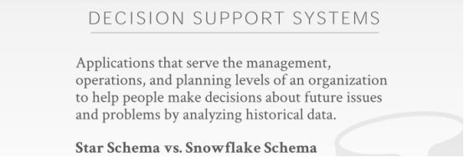

08:15 - 08:17
so the in general
So，总的来讲
8.17-8.25
at a high level, there are two different ways you can model a database application on a back-end data warehouse or analytical database
从高级层面来讲，你可以在后端数据仓库或者分析型数据库上从两个不同的方面进行程序建模

08:25 - 08:27
so you could take the standard schema
So，你可以使用常规方案
8.27-8.31
, that you know your application would have like typically it's usually a tree schema
你知道的，你的应用程序通常会使用一种tree schema
08:32 - 08:32
because you have this hierarchy
因为你这种层级结构确实很容易设计数据结构和算法，
8.32-8.33
,I have customers
我有用户信息
8.33-8.34
, customers have orders
用户拥有对应的订单信息
8.34-8.35
,orders have items
订单信息中又包含了商品信息
08:37 - 08:39
but those schemas can be quite messy
但这些schema可能很混乱
8.39-8.42
and they're not going to be very efficient for analytical queries
对于分析型查询来说，它们的效率并不高
08:43 - 08:44
so instead
So，相反
8.44-8.48！！
you would model your database using either what's called a star schema or a snowflake schema
你会使用Star schema或者SnowFlake Schema来对你的数据库进行建模
08:48 - 08:53
and sometimes you see analytical databases, that they'll say hey we only support star schemas
有时，你们会看到一些只支持Star schema的分析型数据库
08:53 - 08:54
you can't do a snowflake schema
你无法在这些数据库中使用Snowflake schema
8.54-8.58
,you'll see this is basically a subset of this
简单来讲，Star Schema其实是Snowflake Schema中的一个子集
08:58 - 08.59
but you see why
但在后面你会看到我为什么这么讲
8.59-9.02
let's discuss why this matching might be better for it some analytics
让我们来讨论下为什么这种方案对于某些分析来说要来得更好
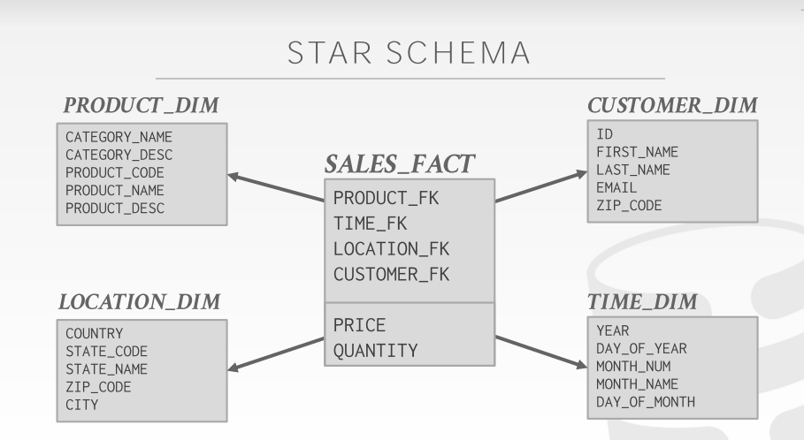

09:04 - 09:08
so a very common arrangement would be something like this
So，如图所示，这是一种非常常见的安排
09:08 - 09:10
so this is a star schema
So，这就是一个关于Star Schema的例子
09:10 - 09:12
and you have two types of tables in a star schema
在Star Schema中，你有两种类型的表
9.12-9.14
you have facts tables and dimension tables
即Fact table和Dimension Table（看图中的后缀名）
09:14 - 09:17
so the middle of the star is the fact table
So，中间这张表就是Fact Table
09:17 - 09:20
think of this is like whatever event you're trying to mode
不管你要对哪种事件进行建模
9.20-9.23
this is where you store all the occurrences of them
这里就是你保存所有出现事件的地方
09:23 - 09:24
so if you're like Walmart
So，以沃尔玛为例
9.24-9.32
and your data warehouse keeps track of every single item that anyone has ever bought, at any Walmart stored at any given time
你的数据仓库会跟踪在任意给定时间里任何人在任何沃尔玛门店处所购买的每个商品信息

09:32 - 09:36
all of those items getting scanned at the cash check or the checkout counter
收银台会扫描所有这些商品信息
9.36-9.38
, that's another event that we've put in our fact table
这就是我们要放入我们Fact Table中的一个事件
09:39 - 09:43
so this thing is gonna be massive, like hundreds of billions of records
So，这些东西的数据量很大，可能有上百亿条记录
09:43 - 09:43
same thing Amazon
Amazon也是如此
9.43-9.47
every single item that anyone's ever bought on Amazon goes and you're in your fact table
任何人在Amazon上所购买的每个商品都会进入你的Fact table
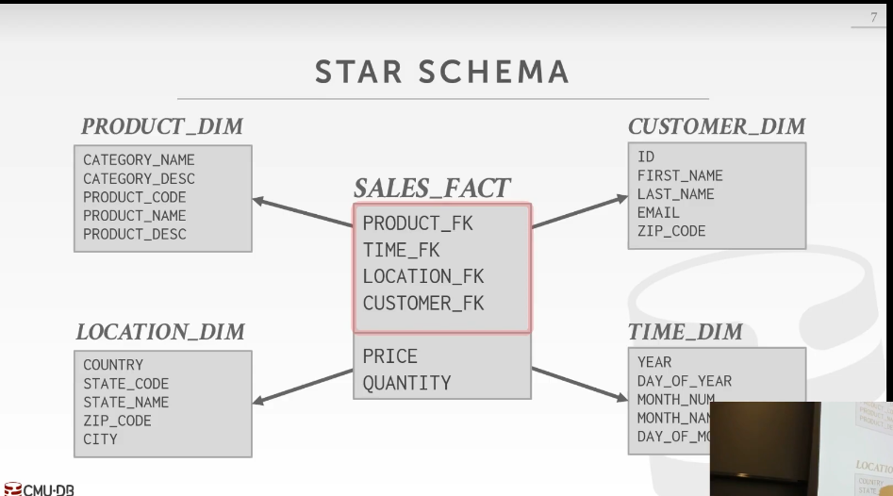

09:47 - 09:53
but we're not actually going to store any information about what these items are that someone bought
但我们实际不会去保存任何关于这批商品的购买者是谁的信息
09:53 - 09:57
have foreign key references to our outer dimension tables
我们会使用外键引用来指向这些dimension table
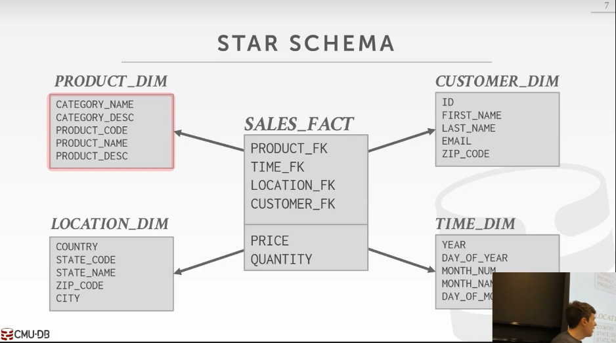

09:58 - 10:01
where they're going to maintain that additional information
它们（dimension tables）会去维护这些额外信息
10:01 - 10:02
all right

10.02-10.03
cuz can this is things we massive
因为这些数据量太大了
10.03-10.06
we want this to be through as trim as possible
我们想让我们的Fact Table尽可能地精简
10.06-10.08
because we have billions of rows
因为我们拥有数十亿行数据
10:08 - 10:11
so we put all the actual metadata in the dimension tables
So，我们会将这些元数据放在dimension table中
10:11 - 10:13
but in a star schema
但在Star Schema中
10.13-10.20
, you can only have one one level dimension tables out from the center of the star
在星星的中心外侧，你只能拥有一层dimension table(知秋注：将整个体系图看作是一个四角星结构，只针对这个例子，因为可能是更多角的星)
10:21 - 10:25
Right, so there's no additional tables over here that these guys can join with
So，这里没有其他额外可以加入的表
10:26 - 10:26
Right, in this case here,
在这个例子中
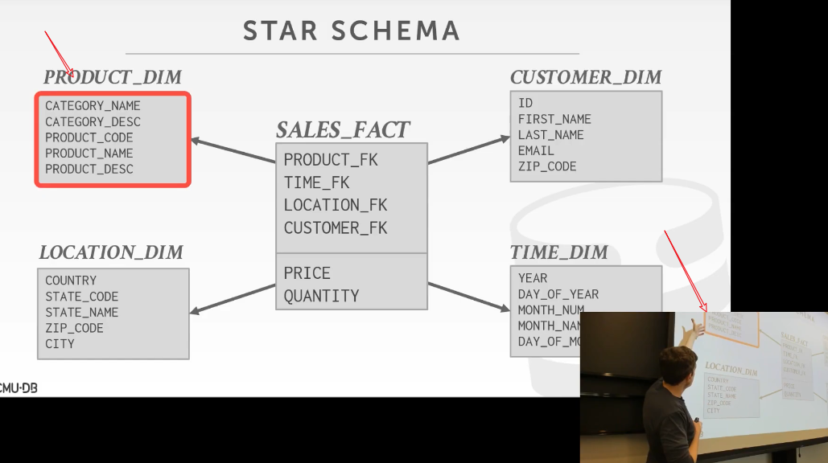

10.26-10.28
I have a category named a category description
我有CATEGORY_NAME和CATEGORY_DESC这两个字段
10:28 - 10:35
so I could extract that out and normalize that store that has another dimension table with another foreign key going from this to this
So，我可以将它们提取出来，对它们进行规范化设定，然后保存到另一张dimension table中，并在通过外键来将这两张表关联起来（知秋注：所谓的规范化设定，就好比我们看到一个Integer，就能知道它代表什么意思）
10:35 - 10:39
but under a star schema, you know you're not allowed to do that
但在Star Schema中，我们不允许你这么做
10:39 - 10:41
and we take a guess why
你们可以猜下这是为什么
10:45 - 10:45
yes
请问
10:48 - 10:48
exactly
没错
10.48-10.53
so you said the time it takes you to diverse or join those different tables is going to be expensive
正如你说的，对这些表进行join操作所要花的时间成本实在是太高了
10:53 - 10:56
because again we're not doing like find where Andy's items
因为我们并不会去做诸如：请找到Andy购买的商品清单之类的事情
10:56 - 11:02
we're saying find all the items that the you know that the state of Pennsylvania has bought within this date range
假设我们要做的是找出这段时间内，宾夕法尼亚州中购买的所有商品
11.02-11.05
can be hundreds of millions of rows
这可能就会有上百万行记录
11:05 - 11:09
so we want to avoid as much as doing as many joins as possible
So，我们想尽可能避免做太多的join操作
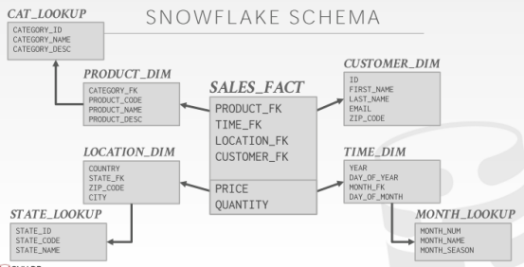

11:10 - 11:14
so a snowflake schema is where you're allowed to do have multiple dimension outside of it
So，在Snowflake schema中，它允许你拥有多层dimension table
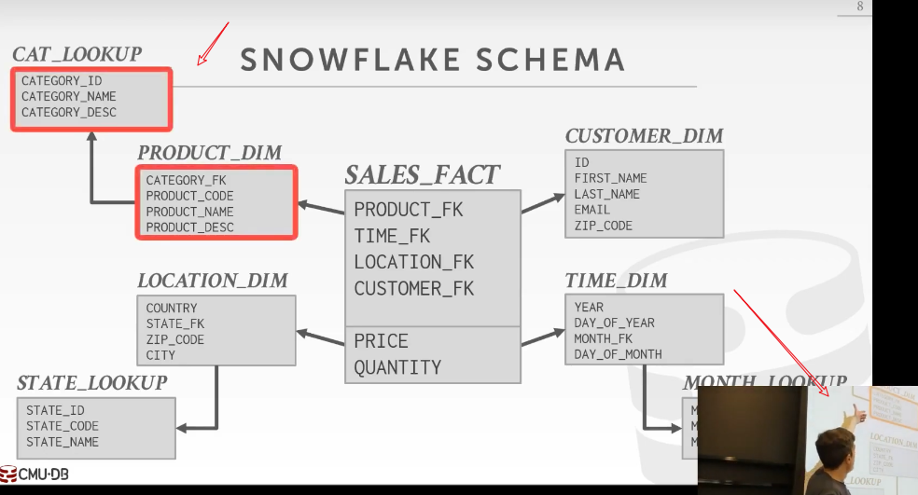

11:15 - 11:16
right so again going back up here ,right
So，来看这里
11:16 - 11:19
I have now can break out my category information
这里我将我的分类信息拆分了出来
11.19-11.21
I have a foreign key in the product dimension table
我在我的PRODUCT_DIM表中建立了外键
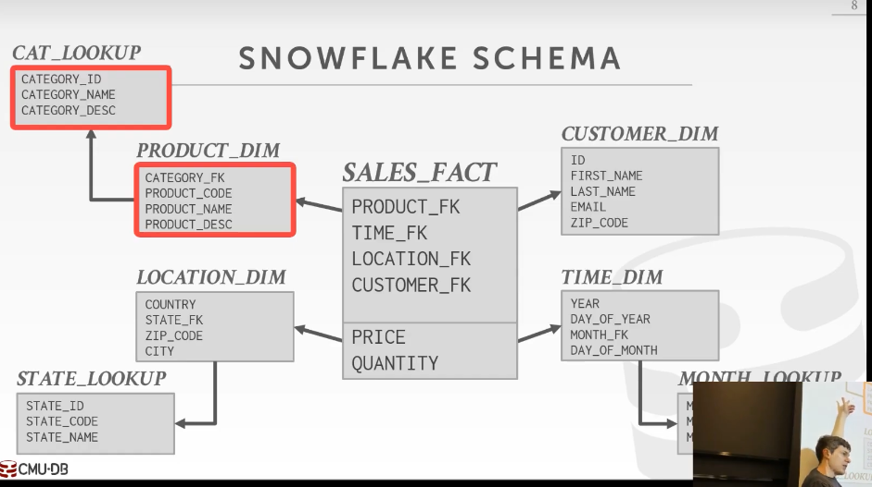

11:21 - 11:23
and then I have what is called now a lookup table
接着，我将这个拆分出来的表叫做CAT_LOOPUP表

11.23-11.26
which is the things beyond the dimension table
这里面保存了PRODUCT_DIM表以外的一些信息
11.26-11.30
where I have that normalized information as the output
我将这些范式化信息作为输出结果
用于作为规范化的信息（normalized information）来作为输出结果
11:30 - 11:31
and as I said
正如我说的
11.31-11.40
a some database system , some OLAP systems will say explicitly, you can't have look-up tables ,you can't have multiple levels beyond the first dimension table
某些OLAP系统明确表示，你不能有这种查询表，你也不能拥有多层dimension table
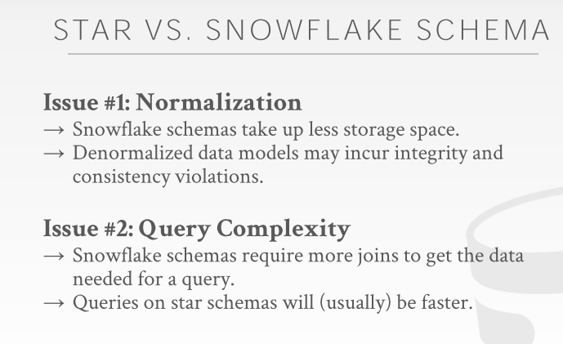

11:42 - 11:49
so the main sort of two issues in this world as she said one of them is performance
So，正如她所说，其中一个主要原因就是性能问题
11:49 - 11:53
the other one is actually going to be the integrity of the data that were storing
实际上，另一个原因则是这些被保存数据的完整性（知秋注：非规范化的数据模型可能会导致完整性和
一致性问题）
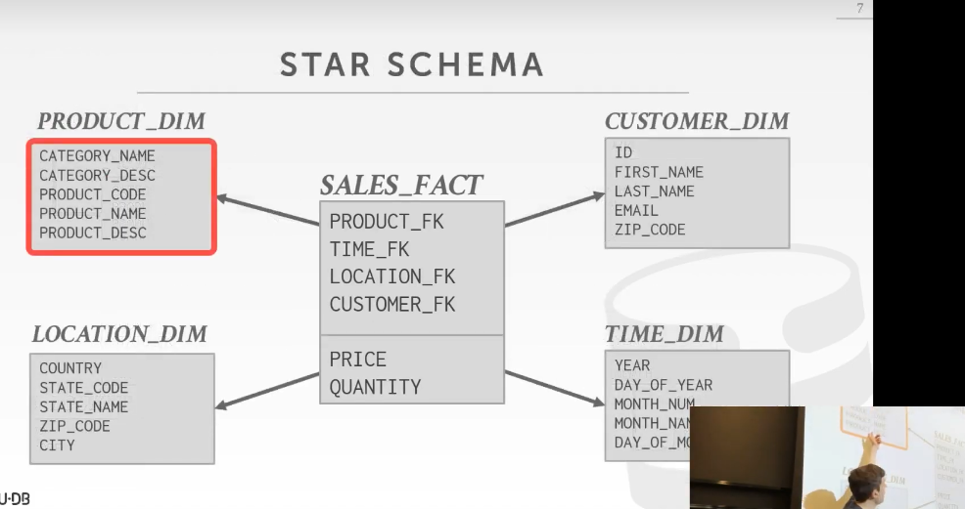

11:55 - 11.57
again so going back here,
So，回到这里
11.57-12.01 ！！！！！！！
if I collapse down my lookup table into a single dimension table
如果我将我的查找表合并到一个dimension table中
12:01 - 12:04
well I'm gonna be repeating the category name over and over again
我就会遇上不断重复的分类名称(category_name)
12:04 - 12:06
so now if the category name changes
So，如果分类名称(category_name)发生了变化
12.06-12.12
,I need to make sure in my application code, that I go update all the records that have that same category name
在我的应用程序代码中，我需要确保我更新了所有包含有该分类名称的records （记录条目）

12:12 - 12:14
so that everything is in sync
这样的话，所有的东西都是同步的
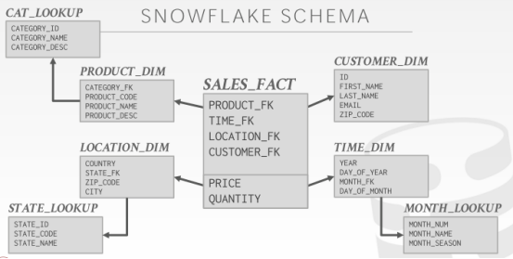

12:14 - 12:17
if I'm normalized out like this in the snowflake schema
如果我将数据归类成Snowflake schema中的样子
12.17-*12.17
I don't have that problem
我就不会遇上这种问题
12.17-12.19
,because I want have one entry for the category
因为我会有一个分类条目(知秋注：如果某一分类发生了变化，比如某一个分类id对应的category_name发生了改变，我只需要更新该分类id对应的分类条目的category_name即可，其他无须改变)
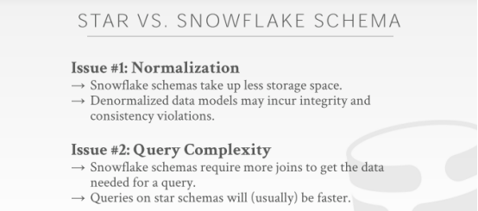

12:21 - 12:24
right so if you do a star schema
So，如果你使用的是Star Schema
12.24-12.32
then this extra work that you have to do in your application to make sure that your denormalized tables are are consistent
你必须在你的应用程序代码中做些额外工作，以确保这些非规范化（denormalized ）的表中的数据都是一致的

12:32 - 12:35
you now actually potentially storing more redundant information that's unnecessary
实际上，你们可能会去保存更多不必要的冗余信息
12.35-12.39
,and so the size of your database could be larger
So，你数据库的体积可能就会变得更大
12:39 - 12:40
it's not that big of a deal
这并不是什么大问题
12.40-12.46
, because again the fact table is the main juggernaut in this model
因为Fact table才是这个模型中的重点
12:46 - 12:47
and we will have ways to compress that down
我们可以通过多种方式对其进行压缩
12.4712.52
,so the the storage overhead of denormalized tables is not that big of a deal
So，这些denormalized 表的存储开销其实不是什么大问题
12:52 - 12:54
it's more the integrity stuff that's more important
更重要的地方在于数据库的完整性
12:55 - 12.56
and then as she said
正如她所说
12.56-13.05
,the complexity of the queries with a star schema are gonna be significantly less than the complexity of the queries in a snowflake schema
Star Schema中查询的复杂度明显小于Snowflake Schema中查询的复杂度
13:05 - 13:09
because there's only so many joins I could possibly do
因为我join操作的工作量就那么多
13:09 - 13:11
I only have to go sort of one level deep
并且我dimension table的层级只有一层
13:11 - 13:15
as we talked about a query optimization
正如我们讨论查询优化时所说
13:15 - 13:19
the having more tables join against, just makes everything super harder, when we have to figure out the join ordering
当我们需要弄清楚join操作的顺序时，如果表数量越多，那么进行join操作时，事情就会变得超级难
13:20 - 13:28
and so by restricting ourselves to a star schema, but may end up finding a the optimal plan whereas the snowflake schema we may not be able to
So，我们为了限制自己并去使用Star Schema，最终我们会找到一种我们在Snowflake schema中可能无法做到的更优方案
13:30 - 13:32
so again when you go out in a real world
So，当你踏入社会，
13.32-13.33
,if you come across data warehouses
如果你遇到数据仓库
13.33-13.36
you're likely to see either these two approaches
你可能就会看到这两种方案
13:36 - 13:38
Because they're better for analytics
因为它们更适合用于分析处理
13:39 - 13:45
and this distinction between the dimension table and the fact table will come up when we start talking about doing joins
当我们开始讨论执行join操作时，我们会去讲下dimension table和fact table之间的区别
13:46 - 13:52
because we need to decide how we're going to move data between nodes， if we can't do any local joins on our machines
因为如果我们无法在本地机器上执行join操作，我们就需要决定该如何在节点之间移动数据

13:53 - 13:53
okay
============================
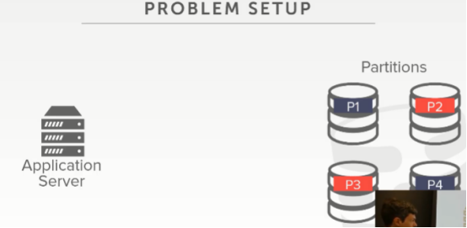

13:55 - 13:58
all right so let's talk about the problem we trying to solve today
So，我们来讨论下我们今天要尝试解决的问题
13:58 - 14:02
and I've already sort of briefly just mentioned just now
其实我刚刚已经提到过了
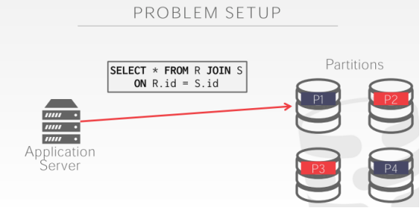

14:02 - 14:06
so our query shows up in a master node that wants to join on R and S
So，在master节点处有我们的一个查询，它想对R表和S表进行join操作
14:06 - 14:09
and let's say that the two tables R and S
假设我们有两张表，即R表和S表
14.09-14.14
,are just split across the different partitions on the different nodes uniformly
这两张表被均匀地拆分到不同节点上的不同分区中
14:15 - 14:20
so what's the stupidest way for me to execute this query in this set up
So，对我来说，在这种情况下，执行这个查询的最笨方式是什么？

14:26 - 14:26
yes
请讲
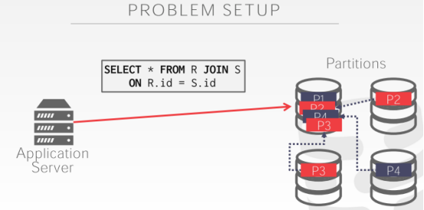

14:28 - 14:29
exactly right
说的没错
14.29-14.32
,the dumbest thing I could do and it would work it would still be correct, is that
为了能得出正确结果，我所能使用的最笨办法是
14.32-14.36
I know I need touch data set partitions two three and four
我知道，我需要去访问分区2、3和4中的数据
14:36 - 14:40
and so I just copy them in their entirety up into the the node where partition one is,
So，我直接将它们的数据整个复制到分区1中
14.40-14.42
now all my data is local
现在我的数据就都在本地了
14.42-14.44
I do my join and spit back the result
我执行我的join操作，然后返回结果
14:45 - 14:46
why is that stupid
为什么这样做很笨呢？
14:48 - 14:48
yes
请讲
14:50 - 14:52
he says me you may not need all the data.
他表示我们可能不需要全部数据
14.52-14.53
, potentially yes
部分正确
14.53-14.55
but team Team stupider
但还有更蠢的原因
14:56 - 14:56
yes
请讲
14:59 - 15:00
absolutely
说的没错
15.00-15.02
yeah you're not doing any computation on the other nodes
这样做的话，你就不会在其他节点上执行计算了
15:02 - 15:05
like this defeats the whole purpose of having your distributed database
这就违背了你使用分布式数据库的目的
15:06 - 15:07
all right, think about what I did
思考下我这里所做的事情
15.07-15.08
I bought a bunch of machines
我买了一堆机器
15.08-15.10
I partition my table across these machines
我将我的表拆分到这些机器上
15:11 - 15:12
but then my query shows up
但接着，数据库要执行我的查询
15.12-15.14
and I just copy things back over to the singing machine anyway
然后，我将这些数据又复制到了一台机器上
15:14 - 15:18
so I bet it would have been better off just buying this one machine and doing the join there
So，我为什么不干脆只买一台机器，并在这台机器上执行join操作呢？
15:20 - 15:22
right so this is the problem we're trying to solve today
So，这就是我们今天试图解决的问题
15:22 - 15:23
we're trying to say
我们试着说
15.23-15.24
,all right

15.24-15.26
if a query shows up and it wants to do a join
如果我们拿到一个查询，它想去执行一次join操作
15.26-15.30
, we need access data that's put now across multiple resources
我们需要访问的数据分布在多个机器资源上
15:30 - 15:32
how do we actually do this efficiently
我们实际该如何有效地执行这个操作呢？
15:32 - 15:39
what do we need to be mindful of when we decide whether we move data, or copy data or push the query, or pull the results
当我们选择移动/复制数据，或者推送这些查询、拉取结果时，我们需要注意哪些东西呢？
15:40 - 15:43
all right, these are all bit we have to deal with today
这就是今天我们所要面对的东西
15:43 - 15:47
this also assumes in this example that my database can't fit in on a single node
在这个例子中，我们假设我的数据库无法放在一个节点上
15:48 - 15:50
right again think of like the Walmart database
思考下沃尔玛的数据库
15.50-15.52
it's whatever hundreds of petabytes,
它的大小差不多是数百PB
15.52-15.54
it's not gonna fit on a single machine
它无法存放在单个机器上
15:54 - 15:58
so we're gonna happen run distributed environment order to get any work done
So，我们想让它放在分布式环境下运行，以此来完成任何工作
15:59 - 16:00
OLTP it's not an issue
OLTP则没有这种问题
16.00-16.03
OLTP I'm only touching andy`s data
在OLTP中，我只涉及Andy的数据
16:03 - 16:07
andy's data is maybe couple hundreds of kilobytes or megabytes
Andy的数据可能就只有一两百KB或者MB
16:07 - 16:12
right it's not I can easily fit that on a single box and do all my transactions on that one box
我可以很容易地将它放在一台机器上，并在该机器上执行我的所有事务
16:13 - 16:17
in analytics, I'm trying to touch the entire table or large portions of the table
但在进行分析的时候，我会试着访问整表数据或者该表中的大部分数据
16.17-16.19
, I'm not going to be able to do everything on a single node
我无法在一个节点上干所有事情
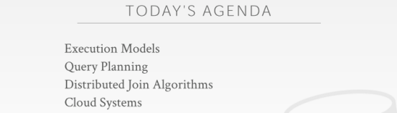

16:20 - 16:26
so today our focus is going to be on first discussing the execution models we have in a distributed database system for analytics
So，今天我们的重点首先是讨论下分布式数据库系统中用于处理分析的执行模型

16:26 - 16:29
we've already briefly touched on this a little bit in the first lecture
我们已经在第一节课的时候简单接触了下这个
16.29-16.32
, but now we'll talk about it more more concretely and see why it matters
但我们现在会更具体的讨论下它，并看看它为什么很重要
16:32 - 16:35
then let's briefly talk about the issues doing query planning,
接着，我们会简单讨论下我们在执行查询计划时所遇到的问题
16.35-16.37
then we'll talk about how we do distributed joins
然后，我们会讨论如何执行分布式join操作
16:37 - 16:42
the spoiler would be that all the algorithms we talked about early in the semester still remain, we still do them
我们这学期前面所讨论过的那些算法，我们这里依然会去使用它们
16:43 - 16:46
there's no magic distributed join that doesn't exist on a single node
这并没有什么神奇的，分布式join操作不会只在一个单节点上进行
16:46 - 16:48
it's just the question is
这里的问题是
16.48-16.52
again where do we move data or where do we move the computation
我们要将数据移动到哪，我们要将计算移动到哪
16:52 - 16:59
and then I'll finish up with sort of a quick smattering of , what this sort of state of the art of cloud databases look like, in the world today
然后，我们讨论下当下的云数据库是什么样的
17:01 - 17:05
and just you know just it again ,you'll see how just because it's in the cloud
因为这些数据库是放在云端的
17.05-17.08
doesn't mean we still don't care about all the things, we talked about the entire semester
这并不意味着我们就不会关心我们整个学期所谈论的东西
17.08-17.09
, okay
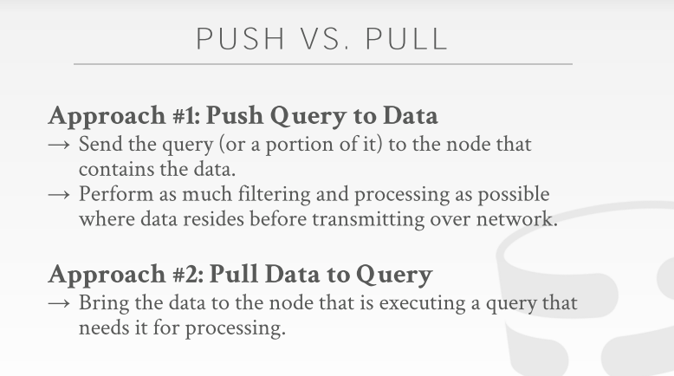

17:11 - 17:12
all right
======================
17.12-17.13
so as I said
So，正如我说的
17.13-17.19
I briefly touch about this first issue for the execution model， when we talked about just to the introduction to distributed databases
当我们在介绍分布式数据库的时候，我简要介绍下执行模型中的第一个问题

17:19 - 17:26
but the two approaches we have to execute a query are either a push VS. a pull
我们执行查询的方式有两种，push和pull
17:27 - 17:28
so with a push
So，我们来讲下push
17.28-17.29
the idea is that,
它的思路是
17.29-17.39
we want to send the the query or the portion of the query like the plan fragment, to the location of where the data is located
我们想将查询或者该查询的碎片发送到数据所在的地方（知秋注：查询碎片：分割任务后的子查询元素）
17:39 - 17:42
then run that portion of the query at that local data
接着，在该位置上执行这部分查询
17:42 - 17:46
and then now just send back the result to whoever asked for it
然后，将执行结果返回给要求执行该查询的人
17.46-17.50
like, the home node or the base node that's coordinating the query
比如，用于协调该查询的home节点或者base节点

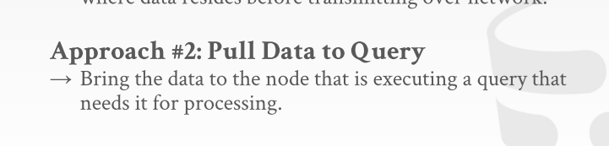

17:52 - 17:53
the idea here is that
第二种方案的思路是
17.53-17.59
we want to just as we we do projection push down or predicate push down on a single node system
就如同我们在单节点数据库系统中所做的projection下推和判断条件下推一样
17:59 - 18:07
we want to filter out and remove as much useless data as early as possible Before we send anything over the network
在我们将任何数据通过网络发送之前，我们想尽早地过滤并移除掉无用的数据

18:08 - 18:14
so if we can send a portion of the query to where the data is located ,crunch on it there, do some early filtering
如果我们将该查询的一部分发送到数据所在的位置，并对数据进行早期过滤
18:14 - 18:17
and then when we transmit the data back to another node
接着，当我们将数据传输回另一个节点时
18:17 - 18:20
we're not just blindly copying all the data that the node has
我们不会去盲目地复制该节点中的所有数据
18:20 - 18:25
we're just limiting it to the subset of that we actually need for this particular query
我们只会去复制该查询所需要的那部分数据
18:26 - 18:28
now we'll see in a second
我们稍后会看到这个
18:29 - 18:32
the lines get blurred and I shared disk system whether you're doing one of versus another
在shared disk系统中，这些界限其实很模糊
18:32 - 18:35
because in a shared disk system, in general you can't do any filtering
因为在shared-disk系统中，通常你没法做任何过滤
18:36 - 18:38
because it's just a just you know read and write a single page
因为当你在对一个page进行读写时
18.38-18.39
,you can't do anything special
你没法做任何特别的事情
18:40 - 18:43
but for shared disk systems again the lines are blurred
但对于shared disk系统来说，这些界限都是模糊的
18:44 - 18:48
the other approach is to pull the data at the query which is what I shared disk system normally would do
另一种方案就是拉取该查询需要的数据，这也是shared-disk系统通常会做的事情
18:50 - 18:53
where we grab whatever the data we need for execute this query,
我们会去获取执行该查询所需要的数据
18.53-18.58
we recognize based on the query plan, you know these are the pages I want to access
基于查询计划，我们会意识到这些page是我想访问的page
18:58 - 19:03
we pull the data out make a copy of it transmitted over the network bring it to the node where our query is located
我们会去拉取这些数据，并将这些数据的副本通过网络传输到我们查询所在的节点
19:04 - 19:05
Then we can then process it and crunch on it
接着，我们就可以对这些数据进行处理
19:06 - 19:07
and of course again
当然
19.07-19.09
the issue here is that
这里的问题在于
19.09-19.10
in an analytical system
在一个分析型系统中
19:10 - 19:18
the amount of data the size of the data are relative to the size of the query is gonna be quite different
数据量的大小相对于查询的大小是相当不同的
19:18 - 19:22
like a query say it's just a SQL query couple kilobytes
假设这个查询是SQL查询，它只有2kb那么大
19:23 - 19:27
the most I've ever heard from like Google or Facebook is that
我从Google或Facebook那里听到最多的东西是
19.27-19.32
,sometimes they have queries that are like the SQL text itself is like 10 megabytes
他们有的查询，比如SQL语句的文本差不多就有10MB那么大
19:32 - 19:34
Right, that's that's a large as query,
这是一个很大的查询
19.34-19.38
but still that compared to like reading a terabyte of data it's nothing
但比起读取1TB数据来说，这不算什么
19:38 - 19:41
so the thing we have to be mindful whether you want to one versus the other is
So，在使用这两种方案时我们要注意的东西是
19.41-19.44
you know, where's the data located ,how can I access it
这些数据是否在本地，我该如何访问这些数据
19:44 - 19:50
and is my query going to be larger or smaller in size to transmit over the network ,then the data I'm trying to access
通过网络传输我的查询时，我查询的体积是会变大还是变小，接着就是我要试图要访问的数据的体量是多少
19:51 - 19:55
and in analytics, it's always the case that the data you're trying to crunch on is larger .
在分析的过程中，通常你要处理的数据量会更大
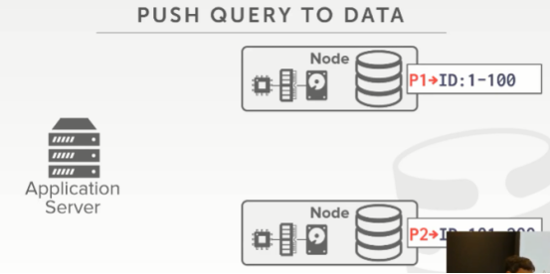

19:56 - 19:59
so let's see this in the context of a shared-nothing system
So，我们来看下这在shared-nothing系统中是怎么样的

