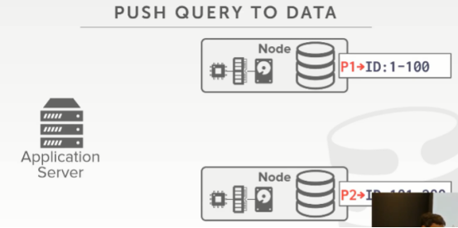

19:59 - 20:03
so shared nothing systems are typically push data to push the query to the node
So，shared-nothing系统通常会将查询推送到节点处
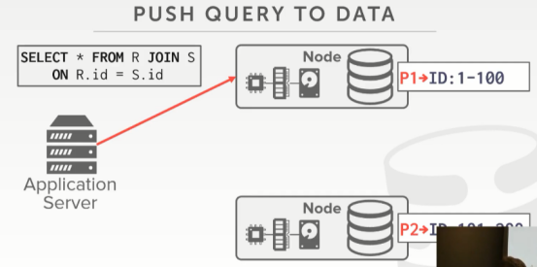

20:04 - 20:06
so my query shows up to this node here
So，我的查询会推送到这个节点处
20.06-20.10
, it's in charge of coordinating with the other node to process the join
该节点会与其他节点一起协作来处理这个join操作
20:11 - 20:15
so we're gonna do our query planner I want to say on this node
So，我们会去执行我们的查询计划，假设在上面这个节点处
20:15 - 20:21
if we had recognized oh we need to access the ID field for R and S tables
如果我们意识到我们需要去访问R表和S表中的id字段
20:22 - 20:26
and I know that this node down here has a partition that I want to access
并且我知道，下方这个节点中放着我想去访问的一个分区
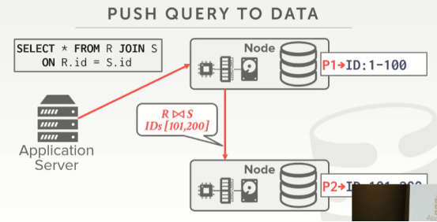

20:26 - 20:30
so I'll just send information I'll send the query plan fragment down to this guy
So，我会将对应查询计划的片段发送给下方这个节点
20.30-20.35
, and say hey I know you have this data between 101 and 200, crunch on this join
并说：hey，我知道你保存着id为101到200这个区间的数据，请对它们进行join操作
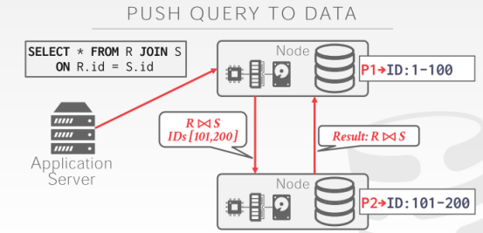

20:35 - 20:37
and then send me back the result
然后，将结果返回给我
20:37 - 20:44
and the node up above is responsible for taking the result of that this guy sent, plus it's local result
上方这个节点会负责去获取下方这个节点所生成的结果，并将该结果与它的本地结果进行合并
20:44 - 20:47
combining them together to then produce a sing result back to the application
并将合并完的结果返回给应用程序
20:48 - 20:51
so again we had this transparency issue or transparency guarantee
So，我们就拥有了这种透明性问题或者透明性保证
20.51-20.58
, where the application doesn't know ,doesn't care where the query actually executed long as it gets back a single result
即应用程序不知道也不在意这个查询实际是在哪执行的，只要它拿到返回的结果就行了
21:01 - 21:03
so in a shared-nothing system
So，在一个shared-nothing系统中
21.03-21.07
it's quite obvious, that you'd want to do push the query of the data
很明显，你想将对应查询片段推送到数据所在的位置

21:07 - 21:10
right because this makes no sense for us to actually have to copy this data up and processes it there
因为这样做的话，对我们来说，我们就不需要将数据复制到一个节点，再对数据进行处理了
21:10 - 21:13
it's just better just to send the query do the crunching locally for this example
对于这个例子来说，将查询发送到数据所在节点处，并在该节点处对数据进行处理，这种做法其实更好
21:15 - 21:18
, we'll see some scenarios where maybe you do want to do some copy
我们会看些场景，在这些场景例子中，你可能想对数据进行一些复制
21:19 - 21:19
yes
请讲
21:23 - 21:24
your question is
你的问题是
21.24-21.27
what if S is distributed as well then what
如果S这张表也是分布在各处，然后你想说什么？
21:27 - 21:28
well in this case here,
Well，在这个例子中
21.28-21.29
it is distributed
它是分布式存储的
21.29-21.32
I'm just saying like it's partitioned just but it's partition
我想说的是它是保存在不同分区中的
21:32 - 21:34
well comment to your question later on like
Well，我之后再去点评你的问题
21:37 - 21:38
correct
说的没错
21.38-21.39
what we'll come to that later
我们稍后会讲这个
21.39-21.40
in this simple example
在这个简单例子中
21.40-21.43
assume that, R and s are both partition on ID
假设R表和S表都是根据id进行分区的
21:44 - 21:48
the ranges of the values at this partition are exactly the same
它们在这个分区的id值范围都是完全相同的
21:48 - 21:50
so, therefore, I know when I'm doing a join at this node
因此，我知道当我在这个节点进行join操作时
21.50-21.54
, I don't need to look at any other partition in my cluster
我不需要去查看我集群中的其他分区
21:54 - 21:58
everything I need to have compute node for a single tuple in R, it`s located here
我计算所需要用到的R表中的数据都在这个节点处
22:01 - 22:03
but yeah exactly right I'm joining the partition key
说的没错，我是使用Partitioning Key进行join操作的
22.03-22.04
,well see those scenarios in a second
我们稍后会看些例子
22.04-22.05
,yes question
请讲

22:14 - 22:15
the question is
她的问题是
22.15-22.17
, in my example here,
在我的例子中
22.17-22.21
my tables are partitioned on my join key
我的表是根据我进行join操作的那个key来分区的
22.21-22.22
, which is the best-case scenario
这其实也是最好的情况
22.22-22.23
, how often does that happen
这种情况出现的频率是怎么样的呢？
22:29 - 22:32
usually for the fact table pretty often
通常对于fact table来说，这是很常见的
22:33 - 22:34
right like

22:37 - 22:39
I would say it's pretty common
其实我应该说这很常见
22:40 - 22:41
let me think about it like
让我思考下
22.41-22.42
in a real system like
在一个真实系统中
22.42-22.46
so I want to partition, I partitioned on user IDs
假设我想进行分区，我会使用用户id进行分区
22:48 - 22:51
and you know the fact table could say
fact table表示
22.51-22.54
here's this person who bought this item
这个人买了这个商品
22:54 - 22:54
and so

22:56 - 22.58
it's a bad example
这是个糟糕的例子
22.58-23.04
,so say I want to do a join between like, here's the user IDs and here's all their items that they bought
假设，这里是用户id以及用户所购买的所有商品
23:04 - 23:08
and then here's the session of how they visited the webpage
接着，这里是他们访问网页的session
23:08 - 23:10
just to figure out what items I looked at before I bought something
在我购买任何东西之前
23:10 - 23:14
anyone trying to figure out to learn like, oh if they go look at these much items
有人会试着去弄清楚，Oh，如果有人买了这么多东西
23:14 - 23:16
then they're more likely to buy something
那么，他们就会更乐意买这些东西
23:16 - 23:17
and so in that case
So，在这个例子中
23.17-23.19
the user ID would be the partitioning key
用户id就是partitioning key
23.19-23.20
and that would work out nicely
并且它的效果非常不错
23:20 - 23:22
so it's not always the case
虽然我们不一定总是遇上这种情况
23.21-23.23
,but I would say it's common enough
但我表示这足够常见
23:23 - 23:26
but we'll see in a second how we handle case where it's not this like this
但我们稍后会看我们如何处理一个不是这种情况的例子
23:26 - 23:28
the main thing I emphasized here is
这里我主要强调的东西是
23.28-23.33
we can push the query to the data , and that's be better for us
我们可以将查询推送到数据所在位置，这样做对我们来说会更好
23:33 - 23:36
because this this data is gonna be larger than then this guy here
因为这些数据可能要比这个节点上数据的量还要大
23:36 - 23:40
plus we can also get the the additional benefit that we parallelize the computation
并且我们也能获得额外的好处，即并行化计算
23:40 - 23:42
because now the top node doesn't have to do all join
因为上面这个节点不用去执行所有的join操作了
23.42-23.45
, this guy can do the join you know portion the join
这个节点会负责部分join操作
23:45 - 23:46
,and this guy can do the other portion the join
下面这个节点则会负责另一部分join操作
23:46 - 23:48
and we just combine it together
我们将这两个结果合并在一起
23.48-23.49
,and the combined part is cheaper
合并部分的成本更低
23:49 - 23:51
it's cheap relative to the join cost
相对于join操作的执行成本来说，合并的成本相对较低
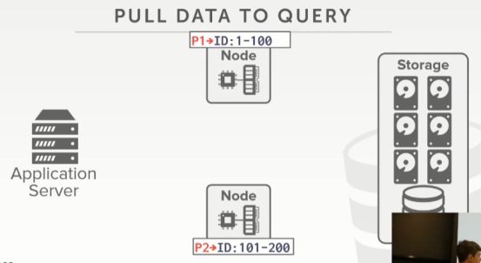

23:54 - 23:57
so the other approach is the pull the data to the query
So，另一种方案是将数据拉到查询这边
23:57 - 24:00
again this is where I'm saying in a shared disk system the lines are blurred
正如我说的，在shared disk系统中，这种界限很模糊
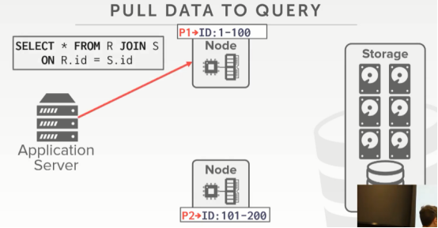

24:01 - 24:04
so we send our query to this node here
So，我们将查询发送到这个节点
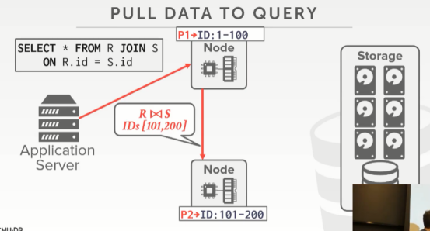

24:04 -24:07
this node would recognize that we've logically partitioned the data
这个节点意识到，我们对数据进行了逻辑分区
24.07-24.10
, such that this node down here is responsible for this range
比如：下面这个节点负责101-200范围的数据
24:10 - 24:12
that node on top of that range
上面这个节点负责1-100范围的数据
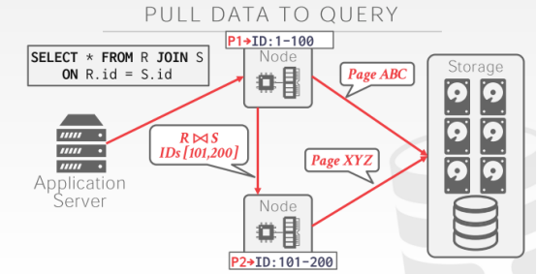

24:12 - 24:16
so then they then go to the the share disk
So，接着它们跑到共享磁盘这里
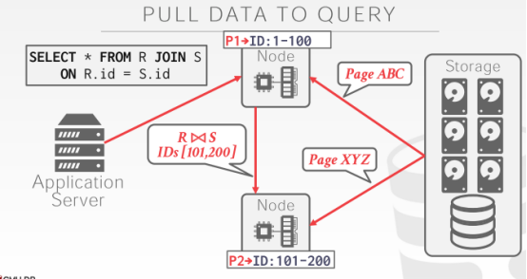

24:16 - 24:18
go access those pages,
访问这些page
24.18-24.21
pull back the results or so pull back the pages they need
并拉取他们需要的数据
24.21-24.23
,then they compute their local join
然后，它们在节点本地执行join操作
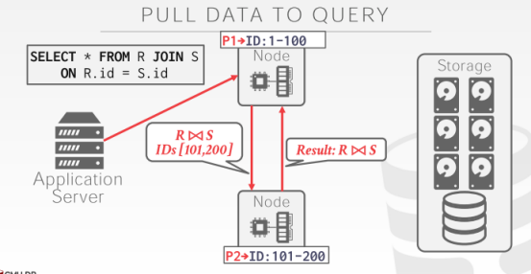

24:24 - 24:27
and then this guy shows up the result to the other one
然后，这个节点会将执行结果向另一个节点展示
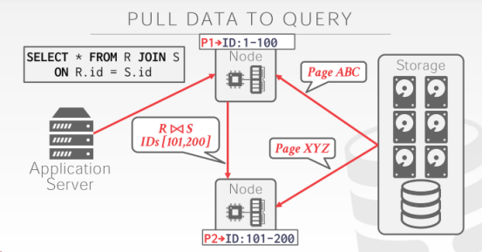

24:27 - 24:34
so again this step here would be pulled of data to the query
So，这一步其实是将数据拉取到查询所在的节点
24:34 - 24:36
because I'm just blindly asking for pages where it's located here
因为这里我只是盲目地去询问page所在的位置
24.36-24.38
, and I have to copy it over here
然后，我需要将数据复制到这里
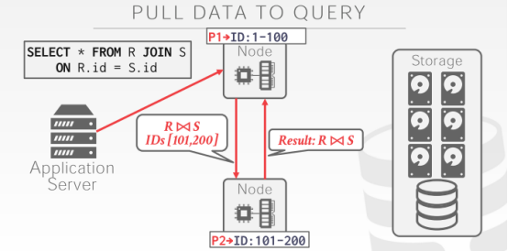

24:38 - 24:42
but then certainly this part here was push the query to the data
但在这部分，我们将查询推送到数据这里
24:42 - 24:46
because this guy was able to you know compute the join locally ,and send the result up
因为下面这个节点能够在本地计算join操作，然后将结果发送给上面这个节点
24:47 - 24:50
so would you say that this is a pull versus a push
So，你们可能会问这是pull还是push呢？
24:51 - 24:52
again it's both
两者都有
24:55 - 25:00
well see it it will, I don't think I've a slide about this but
我不觉得我做了与这有关的幻灯片
25:02 - 25:07
the cloud vendors are recognizing about having a dumb disks, if you want to call it that
云厂商意识到他们要转储磁盘，如果你想这么称呼的话
25:08 -25:10
Andy shared-disk databases is a bad idea .
Andy表示shared-disk数据库是一个糟糕想法
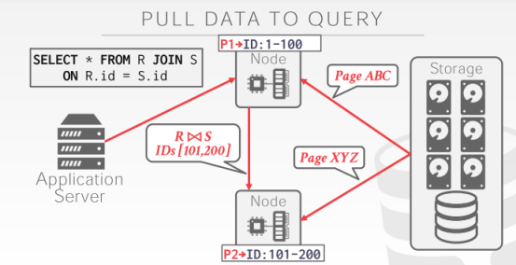

25:11 - 25:15
because again I'm just always copying this page, without checking to see whether actually need data on the page
在不检查我所需的数据是否在这个page上的情况下，我始终要去复制这个page
25:16 - 25:17
I just know that I think I need to look at it,
我觉得我需要去查看下这个page
25.17-25.19-
so I just say go give me this page
So，我就会说，请给我这个page
25:19 - 25:20
on like Amazon s3
以Amazon S3为例
25.20-25.21
they now have a filter command
它们有一个过滤相关的命令
25.21-25.23
where you actually can do predicate push down
实际上，你就可以将判断条件下推
25:24 - 25:25
and even when you say go get this page
当你表示要获取这个page时
25:25 - 25:26
you can also say like,
你可以说
25.26-25.30
oh but it also check this filter for me to see whether everything actually matches inside the page
你要帮我去过滤这些数据，帮我检查下该page中这些数据是否符合我的条件
25:30 - 25:32
and if yes then send it to me if no then don't
如果符合我的条件，那么就将数据发送给我，不然就不用将数据发送给我
25:33 - 25:36
Right, so again that's pushing the query to the data
So，这就是将查询发送到数据所在位置的工作方式
25:37 - 25:39
so again the lines are blurred
So，这些界限很模糊
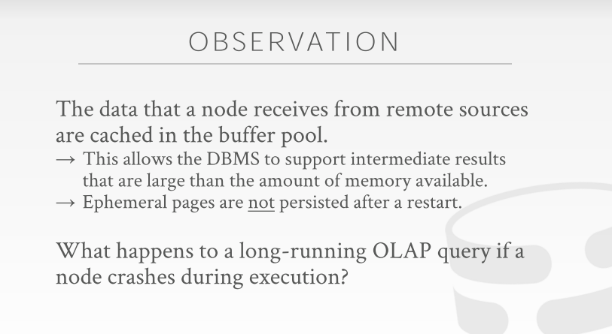

25:41 - 25:41
okay

25:43 - 25:46 !!!!!!!!
so one thing we talk about though is that
So，有个东西我们要讨论下，
25.46-25.52
, I said that last class we made a big deal about
在上节课的时候，我有说过，
25:52 - 25:55
if we have a transaction commit and it touches multiple nodes
如果我们要提交一个事务，该事务涉及多个节点
25:55 - 26:03
I want to make sure that everyone agrees ,that all the nodes would have to agree that this transaction is allowed to commit， before we tell the outside world then it committed
在我们告诉外界该事务被提交之前，我想确保所有节点都同意我们提交这个事务

26:03 - 26:06
all right because we're modifying the database
因为我们修改了数据库
26.06-26.07
we don't want to lose any changes
我们不想丢失任何修改
26:07 - 26:08
but in an OLAP database
但在OLAP数据库中
26.08-26.11
we're just doing read-only queries
我们只是执行只读查询
26:13 - 26:18
so we're not really worried about updating DBMS multiple locations and keeping those in sync
So，我们并不担心要对多个地方的DBMS数据进行更新，并让数据保存同步
26:18 - 26:20
but now we have to deal with the case
但现在我们需要处理这种情况
26.20-26.22
where a node could crash,while we're processing the query
当我们处理一个查询时，有一个节点崩溃了
26.22-26.25
,and we had to figure out how to handle that
我们需要弄清楚该如何处理这个问题
26:25 - 26:28
so the important thing to understand is that
So，这里要理解的重要事情是
26.28-26.33
when we go request data from another machine or the shared disk
当我们从另一台机器或者共享磁盘处请求数据时
26:33 - 26:36
and we get the copy of that data when we receive that
我们会去拿到该数据的副本
26:36 - 26:41
that's gonna get stored in the buffer pool just like any other data we have that we read from disk
就像我们从磁盘中读取到的其他数据一样，这些数据会被放入buffer pool中

26:41 - 26:45
but it's stored in like a temporary buffer space
但它是被保存在一个临时buffer空间中
26.45-26.48
,meaning it could get page to the disk
这意味着它可以将page写入磁盘
26.48-26.49
, because we run out of space
因为我们会耗尽磁盘空间
26:50 - 26:52
but if we crash or restart the system to come back
但如果系统崩溃重启后
26.54-26.55
,all that temporary spack disk is blown away
所有临时空间中的数据都会消失不见
26:55 - 27:03
because the the query or the transaction that was protected the query that was , that was running that needed that data is now gone, because I crashed
因为系统崩溃，所有执行该查询所需的数据都消失不见了，
27:03 - 27:05
and so I don't need to persist anything
So，我不需要对任何数据进行持久化
27:06 - 27:12
so these OLAP queries for really large databases can take a long time
So，对于大型数据库来说，这些OLAP查询要花的时间很长
27:13 - 27:16
it's not unheard of to have queries that could take hours
这种要花数小时执行的查询并非闻所未闻
27:17 - 27:19
I've also heard of queries that take days
我甚至还听说过那种要执行数天的查询
27:21 - 27:24
for column stores that's gotten much better
对于列式存储来说，它们的执行效果会更好
27:24 - 27:24
but back in the old days
但在以前
27.24-27.32
it was certainly very common for like, a quarter to take days, like you want you run your reports once a month, and takes like a week to run it
这相当常见，就好比当你每个月要生成一份报告时，你就要花1周的时间去执行这个查询
27:32 - 27:34
so if we had this long running query
So，如果我们正在执行这个要慢查询
27.34-27.37
and our node crashes what should we do
如果我们的节点发生了崩溃，我们应该做什么呢？
27:37 - 27:38
it's not a correctness issue,
这并不是正确性问题
27.38-27.40
because we weren't updating anything
因为我们不会去更新任何数据
27:40 - 27:45
but ideally be nice may be that we may not have to restart the whole thing from scratch if it's gonna take days
但理想情况下，如果这个查询要花数天时间执行，如果中途系统出现问题，但我们无需从头开始执行这个查询的话，这就会很nice
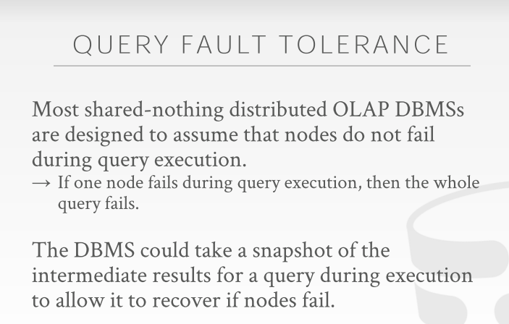

27:47 - 27:56
so the design decision that most shared-nothing distributed databases make
So，大部分shared-nothing分布式数据库系统所做的设计决策是
27:56 - 28:00
is that they're not gonna actually support query fault tolerance
它们实际不会对查询进行容错方面的支持
28:00 - 28:01
meaning
这意味着
28.01-28.02
if your long-running query crashes
如果你这个执行时间很长的查询发生了崩溃
28.02-28.05
, if a node crashes during your query is running
当你查询执行的时候，如果一个节点发生了崩溃
28:05 - 28:08
unless there's a replica that has the data you need
除非这个replica上有你需要的数据
28:08 - 28:12
that could you know fill in some missing piece depending where you are in the query plan
取决于你查询计划的进度，你可以去填补一些缺失的数据
28:12 - 28:14
they're just gonna abort the query
它们会中止这个查询
28.14-28.15
and throw back an error
并抛出一个错误
28.15-28.17
and tell you to restart it
然后告诉你重新执行这个查询
28:18 - 28:21
and we take a guess why they make this decision
我们可以猜下他们这样做的原因是什么

28:25 - 28:27
it's expensive right
这样做的成本很高
28.27-28.28
, I'm running a long-running query
假设我正在执行一个耗时很长的查询
28.28-28.31
, it starts generating a bunch of enemy results
它会开始生成一堆数据
28:31 - 28:34
and now I got to make sure I flush them all the write them to the disk
现在我要去确保将这些数据写入到磁盘
28.34-28.37
and make sure there's durable across replicas
并确保这些数据都持久化到replica上
28:37- 28:37
in case that there's a crash
以防系统崩溃的情况发生
28.37-28.39
that's gonna make your query to run a lot slower
这会让你查询执行的速度变慢
28.39-28.41
because the disk is super slow
因为磁盘的速度会超级慢
28:41 - 28:47
so in this sort of traditional data warehouse world
So，在传统的数据仓库中
28:47 - 28:47
they would say
他们表示
28.47-28.52
oh you just pay me ten million dollars to for this very expensive database system Software
你们要向我支付1000万美金来购买这个非常昂贵的数据库系统软件
28:53 - 28:56
I assume you're not running on machines you found at Goodwill
假设，你并不是在Goodwill上所购买的机器上运行这些软件
28.56-28.58
I'm assuming you're buying on high-end hardware
假设你们买的硬件非常高端
28:58 - 29:01
so the likely that high-end hardware is gonna have a catastrophic failure
So，高端硬件可能会遇上灾难性的故障
29:01 - 29:05
where you know it's gonna crash in the middle of query, is gonna be low
执行查询时发生崩溃的可能性会很低
29:05 - 29:12
so therefore I'd rather not pay the penalty of taking snapshots or writing me results about the disk as I run
So，当我执行查询的时候，我不会付出一定代价去制作快照或者将结果写出到磁盘
29:13 - 29:14
so in general
So，通常来讲
29.14-29.20
most OLAP systems are going to if a query if a node crashes during query execution
对于大部分OLAP系统来说，如果查询执行的时候有一个节点发生了崩溃
29:20 - 29:26
and let's say it's not just reading from a disk ,where you have copies of like it's it's some the middle part of the query we have enemy results
我们无法从该节点磁盘上读取数据，你也就拿不到本应从它身上得到的有关查询的中间部分结果
29:26 - 29:28
that you say the query fails
在这种情况下，你会说该查询失败了
29:29 - 29:32
is when Hadoop came out in the mid-2000s
Hadoop是在2000年代中期的时候出现的
29:32 - 29:34
they were actually taking snapshots
实际上，它们会去制作快照
29:34 - 29:38
they were actually taking you know writing at every step of a query plan writing that out the disk
在执行每一步查询计划的时候，它们会将数据写出到磁盘
29:38 - 29:40
but that made it super slow
但这使它的速度变得非常慢
29:40 - 29:45
right cuz it gives back in the old days when even still now
无论是过去还是现在
29:45 - 29:48
but like when Google was building that produce
当Google将Hadoop投入生产使用时
29:48 - 29:50
they talked about running on you know cheap hardware
他们使用廉价的硬件去运行Hadoop
29:50 - 29:53
where if you're running 1,000 node cluster,
如果你的集群中有1000个节点
29.53-29.55
and your query is run across 1,000 nodes
你的查询会在这1000个节点上执行
29:55 - 29:57
the likelihood that any nodes gonna crash during that time is pretty high
在执行查询的时候，任何节点发生崩溃的可能性都很高
29:58 - 30:00
so and they're well they would rather take the snapshots to avoid this
So，他们更想通过制作快照来避免这种情况发生
30:01 - 30:01
yes
请讲
30:09 - 30:14
we're not so much transactions here ,which read-only queries analytical queries
我们这里只有只读分析型查询，没有那么多的事务
30:15 - 30:23
right so if it's a if say in from last class , which I went transactional distributed database transactions
在上一堂课，我聊了事务型分布式数据库
30:23 - 30:29
if a node fails that while we're exiting transaction, we just abort that transaction, because who cares
如果一个节点挂了，我们会关闭(exit)事务，我们要做的仅仅就是中止这个事务，就这么简单
30:29 - 30:33
so that transaction what ran for 50 milliseconds, who cares
so 那个事务只跑了50ms，谁会关心中止它的代价
30:34 - 30:37
if now I have analytical where that's gonna take days to run
如果我有一个要跑好几天的分析型查询
30:37 - 30:41
if it's take if takes five days to run, I cry the fourth day the night's wasted four days of work
如果跑完它要花5天时间，如果在第四天晚上的时候挂了，我得哭死
30:42 - 30:46
some people would get actually pissed about that, because now you gotta you know start it up and run all over again
有些人就得砸桌子了，因为又得重新开始全部运行一遍！
30:47 - 30:56
and so you could take a snapshot ,some systems allow you to take snapshots ,as you run the query at the oleg as the output of one query plan as gets fed into the next operator
so ，你可以搞一个快照(snapshot),有些系统允许你搞快照，即你可以把一个查询计划用于传入下一个operator的输出做成一个快照
30:56 - 30:59
I'll just write all that out to disk as well, so that if I crash at that point I can bring it back
我将这些输出写出到磁盘，so，如果我在这个点发生了崩溃，我可以恢复过来
31:00 - 31:02
there's ways to turn that on but by default most systems do not
这就是解决这个问题的办法，但默认情况下，大多数系统是不会这么做的
31:03 - 31:05
because they don't want to pay that performance penalty overhead
因为他们不希望在这上面消耗太多的性能
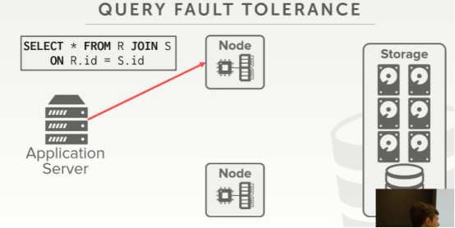

31:07 - 31:10
so again on a shared your system it's easy to visualize
so，再次回到这里，在一个shared-disk 系统中，我们很容易想象到
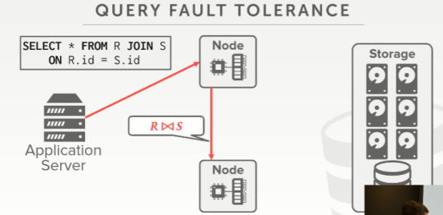

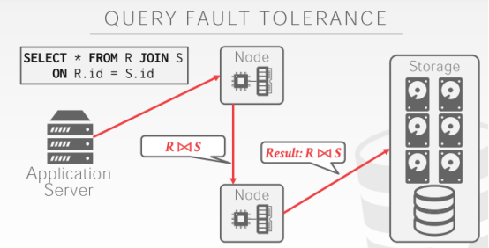

31:10 - 31:12
and we're doing that same join ,we send the plan timing down here
我们做一个相同的join操作，我们将部分查询计划下发到下面这个节点
31:12 - 31:16
and then as it computes the join result
然后他计算出join的结果
31:16 - 31:18
it's gonna write that out to the shared disk
它会将结果写出到这个共享磁盘
31:18 - 31:23
there's some notification to a coordinator to say hey if you're looking for this join result
会与一个通知发给协作者，说，hey，如果你要查看这个join的结果
31:23 - 31:25
here's where to go get it on the shared disk
你可以从共享磁盘这里获取到
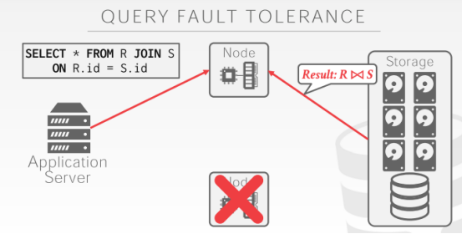

31:26 - 31:30
and that way this guy crashes and goes away, this guy knows he can just pull it from from there
同样，下面这个节点挂掉了，上面这个家伙可以从共享磁盘那里拉取想要的数据
31:30 - 31:32
and not worry about you know how to read good anything
无须担心你能不能读到你想要的东西
31:35 - 31:39
so so again this is an important design decision that the distributed DBMS are gonna make
so，这是分布式DBMS的重要设计决策
31:39 - 31:47
their there they're not gonna provide you what sometimes called query resiliency or fault tolerance where the query executes
它们不会为你在查询执行时提供那些，有时我们称之为查询弹性或容错的功能
31:47 - 31:49
they maybe restart the query for you
他们可能就是重新为你执行这个查询，仅此而已
31:50 - 31:55
but they're not gonna try to pick up where a node was running at the Miller at the crash
但他们不会在一个节点崩溃后，再去尝试选择一个正在运行的节点去执行这段查询
31:57 - 31:57
okay
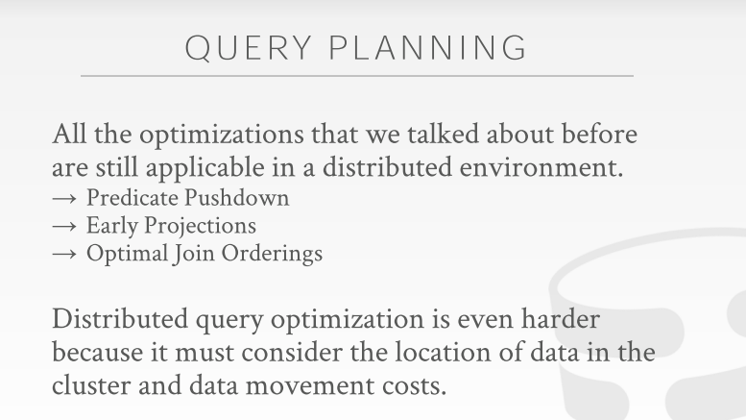

32:00 - 32:04
all right so the other thing you got to worry about now is also have new query planning
all right，so，另一件你需要去关心的就是新的查询计划
32:05 - 32:11
so we have all the same issues that we had before, join orderings, how to do predicates pushdowns or the projections
so 我们之前也同样看过这些话题，最佳join的顺序，该如何去做条件下压（predicates pushdowns）以及提前映射（projection ）操作
32:11 - 32:16
all those same decisions we had to do on a single node system ,we have to do in the distributed system
这些我们在单节点系统上做的工作，我们现在要放在分布式系统中了
32:16 - 32:25
but now we have a certain extra level of planning, where we need to reason about ,where our data is located, how its partitioned or replicated
但现在，我们要有一些额外的计划，因为我们需要去考虑我们的数据是不是在本地，还是它被分区了，或者它有被复制容错（replicated ）
32:25 - 32:31
and now account for the network communication cost for our algorithms
我们还要将网络通信的成本考虑在我们算法中
32:34 - 32:37
right and this makes more sense in a second , when we talk about the different scenarios
当我们谈论不同的场景时
32:37 - 32:41
but like the join ordering still matters
比如，join的顺序依然很重要
32:41 - 32:45
but now it's also like ,alright well I need it should I join these two tables first
但现在，就像我们首先需要去将这两个表进行join操作
32:45 - 32:49
because they're on the same node a partition in the same way and therefore that can be really fast
因为这两张表在同一个节点上，同一个分区中，因此它会非常的快
32:50 - 32:53
even though if I was on a single node, I may not want to join those two table first
甚至于，如果我就在一个单节点上，我可能不想首先请join这两张表
32:54 - 32:58
so that just could now included in your cost model to have you help me make a decision about
so，我可以仅根据我的成本模型（cost model）来帮我做出最好的决策
32:58 - 33:03
again what's the write this query planned a most optimal query plan for the for the system
即在这个系统下，为这个查询写出一个最优的查询计划
33:03 - 33:08
again just as I said before doing query optimization on a single node is hard
就像我之前说的，在一个单节点上做查询优化很难很难了
33:08 - 33:09
this is just even harder
但这个更难
33:12 - 33:12
okay

33:13 - 33:22 ！！！！！！
and like we ,sometimes you can make a decision on a single node and centralize the location ,sometimes you can make it into distribute across all the nodes
就好像，有时候，当要查询的数据都集中在本地的话，我们需要在单节点上做决策，有时候你的数据横跨多个节点，此时你会有一个中央节点做协调，你要在这种场景下做决策（知秋注：有点类似于fork join）
33:22 - 33:30
but now again you had this,you have to make sure all your statistics, and all your nodes are updated ,as much as possible,to help you make decisions about what the best plan could be
所以，现在，你必须确保所有统计信息和所有节点都尽可能得到更新，以帮助你来决定最佳方案是什么
33:30 - 33:33
it's just everything just much much harder when it's distributed
当它分布式以后，一切就变的真的很难很难了
33:34 - 33:38
but now same way we have now a query plan
但，现在，同样的，我们要有一个查询计划
33:38 - 33:44
what do we actually want to send to our different nodes, that are going to participate in executing a join query
将查询计划发送到我们各个不同的节点之上，用来在节点处执行join查询
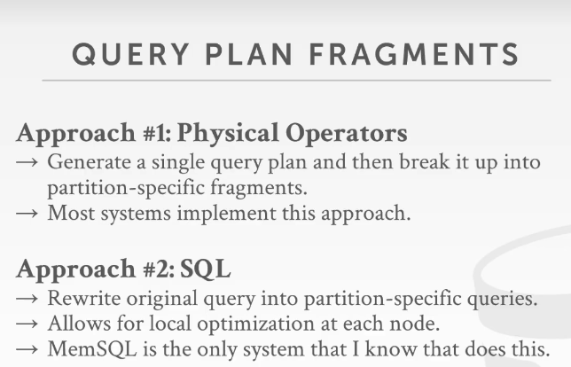

33:45 - 33:47
so there's two approaches
so，这里有两种方式
33:47 - 33:55
one is we could actually send the physical plan or plan fragment to the node for it to execute
一种是我们可以发送物理计划片段到节点上执行
33:56 - 34:01
by just taking the query plan that we've generated on you know on the base node of the home node
这个查询计划是在home node上生成的
34:01 - 34:05
and then carving it up to say well I know this portion of the query plan needs to execute on this node
然后，它会说，well，查询计划的这一部分需要在此节点上执行
34:05 - 34:07
this other portion the query planner needs actually on that node
查询计划的另一部分需要在那个节点上执行
34:08 - 34:10
you just share those physical operators to the other nodes
你要做的就是将这些物理操作发送到其他节点上
34:10 - 34:16
they just take them and immediately execute them without reasoning about whether that's the best thing to do for the local data
它们在接收到这些计划后，会立即执行，这些节点不会在意你这个对于我本地的数据来讲是不是最好的方案
34:17 - 34:18
and then sending back the results
然后，在执行完后返回结果
34:19 - 34:25
so as far as they know most distributed databases that are doing analytics, do this first approach
到现在为止，大部分分析型的分布式数据库，使用的都是第一种方案
34:26 - 34:32
well the generate the run the query plan through an optimizer once, generate a global plan for the entire cluster for the query
通过优化器一次性生成用于全局的、整个集群运行的查询计划
34:33 - 34:36
then carve it up into two plan fragments and divide it up
然后将它分割为一些计划片段并发送出去
34:37 - 34:42
another approach is to actually take the SQL query that came in
另一种方案实际上是在拿到SQL查询后
34:42 - 34:49
and then rewrite it to have it be on a per partition basis have a C query each individual partition
对它进行重写，即为每一个分区都重写一个适合它执行的语句
34:49 - 34:56
and then send that out ,then when the node that where the partition is located it gets that SQL query
然后将重写后的sql语句发出，对应分区的节点就得到了可以在它本地执行的sql查询语句
34:56 - 35:01
then it runs it through its own query optimizer to generate the physical plan that it wants to execute
然后通过它自己的查询优化器去为它生成物理计划并执行它
35:02 - 35:10
the idea here is that, if we can assume that the , if we did a global plan on a single node
此处的想法是，如果我们在一个单节点上来做一个全局计划
35:11 - 35:19
the statistics and information about ,what's best at each partition is not going to be up to date or you know or fresh
那就需要有关的统计信息，每个分区的一些最新的相关信息
35:19 - 35:25
and therefore rather than me trying to reason at my home node, what the best thing to do at this other node
因此比起我们尝试在 home node上去推断诸如在另一个节点处该怎么做才是最好的
35:25 - 35:30
I'll just say to this other node, hey I think you need to execute this query or I need to react to this query for me
我所说的另一个节点，是指你需要去执行查询的地方
35:30 - 35:36
and then that node can then do all the local optimization and all local planning when that psycho query arrives
然后，在那个节点上做所有的本地优化，得到最适合自己的本地物理查询计划
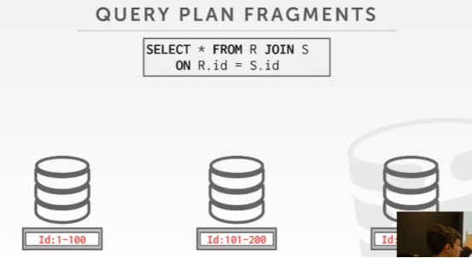

35:38 - 35:40
so again look at example here
so，来看这里的例子
35:40 - 35:47
so this is my query like this ,and so I could in this case it there's you know there's no join order
这是我的查询语句，so，在这个例子中没有什么join的先后顺序可言
35:48 - 35:51
ah well it's either RS or SR
可以是RS，也可以是SR
35:51 - 35:55
but I just say alright well I know me actually the query ,and need such data at these three partitions
实际上，对于这个查询来说，它所涉及的数据分布在这三个分区上
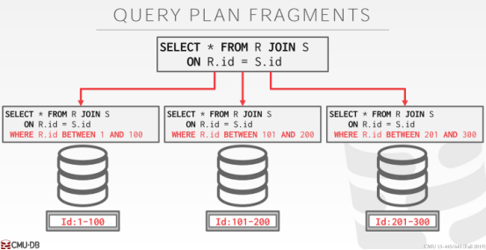

35:55 - 35:59
so I'll rewrite MySQL statement to now include a where clause
so，我会重写MySqL的where子句
35:59 - 36:06
that says here's the portion of the data you need to look at, which matches what the partition key is ,or the partition ranges
看这里的这部分数据，它的partition key的值的范围
36:07 - 36:12
then the node gets this each node gets these individual query plans, running through its own optimizer
然后每个节点会拿到属于各自切分后的查询语句，通过各自的优化器来获取到最适合自己的查询计划
36:12 - 36:20
and then they can decide, Oh based on the data I have here is it better to join R and S,or S and R, shut you a hash join, shut you a sort-merge join
每个节点都可以基于自身数据状况，去选择R与S join还是S与R join更好，根据自身选择hash join或者sort-merge join
36:21 - 36:25
I can make a local decision here, because I have the best view of what's what date I'm actually storing
我可以在本地进行决策，因为我可以根据我自己实际存储的数据来选择最好的方案
36:25 - 36:27
whereas the home node again could be out of date
然而要知道的是，home node那里的信息可能是过时的（知秋注：这些分区数据的范围可能会变大或者有更多新的分区）
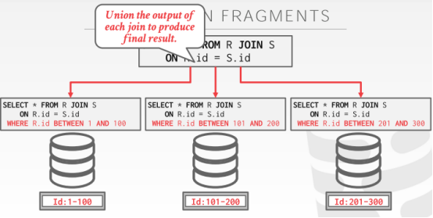

36:31 - 36:37
so the only database something that actually that I'm aware that actually does something like this is is MemSQL
我知道的实际只有MemSQL 这个系统是这么搞的
36:37 - 36:41
everybody else sends the physical plan
其他用的都是物理计划
36:43 - 36:46
I don't I mean to me this seems convincing that you could do this
我这里的意思并不是说，我在通过这个数据来说服你应该这么做
36:46 - 36:52
I think you still have to make a higher-level decision of the possible join order at you know
我想的是你依然要有一个更高的视角去做决策，比如join 顺序，你知道的，
36:52 - 36:56
if you have multiple tables more than two ,like R S and T
如果你有多个表，不只是这两个，就好像你有R S T三张表
36:56 - 37:02
should I join R and S, or T and S first, like I think there is some information there , that you may have the reason about at the upper level
我是先R Join S呢还是先T Join S，我想这里要有一些信息，用来在更高一层去确定这些信息
37:02 - 37:09
but when it comes time for the local node to make this decision ,you know everything it doesn't worry about communicating with anybody else
当它到达本地node去做这个决策时，你完全无须担心它是否还需要和其他人进行通信
37:11 - 37:16
I'm not saying one is better than other, I think this has interesting implications that have not been explored in the research
我并没有说哪个比哪个更好，我想这个里面隐含了一些我们很感兴趣的东西，可以让我们去研究探索
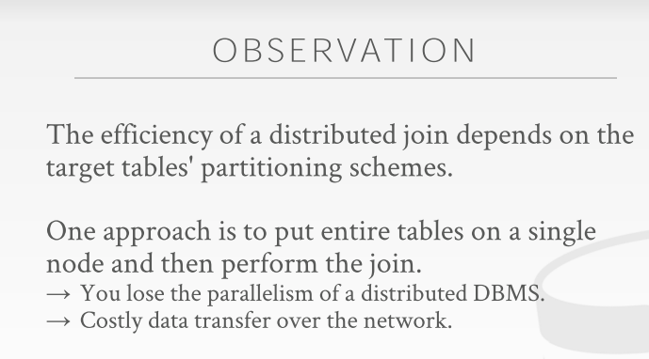

37:19 - 37:19
okay

37:21 - 37:23
so now we want talk about joins
so，now，我们来探讨下join
37:23 - 37:27
again joins are those expensive most important thing you have to do in a single node database
join在单节点数据库中是很消耗性能但又很重要的存在
37:27 - 37:30
and just you know also in a distributed database
然后，你知道的，它在分布式数据库中同样如此
37:31 - 37:37
for analytical workload the large portion of the time that the system is going to spend executing a query
对于分析型工作负载，系统将花费大部分时间来执行查询
37:37 - 37:40
where I be reading data from disk or doing our join
我需要从磁盘上读取数据并来进行我们的join操作
37:42 - 37:44
as we said reading from data from disk
对于我说的要从磁盘上读取数据
37:44 - 37:47
there's you know there's there are some methods you can do to speed that up
有几个方式可以加快它的速度
37:47 - 37:52
but in the end of the day you're usually bound on how fast you can get things of the physical device
但最后，你通常会受制于以多快的速度从物理设备上获取信息
37:52 - 37:55
but for joins we can be smart about things
但对于join来说，我们可以更机智一些
37:56 - 37:59
so as I showed in the first example
so，对于我展示的第一个例子来说，
37:59 - 38:07
the easiest way to do a join is just get all the data we need to do our join ,put them on a single node, and run our join album
最简单的方式就是去拿到执行我们这个join相关的所有数据，把它们放在一个单节点上，执行即可
38:08 - 38:14
but as I said, you lose all the extra parallelism actual resources you have by dividing the data across multiple nodes
但就像我说的，你会丢掉所有的并行处理能力，要知道，实际上你的数据资源已经被分割到很多节点中了
38:14 - 38:20
you lose all those benefits ,and you also you know you may not be able to actually put everything in memory to run things fast
你将所有这些优点都丢掉了，而且，你要知道，你不可能将所有的数据都放在这个单节点内存中去执行
38:22 - 38:29
so there's before different approaches actually, how we actually or afford it scenarios you need to handle, when we want to do it should be to join
so 有没有和这种不一样的方案，来让我们可以应对这种场景，即当我们想要去做这种join操作时，我们该如何去处理
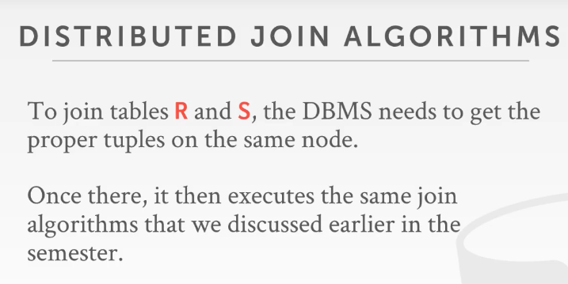

38:30 - 38:36
and again a distributed join is gonna be the exact same way ,we would do a join on a single node system
对于分布式join来说，大体和我们在单节点系统上做的join一样，
38:36 - 38:43
but the idea is that we need to figure out how to get the data we want to join together on a node
但我们这里的idea是，我们需要弄清楚我们想要进行join操作所需要的数据信息，该如何从一个（或多个）节点上获取
38:43 - 38:46
it could be one node to be multiple nodes
可能是一个节点，也可能是多个节点
38:46 - 38:51
such that we can do a join locally without having to coordinate with any other node ,while we're doing the join
我们可以在本地做join，在进行本地join的这个过程中不需要去和其他节点一起沟通协作
38:53 - 38:58
so when we do that local join, it's all the same algorithms, the server's join, nested loop join the hash join, that we talked about before
so 当我们在做本地join时，所用算法和我们前面学的单节点系统用到的是一样的，比如nested loop join、 hash join,等
38:58 - 39:00
all the same optimizations apply
同样，优化也是一样的，没什么区别
39:00 - 39:07
it's the step you have to deal with before you do that join of how to get the data to a node that's gonna need it
这是你必须执行的步骤，即在你进行join操作之前，你要考虑该如何到一个节点获取到join操作所需要的数据信息
39:08 - 39:13
so again we're gonna talk about four different scenarios if you've already sort of come up in our earlier examples
基于我们前面已经接触的例子，我们从四个不同的场景来探讨，
39:13 - 39:15
and we'll see how we actually wanna handle them
我们来看看我们实际是怎样处理它们的
39:16 - 39:19
and again the main takeaway is that there's no magic here that we can actually do
对于我们实际要做的这些，真没什么黑魔法在里面
39:19 - 39:24
there's no magic industry to join algorithm, that's gonna form so much better than a single node one
并没有给join算法添加什么黑魔法，为了让它比在单个节点下做的更好
39:25 - 39:28
it's all about how to get the data to where needs to be
都是关于如何将数据传输到需要的位置
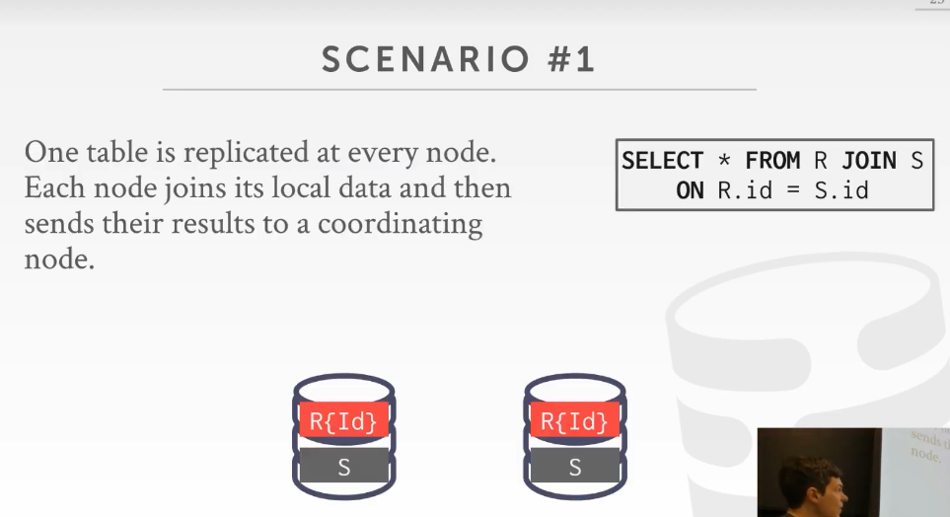

39:30 - 39:38
All right, the best-case scenario would be one where the table is one of the tables for joining us partitioned on the join him
All right, 最好的情况是进行join操作所依据的条件字段，同时也是其中一张表分区依据
39:39 - 39:44
and then the other table is replicated in its entirety at every single node
然后，另一张表会被整体复制到每一个单独的节点中
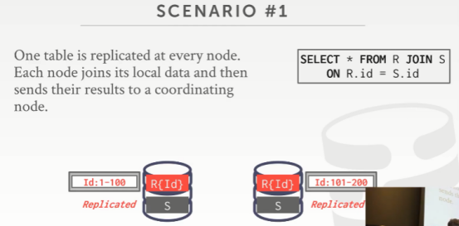

39:45 - 39:52
so in this case here, the R table is partitioned on the ID it's ID field, which is in R join clause
so，在这个例子中，R表通过id字段来进行分区，我们也是根据id这个字段来进行join的
39:52 - 39:54
and then the S table is replicated in every node
接着，S表会被复制到每个节点处
39:55 - 39:57
again this could be the fact table
这个可能会是Fact table
39.57-39.58
this could be the dimension table
这个可能是Dimension table
39:58 - 40:04
that this is small enough where we could split it up or small enough where we could replicate it on every single machine
我们已经将这张表拆分的足够小，并将它复制到每台机器上了

