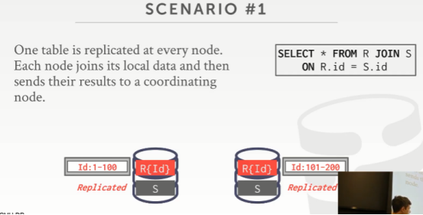

40:05 - 40:06
so in this case here
So，在这个例子中
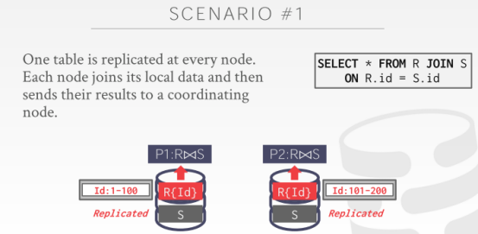

40:06 - 40:16
again all we need to do is have every single node ,do a local join to produce the result for the data ,that it has you know store in local storage
我们所需要做的事情就是让每个节点对它们本地所保存的数据进行join操作，并生成结果
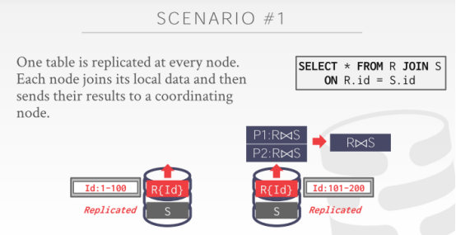

40:16 - 40:24
and then we just need to transmit the the output of one of joining one node to some centralized location
我们需要做的就是将一个节点所执行join操作的结果传输到某个中央位置
40:24 - 40:28
so that we can combine the results that produce a single answer to our application
So，这样我们就可以将这些执行结果合并为一个结果，并返回给我们的应用程序
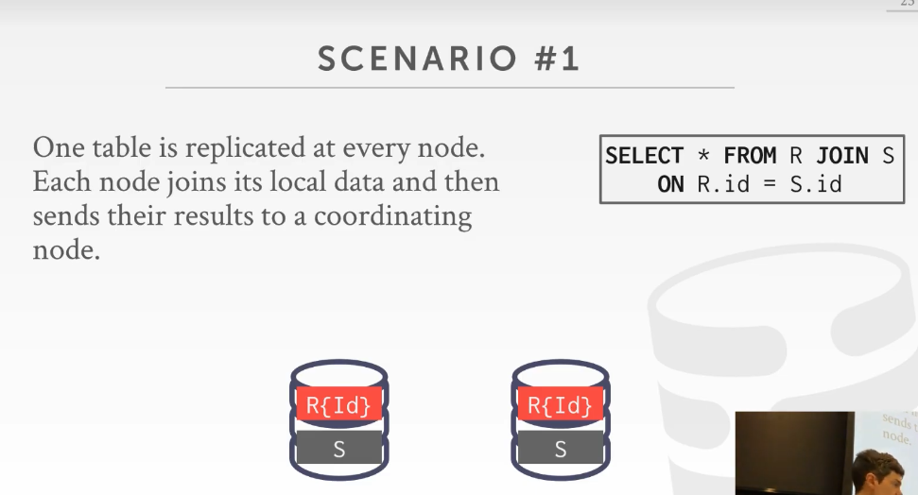

40:29 - 40:30.
all right

40.30-40.31
again this is the best-case scenario is
这是最佳情况
40.31-40.36
this transfer to get the join result from this node to that node, is unavoidable
因为像这种将一个节点的join结果传输到另一个节点，这是不可避免的
40:36 - 40:37
we have to do it
我们必须这么做
40:37 - 40:38
but when we actually get the join
但当我们执行该join操作时
40:38 - 40:40
we didn't need a coordinator or communicate with any other node
我们不需要与其他节点进行通信
40.40-40.42
, because everything we needed was local to us
因为对我们来说，我们所需要的所有东西都在该节点本地
40:43 - 40:46
so this gives us the benefit of a distributed database
So，这就是分布式数据库的好处
40:46 - 40:51
because now we can run this join in parallel on every single node without any coordination
因为我们在不需要进行任何协调的情况下，我们就可以并行执行join操作
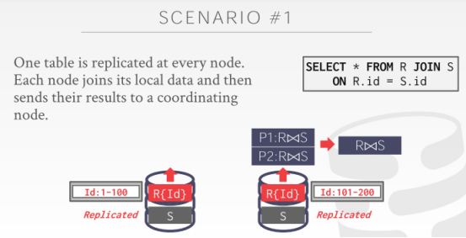

40:52 - 40:56
and then everyone just sends the result back to the head node
然后，所有节点只需将结果返回给头节点即可
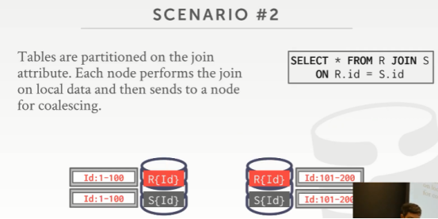

40:59 - 41:01
next best-case scenario is
下一个最佳情景案例是
41.01-41.08
where both the tables are partitioned on the join key
这两张表都使用join key进行分区
41:08 - 41:10
again in this case here
在这个例子中
41.10-41.15
the again S.ID on the last slide it was partitioned on today was replicated
在上一张幻灯片中，S表是被复制到每个节点
41:15 - 41:17
this one is partitioned on the ID field
在这个例子中，它是根据id字段进行分区的
41:17 - 41:26
the range of the partition for S is the same as the range for Partition on R
S表的分区范围与R表的分区范围是相同的
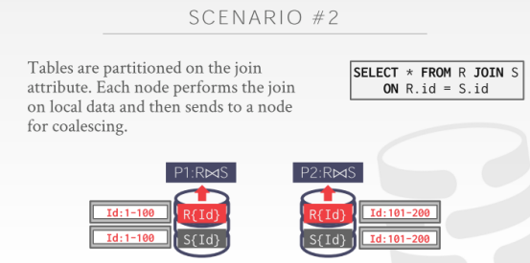

41:27 - 41:28
so again just like before
So，就和之前一样
41.28-41.30
we compute our local join
我们在节点本地执行join操作
41.30-41.33
could be a hash join going to be nested loop could be sort merge, it doesn't matter
你可以使用hash join，也可以使用nested loop join，或者sort-merge join，这都可以
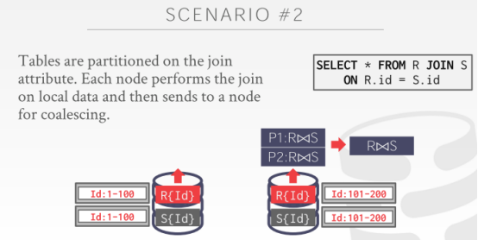

41:33 - 41:37
and then this guy's transmits the result to this other node where we combine it together
然后左边这个节点将执行结果传输到另一个节点处，然后我们在这里将结果进行合并
41:38 - 41:39
yes
请讲
41:54 - 41:57
so his question is about data skew
So，他的问题是关于那些有偏向性的数据
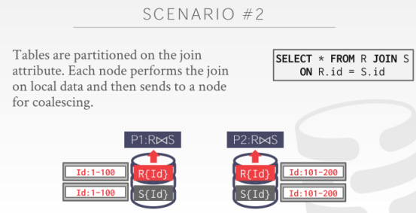

41:58 - 42:00
so in this example here
So，在这个例子中
42.00-42.05
,I'm showing you that the ranges are the same 1~100 and 101~200
我向你们展示的范围都是相同的，即1-100和101-200
42:05 - 42:11
but it doesn't necessarily tell you how many tuples exist ,in this range or this partition
但它不一定要告诉你这个范围或者这个分区中存在着多少tuple
42:11 - 42:14
so like say this ID is the primary key for R
So，假设id是R表的主键
42.14-42.17
, so there's exactly one hundred tuples for R
So，那么这个分区中，R表确实有100个tuple
42:17 - 42:21
but say this is IDs not the primary key for S
但假设id不是S表的主键
42:21 - 42:24
I could have a billion entries within this range
那么在这个范围内我可能会有十亿个tuple
42:24 - 42:26
and then a billion entries for that range
在另一个范围内我也有十亿个tuple
42:26 - 42:27
how do I handle that
我该如何处理这种情况呢？
42.27-42.28
,well in that case
Well，在这种情况中
42.28-42.32
you would not want to have the same range as the ID field
你可能不会想使用和id字段相同的范围
42:32 - 42:35
so in that case you will have to shuffle some data around which we'll talk about in a second
So，在这个例子中，你就需要对某些数据进行shuffle，这个我们之后会讲
42:36 - 42:37
there's the best-case scenario
这就是最好的情况
42.37-42.41
these are uniformly distributed exact same range
在这种情况下，数据都是均匀分布，并且拥有相同的数据范围
42.41-42.42
,I don't need to coordinate
我也不需要进行协调
42:44 - 42:50
I'm sure it doesn't I agree ,but it won't have a real-world ,I'm saying best-case of worst-case scenario
我这里说的是最好情况以及最差情况
42:50 - 42:52
and we'll see how to handle as things get worse
我们会去看下如何处理糟糕情况
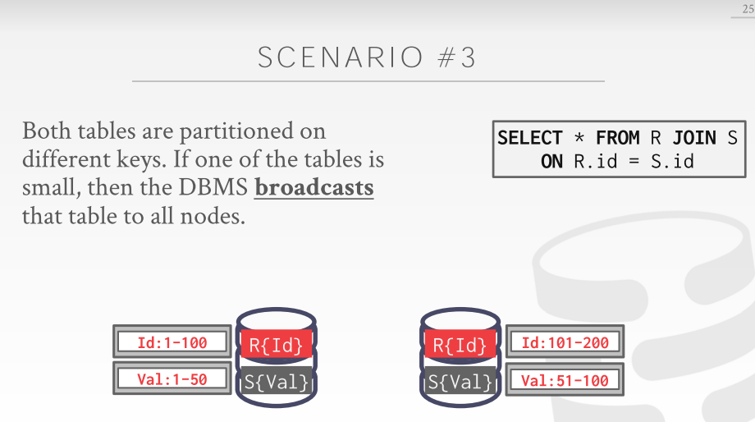

42:55 - 42:56
all right
42.56-42.59
so so related to him
So，这里与他刚才说的东西有关
42:59 - 43:00
so so the next issues gonna be
So，下一个问题是
43.00-43.07
let's say that when R tables is not partitioned ,on the the same attribute that we want to join on
假设当R表并没有使用我们进行join操作所基于的那个条件属性进行分区（知秋注：两张表都是以其他字段进行的分区）
43:07 - 43:10
so in this case here S is partition on the value field
So，在这个例子中，S是使用val字段进行分区
43:11 - 43:12
so in this case
So，在这个例子中
43.12-43.15
,we can't compute our local join,
我们没法在节点本地执行join操作
43.15-43.18
because for every single value of R.ID here
对于R.id对应的每个tuple来说
43:18 - 43:24
I don't know whether it's it's, you know a matching tuple will exist on my local partition,
我不清楚在我的本地分区中是否存在与之匹配的tuple
43.24-43.26
then maybe will over here with the same ID
可能具有相同id的tuple是在另一个分区
43:28 - 43:31
so this case this is called a broadcast join
So，在这种情况下，这种叫做broadcast join
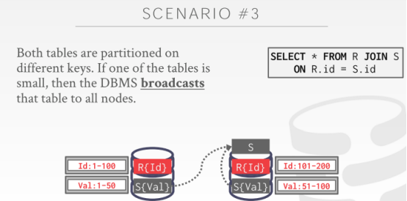

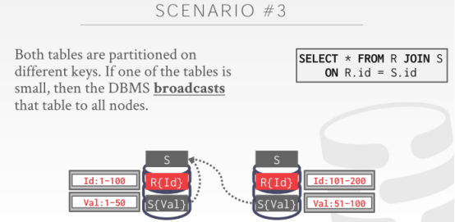

43:31 - 43:32
and the basic idea is that
它的基本思路是
43.32-43.43
you copy the portion of the table that's missing from each partition to every other partition
你将那些每个分区中所缺失的那部分表数据复制到所有其他分区中
43:43 - 43:47
so that now this node has a complete copy of the table
这样一来，这个节点就拥有了该表的完整副本
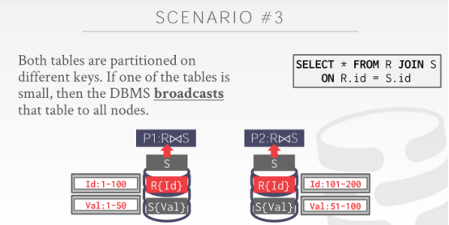

43:48 - 43:51
and then now you just compute your local join
现在，你就可以在节点本地执行join操作了
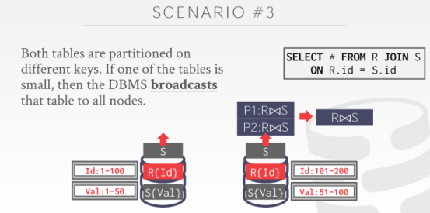

43:51 - 43:53
and then send the result over to the other guy
然后，将结果发送给另一个节点
43:54 - 43.56
again this assumes that S is small enough
这里假设S表足够的小
43.56-43.58
, that it could you reside in memory
它可以放入内存中
43.58-44.01
not overwhelm this machine or this node here
并且也不会弄垮这台机器或者这个节点

44:02 - 44:03
you try to copy everything here
你会试着将所有数据都复制到这个节点
44:06 - 44:08
Right the broadcast means that
broadcast的意思是
44.08-44.12
you're basically generating every node would end up with a replicated copy of the table
每个节点都会有一份该表的副本
44:13 - 44:18
sometimes just see you ever heard to as a broadcaste hash join , broadcast sort-merge join
有时候你们会听到broadcast hash join和broadcast sort-merge join之类的东西
44:18 - 44:21
it just means they're doing this initial step
这意味着当它们在执行初始步骤的时候
44.21-44.23
, where they transmit the data across to different nodes
它们会将数据传输到不同的节点
44.23-44.24
that everyone has a complete copy
这样每个节点都会有一份完整副本
44:25 - 44:26
and then you do the join
然后，你就可以进行join操作
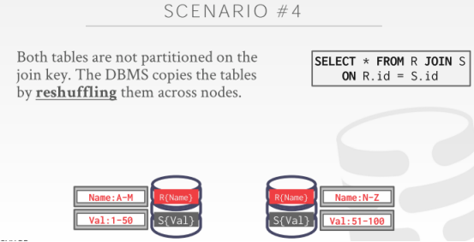

44:30 - 44:32
the last scenario is the absolute worst-case scenario
最后一种情况无疑是最糟糕的情况
44.32-44.36
is where both tables are not partitioned at all on our join key
即这两张表都没有使用我们执行join操作的key来进行分区
44:36 - 44:40
and now we need to reorganize the layout of the data
现在，我们需要去重新组织下该数据的布局
44:41 - 44:43
so that we compute our join more efficiently
这样我们才能更高效的执行我们的join操作
44:44 - 44:48
so this will be called a shuffle join, shuffle hash join
So，这种叫做shuffle join或者叫做shuffle hash join
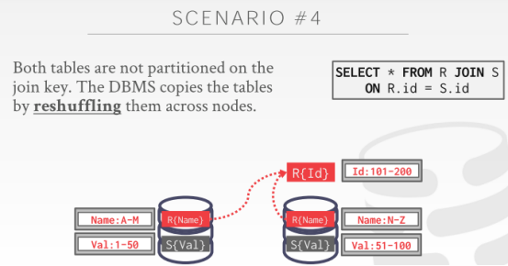

44:48 - 44:53
so basically we recognize that we'll really want things to be partitioned on the ID field
So，简单来讲，我们意识到，我们想让这些数据是根据id字段来进行分区的
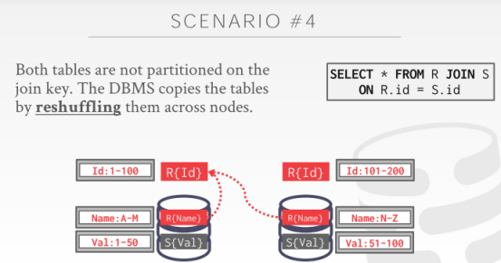

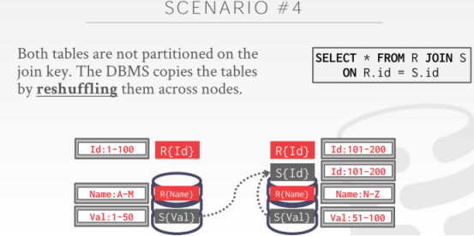

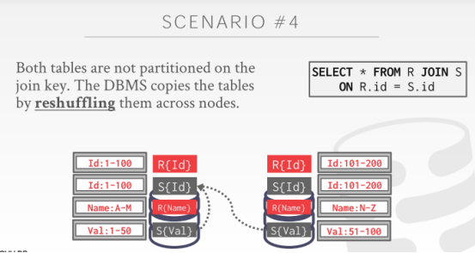

44:53 - 44:58
so let me just start copying the data that I need from these two tables to these two different nodes
So，我会将这两张表中所需要的数据复制到这两个不同节点上
44:58 - 45:02
if this has to spill to disk run out of space, that's unavoidable,
因为内存空间耗尽的原因，这些数据会溢出到磁盘，这是不可避免的
45.0245.04
so we just go ahead and do that
So，我们继续执行我们的操作
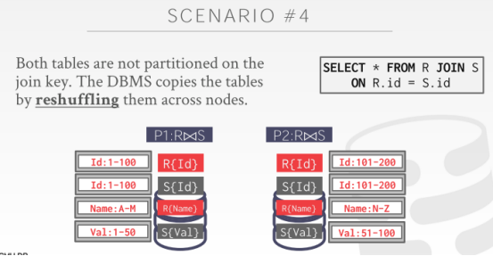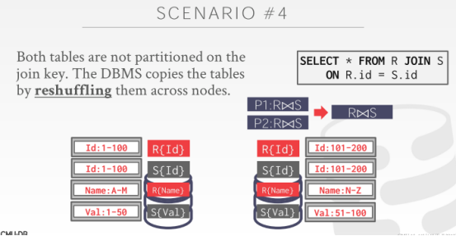

45:04 - 45:07
and then once I know I have everything Partition the way I want to partitioned
一旦我知道，在所有数据都是按照我预想的方式进行分区了之后
45.07-45.11
, then I can keep my local join and generate the results
那么，我就可以在本地执行join操作，并生成结果
45:13 - 45:13
yes
请讲
45:16 - 45:16
what
你再说一遍
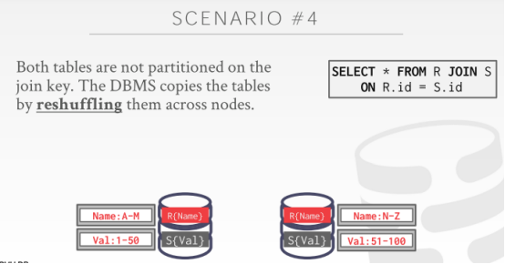

45:21 - 45:22
so his question is
So，他的问题是
45.22-45.24
and the space is limited what can you do
如果空间是有限的，我们该怎么做
45:24 - 45:25
so the point I'm trying to make here is like
So，此处我尝试要做到的事情是
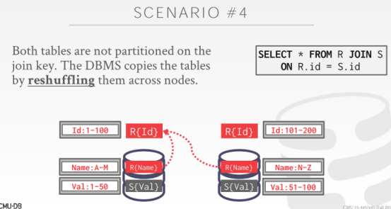

45:29 - 45:30
Think about what you end up doing here right
思考下你们这里最终在这里做什么
45:30 - 45:36
so I have to now make another copy of R on you know and store it on this node
So，我现在需要将R表的副本复制并保存到左边这个节点上
45:37 - 45:39
and so if it doesn't fit in memory
So，如果它无法放入内存
45.39-45.39
just as I said like,
正如我之前所说
45.39-45.44
it's gets spilled as a temporary result for the query could get spilled a disk,
该查询的临时结果就会溢出到磁盘
45:44- 45:46
that's unavoidable
这是不可避免的
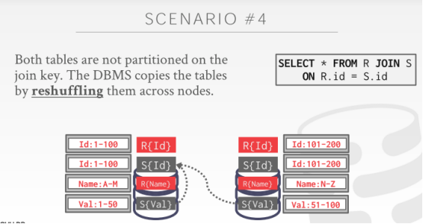

45:47 - 45:49
right but the more important thing is that,
但更为重要的地方在于
45.49-45.50
now when I compute the join
当我计算join时
45.50-45.52
, I want that to be fast as possible
我想让它的执行速度变得尽可能快
45.52-45.53
, because that's the most expensive thing
因为它是执行成本最高的东西
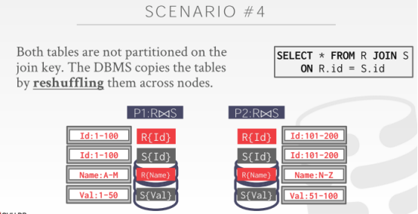

45:53 - 45.55
so by copying data around
So，通过复制数据
45.55-45.57
when I do the join
当我执行join操作时
45.57-45.58
everything is partitioned nicely the way I want it
所有数据都以我想要的方式分好了区
45.58-45.59
and it's more efficient
执行join操作时，这就会变得更高效
46:04 - 46:05
this question is
他的问题是
46.05-46.07
do we always assume that the disk is enough
我们是否始终假设我们的磁盘空间是足够的？
46:14 - 46:15
for our class, yes
在我们的课上，我们会假设磁盘空间是足够的
46.15-46.17
in the real world, no
但在现实生活，这个假设是不成立的，磁盘空间可能不够
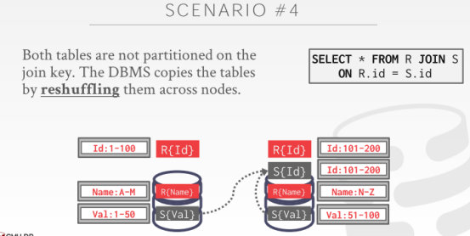

46:17 - 46:19
what will happen is
这里要发生的事情是
46.19-46.20
the database recognizes that
数据库会意识到
46.20-46.23
if I get to here
当我执行到这一步的时候
46.23-46.25
,and I can't copy any more data to this node here
我无法再往这个节点中复制更多数据了
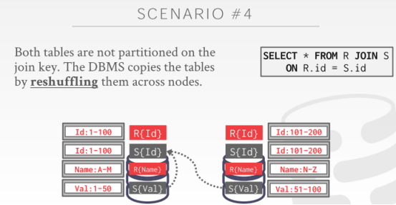

46:26 - 46:27
the query would fail
该查询就会执行失败
46.27-46.29
, just say I run out of swap stays for space
这里我表示磁盘的空间用完了
46.29-46.32
, and you throw an error and the query fails
接着，我们就会抛出一个错误，然后查询就会失败
46:34 - 46:37
and actually related to his question about the distribution of data
实际上，他的问题和数据分布有关
46:38 - 46:42
if say it was partitioned on the ID field
如果我们假设这里是根据id字段进行分区的
46:42 - 46:48
but the distribution was highly skewed sister that most of the data was on this node for S instead of that node
但这个数据的分布是极度倾斜的，S表大部分的数据是在这个节点上，那个节点它的数据很少
46:48 - 46:52
I can still do this reshuffling to to realign my data
我依然可以对我的数据进行shuffle操作，以此来对我的数据进行对齐
46.52-46.54
maybe move some data from R and S over here
我可能会将旁边R表和S表中的某些数据移动到这里
46:54 - 46:56
so that things even get balanced
这样，就能让两边数据平衡
46:57 - 46:59
but still it's still called a shuffle process
但这过程依然是shuffle过程
47:00 - 47:00
question
请讲
47:05 - 47:06
how does a lot more compact oh sorry
oh sorry，再讲一下
47:14 - 47:14
yes
Yes
47:21 - 47:23
of course how do you manage what sorry
你该如何管理什么？能再讲一下吗？
47:33 - 47:34
Her question is
她的问题是
47.34-47.36
how do I make a decision about what data to send
我该如何决定要发送哪些数据
47:37 - 47:38
because if things are replicated,
因为如果这些东西都被复制了
47.38-47.43
I don't want to waste you know waste network transmission of sending data that I don't need to send
我不想去浪费网络带宽来发送那些我不需要发送的数据
47:43 - 47:45
you know everything ahead of time
你会提前知道所有这一切
47:45 - 47:46
right SQL is declarative
SQL是声明式的
47.46-47.48
we know what the query is
我们知道这个查询是什么
47.48-47.49
,we know what data are trying to access
我们知道我们在尝试访问哪些数据
47:49 - 47:51
we then look in our system catalog
接着，我们会去查看我们的System Catalog
47.51-47.54
our system catalog is gonna tell us, how this data is actually partitioned
我们的System Catalog会告诉我们这些数据的实际分区情况
47:54 - 47:55
we know this ahead of time
我们会提前知道这些
47:56 - 47.58
so the query planner can make a decision
So，查询计划可以做出决策，并表示
47.58-48.00
, oh well this data partition this way
Oh，这些数据是以这种方式进行分区的
48.00-48.01
,and it's this size,
它的大小是这样的
48.01-48.02
and it's in on this node
它是放在这个节点上的
48:02 - 48:05
so therefore and either move or not move it or copy here , don't copy there
So，因此我们可以选择去移动数据，或者不移动数据，以及需不需要去复制数据
48:06 - 48:07
I can do all that ahead of time
我可以提前做这些事情
48.07-48.11！！！！！！！
, it's not like as I'm going along , as I say oh well yeah maybe I should copy this
而不是当我执行的时候，我再去说我可能需要复制这些数据
48:12 - 48:13
you figure out everything ahead of time
你会将这些事情都提前弄清楚
48:14 - 48:16
except for the issue he brought up
除了他刚提的问题以外
48.16-48.16
or like I ran out of disk space
即我可能会用光磁盘空间
48.16-48.20
,you know you just fail ,nothing you can do
你知道的，遇上这种情况，查询就会执行失败，对此你无能为力
48:24 - 48:34
and then the how efficient the database system is in making those decisions about , what the copy or not the copy, depends on how good your query optimizer is
数据库系统做出这些决策（比如是否需要复制数据）效率取决于你查询优化器的好坏
48:34 - 48:38
which is why people pay a lot of money to have people like work on query optimizers
这就是为什么人们愿意花很多钱去请人负责他们的查询优化器的原因所在了
48:38 - 48:39
question
请讲
48:43 - 48:43
your question is
你的问题是
48.43-48.46
what if the data is sorted on the partition ID beforehand
如果数据提前根据partitioning id进行排序的话，会怎么样
48:46 - 48:48
but it's partition ID or join ID
你指的是partitioning id还是join id
48:50 - 48:54
so if it's sorted for what I'm showing here who cares
So，正如我这里所展示的，没人会去在意这个
48:55 - 48.58
right cuz what I care about is the locality of the data
因为这里我关心的是数据的所在位置
48.58-49.01
, I need to join R.ID on S.ID
我需要根据条件R.id=S.id进行join
49:01 - 49:02
so I want to make sure that
So，我想去确保
49.02-49.04
when I do that join locally
当我在本地执行join操作时
49:04 - 49:11
I have all the data that I need you know to join the outer table at the inner table ,is at my local node
我要确保我用来对outer table和inner table进行join时所需要的所有数据都在我的本地节点
49:11 - 49:13
it can't be at some other node that I don't know about,
这些数据不能放在那些我不知道的节点上
49.13-49.16
and that could end up with a false negative or false positive
这可能就会导致假阴性或者假阳性的问题出现
49:17 - 49:19
so sorting doesn't matter
So，对数据进行排序其实并不重要
49:19 - 49:23
sorting would matter when we can make a decision about do I want to do a sort merge or hash join
只有当我们决定要不要使用sort-merge join或者hash join的时候，排序才会变得重要
49:24 - 49:28
word like a step above this, we're designing how do we move data or not
就比如在这一步之上，我们要去设计我们该如何移动数据
49:32 - 49:32
yes
请讲
49:39 - 49:39
okay

49.39-49.39
so question is
So，他的问题是
49.39-49.41
what am I actually transmitting here
这里我实际传输的是什么东西
49:42 - 49:44
and be clear I'm not swapping this,
要明确的一点是，我并没有交换数据
49.44-49.45
I shouldn't have a divider line
这里我不应该使用分割线
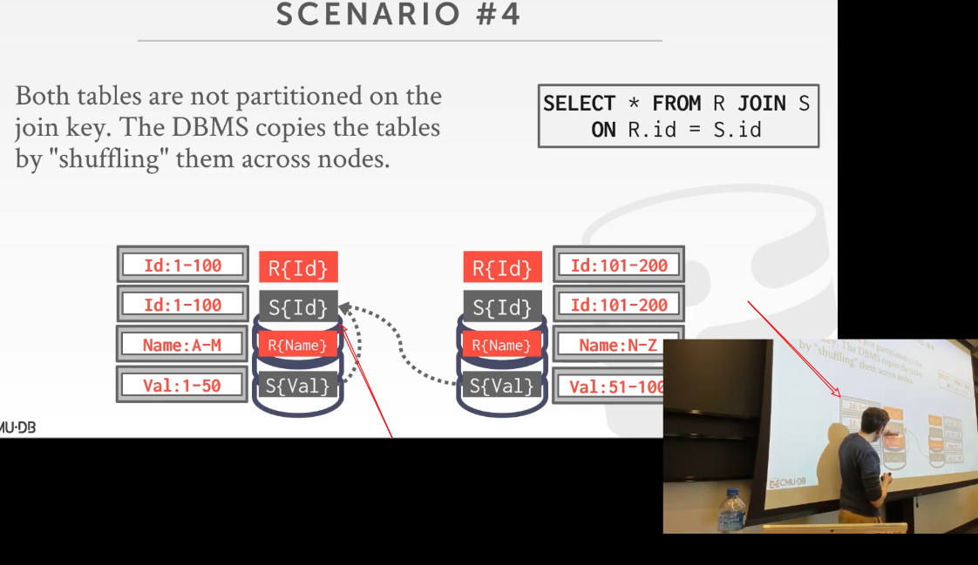

49:45 - 49:48
so this is the permanent data on this node
So，这部分数据是该节点的永久数据
49.48-49.49
, it does not go anywhere
它不会跑到其他地方去
49:50 - 49:53
I just make extra copies as temporary data to do my join
我只是将一些副本数据作为用于执行我join操作的临时数据
49.53-49.55
, and then I throw it away when my queries over
当我的查询执行完毕时，我就会将这些临时数据给丢掉了
49:55 - 49:57
so even though I'm shuffling here on ID
So，即使这里我根据id来对数据进行shuffle操作
49:58 - 50:03
the I'm still going at the end of a partition R name and value here , this stays
我依然要知道它是以R{Name}和S{Val}来分区的
50:03 - 50:07
but then your other question is , what am I actually transmitting
然后你的问题是，实际上我传输的是什么
50:07 - 50:12
my transmitting the whole tuple or am I transmitting the summit some identifiers next slide
我传输的是整条tuple还是只是一些id
50:13 - 50:14
okay we'll get to that yes
Ok，我们稍后会讲，请讲
50:25 - 50:26
your question is
你的问题是
50.26-50.27
on a local node
在一个本地节点上
50.27-50.29
if the data is not sorted
如果数据是未排序的
50.29-50.31
, how do I make sure that there's no duplicates, duplicates of what
我该如何确保这里面是没有重复的数据？哪些重复的数据？
50:33 - 50:35
for the join
你说的是用于join操作的数据？
50:40 - 50:44
aha is a partition ID the primary key or a unique ID
这里的partitioning id使用的是主键还是唯一id？
50:55 - 51:01
well ,yes all right get 2 questions that
Well，你其实问了两个问题
51:02 - 51:03
so I think what you're asking is actually,
So，我觉得你实际问的东西是
51.03-51.04
if I have a primary key,
如果我有一个主键
51.04-51.06
then I need to guarantee it's unique
那么我需要保证它是唯一的
51:06 - 51:09
but my my partition key is not the primary key,
但如果我的partitioning key不是主键的话
51.09-51.12
how do I make sure that I enforce that
我该如何确保我强制它是唯一的呢？
51:13 - 51:15
So that is a transaction
So，这和事务有关
51:17 - 51:19
right that's not us, we're just doing analytical queries
这与我们这里做的事情无关，我们这里做的只是分析型查询
51:20 - 51:21
we assume we don't like

51:22 - 51:28
we assume that someone else has solved that for us when they stored the data as a part of a transaction
我们假设其他人在将数据存储为事务的一部分时就已经为我们解决了这一问题
51:29 - 51:30
so in your example
So，在你的例子中
51.30-51.33
if I have a partition key that's not the same as the primary key
如果你有一个partitioning key，但它并不是主键
51:33 - 51:35
then I insert a new record,
接着，我插入了一条新纪录
51.35-51.36
how do I make sure that's unique
我该如何确保它是唯一的呢？
51:37 - 51:44
while I need to maintain a sort of centralized index that I look up and see whether this key does party exist
我需要去维护一份中央索引，我会在里面进行查找看看某个key是否存在
51:44 - 51:50
or at the broadcast the query to every node to say hey I'm certain this key do you already have a copy of it
或者，当你将查询广播到每一个节点，并询问你是否有该key的副本
51:52 - 51:55
I'm saying you could, right
我说的是，你可以这么做
51:57 - 52:00
help me how come in me how could how could that be
这种索引是怎么样的
52.00-52.01
, here's a node, here's an index
这里有一个节点，这里有一个索引
52:02 - 52:05
we're building idiots we do have everyone, right ,we can do this
我们可以构建这样的中央索引，这样我就知道了所有，我们可以这么做
52:09 - 52:17
again ,like I don't care about in this world for these queries ,I'm not enforcing integrity constraints
在这些分析型查询中，我不会强制使用这些完整性约束
52:18 - 52:26
I'm just running this read query is analytical queries to figure out , you know how to compute the join efficiently on a large data corpus
我会去执行这些分析查询以弄清楚该如何对大量的数据以更高效的方式计算这些join操作
52:26 - 52:28
the transactional side,
从事务方面来讲
52.28-52.30
it cares about integrity constraints
它会去在意完整性约束方面的东西
52.30-52.32
because you're modifying the state of the database
因为你会去修改数据库的状态
52:41 - 52:42
no No
你说的不对
52.42-52.46
so so going back to my initial example here
So，回到我刚开始的那个例子
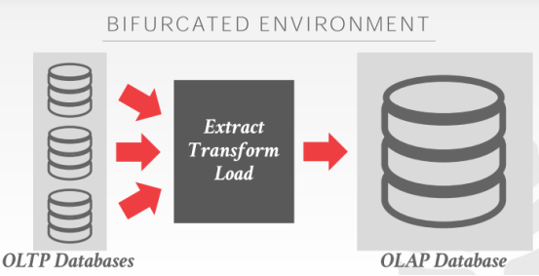

52:51 - 52:52
like for this ETL thing
就拿这里的ETL来说
52:53 - 52.58
so this thing of this like your bulk loading a bunch of data
So，这里你会加载大量的数据
52.58-53.02
like, this is sort of streaming, it's not happy it's not like all at once here's a bunch of data
这里传入的是数据流，它不会立刻将一大堆数据加载到位
53:02 - 53:07
but you're streaming incrementally updates from the front end to your back end data warehouse
但你会逐步将数据流从前端的OLTP数据库发送到后端数据仓库中
53:08 - 53:13
and the back end data warehouse could choose or not choose to enforce those integrity constraints as it comes in
当这些数据传入的时候，后端数据仓库会决定要不要使用这些完整性约束
53:14 - 53:20
but it won't be on the critical path of when we execute our queries
但当我们执行查询时，这并不会对我们产生很大的影响
53:20 - 53:21
because I'm running a selects statement
因为我执行的是一个select语句
53.21-53.23
I'm not checking to see whether my primary key is unique
我不会去检查我的主键是不是唯一的
53:23 - 53:29
so now how you enforce that integrity constraint as you ingest the data into your back end data warehouse
So，当你从你的后端数据仓库中提取数据时，你该如何强制使用这种完整性约束呢？
53:29 - 53:32
well that's the same thing we talked at last class how to do transactions
Well，这和我们上节课讨论如何执行事务时所讲的是一回事
53:32 - 53:34
because that is a type of transaction
因为这就是事务的一种类型
53:34 - 53:36
you know insert something make sure it's unique
比如：插入某个数据时要确保它是不是唯一的
53:36 - 53:41
I need to coordinate across multiple nodes, if I'm not everything's not on a single node
如果执行事务所涉及的那些数据并不在同一个节点时，我们需要对多个节点进行协调
53:41 - 53:44
to make that check it does everyone agree that we can go ahead and make this change
并检查是否所有节点都同意我们执行这个修改
53:45 - 53:56
so a lot of times in these analytical data warehouses they will have they will sort of have a separate engine or a storage area
So，很多时候，在这些分析型数据仓库中，它们会有一个单独的引擎或者存储区域
53:56 - 54:04
,that is designed to do efficient more are more efficient updates than what a you know a traditional column store DBMS would do
它是为了让更新变得更有效率而设计的，这要比传统的列式存储DBMS的效率还要高

54:05 - 54:07
if you take the advanced class
如果你们要学cmu 15-721这门课的话
54.07-54.07
we will cover that
我们会介绍这个
54.07-54.08
, we didn't cover that here
我们就不在这里介绍这个了
54:10 - 54:12
right so again for our purpose here today
So，出于我们今天的目的
54.12-54.14
we don't care about enforcing that integrity constraint
我们不去关注完整性约束方面的东西
54.14-54.17
,we assumed that it was already handled for us
我们假设它已经为我们处理好了
54:17 - 54:21
some database systems I mean some data warehouses,they just turn all that crap off
我的意思是在某些数据仓库中，它们将这些没用的功能关闭了
54.21-54.25
they turn off foreign keys, they turn off unique keys
它们禁用了外键和唯一键
54:25 - 54:29
your data is a little dirty ,who cares for analytics
对于整个分析过程，谁会去在意你的数据是不是dirty的呢（知秋注：分析型数据库的数据量是超级大的，不要在意那点50ms内的小细节）
54:46 - 54:46
right so this question is
So，他的问题是
54.46-54.55
, you have your bank account or what it whatever your game information
假设你有银行账户或者说这里是你的游戏信息
54:56 - 54:58
you update your user account on the front end OLTP database
你会去更新你前端的OLTP数据库中的账户信息
54:58 - 55:01
because that's what that's the users are touching this part
用户会接触OLTP数据库中的数据
55.01-55.02
,and they don't touch the back in dataware house
它们不会接触后端数据仓库中的数据
55.02-55.03
they make updates here
它们会在OLTP数据库中更新数据
55:04 - 55:09
that update gets propagated
更新会进行传播

and you want to go update the record here has that happen advanced class
你想要在OLAP端去更新这个record，具体请关注我们的高级课15-721
55:09 - 55:09
in general
一般来讲
55.09-55.10
what I'll say is like
这里我要说的是
55.10-55.17
you buffer a bunch of changes in a sort of write-optimized storage layer or execution engine in these data warehouse
你会将一堆修改缓存在一个为写操作而优化的存储层或者执行引擎中
55:17 - 55:21
and then they periodically merge the change into the data warehouse
然后，它们会定期将这些修改合并到数据仓库中
55:22 - 55:27
or into like the main column store tables for the for that for the new analytics
用于新的数据分析
55:28 - 55:29
different systems do different things
不同的系统有不同的做法
55:35 - 55:35
okay

55:40 - 55:40
so
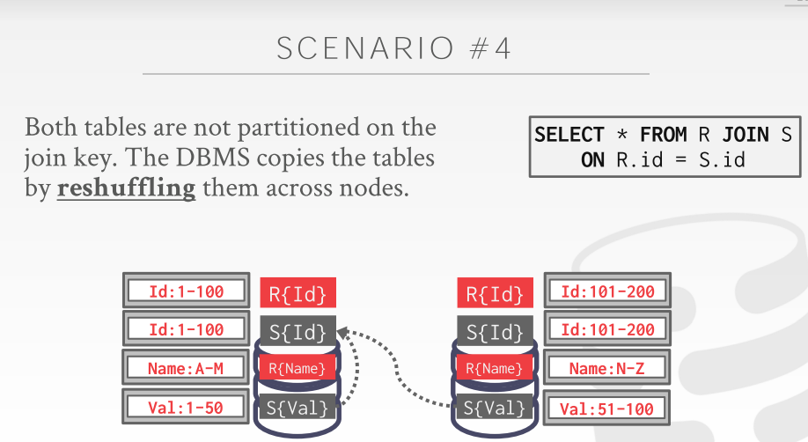

55:42 - 55:44
any other questions about this stuff here
对此你们还有任何问题吗
55:45 - 55:47
yes go ahead
请讲
55:53 - 55:53
yes

56:01 - 56:02
her question is
她的问题是
56.02-56.03
I said here that
这里我说过
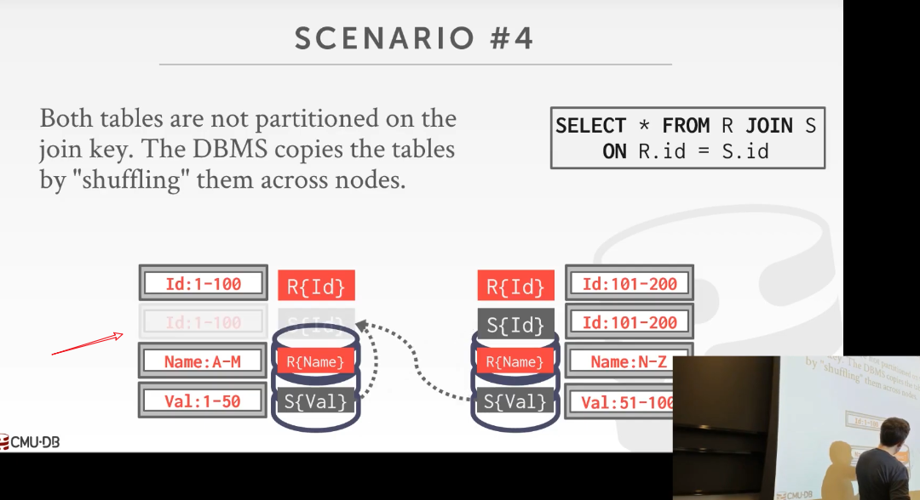

56.03-56.07
when we go to copy this thing here for this particular query
当我们为这个查询将这些数据复制到这里时
56:07 - 56:09
if we run out disk space
如果我们用完了磁盘空间
56:10 - 56:12
and the query crashes
然后，这个查询就崩溃了
56.12-56.17
, couldn't the query optimizer figure that ahead of time ,and say oh I'm not gonna have a disk space
查询优化器是否能提前弄清楚我们有足够的磁盘空间了
56:17 - 56:22
let me let me make sure that maybe not run a certain way here
它能否提前告诉我这个节点可能无法执行这个查询
56:22 - 56:28
the query optimizer is usually do not reason about what our other queries running at the same time
查询优化器通常不会去推断同一时间是否有其他查询正在执行
56:29 - 56:30
it assumed your query runs in isolation
它假设你的查询是单独执行的
56:33 - 56:38
and that it could reason about certain things like
它所能推断出的东西是
56:39 - 56:45
some sort of some systems you can specify how much temporary buffer space or temporary disk space, the queries allowed to use
在某些系统中，你可以指定这些查询可以使用的临时buffer space有多大或者临时磁盘空间有多大
56:45 - 56:46
and then if you exceed that
如果你超过了指定的空间大小
56.46-56.47
your query fails
那么你的查询就会执行失败
56.47-56.50
,and it throws you back hey you know creases parameter if you want to keep running
然后它会给你抛出：hey，如果你想保证运行这个查询的话，你需要增加参数值
56:51 - 56:58
so it could potentially figure out at planning time ,oh I'm gonna copy over more data than I have space for this particular query, and throw an error
so 它可能在查询计划执行前这个时间去指出（知秋注：在执行前提前把数据准备到位）：oh，这个查询对我来说，要复制数据大于我本地的空间，于是就抛了个error
56:59 - 57:02
but if like you disk physically runs out of space
但如果你的磁盘是物理意义上的空间耗尽
57.02-57.08
even though you're not within that you know you haven't exceeded that limit on a query basis
甚至于你并没有超过这个查询限制（知秋注：因为同时可能有多个查询并行进行，那对于某一个查询来说，空间可能就是够的，只是多个查询的话，就不够了）
57:09 - 57:13
the query optimizer usually does not think about or cannot reason about what queries are running the same time
查询优化器通常不会推断出哪些查询在同一时间执行
57:13 - 57:14
Because that just makes your life harder
因为这会让你处理起来变得更加困难
57:15 - 57:19
Because like this query first-years up I plan it, I say all right nothing's running now
因为就像我先拿到了这个查询，为它设定了查询计划，我会说，all right ，这会并没有什么join操作
57:19 - 57:23
let me go ahead and choose one kind of plan because I'm running by myself
于是选择一种查询计划，并执行它
57:23 - 57:24
and start running
然后开始执行
57.24-57.25
and then this other query now shows up
接着，我们又拿到了另一个查询
57:25 - 57:30
I don't want to go back and modify that other queries plan to say hey now you're also be running another query at the same time
我不想去回头并修改其他查询计划：即说，hey，现在，在同一时刻，我们还有另一个查询要执行
57:30 - 57:31
that's way too hard
这太难了
57:39 - 57:39
No no no
No No No
57.39-57.41
my comment was that,
我是这样说的
57.41-57.43
sometimes you see in data warehouses
有时你会在数据仓库中看到
57:44 - 57:53
so the database system itself could support schema enforcing integrity constraints , foreign keys , primary keys referential integrity and stuff like that
数据库系统本身可以支持强制完整性约束，外键，主键引用完整性和类似内容的架构
57:54 - 57.55
it could support those
它可以支持这些东西
57.55-58.00
,but the application developer the person building the data warehouse
但对于那些构建数据仓库的应用程序开发者来说
58:00 - 58:03
may say I don't want to pay the penalty to check for foreign keys
他们可能会说：我们不想为检查外键而付出成本
58.03-58.04
let me turn all that off
让我把这个功能关掉吧
58:20 - 58:21
this question is
他的问题是
58.21-58.22
I said that
我之前说过
58.22-58.23
in the previous slide
在前一张幻灯片中
58.23-58.27
, that in general
通常来讲
58.27-
most shared-nothing ,actually shared disk
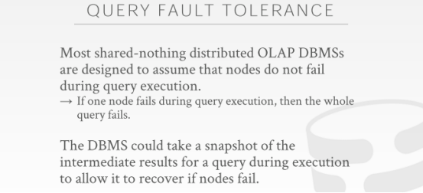

58:32 - 58:40
Most distributed OLAP databases do not support query fault tolerance or query resiliency
大部分分布式（使用shared-nothing架构）OLAP数据库并不支持对查询进行容错，或者query resiliency（弹性）
58:40 - 58:47
where if a query if they know crashes that's a response for executing query halfway through the query execution
即如果在执行查询的途中发生了崩溃，
58:47 - 58:54
they are not able to recover the enemy results of that query it was had or computed
他们无法恢复曾经查询或计算过的查询的中间结果
58:54 - 58:57
and then picked the query up where it left off
然后，也就无法从该查询崩溃的地方开始继续执行
58:57 - 58.57
in general
通常
58.57-58.59
they just killed the whole thing throw an error
它们会干掉整个查询并抛出一个异常
58.59-59.01
or maybe restart it silently for you
或者安静地为你重新执行这个查询
59:02 - 59:04
that has nothing to do with logging and recovery
这与logging和recovery并没有什么关系
59.04-59.06
,we absolutely still need logging and recovery
我们肯定依然需要用到logging和recovery
59:06 - 59:08
and we still do that
我们依然要用到它们
59:09 - 59:14
this is more about while the queries running do I can I take snapshots as I go along
当查询在执行的时候，我是否该制作snapshot
59:14 - 59:18
so that I can pick up midway where the query was running if I know Goes Down
So，这样的话，如果查询崩溃了，那么我就可以从查询崩溃的地方开始执行
59:18 - 59:22
and I'm in the the statement I made was that
我之前有说过一句话
59.22-59.26
,to the best of my knowledge ,most distributed OLAP systems do not support that query resiliency
据我所知，大部分分布式OLAP数据库系统并不支持query resiliency
59:26 - 59:30
because taking the check points the snapshots of the intermediate result is expensive
因为制作这种中间结果的snapshot所要付出的成本非常高
59:37 - 59:39
Logging of what so what logging of what
你要记录什么日志
59:42 - 59:44
the query of the database
记录对该数据库的查询？
59:45 - 59:53
we're still all the fault on all the the D the D in acid stuff that we talked about before, we are still doing that
我们之前谈论过的ACID中的D，这里我们依然会这样做
59:53 - 59:55
we are still making sure that
我们依然会去确保
59.55-59.58
if we ingest data from the outside world up to our database
如果我们从外界提取数据到我们的数据库时
59.58-1.00.00
, we don't want to lose that
我们不想丢失这些东西

