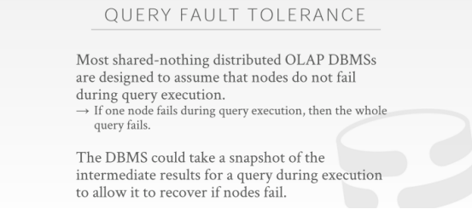

01:00:00 - 01:00:04
and so what they will all provide durability guarantees
so 它们会提供那些持久性保证
01:00:05 - 01:00:07
again I am I have a hundred petabytes of Walmart
我有沃尔玛一百PB的数据
01:00:07 - 01:00:09
they don't want to lose that data
沃尔玛不想丢失这些数据
01:00:09 - 01:00:12
all right and DBMS will guarantee that they won't
all right，DBMS 会保证它们不会丢失数据的
01:00:24 - 01:00:30
when you say operation again what do you mean like the an update to it or we are query, I got like a select query
当你要进行一个操作，比如对它进行一个update更新或者我们进行一个select查询
01:00:37 - 01:00:41
let's take us let's go let's sit down afterward ok ？I'll go through this
请先坐下，我等会儿会讲这个的
01:00:42 - 01:00:43
I think there's something you're missing here
我想关于这块你应该是少考虑了什么
01:00:45 - 01:00:45
okay
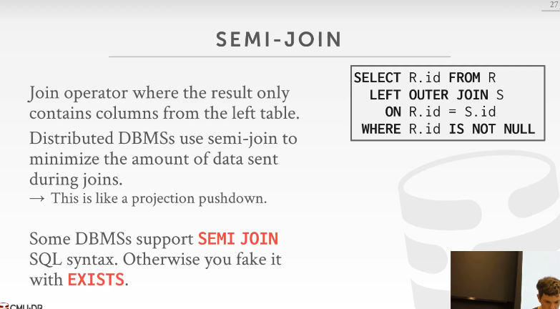

01:00:47 - 01:00:53
so to his question about what am I actually sending, when I do these to semi-joins
他的问题是，当我做这些semi-join时，实际上我会发送什么
01:00:53 - 01:00:58
and I`m sending the whole tuple or I`m sending them sending an identifier
我是要发送一整条tuple呢，还是只发送一个id
01:00:58 - 01:01:06
and I always say the answer is that , you're sending, at the very least you're sending the minimum amount of information that you need in order to compute the join
我一直有强调，你所要发送的数据，取决于你进行join计算要使用的最小信息量
01:01:07 - 01:01:10
and then the worst-case scenario you're sending the entire tuple
那最坏的情况就是你要发送一整条tuple
01:01:10 - 01:01:16
and in general, again the good distributed databases
一般来说，对于一个优秀的分布式数据库系统
01:01:16 - 01:01:19
that are doing analytics will minimize the amount that data that you actually need
它们会使用最少数量的数据来做分析
01:01:21 - 01:01:26
and so they're petite have a query would be called using what is called a semi-join
so，我们为这种查询行为专门起了个名字，叫semi-join
01:01:27 - 01:01:37
a semi-join is like a regular join, but the idea is that ,we're not really gonna do a join on the on the right table or the inner table
semi-join其实也是一个常规得到join，但这里的思路是，我们实际上不会去基于右表（right table）或内表（inner table）去做join操作，而是会以左表（left join）为基础来做
01:01:37 - 01:01:42
we're only gonna check to see whether if we dare to join， a tuple would match
如果我们执行一个join，我们只会检查这个tuple是否匹配这个join条件
01:01:43 - 01:01:46
so the query optimizer can recognize that
so 查询优化器就可以认知到，
01:01:46 - 01:01:54
it may not need any values or attributes are from the columns of the inner table
它可能不需要这个内部表那么多列属性
01:01:55 - 01:01:59
and therefore it can rewrite the query just as do an existence check
因此，它可能会对查询重写，即只作存在性检查
01:01:59 - 01:02:06
and send the middleman information back and forth we knows to do that semi-join rather than copying the entire tuple
然后，将结果给中间人发送回去，由此来看，使用semi-join要比复制整条tuple要靠谱的多
01:02:07 - 01:02:10
again like a natural join you would do the join
对于 natural join来说，你在做这种join操作时，
01:02:10 - 01:02:17
and then the output would be all the result in the combination or the concatenated, tuple on the right and the left table
输出的是左表和右表tuple进行级联结果
01:02:18 - 01:02:23
and a semi-join it's just the attributes that needed to compute to join from the outer table
semi-join 就是只需外表（outer table ）参与计算的属性(知秋注：图中的话就是R表的id)
01:02:24 - 01:02:33
so in this case here say I have a query like this ,select R.id from R , doing outer join on S and we'll just match my ID
就好比这里的这个查询select R.id from R left outer join on S，我们只需要匹配我的id就好
01:02:33 - 01:02:40
and then this is a poorly written query ,because they're basically saying , where R.id is not null, then match up with what on s
这个查询写的不咋地，这个查询基本上在说，R.id不能为null，然后判断R.id=S.id
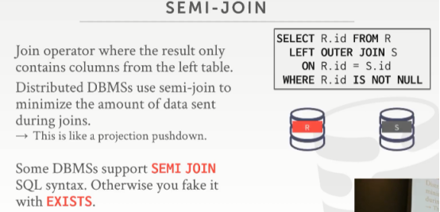

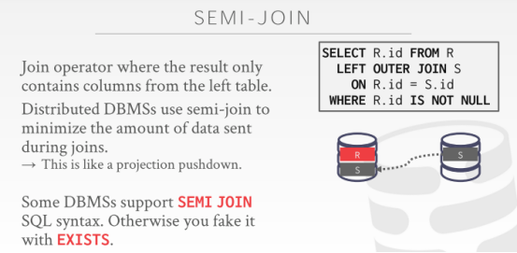

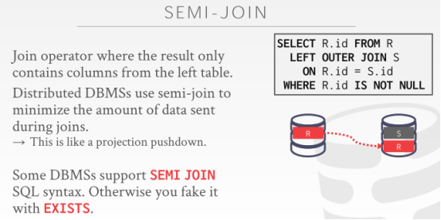
01:02:41 - 01:02:47
so if we didn't do a semi-join, we either have to copy s over here or R over here
如果我们不做semi-join，我们就要将S复制到这里或者将R复制到这里
01:02:48 - 01:02:51
again we're copying the entire tuple that would be expensive
这样去复制整条tuple是很消耗性能的（知秋注：其实更多还是网络性能和占据大量的内存）
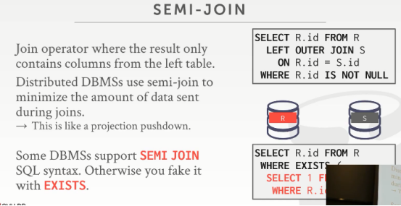

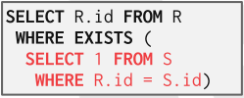

01:02:51 - 01:03:00
but we could rewrite this query to be like this, where we just check to see whether there exists a tuple in S, that has the same id as R.id
我们可以将此查询重写为这样，我们就是去检查下，看看S中是否存在这样的tuple，它的id和R.id相同
01:03:01 - 01:03:05
and then if that's true then we just spit out all our R.ids that match
然后，如果为true，我们就将所有匹配的 R.id输出
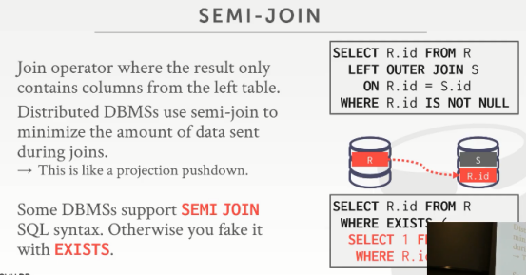

01:03:05 - 01:03:09
so in this case here the only thing I need to send over is just maybe just the R.ids
在此处这个例子中，我们只想输出这个R.id
01:03:09 - 01:03:13
because that's the bare minimum information I need in order to compute this join
这就是我们计算这个join所需的最小信息量
01:03:16 - 01:03:26
so some systems like Claude hours and Paulo actually has an explicit semi-join keyword you can give it
一些数据库实际上会有显式的semi-join关键字供我们使用
01:03:26 - 01:03:28
otherwise, you can try to fake it with it exist
否则，若没有，你可以尝试使用EXISTS
01:03:29 - 01:03:33
the high-end systems can check to try to rewrite your query into a semi-join
高端的系统会去检查并尝试将你的查询重写为semi-join
01:03:33 - 01:03:37
again it's part is figuring out what data I need is transmitted between the different nodes
一部分是要弄清楚我需要在不同节点之间传输哪些数据
01:03:37 - 01:03:45
and includes that in its cost calculations in the optimizers cost model or to decide, how much data might transmit in between different nodes as one plan better than another
包括通过优化器optimizer的成本模型计算来决定在不同节点间可能要传输数据量的大小，一次来确定那个计划方案会更好
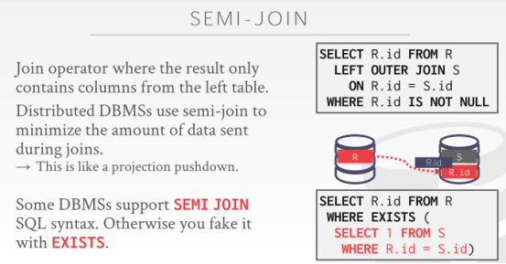

01:03:49 - 01:03:56
so like I could have I could say select R.id from R semi-join on S.id
so 这里，我可以这么写：select R.id from R semi-join on S.id
01:03:57 - 01:04:02
explicit SQL that does that says hey you're doing a semi-join, or I can rewrite it as this
通过这种显式的SQL来表达，我们这里做的是一个semi-join，或者我可以像这样进行重写
01:04:02 - 01:04:06
most systems you have to do this because they don't have I don't think semi-joins in the SQL standard
大多数系统你只能这么做，即使用EXISTS的方式，因为我不认为semi-join是SQL标准
01:04:08 - 01:04:08
Yes
请讲
01:04:11 - 01:04:15
questions who does who does this work and this example here, this is the application programmer
她的问题是这块儿的工作谁在做，拿这个例子来说，这是程序开发者的事情
01:04:17 - 01:04:24
the the high-end enterprise systems that have good query optimizers could figure out how to potentially rewrite this for you
对于高端的企业系统来说，它们有很好的查询优化器，可以很清楚该怎样去重写这个sql语句的
01:04:24 - 01:04:36
They can do that for you
它们可以为你做到这些
01:04:29 - 01:04:32
her quite your question is the query optimizer mind another node ？another like what do you mind another node
她的问题是查询优化器介意在另一个节点，你在意它什么呢？

01:04:42 - 01:04:44
even so this is like a partition that you think
比如，这个节点是一个分区
01:04:46 - 01:04:50
it doesn't matter, doesn't matter what the query optimizer is running this node here or another node, doesn't matter
没必要在意这些，你无须在意查询优化器是放在这个节点还是另一个节点
01:04:50 - 01:04:55
did for more talked about here, this is just sort of like the semantics of the semi-join
不要在意太多，这里只是做了一个semi-join
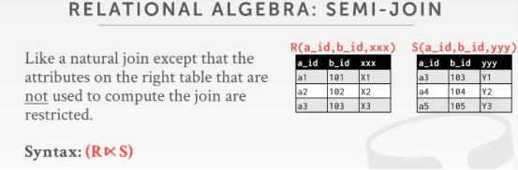

01:04:56 -01:05:01
so from relational algebra standpoint, it just looks like this, I'm joining R and S
so 从关系型代数的角度，这就像是，我在做R join S
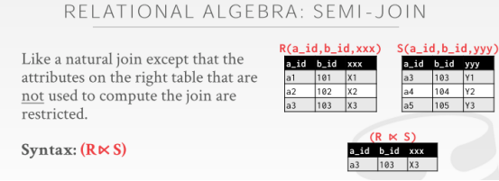

01:05:02 - 01:05:11
and then this is the semi-join operator, the output would be just can to be A_ID B_ID that I used to compute the join
然后，对于semi-join操作来说，我在计算join时，它的输出就可以是a_id、b_id（如ppt所示）
01:05:11 - 01:05:13
and nothing from the inner table
不会从内表中拿任何东西的，所有的结果都从外表去拿（知秋注：外表是R，内表是S，默认是左连接join）
01:05:17 - 01:05:18
so this clear
so 这些清楚了吧
01:05:19 - 01:05:20
there's have a question on it
对于它还有其他问题么
01:05:23 - 01:05:26
All right, so we have ten minutes
All right, so 我们还有十分钟
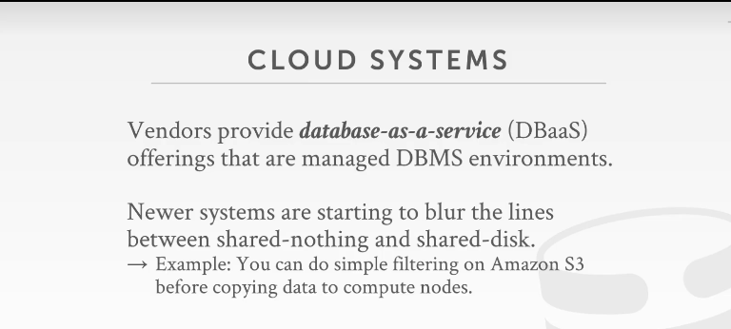

01:05:27 - 01:05:33
so as I said this is to sort of crash course on
so 我讲了这一系列关于故障的解决应对课程
01:05:33 - 01:05:39
the main design decisions in the issues in tuning and available database
在碰到的这些数据库问题中主要的设计需求在于
01:05:39 - 01:05:46
if you're not going to be building a you know an available DBMS ,actually working on the internals of the system, you just want to be a user of them
如果你要构建这么一个可用的dbms，它实际是工作在一堆内部dbms系统之上的，你就是想去使用它们而已
01:05:46- 01:05:49
the main issue you're going to deal with is that partition key
主要问题在于你要去处理这些 partition key
01:05:49 - 01:05:56
how to pick that in such a way that most your joins can operate on a local node without having to do a broadcast or our shuffle
以便你选择一个方式去将你绝大多数的join操作在一个本地节点上执行，无须去做那种广播（broadcast）或对我们的数据进行shuffle
01:05:57 - 01:06:04
and the various systems that are out there, mostly the enterprise guys have tools to help you try to figure these things out for you
绝大部分的企业级系统有工具来帮你弄清楚这些事情
01:06:05 - 01:06:05
okay

01:06:07 - 01:06:09
all right let's talk bout Cloud databases
all right，我们来讨论下 Cloud databases
01:06:09 - 01:06:17
so the definition of comp cloud databases a bit nebulous, no pun intended
cloud databases的定义有点朦胧
01:06:17 - 01:06:18
the the

01:06:19 - 01:06:25
typically what it means is if some vendor offering you what is called a database-as-a-service from DBaaS
通常来说，它的意思是，一些企业给我们提供了一种叫做database-as-a-service（DBaaS）的服务，即将数据库作为一个服务提供给大家
01:06:26 - 01:06:29
the idea is that you give Amazon whoever your credit card
这里的思路是，就像你拿你的信用卡给Amazon交个费，
01:06:29 - 01:06:34
and they will say here's your JDBC or no ODBC connection ,port number and hostname
然后Amazon会给你属于你的JDBC 或 ODBC connection 、端口号和 hostname

01:06:35 - 01:06:37
That you should start shoving queries into it
然后，你就可以在它之上进行你的数据库操作
01:06:37 - 01:06:42
and you don't worry about how to manage the nodes, you don't worry about how to do backups
你根本就不要管该如何去管理这些节点，也无须担心要去做备份啥的
01:06:43 - 01:06:44
they take care of all of that for you
它们都给你做好了
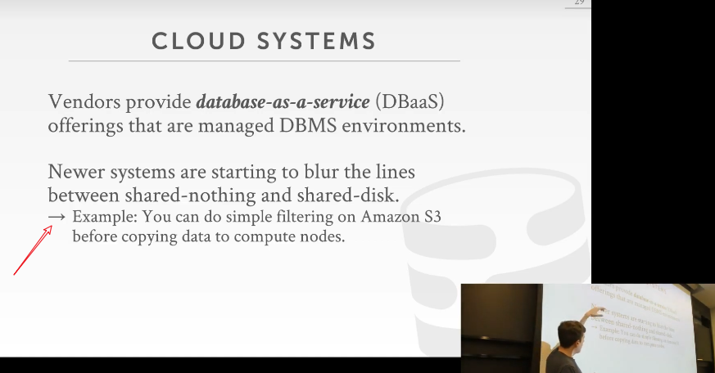

01:06:46 - 01:06:49
and so I already sort of mentioned this before
so 关于下面这点，我已经在前面涉及过了
01:06:49 - 01:06:56
but the in these some major cloud vendors people that control the whole stack, like Amazon, like Google, like Microsoft
在这些主要的云供应商中，比如Amazon、Google、Microsoft
01:06:57 - 01:07:03
the lines between what is a shared disk system versus a share nothing system is starting to get really blurry
关于shared disk system vs share nothing system之间的使用界限已经非常模糊了
01:07:04 - 01:07:10
because they can push down database logic between up and down the different layers of the system stack
因为它们可以在系统的不同层之间上下移动数据库逻辑
01:07:10 - 01:07:14
in a way that you typically can't do unless you control the hardware yourself
这样的话，你通常很难去做一些事情，除非你自己控制着这些硬件
01:07:15 - 01:07:22
so for example Amazon has something called Aurora, Aurora is a shared disk version of MySQL in Postgres
so ，举个例子来讲，Amazon 有个叫Aurora的产品，Aurora是一个shared disk类型的数据库产品，它有MySqL和Postgres两个版本（知秋注：想要对Aurora有更多了解，可以参考MIT 6.824对应的课程部分）
01:07:22 - 01:07:29
but they actually push logic to do transaction management down into the storage layer in the EBS
他们实际上将事务管理逻辑推入到EBS的存储层
01:07:29 - 01:07:31
again at the shared disk level
即是在shared disk 级别来做的
01:07:31 - 01:07:38
and so now it's not pure shared disk system anymore, it starts to look a bit more like a shared-nothing system
so，现在，它不再是纯粹的shared disk system了，它开始有点像shared-nothing system（知秋注：因为在存储层面涉及到了事务处理）
01:07:40 - 01:07:47
so alright so I think in the next ten years, I think the cloud systems will receive the more you see the most innovation in the cloud systems
so，我认为在未来十年，你将会看到云系统中更多特别具有创新性的东西
01:07:47 - 01:07:49
and I think it's really really interesting what they can kind of do
我想这是我们很感兴趣的东西
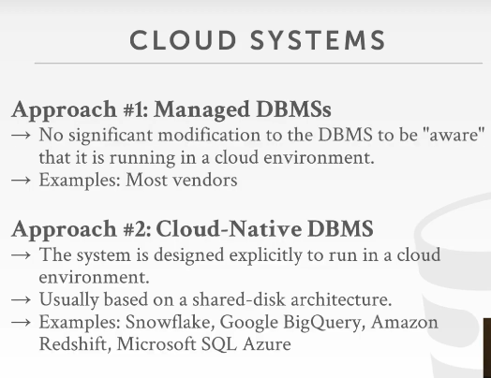

01:07:51 - 01:07:59
alright so I think I've really talked about this in general, a cloud system could either be a managed database or a cloud-native database
alright ，大体来说，一个cloud system可以是托管数据库（managed database）或云本地数据库（cloud-native database即我们常说的云原生数据库）
01:08:00 - 01:08:06
so managed database would be just taking an off-the-shelf database, that system that was written, to run on-premise on dedicated hardware
so所谓managed database就是只是采用现成的数据库在专用硬件上本地运行
01:08:06 - 01:08:10
and now you're just running this for you as a service, take MySQL take Postgres
now，你就是将运行的MySQL 、Postgres 作为一个服务（提供出来）
01:08:11 - 01:08:15
and then you plop it into an EC2 instance ,and then have people connect to it
然后将它放入一个Amazon EC2实例，接着让人们去connect它
01:08:16 - 01:08:21
and they don't know and don't care that you're managing EC2 for them, that they could have done that themselves
人们无须关心去管理这些EC2，Amazon 已经帮他们管了
01:08:22 - 01:08:26
but you're just providing a service to do all the backup and other management stuff for them
你只是提供一项服务来执行一些备份和其他管理工作
01:08:27 - 01:08:32
so most of the times when you see when you get a cloud database, it's gonna be it's gonna be the first one
so，大多数时候，当你拿到一个cloud database，它往往会是ppt中的第一种情况
01:08:32 - 01:08:39
now there are some systems where though they'll refer to themselves as being a cloud-native DBMS
now，在某些系统中，它们会将自己称为cloud-native DBMS
01:08:39 - 01:08:45
and these are ones where they're designed to operate in a cloud environment, and typically they're going to be a shared disk architecture
这些都是为了在云环境中运行而设计的，通常它们用的是shared disk架构
01:08:46 - 01:08:50
because they don't want actually have to build you know replicate EBS or S3
因为他们并不想去构建类似于有可复制能力的EBS 或S3系统
01:08:50 - 01:08:55
so they'll build on top of the existing storage infrastructure that these cloud vendors provide you
它们会基于这些云供应商为我们提供的现有存储基础架构来构建云系统
01:08:55 - 01:08:58
and they're providing the compute layer on top of it
它们在这些存储基础架构之上提供一个计算层
01:08:58 - 01:09:02
you know Stefan do query planning, you still have to do all the fault-tolerant stuff we talked about before
比如在这一层做查询计划工作，你也可以做我们之前讨论过的容错（fault-tolerant）等
01:09:02 - 01:09:05
but they don't worry about actually how to you know persist things to disk
但你无须担心它们实际上是如何将数据持久化到磁盘的
01:09:05 - 01:09:08
they just let cloud vendor provide that for you
持久化这个东西，云服务上会提供给你的
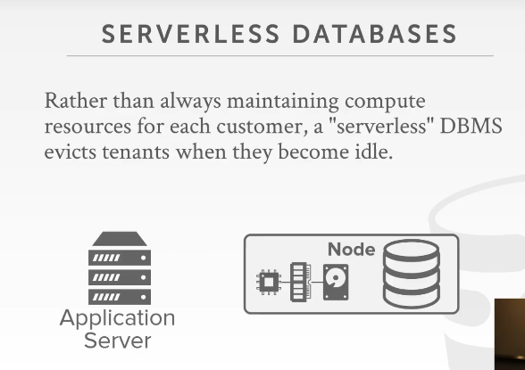

01:09:11 - 01:09:15
so there is now also a new class of systems that label themselves as being serverless, yes
现在还有一类新的系统，我们称之为 serverless，请讲

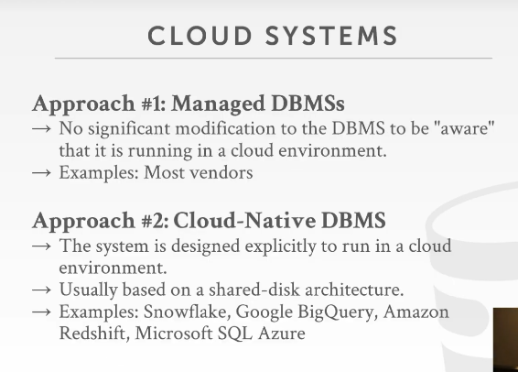

01:09:25 - 01:09:29
yeah question is what would it like what is it what is truly the difference here
她的问题是这两块的区别在哪里
01:09:29 - 01:09:33
so this would be a manager this would be just using MySQL example
so 对于第一种方案来说，这里可以这么说，它托管了一个MysqL实例
01:09:34 - 01:09:40
I take MySQL, I didn't run it, without making any changes to it ,I run it in a container or I run it in a VM
我得到了MySQL服务，不需要对它进行任何的改变，它运行在一个容器中
01:09:41 - 01:09:44
and it's the same software that I would run on my local machine
它和我们在本地机器运行的软件一样
01:09:45 - 01:09:47
but just now I'm running it in a cloud for you
只不过这里它运行在了云上而已
01:09:48 - 01:09:56
right and then old and then the , the service provider will then also do the backups and recovery and all the other stuff for you
然后，作为服务提供商，它背地里还为我们提供了备机（backups）、恢复（recovery）还有其他一些东西
01:09:56 - 01:10:00
this would be like I'm building a new database system scratch, or I take an existing one
这就像是我是要从头开始构建新的数据库系统，还是我会采用一个已存在的数据库系统
01:10:00 - 01:10:05
and I make heavy changes to it to be designed to work in a cloud environment
我对其进行了重大更改，以使其可以在云环境中工作
01:10:06 - 01:10:08
so up here running MySQL
so，就好比这里我运行了一个MySqL
01:10:08 - 01:10:12
MySQL doesn't know anything S3, doesn't know anything about the performance implications of
MySqL对S3一无所知，它不清楚任何关于S3性能上的东西
01:10:12 - 01:10:15
you know reading EBS and things like that just have a disk it has these properties
你在读EBS的时候，所做的事情就像是在读一个给我们提供了这些潜在功能的磁盘
01:10:15 - 01:10:19
this would be like oh I've designed the system's explicity to work on S3
我们会在S3上来设计这个系统进行工作
01:10:19 - 01:10:21
S3 provides me these guarantees provide me these properties
S3 给我们提供了这些功能性的保证
01:10:21 - 01:10:24
that information now permeates all throughout the system
这些信息会在整个系统中可见
01:10:24 - 01:10:31
my query optimizers cost model can reason about,you know what's the speed of writing S3, or what you know what can you do a S3, you can't do on EBS ,stuff like that
我的查询优化器成本模型可以推断出，你写入S3的速度是怎样的，你可以在S3上做什么，不能再EBS上做什么，等诸如此类的事情
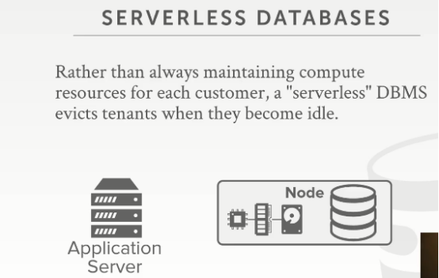

01:10:35 - 01:10:38
alright so there's a the buzzword going around now is serverless
alright ，so，这里有一个当下极为流行的词汇，即serverless
01:10:39 - 01:10:40
so of course serverless databases
即这里的serverless databases
01:10:41 - 01:10:45
and so it's the same everything's the same that we talked about before
so 它和我们之前谈到的都是一样的
01:10:45 - 01:10:51
it's just that the idea is that when your machine goes idle, your database connection those idle
这里的思路是，当我们的机器清闲了，你的database connection处于闲置状态
01:10:51 - 01:10:53
because your application is no longer sending queries
因为你的应用程序不再发送查询请求
01:10:54 - 01:11:00
they will try to then deeper vision or have you not pay for hardware that you're not actually using
服务商会尝试更进一步的做法，即当你实际上并未使用数据库服务的时候，你并不需要为硬件来支付开支的
01:11:01 - 01:11:06
so let's say that I have again a managed database system, I have a single node, it's running MySQL
so 假设我有一个托管数据库系统（managed database system），我有一个节点，它正在运行MySQL
01:11:06 - 01:11:10
and so I pay for the instance I pay for the storage
so 我要为数据库实例以及底层存储支付金钱
01:11:11 - 01:11:13
and I have to provision it to be running all the time
我得一直运行着它
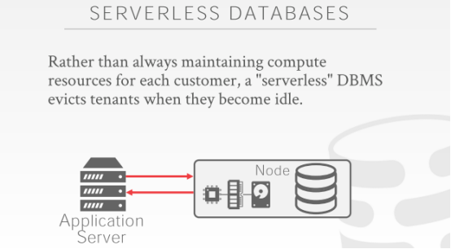

01:11:13 - 01:11:17
so my application sends queries to this guy, and you know and gets results comes back
so ，我的应用程序会发送查询请求到这里，然后得到返回的结果
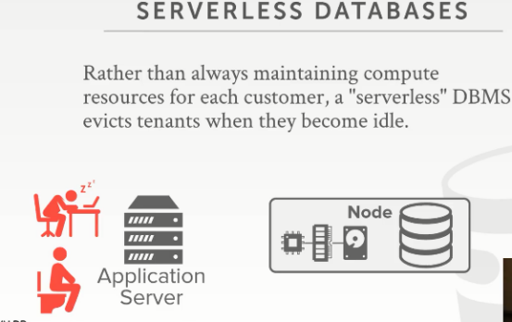

01:11:17 - 01:11:22
but now if my application goes to sleep ,or walks away, goes the bathroom, does whatever
如果我的应用程序清闲了，比如它是个人的话，那就是睡觉了，出去溜达了，去厕所了，等等
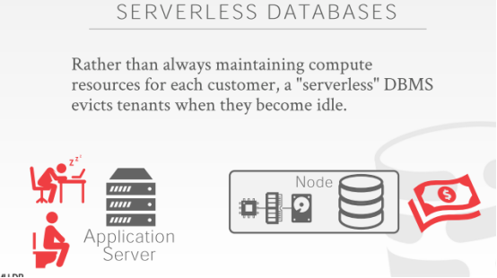

01:11:23 - 01:11:28
then I'm paying for these resources I'm not actually using
实际上，此时，我并没有使用节点处的资源，但我还得为它掏钱
01:11:28 - 01:11:32
right because I have to provision the hard right that provision the EC2 instance, I provisioned the EBS storage
因为我必须配置EC2实例，所以配置了EBS存储
01:11:32 - 01:11:36
right so I'm paying for the stuff to run and not actually do anything

so，哪怕我实际上并没有做任何工作，我也得支付相关费用

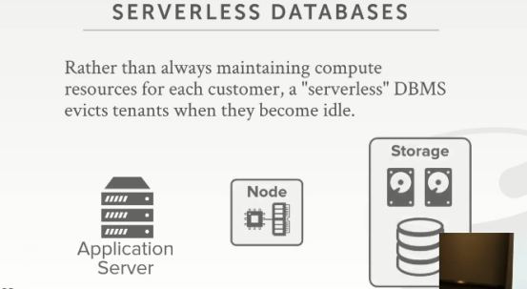

01:11:37 - 01:11:42
so the idea with the serverless database is it's almost always a shared disk architecture
serverless database的思路是，它几乎总是 shared disk 体系结构
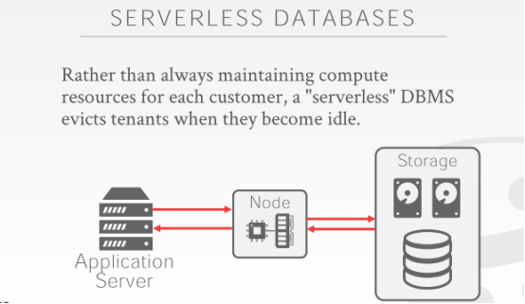

01:11:44 - 01:11:47
is that I can do all my queries that I had before
我可以和我之前一样，去做我的查询工作

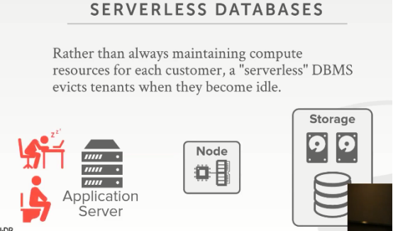

01:11:47 - 01:11:52
but now when I go to sleep, I decommission the compute side of things
但现在，当我要去睡觉的时候，我停下我计算的脚步
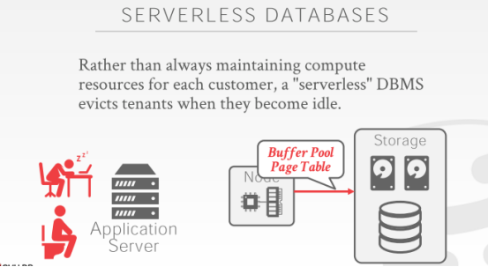

01:11:52 - 01:11:57
this goes away but before I do I basically take a snapshot of what pages are my buffer pool
在走之前，基本上我会制作一个我自己buffer pool的一个快照
01:11:58 - 01:12:03
I take a checkpoint then record all the page IDs or what's in my buffer pool , write that out the shared disk
通过这个checkpoint，来记录我buffer pool中所有的pageId，将这些写出到shared disk
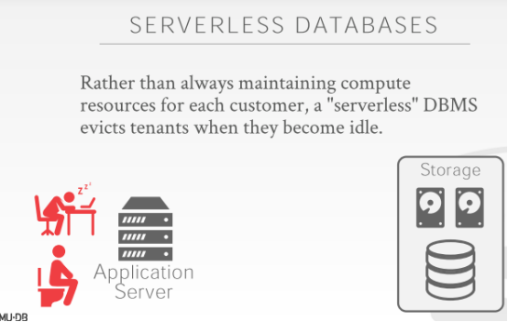

01:12:03 - 01:12:05
then kill off my computer
然后关闭我的电脑

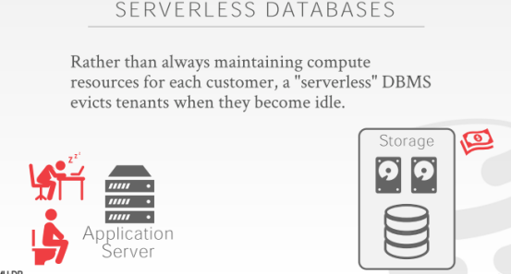

01:12:06 - 01:12:11
and so now the only thing I'm paying for is storage, just paying for my database rest at idle on disk

so，现在，我要支付的只是存储我自己数据的那一部分（知秋注：Node实例就不需要花钱了）

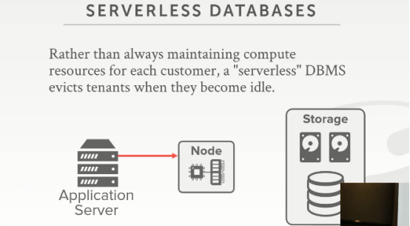

01:12:12 - 01:12:17
and then if I ever wake up and come back and execute a query ,the very first thing we're gonna do is say
然后，当我醒来回到工作岗位，要执行查询的时候，要做的第一件事是，
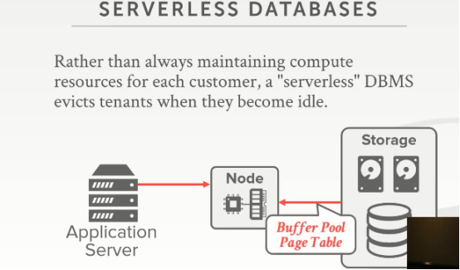

01:12:17 - 01:12:20
alright well before I shut down the last time, what was in my buffer pool
我上次关闭的时候，我buffer pool的那些东西呢
01:12:20 - 01:12:24
and got it trying to fetch that in and make it as if I was still running all the time
然后将这些东西从存储位置处拿到，并放入node，并让我可以继续进行工作
01:12:28 - 01:12:33
so this is one way to do it if you assume that there's only one customer I'm running on a single node
so 这里，我们假设的是当下这个单节点上只有一个Customer运行
01:12:33 - 01:12:38
another common setup would be you run multiple customers or multiple tenants on a single node
另一个常见的设置是你在单个节点上运行多个customers
01:12:38 - 01:12:41
and then you just recognize that this customer has not sent me to query in a while
然后，你就会意识到，在一段时间内，这个customer并没有发送给我查询请求
01:12:41 - 01:12:45
and then I write out its buffer buffer pool page contents out the disk before
然后，我就将它的buffer pool page内容写出到磁盘
01:12:46 - 01:12:46
yes
请讲
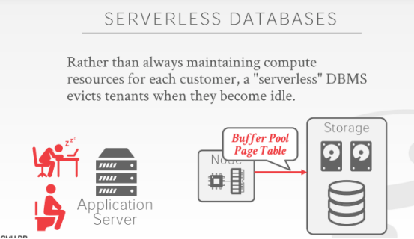

01:12:55 - 01:12.56
so this question is
So，他的问题是
1.12.56-1.12.59
why am I doing this section step
为什么我要做这一步
1.12.59-1.13.05
,why am I actually writing the buffer pool page contents out to disk ,before you know why do I care about this
为什么我要将这些buffer pool page内容写出到磁盘，为什么我会如此关心这个东西，
01:13:06 - 01:13:11
because you want to make it as if like the the most expensive thing is fetching things from disk
因为你知道，成本最高的事情就是从磁盘中获取数据
01:13:12 - 01:13:12
so ideally
So，这里的想法是

I want to have you know my query the next query shows up a minute later
我想在一分钟中去执行下一条查询
01:13:17 - 01:13:20
I don't want to have everything all now evicted from my buffer pool
我不想现在从缓冲池中逐出所有内容
01:13:20 - 01:13:25
and I have to pay this big upfront cost of warming all my data I'm bringing into memory
这样我需要付出很大的代价来warm （预加载）我们的数据，即将它们放入内存中
01:13:26 - 01:13:30
so you record all this information so that when you come back again a minute later
so，你记录了所有这些信息，当你在一分钟后回来时，
01:13:31 - 01:13:35
it looks like the thing was still running, and you don't like you still paid a penalty case you have to fetch it in
它看起来就像是依然在运行状态中，你不想要那种你还得要从磁盘中获取数据这种消耗性的惩罚
01:13:35 - 01:13:37
but you don't have to wait to fetch everything in
你不必等待去获取所有内容
01:13:38 - 01:13:39
you try to maybe prefetch some stuff
你会尝试预获取一些东西
01:13:40 - 01:13:42
you pre-warming with creamer in the cache yeah
你可以在缓存中进行预热
01:13:43 - 01:13:47
every database system does this when you call shut down do it like a crash shut down they're already doing this
每个数据库系统在调用shutdown时都会这样做，崩溃时也一样

01:13:58 - 01:14:04
correct so his question is, if I don't do this step well this still work
对的，so 他的问题是，如果我不去做这一步，它依然可以工作
01:14:04 - 01:14:10
yeah it'll be correct it'll be slow, right, this is just an optimization to can warm the cache
yeah，没问题，它会比较慢， right,这就是一个优化，即预热缓存
01:14:21 - 01:14:28
in a cigarette-like we're just storing the page ID, we had in the buffer pool at the moment did a shutdown
在我们执行shutdown的时候，我们要存储我们在buffer pool中对应的pageId（知秋注：因为你这个应用都停了，你就是要落地你在buffer pool中对应的数据）
01:14:29 - 01:14:34
so then the first query shows up, and then say the first query says go give me page 1、2、3
so 第一个查询说，给我Page123
01:14:34 - 01:14:39
it says oh I also had 456789 also in there let me go fetch them and fetch the Nolan
它会说，我也会将4、5、6、7、8、9拿过来（知秋注：也就是预热缓存的操作）
01:14:41 - 01:14:41
Yes

01:14:44 - 01:14:48
this question her question is how does it like to be stateless as in the serverless
她的问题是，在serverless中，该如何才能做到无状态（stateless ）
01:14:48 - 01:14:51
it's usually what people mean my service is stateless
通常，人们口中所说的他的服务是无状态的
01:14:52 - 01:14:54
But it isn't right
但，它并不是
01:14:55 - 01:14:59
so if serverless from the perspective of the end-user
so, 如果从终端用户（end-user）的角度来看serverless
01:15:00 - 01:15:06
meaning like I don't have to say provision me this machine, so a lot of cloud vendors, they're not doing a serverless architecture
这就好像是在说，没有必要给我提供这么一台某种意义上单独的主器，so，对于很多云服务厂商来说，他们没有做serverless 架构
01:15:06 - 01:15:12
you basically say, you know I want to pay for this dedicated resources to be available for me at all time
你基本就是在说，我想为此专用资源付费，以便随时可以使用
01:15:13 - 01:15:15
if you're not using them they're so charging you they're happy
如果你没有使用这些资源，而他们依然收着你的钱，他们当然很高兴
01:15:16 - 01:15:16
right

01:15:17 - 01:15:23
but if I mean I have one query a minute ,I don't want to me you know, I don't want to provision a whole machine just to send X 60 queries an hour
但，如果我一分钟才发一个查询请求，我不想去专门搞一台主机，就为了一小时那60个查询？
01:15:23 - 01:15:27
whereas in this architecture I can still have my database still as if it was running all the time
而在这种serverless 架构中，我仍然可以保持数据库一直运行
01:15:28 - 01:15:33
but I'm not paying that pending, so I pay or not I paid on a per-query basis plus whatever I'm storing over here
但我无须去花那么多钱，我只需要为我每次查询花费一次即可，还有就是为存储数据花费一些
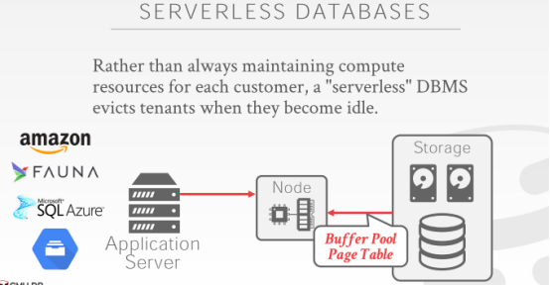

01:15:37- 01:15:43
so the main vendors that are in this space would be Amazon has a serverless version of MySQL
so 关于这个领域，主要的供应商有Amazon提供的一种MysqL版本的serverless 产品
01:15:43 - 01:15:47
and then faunaDB is a as a separate database startup that does
FaunaDB是另一个数据库初创企业所做的数据库系统
01:15:48 - 01:15:53
so Amazon will try to all these guys are doing not exactly this where you kill the machine
这些系统并不会真的将主机停下来
01:15:53 - 01:15:58
they're just recognizing this customer has not sent a query while and then they write everything out to disk
它们只是会认知到，这个customer在一段时间内不会再发送查询请求，然后，它们就将关于该Customer的一切东西写出到磁盘中
01:15:59 - 01:16:02
so Azure can do this and then Google
So，Azure和Google都能做到这点
1.16.02-1.16.05
, I think it's these icons are so useless
我觉得这些图标真的很没用
01:16:05 - 01:16:06
because this like doesn't say the name
因为它并没有说出它表示的名字是什么
1.16.06-1.16.07
, I know and I second what this says
我想了一会儿才知道，它是什么意思
01:16:07 - 01:16:09
I think it's the Google fire store
我觉得它是Google的Firestore
01:16:09 - 01:16:10
so not spanner
So，它并不是Spanner
1.16.10-1.16.12
or not the big query stuff
它也不是bigquery
1.16.12-1.16.13
it's only for fire store
它代表的只是firestore
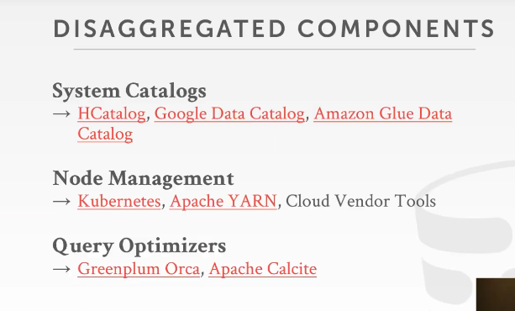

01:16:15 - 01:16:15
all right

1.16.15-1.16.18
so another interesting thing about this is that
So，对此，另一件我们感兴趣的事情是
01:16:18 - 01:16:23
you could potentially build a database system without having to write every piece of the system yourself
你可以在不需要手写系统中每个组件的情况下，就能构建一个数据库系统
01:16:25 - 01:16:30
so there's enough open-source software that's out there now or services
So，这里有一堆相关方面的开源软件或者服务
01:16:30 - 01:16:33
that are out there you can cobble bunch of these things together
你可以将这些东西都放在一起
01:16:33 - 01:16:37
and make a new cloud database without having to write everything from scratch
在不需要从头开始写起的情况下，就能做出一个新的云数据库
01:16:38 - 01:16:39
so we've already talked about
So，我们之前已经讨论过这个
1.16.39-.16.40
like as I said
正如我说的
1.16.40-1.16.42
her question was what is the cloud-native database
她的问题是什么是云原生数据库
01:16:42 - 01:16:46
well it's one where you assume that you can write you know you the sulfur is written to assume you're writing to S3
假设你要基于S3去写一个数据库
01:16:46 - 01:16:50
and you take those it's guarantees or performance implications into the design
你可以使用这些来做一些约束保证或性能融入到你的设计中
01:16:51 - 01:16:54
so that would be sort of one example,
So，这就是其中一个例子

you're not the write that you know disk manager
你不需要去写磁盘管理器
01:16:55 - 01:16:56
you just let S3 handle that for you
你只需要让S3去为你处理即可
01:16:57 - 01:16:59
you may not have to write your catalogs ,right
你可能不需要编写你的catalog
01:16:59 - 01:17:04
you get metadata as a service through these bunch of different types of software
你可以将这些不同类型的软件拿出一个来作为服务，就可以得到metadata
01:17:05 - 01:17:06
you may not the manage your cluster
你可以不用去管理你的集群
1.17.06-1.17.12
you can relies on Kubernetes, or yarn ,or these other tools that the vendors have to handle all that for you
你可以依靠Kubernetes、Apache YARN或厂商提供的工具来为你管理这些
01:17:12 - 01:17:15
and then you may not even have to build your own query optimizer
你可能也不需要去构建你自己的查询优化器
01:17:15 - 01:17:21
so there actually are some open source sort of optimizers as a service
So，实际上这里有一些开源的查询优化器
1.17.21-1.17.24
,where its runs on a separate node
你可以在单独的节点上运行它
01:17:24 - 01:17:28
you just feed it a bunch of XML or JSON metadata to say , here's what my data looks like here's my query plan looks like
你可以往它里面传入一堆XML或者JSON元数据，以此来表示这是我的数据和查询计划
01:17:29 - 01:17:35
and then the separate machine will then crunch on it and spit out a potentially optimized plan for you
这个单独的机器会对它处理，并为你制定出一个优化过的计划
01:17:35 - 01:17:37
I don't know how good these things are actually are
我不清楚这些东西好不好
1.17.37-1.17.41
, I'm there has been any study actually to evaluate them yet
目前它们并没有什么相关的评估报告
01:17:41 - 01:17:44
we looked at Orca when we were building our system and we passed on it
当我们在构建我们的系统时，我们看了下Orca，我们并没有使用它
01:17:44 - 01:17:47
because at the time the documentation was terrible
因为在那个时候，它的文档很糟糕
01:17:47 - 01:17:49
Calcite written in Java
Calcite是用Java来写的
1.17.49-1.17.50
,so that was a non-starter for us as well
对我们来说也没啥大用
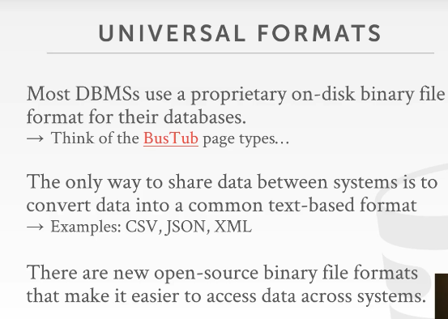

01:17:51 - 01:17:52
all right
1.17.52-1.17.57
,the last thing I briefly talked about is file formats
最后我要简要讨论的东西就是文件格式
01:17:58 - 01:18:01
so pretty much until very recently
So，一直到最近
1.18.01-1.18.06
every single DBMS always had their own proprietary binary file format
每个DBMS始终都有它们自己专有的二进制文件格式
01:18:06 - 01:18:07
meaning like
这意味着
1.18.07-1.18.09
MySQL writes a bunch of files a disk
MySQL会将一堆文件写入到磁盘
01:18:09 - 01:18:11
you can't read those files into Oracle
你无法在Oracle中读取这些文件
1.18.11-1.18.13
,well because Oracle has its own file format
因为Oracle有它自己的文件格式
01:18:13 - 01:18:16
can you do the same thing when you built put your projects on BusTub
当你们使用Bustub来构建你们自己的DBMS时，你们也可以做相同的事情
01:18:16 - 01:18:18
BusTub has its own page formats
Bustub有它自己的page格式
1.18.18-1.18.20
,that can't be read by anybody else
它无法被其他DBMS所读取
01:18:21 - 01:18:22
so this is problematic now,
So，现在这就很成问题了
1.18.22-1.18.24
if you're in a cloud environment
如果你在一个云环境下
1.18.24-1.18.25
where you have a bunch of different services
你有一堆不同的服务
01:18:26 - 01:18:27
that may want to share data
它们想要共享数据
1.18.27-1.18.30
, like a bunch of data I want to generate my OLTP databases
比如：我的OLTP数据库生成了一堆数据
01:18:31 - 01:18:33
and maybe I want to run that data through spark
可能我想将这些数据放入Spark中处理
1.18.33-1.18.36
or learn that data through through Vertica or some other distributed database
或者我想将这些数据放入Vertica或者其他分布式数据库中
01:18:36 - 01:18:37
so there right now
So，此时
1.18.37-1.18.40
if everything's based on a proprietary binary format
如果所有数据都是以一种专有的二进制格式保存的话
01:18:40 - 01:18:43
the only way you can get data out from one system and put into another system
你将这些数据从一个系统放入另一个系统的唯一方法是
01:18:43 - 01:18:48
It`s to make copies and put it into one of these human readable text readable formats
复制这些数据，并将这些数据转化为我们能看得懂的可读文件格式
01:18:48 - 01:18:52
and so now instead is that there's these open source binary formats
相反，这里有一些开源二进制格式
1.18.52-1.19.00
, that a bunch of cloud vendors ,or and distributed databases ,or data science ecosystem tools are now supporting to that
现在有一堆云厂商、分布式数据库或者数据科学生态工具支持这些格式
01:18:58 - 01:19:04
I could use write out to S3 or EBS or my distributed file system
我可以将这些格式的数据写入到S3或EBS或我的分布式文件系统中
01:19:04 - 01:19:07
a bunch of these files in this format,that might get my DBMS generated
我的DBMS可以生成一系列这种格式的文件
01:19:07 - 01:19:12
and then I could suck them in and read them into another database without having to do that any deserialization or conversion
在不需要做任何解密或转换的情况下，我可以将这些数据塞入另一个数据库，并在该数据库中读取这些数据
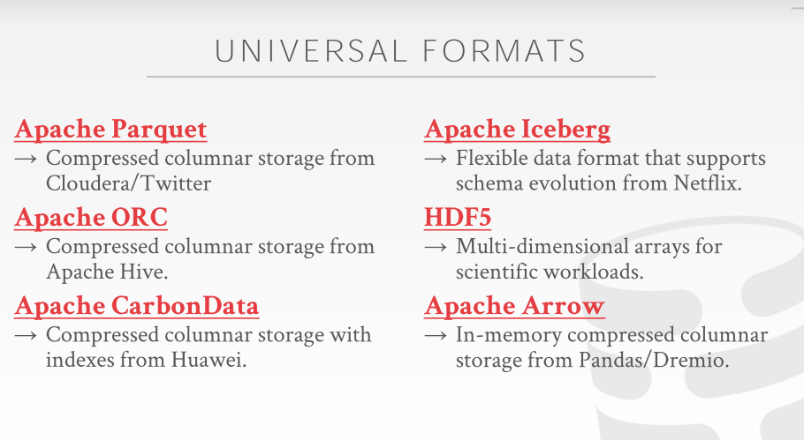

01:19:14 - 01:19:17
so some of these you may have heard of
So，你们可能之前听过其中一些
1.19.17-1.19.19
,but these are just these are sort of a main ones
但这些都是属于比较主流的那一类
01:19:19 - 01:19:21
Parquet and ORC two most common ones
Parquet和ORC是其中最常见的两个
1.19.21-1.19.26
Parquet Cloudera and twitter and ORC came out of hive
Twitter和Cloudera使用的是Parquet，ORC则是根据Hive所修改出来的
01:19:26 - 01:19:29
and again think of these are like binary column store formats
这些都是二进制列式存储格式
1.19.29-1.19.32
, that are not tied to any one specific database system
这些不与任何特定的数据库系统挂钩
01:19:32 - 01:19:33
like an open specification
这就像是一种开放标准
1.19.33-1.19.35
that anybody can modify their database system
任何人都可以修改他们的数据库系统.
1.19.35-1.19.38
modify their application to read this data natively
修改他们的应用程序让它们做到原生读取这些数据
01:19:39 - 01:19:43
CarbonData is a newer one actually 2016 I think
我记得CarbonData是一个比较新的格式，它实际是在2016年推出的
01:19:43 - 01:19:47
that's like ORC and the parquet that came out of Huawei in China
它和ORC以及Parquet类似，它是由中国的华为推出的
01:19:48 - 01:19:52
Iceberg is another new one from Netflix
Iceberg则是由Netflix所推出的一种新型存储格式
1.19.52-1.19.54
that I've just notified recently by somebody
这也是最近才有人告诉我的
01:19:55 - 01:19.56
I have looked into much into yet
我还没有怎么看这个东西
1.19.56-1.19.57
but they claim that
但他们声称
1.19.57-1.20.00
they can support schema evolution
他们支持schema evolution（schema 进阶版）
1.20.00-1.20.00
like I can do change columns
就比如我可以对列进行修改

