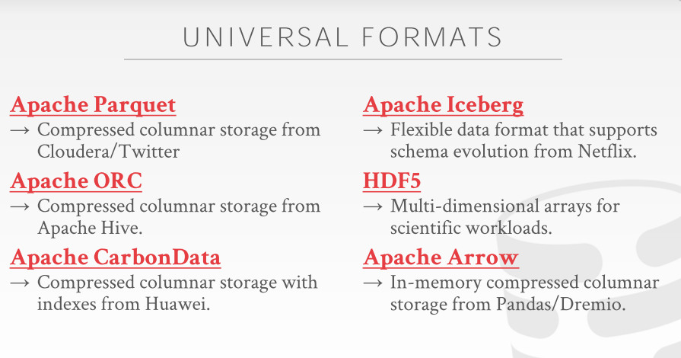

01:20:01 - 01:20:04
and you know change names ,change column types, the way these other guys can
比如修改名称，修改列类型之类的事情
01:20:05 - 01:20:06
these other guys are read-only
其他这些都是只读的
1.20.06-1.20.06
like I create the file
比如：我创建了文件
1.20.06-1.20.07
, and then I freeze it
接着，我就将这个文件冻结
1.20.07-1.20.09
and I can't go back and change them
然后，我就没法回过头去修改它了
01:20:09 - 01:20:17
HDF5 is not typically used in cloud systems or in sort of traditional Silicon Valley database for tech companies
在cloud system或者传统的硅谷那些数据库科技公司通常不会去使用HDF5
01:20:17 - 01:20:20
this is mostly found in HPC in the scientific world
这种格式最常见于高性能计算领域和科学领域
01:20:21 - 01:20:28
this is for like a Readata like you can have your particle collider can well spit out bunch of these files in this type
通过它，你可以通过这个类型来管理大量的文件（知秋注：有点类似于文件管理系统）
01:20:28 - 01:20:31
and then Arrow is an in-memory column format
Arrow是一种内存型列式格式
1.20.31-1.20.33
that came out of Pandas/Dremio
它是由Pandas/Dremio所推出的
01:20:34 - 01:20:38
that think of this is like it's like parquet ORC, but it's for in-memory data
你们可以将它想象成Parquet和ORC之类的东西，但它是内存型数据
01:20:38 - 01:20:41
so our database system is building here at Carnegie Mellon
So，我们的数据库系统是在CMU构建的
1.20.41-1.20.44
, our native stored format is actually arrow
实际上，我们的原生存储格式使用的就是Arrow
01:20:44 - 01:20:52
so you could take data that our DBMS generates , dump it out and feed it into pandas or whatever it's I can't learn you want , anything that reads the arrow format
So，你可以将我们DBMS所生成的数据转储出去，并放入Pandas之类的东西中进行处理，或者任何能读取这张Arrow格式的数据的工具（知秋注：pandas 是基于NumPy 的一种工具，该工具是为解决数据分析任务而创建的）

01:20:53 - 01:20:55
so I think this is the right way to go
So，我觉得这是正确的做法
01:20:55 - 01:20:57
it is sort of you get to the lowest common denominator
我觉得这就像你拿到了最小公分母一样
01:20:57 - 01:21:005
like there's you know the compression scheme and all these these different these formats may not be the best for all possible applications
对于所有应用程序来说，这些压缩方案和不同格式可能并不是最好的
01:21:02 - 01:21:06
and certainly if you write a custom one
当然，如果你自己写了一个
01:21:07 - 01:21:09
you could probably get much better compression or better performance
你可能会得到更好的压缩比或更好的性能
01:21:10 - 01:21:13
but this this provides you interoperability, okay
但这个会给你提供数据库间的互操作性，okay
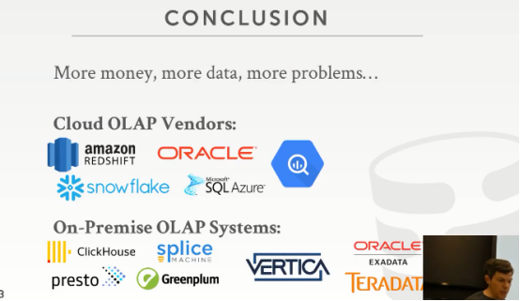

01:21:14 - 01:21:17
all right so just a finish up, OLAP
so，我们来对OLAP做个收尾
01:21:18 - 01:21:25
it means if you if you need analytical database , that needs to scale, then you have money, because you're getting data,right
如果你需要一个分析型数据库，需要去scale，那你就需要money，因为你要更多的数据，
01:21:25 - 01:21:29
people actually using whatever application you have , and you're actually able to process it
人们实际上正在使用你提供的任何应用程序（浏览器端、手机端等），并且实际上能够处理人们发来的请求
01:21:29 - 01:21:31
but the more data you get and more problems you're gonna have
但，随着数据积累越来越多，随意而来的就是越来越多的问题
01:21:31 - 01:21:39
because these distributed databases you know all the additional management concerns and problems, that you have with the distributed system you do have to account for
因为对于分布式数据库来说，有太多管理上的问题需要你去考虑

01:21:40 - 01:21:48
all right, so here's question last time can I names what are some interesting or now these weren't good
all right, 这里有个问题，我之前说了这些命名不是很好
01:21:48 - 01:21:52
but what are the main OLAP systems you could possibly look at
但，你能看到的主要的OLAP system就这些
01:21:52 - 01:21:57
well in the cloud REDSHIFT and snowflake are the key to two players
Amazon的REDSHIFT 和snowflake是关键的两个玩家
01:21:57 - 01:22:01
Oracle and Microsoft and Google also have their own Pacific services
Oracle 、Microsoft 和Google 也有它们自己的产品服务
01:22:01 - 01:22:04
I think these two are the probably the biggest ones
我认为这两个是最大的存在
01:22:04 - 01:22:08
so this is run if you're running on a cloud， if you want to run on-premise
so，这是在云上运行的这些数据库（知秋注：可以看作是公有云），如果你想要运行的是on-premise（知秋注：可以看作是私有云）
01:22:09 - 01:22:12
the one that I'm actually super interested in is ClickHouse
我实际上最感兴趣的是ClickHouse
01:22:13 - 01:22:17
so distributed in-memory column-store system out of Russia from the Yandex guys
ClickHouse是俄罗斯第一大搜索引擎Yandex开发的内存型列式储存数据库.
01:22:18 - 01:22:23
and when you read their web page the list of the things that they support, it's actually amazing and it's open-source to
当你去它们的web网页去看它们的支持列表时，你会感觉到不可思议，而且它是开源的！！
01:22:25 - 01:22:30
presto is runs on top of I think SPARK and Hadoop
presto ，我想，它是运行在SPARK 和 Hadoop 之上的
01:22:30 - 01:22:37
splice machine is HBase plus SPARK, Greenplum is the fourth version of Postgres that somebody made distributed
splice machine是HBase + SPARK,Greenplum 是Postgres 的一个分布式版本
01:22:37 - 01:22:41
it was a startup back in the 2000s they got bought by EMC
它开始于2000年，它被EMC买了
01:22:41 - 01:22:46
the EMC says we don't wanna be a databases company ,so then they merged with VMware became pivotal
EMC说他们不想成为一个数据库公司，然后它们合并到VMware，变成了pivotal
01:22:46 - 01:22:47
but in May open-sourced it
它是开源的
01:22:47 - 01:22:53
Vertica was founded by my advisors back in New England
Vertica 是由数据库研究人员Michael Stonebraker和Andrew Palmer于2005年创立，其中一个有作为我们的客座演讲者
01:22:53 - 01:22:59
they got bought by HP the guy came gave a talk a few weeks ago or the semester
它被惠普收购了，这家伙前几周有给我们做过分享
01:22:59 - 01:23:03
so the way to think about this is like if you have no money start here
你可以这么去思考，如果你没钱，你就从这里开始
01:23:04 - 01:23:05
if you have the money
如果你有钱
01:23:06 - 01:23:09
you could start over here like , Oracle EXADATA and Teradata are super super expensive
你可以从这里开始，Oracle EXADATA 和Teradata 是真的贵！
01:23:10 - 01:23:14
like EXADATA I don't think you can buy a machine for less than like you know two million dollars
拿EXADATA 来说，我不认为你可以花不到200万美元买到一台机器
01:23:14 - 01:23:15
because you're buying custom hardware
因为你买的是定制化硬件
01:23:17 - 01:23:17
okay

01:23:20 - 01:23:24
alright if you don't want to go down this route its setting up a whole distribute database
如果你不想通过这条路去建立一个完整的分布式系统
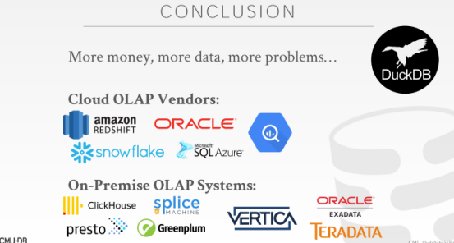

01:23:25 - 01:23:28
there's a newer system and I was all very excited about called DuckDB
有一个更新的系统，我可以很兴奋告诉大家，它叫DuckDB
01:23:29 - 01:23:35
it's out of Europe, think of this DuckDB as like SQLite for analytics
DuckDB 可以认为是用于SQLite 的分析
01:23:35 - 01:23:39
so you can run it as an embedded database , it actually you can connect to it through the SQLite terminal
so，你可以将其作为嵌入式数据库运行，实际上你可以通过SQLite终端连接到它
01:23:40 - 01:23:45
but it's a column store and can do you can do analytics on in the same kind of way you can do here
但它是列式存储，你可以采用与此处相同的方式进行分析
01:23:45 - 01:23:49
so if your data can fit on a single node, DuckDB might be the right thing
so，如果你的数据可以放在单个节点上，DuckDB 可能是一个不错的选择
01:23:49 - 01:23:52
And it's open source ,okay
它是开源的


01:23:53 - 01:23:57
All right ,so that's it ,for the the main material and the semester
All right ，这就是本学期的主要内容了
01:23:58 - 01:24:02
the next class after the holiday we'll have a guest speaker from Oracle
下节课会有来自Oracle的客座讲师来给大家分享
01:24:02 - 01:24:05
and again we'll have the final review and the potpourri session on Wednesday
我们将在周三进行最终审查
01:24:06 - 01:24:15
so at this point again ,you should be confident enough to go out in the real world , and either manager database or use database , and know enough about to opine whether
再次，在此时此刻，你应该有足够的信心在走到社会中，无论是管理数据库还是使用数据库，你都有足够的能力
01:24:15 - 01:24:17
you know it the system you're working with is making good ideas
你可以为你正在使用的系统提供好的建议
01:24:17 - 01:24:17
okay

01:24:18 - 01:24:31
we've covered a lot and you guys hopefully,^^^^^^
我已经讲了好多了，希望大伙可以对数据库开发有足够的信心！相信自己！
you guys okay okay don't know you can't

