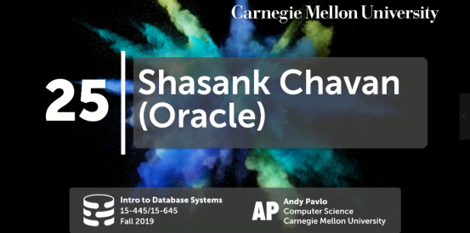



00:15 - 00:18
All right,welcome back DJ drop table,thank you
DJ Drop Table，欢迎你回来
00:21 - 00:24
you didn't buy your girlfriend present I heard
我听说你并没有给你女朋友买礼物
00:26 - 00:32
ok lets you ever some people christmas for the holiday okay okay
圣诞节马上到了，别忘准备礼物
00:34 - 00:37
so alright what's up for you guys,
So，你们过得怎么样？
0.37-0.39
alright so this last week classes
So，在上周的课上
00:39 - 00:42
the project 4 still due, homework 5 what we due
我们说过Project 4和Homework 5这两个都要截止了
00:43 - 00:44
and then on Wednesdays class
在周三的课上
00:44 - 00:48
we'll have the system potpourri and the final review
我们会去介绍System Potpourri，并且做下期末复习
00:48 - 00:55
and I'll also be announcing the result of the Paternity test about my kid and well
我也会去讲下亲子鉴定的结果
00:55 - 01:00
we're not two mile away ,alright so I'm outside at the end of class on Wednesday as well

01:00 - 01:04
all right before we switch over to speaker
在我们将话筒交给演讲者之前
1.04-1.06
any questions about what's remaining progresses the semester for you guys
在这学期的安排上面，你们还有任何问题吗？
01:06 - 01:06
yes
请讲
01:08 - 01:12
extra credit will due the same day as project 4, it should be on the website
Extra Credit的截止日期应该和Project 4是一样的，网站上应该有写
01:14 - 01:19
it will send off the feedback for the extra credit tomorrow or Wednesday
我们会在明天或者周三的时候放出你们所交的Extra Credit的反馈
01:20 - 01:21
okay any other questions
Ok，还有其他问题吗？
01:23 - 01:25
All right guys

1.25-1.30
,so we're super excited today to have Shashank from Oracle come and give a guest lecture
So，今天我们超级兴奋，因为Oracle的Shashank会给我们做一场演讲
01:30 - 01:31
and again like I said
正如我说的
1.31-1.32
the reason why I like having him here
我请他来这里给我们讲课的原因是
01:32 - 01:35
because it's gonna make me not seem crazy
因为这不会让我显得太过疯狂
01:35 - 01:36
that I did tell you all these about databases and just didn't make things up
我跟你们讲了有关数据库的一切，只是我没讲如何将它们融合在一起
01:36 - 01:41
,he's gonna say oh yeah there's a real system there making lots of money
Shashank会讲一个赚了很多钱的数据库系统
01:41 - 01:44
it does all the things that we talked about this the semester
这个系统涉及了我们这学期所讲的所有内容
01:44 - 01:47
but he's gonna talk about it in the context of an in-memory database
但他要讲的是内存型数据库系统的相关内容
1.47-1.49
, which is not what we talked about
这是我们还未谈论的东西
01:50 - 01:53
but it's going to apply the same concept in a different environment
但它使用的依然是相同的概念，只是环境变了而已
01:53 - 01:56
and if you're interested in the kind of things he's talking about today
如果你们对他今天所讲的东西感兴趣
01:56 - 02:01
this is what the advanced class 15-721 will be entirely about next semester ,okay
这其实是我们在下学期15-721中要讲的内容
02:02 - 02:03
so Shashank is a vice president of in-memory database technologies is that correct
So，Shashank是Oracle中负责内存型数据库技术的VP，我说的没问题吧？
02:08 - 02:08 Shashank
that's correct
没问题
02:08 - 02:11
so he has an undergraduate and a master's degree from UC San Diego
So，他获得了加利福尼亚大学圣迭戈分校的本科和硕士学位
02:11 - 02:14
and he's been an Oracle for six years nine years
你已经为Oracle工作了6年？还是9年？
02:14 - 02:14 Shashank
nine years
9年
02:14 - 02:15
nine years , okay
工作了9年
02:16 - 02:21
and again like a real dude working on the system, this is some marketing ,this is real
这位老兄已经在这方面工作了很久，这方面是有些市场的
02:22 - 02:26
so by all means stop and ask some hard technical questions ,push him
So，今天不要问我那些高难度的技术问题，请把这些问题丢给他
02:26 - 02:27
and see whether he actually knows what he's talking about,okay
并看看他是不是真的了解他所谈论的东西
##### Shashank #####
02:33 - 02:33
awesome all right
Awesome
2.33-2.36
hey guys thank you for coming
感谢你们来听我的分享
02:37 - 02:39
so again my name is Shasank Chavan
So，我的名字是Shashank Chavan
02:40 - 02:44
I come here every now and then I guess there's a PDL lab that they come here for the retreats

02:44 - 02:47
and I think it's like winter and spring I think
我觉得它应该是在冬季和春季？
02:47 - 02:49
and Andy`s kind enough to invite me
Andy热情地邀请了我
02:49 - 02:51
so thank you again for inviting me here
So，再次感谢你邀请我来让我进行分享
02:51 - 02:56
so today's talk is gonna be on this top five innovations of Oracle's database in-memory
So，今天分享的主题是关于Oracle数据库在内存中的5大创新
02:56 - 03:01
so this talk was initially given to folks actually know about the database in-memory product
So，这场分享一开始是给那些对内存型数据库产品有过了解的人而举办的
03:01 - 03:06
I kind of changed it a little bit to kind of give you guys a background on what database in-memory is
我对我要讲的内容做了一些修改，我会给你们介绍下什么内存型数据库的背景
03:06 - 03:11
like Andy said please feel free to stop me at any point in time any time you have a question of
就像Andy说的，当你们有问题的时候，你们可以随时打断我
03:11- 03:12
no problems
这没关系
03:12 - 03:12
I as I was telling Andy,
我之前跟Andy讲过
3.12-3.14
I usually have more slides
我通常会使用很多幻灯片
3.14-3.16
, and I have time for the talk so sometimes I talk too fast
我为了有时间讲完我要讲的内容，有时候我的语速会过快
03:16 - 03:19
so just interrupt me any time you want to, okay
So，当你们有问题的时候，随时打断我就行了
03:20 - 03:24
okay so let me see I just wanna make sure I'm following the slides appropriately ,okay
Ok，我先来检查下幻灯片的播放顺序对不对
3.24-3.26
great so that's my next slide
Great，这是我的下一张幻灯片
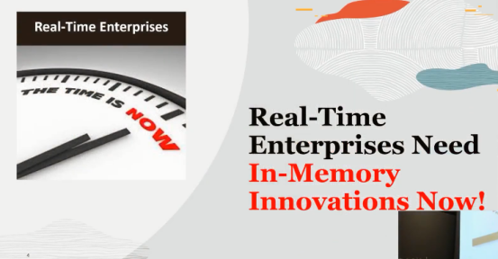

03:26 - 03:29
all right so I like to start off with this motivation slide
So，我想先从这张幻灯片开始讲起
03:30 - 03:34
this is talking about real-time enterprises need in-memory innovations now!
这里我们要讨论的是那些对数据有实时要求的企业需要我们这种内存中的创新


03:35 - 03:35
okay

3.35-3.43
so the slide that I have currently what I really wanted to show was this slide
So，我真正想展示的是这张幻灯片
3.41-3.43
with our presidents tweeting in the morning
从这张图上，我们可以看到我们的总统在早上发推特
03:41 - 03:47
”called to arms” Real-Time EnterpriZes Need in-memory innovations now!

03:47 - 03:49
but I was told would be too political
但这里我所讲的内容可能太过政治
03:50 - 03:53
so I opted for this instead
于是，我就换掉了这张图片
03:53 - 03:55
but I actually like this one better
但我觉得这张图片实际上会更好
3.55-3.56
because it's real,.
因为这张图片很现实
3.56-3.57
it actually is very true
实际上，它非常真实
03:59 - 04:00
He literally said that
特朗普确实这么说了
04:00 - 04:00
no
其实没有
04:03 - 04:08
this is actually when the impeachment trial started I think is when we put the slide Together
这实际上是谈判开始时的图片，然后我就将它放到幻灯片上了
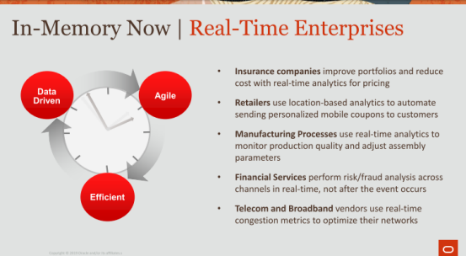

04:08 - 04:09
but the reality is
但现实是
4.09-4.13
following real time enterprises our enterprises that need access to data now
这些Real-Time企业需要做到对数据的实时访问
04:13 - 04:17
their data-driven, they are agile ,they're efficient
它们是数据驱动的，它们是敏捷且高效的
04:17 - 04:19
they want to be able to react instantly to data
他们想要能立刻对数据做出响应
04:19 - 04:23
so you can imagine they're a bunch of enterprises that fit this category
So，你们可以想象得出，有一堆属于这个分类的企业
04:23 - 04:27
right like insurance companies retail is manufacturing process these financial services
比如：保险公司、制造工艺，金融服务
04:27 - 04:30
people need to do fraud detection in real time
人们需要能够实时检测出欺诈行为
04:30 - 04:35
actually this just happened ,yesterday I was buying some speakers that Best Buy
实际上，我昨天在BestBuy上购买扬声器的时候就发生过这种事情
04:35 - 04:36
because they're on sale
当它们在出售商品时
04:36 - 04:39
and literally after I made that purchase
其实应该这么讲，当我买完商品后
04:39 - 04:40
I got a text message that says,
然后，我收到了这样一条消息
4.40-4.42
are you certain that you want to make this purchase,
该消息表示：我想购买这个商品
4.42-4.43
did you make this purchase blah blah blah
上面还有我是否买个这个商品之类的消息
04:44 - 04:48
because they immediately know that I'm not the kind of person that makes a 500 purchase
因为他们立刻知道我并不是那个买了500美金商品的人
04:48 - 04:51
you know on the spur of the moment that's just not me
你知道的，并不是我买了这个商品
04:52 - 04:54
so anyways that that's real time
So，总而言之，这种就是Real-Time（实时的）
04:54 - 04:56
and so in order to achieve that
So，为了做到这一点
4.56-4.58
we need a lot of things to come in place
我们需要做到很多东西
04:58 - 05:01
so we see the demand that's coming from enterprises companies right
So，我们看到很多企业都有这样的需求
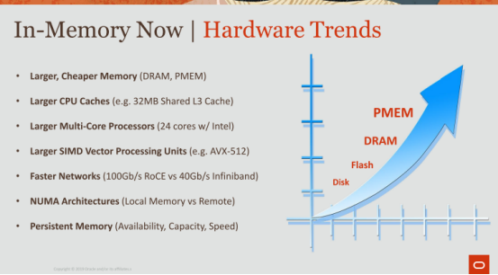

05:02 - 05:05
so what's actually making this possible
So，是什么使这变为可能呢？
05:05 - 05:08
so if you look at the hardware trends okay
So，如果你看下硬件发展趋势
05:08 - 05:10
you're starting to have larger, cheaper,memory
最上面，我们有容量更大，价格更低的内存
05:11 - 05:13
so DRAM everybody's familiar with memory
So，DRAM也就是人们所熟悉的内存
05:14 - 05:17
PMEM I don't know how many of you are familiar with persistent memory
我不清楚你们中有多少人知道PMEM（持久内存）
05:17 - 05:20
I talked about that and the last bullet there, so I'll get to that then
我稍后会去讲这个PMEM
05:20 - 05:22
you have larger CPU caches
我们现在拥有了更大的CPU缓存
05:22 - 05:28
so now we're talking about 32MB of shared L3 cache on Intel's latest processors
So，在intel最新的处理器上它的共享L3 cache的容量是32MB
05:28 - 05:31
you have larger multi-core processors
现在我们也拥有了更多核的CPU处理器
05:31 - 05:34
so 24 cores with Intel cascade Lake
So，intel的cascade Lake架构CPU拥有24个核心
05:34 - 05:37
larger SIMD vector processing Units
接着是更大的SIMD Vector Processing Units
5.37-5.42
show of hands the folks who know what simd is you hear that before single instruction multiple data
举下手，让我看看有没有人知道SIMD（single instruction multiple data）
5.42-5.42
, excellent okay
Excellent
05:42 - 05:50
so now you have 512 bit SIMD registers, that can paralyze your operations essentially in a single cycle
So，现在我们拥有512位的SIMD寄存器，它们可以在一个cycle中并行执行你的操作
05:50 - 05:51
faster Network
更快的网络
5.51-5.58
so you have 100Gb/s RoCe vs the 40Gb/s, that you have with Infiniband
So，RoCe(RDMA over Converged Ethernet)的速度是100Gb/s，Infiniband的速度是40Gb/s
05:58 - 05.59
Numa architectures
Numa架构（非统一内存访问架构）
5.59-6.03
so that you have now you have to concentrate on local memory vs remote memory
So，你现在必须去关注本地内存和远程内存
6.03-6.04
there's a bunch of factors
这其中存在着很多因素
06:04 - 06:15
persistent memory is really the biggest in my mind and at Oracle and a lot of our group ,we think is a big-time game changer in the memory technology space
对于Oracle以及我们的很多工作组的成员还有我来说，我们觉得持久内存是内存科技领域的破局者
06:15 - 06:17
so persistent memory is basically like DRAM
So，简单来讲，持久内存和DRAM很像
06:17 - 06:18
it's just like memory
它很像内存
6.18-6.23
, except it's a lot larger about 3x times the size of DRAM
除了它比DRAM的容量大3倍以外
06:24 - 06:26
it's got availability
它具备可用性
6.26-6.27
because it's persistent
因为它是持久化的
6.27-6.28
you pull the plug
当你拔掉电源
06:28 - 06:30
you're doing you put the plug back in
然后又将电源插上去后
6.30-6.33
the data still they're sitting in these persistent memory dimms
这些数据依然存放在持久内存中
06:33 - 06:35
and it's it's fast
它的速度很快
6.35-6.37
it's not faster than DRAM
它的速度并没有DRAM那么快
06:37 - 06:39
but it's way faster than flash
但它的速度要比闪存快
06:39 - 06:44
so it's got a lot of really cool qualities, and all of these things combined
So，这里真的有很多很Cool的特质，并且所有的东西都结合在了一起
06:44 - 06:49
help us move towards meeting the requirements of real time enterprises
帮助我们在满足这些Real-time企业的需求上不断迈进
06:50 - 06.53 Andy
so there's a lot of projects relies on logging and recovery doing Aries
So，有很多项目都是使用ARIES来做到logging和Recovery
6.53-6.55
so think about this
So，思考下这个东西
6.55-6.58
you're writing your ability to write out dirty pages in your buffer pool
你会将你的dirty page写入你的buffer pool中
6.58-7.02
persistent memory you don't want to do on project 4 if that exist
你不会想在Project 4中使用持久内存，即便它存在的话

07:03 - 07:03
exactly
确实如此
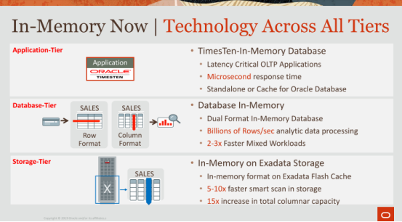

07:05 - 07:05
okay

7.05-7.08
where do we have in-memory today

7.08-7.10
in case we have different tiers
如图所示，这里我们有几个不同的层面
07:10 - 07:13
so the top tier here is application-tier
So，最上面的一层是应用程序层
07:13 - 07:16
this is where you care about an immediate response time
这里你所关心的东西是即时响应时间
07:16 - 07:18
so imagine you have an application
So，想象一下，你有一个应用程序
07:18 - 07:22
and you're gonna link this database directly into your applications
你将数据库直接链接到你的应用程序中
07:22 - 07:24
shares the same process base the memory space
它们共享相同的进程和内存空间
7.24-7.25
everything is shared
所有数据都是共享的
07:25 - 07:27
and so you're gonna get immediate response time
So，这样你的即时响应时间就很短
07:27 - 07:29
this is extremely important
这点非常重要
7.29-7.30
if you're like OLTP sensitive
如果你的数据库针对OLTP的
07:31 - 07:33
and you want to do an insert very quickly or read very quickly
并且你想做到快速插入数据或者快速读取数据
07:33 - 07:35
you're just getting a value for this particular key
比如，拿到特定key所对应的值
07:36 - 07:43
so that's TimesTen ,TimesTen came out years ago was one of the first in-memory did I think it was the first in-memory database
So，TimesTen是我记忆中第一个内存数据库
07:43 - 07:45
I think it's what Oh No maybe 20 years ago
它是20年前所推出的
7.45-7.46
, so it was 96
So，它是在1996年左右推出的
7.46-7.48
, okay much long enough
Ok，它出现很久了
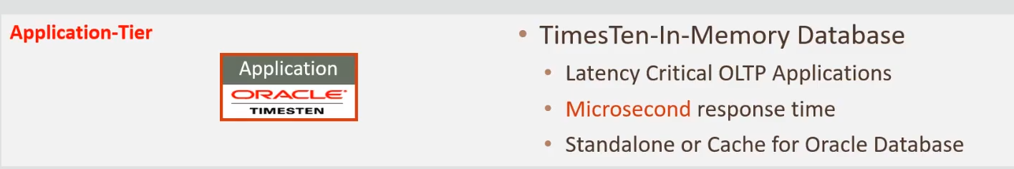

07:49 - 07:51
so that's that TimesTen
So，这就是TimesTen
7.51-7.52
, that's in the application-tier
它是在应用程序层的
07:52 - 07:54
Database-tiers what I'm gonna talk about
我接下来要讲的是数据库层面的东西
7.54-7.56
, that's where we have Oracle database in-memory
我们将Oracle数据库放在了内存中
07:56 - 08:01
and this is where we really care about analytics, but will also mix workload performance

08:01 - 08:05
and it's embedded directly into a real working enterprise database
它直接被嵌入到了企业数据库中
08:06 - 08:10
and then you're processing things that billions of rows per seconds , when you're looking at Analytics
当你对数据进行分析时，你就会每秒处理数十亿行数据
08:11 - 08:13
then there's also the storage-tier
接着，这里还有存储层
08:13 - 08:14
so I'll talk about that as well
So，我之后也会讨论
08:14 - 08:15
and by the storage-tier means
存储层的指的是
8.15-8.24
where the data is actually residing whether it be on on disk in some persistent store on flash, or something close to basically a persistent store
即数据所实际存放的位置，它可能会放在磁盘上，或者闪存上，或者某种类似于持久化存储设备的东西上
08:24 - 08:29
so yeah the application tier your database-tier ,storage-tier ,and I'll talk mostly about the database-tier
So，我们今天主要讨论的是这三个层面中的数据库层
08:29 - 08:31
and the storage-tier okay
以及存储层
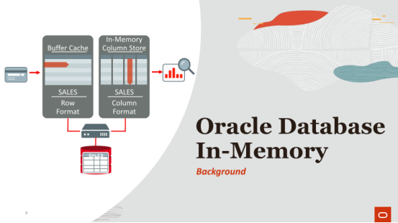

08:32 - 08:32
okay

8.32-8.39
so I'm gonna start off with a background on what Oracle database in-memory is
So，我会先去介绍下Oracle的内存数据库的相关背景
08:39 - 08:39
okay
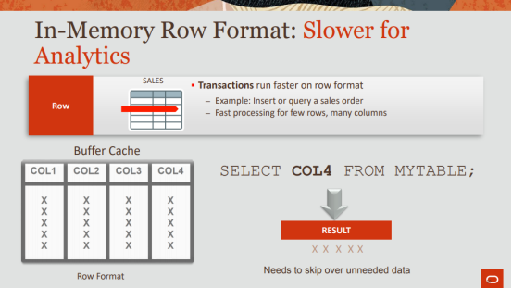

08:39 - 08:41
let's start with some basics okay
我们先从一些基础开始讲起
08:42 - 08:47
so before we had column databases which is in the next slide
So，在我们拥有列式数据库之前，这个我们会在下一张幻灯片中讲下
08:47 - 08:48
we basically have row databases
简单来讲，在它出现之前，我们使用的是行式数据库
08:49 - 08:53
row wise databases are fantastic , if you care about transactions
如果你比较关心执行事务这方面的话，行式数据库的效果就会很棒
8.53-8.53
, okay

08:53 - 08:56
so as an example ,your an ATM machine
So，以ATM机为例
08:56 - 08:57
you have you ATM card
你有一张ATM卡
08:57 - 09:00
you wanted the deduct 25 $20 from your account
你想从你的账户中取20美金
09:01 - 09:03
that's a transaction that you're applying
这就是你要执行的交易（事务）
09:03 - 09:16
you're going to quickly search through this gigantic database of you know millions or billions of users ,not billions, but certainly many millions and search for your particular account, find your balance, and deduct $20 from it
你就会在这个拥有数百万用户信息的大型数据库中找到你的账户，然后找到你的存款余额，并从里面扣除20美金
09:16 - 09:24
so that's like looking for a specific row and potentially accessing multiple columns within that row
So，这其实就是在寻找一个特定的行数据，并访问该行中的多个列数据
09:24 - 09:26
that's great for it that's transaction processing
对于事务处理来说，行式数据库真的很棒
09:27 - 09:33
so row database is very good for accessing a particular row and then touching multiple columns within that row
对于访问一个特定的行数据并接触该行的多个列数据来说，行式数据库真的很棒

09:33 - 09:34
so as an example here
So，来看下这里的例子
9.34-9.39
, if you're running this query like select COL4 from mytable
如果你执行下图上这条SQL语句

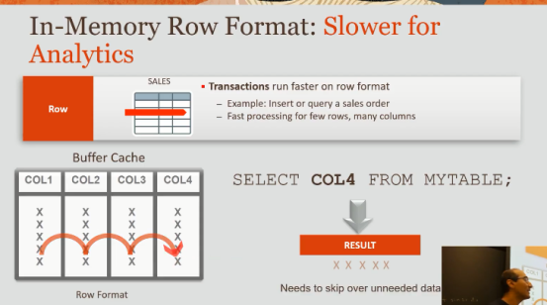

09:39 - 09:45
what you have to do is you basically have to process each row, and hop to COL4 to get to it
简单来讲，你必须对每行数据进行处理，拿到每行第四列的数据
09:46 - 09:48
right so the problem is
So，这里的问题是
9.48-9.49
when it comes to analytics is
当我们要对数据进行分析时
9.49-9.52
,you're basically visiting every single row
你基本上就要去访问每行数据
09:52 - 09:59
but on top of that ,you're going column by calling ,column touching multiple cache lines to get to the column ,that you care about
但在此之上，你通过访问cache line去获取这些你所在意的列数据
09:59 - 10:05
so it's again fantastic, if you want to get to a specific row and access a specific column
So，如果你想访问并获取特定列的数据，那么这就很棒
10:03 - 10:06
, that's row format
这就是行式数据库
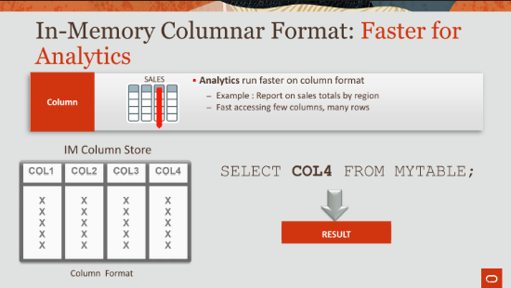

10:08 - 10:11
now column format is fast for analytics
在分析数据方面，列式数据库的速度很快
10:11 - 10:12
okay

10.12-10.14
analytics is where you say
分析数据指的是
10.14-10.16
, I actually care about visiting all the rows
我关心的是我访问的所有行数据
10:17 - 10:20
but I'm only interested in certain columns, right
但我只对某些列的数据感兴趣
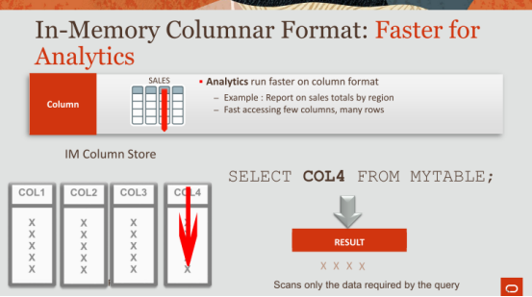

10:21 - 10:22
so in this case now,
So，在这个例子中
10.22-10.26
if I just want to say select COL4 from mytable
如果我想执行图上这条SQL语句
10:26 - 10:29
all I need to do is visit COL4, okay
我所需要做的就是访问COL4的数据
10:29 - 10:32
the data is stored in columns in contiguous memory
数据是保存在这些连续内存中的列里面的
10:32 - 10:36
each column here is in a contiguous piece of memory
这里的每个列就是一块连续的内存
10:37 - 10:40
any questions so far the difference between row format and column format
在讲行式和列式方面，你们有任何疑问吗
10:41 - 10:44
we don't do that ok great awesome .
Ok，看起来并没有什么问题，Awesome
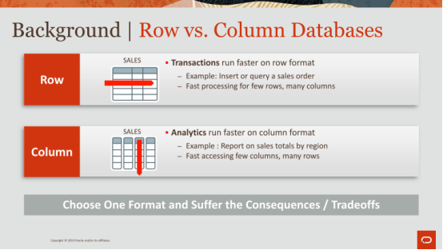

10:45 - 10:46
okay

10.46-10.53
so the innovation on what Oracle develop for our in-memory product is
So，Oracle所开发的这种im-memory产品的创新点在于
10:53 - 10:56
we decided that you can't just have one or the other
我们决定你不能只使用一种格式
10:56 - 10:59
it's just not feasible really for enterprise companies
对于企业和公司来说，这不可行
10:59 - 11:02
enterprises are basically more interested in mixed workloads
基本上来讲，企业对混合workload更感兴趣
11:02 - 11:03
sometimes the running analytics
有时他们会让数据库去分析数据
11:03 - 11:04
sometimes the running transactions
有时他们会让数据库执行事务
11:05 - 11:07
sometimes and it could be very mix
他们的workload是非常杂乱的
11:07 - 11:10
sometimes they run ad-hoc queries use gigantic queries
有时他们会去执行ad-hoc查询（即席查询）或者那种大型查询
11:10 - 11:11
sometimes a very very simple queries
有时候，它是非常简单的查询
11.11-11.13
, so it's a mix
So，它是混合的
11:13 - 11:18
and so we basically decided , that you're not you can't just choose one format
简单来讲，你不能只使用一种格式
11:18 - 11:19
we basically want to have both formats
简单来讲，这两种格式我们都想要

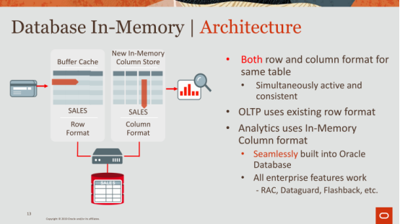

11:19 - 11:22
and so that's why we have this thing called dual format architecture
So，这就是为什么我们会有这种双格式架构（dual format architecture）的原因了
11:23 - 11:25
so with dual format architecture
So，在这种双格式架构下
11.25-11.29
we basically maintain both the traditional row-store that's sitting in your buffer cache
简单来讲，我们要去维护放在你buffer cache中的那些传统的行存储数据
11:30 - 11:34
as well as a columnar representation that's sitting in-memory
我们还要去维护那些放在内存中的列存储数据
11:34 - 11:36
okay we maintain both
Ok，这两种数据我们都要维护
11:36 - 11:41
and both of them are simultaneously active and consistent with each other
这两者都处于活动状态，并且彼此一致
11:41 - 11:43
all the brains goes into the optimizer
所有的事情都是优化器来决定的
11:43 - 11:48
the optimizer decides when it sees the query which path it should take
当优化器拿到查询时，它会去决定该使用行存储数据还是列存储数据
11:48 - 11:49
so for example
So，例如
11.49-11.50
,if it sees a query that says
如果优化器拿到一个查询，它表示
11.50-11.54
, I really want to get to this particular row ,this key and extract that value
我想拿到这一行中的这个key所对应的值
11:55 - 11:57
and I have this OLTP index on it
在这一行上面我们一个OLTP索引
11:57 - 11:59
the optimizer will say go to the buffer cache
优化器表示它要去访问buffer cache
11:59 - 12:01
and fetch the index block for it
拿到这个索引区块
12.01-12.02
,and read that row
并读取这一行
12:03 - 12:04
and that's how fast it'll get that row
这就是它能快速读取到这行数据的原因所在
12:05 - 12:07
if the query is an analytic query
如果该查询是一个分析型查询
12.07-12.11
,and you're doing some kind of crazy aggregation or group by somewhere some joins or whatever it is
如果你要做一些疯狂的聚合操作、GroupBy操作或者join操作
12:12 - 12:15
it'll use the column store ,okay
它就会使用这种列存储数据
12:16 - 12:21
so it's for us when we develop this database in-memory
当我们开发这个database im-memory功能时
12:21 - 12:24
we built it natively into the database
我们在数据库内原生构建了它
12:24 - 12:28
so it's not a separate storage engine, it's part of the existing storage engine
So，它不是一个单独的存储引擎，它是现有存储引擎的一部分
12:28 - 12:33
it's basically just a think of the the column representation as if it was an index

12.33-12.35
and index that resides in-memory

12:36 - 12:37
okay any quick question
Ok，有任何问题吗？请问
12:51 - 12:57
so if it depends on what the percentage of writes are to do your workload
So，这取决于你workload中的写操作的占比
12:57 - 13:03
so I'll cover that in second in terms of how we handle writes or updates or whatever or DML in general
So，我稍后会讲，我们该如何处理写操作或者更新操作或者DML之类的东西
13:03 - 13:07
if you're doing let's say 1% of your workload is writes, ok
假设你1%的workload是写操作
13:08 - 13:09
that's not a problem
这不是什么问题
13.09-13.13
that's basically a mixed workload even five to ten percent is fine
基本上来讲，这就是一个混合workload，即使写操作的比例是5%-8%也没问题
13:13 - 13:18
when you start getting to a higher percentage or like twenty thirty forty percent maybe let's say
当你写操作的比例变得更高时，假设是20%，30%或40%这种
13:18 - 13:20
this is not the right solution for you
对于你来说，这可能并不是正确方案
13:20 - 13:24
because now as you'll see you're basically oops ,I'm sorry I don't know how that advanced ah
抱歉，我不知道如何切换下一张幻灯片
13:24 - 13:28
you know you're probably running with the timer yeah, okay
你知道的，我们在赶时间
13:30 - 13:33
so what you're doing is you're basically maintaining both ,right
简单来讲，这两个你都要去维护
13:33 - 13:36
you're maintaining this column store and the rows store
你要去维护列存储数据以及行存储数据
13.36-13.37
,and that could become problematic
这就会很成问题
13.37-13.38
okay

13:38 - 13:41
so I'll describe how we handle that very efficiently
So，我会去描述我们如何高效地处理这个
13:43 - 13:44
any other questions
还有其他问题吗
13:49 - 13:52
next one all right cool
我想要下一张幻灯片
13:54 - 13:54
awesome
Awesome
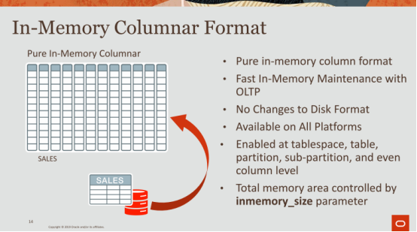

13:55 - 13.56
all right

13.56-13.58
let's go into some of the details, okay
我们来看下其中的一些细节
13.58-14.00
in terms of how we store this data
即我们如何保存这些数据
14:00 - 14:03
so what you see here is a table
So，你们这里所看到的是一张表
14:03 - 14:06
we store the data in a very pure in-memory column representation
我们将数据保存为一种pure in-memory column格式
14:07 - 14:11
so sales table continues to sit on disk
So，这张Sales表依然是放在磁盘中的
14.11-14.12
, doesn't change ,right
它并没有发生什么改变
14:12 - 14:15
it's exactly as you guys know it to be
它就和你们知道的那样，没有什么变动
14:15 - 14:16
it can be pulled into the buffer cache
它可以放入buffer cache中
14.16-14.20
, if it's accessed that doesn't change
如果有人访问这张表，它并不会发生什么变化
14:20 - 14:21
but what you do is
但你所做的事情是
14.21-14.24
if you say bring this table into in-memory
如果你说你要将这张表放入内存中
14:25 - 14:28
we will basically bring it into in-memory
那么我们就会将它放入内存
14:28 - 14:31
we'll take the rows transpose them into columns
我们会将这些行数据变成列数据
14:31 - 14:36
and then store the columns into blocks of contiguous pieces of memory
并将这些列数据保存到这些连续的内存区块中
14:37 - 14:38
okay

14.38-14.39
there's no changes to the disk format
这不会对磁盘格式造成什么改变
14.39-14.43
Oracle so we support all platforms
我们Oracle支持所有的平台
14:43 - 14:46
you can enable in-memory at any level
你可以在任何层面都使用in-memory功能
14:46 - 14:51
okay at the tablespace level at the tables at a column level even
比如：tablespace层面、table层面或者column层面
14:51 - 14:52
you can specify any level
你可以指定任意层面使用这个功能
14:52 - 14:54
and the only thing you do need to do is
你唯一需要做的事情是
14.54-14.59
you need to tell us how much memory you want to reserve for your column store
你需要告诉我们，你想为你的列存储数据保留多少内存
14:59 - 15:00
Okay

15.00-15.03
that's as I'll talk about some of the future stuff we're working on
我稍后会讲下我们未来要做的东西
15.03-
but that's a

15:05 - 15:07
the only thing you really have to do is tell us how much memory
你唯一需要告诉我们的事情就是你要使用多少内存
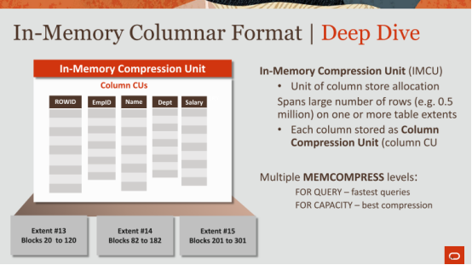

15:08 - 15:11
now if you dive in deeper into us okay
如果你对此更加深入的话
15:11 - 15:18
we basically block out these rows in something called IMCU in-memory compression unit,okay
简单来讲，我们会对这些行数据进行打包，打包出来的东西叫做IMCU（in-memory compression unit，内存压缩单元）
15:18 - 15:20
IMCU in-memory compression units
IMCU，内存压缩单元
15:20 - 15:26
and in IMCU basically has about a half a million rows half a million to a million rows
简单来讲，一个IMCU会包含一百万个行数据
15:26 - 15:28
and within each IMCU
在每个IMCU中
15.28-15.31
you have all the columns for that table
你拥有该表的所有列
15:31 - 15:34
so here in this sales table here
So，在这个Sales表中
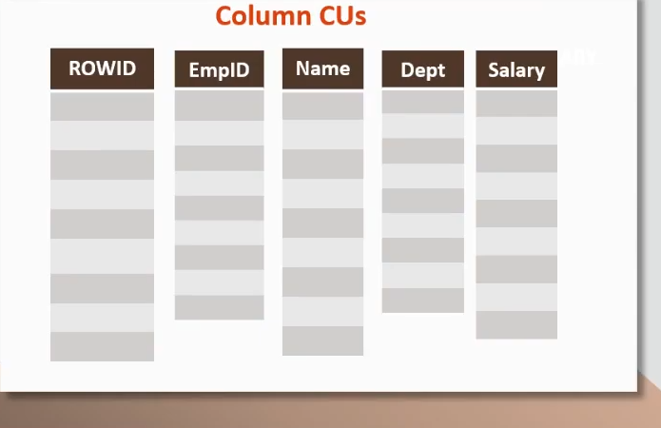

15.34-15.37
,you have the employee ID, name ,Department ,salary
我们有EmpID，Name，Dept以及Salary这几个字段
15:37 - 15:40
okay we also have this row ID column
我们还有一个ROWID字段
15:40 - 15:42
now this is really important
ROWID非常重要
15.42-15.45
, this is kind of the little trick that we have
我们可以通过它来使用某种小技巧
15:45 - 15:52
that row ID column maps to the actual locations of those rows on disk
ROWID这一列指向的是这些行数据在磁盘上的实际位置
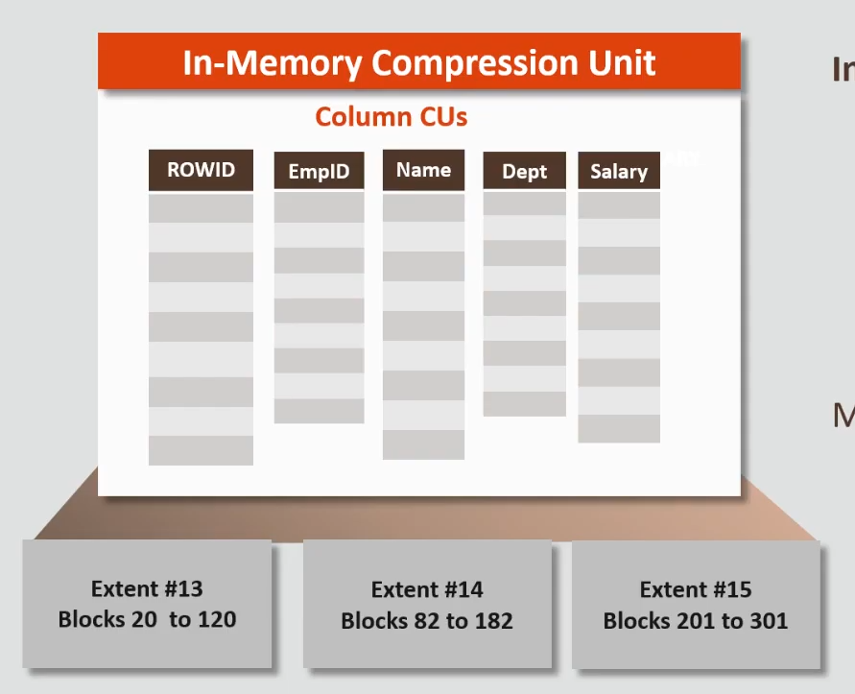

15.52-15.53
which is this bottom part here
也就是底部这部分东西
15:54 - 15.57
so on disk we basically store data in extents
So，基本上来讲，我们将数据保存在磁盘上的extent中
15.57-16.01
which are basically contiguous pieces of blocks
简单来讲，extent就是为存储数据而分配的一组连续的数据块
16:01 - 16:03
and this extent says
这里表示
16.03-16.05
extent number 13 as blocks 20 to 120
extent #13中保存的是从20到120的Block
16:06 - 16:08
extent number 14 as blocks to 82 to 182
Extent #14所保存的是82到182的Block
16:08 - 16:13
and in each block you have like you know some you know hundreds 100 or thousands of rows
在每个Block中，它里面包含了100行或者上百行的数据
16:14 - 16:22
and so this IMCU is mapped directly to the physical locations on disk
So，IMCU会直接映射到这些行数据在磁盘上的物理位置
16:22 - 16:24
and why this is important is
它为什么很重要呢？
16.24-16.27
,because when you have a modification to a row
因为当你要对某行数据进行修改时
16:27 - 16:30
it's very easy to say which IMCU does that map to
我们可以很容易地知道它对应的是哪个IMCU
16:31 - 16:36
and I'll go through a another slide that talks about , how we utilize this when we talk about DML
当我们讨论DML的时候，我们会在另一张幻灯片上讨论我们该如何利用这个
16:37 - 16:39
so the only other point to make here is
So，这里我们可以做的另一件事情就是
16.39-16.43
you can specify ,how you want to compress this column
你可以明确下你想如何压缩这个列的数据
16:43 - 16:47
so you know you don't think you guys talked about compression yet,or different data formats
So，我不清楚你们是不是讨论了数据压缩，或者不同的数据格式
16:47 - 16:51
and you guys heard a dictionary encoding before , or prefix encode
你们之前有听过字典加密或者前缀加密吗
16:51 - 16:53
okay so well I think I have a few slides on this
Ok，我应该做了一些幻灯片
16:53 - 16:56
but you can specify what compression levels you want,you're limited to on memory
但你可以指定你想要的压缩级别，你可以限制在内存中进行压缩
16:56 - 17:00
so you can bring it into memory and compress it however you which way you want to
So，你可以将数据放入内存，并使用你想要的方式来对它进行压缩
17:01 - 17:01
okay

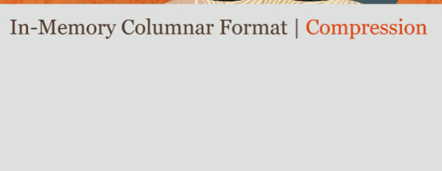

17.01-17.04
so that's how we store things
So，这就是我们保存数据的方式
17.04-17.06
as I'm shocked here's the slide on on compression
我这里所展示的这张幻灯片是关于压缩的
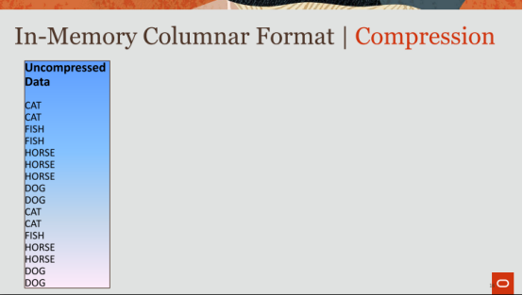

17:06 - 17:08
so how do we actually store this data okay
So，我们实际该如何保存这些数据
17:08 - 17:11
so imagine this was your column
So，想象一下，这就是你的列数据
17:11 - 17:14
okay this is your uncompressed data
Ok，这就是你未压缩的数据
17:14 - 17:18
and I have Cat Cat, fish fish, horse horse horse horse ,dog dog, cat etc
在这里面，我有CAT CAT，FISH FISH，HORSE HORSE之类的数据
17:18 - 17:19
okay

17.19-17.23
it's not actually sorted I have dogs here and cats here ,but this is just my example
但在我的例子中，这些数据实际上并没有被排序
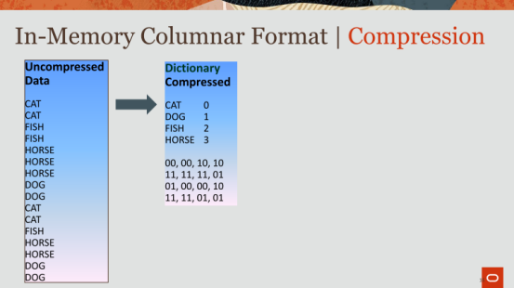

17:23 - 17:26
so the first thing we do is we dictionary encode this
So，我们首先会做的就是使用字典对这些数据进行加密
17:27 - 17:29
so dictionary encoding means is
So，字典加密的意思是
17.29-17.33
it identifies the distinct symbols in that column
它会去识别该列中的那些去重后的字符
17.33-17.36
, pulls out those distinct symbols
它会将这些去重后的字符拉出来
17:36 - 17:38
and then sorts those distinct symbols
然后对这些去重后的字符进行排序
17:39 - 17:41
and then assigns a code to them
接着，给它们分配一个编码
17:41 - 17:46
so you have cat, dog ,fish ,horse, that's all you have in this in this column
So，这里就是你列中去重后的字符，它们是CAT、DOG、FISH和HORSE

17:46 - 17:47
I sort them
我对它们进行排序
17.47-17.50
and I sign them codes at 0 1 2 & 3
我给它们分配的编码是0、1、2和3
17:51 - 17:57
and and you just have to replace the values of Cat Cat, fish fish etc with the codes themselves
然后，你必须将CAT CAT，FISH FISH之类的数据替换成这些编码
17:58 - 18:00
and we take it one step further
然后我们再进一步对它们进行处理
18:00 - 18:01
we actually bit pack those codes
我们使用bit来打包这些编码
18:02 - 18:04
so because they're only four distinct symbols there
So，因为这里去重后只有4个不同的字符
18:04 - 18:08
I only need two bits, right to represent each one of those symbols
我只需使用两个bit来代表每个字符
18:08 - 18:13
so 00, 00,10 etc ,
So，就如这里的00，00，01等等
18.11-18.13
ok so far so good
Ok，到这里都没问题吧
18:13 - 18:14
so that's the dictionary encoding
So，这就是字典加密
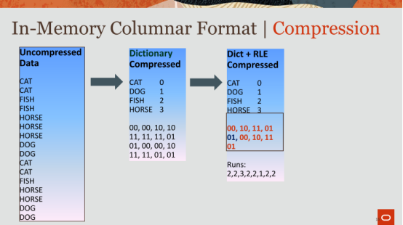

18:15 - 18:16
the next thing we do is
我们接下来要做的事情是
18.16-18.20
we apply orally or run length encoding
我们会使用Run-length加密
18:20 - 18:21
run length encoding is basically saying
简单来讲，Run-length加密指的是
18.21-18.27
let me see if I can identify a run of the same symbol and number of times

18:25 - 18:33
and replace all end copies with a single copy along with the run, right account

18:33 - 18:35
so here you notice that
So，此处你们会注意到
18.35-18.40
we have Cat Cat and fish fish or rather 00, 00 and 10, 10,
这里我们有CAT CAT和FISH FISH，旁边则是00，00和10，10之类的东西
18.40-18.43
where I can replace that with just 00 and 10
我可以使用00和10来替换这些东西
18:43 - 18:45
and then I have a run over there
这里我有一个run
18.45-18.48
is this little button the yeah, there
我是不是该按这个按钮？
18.48-18.50
you go perfect
好的
18:50 - 18:53
so then you can see their names basically maintain some runs
So，你可以看到它们的名字维护了一些runs
18:53 - 18:56
that just identifies how many runs there are for those symbols
这用来识别每个符号的runs数量
18:56 - 18:57
so far so good
So，到目前为止没问题吧
18.57-18.58
, okay
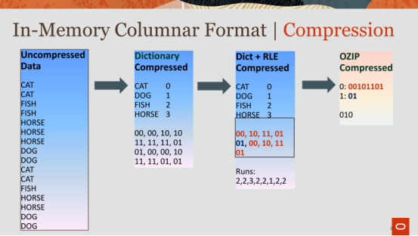

18:59 - 19:01
then we take it one step further
然后，我们这里再做一步
19.01-19.04
,we apply something called OZIP or oracle zip
这里我们使用了一种叫做OZIP或者Oracle Zip的东西
19:05 - 19:10
oracle zip is very much it's pretty much a fancy dictionary encoding algorithm
Oracle Zip是一种非常棒的字典加密算法
19:11 - 19:12
but it's fantastic
它很棒
19.12-19.14
,because it's very simple
因为它很简单
19.14-19.18
,and it's hardware friendly to decompress
在解压缩方面，它对硬件友好
19:18 - 19:21
I won't go into too many details what we describing what's happening here
我不会对此过于深入，我这里只是介绍这里发生的事情
19:21 - 19:21
so what it's doing is
So，它这里所做的事情是
19.21-19.28
it's now finding patterns within the the encoded the values now
它会在这些加密的值中查找匹配的字符
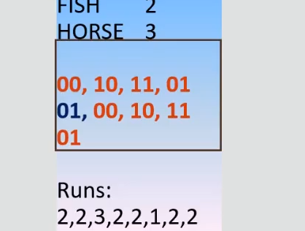

19:28 - 19:30
so here you have 00, 10 ,11, 01
So，这里我们所拥有的值是00，10，11和01
19.30-19.35
and you see the same pattern of 00101101
你可以看到这里有相同的字符串，即00，10，11和01
19:35 - 19:43
so you'll replace the set of of 8 bits now with a single code of 0 or sing a bit of 0
So，你会将这8个bit使用一个0来替换
19:43 - 19:45
and you'll replace 01 with 1
你用1来替换01
19.45-19.47
,and now you've compressed it even further
现在，你就可以对数据进一步压缩
19:48 - 19:52
so you're building and yet another dictionary on top of the encoded stream
So，你现在就会在这个加密stream上建立出另一套字典
19:53 - 19:54
so far so good
So，到目前为止都还好吧
19.54-19.54
ok

19:55 - 19:56
so that's what we do
So，这就是我们的做法
19.56-19.57
we take it to kind of stream
我们拿到一个stream
19:58 - 19:59
and then you can actually take this
然后，你就可以对它进行这些流程处理
19:59 - 20:04
and you put Z ZLib on top of it or Bzip ,alright at a higher level compress on top of it
你可以使用ZLib或者BZip之类的压缩算法来对这些stream进行压缩

