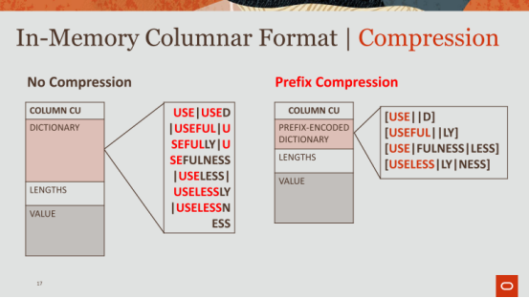

20:06 - 20:06
okay

20:07 - 20:11
all right one more compression form I want to talk about is something called prefix encoding
All right，我还想讨论的一种压缩形式就是前缀编码
20:11 - 20:13
so we talked about that dictionary, right
So，我们已经讨论了字典加密
20:13 - 20:18
a cat dog horse etc notice how they were all sorted

20:19 - 20:20
well so once it's sorted
So，一旦这些数据被排好序
20:20 - 20:26
you can actually remove a common prefixes from adjacent symbols and store them separately
实际上，你可以移除这些连续标志符的公共前缀，并将这些公共前缀单独保存起来
20:26 - 20:33
so the example I have here in this dictionary is use ,used ,useful, usefully, usefulness etc right

20:33 - 20:39
and they all have used , but some of the symbols can actually benefit for something more like useful

20:39 - 20:41
so what we'll do is
So，我们要做的事情是
20.41-20.44
we'll basically take out maybe like a block of eight symbols
简单来讲，我们会从中取出一个包含8个标志符的区块
20:44 - 20:48
and then from those eight symbols we'll find the the common prefix across those eight symbols
然后，我们会从这8个标志符中找出它们的公共前缀
20:49 - 20:49
in this example
在这个例子中
20.49-20.51
, I think I'm using two symbols
我使用了两个符号
20.51-20.56
, so use for use and then D is the suffix for used
So，对于USE和USED来说，USE的前缀就是USE，D是USED的后缀
20:56 - 21:02
so I just maintain the prefix along with an empty suffix here for the first symbol ,and D for the second one
So，这里我维护了一个公共前缀USE，第一个标志符的后缀是空的，第二个标志符的后缀则是D
21:02 - 21:05
and then the next one we'll use useful
接着，在下一个例子中，我们使用的公共前缀是USEFUL
21:05 - 21:09
because the third symbol here is useful
因为这里第三个标志符是USEFUL
21.09-21.10
,and the same thing
这里我们进行相同的处理
21.10-21.12
, and then our grabs the suffixes
接着，我们拿到了这些标志符的后缀
21:12 - 21:14
so this just gives you some more compression
So，这样你可以对数据进行进一步压缩
21:15 - 21:16
So far so good okay
So，到目前为止都没问题吧
21:17 - 21:20
problem with this stuff is the following right

21:20 - 21:23
you have to decompress it ,and that could take some time

21:24 - 21:27
you can't just point to use and D

21:27 - 21:33
because you have to stitch them up at some point , and give it back to , whatever operator wants the actual symbol

21:33 - 21:36
so there's a cost associated with compressing

21:36 - 21:38
and then decompressing as a result

21:49 - 21:53
for the column, we have specialized formats , where we like

21:53 - 21:56
we know what the format is you don't have to decompress it

21:56 - 22:00
we have some tricks too like for example for a dictionary encoding ,for a prefix encoding

22:00 - 22:07
we have tricks that use SIMD ,that that allow you to not have to ever stitch things back together, when you're doing a scan , when doing a projection you do

22:07 - 22:11
roast or roast or has a compressor very much like dictionary encoding

22:12 - 22:16
but it operates across multiple rows and it's far more complex

22:16 - 22:18
so you're right when you actually have to project back

22:18 - 22:21
it's a complicated stitching algorithm to bring it back together again

22:22 - 22:25
alright so far so good ,okay
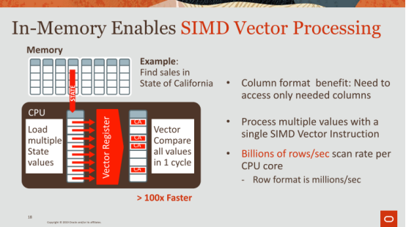

22:25 - 22:30
alright so we talked about how we bring the data into memory

22:30 - 22:32
we talked about how we format it and compress it

22:33 - 22:37
now we're going to talk about ,how do we scan ,how do we actually use that data and actually scan fast

22:37 - 22:43
how do we get to this billions of rows per second versus the millions of rows per second, when you're looking at a buffer cache in a row store

22:43 - 22:45
so this is where SIMD comes into place

22:45 - 22:50
so SIMD again for those of you don't know stands for single instruction multiple data

22:50 - 22:59
and what that does is a lot of most modern processes now now for last ,I don't know 15 20 years maybe, and well since 96 I think

23:00 - 23:08
have a in the processor ,have a vector, a vector ization unit where they have very fat registers

23:09 - 23:10
and not only do they have those fat registers

23:10 - 23:13
they have a sequence of and they have a instruction set

23:13 - 23:19
that can be applied on those registers registers , that allow you to paralyze data operations

23:19 - 23:22
so let's just go through an example to make things clear

23:22 - 23:26
here you have again in your column store and you have a column called state, right

23:27 - 23:31
and your query is fine sales in state of California

23:32 - 23:37
so what you're gonna do is bring the state column into a register

23:38 - 23:41
now you guys we just talked about dictionary encoding right

23:41 - 23:47
so these state columns can all be packed into how many bits do you guys think ,quick thinkers

23:51 - 23:54
exactly okay that's a good answer that's right

23:54 - 23:58
so you got with that five bits or six bits ,thank you ,six bits

23:59 - 24:03
so six bits coming in here ,but you have a register that sets 512 bits

24:04 - 24:09
so I can bring in 64 of these assuming all of them are 8 bits ,let's just say ,right

24:10 - 24:17
I can bring 64 in a 512 bit register 64 states can be loaded at once , that's one instruction

24:17 - 24:21
some number cycles depending on whether it's in in your CPU cache or not

24:21 - 24:27
but let's suppose it is in your CPU cache, okay so it's one cycle, I've loaded them in here

24:27 - 24:34
the next step is to bring in California whatever bit representation California is

24:34 - 24:38
and splat that across another register California, California ,California ,California etc

24:39 - 24:42
then I planned that's one cycle ,okay

24:43 - 24:52
then this is where I use the the instruction set for vector for vector registers here ,where I can do a vector compare all values in one cycle

24:53 - 24:59
so this state will be compared to California, this state will be compared to California etc etc

24:59 - 25:06
and in one cycle it will apply 64 comparisons resulting in a bit mask of 64 bits

25:07 - 25:11
and that tells me which of these 64 states or equal to California

25:19 - 25:21 question
you cannot do that in a single cycle, right

25:22 - 25:28 question
to go do 64 tuples would be ,you know next call 64 times ,this is super phantom

25:28 - 25:32 question
this is why you use a vectorized model just what they're doing here

25:32 - 25:36 question
you can punch of crap all at once and then do the filter review the predicate evaluates your very quickly

25:36 - 25:38 question
that's why they're getting 100x faster

25:43 - 25:45
make make you feel really good

25:48 - 25:51
that's why you guys 100x slower learn

25:52 - 25:56
okay um but but but but Andy's right

25:56 - 26:00
that we actually apply vectorization techniques to all of our operators okay

26:00 - 26:06
so because there's magic in this ,it's it's complicated not when I have a slide on this I think

26:06 - 26:08
but so let's move on here ,okay
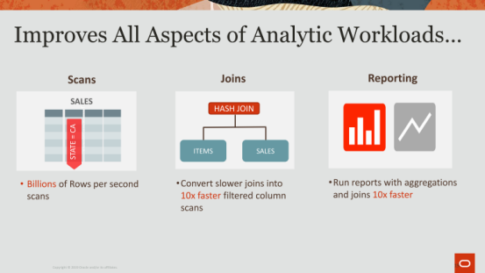

26:08 - 26:10
so that brings me to this slide here

26:11 - 26:15
so we're really looking to improve all aspects of analytics

26:15 - 26:18
so we talked about scans just now with vectorization

26:19 - 26:22
joins we look at vectorizing joins as well

26:22 - 26:25
there's all sorts of nifty techniques ,when you're dealing with a column store

26:25 - 26:27
and you're dealing with dictionary encoding

26:27 - 26:33
you can leverage the format leverage the hardware to again process at the at the billions of rows per second

26:33 - 26:37
here we make joints faster by simply making something called bloom filters faster

26:37 - 26:40
show of hands of folks who know about bloom filters excellent

26:40 - 26:44
awesome excellent excellent, bloom filters are magic ,I love

26:45 - 26:49
okay so that's how we make joints faster ,initially with our first release from five years ago

26:50 - 26:53
and then reporting aggregations group by some things like that

26:54 - 26:54
okay

26:55 - 27:02
yep yep

27:03 - 27:07
this is using SIMD on top of it ,okay let's move on here okay


27:07 - 27:11
so now we finally get to the top-5 ,which is what I wanted to get to so

27:11 - 27:19
top-5 I just want to list five things that we have done in the in the last five years ,I guess

27:20 - 27:25
that I think stand out in terms of what makes database of memory kind of cool for us at least

27:26 - 27:31
and by the way a lot of these most of these resulted in academic papers, that we submit to various different conferences

27:31 - 27:34
so I'll point them out to you as we as we move along
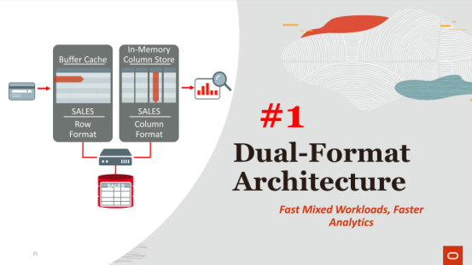

27:35 - 27:41
so the first thing is the dual-format architecture, fast mixed workloads and faster analytics
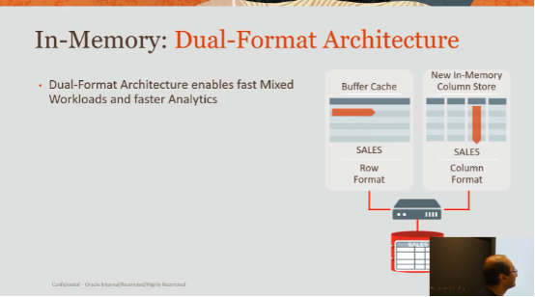

27:41 - 27:46
why we think this is pretty innovative, so let's explain how it works okay

27:46 - 27:51
so the dual-format architecture enables fast mixed workloads and faster analytics

27:51 - 27:56
so if you look at your right, that was our eye drawing I showed to you last time
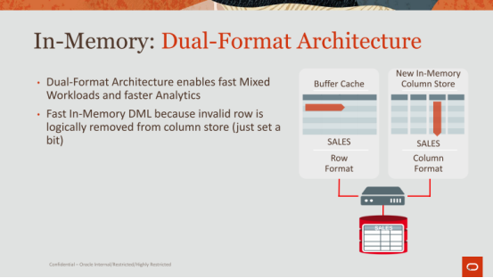

27:56 - 28:04
now you can get very fast in memory DML, because the invalid row is logically removed from the column store

28:04 - 28:09
so I'm going to walk through this example, let's suppose that a row was modified okay
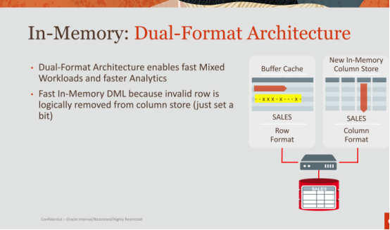

28:10 - 28:15
so that row was modified for whatever reason maybe I call him in there, or some number of columns

28:15 - 28:18
but it was updated or deleted whatever it is

28:18 - 28:20
that happens on the normal path okay

28:20 - 28:23
like it normally does like Oracle has been doing for the last 30 40 years
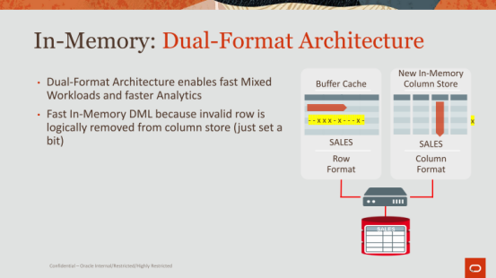

28:24 - 28:32
now when that happens ,that tells us immediately using that row ID CU, remember how I told you we map from disk to the Consular

28:32 - 28:36
we can immediately just set a bit, that says that row is invalid

28:37 - 28:39
that doesn't take that long ,you guys have all set bits

28:39 - 28:42
if you've done, if you create a bloom filter, it doesn't take long

28:42 - 28:48
you do have to find that IMCU , that's a little bit of a lookup, but not that long and then used to set a bit

28:49 - 28:54
so that's how DML is work , super simple you just say this row and that column store is invalid
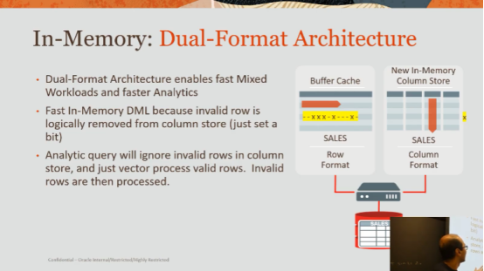

28:54 - 29:01
so now what happens ,when you want to do a scan ,you just ignore the invalid rows ,okay
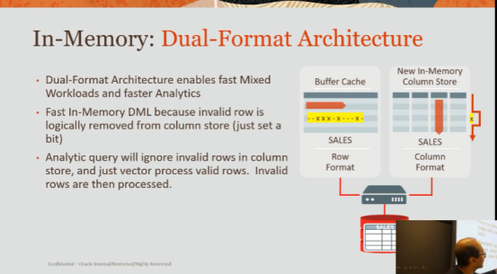

29:01 - 29:06
so here's my example, let's say I'm doing the full table scan

29:06 - 29:10
I just go route and I just sidestep that invalid row and I keep going

29:11 - 29:13
now what happens

29:13 - 29:17
I sidestep that row, but that's not giving me a consistent result now

29:17 - 29:19
I have to actually process that row
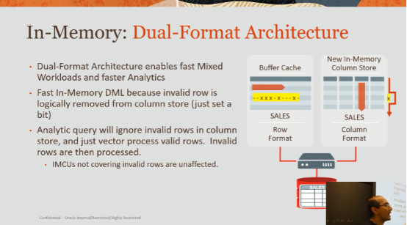

29:19 - 29:25
so just for that row, I will go to disk or the buffer cache to fetch that row

29:26 - 29:30
okay now in all likelihood is probably in the buffer cache

29:30 - 29:35
because I've updated it or I've done something , updating it brings that block into the buffer cache

29:35 - 29:39
and so I'm still technically processing at memory speeds

29:39 - 29:41
because the buffer cache is in memory

29:41 - 29:43
but I'm going against the row store

29:43 - 29:49
right ,now IMCUs not covering invalid rows are unaffected

29:49 - 29:53
so that's when you break up your data into blocks it's got a lot of value to it

29:53 - 29:54
the blocks aren't affected

29:55 - 29:59
they'll still go through a nice ,you know proper vector scan

29:59 - 30:01
the cindy scans that we just we just talked about
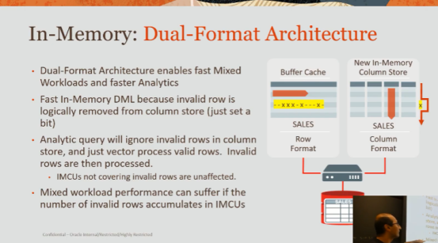

30:02 - 30:04
okay this is an important point

30:04 - 30:10
mixed workload performance can suffer if the number of invalid rows accumulates in your IMCUs

30:10 - 30:13
which goes to to your point over there earlier

30:14 - 30:16
if the rows start to get really dirty

30:16 - 30:18
then I'm just going to the buffer cache all the time

30:18 - 30:21
I'm not leveraging the the common representation
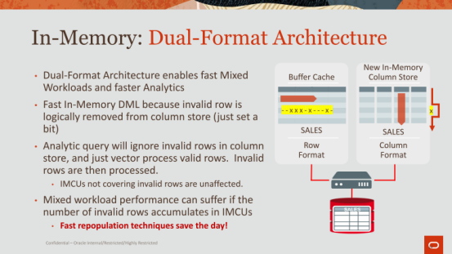

30:22 - 30:25
so this is where fast repopulation techniques save the day!
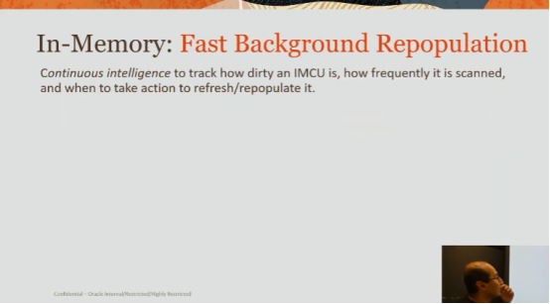

30:26 - 30:28
so let's go through let's explain this for a second

30:28 - 30:34
so we do something called continuous intelligence, okay this is actually an analyst herb

30:34 - 30:42
continues LH intelligence just means , that we will track how dirty your IMCU is, how and how frequently it is scanned

30:42 - 30:44
we do a combination of it

30:45 - 30:46
and I'll explain why

30:46 - 30:50
we care about both how dirty it is and how frequently does it scan

30:50 - 30:54
if your IMCUs super dirty lots of updates are happening

30:54 - 30:55
but you're never scanning it

30:56 - 31:00
I don't necessarily care to refresh it or repopulate it

31:00 - 31:01
no one's actually accessing it

31:01 - 31:06
so it's some combination of it ,that we have an algorithm for that decides ,when we should refresh it
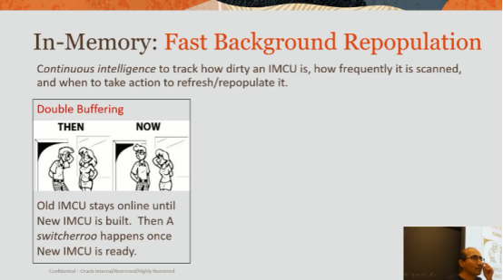

31:07 - 31:10
so the first technique we have is something called double buffering

31:11 - 31:16
so with double buffering the idea here is when you have an IMCU that's dirty

31:16 - 31:18
You need to refresh it

31:19 - 31:22
so we keep the dirty one around

31:23 - 31:26
and in the background, we'll create a new one

31:26 - 31:33
that brings in those dirty rows repopulate sit , and now has a nice fresh copy of the IMCU

31:33 - 31:36
and once it's ready, we do that switcheroo

31:36 - 31:38
and the old one goes out and a new one comes in

31:38 - 31:41
right the main reasons why we want to do this is

31:41 - 31:46
because we don't want your queries to suffer by taking it offline

31:46 - 31:51
every operation, if you if you learn a few things I guess in database classes

31:51 - 31:54
you really want to try to keep everything online

31:54 - 31:56
you never want to bring something down

31:56 - 32:03
and then suffer a slower performance ,while you're refreshing an index or in this case refreshing the IMCU

32:04 - 32:07
anybody understand that double buffering, okay
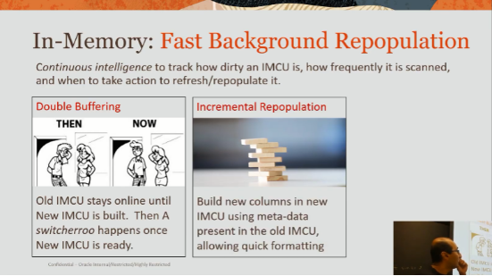

32:07 - 32:11
the second thing is incremental repopulation ,what we call incremental population

32:12 - 32:20
the idea here is you can construct a new column leveraging the information from the old column

32:20 - 32:26
so for example when you do a track, when you're actually going from rows store ,the column store ,is very expensive

32:26 - 32:29
population we call that population to bring it into the memory

32:29 - 32:33
the it's very expensive to identify the distinct symbols

32:33 - 32:39
you basically are going to use a hash table or an art you guys heard of art adapted radix tree and very ,okay okay

32:40 - 32:43
an index or something, yeah great extreme

32:43 - 32:46
you need something to identify give me my distinct symbols

32:46 - 32:48
it's expensive to do that

32:48 - 32:55
and so what you want to do is leverage the fact that , hey I have already created a dictionary before , I just have some some dirty rows here

32:56 - 33:00
so you leverage that to build the new C or the new column column CU

33:00 - 33:02
okay so that's incremental repopulation
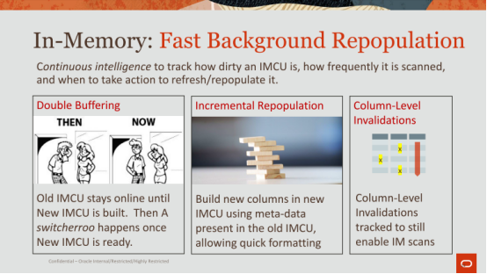

33:03 - 33:06
and the last thing here that we do as a little trickier

33:06 - 33:09
It`s oftentimes when you are invalidating a row

33:09 - 33:12
invalidating you're updating and deleting or whatever

33:12 - 33:16
you're really just touching a column or some number of columns

33:16 - 33:18
you're not actually touching all the columns

33:18 - 33:23
and so if you run a query that's unaffected by by the columns

33:23 - 33:26
because you're only accessing those columns that were not affected

33:27 - 33:29
then you can still go columnar, right

33:29 - 33:32
you don't have to worry about the accessing the invalid grounds

33:33 - 33:39
okay so these three kind of techniques here , allow us to really run mixed workloads faster

33:39 - 33:44
and it gives us this best of both worlds ,okay

34:00 - 34:03
no ,so that's so from the very beginning Oracle

34:03 - 34:07
we've always said that, you can't assume that everything's gonna fit in memory

34:07 - 34:08
that's just it doesn't not realistic

34:08 - 34:12
so so what happens is if you have a limit of whatever memory you have

34:12 - 34:16
you'll populate that bringing it to memory anything that doesn't fit will stay on disk

34:17 - 34:19
now you like I said you have the ultimate control

34:19 - 34:22
you can say which columns you want you can say which partitions you want whatever

34:24 - 34:25
no no

34:28 - 34:30
it's a it's a store it's a column store

34:30 - 34:31
so it's not a cache

34:31 - 34:38
now well I'll talk to you about how we're transitioning over to actually making it a cache ,when we're doing storage tiering and things like that

34:38 - 34:38
okay
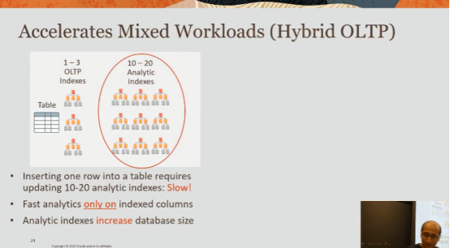

34:40 - 34:43
all right so far so good doing all right on time
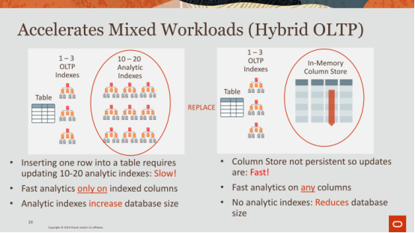

34:43 - 34:46
this is a very quick slide I'm just gonna skip through the animation here

34:47 - 34:49
and this is just telling you how question I'm sorry go ahead
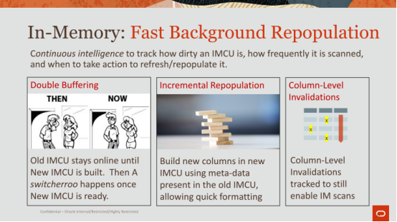

35:14 - 35:19
yes yeah so let me

35:19 - 35:26
okay so I think the question was is that , if you bring you sounds like you're bringing both the row row format column data, and the column their data into memory

35:26 - 35:31
and it sounds like that's inefficient to basically have two versions of your data and in memory

35:35 - 35:38
and you need to keep them in sync and up-to-date ,right okay

35:38 - 35:42
so so that okay so let me see if I can answer this appropriately

35:43 - 35:47
if you're depending on your workload, you might be an analytic heavy workload

35:48 - 35:49
if you're an analytic heavy workload

35:49 - 35:57
you're never going to bring the row formatted data into the buffer cache, make sense

35:57 - 36:00
you're only going to leverage what's in the column store,and you're done

36:01 - 36:06
if you're an OLTP heavy ,all you're doing is transactions inserts ,updates ,deletes

36:06 - 36:10
you're not doing joins or aggregations I think

36:10 - 36:14
you're never going to even bring it into the column store ,that makes sense

36:14 - 36:17
so so that's the the two extremes

36:18 - 36:23
now the middle ground is when you have some percentage of DML ,some percentage of scans

36:23 - 36:31
now where in memory is going to be beneficial is ,of course if you're more heavily towards the scans, than you are to the DML

36:31 - 36:35
now the DML is going to bring thing blocks into the buffer cache

36:35 - 36:37
but it's not going to bring the whole table into the buffer cache

36:37 - 36:39
so that makes sense

36:39 - 36:42
and so you are going to occasionally go down the row store

36:42 - 36:43
because you're just looking for a row

36:43 - 36:45
and you're gonna use an index to get to that

36:45 - 36:47
or you're gonna do analytics and go through all those

36:47 - 36:50
so that's the difference got it okay question

37:01 - 37:01
good question

37:02 - 37:07
so the question is is that since we don't bring it you don't have to bring everything into memory

37:07 - 37:11
what happens when you're doing a full table stand, and you're actually they access something that's not in memory

37:11 - 37:16
that's your question, so it's no different than what I was mentioning about the invalid rows

37:17 - 37:21
if you have an invalid row you have to go to disk to go get it

37:21 - 37:26
so it's the same concept , imagine you have so you filled up 50% of your data in memory

37:27 - 37:28
and you have those in IMCU

37:28 - 37:35
imagine you have the other 50% as empty IMCU or dirty IMCU

37:35 - 37:37
just you know if you can envision that

37:37 - 37:40
then you're always going to disk to fetch those 50% of the rolls

37:40 - 37:42
that's the behavior that you'll have

37:42 - 37:46
so you'll get everything that you can from memory the column store

37:46 - 37:48
and you'll get the rest from disk or the buffer cache, got it

37:49 - 37:52
remember and you can compress the hell out of these things

37:52 - 37:56
so you can fit as much as you can see you say so I didn't say that per pile

37:56 - 37:59
but you can't give you let's say what I want, okay

38:03 - 38:04
okay ,All right there it is

38:05 - 38:10
but you can you can compress it bringing it in until you want it bring everything you can into memory if you can

38:11 - 38:13
okay moving on all right
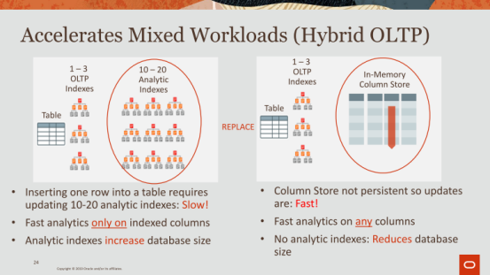

38:13 - 38:15
so this is I'll just blaze through this

38:15 - 38:19
but this is a very kind of a knob somewhat obvious point for me

38:19 - 38:21
because I explain it all the time ,but may not be so obvious to others

38:22 - 38:26
how do we get mixed workloads to run so much faster without doing much

38:26 - 38:28
but just having a calm store

38:28 - 38:31
so normally when you have a mixed workload

38:31 - 38:35
you'll have here's a table, you have one two three OLTP indexes

38:35 - 38:40
okay OLTP index again indexes on columns like key columns primary key columns

38:40 - 38:43
that you really quickly trying to get to the the values of

38:43 - 38:47
and then you have 10 to 20 analytic indexes

38:47 - 38:51
because for all the columns that you want to run analytics on you're gonna have a separate index for that

38:52 - 38:58
now you can basically fill away those analytic indexes all together and just maintain the column store

38:58 - 39:03
and anytime there's an update as I mentioned you can very quickly mark a bit

39:03 - 39:05
that says this guy's been update, this guy's been deleted

39:05 - 39:12
so because the memory the the updates are very quickly to indicate a DML has happened

39:13 - 39:22
okay and that's how and so now you don't pay the cost of updating all of these analytic indexes for every update ,that you have to your to your table
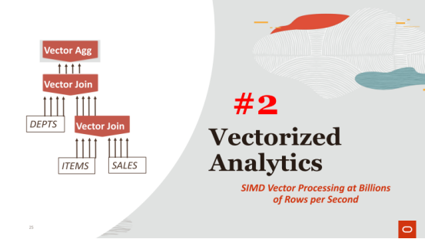

39:24 - 39:27
all right number 2

39:27 - 39:33
vectorize analytics ,so we touched upon this briefly right with the SIMD scans
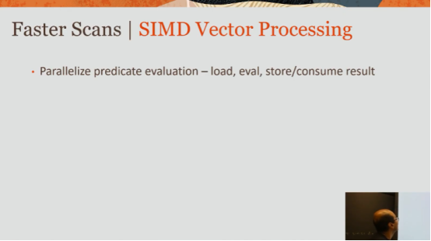

39:33 - 39:37
I'm gonna walk through that a little bit more in detail in terms of how that works

39:37 - 39:43
so paralyzed predicate evaluation - load, eval, store /consumers result

39:43 - 39:45
these are the steps that you take when you want to evaluate a predicate
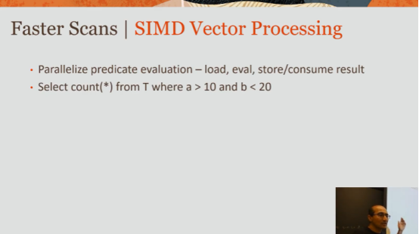

39:46 - 39:48
So let's just go through a quick example

39:48 - 39:55
so let's say you have this select count(*) from table T where a > 10 and B < 20 ,right
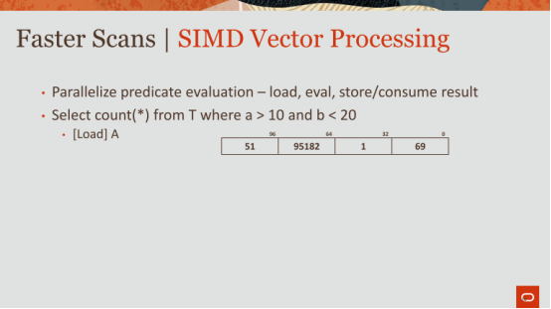

39:55 - 39:58
so the first thing you're going to do is you're going to [load] a

39:58 - 40:01
and you're going to for values into a SIMD eregister

