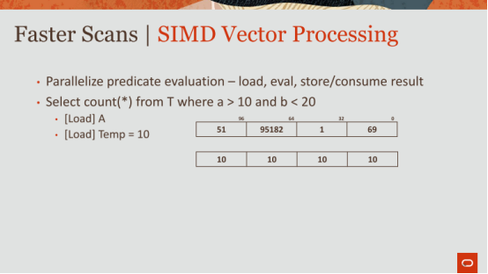

40:02 - 40:07
Right, then as I mentioned you're gonna splat 10 across that Cindy register
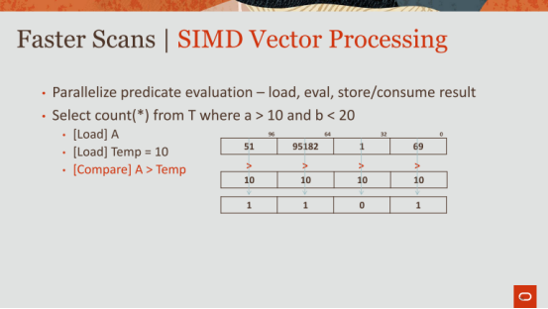

40:08 - 40:13
then you're gonna do a comparison ,greater than, greater than, greater than, greater than all in one cycle

40:13 - 40:16
and you got you know a bit back that says 1101
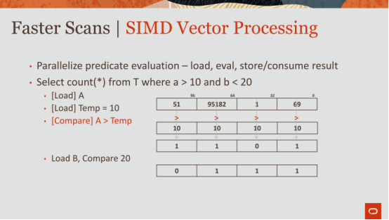

40:16 - 40:18
then you do the same thing for B

40:18 - 40:22
you load B you compare it to 20 ,and that's the bit vector that you have for it
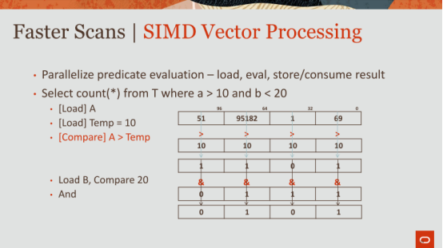

40:22 - 40:26
and now you just need the and those two bit vectors together

40:26 - 40:29
and now you have the final set 0101

40:29 - 40:32
now that is actually not completely done

40:32 - 40:38
because that's stored in a SIMD register 4 bits are stored in 128-bit register

40:38 - 40:41
I don't want to waste 128 bits to store 4 bits
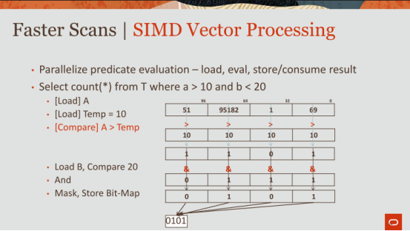

40:41 - 40:46
so you basically pack them, that's another instruction ,that the the Simeon structure set support

40:46 - 40:49
that packs them into just 4 bits literally 4 bits

40:49 - 40:53
and then you store that you know wherever or utilize that on, and then for the next predicate

40:53 - 40:59
so that's you know I a little more details of house SIMD operations work
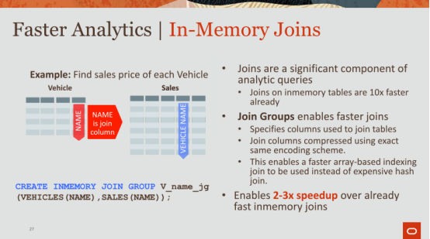

41:00 - 41:04
ok so not just scans, but we're also making joins faster

41:05 - 41:09
so bloom filters you guys are familiar with bloom filters

41:09 - 41:13
the way we make bloom filters even faster, it's a combination of things

41:13 - 41:17
we apply the bloom filter on the dictionary first that's the first thing

41:17 - 41:20
because you only need to run it on two distinct symbols

41:20 - 41:21
you don't need to run it on all the values

41:22 - 41:28
and once you run out on the distinct symbols ,you need to map them back to those symbols that map to those codes

41:28 - 41:32
second thing that we make bloom filters faster is we vectorize the operations

41:32 - 41:35
we use SIMD to basically do a set membership lookup

41:35 - 41:42
this says within the bit vector find determine if this value is set in this in this bit vector

41:42 - 41:46
this slide doesn't talk about bloom filters, this takes it to the next level

41:46 - 41:53
this is saying if you can tell me which two columns across two tables you plan on joining against

41:54 - 41:56
okay and that's what we call this join group

41:56 - 42:02
if you say hey you're going to join between vehicles and sales on this name column

42:02 - 42:05
now once you tell me that or tell us that

42:05 - 42:12
we will encode both of these columns using the same dictionary ,okay

42:13 - 42:17
without this we will we don't know that these two are related

42:17 - 42:22
and so we'll basically have a separate dictionary for this guy, a separate dictionary for this guy

42:22 - 42:26
and they can have different codes depending on how the IMCU are broken up

42:26 - 42:28
and so once they have different codes

42:28 - 42:32
they don't relate to each other anymore like code five here

42:32 - 42:34
doesn't match code eight here

42:34 - 42:40
even though five and eight are both out BMW or whatever, this is vehicles name that BMW whatever

42:40 - 42:45
so once you tell us this we will use the same dictionary to map the codes

42:45 - 42:49
and now you're just doing a code to code match

42:50 - 42:54
you're not doing a normal join you guys implemented a join, okay

42:54 - 42:57
so you know you guys a hash hash join

42:57 - 42:59
hash join drilling involves building a hash table

42:59 - 43:01
you're gonna have to hash the key

43:01 - 43:06
you got a insert into a hash table ,when you do a probe you guys again hash the key

43:06 - 43:10
you gotta do a key comparison ,you got follow chains all of that ,right

43:10 - 43:18
here it's just a okay code ten index into an array ,not null there's a match ,and that's it

43:18 - 43:21
and that whole thing can be vectorized

43:21 - 43:25
it's a very simple operation to do a lookup, that makes sense

43:30 - 43:34
yes yeah good question, so there there cases where we do things automatically

43:34 - 43:37
and then when I talk about the future we're gonna go to an extreme on this

43:38 - 43:38
okay
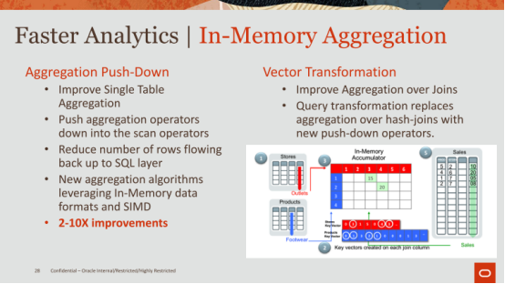

43:40 - 43:47
so that's joins aggregations ,we do the same thing that this the slides very detailed

43:47 - 43:50
so just follow my words and not necessarily look too much at this but

43:51 - 43:53
we have two forms of aggregation push down

43:53 - 43:55
this is single table aviation push down

43:56 - 44:00
this is something it's called vector transformations doing aggregations above a join

44:00 - 44:03
and it's kind of a you know this is complicated, right

44:03 - 44:06
this you can't make much meaning by just looking at this graph

44:06 - 44:09
but let's talk about this first

44:09 - 44:15
what we're doing here is imagine you have a select sum from this table with a predicate

44:15 - 44:19
right normally again with that volcano model, right

44:19 - 44:23
you're sending back every passing row to another operator

44:24 - 44:29
and that operator is then and adding, and adding, and adding, one row at a time

44:29 - 44:31
maybe there's a batch of rows at a time, right

44:31 - 44:38
but it's taking it's doing a couple of things ,one is it's doing it it's copying the symbol into a buffer

44:38 - 44:41
the other operator is reading that buffer

44:41 - 44:45
then it's looking up and aggregate and it's adding it it's it's quite expensive

44:45 - 44:50
what we're doing here is we're saying you know what let's leverage the format

44:50 - 44:52
this was dictionary encoded

44:52 - 44:54
and if it's dictionary encoded

44:54 - 44:59
we can use the dictionary codes ,and aggregate against the dictionary codes ,and the distinct symbols

44:59 - 45:02
and then we can do that all at the scan layer

45:03 - 45:08
and then only project back a partial aggregate result to the higher-level operator

45:09 - 45:13
okay so that's that's the techniques that we're doing aggregation I have an example

45:13 - 45:16
this vector transformation I'm not going to go into this all I'm gonna say is

45:16 - 45:21
again this is a paper that we have in I CDE 2018 I think

45:22 - 45:29
it's a very novel technique that basically pushes aggregations down and joins down into the scan layer

45:29 - 45:35
so basically instead of actually sending all these rows back up ,up ,up across the operators to join operator aggregation toppers

45:35 - 45:38
we do everything in the scan operator and that's that

45:38 - 45:40
I'm again I'm not gonna talk about that
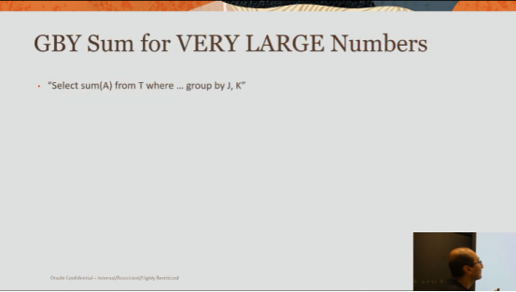

45:40 - 45:42
but I'm gonna talk about this this is kind of cool

45:42 - 45:46
something that you probably don't think about but we have to think about in industry

45:48 - 45:52
very large numbers anybody know how very large numbers are encoded

45:53 - 45:55
there's a variety different formats

45:56 - 46:02
and by very large I'm talking about like , let's say there are 30 plus digits you know

46:02 - 46:05
it's something that doesn't fit in 64-bit and a 64-bit register

46:07 - 46:13
Oracle supports a software implemented type for a number

46:14 - 46:18
you might think of a number is just the register a six an int or whatever right or long

46:18 - 46:21
We treat it as a sequence of bytes

46:22 - 46:27
okay when each set of each byte represents a digit up to 100

46:28 - 46:29
so it's it's its base 100

46:30 - 46:36
so you have the first byte indicates like an exponent as well as a the sign plus a minus

46:38 - 46:39
numerix ,okay

46:39 - 46:44
so this is but the and how its implemented you know how you guys it puts it okay

46:44 - 46:57
so so we basically have a in each operation on a number type is like hundreds of cycles, literally hundreds of cycles ,as opposed to one cycle for doing a simply a register operation

46:58 - 47:02
so let's walk through an example of how we support very large numbers

47:02 - 47:06
so imagine you have a select sum(A) from T where ... group by J,K

47:07 - 47:11
okay so you're doing a someone a grouping by J comma K
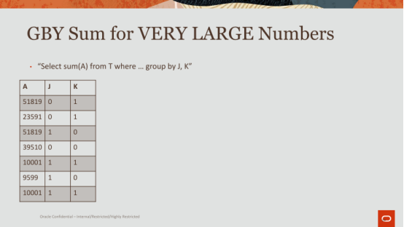

47:11 - 47:14
and let's suppose this is your table, okay

47:14 - 47:20
these are your grouping columns J and K ,and that's your measure column a

47:21 - 47:21
okay
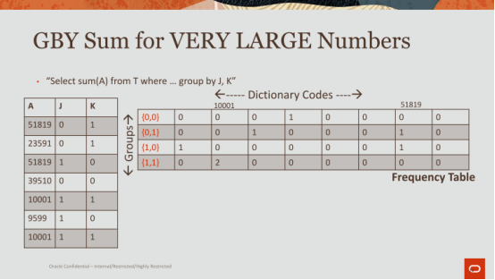

47:22 - 47:24
what we do is we create this frequency table

47:25 - 47:29
and this frequency table on the x-axis are the dictionary codes

47:30 - 47:32
these are imagine these are dictionary codes ,okay

47:32 - 47:36
they they map to actual symbols just for the for to illustrate this example here

47:37 - 47:43
so you're gonna have 0 1 2 3 and this is 10,000 and 1 all the way to 51819, okay

47:43 - 47:48
that's the x-axis, on the y-axis you have the groups the distinct groups

47:49 - 47:56
so the possible combinations of groups are {0,0} {0,1} {1,0} and {1,1} ,if you look at all these values over here
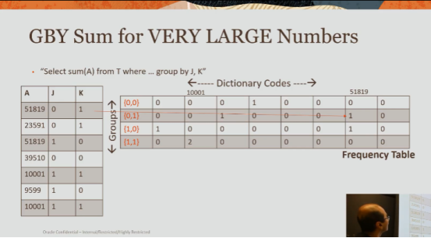

47:57 - 48:04
right now what we do is we walk through each row and we add a count

48:05 - 48:07
so if I go to {0,1} that map

48:07 - 48:11
so this group, I index into 51819

48:11 - 48:14
and I bump up a count here that says I've seen it one time
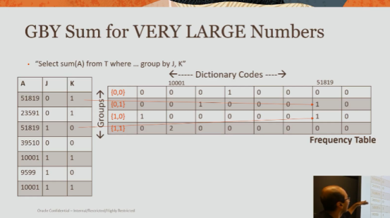

48:15 - 48:20
and I do the same thing for each one of these values 51819, again
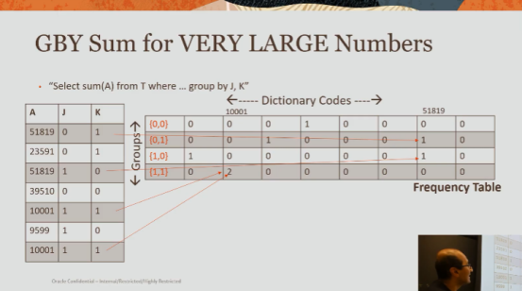

48:20 - 48:23
for the other group I bump it up ,I do this I bump it up

48:23 - 48:30
and in the end I basically have this table that says , how many times have I seen these dictionary codes for these different groups

48:31 - 48:33
everybody with me so far ok
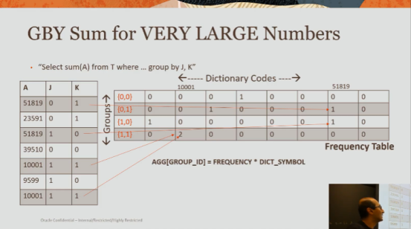

48:34 - 48:45
now what we do is we will aggregate across each group by multiplying the frequency times that dictionary symbol

48:46 - 48:50
so it will say code 0 shows up 0 times

48:50 - 48:54
so I don't need to multiply it ,but this guy shows up one time

48:54 - 48:59
so I need to grab its code look it up in the dictionary and multiply it
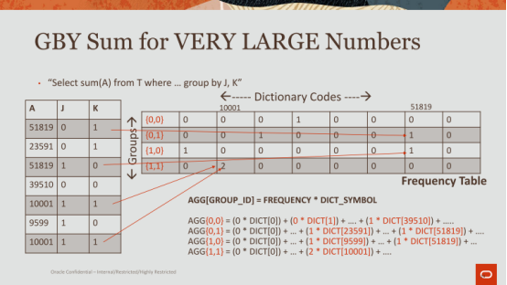

48:59 - 49:06
and so this is basically the operations 0 times the symbol plus 0 times the next symbol and so on

49:06 - 49:08
why do we do this ,question

49:31 - 49:36
If you mapping are you saying if the number groups is too large or if the number of dictionaries

49:38 -49:38
okay

49:42 - 49:42
got it

49:46 - 49:49
absolutely right so you bet you've identified some of the weaknesses of this

49:49 - 49:56
so the question was I think if I understand your question right, it's it's possible that you might have one everywhere here for example

49:56 - 50:00
because it's so diverse I guess it's the right word

50:00 - 50:06
and so you know every one of these codes only shows up one particular group, or maybe the show in all the groups or whatever it is

50:06 - 50:09
and so you basically end up multiplying everything

50:11 - 50:19
and that is a weakness of this it's it depends ,so it's it's a it it depends on the data and how the data is actually organized

50:19 - 50:22
in the case and also it depends on how many groups you have

50:22 - 50:26
if you have many groups , and this table stuffs become very large

50:26 - 50:28
because you have many distinct symbols and many groups

50:28 - 50:32
it's gonna be a very expensive operation to go through this for every single group

50:32 - 50:41
but just just to finish off where the idea here is ,is we're basically replacing addition with multiplication right

50:42 - 50:46
every additional if I have to add each one of these values up and sum up the same value

50:46 - 50:50
and if I can replace that if it let's say it's ten times five

50:50 - 50:54
I'd rather do ten times five as opposed to adding up five ten times

50:54 - 50:58
and this is like an obvious thing you would think about in terms of factoring

50:58 - 51:00
but it's very important for software implemented types

51:00 - 51:05
because each one of these operations is so many so many cycles 80 some cycles

51:05 - 51:11
so as you were saying it does depend on the workload in terms of when this actually kicks in or not

51:11 - 51:14
so that makes sense if I understand that one question again

51:15 - 51:22
the group so the groups can be analyzed by what by by walking through the columns of J&K

51:23 - 51:28
so you will as you walk through J you'll identify how many distinct symbols are in J

51:28 - 51:31
you walk through K how many distinct symbols are K

51:31 - 51:37
you multiply the two like kind of like a multi-dimensional array to get the max possible code

51:37 - 51:39
and that's the that's the table that you create

51:40 - 51:42
and then when you want to index into it

51:42 - 51:46
you take this and this multiply them together ,and that's how you index into the table

51:47 - 51:48
good okay
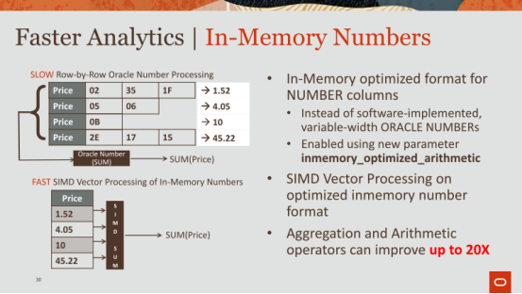

51:48 - 51:52
all right I'm gonna skip through several slides here in interest of time

51:53 - 52:00
so numbers joins are made faster remember expressions I'll skip over here
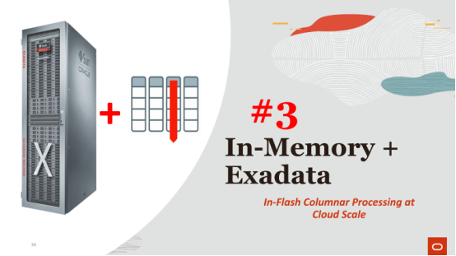

52:00 - 52:05
dynamic scans I'll skip , and I'll move over straight into this thing called a memory plus extra data

52:06 - 52:10
so this is number three where we bringing in memory into the storage tier
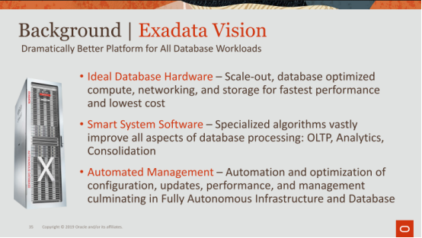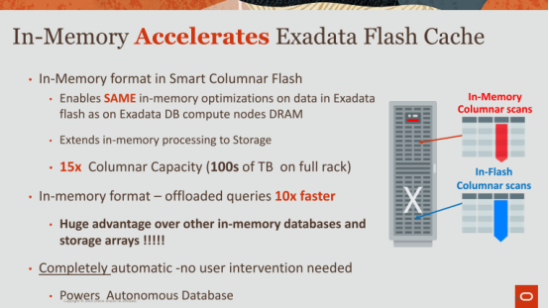

52:11 - 52:16
so with Oracle we have something called Exadata

52:16 - 52:23
Exadata is a database machine, that we build from scratch utilizing basically the best of reed hardware

52:23 - 52:29
so the fastest networking ,the best SSD drives ,a lot of memory a lot of flash ,right

52:30 - 52:35
we build that from scratch and we build it to run Oracle as fast as possible

52:41 - 52:44
that's a good question it's definitely in the millions

52:45 - 52:47
we've sell them in various different configurations

52:47 - 52:53
but it's definitely in the millions, but it's amazing how many people buy them

52:53 - 52:57
it's like amazing, it's a it's a billion-dollar business for Oracle

52:58 - 53:00
ok ok

53:01 - 53:07
so on Exadata you have the compute notes

53:07 - 53:10
and you have storage nodes ok

53:10 - 53:20
compute nodes is where all the higher level SQL operator processing happens joins, and aggregation, and sorting and all that jazz happens there

53:20 - 53:27
on the storage nodes is where you are closest to the data where it sits in the SSD drives

53:28 - 53:33
so that's where you can actually do some fast filtering here

53:34 - 53:41
and then only send back the rows that pass ,through the network to the compute nodes, right

53:45 - 53:46
correct okay

53:47 - 53:55
so what you had without in memory is we have also some flash that's sitting on these storage nodes

53:56 - 53:59
and how we use that flash as we use it as a cache

53:59 - 54:01
and this goes to what Andy was talking about earlier is that

54:01 - 54:11
there we actually have it as a cache in the sense that ,the hottest data that you're accessing ,will be moved from the SSD drives into the flash cache

54:12 - 54:18
and now you will and it will also be stored in a columnar representation

54:19 - 54:22
now the beauty of this is that on the compute nodes

54:22 - 54:27
you're limited to how much DRAM you have, like one and a half terabytes of memory ,which you might think is a lot

54:27 - 54:30
but in again real enterprises that's nothing ok

54:30 - 54:34
it's like a drop in the bucket ,you really need the hundreds of terabytes that flash gives you

54:35 - 54:40
and once you have all of that memory, you can basically do some really nifty storage tiering now

54:40 - 54:45
you can have some most of your hottest data sitting on your compute

54:45 - 54:48
and if you run out of memory ,no problem

54:48 - 54:53
it will automatically get populated into the flash cache sitting on the storage nodes

54:54 - 54:56
now how does a query work ok

54:56 - 55:05
so imagine you're doing a scan a full table scan says ,you know select from my phonebook , all people in my address that live in California whatever

55:05 - 55:07
it's going to go through here

55:07 - 55:11
it's gonna say ok I've exhausted everything that's over here

55:11 - 55:13
the rest of my table is sitting on my storage

55:13 - 55:16
and it's gonna say everything is cached into my flash cache

55:17 - 55:24
it will utilize the same vectorization techniques ,that we've talked about the same improvements ,that we make for joins and aggregations and so on

55:24 - 55:28
it leverages all of that ,it's just doing it from flash

55:28 - 55:33
and so you have to bring it from flash into the D that's local to that storage node

55:33 - 55:37
but then after that you do the same techniques and then you send it back up

55:38 - 55:40
maybe that makes sense

55:40 - 55:43
and this is just the form of storage tuning gives you a much larger column store

55:43 - 55:48
it allows you to place data where it belongs

55:48 - 55:51
hot data in the most expensive memory, that's the fastest

55:52 - 55:57
warm data in the flash cache ,and cold data sitting on your persistence store, right

55:57 - 55:58
on your on your disk
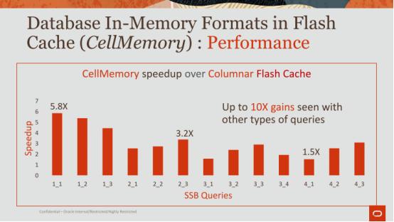

56:01 - 56:03
okay these are just some performance numbers

56:04 - 56:06
I think we can skip that
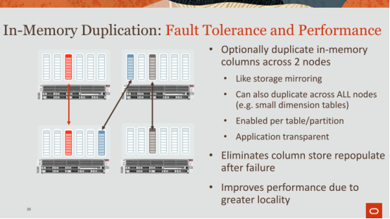

56:07 - 56:09
and we'll skip this

56:10 - 56:14
anybody interested in fault tolerance ,okay good okay

56:14 - 56:17
so let me tell you about how we achieve fault tolerance okay

56:18 - 56:23
on we basically maintain a cluster of nodes we call it rack

56:23 - 56:28
okay on the rack you can have many different nodes ,let's say 4 nodes in this example

56:28 - 56:32
and you have a column store on each one of these nodes

56:32 - 56:35
each one of these nodes has memory you can put a separate you can put a column store in there

56:36 - 56:41
what you can do is you can bring your data into this column store

56:41 - 56:44
and you can duplicate it on any one of these other nodes

56:44 - 56:48
so for example this red IMCU is duplicate on this node

56:49 - 56:52
and this blue is duplicate on that and black is duplicated there

56:52 - 56:56
and you can have at least two nodes that you can duplicate it against

56:56 - 57:02
so that if anything happens to this node, queries just need to be redirected to the node that has that IMCU

57:03 - 57:07
right it's really simple it's as simple as that

57:07 - 57:10
you can do even better by having full duplication

57:10 - 57:13
where this red IMCU is stored everywhere

57:14 - 57:18
and that gives you both availability as well as performance

57:18 - 57:23
performance because every access now when you go to it will be local

57:24 - 57:31
you're not doing a remote access to another node to fetch its contents to and run that query , everything is local

57:31 - 57:31
okay

57:32 - 57:37
so that's how we achieve photons is it's it's fairly simple and straightforward

57:37 - 57:43
every is the IMCU level ,every IMCU which is that half of a million rows gets duplicated


57:43 - 57:44
I'm gonna skip data guard

57:44 - 57:49
and I'll move straight to intelligent automation ,Andy how we doing on time okay

57:50 - 57:56
okay all right all right number 4 is intelligent automation

57:56 - 57:59
this is where we're trying to be a lot smarter

57:59 - 58:10
so far everything I've told you for the most part is the DBA , or you you know do you the user has to direct us in some way says

58:10 - 58:14
hey bring this table and turn memory ,or hey create this join group right

58:15 - 58:16
we want to be a lot smarter
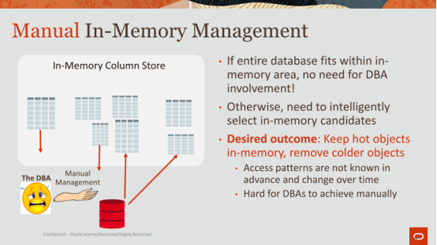

58:17 - 58:20
you guys were all work with Andy

58:20 - 58:24
Andy's the creator of self-driving databases Larry Ellison stole the name

58:25 - 58:25
I said

58:28 - 58:29
We made money out of it

58:30 - 58:35
so anyways so that's where we're moving towards right, self-driving databases

58:35 - 58:41
I have a separate talk later on today that that's talking more about how we achieve this

58:42 - 58:46
but the idea here here is here's a picture of this DBA poor DBA

58:46 - 58:54
and the DBA saying I have to manually manage what to put in this column store ,and what to keep out

58:54 - 59:00
I don't know what tables are hot ,I don't know what's cold ,I know it's warm ,I have no idea what queries you're gonna run, right

59:00 - 59:04
but as I as I mentioned earlier, it's a column store

59:04 - 59:08
so once this store becomes full of tables that's it

59:09 - 59:12
the DBA has to decide what to Vic tout what to bring in

59:13 - 59:20
right and the desired outcome here is you want to keep hot objects in memory, and remove the colder objects
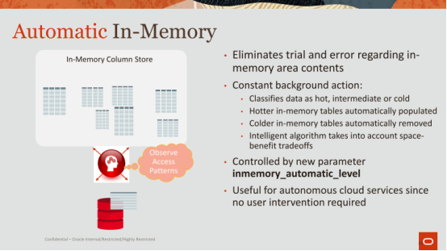

59:21 - 59:24
right so that's what we had ,okay

59:24 - 59:28
what we have now is something smarter, right

59:28 - 59:32
here we will observe the access patterns

59:32 - 59:34
we have something what we call a heat map

59:34 - 59:40
heat map basically says at the very smallest granularity which for us is a block

59:40 - 59:42
and the block has some number of rows

59:42 - 59:49
at the block level ,we will say how often has it been access, how hot is it, and how it's been accessed

59:49 - 59:53
well the access because it scans a DML what how, right
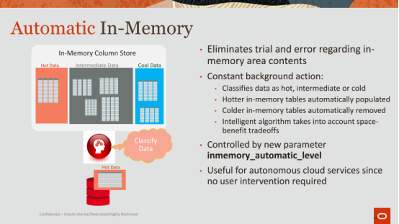

59:53 - 59:59
so we observe the access patterns ,once we observe the patterns will classify the data right

59:59 - 01:00:02
we'll say hot intermediate cool cool data

