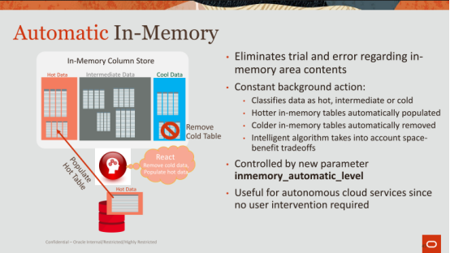

01:00:02 - 01:00:05
and once we classify the data then we take action

01:00:05 - 01:00:08
we'll bring in the hot data in will remove the cold data

01:00:09 - 01:00:11
very simple very straightforward

01:00:11 - 01:00:15
we take it to an even more complicated level

01:00:15 - 01:00:19
where we'll do it we'll do it not just at the table level or the partition level

01:00:19 - 01:00:20
But even at the column level

01:00:20 - 01:00:28
so we'll say something like this column is being used to aggregate on, its a measure column

01:00:29 - 01:00:33
and this column is being used to predicate on okay

01:00:33 - 01:00:40
now if I know that this columns for predication, or for predicates predicate evaluation, and this column is for aggregation

01:00:40 - 01:00:43
I could format them in a different way

01:00:43 - 01:00:49
I might use dictionary encoding for wine, and maybe another compressed format for the other

01:00:49 - 01:00:57
because dictionary encoding in order involves getting the code, looking up in the dictionary, getting the symbol, it's a couple of levels of indirection

01:00:57 - 01:01:01
and that's expensive, but it's really fast for scans

01:01:01 - 01:01:05
because I just need to look at the bit codes, I don't never I never have to decompress it

01:01:05 - 01:01:09
whereas aggregation, I need to actually go get that symbol from the dictionary

01:01:10 - 01:01:11
and then I need to add it

01:01:12 - 01:01:16
so why should I dictionary encode that maybe I should just keep it uncompressed

01:01:16 - 01:01:18
so I have the symbols right there

01:01:18 - 01:01:25
so this is where you can start becoming a lot smarter about knowing how your your data is accessed, how the columns are access ,how they should be formatted

01:01:26 - 01:01:30
maybe remember these maybe these four columns are never accessed

01:01:30 - 01:01:35
get rid of them ,compress them ,or if you want to be safe compress them, or evict them out of the column all together

01:01:35 - 01:01:43
okay so anyways so that's how we're trying to remove the guesswork out of the picture , and just start being a lot lot smarter

01:01:43 - 01:01:48
and this gets complicated, because you guys all work on with the buffer cache

01:01:49 - 01:01:55
imagine you have a mixed workload ,where sometimes you're going to run OLTP, sometimes you're gonna run analytics

01:01:55 - 01:01:58
how much memory do you dedicate for the column store versus

01:01:58 - 01:02:00
how much do you dedicate for the buffer cache

01:02:01 - 01:02:03
right how do you determine that

01:02:03 - 01:02:09
how do you know what the behavior is gonna be today versus tomorrow versus the next day and so on

01:02:09 - 01:02:16
so all of these factors have to come into play ,and you have to be very elastic and being able to switch from one to the other

01:02:16 - 01:02:18
and you have to be very very fast and accurate

01:02:19 - 01:02:22
no customer wants to move over to Oracle's autonomous database

01:02:22 - 01:02:25
and all of a sudden they experience worse performance

01:02:25 - 01:02:28
and be experience like inconsistent performance

01:02:29 - 01:02:31
those like those are two terrible things

01:02:31 - 01:02:35
if the very least you want to be consistently bad, that would be my sister

01:02:35 - 01:02:37
if you're gonna be bad be consistently bad

01:02:37 - 01:02:41
so that the user knows like ,okay at least I know what to expect today and tomorrow and so on
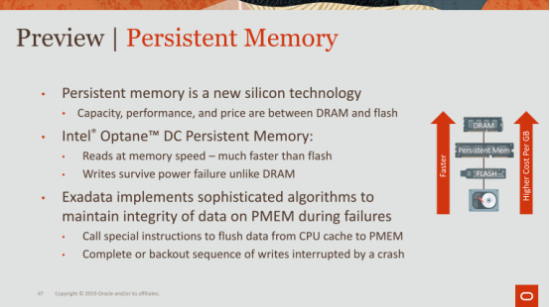

01:02:42 - 01:02:48
all right so um I'm gonna skip through some more things I will talk briefly about question

01:02:51 - 01:02:51
yes

01:02:53 - 01:02:59
so this is this is a finer grain, this is saying for example

01:02:59 - 01:03:05
when the column store is full, the action we could take is just evict out cold columns ,that's it

01:03:05 - 01:03:09
we never will decide what should go in to replace it

01:03:09 - 01:03:13
that's just based on your query, whatever you touch you bring in that's one mode

01:03:14 - 01:03:17
another mode is now will be smarter will evict and tell you what to bring in

01:03:18 - 01:03:21
and yet another mode is an extreme mode

01:03:21 - 01:03:25
that's where like hands off will do everything ,will decide from the get-go

01:03:25 - 01:03:27
what should be in the column store from the get-go

01:03:27 - 01:03:29
what columns should be in there or how to compress it and so on

01:03:42 - 01:03:48
we we just look at, we we just look at frequency NDB, right

01:03:48 - 01:03:52
that's all we really look at you could we do look at if it's a date column

01:03:53 - 01:03:57
for example let's give a date column, if it's a date column, we could be smarter in terms of how we encode it

01:03:58 - 01:04:01
we can code the month separate from the year from the dates and get better compression

01:04:02 - 01:04:07
if it's a number column ,we can impress them with a binary representation JSON ,we can do

01:04:07 - 01:04:10
so we do look at data types to compress them in a much more efficient representation

01:04:10 - 01:04:14
but we don't look at it to derive meaning out of it

01:04:14 - 01:04:20
now that's kind of another level ,once we once we have the queries together in the repository and we have the data

01:04:21 - 01:04:24
and we have access patterns, we can do things like that

01:04:27 - 01:04:29
I don't know if we're like I say we could do it

01:04:31 - 01:04:33
so we haven't actually done anything like that yet

01:04:34 - 01:04:39
because we'll see here's the thing is the data likely will be encrypted as it is

01:04:39 - 01:04:45
and so you know we can't do anything I'm not even an NDB even is difficult you can do it from the dictionary

01:04:45 - 01:04:46
but other than that again

01:04:47 - 01:04:49
any other questions ,question

01:05:03 - 01:05:08
great yeah great question, so that is that's kind of our expert system

01:05:08 - 01:05:09
I don't it's not machine learning

01:05:09 - 01:05:12
but it's like it's an expert system, it's taking to account

01:05:13 - 01:05:20
again but let's just take simplest metrics are ,how often has it been scanned ,how much space does it consume ,and how has it been scanned

01:05:21 - 01:05:23
those are kind of like the three very simple metrics

01:05:23 - 01:05:27
and from that you can divide design an equation

01:05:27 - 01:05:29
that meets a threshold and you optimize for

01:05:30 - 01:05:32
the other part of it that's missing is time

01:05:32 - 01:05:35
I think when wine has been access

01:05:35 - 01:05:39
you take all those into account ,and you've got a pretty smart system without anything more complicated than that

01:05:40 - 01:05:45
this you can go further, you can look at correlation between multiple columns correlation across multiple tables etc

01:05:48 - 01:05:49
question in the back

01:05:58 - 01:05:58
yep

01:06:07 - 01:06:13
Yep good question ,so the question is how do you determine when to bring it into the columns for automatically, right

01:06:15 - 01:06:17
but and when these opposite okay good question

01:06:17 - 01:06:21
so I'll answer the first and when to bring it into memory

01:06:21 - 01:06:23
it's again it's similar to what I was saying those attributes

01:06:24 - 01:06:26
if I know it let's say there's a table that's not in memory

01:06:27 - 01:06:28
And counselor is full

01:06:30 - 01:06:34
how often has this table been scanned, not that often

01:06:34 - 01:06:36
how often these tables been scanned at our memory very often

01:06:36 - 01:06:38
doesn't make sense to replace them

01:06:39 - 01:06:45
once the number of scans for this table has increased above what any of these are the tables have

01:06:45 - 01:06:49
then it makes sense to evict something out from the column store bring something in

01:06:50 - 01:06:55
but it's tricky right ,because you have to know is that just for a short period of time

01:06:55 - 01:06:57
and then it's not gonna be accessed again

01:06:58 - 01:07:02
and I paid all this I spent the last CPU cycles to transpose it bring into memory

01:07:02 - 01:07:07
and now I'm done like it's midnight ,and I don't need to run these reports again

01:07:07 - 01:07:13
so we try to be smart about identifying the access patterns before we take action

01:07:13 - 01:07:15
we're actually a fairly conservative system

01:07:15 - 01:07:17
and we will slowly make modifications

01:07:18 - 01:07:22
it's it's it's like any other system its expert system that you design

01:07:22 - 01:07:24
you're gonna have feedback mechanisms in here right

01:07:24 - 01:07:27
you're gonna say did I make the right decision ,that I just did

01:07:28 - 01:07:31
and if I didn't like I learned from that, I remember that

01:07:31 - 01:07:33
and the next time this situation comes again

01:07:33 - 01:07:36
I'll be smarter about what I would I bring in

01:07:36 - 01:07:41
I'll be honest with you this is not a perfect system, and there's a lot of work that needs to be done here

01:07:42 - 01:07:49
and that's where we're we're trying to figure out, what's the how do we get the 80% of the benefit with 20% of the work

01:07:49 - 01:07:50
so we can quickly get to it

01:07:51 - 01:07:53
it's a question of it

01:08:00 - 01:08:05 - 01:08:10
okay yes yes

01:08:14 - 01:08:17
yes so what we'll do this so the first thing we do let's say 0 & 1 are both hot

01:08:17 - 01:08:19
that's what you're saying right, they're both high

01:08:19 - 01:08:21
you don't have space for both 0 & 1 ,what do you do

01:08:21 - 01:08:25
first thing we do is we say which of these columns are not been accessed

01:08:26 - 01:08:30
okay , normally you have a table that's a very fat table or a fat table

01:08:30 - 01:08:33
okay let live like anybody familiarity TPCH

01:08:33 - 01:08:37
okay TPCH is a benchmark the data warehouse bench mic okay

01:08:39 - 01:08:42
okay TPCH has a table called line item

01:08:42 - 01:08:45
line item has a column called L comment

01:08:45 - 01:08:48
L comment is never used ,okay

01:08:48 - 01:08:50
in the in the queries that are in that particular benchmark

01:08:51 - 01:08:56
L comment for Oracle takes up about twenty percent of the space in memory

01:08:56 - 01:09:01
it's a gigantic varchar not gigantic varchar , but it's a large varchar string

01:09:01 - 01:09:04
and oracle is very aggressive

01:09:04 - 01:09:07
we will dictionary encode it ,which doesn't really make sense

01:09:07 - 01:09:10
because they're all distinct symbols, why the hell am I dictionary encoding

01:09:10 - 01:09:11
I'm not gonna leverage it

01:09:11 - 01:09:15
but we do that because we assume you might scan against it

01:09:15 - 01:09:18
and if you can scan against the dictionary encoding is the smartest thing

01:09:18 - 01:09:22
so going back to your example here is L comment is never used

01:09:22 - 01:09:24
line item is hot, that's a hot table

01:09:24 - 01:09:26
but that column L comment has never used

01:09:27 - 01:09:30
so will evict it out or compress it just to be safe

01:09:30 - 01:09:36
and just that act of compressing your victim out might allow you to bring this other table in, that make sense

01:09:37 - 01:09:44
so we will try to first be very conservative , and try to get both of those tables into the into the column store by compressing columns

01:09:44 - 01:09:48
okay if that doesn't work we take the next bigger action

01:09:48 - 01:09:50
if that doesn't work we take the next bigger action

01:09:50 - 01:09:53
it's very so for example, tables are usually partitioned

01:09:53 - 01:09:55
right you can partition by date

01:09:55 - 01:09:59
maybe the old dates partitions are needed and you only care about the hottest date

01:09:59 - 01:10:03
so you keep that in mind when you Vic the old dates out, that make sense

01:10:03 - 01:10:06
now if you're in a situation where both of these are hot

01:10:06 - 01:10:08
then then we stay conservative

01:10:09 - 01:10:12
we're not going to constantly populate we pick populate a vague

01:10:12 - 01:10:15
that's just gonna add more cycles to do the population

01:10:15 - 01:10:18
so we'll choose one and live live with the consequences

01:10:19 - 01:10:19
okay
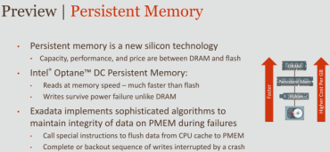

01:10:20 - 01:10:23
all right I know I'm like running our time here
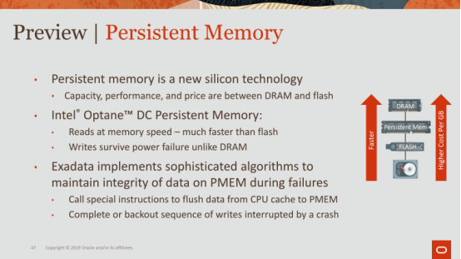

01:10:23 - 01:10:28
so I'm just going to up sorry sorry ,all right persistent memory okay

01:10:28 - 01:10:30
let's just talk very quickly about persistent memory

01:10:31 - 01:10:37
new silicon technology ,capacity, performance, and price are between DRAM and flash

01:10:37 - 01:10:41
this is a nice little picture here that shows

01:10:41 - 01:10:44
as you go from disk to flash to persistent memory the DRAM

01:10:44 - 01:10:46
you're going faster faster faster faster faster

01:10:46 - 01:10:51
but at the same time, you're going higher, cost higher cost ,higher costs per per gigabyte, okay

01:10:51 - 01:10:56
eventually PM is really expensive right now

01:10:56 - 01:10:58
it's really expensive, eventually this will reduce in price

01:10:59 - 01:11:01
but flash is going to be even cheaper also

01:11:01 - 01:11:07
so it's very interesting how we put systems together with all this technology to get the the best performance

01:11:08 - 01:11:13
Intel calls this Optane DC persistent memory DC's data center I believe

01:11:13 - 01:11:16
they're pretty much the only game in town right now

01:11:16 - 01:11:19
okay there's a there's others, but the only game in town right now

01:11:20 - 01:11:26
- reads that memory speed - much faster than flash
- Wirte survive power failure unlike DRAM ,okay

01:11:26 - 01:11:34
you can imagine building as and you're saying building a brand new storage engine ,built on top of persistent memory, right

01:11:34 - 01:11:37
it's tricky as heavy a key here

01:11:37 - 01:11:42
you guys he's gonna give a talk tomorrow on how you can leverage persistent memory

01:11:42 - 01:11:51
it can be tricky ,because it involves leveraging some new instructions to make sure , that data is properly flushed all the way back to to memory

01:11:51 - 01:11:54
I won't go into the details of that
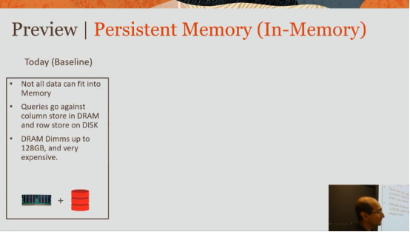

01:11:54 - 01:11:57
I will just bring up this

01:11:57 - 01:12:03
slide here on how we are planning on using persistent memory for our a memory column store

01:12:03 - 01:12:09
so today as a baseline ,you cannot necessarily fit all of your data in memory

01:12:09 - 01:12:11
that's the example or some of us we've been talking about

01:12:12 - 01:12:13
so assume it doesn't fit in memory

01:12:13 - 01:12:16
so you're gonna have disk disk plus memory

01:12:16 - 01:12:20
the queries then have to go against the column store DRAM

01:12:20 - 01:12:22
as well as the row store on disk ,right

01:12:23 - 01:12:29
and DRAM dimms can go up to 128GB, no one buys it at that it's very expensive
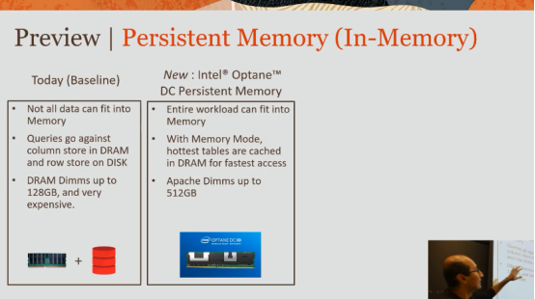

01:12:30 - 01:12:32
so that's today's baseline

01:12:32 - 01:12:39
with PM you can conceivably fit everything inside of a PM mmm Adam okay

01:12:39 - 01:12:41
it's 3x more denser

01:12:41 - 01:12:44
something called memory mode, this is really cool

01:12:45 - 01:12:51
memory mode Intel supports, it allows you to have a your persistent memory dimm

01:12:52 - 01:12:57
And a DRAM dimm sitting on top okay

01:12:57 - 01:13:02
so when you access data the DRAM dimm serves as a cache

01:13:02 - 01:13:06
so your hottest data sits in memory in DRAM dimms

01:13:06 - 01:13:12
and if it's not in that cache ,then we'll bring it from the persistent memory dimm into the DRAM dimm

01:13:12 - 01:13:14
so the DRAM dimm just serves as a cache

01:13:14 - 01:13:16
it's wasted space in the sense that it's a cache

01:13:16 - 01:13:19
it's not like extra memory that you have

01:13:19 - 01:13:25
but the benefit is you are accessing PM almost as fast as DRAM

01:13:25 - 01:13:27
okay so that's called memory mode

01:13:27 - 01:13:30
the hottest tables are cached in DRAM for the fastest access

01:13:31 - 01:13:33
and these DIMMs can be quite large the 512GB
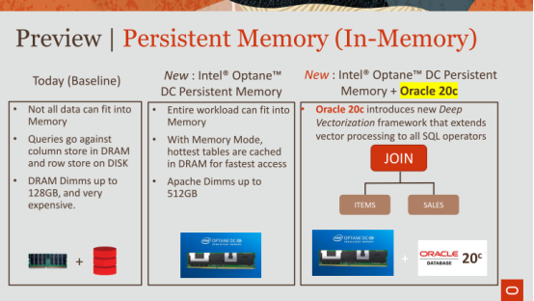

01:13:34 - 01:13:39
and then this just talks about using our latest Oracle 20c and some of the techniques
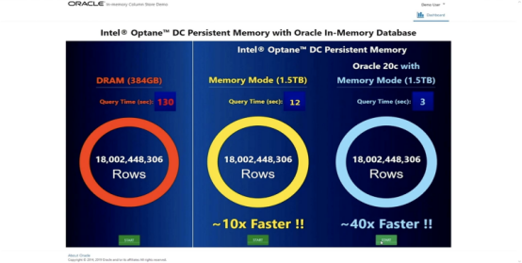

01:13:39 - 01:13:43
so the reason why I mention this is we ran this this benchmark, where we use SSD

01:13:43 - 01:13:48
SSD's another benchmark called star schema benchmark ,it's kind of based off of TPCH

01:13:49 - 01:13:55
and there we showed DRAM about 3804GB, the table didn't fit entirely memory

01:13:55 - 01:13:58
this was a progress bar but that completed

01:13:58 - 01:14:02
we process 18 billion rows and took 130 seconds, okay

01:14:02 - 01:14:04
when it didn't fit entirely in memory

01:14:04 - 01:14:07
and then we use memory mode with persistent memory

01:14:07 - 01:14:10
and it like dropped by 10 X right ,and 10x faster

01:14:10 - 01:14:12
and took 12 seconds to go to 18 billion rows

01:14:13 - 01:14:18
and then we just added Oracle 20c which has some cool techniques for making joints faster

01:14:18 - 01:14:22
and we just showed that that can go an additional you know 4x faster than that

01:14:22 - 01:14:25
and the main point I want to mention is ,this really is a game changer for us

01:14:25 - 01:14:31
we're looking at at persistent memory more as expanded memory, larger capacity

01:14:31 - 01:14:37
so now you could fit everything into memory and gone are the days where you need to put everything on disk

01:14:37 - 01:14:41
okay you got terabytes and terabytes and terabytes of memory

01:14:42 - 01:14:42
okay
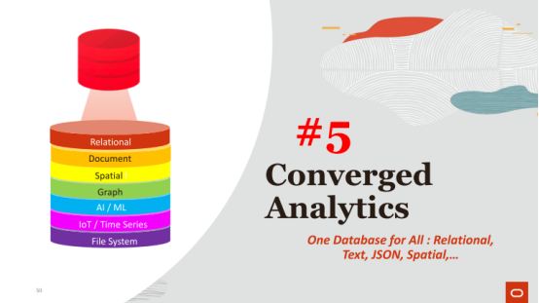

01:14:44 - 01:14:48
I'm gonna skip the converged analytics and I'm just gonna open it up to questions

01:14:48 - 01:14:50
but the main I'll just talk about this slide here

01:14:50 - 01:14:54
the main thing about Oracle, one of the things that we're trying to push Oracles

01:14:54 - 01:15:06
you don't need to have a separate storage engine for a document store or a spatial store Neo4j or graph or AI or IOT or ,you know treat your databases the file system

01:15:06 - 01:15:10
Oracle is trying to position itself as a one-stop shop right
Oracle试图将它自己定义为一种一站式解决方案
01:15:10 - 01:15:12
you can do everything on a single database
你可以在一个数据库上做所有事情
1.15.12-1.15.14
and it's got a ton of benefits
这有很多好处
1.15.14-1.15.16
,one being security
其中一个好处就是安全
01:15:16 - 01:15:25
you don't want to have to migrate your relational data out to bring it into yet a graph database ，just so you can run graph queries on it ,right
如果只是为了对你的数据执行可视化查询，你不会想将你的关系型数据移植到图数据库中

01:15:26 - 01:15:31
there's a the customer in Europe
之前有一个欧洲的客户
01:15:31 - 01:15:34
that they have a they build a graph database
他们构建了一个图数据库
01:15:34 - 01:15:42
and they use a graph to represent transactions between different people on their PayPal system
他们使用一张图来表示他们Paypal系统中不同客户间的交易
01:15:43 - 01:15:47
and they every every edge in their graph node is a transaction
他们图中节点之间的每条线就代表了一笔交易
01:15:47 - 01:15:52
but they have to take their data out of a relational store bring it into the the graph store
但他们需要将他们关系型数据库中的数据放入图数据库中
01:15:52 - 01:15:53
and then they run their query
然后，执行他们的查询
1.15.53-1.15.56
,and that takes one sometime in second
这要花些时间
01:15:55 - 01:15:57
there's always this security violation
这通常是违反安全的
01:15:57 - 01:16:02
now because you're taking this unencrypted data out of the database
因为你从数据库中取出了这些未加密的数据
01:16:02 - 01:16:04
same thing for a document store
对于文档型数据库也是如此
1.16.04-1.16.06-
with MongoDB this MongoDB
以MongoDB为例
01:16:06 - 01:16:11
you can also store JSON nicely inside of your relational database
你也可以很nice地将JSON保存到你的关系型数据库中
01:16:12 - 01:16:13
okay

1.16.13-1.16.15
so I'm not going to talk so much about this
So，我不会对此谈论太多
01:16:15 - 01:16:21
I'll just sort of skip through this and leave it at that, okay
我会跳过这些幻灯片，我们来看下这张幻灯片
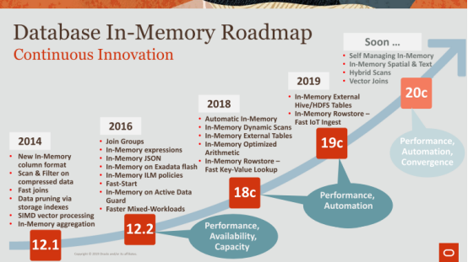

01:16:21 - 01:16:23
so last thing is just this is this innovation summary
So，最后我要向你们展示的就是这样创新摘要
01:16:24 - 01:16:26
I want to make it very clear that
我想向你们清晰地展示这些创新点
1.16.26-1.16.29
,you know this is 2014 when we came out
这是我们2014年推出im-memory功能时所做的创新
01:16:30 - 01:16:34
all of these little bullets here are like kind of massive projects
这里所列出的都是些大型项目
01:16:34 - 01:16:38
and Oracle is kind of committed to in memory
Oracle致力于发展in-memory产品
1.16.38-1.16.44
, and you know our roadmap going up ,so I'm kind of drawing it up higher from 20 to 21 scenes so on

01:16:44 - 01:16:52
we're super committed, because we feel like now's the time in memory is becoming, readily available, it's becoming, cheaper it's becoming larger

01:16:53 - 01:16:58
the hardware technology is all there the requirements again from the real time enterprises is there

01:16:58 - 01:17:00
and so as a result our features need to be there

01:17:01 - 01:17:06
and the main drivers for us are the self managing in-memory database, everything needs to be autonomous

01:17:07 - 01:17:11
really looking at everything not just relational, but spatial text graph etc

01:17:12 - 01:17:19
and also vectorizing all of our operators is not just our simple scans and so on ok

01:17:19 - 01:17:24
I think that's it, I'll skip that, I'll skip that ,I'll skip that

01:17:24 - 01:17:27
and open it to any questions you may have if you have any

01:17:36 - 01:17:36
yeah

01:17:47 - 01:17:48
great question

01:17:48 - 01:17:58
so the question is how do how are we representing this as a single representation of your data, when you want to use it for a graph Corre versus a relational query, or is it like a you know multiple representations

01:17:58 - 01:17:59
I had that right okay

01:17:59 - 01:18:04
so I went through those slides very quickly , but let me explain

01:18:05 - 01:18:09
so what we do for graph or let's say I'll say JSON initially right now for text okay

01:18:09 - 01:18:14
so the techniques that we're doing for text spatial JSON whatever it is

01:18:14 - 01:18:21
It`s representing the data in a much more efficient manner in a in memory in a column store

01:18:21 - 01:18:26
so it's kind of like think of dictionary encoding ,doing some tricks like that to represent your data more efficiently

01:18:29 - 01:18:29
yeah

01:18:35 - 01:18:43 question
like this how important you're looking to hire somebody , would be he would have a background maybe testing database systems or query optimization

01:18:43 - 01:18:44
oh yeah a great question okay

01:18:44 - 01:18:48
so when I when we look to hire people

01:18:49 - 01:18:58
okay so first thing is this I always look for people that are enthusiastic smart and excited about the technology, that's that's first and foremost

01:18:58 - 01:19:00
because we have we have mathematicians

01:19:00 - 01:19:01
we have a mechanical engineer

01:19:01 - 01:19:02
we have a chemist

01:19:02 - 01:19:05
we have all sorts of people that working on database systems

01:19:06 - 01:19:10
the folks that actually have a solid background in database systems however

01:19:11 - 01:19:17
they that's like I don't know it's what's the word the Holy Grail in some in some ways

01:19:17 - 01:19:21
because we interface with we're the core storage engine team

01:19:21 - 01:19:23
but I interface we interface with the optimizer team

01:19:23 - 01:19:25
we're going to face with the exudative team

01:19:25 - 01:19:27
we interact with the hardware team

01:19:27 - 01:19:30
I have a background in compilers in computer architecture

01:19:31 - 01:19:34
so I didn't have a background database systems at all

01:19:37 - 01:19:37
okay

01:19:37 - 01:19:43 question
you have two candidates equal background honking one is a JavaScript programmer

01:19:43 - 01:19:43
okay

