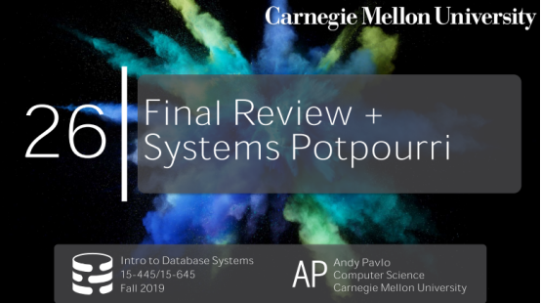

00:17 - 00:19
all right last class and it's snowing
最后一堂课了，还是个雪天

00:20 - 00:22
DJ drop tables thank you
再次感谢我们的DJ drop tables

00:24 - 00:27
so I noticed you don't have your deck today ,what happened
我看你今天没带家伙事儿，出啥事儿了

00:29 - 00:32
yes you had to buy her a gift now
你得给她买个礼物

00:33 - 00:34
yeah so what'd you do
你干啥了

00:35 - 00:40
you sold your deck ,yeah how you gonna how you to drop the beats now
你把家伙事儿卖了，那你现在怎么打拍呢

00:45 - 00:46
but this is getting interfere with your album now right
这会影响到你的专辑
00:49 - 00:51
how long you don't have anything
那得多长时间能缓过来啊
00:55 - 01:01
all right well he's got his problems ,we we have database problems
他遇到了他的问题，而我们有数据库的问题
01:01 - 01:05
but this is the last class and as I said it's just gonna be the final review
这是最后一堂课了，我这作个期末总结吧

01:05 - 01:06
and then a system Potpourri
顺带提下System Potpourri

1.06-1.09
what you guys voted on for what you want to be talked about
以及投票选下你们想要听我讲些什么
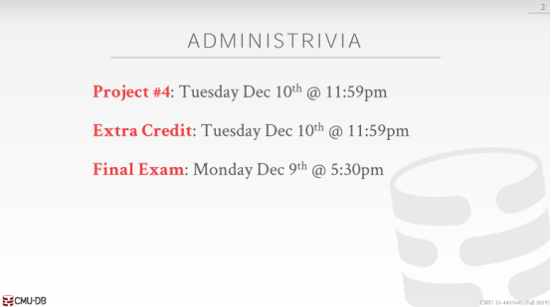

01:10 - 01:13
so just real quickly the remaining things for the semester
So，快速看下这学期我们剩下的东西
01:13 - 01:15
project 4 is due next week on the 10th
Project 4会在下周的时候截止
01:16 - 01:18
and it's way off when's the 10th is that Monday Wednesday
你们记得10号是周一还是周三么？
01:18 - 01:20
it's not even close right
现在你们还有一定的余裕
01:20 - 01:26
so Tuesday December 10th with the the final project , and the and the extra credit will be due
10号的时候，Extra Credit也会结束
01:27 - 01:29
we promised you feedback
我们会给你们写下反馈
01:29 - 01:31
we found people plagiarizing
我们抓到了一些抄袭的人
01:31 - 01:32
so we have to deal with that first
So，我们必须先处理掉他们
01:32 - 01:40
and then we'll hopefully be able to put out, the reviews for the feedback for everyone else within like the next day or so okay
我们希望我们会在截止后的一天放出我们对你们每个人的反馈
01:40 - 01:42
so apologize for the delay
So，要原谅下这种延迟
01:42 - 01:45
over all they were pretty good ,some are better than others obviously
总的来说，你们都做的不错，有些人做的要比其他人更好
01:45 - 01:48
but the feedback will help guide you to finish it up yes
但这些反馈会指导你让你做的更好，请问
01:52 - 01:55
so you remember how when you filled out the form you know click the check box
So，你还记得当你填写表格的时候，你点了checkbox
01:55 - 01:59
yes I agree I'm not gonna plagiarizing , big they still plagiarize, yes
你表示，你同意你不会去抄袭，但有些人还是抄袭，请问
02:02 - 02:05
well the very least zero
Well，最差情况就是0分处理
2.05-2.08
, where I go talk to the Provos or not that's another story,yeah
我会和其他负责这块的人讨论下，但这就是题外话了
02:10 - 02:13
again CMU does around they take this seriously
再说一遍，CMU会严肃对待这件事情
02:13 - 02:15
and the fact that I made you check click that check box
并且，我告诉你们让你们点checkbox这件事
02:15 - 02:18
and it's on video saying me saying don't plagiarize
我已经用视频记录下来了，我跟你们说过不要抄袭
02:18 - 02:19
you don't have any evidence
你没有其他证据能反驳我没说过这句话
02:20 - 02:23
not you understand whoever did it yeah yeah

02:25 - 02:31
and then the final exam is due on a Monday Dec 9th after you going back to extra credit
期末考试会在12月9号的时候举行
02:31 - 02:33
this is why we have it's like a wiki stylus ,we have revisions
这其实就像是wiki那样，我们会有多个版本数据
02:33 - 02:38
so the person could go back and try to remove the text
So，人们可以回到之前的版本，并移除掉文本
02:38 - 02:39
but it's still in the Databases
但这些数据依然是在数据库中的
02:39 - 02:41
we can go see always go see it anyway
我们始终能看到这些数据
2.41-2.42
again not you ,but in general
你不一定能看到这些数据，但总的来讲，是可以看到的
02:42 - 02:48
all right final exam is on Monday at 5:30 p.m. in posner hall
All right，期末考试是在周一下午五点半的时候举行
2.48-2.51
I which I think is over there ,the old business school
我觉得应该是在老的商科学院那里
02:53 - 02:55
yeah so that so we'll cover that first okay
So，我们会先去讲这这块内容
02:55 - 02:57
so any questions about the extra credit or project 4
So，对于Project 4或Extra Credit你们有任何问题吗？
02:58 - 03:06
and then for homework five, we will have that graded and released by Friday , whatever I think he was due yesterday
再讲下Homework 5，我们已经打好分，我们会在周五的时候告诉你们成绩如何，Homework 5应该是昨天才截止的
03:06 - 03:07
so four days after that
So，应该是在4天后，我会给出你们的成绩
03:07 - 03:09
unless everyone has already turned them in we'll send it out, okay
除非所有人都已经交了，我们才会立刻发布你们的成绩
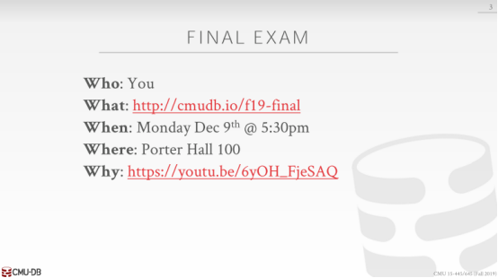

03:12 - 03:14
all right the final exam
All right，来讲下期末考试
03:14 - 03:15
all right

3.15-3.16
so you have to take it
So，你必须参加期末考试
3.16-3.20
,uh or you don't have to,but you should
或者，你也不一定要参加，但你应该要参加
03:20 - 03:23
this is not published yet ,but I'll post this after class
我还没将它发布出去，但我会在课后发布这个
03:23 - 03:29
this will be basically a summary of everything that I've talked about like ,it's the the same thing, I did for the midterm
这就和我在期中考试前所说的一样
03:29 - 03:34
it's like the sheet of everything you need to know, what chapters in the book ,what homeworks matter and things like that
你们可以去带一张纸，纸上可以写满你需要用到的那些知识
03:34 - 03:37
again posner hall 100 at 5:30 p.m. don't come to this room
考试的地点是在Posner Hall 100，考试时间是在下午5点半，所以你们不要来这个教室参加考试
03:37 - 03:40
and then if you're curious why you should take this other than you want to pass the class
除非你只想及格线飘过，不然你别好奇为什么我让你们带这张纸
03:41 - 03:41
you can watch that video
你可以去看下这个视频
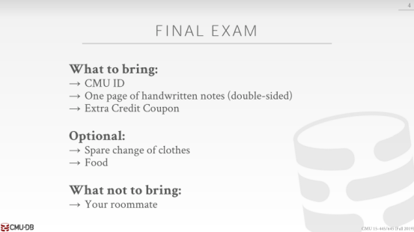

03:42 - 03:44
all right so what do you need to bring
So，你们需要带哪些东西呢？
03:45 - 03:46
you should bring your CMU ID
你们应该带你的CMU学生卡
03:46 - 03:50
because it's Class of 95 people or 96 people, I don't know I know everyone
因为选这门课的人有95个或者96个，我没法一一说出你们的名字
03:50 - 03:51
so I need to check your ID
So，我需要检查你的学生卡
03:51 - 03:56
this like the midterm it's one page of handwritten notes double-sided,
就和期中考试一样，你们能带一张双面写满笔记的纸
3.56-3.59
no shrinking down the slides, no copy and pasting the text
没必要直接把幻灯片给复制下来，也不要复制粘贴某些文本
03:59 - 04:03
if you write it by hand on your iPad，want to print that that's okay
如果你是在iPad上手写了这些笔记，你想将它们打印下来，这是Ok的
04:03 - 04:07
but again just know like text text ,right from a word processor
但不要是从Word那些软件上打印下来的文本
04:07 - 04:13
and then if you were in the class on Monday bring your extra credit coupon
到了那天，你需要携带你的Extra Credit Coupn
04:13 - 04:16
and you have to turn that in when you turn in your exam
你考试的时候，必须上交这个东西
04:17 - 04:19
so the thing is you optional
So，再来讲下Optional部分
4.19-4.20
if you want to change your clothes halfway through
如果考试中途你想换下衣服
04:20 - 04:22
somebody did that two years ago, I'm fine with that
有人两年前这么干了，我是无所谓
04:22 - 04:26
because also it's at 5:30 ,uh you could bring food
因为考试的时间是在下午五点半，所以你可以带些吃的
04:26 - 04:27
I think there's will give our candy
我觉得他们会提供些糖果给你们
04:27 - 04:28
I'll try to do something better than that
我会试着提供些更好的东西
04:28 - 04:30
but don't you know I can't can't promise anything
但我没法保证什么
04:30 - 04:33
right it's not gonna be a full four-course meal before the exam
考前准备的,也不是什么像样的四种吃的

04:34 - 04:39
what not to bring again , I think we talked about all the problems on the midterm everyone brought weird stuff in previous years
别啥都带，我们在期中的时候说过那些事，前几年有人带进了奇怪的东西
04:40 - 04:44
two years ago again ,so when you brought the roommate, just to hang out ,don't do that okay
就两年前，有人把室友领进来了，还只是闲逛，别干这事了，好吧
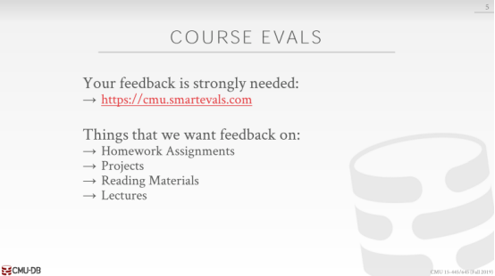

04:47 - 04:52
all right before we get into the the course material for that for the for the exam ,yes sorry go ahead
在我们开始了解考试的课程资料之前， 你先说

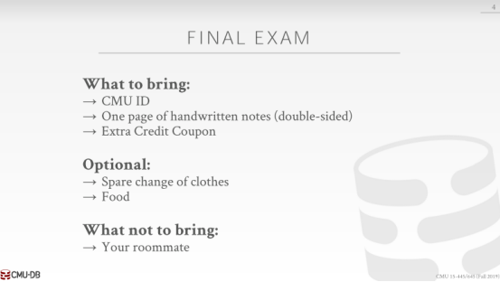

04:55 - 04:58
is that what pH means all right then yeah I did whatever that is yes
PH么，哦哦 是的

04:59 - 05:02
hey where's Porter Hall oh that's the one over there yeah
Porter Hall吗，那就是那边的人

05:02 - 05:04
if it's not gates, I don't know where it is right
如果不是那个门的，我就不知道对不对了

05:04 - 05:06
I'll be honest that this is my seventh year

05:08 - 05:13
okay so right so the announcer some Piazza as well

05:14 - 05:16
I need everyone to fill out the course evaluations
我需要大家填写课程评估

05:16 - 05:18
I don't care whether you say I'm an awful person
我不在乎你说我是一个可怕的人

05:18 - 05:21
I have bad hygiene or you hate the class, that actually is useful to me
我不讲卫生或者你讨厌这个课，实际上对我有用

05:22 - 05:25
I you know I actually read these things
实际上我读到过

05:25 - 05:31
so the things that I mentioned in getting feedback from or like , was the particular mark assignment you thought was unnecessary or stupid

05:32 - 05:38
anything about the projects ,you've seen my announcement of Piazza , that we're looking for people to help with expanding busTub further
关于project 的事，你已经看过我在Piazza 的公告，就是我们要招人来扩展BusTub项目。

05:38 - 05:41
you know fixing all the things and maybe went wrong this semester
修复所有东西，可能是这个学期的错误

05:41 - 05:44
but if there's again something about the project that you thought was too hard
但如果有你认为比较难的project

05:44 - 05:45
the pacing was not right
寸步难行的那种
05:45 - 05:48
you wanted more documentation ,less documentation into that was too easy too hard
你想要更多文档的话就比较容易了

05:48 - 05:51
again that feedback is actually super useful to me
这种反馈对我来说很有用

05:51 - 05:56
all right so undergrads are awesome at at filling out course evaluations
本科生在填写课程评估时就很好

05:56 - 05:57
like, if your stinks they'll tell you
就像：如果你有体味，他们会告诉你

05:58 - 06:03
the master students you guys , you guys to click five five five five on everything ,Andy's the great professor
研究生呐，评估里无脑选5，啊安迪贼牛逼

06:03 - 06:04
I don't want any that the right
我不想这样

06:04 - 06:08
just like I actually read this ,the university apparently reads it too
我能读到，学院那也能读到

06:08 - 06:09
I don't care about them
我并不在意

06:09 - 06:11
but I actually make the course better based on your feedback right
基于你们的反馈我会更好的备课

06:12 - 06:16
one year a kids psychoanalyze me with a Myer Briggs test in the feedback， that was useful
有一年，一个小伙子在反馈中用 Myer Briggs test 精神分析我，挺有用的

06:17 - 06:20
so again please go for the cell and I'll send a reminder on Piazza

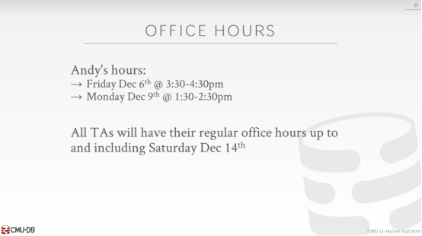

06:21 - 06:24
all right so I didn't have office hours on Monday
周一我不在办公室

06:24 - 06:29
but I'll have office hours extra office hours this Friday at 3:30 in my office
但 周五下午3:30 我会在办公室

06:29 - 06:34
and then I'll have my regular office hours at 1:30 on the day of the exam
在考试当天下午 1:30我在

06:34 - 06:36
if you can't make either of these and you're dying to talk to me
如果你这2个时间都不行

06:36 - 06:38
please send me an email and I'll try to make arrangements
请给我发邮件，我会尝试安排

06:39 - 06:44
I may have to like do it over Skype or hangouts , because because of the thing the baby
我可能需要用Skype 和hangouts ,因为有宝宝的事

06:45 - 06:50
and then all the TAs will have the regular office hours up until and including September December 14th
所有TA 都将在常规办公时间截止到9月14日，包括9月14日

06:51 - 06:55
right so the due date for the project 4 is on the 10th
project 4的截止日期是 10号

06:55 - 06:57
they're gonna get for late days, so it'll go out into the 14th
他们会晚几天。就是到14号

06:58 - 07:01
ok any questions about office hour stuff
关于办公时间，还有问题吗
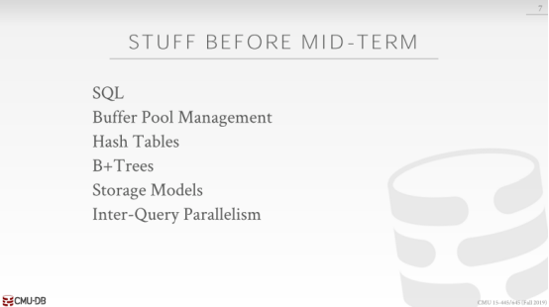

07:03 - 07:08
alright so this always comes up every year , what do you need to know from before the midterm
每年都会提到的事：期中考之前，你想知道什么

07:08 - 07:13
so the exam is not cumulative meaning like, I'm not gonna ask you questions specifically about like buffer pools, right
考试不会超纲的，比如我不会问你buffer pool 的问题

07:13 - 07:15
you know what how does this eviction policy work
像 buffer pool 的清理机制

07:15 - 07:18
but you obviously didn't know ,you know it's a part of a DBMS
但是你显然不知道,它是DBMS的一部分

07:18 - 07:22
we've covered through the full stack , you need to know how all these different pieces work together
我们覆盖了全部堆栈，你需要知道所有的这些部分如何在一起工作

07:22 - 07:34
so the things that you have to know about from the previous prior to the term would be the buffer Pool management ,hash tables, B+trees ,storage models and then Inter-query parallelism, which is again running multiple queries at the same time
你必须在这个术语前了解已下：buffer Pool management ,hash tables, B+trees ,storage models 和 Inter-query parallelism ，它同时运行多个查询

07:34 - 07:36
and you obviously didn't know how that works
而你还不知道那是怎么运行的

07:36 - 07:38
because you have to do transactions, I could be updating the database at the same time
因为你要做事务，同时我要更新数据库

07:39 - 07:44
ok so this is clear , we're not asking you separate questions， like in the earlier homeworks before the midterm
我们不会单独问你问题，比如期中之前更早的家庭作业那样

07:45 - 07:49
but this is background knowledge that you just you know if you forgot this already you have other problems ok
这些就是考试范围了，如果你忘了，那就是你的问题了

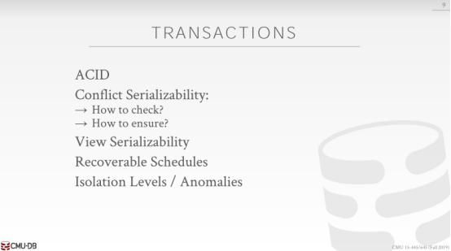

07:51 - 07:54
all right so the main thing we spent time talking about was about transactions
我们花时间谈论的主要是事务

07:55 - 07:59
right you should be aware of what the basic concept of ACID
你应该了解 ACID的基本概念

07:59 - 08:01
what the different properties that are combined in the acronym
这些缩写里组合不同的属性

08:01 - 08:03
and what the data's meant is supposed to provide
数据应该提供什么属性

08:04 - 08:11
then we did a we talked about the difference between conflicts serializability and view serializability ,number of you serializability, nobody can actually do
然后我们讲了 conflicts serializability 和 view serializability的区别

08:11 - 08:14
so there's no way to actually check this, it's just a higher level concept
没有方法来验证它，它是一个高级的概念

08:15 - 08:17
but for conflicts serializability you want to know how to check this
但是对于 conflicts serializability， 你想知道怎么验证这个

08:17 - 08:24
and how the database system can ensure that it generates a schedule ,for you know that's guaranteed we conflict serializability
数据库怎样确保它生成计划，来保证我们的 conflict serializability

08:26 - 08:29
what it means to have a recoverable schedule, right
这意味着我们要有一个可恢复的调度

08:29 - 08:30
amazing basically means no cascading aborts
就意味着没有级联终止

08:31 - 08:35
and then isolation levels and the anomalies

08:35 - 08:38
right ,dirty reads ,unrepeatable reads and phantoms
脏读、不可重复读、幻读
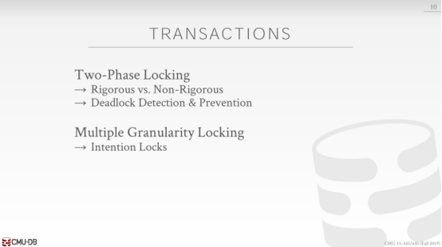

08:41 - 08:51
then we talk about concurrent protocols to actually generate schedules on the fly for arbitrary transactions, that are conflicts are reliable

08:52 - 08:55
so we spent a whole class talking about two things locking
我们花了一整堂课来讲这两件事

08:55 - 08:57
so you know what the basic protocol is
你知道了基本协议是什么

08:57 - 09:00
but the difference between the non rigorous and rigorous one is

09:00 - 09:03
what's the difference , what is rigorous two phase locking mean
有什么区别，严格的两阶段锁是什么含义

09:06 - 09:07
in the back ,yes
来，你说

09:09 - 09:12
thanks Man ,yeah so rigorous is you've released all the locks at the end

09:12 - 09:15
there is no shrinking phase ,regular two-phase locking

09:15 - 09:19
so as you release one block then you're now in the shrinking phase ,and you can't acquire any new locks

09:20 - 09:25
then we talked about multiple granite multiple mostly granularity in locking ,right
然后我们讲到了 多粒度锁

09:25 - 09:27
and the big thing there was the intention locks
大部分都是 意向锁

09:27 - 09:36
right how do I notify or how do I post information about , what I'm gonna do at the lower levels of the lock hierarchy in the upper level

09:36 - 09:37
so I don't have to take me locks on everything
我不用锁定所有

09:38 - 09:44
right if I have to take a lock on if I want a go and update a billion tuples , and my tables at billion tuples
如果我想去更新一百万的 tuples ，以及所涉及到的表

09:44 - 09:49
I better up just taking a single lock on the table , rather than locking every single individual tuple
那我最好一个锁加在表上好过加在每个tuple 上

09:50 - 09:55
and then important to know how you release these locks, like in what order is it top down or bottom up
然后重点是 怎么释放这些锁，比如 自上而下或自下而上

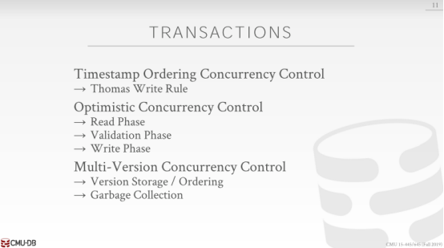

09:57 - 10:01
then we spent a lecture on talking about timestamp ordering concurrency control ,alright
接着 我们讲了 timestamp ordering concurrency control

10:02 - 10:06
so you know what the Thomas Write rule is the base of protocol that we talked about
你知道 Thomas Write rule 我们提到协议的基础

10:06 - 10:08
then we spent time talking my optimistic concurrency control
然后花时间讲了 optimistic concurrency control

10:08 - 10:12
what are the three phases ,read phase, validation phase and write phase
它有3个阶段 read phase, validation phase 和 write phase

10:12 - 10:15
when do we actually acquire a timestamp for transaction in these different protocols
我们何时获取这些不同协议的事务时间戳

10:17 - 10:19
in the basic timestamp ordering what when you get a timestamp
在 basic T/O 中何时获取时间戳

10:22 - 10:24
when the transaction starts
何时开启事务，

10:24 - 10:26
in optimistic control, when you get a timestamp,
在 optimistic control 中何时获取时间戳

10:28 - 10:28
what`s that
你说啥？

10:29 - 10:31
when you validate yes when you finish the write the read phase
当你验证时，当你完成写、读步骤时

10:32 - 10:34
then we talk about multi-version concurrency control
然后我们讲了MVCC

10:34 - 10:36
I'm not gonna worry so much about the

10:36 - 10:44
again the the concurrency control protocol of that you would use in MVCC, like either you know MV 2PL or MV OCC
你在MVCC中使用并发控制，比如你知道的 MV 2PL或MV OCC

10:44 - 10:51
I'm more care about the Version storage / ordering of the Delta records are doing the pen only or you're doing the time travel tables
我更多关心的是 Version storage / ordering

10:51 - 10:52
and then how you want to do garbage collection
然后是你想怎样做GC

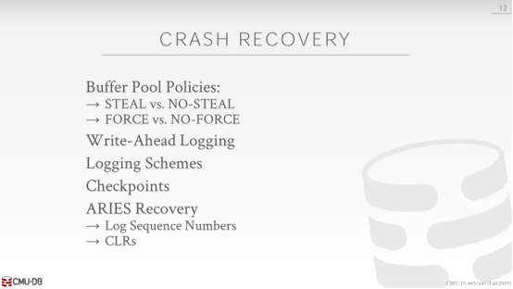

10:56 - 10:58
then we spend all the time talking about crash recovery
接着我们讲到了 crash recovery

10:59 - 10:59
question yes
你说

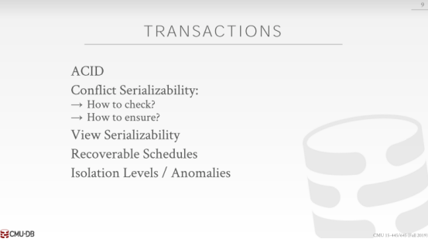

11:06 - 11:12
right so the isolation levels again it's uh it's it's sort of a the very top you have serializable isolation
隔离级别最高的是 可序列化 级别

11:13 - 11:18
and then below that you have repeatable read ,below that you have read committed, and below that you have uncommitted read
接着是 可重复读，然后是读已提交的，最后是读未提交的

11:19 - 11:21
and so basically as you go down that hierarchy
基本上就是这个层级结构

11:22 - 11:29
the the DBMS is not enforcing or protecting you from different entities certain kind of all not anomalies
DBMS不会强制执行或者保护你免受不同实体的的异常

11:29 - 11:33
so if your Serializable isolation ,then you don't have phantoms
如果你是可序列化 级别，你就没有幻读

11:33 - 11:35
you don't have dirty reads and you don't have unrepeatable reads
也没有脏读和不可重复读

11:35 - 11:40
but then if you go down to repeatable read ,then you're not gonna do phantom checking
但是你调到可重复读，你就不会做幻读检查

11:41 - 11:47
if you go down to read committed ,now you're not doing , now you're not doing on repeatable reads
如果你调到读已提交的，你就不会做可重复读

11:48 - 11:52
and then read uncommitted read or read uncommitted is is no protections
读未提交没有保护

11:53 - 11:53
yes

11:57 - 11:59
so question is it's snapshot isolation when we levels
他的问题是 快照隔离级别是哪一层

11:59 - 12:01
snapshot isolation is a weird one
快照隔离级别是特殊的一个

12:01 - 12:09
it is it's almost a throg '''l to some answers no it's not in that main hierarchy
答案是 它不在主流的隔离层级

12:10 - 12:12
if you take the advanced class we'll discuss a bit further
如果你选了高级课程，我们将进一步讨论它

12:12 - 12:17
but basically in 1992 ,when they invented , when they came up the ANSI standard for these isolation levels
基本上在1992年，当他们发明并提出这些隔离级别就成了ANSI标准

12:18 - 12:23
the guy that was supposed to double check the other guy, didn't double check that they missed snapshot isolation
那些人应该是没有仔细检查，就落下了快照隔离

12:23 - 12:30
so there's an anomaly that can occur on our snapshot isolation , that the that cannot occur the other ones
我们的快照隔离可能发生异常，不能发生另一个

12:30 - 12:33
and but the ANSI standard doesn't support it
但是 ANSI标准不支持它

12:33 - 12:36
you don't the worry about that, just go with the ANSI standards
你不用担心那个，只是ANSI标准

12:36 - 12:41
so serializable, repeatable read ,read committed, uncommitted reads, read uncommitted
所以只有 序列化、可重复读、读已提交、读未提交
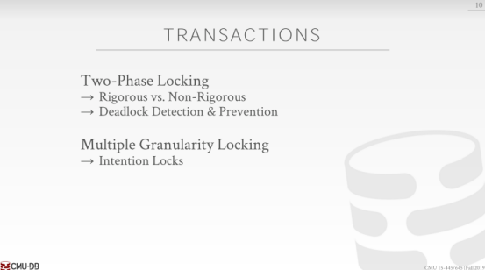

12:45 - 12:52
yes snapshot isolation is a it's not a straight hierarchy the tree actually way more complicated
快照隔离级别不在这个树形结构层次，实际上是更复杂的

12:52 - 12:55
but we'll cover that meet in the advanced class if you take that
如果你感兴趣，我们会在高级版课程提到

12:55 - 12:57
the auntie ones are fine for the for the final exam

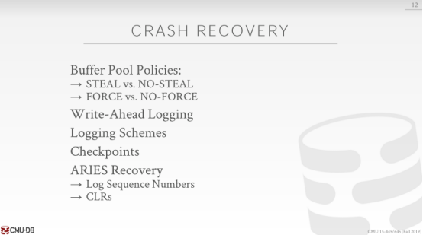

12:58 - 13:00
alright so we talked about crash recovery
我们来讲 crash recovery

13:00 - 13:06
we talked about the different puffer Pool policies steal vs no-steal ,what a steal mean
我们讨论了 缓冲池策略 steal和no-steal的区别， 那这个steal是什么意思

13:11 - 13:11
yes

13:16 - 13:24
So she said ,so with steal policies means that, a the DBMS was allowed to write dirty records or dirty pages out the disk from uncommitted transaction
她说，steal策略就是 允许DBMS 把 未提交的事务的脏数据或脏页写入到磁盘

13:24 - 13:26
under no-steal you're not allowed to do that
no-steal就是不能作这种事

13:27 - 13:31
and forces and no-force somebody other than Paulina
那forces 和no-force 区别呢？ 有人回答吗 Paulina

13:37 - 13:45
correct so she said you have to write all you have to write all dirty records out to disk, before transactions allowed to be saying that it's committed
她说 在事务提交之前，你必须把所有肮数据写给磁盘

13:45 - 13:47
and then under no-force you don't have to do that
no-force就是不能作这种事

13:48 - 13:52
so with write-ahead logging is it using steal vs vs no-steal
write-ahead logging它使用了steal策略还是no-stral粗略？

13:54 - 13:57
just no-steal, no sorry it's already using steal ,wrong ,right
no-steal策略吗，不它使用了 steal 策略，你答错了

13:57 - 14:05
because the with write-ahead logging I have to make sure that the log records , that correspond to the changes to the data the data pages
因为 write-ahead logging 中我需要做日志记录来应对数据页的修改

14:05 - 14:08
the log records have to be written to disk ,before my transactions a lot of commits
日志记录必须在事务做提交之前写到磁盘

14:08 - 14:14
but I'm allowed to at some later point write out the the dirty records, you know after the transactions already committed
但是我允许在事务提交之后写入当数据

14:15 - 14:16
Which means that it's also no force
哪一个是 no force 策略

14:19 - 14:21
we talked about different logging schemes
我们说了不同的logging schemes

14:21 - 14:24
the main distinction I care about is logical vs physical
我关心的主要区别是逻辑日志还是物理日志

14:25 - 14:33
right physical is where you're actually writing out the the the low-level bits or bytes ,that got changed to the database system in your log records
物理日志实际上是在底层写出 bits 或 bytes，来更改DBMS中的日志记录

14:34 - 14:37
and then logical log and you're just writing a high-level command that made the change
逻辑日志，您只需编写高级命令来更改

14:37 - 14:39
so like the SQL query
就像SQL 语句

14:39 - 14:40
and so there's trade-offs these things
这些东西是有权衡的

14:40 - 14:47
right so if my query is gonna update a billion tuples , with logical logging all I have to have is that update query in a single log record
如果我的语句要更新十亿个tuples ，那使用逻辑日志，我只需要在单个日志中更新更新

14:47 - 14:51
and that'll battle that's enough information for me to record what change that made
这些信息足够记下我的变化

14:51 - 14:57
and physical logging, I have to have a billion log records that correspond all the change I made to every single tuple
而物理日志中，我必须有十亿条日志记录来对应我修改的每个tuple

14:59 - 15:01
then we talked about how do you checkpoints
接下来说下检查点

15:01 - 15:06
so you should know about the sort of the difference between the fuzzy vs no-fuzzy right
你应该知道fuzzy 和no-fuzzy的区别

15:07 - 15:14
fuzzy means that I'm allowed to write out inconsistent data to the database system or to the disk , when I'm taking the checkpoints
fuzzy 的意思是，当我到检查点时，我可以将不一致的数据写入到数据库或磁盘

15:14 - 15:19
but I need to know what was going on at the time in my system , when I when I'm taking the check point
但是当我到检查点时，我需要知道我的系统中发生了什么

15:19 - 15:22
So that I can reconcile after recovery
我可以在恢复之后调和

15:22 - 15:28
what pages may or may not gotten written , during the checkpoint or may have been modified , while I was taking the checkpoint
在检查点期间时，哪些页可能会被写入，哪些页可能不会写入
或者在我处理检查点的时候被修改过。

15:28 - 15:31
right in the in the non fuzzy checkpoint case
no-fuzzy检查点那

15:31 - 15:35
they're basically stopping the world for a brief period while you write everything out
在你把一切写出来的期间，它基本上让系统短时间内停一会

15:35 - 15:38
so that way you're guaranteed to have a consistent checkpoint
这样你就可以保证有一个一致的检查点

15:39 - 15:42
and then we talked about ARIES recovery for a lecture right
接下来我们用一节课的时间讲了 ARIES recovery

15:42 - 15:46
what are the three phases ,like the analyze ,the redo and the undo
有三阶段：analyze 、redo 和undo

15:46 - 15:48
so you know how far back in the log

15:48 - 15:50
you need to look at for each of those phases potentially

15:52 - 15:56
right it should know about the conversation log records ,when you write them, when you read them
当你读或写的时候，它应该有会话级别日志记录

15:58 - 16:02
right if I have a compensation log record in my log ,and I apply it, but then I crash, before I you know finish my recovery ,when I come back around the second time ,do I need to make another CLR for that first one
如果我的日志中有一个补偿日志记录，并且我应用了它，但是我崩溃了，在我完成恢复之前，当我第二次回来时，我是否需要为第一次创建另一个CLR

16:11 - 16:13
no right because you've already done it
不用了，因为你已经做过了

16:13 - 16:16
the CLR has information to tell you how to how to undo the original update
CLR有信息告诉你如何用undo原始更新

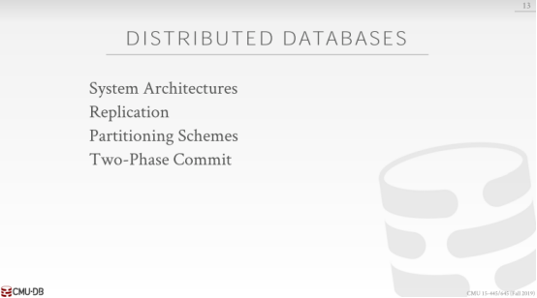

16:20 - 16:24
all right and then we briefly talked about distributed databases
让后我们简单的说了分布式数据库

16:25 - 16:30
you know that we can't obviously go real deep into this ,beyond what was what was covered in homework 5
我们显然不能学的更深入，对于作业5优点超纲了

16:31 - 16:37
so this you know about the different system architectures we talked about, shared everything, share disk, shared memory, shared nothing
我们讨论了不同的 system architectures ，共享一切，共享磁盘，共享内存，什么都不共享

16:37 - 16:40
what are the trade-offs for these or when would one be better than another
这些都有什么取舍，或者啥时候一个比另一个好

16:41 - 16:45
how did we actually gonna do replication and in these different environments at the distributed environment
我们实际上是如何在分布式环境中的这些不同环境中进行复制的

16:45 - 16:49
how do we make sure that the the database system is fault tolerant
我们怎样确保DBMS的容错

16:49 - 16:53
how to make sure that database system，if we're making updates is consistent ,across all the copies of the data
如果我们刚好在更新的时候，如何确保数据库系统中数据在所有副本中保持一致

16:54 - 16:56
how we do partitioning
我们怎样分区

16:56 - 17:01
again high level things you know we talk about hash partitioning, what are the benefits of them how to actually find the data you need
在高层级上我们讨论hash partitioning，它的优势是什么，如何找到所需数据

17:02 - 17:03
and then two-phase commit
然后是两阶段提交

17:03 - 17:09
you know under what circumstances, you know at what steps would you do at different phases of the protocol
在什么情况下，在协议的不同阶段你会采取什么步骤

17:10 - 17:14
don't worry about Paxos , that's too hard for for final exam in databases
别担心这个，这对数据库期末考试来说太难了

17:16 - 17:16
okay

17:18 - 17:19
so any questions about the fire
这还有什么问题么

17:19 - 17:23
to sweeten the deal, I forgot to announce this earlier

17:23 - 17:27
if you take the final exam , when you turn it in, I will give you a busTub sticker
如果你参加期末考试，当你交卷的时候，我会你个busTub 贴纸

17:27 - 17:29
you can put on your laptop okay
你就可以贴在你的笔记本上

17:29 - 17:31
we have enough for everyone
我们有足够的量给每个人

17:32 - 17:32
yes

17:36 - 17:40
this question is what is the duration of the exam, it will be the same as the midterm
这个问题是 考试考多长时间？它和期中考试一样

17:40 - 17:42
but you have three hours
但是你有3个小时

17:42 - 17:44
and there's always somebody who takes three hours
总有人要3个小时的

17:46 - 17:48 - 17:52
yeah yes yes

17:55 - 17:57
yes who questions question is will they be present yes

17:57 - 18:03
when I post the review guide, I will post a same way I did in the midterm I post the practical exam, yes
我会发布复习指南，和其中考试一样，发布实践考试

18:05 - 18:08
these will be my own choice yes ,it's easier to grade
这些将是我自己的选择，评分更容易

18:10 - 18:10
yes
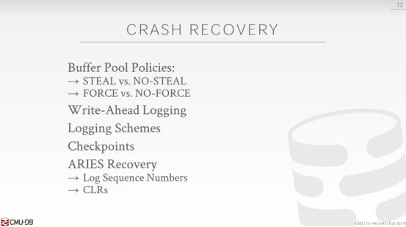

18:18 - 18:26
all right ,so this question is I made the distinction between force vs no-force or steel vs no-steel , would there be a case where you would have won like, won't you won't want to use one
这个问题是，我区分了 force 和 no-force 策略，steel 和no-steel 策略 。。。。。

18:28 - 18:34
so no I think you have to be one you have to be sort of like steel no-force or no-steel force ,right
不对，我想你想要排组合 比如 steel no-force 或者 no-steel force

18:34 - 18:35
we talked about shadow paging
我们讲下分页

18:35 - 18:39
shadow paging was an example of no-steel force
分页是一个no-steel force 的例子

18:39 - 18:43
because I wasn't allowed to over write dirty pages from uncommitted transactions

18:44 - 18:48
because I had this shadow copy on the side I was making all my updates there

18:48 - 18:51
right so that's that's that's the no-steal part

18:51 - 18:55
and then the fourth part is when my transaction went to kokum it with shadow paging

18:56 - 18:58
I had to make sure all those dirty pages were flush to disk

18:58 - 19:08
and then I flipped the pointer the root pointer to now , you know point to the the old the new the shadow becomes the new master ,when I do that I make sure I have to make sure everything's all have already flushed

19:08 - 19:14
so again write-ahead logging is steel no-force, shadow paging is no-steel force

19:16 - 19:26
and then the the the main takeaway was that the read-ahead logging it is ,almost always I can't think of maybe some cases I haven't thought of it , it's almost always better

19:27 - 19:30
and it's what every system uses ,most systems

19:35 - 19:35
any other questions

19:38 - 19:38
yes
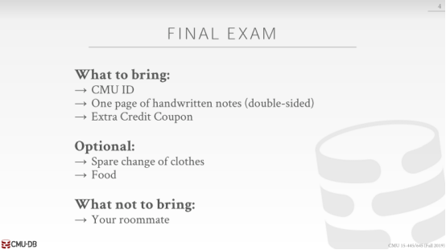

19:41 - 19:46
yes so this question is unlike the midterm do I not need a calculator I forgot to highlight that yes

19:46 - 19:47
you do not you don't need it

19:48 - 19:52
I can think of what we did in the homeworks ,we didn't estimate joins we didn't

19:54 - 19:57
yeah I don't think it like it live is that

