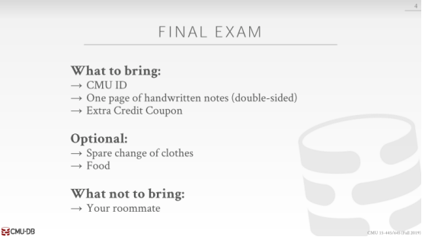

19:58 - 20:01
there we no questions on like query optimization stuff

20:01 - 20:05
that's the only thing I can think of may need a calculator,right say don't worry about that

20:08 - 20:09
you know the questions

20:10 - 20:10
yes

20:18 - 20:21
like two phase locking stuff or about the hierarchy

20:24 - 20:29
yes sir so her question is are there more questions about like multi-granular granularity locking

20:30 - 20:36
so so in in the in the textbook all the odd problems the solutions are online

20:37 - 20:39
I haven't looked at I haven't looked at the newer version

20:39 - 20:40
but like there might be some questions are there you can look at

20:41 - 20:47
and then we do the odd ones and you go to the DB, like DB the links on the web on the course websites are DBDB.com

20:47 - 20:50
they'll have the solutions to our problems, you can just follow those

20:51 - 20:55
I'll put a link on the the final review web page yes

20:58 - 21:03
especially can you bring a notes on midterm ,one cheap ,one cheap

21:04 - 21:05
copy whatever you need

21:09 - 21:09
okay
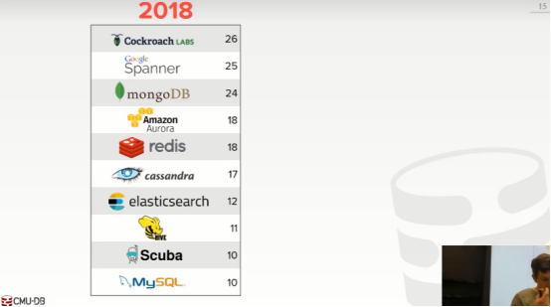

21:13 - 21:18
all right so this is my one this this is pie my favorite one of the favorite lectures, well they're all good ,but

21:19 - 21:21
cuz he talked about more databases

21:21 - 21:27
alright so again I asked everyone in the class to vote on what systems they were most interested in learning about

21:27 - 21:32
so here's the tally from last year, for the top 10 CockroachDB Spanner and MongoDB
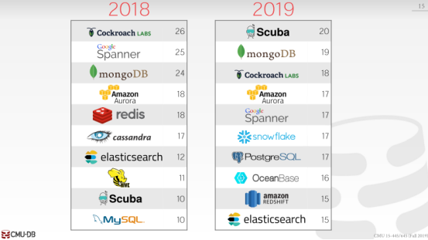

21:32 - 21:35
and here's what we ended up with this year

21:35 - 21:40
which is very surprising scuba came up first , followed by MongoDB ,fought by CockroachDB

21:40 - 21:46
and surprisingly this is my I think fifth or sixth year teaching like this puppy thing

21:46 - 21:48
spanners always been in the top three, right

21:49 - 21:53
and so the only thing I could think of that people why people didn't vote for this as much is

21:53 - 21:55
because the name got changed a cloud spanner

21:56 - 21:58
right and maybe people didn't think it was the same thing

21:58 - 21:59
so that's okay

21:59 - 22:03
but scuba is a really interesting system, so we'll start that for that first okay


22:04 - 22:06
all right so Facebook Scuba

22:06 - 22:09
now so I also noticed that people vote for the ones or has like

22:09 - 22:14
if has a name of a company in front of it like, Amazon, Aurora, Baidu, OceanBase, then people vote for those things more

22:15 - 22:18
so all right all right Facebook Scuba
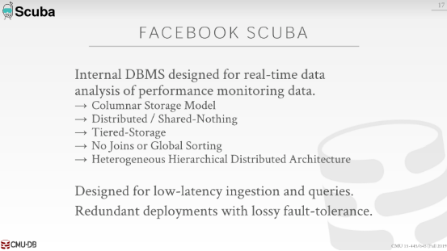

22:18 - 22:24
so what the you know what we're trying to do here in the system potpourri

22:24 - 22:27
It`s to show you that we can now look at real world systems

22:28 - 22:35
and start using the vernacular that we've discussed all through it an entire semester , to sort of start to understand ,what this thing is actually doing

22:36 - 22:40
right so now I could say this things out to shared nothing to shoot the system and you know what that means

22:40 - 22:42
you know what the implications of that are

22:42 - 22:46
you know what the performance characteristic performance challenges you would have in a system like this

22:47 - 22:54
so scuba is an internal database system ,that Facebook isn't working on for several years now , was first announced in vldb in 2013

22:55 - 22:57
and they've been still working on it

22:57 - 22:59
it's it's not open source ,right

22:59 - 23:05
there's it's only till very recently, is there now some public information about the newer version

23:05 - 23:12
and actually turns out, because the guy that that's actually leading the project is CMU database alum, like he got his PhD here before I showed up

23:12 - 23:17
and he's now running that whole the the running the the development of this database system

23:17 - 23:20
and then his boss is actually a

23:20 - 23:27
his boss's is the mother of another CS student here in the department, who actually worked on busTub over the summer

23:28 - 23:30
all right so it's all to all one giant CMU family

23:30 - 23:34
all right so scuba is a it's a it's MIT

23:34 - 23:41
it's designed for having low latency queries and ingestion of, internal metric data generated from from Facebook's different services

23:42 - 23:44
all right so this is not running an OLTP to the application

23:44 - 23:47
this is not running ,it's not a good joins warehouse

23:48 - 23:52
think of like every single time you click something on Facebook,right on the website

23:52 - 23:55
that causes a bunch of functions are going to vote on the servers

23:55 - 24:01
and you can they can have their developers instrument those function calls to keep track of the performance metrics

24:02 - 24:03
right throughout the entire stack

24:04 - 24:06
and then all that data then gets shoved over to scuba

24:06 - 24:10
now they can use that and then run queries on that data to try to figure out

24:10 - 24:13
you know why does this function take you know run it slower

24:13 - 24:16
what are some problems I'm seeing and my giant fleet

24:16 - 24:20
so the newer version of scuba is now a column store

24:20 - 24:23
it's a distributed/shared-nothing system

24:23 - 24:28
it's using a tiered-storage, just means that this just means that like you can have a

24:28 - 24:33
you know you can have a in-memory cache, flash cache, and then may be slower disk below that

24:34 - 24:38
and then it's gonna be using a heterogeneous hierarchical distributed architecture

24:38 - 24:43
and so one interesting about the system as well is that since they are trying to have this thing be really fast

24:44 - 24:46
but you want to run your queries very quickly over a lot of data

24:47 - 24:49
they are not a lot that can support SQL

24:49 - 24:50
they're not going to support joins

24:50 - 24:52
they're not going to support global sorting

24:53 - 24:55
so you can only write queries that access one single table

24:55 - 25:01
and you have a where clause that do you know yes simple filtering, and then you can aggregate aggregations

25:02 - 25:06
another interesting about it, that's gonna be different than everything we talked about before is that

25:06 - 25:11
they're gonna have to have replication to have or done a deployment of an entire Scuba cluster

25:12 - 25:16
so you would think about like you have a bunch of machines, I send all my data to this this this cluster

25:17 - 25:20
but I'm also going to send it to other clusters running in different data centers or different regions

25:21 - 25:25
but they're gonna allow for lossy fault-tolerance in this environment

25:25 - 25:31
because the data that they're collecting , it's valuable would not like bank account invaluable

25:31 - 25:35
right so like say you know you go click on something in your time on a Facebook

25:35 - 25:37
that generates a bunch of performance metric data

25:37 - 25:40
if that data gets lost yeah right

25:40 - 25:43
it's not that not the end of the world , you know actually I want to lose everything

25:44 - 25:49
but they're an allow they're gonna tolerate queries to end a you know may have false negatives false positives

25:49 - 25:52
Because they're gonna end up missing data that just end up again getting missing

25:52 - 25:56
and so the way they're gonna try to avoid that is to running multiple points

25:56 - 25:58
they'll run the query in different regions at the same time

25:59 - 26:07
and then when they get back the result they see , which query actually read them , had the the fewer number the fewest number of missing data

26:07 - 26:09
and then they use that as the CREP result

26:10 - 26:12
but if they lose some data it's not a big deal

26:12 - 26:19
and actually going to be they're gonna have retention policy, where you can say any data stored in this table, after after you know seven days just thrown away

26:19 - 26:20
And who cares
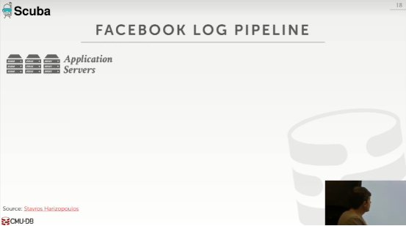

26:22 - 26:27
all right so here's here's the high-level pipeline of what they're trying to do

26:27 - 26:29
so you have your different application servers

26:29 - 26:31
right these are all running the the

26:32 - 26:35
you know the running the website, running all the back-end stuff you need to support the website
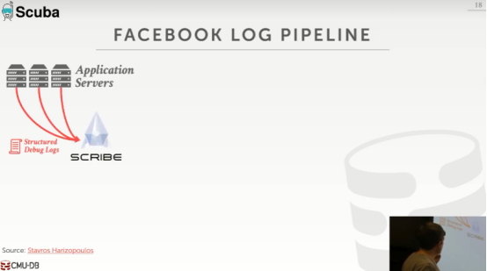

26:36 - 26:39
so these guys can be generating structured debug logs

26:39 - 26:44
so think of this as like a JSON, document, that the application server spits out to say

26:44 - 26:47
you know here's how much time I spent in the CPU for this function in that function

26:48 - 26:52
so then they're gonna load this into this internal tool that they develop called scribe

26:53 - 26:55
I think of this it's sort of like a Kafka kind of thing

26:55 - 26:57
we have a bunch of log records coming in

26:57 - 27:00
and then you can have the pub sub system to say

27:00 - 27:02
here's how to categorize the data I've collected

27:02 - 27:06
and here's in other systems get notified when new information arrives to it

27:06 - 27:10
so this is an older thing that since over ten years old

27:10 - 27:12
there's an open-source version that they have on github

27:12 - 27:13
but that was like abandon a decade ago

27:14 - 27:18
so that supposedly the the internal version it's much better than what's on online now
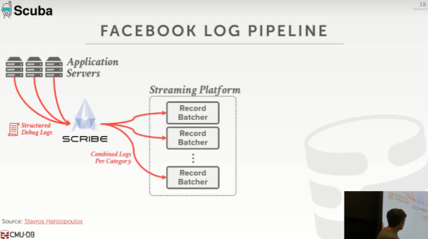

27:19 - 27:25
all right so the scribe is now gonna take the structured logs look at some tag to say

27:25 - 27:30
you know it's it's generated for you know this particular application type or this service

27:31 - 27:34
and it's gonna combine them and get together based on that category

27:34 - 27:38
and then it's gonna send them to this streaming platform or they call it the tailor service

27:38 - 27:40
because they're just tailing the log

27:40 - 27:44
and this is just gonna bash together a bunch of these log records they've gotten from scribe
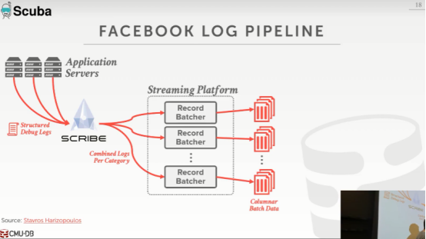

27:44 - 27:47
and then when they have a large enough batch

27:47 - 27:50
they're gonna convert that into a columnar data file

27:50 - 27:53
think of like park' or orc that we talked about last week

27:53 - 27:58
all right this thing's like a standalone file, almost like a CSV ,but it's actually a binary column store

27:59 - 28:04
and so if they have a larger batch ,they're gonna generate these these column store files
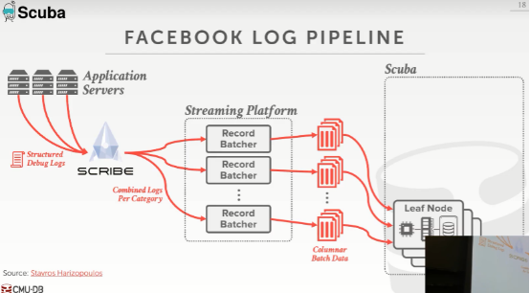

28:04 - 28:08
and then now they're gonna feed this into the leaf nodes in scuba

28:08 - 28:11
and so we're talking to 16 aggregation notes and leaf nodes

28:11 - 28:16
but this is basically the storage nodes think of this as like the the shared disk architecture

28:16 - 28:19
but you can actually have you know run queries down here

28:19 - 28:22
or the the last class when Shasank talked about Oracle Exadata

28:22 - 28:28
but they had the storage nodes at the bottom could actually do filtering and predicate evaluation down there, same same idea here

28:29 - 28:31
so now one additional thing they're going to do
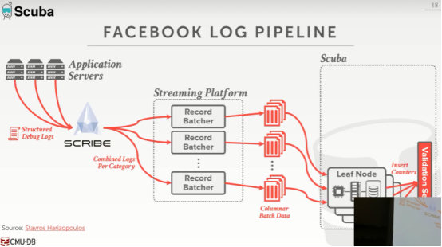

28:32 - 28:39
is that they're gonna each of these leaf nodes are going to update this validation service, with information about the number of tuples

28:39 - 28:40
that they've inserted for each table

28:42 - 28:45
and we'll see it in a second, this is how they're gonna determine

28:45 - 28:50
which which when they run the query on multiple deployments or multiple clusters

28:50 - 28:53
you'll check that thing to say well how much data is actually missing

28:54 - 28:55
so I know I sorted a million tuples

28:56 - 28:59
but I only read maybe 500,000, so half of my data went missing

28:59 - 29:03
again they're not they're not gonna go freak out, that's okay, in their environment

29:03 - 29:07
but just they keep track of this ,and they know that which query is producing the most accurate result
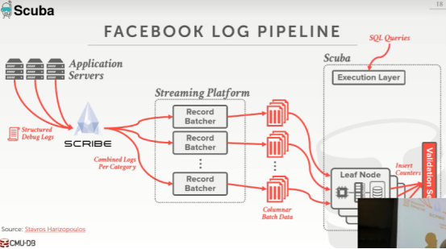

29:08 - 29:10
so now it's again it's a SQL system

29:10 - 29:17
so they have a vistas SQL interface or these dashboards, that people can use internally at Facebook
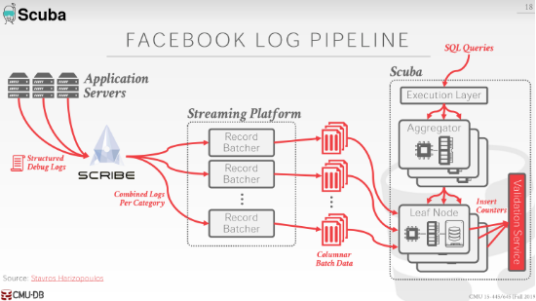

29:17 - 29:19
that sends SQL queries to this execution layer

29:19 - 29:21
which then is gonna send it to these aggregators

29:21 - 29:24
who then are gonna farm it down to these leaf nodes

29:24 - 29:26
so I'll discuss this hierarchy and a few more slides

29:27 - 29:30
but this is an important distinction between all the distributed databases we talked about

29:31 - 29:33
because it's a heterogeneous environment

29:33 - 29:38
so the leaf nodes are doing things that are separate or different than what the aggregator notes are doing

29:38 - 29:41
right and you obviously have more of these ,because you're have more data

29:41 - 29:41
yes

29:44 - 29:46
the question is the categories name is accurate yes

29:46 - 29:54
think of like it's some internal tag , that that Facebook is ascribing to a particular class of log records

29:54 - 30:00
right so again say it's like I don't know the facebook inbox or messenger right

30:00 - 30:02
so you'd say that would be one category

30:02 - 30:06
so all the the log records from the messenger app go to get combined together
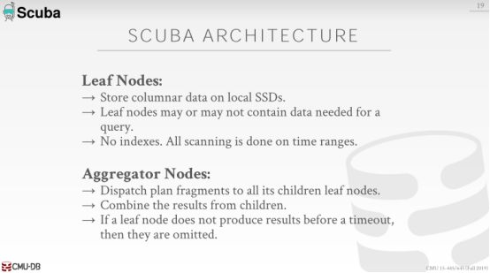

30:09 - 30:14
okay so again all right it's a header juice architecture

30:14 - 30:16
and we have leaf nodes , aggregator nodes

30:16 - 30:19
so the leaf nodes are going to store the column our data

30:19 - 30:25
that we're getting out from the the record batchers in a columnar format

30:26 - 30:31
and the for each query every query is gonna go to every single leaf node

30:31 - 30:35
so the may not be data that the query needs on that leaf node

30:35 - 30:44
but they're not going to store any additional metadata or maintain any indexes on these leaf nodes ,to give me it'll figure out whether I need to touch data at them

30:44 - 30:49
so they're trying to make this thing be as fast as possible to trying to make this both in terms of how fast the query can execute

30:49 - 30:51
but also how fast you can ingest new data

30:52 - 30:58
so if I don't have to maintain any metadata or catalog information about which data is that what leaf node

30:59 - 31:01
then I can ingest new data very quickly

31:01 - 31:04
and then every query shows up and just scans everything

31:04 - 31:08
and then that determines whether the you know you have data that you actually need

31:10 - 31:11
that makes sense right

31:11 - 31:13
so like when we talk about partitioning before

31:13 - 31:16
we talk about how there's and we'll see this a Mongo and cockroach

31:16 - 31:19
there to maintain this this state table that says

31:19 - 31:23
if you want data within this range or this hash value go to these nodes

31:23 - 31:24
they're not gonna have any of that

31:25 - 31:27
they just blast everything to everything every query goes everywhere

31:29 - 31:31
so the aggregator nodes when they get a query

31:31 - 31:35
they're going to dispatch plan fragments to the leaf it's shown in leaf nodes

31:35 - 31:36
there Dan gonna do on the leaf nodes

31:36 - 31:40
they're gonna do the scan and some some basic computation

31:40 - 31:41
but I'm gonna send the result up to the aggregator nodes

31:42 - 31:47
we're then going to combine the results from multiple leaf nodes to produce a single result

31:47 - 31:50
and then send that up to a root node who combines combines the final result

31:51 - 31:54
so this is an allow them to scale out the system very easily

31:54 - 31:58
because I know if my aggregator are running slow I can add those nodes

31:58 - 31:59
because they don't have any state

31:59 - 32:01
right that's not where the data is actually stored

32:01 - 32:05
or if I need to scale out my leaf nodes, I just add more of those, and keep my a Grenadiers ,but the same

32:05 - 32:12
but it's a very interesting architecture that shows up in a lot of other Facebook system design

32:12 - 32:15
the MemSQL guys when they before they started MemSQL

32:15 - 32:17
they spend their time at Facebook , and they saw this kind of architecture

32:17 - 32:23
and then they sort of copied it or inspired by it, when they went off MemSQL

32:23 - 32:24
so MenSQL works the same way

32:26 - 32:32
okay so again we talked about this this tolerating lost or missing data

32:32 - 32:37
so if a leaf node either has no data or that it's down

32:37 - 32:41
and it can't produce any results within a time out then they just ignore it and that's okay

32:42 - 32:46
and they use the validation service to figure out well how much data was this thing actually have

32:46 - 32:48
and that'll determine the quality of the query a query result
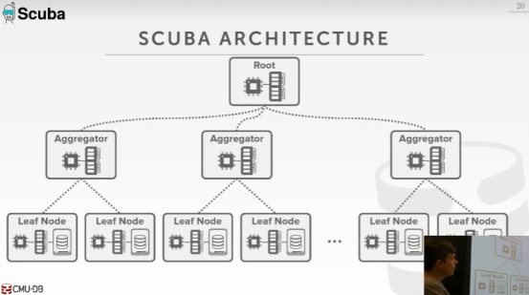

32:49 - 32:51
so let's see what the end the full pipeline looks like

32:52 - 32:55
so again this is this is be considered one scoop of cluster

32:55 - 33:01
they're gonna they're gonna have multiple instances of the same kind of cluster running in, different data centers, different regions

33:01 - 33:03
and they're gonna vote a query on all than at the same time

33:03 - 33:06
and they all get back the same result, and you pick out which one is the best one
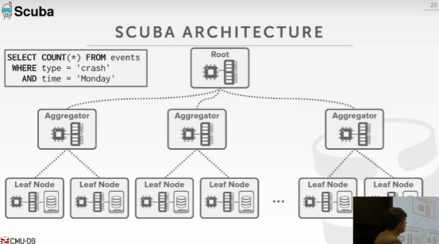

33:07 - 33:13
so my query shows up I want to do a an aggregation of the number of vents , that crashed on there was a crash on a Monday

33:14 - 33:16
again so I can only do single table queries

33:16 - 33:19
I can do aggregations, I can do group bys, I can do filtering under scans

33:20 - 33:23
but I can't do global global sorting on I can do joins
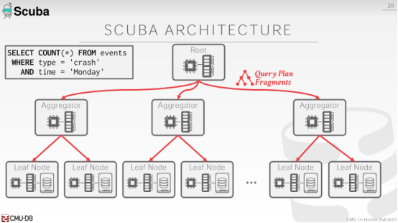

33:23 - 33:27
so the routes gonna get the query ,and that's going to break it up to query plan fragments

33:27 - 33:29
that's can then distribute down to the aggregators

33:29 - 33:33
and the aggregators are gonna tribute them down to their delete nodes

33:33 - 33:36
all the leaf nodes are now going to do a scan and then send results back up
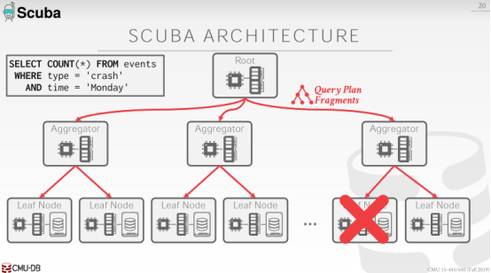

33:37 - 33:41
but let's say while we're executing this query this node goes down which happens ,right

33:41 - 33:43
if you have a large large cluster
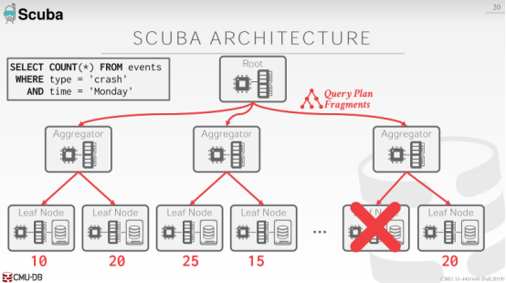

33:44 - 33:49
so everybody else I'm still wrong, everybody else is still gonna be able to do the computation for this query
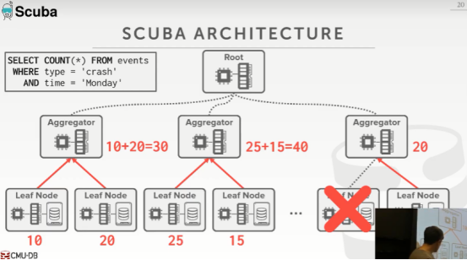

33:50 - 33:55
and then they send the results back up to the aggregators prepend just can't combine it together, right

33:55 - 33:58
so I'm doing accounts I want to know the number of events that occurred

33:58 - 34:01
so this guy says has I have 10 events, he has 20 events

34:01 - 34:05
so this guy just takes 10 plus 20 and produces 30 ,and then sends it up to the root
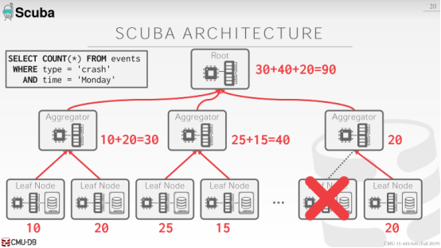

34:06 - 34:09
and the root does the same thing just adds all the results at different aggregators

34:09 - 34:11
and then produces the final result

34:13 - 34:13
so this is clear

34:17 - 34:28
yes yes

34:33 - 34:35
so this query is to scan everything right

34:35 - 34:39
so there is no again, there's no metadata

34:39 - 34:45
there's no catalog to tell me anything about whether or not these leaf nodes had the data in my that I have my where clause

34:46 - 34:47
so I don't know ,but I don't know where type is

34:47 - 34:49
I don't know where time is, so I send it everyone

34:49 - 34:52
so everyone essentially he's gonna in this example here

34:52 - 34:55
everyone's gonna do the exact same query run it on the leaf nodes

34:56 - 35:00
alright so he's doing a count star work type II type equals crash time ,he goes Monday, he has 10

35:00 - 35:03
he just shoves that up, and this guy knows well I'm doing this count thing

35:04 - 35:07
so I just added some up numbers together please the result

35:12 - 35:12
yes

35:18 - 35:21
So question ah is it true that for every single query

35:21 - 35:25
you would always copy the same query down to the leaf nodes

35:25 - 35:29
no because like for averages the way you do that is account on the sum

35:29 - 35:31
and then you can put the average up at the top

35:31 - 35:33
so that that would be different ,yeah

35:37 - 35:41
so there really isn't like since there's no joins

35:41 - 35:43
the cook there's not really a query optimizer here

35:43 - 35:48
it's just I need to know what the I just convert the SQL to a query plan and to shut that down

35:48 - 35:51
and there's some basic heuristic they probably do to figure out like

35:51 - 35:54
you know how to actually break it up and send it down leaf node ,yes

36:03 - 36:06
so this question is why was it why was it decided to have a root node here

36:06 - 36:12
and how all the clients go to this versus having everyone can penally go to any aggregator

36:13 - 36:14
and then any aggregator can talk to anybody else

36:15 - 36:23
so the my understanding is that there's actually a there's a layer above this as well

36:23 - 36:25
the root were they're doing a mission control

36:26 - 36:32
so they can do some things like, oh if a query if a node is sending too many queries

36:32 - 36:35
a client sending too many queries ,maybe want to throttle them or like

36:35 - 36:39
if I know I'm getting bad data from some some set of these nodes

36:39 - 36:44
then I can have someone to make a decision about what to exclude or not include them in my query execution

36:44 - 36:50
so it's allows them to have a single location to have a global view of what's going on in the cluster

36:51 - 36:52
doesn't know about what's in the database right

36:52 - 36:56
because that's that would be to extensive maintain and keep keep it fresh all the time

36:56 - 36:59
it just knows that like these nodes are performing and well they're not well

37:01 - 37:01
yes

37:13 - 37:20
his question is say that this node had a ton of results ton of that would match my predicate

37:21 - 37:24
I wouldn't be better for me just abort this query

37:24 - 37:27
because that because I'm my counts me way off

37:27 - 37:31
how do you know that this node has all the date has a lot of data that matters for your clearing

37:33 - 37:34
You don't know yeah

37:37 - 37:40
so again think about what this is design for

37:40 - 37:43
this is design for logs being generated by machines right

37:43 - 37:45
it's not like hey here's my bank account

37:45 - 37:47
I want that to be you know you know to the penny

37:48 - 37:54
so if you get loosey-goosey results that still was probably okay

37:55 - 37:59
and then the way they sort of overcome that again is by having that validation service

37:59 - 38:01
they can determine, how much data did they actually not read

38:02 - 38:07
so then also again then they have a bunch of a Dunant copies of the system running at the same time

38:08 - 38:09
they're all gonna produce the same query

38:09 - 38:13
so the likelihood that every single every single cluster

38:13 - 38:15
that's running Scuba for a single query is gonna have this node fail

38:16 - 38:19
exactly you know exactly this node has this data fail is pretty low

38:20 - 38:24
so at least one of those clusters will have a more active result , and that's the one they'll use

38:26 - 38:28
that's way different we talk about entire semester

38:28 - 38:29
that's why I like the system

38:29 - 38:31
because it's like we talked about never losing data

38:32 - 38:33
now I'm saying it's okay to lose data

38:34 - 38:37
because and it's like if the tree falls in the woods and no one's around to hear it who cares

38:37 - 38:42
if this node goes down and no you know no one knows and it cares about what data is actually on it, does it matter

38:44 - 38:51
and because they're not in ,you know running wrap or patos every single time , or they're updating data, this thing can run really fast
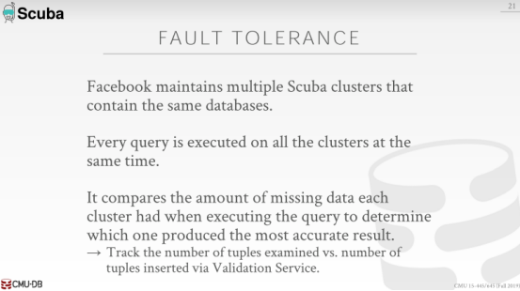

38:54 - 38:57
all right so this is summarizes our whatever I already said before right

38:57 - 39:04
so for every scuba deployment, there's me multiple ,there's a really multiple scuba deployments running in their regions

39:05 - 39:07
we run the query at the same time on all the regions

39:08 - 39:09
and then they come back with a result

39:09 - 39:14
and then the result is annotated with information from the validation service that says

39:14 - 39:17
how many how much data did I end up not reading

39:17 - 39:22
right picked the one that has the that has the most the read the most data okay

39:26 - 39:34
again so we know the guy Stavros that runs us he got his PhD from CMU in 2007-2008

39:34 - 39:37
and now he's in charge of us so any questions

39:39 - 39:40
all right good step
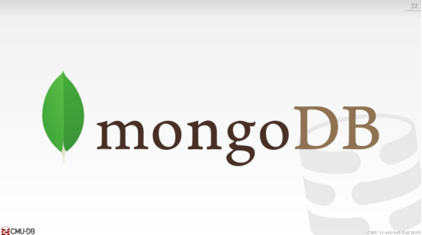

39:41 - 39:45
all right number two was MongoDB ,MongoDB is always always picked every year

39:46 - 39:49
so let me ask you guys I asked this every year ,why did you guys pick Mongo

39:51 - 39:54
I assumed you picked Facebook cause some of you want to get jobs at Facebook

39:54 - 39:57
because you think like I go in the job interview I could talk intelligently about scuba

39:58 - 40:01
same thing for MongoDB you want to work at MongoDB or do you want to use MongoDB

