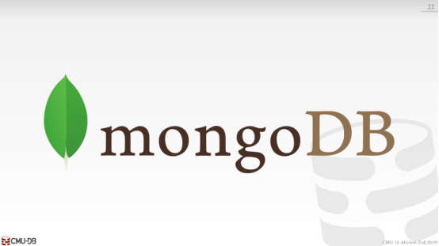

40:03 - 40:07
some people already done internships, some people are going to new internships there ,yes

40:09 - 40:11
he says it's much different than what we normally do ok

40:12 - 40:14
so I've known the MongoDB guys for a long time

40:14 - 40:21
the one of the co-founders actually went to brown, before I did

40:22 - 40:30
he so he like we've known Elliot since like 2009 ,when he first started assessment can you come give talks at,this year's Sparta they're all the time
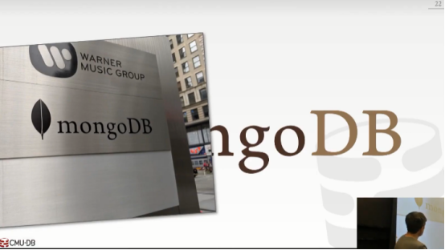

40:30 - 40:32
and I actually was there in August

40:32 - 40:34
they have a new office building

40:34 - 40:37
they used to be right around the corner from Times Square which is awful

40:37 - 40:39
they're still in Midtown but they have a nice office building

40:40 - 40:45
so you know they're a big deal if you have the sign for your company outside the building, right

40:45 - 40:47
Above that says Warner Music Group, they have the money

40:47 - 40:49
Mongo is doing pretty well it's all for the databases
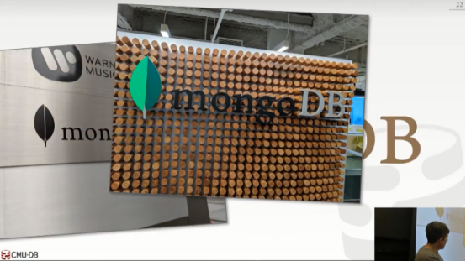

40:49 - 40:53
so this is their Lobby ,the lobbies nice looks familiar, right yeah


40:53 - 40:54
um the view is amazing

40:55 - 40:59
so this is from the kitchen, I mean it was a cloudy day, the view is absolutely stellar uh

41:00 - 41:02
and again all paid for by databases it's amazing
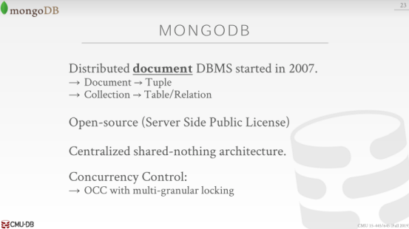

41:03 - 41:08
all right so what is Mongo, Mongo is a distributed document model DBMS

41:09 - 41:14
so when I say document think of JSON like a JSON object

41:15 - 41:21
and in the MongoDB world the language for when we talked about the entire semester, has been slightly different

41:21 - 41:26
so again instead of saying tuple to say document instead of saying table, they or a relation they say collection

41:26 - 41:28
but the high-level concepts are still the same

41:29 - 41:33
so it's one of the earliest of our original NoSQL systems

41:34 - 41:35
it was open source

41:35 - 41:341
it used to be GPL ,but now they switch to the server side license , and this is basically to protect them from Amazon

41:41 - 41:42
right MongoDB got so popular

41:42 - 41:45
they were worried about Amazon coming along

41:45 - 41:48
and just running MongoDB in a hosted environment

41:48 - 41:50
and selling it for cheaper than what MongoDB could

41:50 - 41:51
so they switched their license

41:52 - 41:57
now Amazon did come out with a system that does clone the mummy protocol called document DB

41:58 - 42:01
but my understanding of how it works is that underneath the coverage is just Postgres

42:01 - 42:06
so the wire protocol looks and smells like looks like looks like MongoDB

42:06 - 42:09
but underneath it is just Postgres

42:09 - 42:16
so it's going to very centralized shared nothing architecture with a heterogeneous configuration

42:17 - 42:20
and originally they you know as this NoSQL system

42:20 - 42:23
they didn't do transactions and they need new joins in a NewSQL

42:23 - 42:27
so right now the latest versions the Mongo ,that will they do transactions

42:27 - 42:28
they brought in transactions ,and they also do joins

42:29 - 42:31
the only thing they haven't brought in is SQL

42:32 - 42:39
now there are some hacky tools that can convert SQL into MongoDB queries

42:39 - 42:43
as far as I know I've never run across anybody that runs this and those things in production alright

42:44 - 42:47
so they're MongoDB have their own API which I'll show in a second

42:47 - 42:50
that is basically you write JSON queries to read JSON data
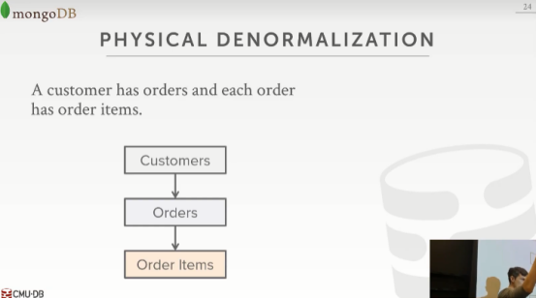

42:52 - 42:59
so one important concept about the document data model, which is quitly different that we talked about the entire semester,is this concept of denormalization

43:00 - 43:06
so in the relational model ,we would define our tables or define our relations

43:06 - 43:10
and we would use foreign keys to say there's a reference from this table to another table

43:10 - 43:14
right so if gain if I'm by modeling Amazon is my store information
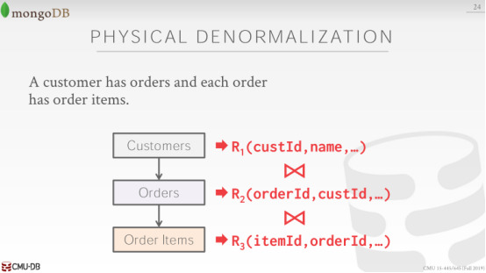

43:15 - 43:17
so I have customers ,customers orders ,and orders have order items

43:17 - 43:21
so in a relational database system, I would define these as separate relations

43:21 - 43:25
and then if I want to say for a given customer ,give me all the items that they bought

43:25 - 43:28
I would have to do a three-way join between these three tables

43:29 - 43:35
and the NoSQL guys argue that that would that was expensive to do, to do these joins

43:35 - 43:38
you know because it's now you got to run your hash join a nested loop join right

43:39 - 43:44
so what they would argue you'd want to do in a document data model is to denormalize

43:44 - 43:46
what basically says combined together

43:46 - 43:53
the the related information about a single entity in your application into single JSON document
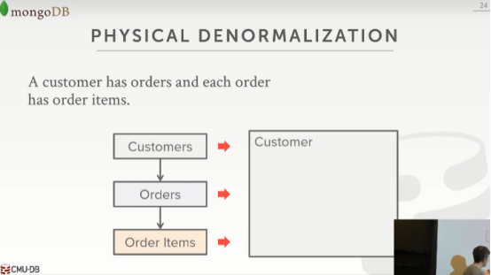

43:54 - 43:57
alright so setup in this getting this environment here, instead of having a three different tables

43:58 - 43:59
you would have one table called customer
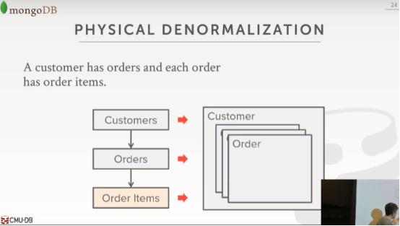

44:00 - 44:03
and then inside each customer record you would embed their orders
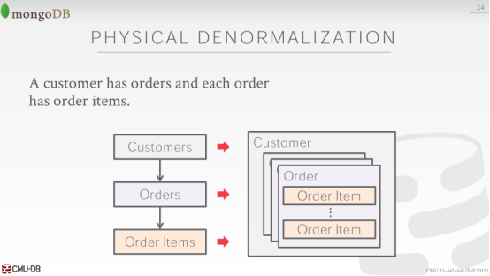
44:04 - 44:07
and then which eaten within each order you would embed their order items

44:07 - 44:11
so now if I want to go get all the order items that Andy bought

44:11 - 44:14
I go get my customer record from the database system

44:14 - 44:18
and then I just reversed now inside the JSON document to get what I want

44:18 - 44:21
now MongoDB did not invent that idea

44:21 - 44:26
that's an old idea from the 70s ,XML databases did it in the early 2000s late 1990s

44:26 - 44:29
the object-oriented guys did this in the 1980s

44:29 - 44:31
so MongoDB did not invent that

44:31 - 44:37
what MongoDB was sort of famous for was having a you know fast distributed JSON database system

44:37 - 44:40
right when sort of web bill and and JavaScript was becoming prominent
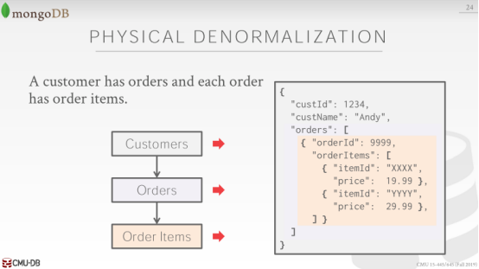

44:41 - 44:48
so again we just look like this and your your JSON document would have inside of it and array called orders

44:48 - 44:51
and with inside that you have additional JSON documents for every single order

44:51 - 44:55
and decide every single order you have an array for order items , and then all the items that they bought

44:56 - 45:00
right so again we've talked to us and they're actually the first class

45:00 - 45:03
some a performance standpoint this is we really fast

45:03 - 45:07
again it's one read to go get you know all Andy's order items

45:08 - 45:14
the bad thing is going to be obviously, now we're gonna duplicate a bunch of information about these different order items over and over again

45:15 - 45:19
and now I need to write my application code to make sure that everything is is is

45:19 - 45:23
the I maintain the integrity of all of this information

45:23 - 45:24
so if I change the name of item

45:24 - 45:28
I have to write code to go through all my inside all my customer records and make sure I update everything
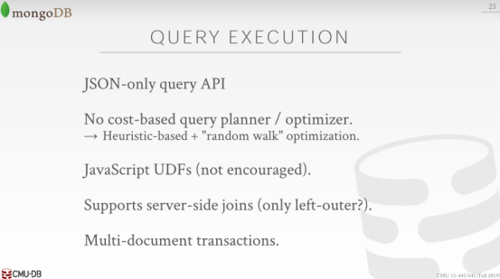

45:30 - 45:35
so the way you panic reacts to you queries is through a JSON-only query API

45:38 - 45:41
they don't have a query optimizer

45:42 - 45:45
at least not in a call space one that we talked about before

45:45 - 45:46
and I think a briefly talked about us when we talk about query optimization

45:47 -45:49
so they basically do is do your query shows up

45:50 - 45:55
and they're gonna generate sort of every possible combination for that given query

45:55 - 45:59
and then there's gonna blast every node with different different combinations of that query

46:00 - 46:02
and then whatever one comes back first

46:02 - 46:05
then they learn that that's the better one to use because it came back more quickly

46:05 - 46:08
so the next time you actually that same query or similar query

46:08 - 46:11
they'll just reuse the query plan that they generated before

46:12 - 46:14
and they'll do this maybe like a thousand times

46:14 - 46:16
and then just after the thousand query invocation

46:16 - 46:22
they'll do that sort of blast them all out first or blast them all out ,and see which one comes back first thing

46:23 - 46:24
so you may think is kind of hacky right

46:24 - 46:28
I spent two lectures talk about ,how hard it is to do a query cost-based scoring optimization

46:28 - 46:31
and and how hard the problem at you be

46:32 - 46:35
and they chose this cuz back in the day they didn't do joint

46:35 - 46:38
so you didn't have to worry about joint owner ,he's just basically was picking what index to use

46:38 - 46:41
so the random walk approach would actually work

46:42 - 46:45
I don't think they do anything sophisticated for the joins now

46:45 - 46:49
they might just use basic- heuristic, this table or this collection is smaller than this one .

46:49 - 46:51
so it's one versus the aunt once the inner versus

46:52 - 46:55
the outer they support JavaScript UDFs, we'd actually didn't talk about UDFs for this semester

46:56 - 47:01
it's basically like a function you can write in your query that gets invoked on the data server-side

47:02 - 47:07
they do now support joins ,and they now support also multi-document transactions

47:08 - 47:11
though the early benchmark numbers for MongoDB were amazing

47:11 - 47:12
like you could write data into it very quickly

47:12 - 47:15
because what they were doing is one they weren't doing transactions

47:16 - 47:22
and they weren't actually guaranteeing anything was actually written to disk, when you got response back, that you're right succeeded

47:23 -47:27
was actually even worse of that, if the database ever got the packet for your right

47:27 - 47:30
they'd immediately come back when to acknowledge and say yeah we got it

47:30 - 47:35
then at some later point would act to the right would actually be executed and in log to disk

47:35 - 47:38
so if you wanted to see whether you're right actually made it to disk

47:38 - 47:42
yet when you got back the response you had to go back again and say hey did my right make it

47:42 - 47:46
alright she had to do two round-trips to see whether your right was actually successful

47:46 - 47:48
that used to be default for a long time

47:48 - 47:51
so if you look at the early benchmark numbers for MongoDB, they're amazing

47:52 - 47:57
then 2013 or 2012 they actually turned that off it's known MongoDB

47:57 - 48:02
All right now they're actually doing wirte ahead log,and we'll talk about a second

48:02 - 48:06
and they support multi-document transactions across multiple machines, which is impressive it's not not easy to do
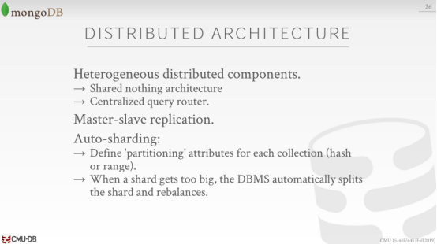

48:08 - 48:11
alright so the system architecture I think we've already talked about before

48:11 - 48:15
it's a heterogeneous distributed components ,shared-nothing the centralized query router

48:15 - 48:17
they're doing master-slave applications

48:17 - 48:22
you can have your rights from from ,when masternode a master partitioner shard will go off to other shards

48:22 - 48:27
so part of reason I think MongoDB was very successful in the early days

48:27 - 48:29
was they actually supported Auto-sharding

48:30 - 48:35
so the idea was here that like you just start shoving data into your database

48:35 - 48:38
and you know it'll be distribute across multiple nodes

48:39 - 48:41
but then if one of those nodes gets too full

48:41 - 48:44
MongoDB will automatically move your data around to balance things out

48:45 - 48:48
it didn't always work the way people thought it was going to work

48:49 - 48:54
but you know back in like 2010, when I would go out to Silicon Valley

48:54 - 48:58
and you ask people like you know oh they're doing a startup and they're basing it on MongoDB

48:58 - 49:02
you ask him why and maybe say oh, because this Auto-sharding thing was a big deal for them

49:02 - 49:05
because you know at the very beginning most people don't have much data

49:05 - 49:07
because you're you know you're start-up you have a stupid Twitter app

49:07 - 49:08
no one's using it you can run on single machine

49:08 - 49:12
but of course no one doesn't start out thinking that they're gonna fail ,everything everyone thinks they're gonna be big

49:12 - 49:14
so of course I'm gonna need you know 20 machines in the future

49:15 - 49:17
so I wanna make sure MongoDB can scale it with me

49:17 - 49:21
right with with MySQL and Postgres and other relation databases at the time you couldn't do that

49:22 - 49:24
so that I think this was a big deal

49:24 - 49:29
but there's a famous Foursquare outage 51 it was super Foursquare is

49:29 - 49:31
think of like how to describe this

49:31 - 49:34
it was app you could check in what location you were in, it's still around

49:34 - 49:38
but it's not not sort of the not not a phone app everyone uses

49:38 - 49:42
but they were using MongoDB ,and there was a famous like you know multi-day outage

49:42 - 49:43
because the auto sharding stuff got stuck
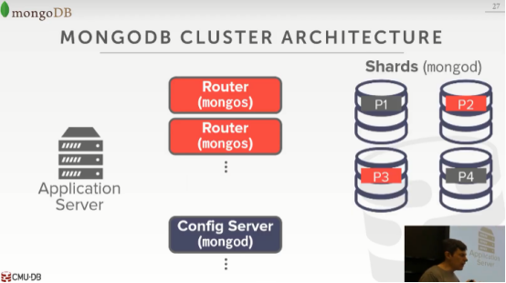

49:45 - 49:48
alright so here's the architecture ,again we talked about this before

49:48 - 49:50
and we have different type node types

49:50 - 49:52
we have routers ,we have config server ,and we have a shards
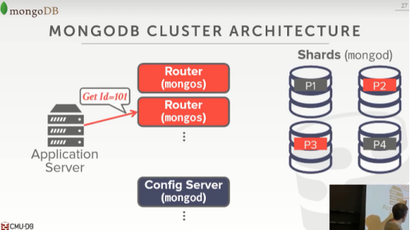

49:52 - 49:55
so every query from the application always goes to the router

49:55 - 49:58
and the router says oh I know I want to look up ID 10

49:58 - 49:59
but I don't know information about where that is
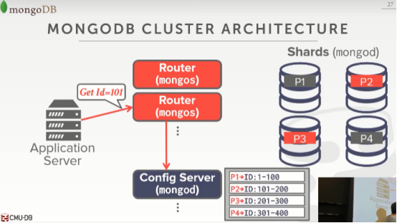

50:00 - 50:04
so I go to the config server to config server tells me and it looks in the chart table it says
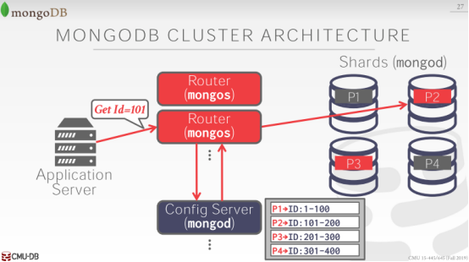

50:04 - 50:06
the data you want is that it's located it's node

50:06 - 50:10
so then now the router knows how to send the query to the right location

50:10 - 50:11
or it could blast it out to all of them

50:11 - 50:15
so again this is important distinction between the scuba stuff and we're talking about here

50:15 - 50:17
scuba doesn't haunt have it this partition or sharding table

50:18 - 50:19
it blasts the query to everyone

50:20 - 50:22
in MongoDB since you don't want to waste resources

50:22 - 50:25
because you're trying to run you know update query ISM for your website real quickly

50:25 - 50:28
you you maintain this information to figure out exactly where the query needs to go

50:28 - 50:32
so you only touch them the data ,you only touch you can do that has the exact data, you need yes

50:35 - 50:38
so a question is it sort of catching on the router yes

50:38 - 50:39
so like you wouldn't always have to do this

50:40 - 50:43
but this would be the this would consider to be stateless

50:43 - 50:47
so if I crash I come back I just I get my cache version from this again

50:48 - 50:51
but any update to like if I say I'm doing the auto shouting stuff

50:51 - 50:54
and I add a new node right move some of data to another thing

50:54 - 50:56
I update this thing and that's done as a transaction

50:58 - 50:58
yes

51:02 - 51:04
what is the origin of this what do you mean

51:08 - 51:12
oh the naming ,oh I think Mongo just means humungous, I thought it is

51:13 - 51:16
right so and so this is like actually the s I don't know that is

51:16 - 51:19
but like maith backwards I don't know no

51:22 - 51:25
yeah it's this demon or data is P1 just demon

51:25 - 51:28
and Mongo asks I don't know what that means, yeah I don't know the ask means
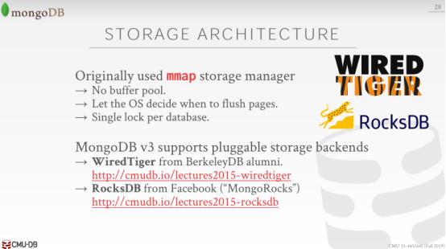

51:33 - 51:38
so another thing I said during this semester ,was that never use MF for your database

51:38 - 51:43
well when month when MongoDB first came out, they were using MF their database

51:43 - 51:47
and we actually did a little study on MF database systems

51:47 - 51:50
in my in our opinion we haven't published us yet

51:50 - 51:54
the MongoDB implementation of using MF is probably the most sophisticated one that we've ever seen

51:55 - 51:56
it's probably the best one

51:56 - 51:59
But it still sucks, it's still bad alright

51:59 - 52:03
so basically what happened is the way they would use a map is

52:03 - 52:09
they would have they'd basically maintain multiple copies of the database in memory

52:09 - 52:14
and you would do your updates to this like sort of private copy that would then get read to disk

52:14 - 52:17
and then you had to replay the log to update the sort of the master copy

52:18 - 52:22
and so the OS could swap things out anytime it wanted ,it was a big big pace for them

52:23 - 52:27
the other big problem they had was they had a single lock for the database ,now there's a not in time

52:27 - 52:28
because they were using MMAP

52:28 - 52:33
but I think it's sort of probably probably helped make things easier using MMAP

52:34 - 52:37
so that means that in the entire database system ,even though you may be split across multiple machines

52:38 - 52:43
in the earlier versions as a MongoDB ,you could only have one writer in the entire cluster at a time

52:43 - 52:46
so if I have 20 machines I have one query that comes along

52:46 - 52:48
I basic Lock all 20 machines to do update on one of them

52:50 - 52:53
and then in the newer versions of Mongo since V3, they got rid of this

52:54 - 52:59
so what they end up doing was they bought this this storage engine startup called WiredTiger

52:59 -53:04
which was founded by the guy that one of the guys that invented BerkeleyDB

53:04 - 53:07
BerkeleyDB is an DBMS, WiredTiger at a DBMS

53:07 - 53:09
we're gonna talk about this too much

53:09 - 53:15
but Postgres ,MySQL these are all database systems that like run as a standalone demon or standalone system

53:16 - 53:17
and you have multiple clients connecting them

53:18 - 53:22
SQLite is typically used as an embedded database, you embed it inside your application

53:23 - 53:24
and it provides you the database functionality

53:24 - 53:27
but when your application closes the database closes

53:27 - 53:29
so WiredTiger is sort of like SQLite

53:30 - 53:33
but it doesn't support SQL it supports like a key value store API

53:34 - 53:39
so probably one of the best acquisitions in a long time

53:39 - 53:43
they bought WiredTiger and they replace the mmap stuff with with the WiredTiger engine

53:44 - 53:46
so when you run when you run MongoDB now

53:46 - 53:49
you get the WiredTiger engine by default and it's amazing

53:51 - 53:52
questions are yes

53:57 - 54:00
this question is if you think MF is so complex why would you use this

54:01 - 54:06
so again I can't I want to prove it scientifically

54:06 - 54:09
I can't yet so just take everything what I say like this is my opinion

54:10 - 54:12
mmap is like a seductress ,right

54:12 - 54:17
it's like it's this sexy thing that looks like gives you what you want for a buffer pool manager

54:17 - 54:19
right without having to do it, because the OS does it for you

54:19 - 54:21
you don't need an eviction policy the OS does that

54:21 - 54:25
you don't need to worry about paging, you know keeping track of dirty pages and things ,I think OS doesn't that

54:26 - 54:28
so it's this thing that looks like it's gonna give you everything you want

54:29 - 54:35
but it's like it's the extra 5% you actually need to actually make it be durable and safe

54:35 - 54:36
that's when all the problems come in

54:37 - 54:39
so like it's sort of like the query optimizer

54:39 - 54:44
it's a Tibetan query optimizer ,let's do something really simple and just blast everything out and see what comes back first

54:44 - 54:49
so set it bearing a buffer pool manager, I'll just use the os's buffer pool cache or the mmap cache

54:55 - 54:57
let's take that one off line

55:01 - 55:04
hey me Elliot I mean L is a really smart guy the co-founder

55:05 - 55:10
and I've wildly successful right like it's a public company right

55:14 - 55:19
I think you know by using mmap although it causes problems in

55:21 - 55:25
it can cause problems when you really start to try to scale up and scale and Hammer the system

55:25 - 55:27
it allows you to build a system pretty quickly

55:28 - 55:30
so instead of spending six months having to develop a buffer manager

55:30 - 55:33
that's you know safe and transactional and things like that

55:33 - 55:35
use these OS you know mmap

55:36 - 55:38
and then when they got enough customers, they got enough money

55:38 - 55:40
they bought WiredTiger and did it right

55:43 - 55:47
MySQL was the same way ,right Mike well he didn't use mmap please I don't think

55:48 - 55:50
like MySQL InnoDB is amazing

55:50 - 55:53
InneDB is fantastic it's a solid database engine storage engine

55:54 - 56:00
but the original engine they use was MyISAM ,that thing sucks

56:00 - 56:02
that thing lost data all the time ,right you it would you have corruption

56:03 - 56:07
and so but it got MySQL go up and running pretty quickly a lot of people are using it

56:07 - 56:10
and then eventually InnoDB came along and MySQL bought them out and started using it

56:12 - 56:15
that's a not a very uncommon strategy for database business

56:18 - 56:20
all right let's do a demo

56:22 - 56:25
so when we have to tell you is semi semi illegal

56:27 - 56:29
alright anybody is about Mongo, yes

56:33 - 56:36
this question is why would you want to maybe use Mongo for others

56:36 - 56:41
so the I think that being in a stupid architecture is matters a lot

56:43 - 56:49
the the document model is actually better for application development right

56:49 - 56:52
think about you when you write Python code ,you write Java code

56:52 - 56:54
you're writing an object ,it is object oriented programming languages

56:55 - 57:01
and so it kind of if you can have now your object just be written out as a JSON document

57:01 - 57:04
and then putting the database and fetch it back in and we instantiate in your application code

57:05 - 57:07
that could potentially be faster

57:09 - 57:13
but the thing I would stress though there's nothing about what MongoDB is doing

57:14 - 57:15
because it's document database system

57:15 - 57:18
that is different than anything we talked about this entire semester

57:18 - 57:22
why are tired doesn't know that it's actually being used for a document database system

57:22 - 57:24
it's doing write ahead logging

57:24 - 57:27
it's doing all the crash recovery stuff we're doing it's doing transactions

57:27 - 57:29
underneath our covers in the same way that we talked about

57:30 - 57:36
so there's nothing about in the document that invalidates or changes anything we talked about here today

57:36 - 57:38
it's all at the application level ,hey

57:38 - 57:43
it's all sort of client level to quit what the query looks like, what the query is actually gonna do

57:43 - 57:46
everything else below is everything we talked about the entire semester

57:47 - 57:47
yes

57:51 - 57:53
the question is do they use special compression enemies

57:53 - 57:56
so that would be WiredTiger, I think it's just snappy

57:57 - 57:58
yeah yes

58:04 - 58:09
again the the the older versions the user name the default username passwords test test

58:09 - 58:11
it's not that way anymore yes


58:16 - 58:22
ok all right so the last one we have 10 minutes left is CockroachDB

58:22 - 58:23
actually I was there in the summer as well

58:24 - 58:28
so when I went MongoDB and CockroachDB their headquarters are in in New York City


58:28 - 58:32
so when I was out visiting CockroachDB whatever I visited both of them at the same time

58:32 - 58:35
this is their old office they had this nice little pixel art thing for the cockroach


58:36 - 58:40
house and this is their newer office though, I was actually surprised how big it actually is

58:40 - 58:43
I gave a game I gave a talk there

58:43 - 58:49
they just raised 55 million dollars as a Series C round ,which is a little money for a database company

58:49 - 58:52
so that's actually very impressive how do

58:52 - 58:54
I assume that means they're doing well so that's good
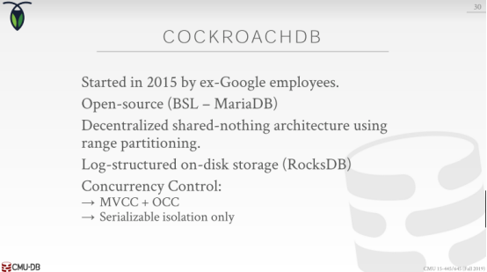

58:55 - 59:00
right so CockroachDB started in 2015 by some ex-Google employees

59:00 - 59:07
they were I think incorrectly characterized as the open-source version a spanner from Google spanner

59:08 - 59:11
I don't think they ever said that people sort of tributed that to them

59:12 - 59:13
I would not say that's true at all

59:13 - 59:18
CockroachDB is sort of a core architecture is fundamentally different than spanner

59:18 - 59:22
and spanner has one magic piece that nobody else has that cockroach doesn't do ,and nobody else does

59:23 - 59:28
so is a decentralized shared-nothing, homogeneous database architecture

59:28 - 59:29
and they're going to be doing range partitioning

59:30 - 59:34
the internal storage engine they're gonna use is RocksDB

59:34 - 59:36
so the same question is why would anyone want to use mmap

59:37 - 59:40
right well my answer was because so you don't have to build that piece yourself

59:40 - 59:44
so CockroachDB, they then wouldn't spend time writing a storage manager

59:45 - 59:47
right the same way that you know the WiredTiger piece from MongoDB

59:47 - 59:50
so a lot of these newer database system startups

59:50 - 59:53
they're using RocksDB or LevelDB, these embedded storage engines

59:54 - 59:56
so they don't have to worry about right reading writing data from disk

59:56 - 60:00
and they worry about the high level parts of like you know managing transactions in a trivet environment

