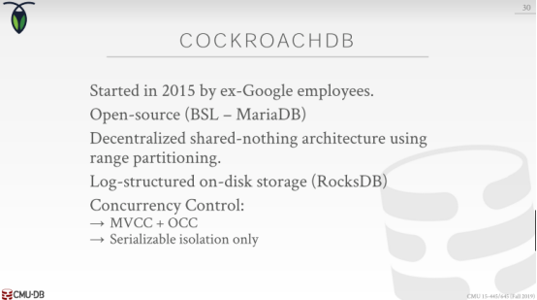

01:00:01 - 01:00:06
so they're going to be doing MVCC, you know OCC

01:00:07 - 01:00:09
and I know but this is still true

01:00:09 - 01:00:12
but they're only going to support serializable snapshot isolation

01:00:12 - 01:00:17
so I I don't think they support the other assistant isolation levels

01:00:17 - 01:00:19
They also speak the Postgres wire protocol

01:00:20 - 01:00:23
so that means that if you have an existing Postgres application

01:00:23 - 01:00:28
you can just in theory point it to CockroachDB, it's pointing at progress now

01:00:28 - 01:00:30
you migrate your data bit over to CockroachDB

01:00:30 - 01:00:34
and you don't have to change potentially any of the SQL

01:00:34 - 01:00:38
it's not entirely true for everything like there's some things that are different like Auto increment keys

01:00:39 - 01:00:44
but in general it's migrating to a CockroachDB even Postgres is a should not be an owner snek
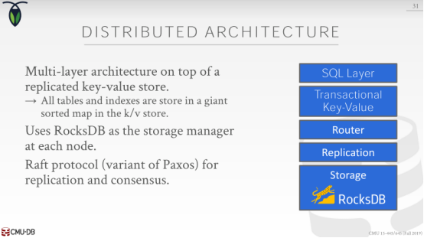

01:00:46 - 01:00:51
so at its CockroachDB is a distributed key-value store transaction attributed key value store

01:00:51 - 01:00:54
so that means that the lower storage engine of the system

01:00:55 - 01:00:56
and RocksDB is a key value system

01:00:56 - 01:00:59
but then the way they're doing transactions or sorry

01:00:59 - 01:01:02
the way they're managing the the database across multiple machines

01:01:02 - 01:01:03
It`s essentially just going to be a key value store

01:01:04 - 01:01:11
and so so using that now they can build layers above that, to provide the full sort of SQL compatibility that you would want

01:01:12 - 01:01:15
all right so once you get past like the SQL query shows up

01:01:15 - 01:01:21
they can then convert that SQL query ,the query plan is essentially going to be a bunch of key value API calls

01:01:22 - 01:01:24
that can then read and write data from from different nodes

01:01:26 - 01:01:31
so the way they're going to coordinate the updates throughout the system is using raft

01:01:32 - 01:01:36
raft is essentially at a high level which same thing as paxos

01:01:36 - 01:01:39
it's a consensus protocol that allows me to say, when I make an update

01:01:39 - 01:01:41
and I want to commit a transaction across multiple machine

01:01:41 - 01:01:48
everyone's gonna agree or quorum has to agree that the updates allowed to proceed or to occur

01:01:48 - 01:01:50
in order for that transaction to be able to commit
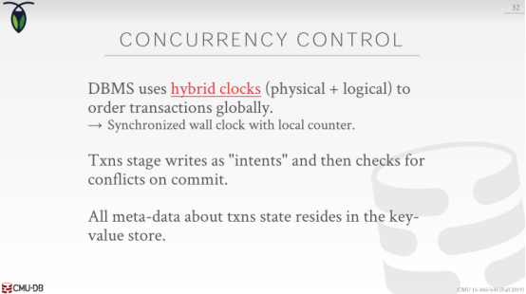

01:01:52 - 01:01:57
so the way they're going to do OCC is through using timestamps ,

01:01:57 - 01:01:59
it's using what are called hybrid clocks

01:02:00 - 01:02:06
so I think I talked about this a little bit or Prashant Agra this one we talked about timestamp concurrency control

01:02:06 - 01:02:11
we need a way to have a clock that we can you nuclei identify every transaction

01:02:11 - 01:02:13
and that clock needs to always be always increasing

01:02:13 - 01:02:17
so we know what transaction in the Serializable will order as their neck solution , what transaction came before the other

01:02:18 - 01:02:25
so you could just use the physical clock, which is you know from from the actual CPU , like I'm a machine itself what's the system time

01:02:25 - 01:02:30
but the problem in that one is that's not going to be guaranteed to be highly synchronized across multiple machines

01:02:31 - 01:02:34
right there's every computer has a clock

01:02:34 - 01:02:37
that clock is not super super accurate it's not like an atomic clock

01:02:38 - 01:02:42
right this can mean you know counting electrons coming off of an atom

01:02:42 - 01:02:45
it's gonna be some kind of quartz crystal thing that it has to approximate

01:02:45 - 01:02:47
so now you can have a bunch of skew and your clocks

01:02:48 - 01:02:51
and so now what could happen is you know transaction rise on one node

01:02:51 - 01:02:54
it thinks it's timestamp 1 ,another transaction Rises another node it thinks it's timestamp 1

01:02:55 - 01:03:01
and now I have a conflict I have pie of a yeah complicated that I've resolved

01:03:02 - 01:03:08
so the way they're going to handle that is through a hybrid clock , where you'll still use the system clock to try to get what the current time is

01:03:08 - 01:03:10
but then you also used a logical clock

01:03:10 - 01:03:15
that allows you to have globally ordered transactions without having to synchronize every single time

01:03:15 - 01:03:18
so basically took a little calendar that says , here's my current timestamp

01:03:18 - 01:03:22
and I just my machine would add one to a disk illogical counter to increase it

01:03:24 - 01:03:28
so what's gonna happen is under OCC, transactions gonna stage all those rights

01:03:28 - 01:03:31
and the system says these are the modifications I want to make yes question

01:03:36 - 01:03:39
his question is how's a hybrid clock different than the Google spender clock

01:03:40 - 01:03:45
the Google spanner clock is not, the Google spent to the treatment

01:03:45 - 01:03:46
I don't get too much into spanner

01:03:47 - 01:03:57
Google spanner is relying on the the, harbour clocks to have super accurate times, that are synchronized across all the machines

01:03:57 - 01:04:04
and the true time API gives you a bound of how long we have to wait for someone to show up with a lower timestamp

01:04:05 - 01:04:10
it's a way to basically is like this is like true time ,but using only software

01:04:11 - 01:04:15
so if you have really bad clock drift ,like this one machines one hour behind another machine

01:04:15 - 01:04:18
no transaction could potentially have a complete

01:04:18 - 01:04:21
because you yeah every transaction think they're gonna in the past in the future get messed up

01:04:22 - 01:04:27
so you have to make sure that you try to keep the clocks in the sink using like NTP

01:04:27 - 01:04:29
spanner doesn't do that

01:04:29 - 01:04:31
spanner does that you know the GPS satellites plus the atomic locks

01:04:31 - 01:04:33
they have super fine granularity

01:04:36 - 01:04:40
all right so again different than scuba

01:04:40 - 01:04:43
all the metadata about where the data exists what the transaction state is

01:04:43 - 01:04:46
that's when the Vista exists in their own key value store as well

01:04:46 - 01:04:47
and that's all considered transaction
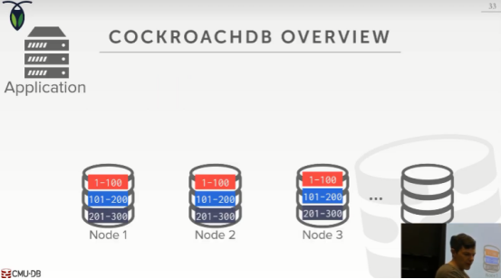

01:04:48 - 01:04:49
So let's look at a simple example here

01:04:50 - 01:04:55
so we have our application comes along , and what may be update data and this classter
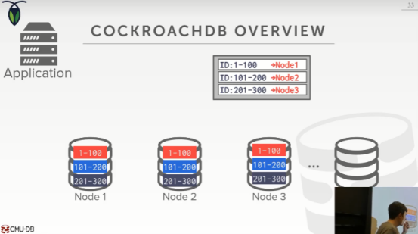

01:04:56 - 01:05:04
so again different from scuba ,we maintain a partition table just like a MongoDB to keep track of what node is responsible for ,what range of data

01:05:04 - 01:05:06
so when my query shows up
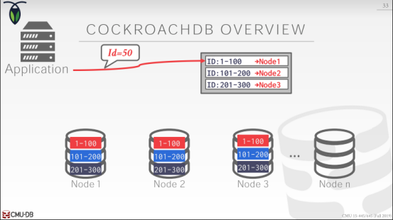

01:05:06 - 01:05:12
the first thing like the consult is my is this partition table, which actually would be replicated on every single machine

01:05:14 - 01:05:20
and say well I want to access key or ID=50 ,what machine what what node is the leader for that
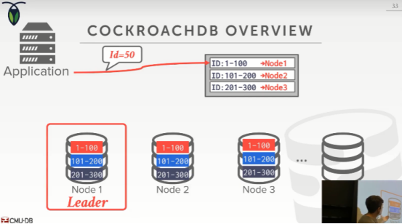

01:05:21 - 01:05:23
and then in this case here it's this guy
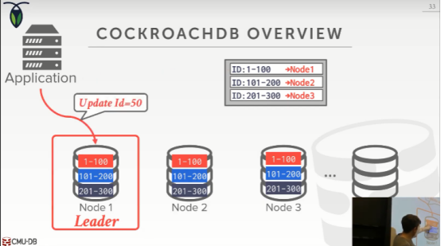

01:05:23 -
so now my right has to go here did you my update
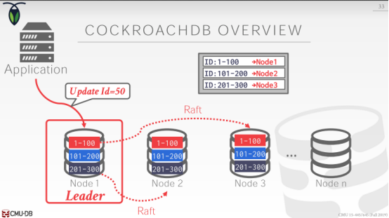

01:05:26 - 01:05:29
and then the update has to get propagated to the other nodes

01:05:29 - 01:05:34
and then we use raft to to get everyone to agree that we're gonna go ahead and commit this transaction

01:05:36 - 01:05:36
all right

01:05:38 - 01:05:40
so instead of using two phase commit they're just using raft
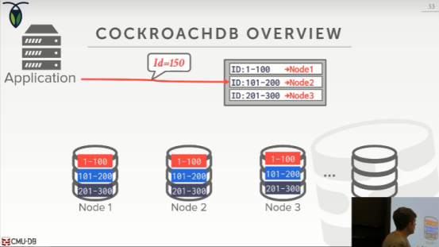

01:05:41 - 01:05:45
so now if I want to do now I read say for this this ID=150
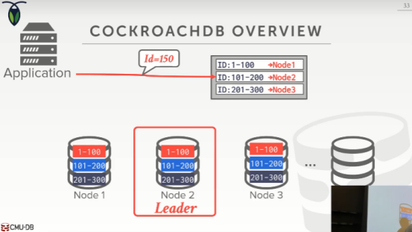

01:05:45 - 01:05:50
well I'm always going to go to the leader where this guy is located

01:05:50 - 01:05:56
even though I have multiple copies of the data on different notes ,and I in theory I could read at these other nodes

01:05:56 - 01:06:03
but I always want to do my read on the leader to make sure, that I'm reading the most you know the most consistent or up-to-date version of it

01:06:03 - 01:06:06
because maybe these other nodes have not seen the latest update yet

01:06:06 - 01:06:08
because you and a raft you only need a quorum

01:06:08 - 01:06:14
you don't need to have a every node agree ,which is different you know to Bayes committee everyone this one you always need a quorum

01:06:14 - 01:06:15
so some node could be behind

01:06:15 - 01:06:17
but you were still allowed of committed transaction
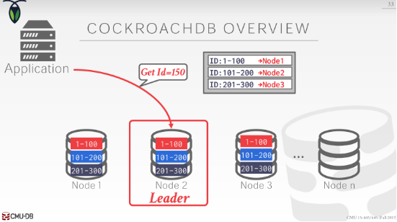

01:06:17 - 01:06:22
so to handle that all the reads are always going to go to whatever the leader node is for an ID

01:06:23 - 01:06:26
and to avoid having every query go to just a one node

01:06:26 - 01:06:29
that's why we have this table appeared to tell us which one's the leader

01:06:29 - 01:06:31
and we're going to distribute that across multiple nodes

01:06:31 - 01:06:35
so the guest so the reads can then be scattered across multiple machines

01:06:38 - 01:06:42
again it's just doing the consensus protocol

01:06:42 - 01:06:45
the replicated replicated rights that we talked about in the semester

01:06:46 - 01:06:52
the hard so the core concepts aren't any error arm aren't mind blowing aren't dramatically different , than what we've already talked about

01:06:52 - 01:06:54
the hard part is the engineering making this actually work

01:06:55 - 01:06:58
and that's what you know that that's what they're spending all their time to make happen

01:06:58 - 01:07:02
so that you don't have you know ,lost writes or missing updates and things like that

01:07:04 - 01:07:04
okay
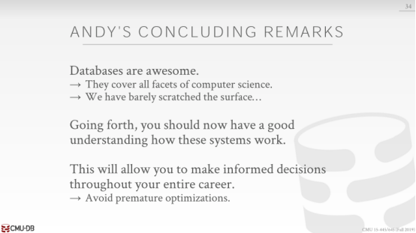

01:07:06 - 01:07:08
all right so let's finish up

01:07:08 - 01:07:12
so hopefully I've conveyed throughout the entire semester

01:07:12 - 01:07:14
that I love databases they're awesome

01:07:14 - 01:07:17
Your hit him you're gonna hit him throughout the rest your life

01:07:17 - 01:07:21
and so what hopefully this course has provided for you, is the ability to say

01:07:22 - 01:07:25
you know something's running slow in our application

01:07:25 - 01:07:29
because it's the database what kind of database system am i running on

01:07:29 - 01:07:31
what is my data look like, what does my query look like

01:07:31 - 01:07:35
it allows you to now make an informed decision about

01:07:35 - 01:07:40
how these systems work ,and whether you're you know ,you're choosing the right database system for your given application or workload environment

01:07:41 - 01:07:44
right because not everyone's gonna go off and build a database system

01:07:45 - 01:07:50
but I guarantee you no matter what you do especially you mean even if you don't stay in the tech field

01:07:50 - 01:07:52
you're gonna chrome across databases

01:07:52 - 01:07:55
like Excel is a database, I said we're using Excel ,you're using a database

01:07:56 - 01:08:01
so and the other thing I would say also to that's super-important is

01:08:01 - 01:08:06
I would avoid premature optimizations in deciding what database system to use

01:08:07 - 01:08:12
always start with something that is is maybe it's just good enough of what you need right now

01:08:12 - 01:08:17
and don't worry about you know potentially scaling up to you know millions of users in the future

01:08:17 - 01:08:19
all right that was sort of MongoDB example

01:08:19 - 01:08:22
everyone said oh my startup is gonna be huge, I don't have a million customers

01:08:22 - 01:08:23
of course I wanted to distributed database that can scale out

01:08:24 - 01:08:28
well know in the very beginning you probably just use Postgres or MySQL on a single box

01:08:28 - 01:08:31
and that'll get you you know maybe for the next two years that'll be good enough

01:08:31 - 01:08:35
but maybe you buy some better hardware and scale up a little bit more as your domain increases

01:08:35 - 01:08:37
but don't worry about bringing in distributed system

01:08:36 - 01:08:40
because that's gonna bring more complexities that you maybe need right now

01:08:40 - 01:08:44
you should focus on what makes your app , you know what you need for your application to succeed

01:08:44 - 01:08:47
so people often ask me what database system should I start with

01:08:47 - 01:08:50
if I'm building an application ,my interest Postgres or MySQL

01:08:51 - 01:08:54
for you know 99% of applications that's gonna be good enough

01:08:54 - 01:08:58
because what will happen is if your application does blow up

01:08:58 - 01:09:01
and you do have a lot of customers, what are you gonna have

01:09:02 - 01:09:02
money

01:09:02 - 01:09:06
so now you can go pay me to come tell you how to scale out your database

01:09:06 - 01:09:08
all right or one of my students right

01:09:09 - 01:09:17
so a avoid you know introducing new complexity by bringing in a you know going overboard with with a database system, you don't need

01:09:18 - 01:09:20
like maybe starting with Amazon RDS would be a good choice

01:09:20 - 01:09:23
and then you just scale up and buy a bigger instant size

01:09:23 - 01:09:28
and you add Azure as your as your data size crows or your need grows okay

01:09:29 - 01:09:31
all right any questions yes

01:09:33 - 01:09:36
boom okay all right so yes
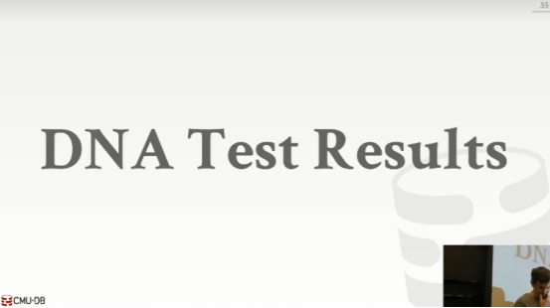

01:09:40 - 01:09:44
so uh I did get a my test results came back last week
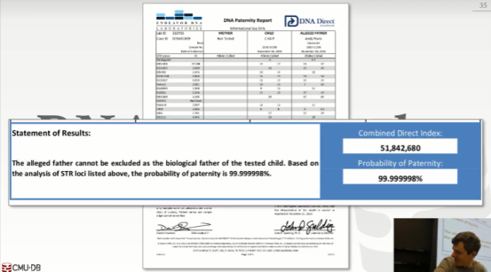

01:09:49 - 01:09:56
right this is it, it's mine ,isn't it there's no

01:09:58 - 01:10:06
so the probability that I am the father of my child is 99.999999 8%

01:10:07 - 01:10:11
so there is a 0.000002% chance that it's not mine

01:10:11 - 01:10:14
but at this point I've accepted my feet and it's definitely my kid okay

01:10:18 - 01:10:25
Yeah, no it's yeah, all right, yeah, it's mine ,all right ,all right, guys

01:10:34 - 01:10:37
so I'll see you at the final exam on Monday

01:10:37 - 01:10:39
and then the I'll have office hours on Friday

01:10:40 - 01:10:42
and then again this is the last class with DJ drop table

01:10:42 - 01:10:46
so again rattleballs for him staying with his time Spencer ,okay

01:10:46 - 01:10:48
all right guys take care

