# Homework 3

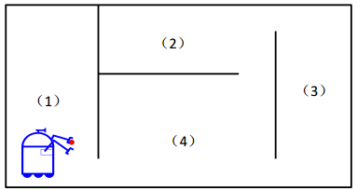**A robot cleaner is roaming within an apartment with four rooms. The map of the apartment is given as follows. The probability of the robot going through each door is 0.1. Please answer the following questions:**

**(1) What is the Markov model for the robot roaming?**

**(2) what is the probability of the robot staying at each room?**

**(3) what is the probability of the robot going through the door between (1) and (4) when the robot is going through a door?**

**Solutions:**

1. We have four states in the model, showing in the next picture

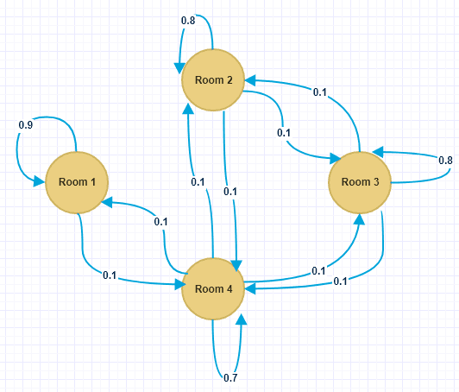

1. From the model, wo can get a matrix, $S=\left[\begin{matrix}\begin{matrix}0.9 & 0 \\ 0 & 0.8\end{matrix} & \begin{matrix}0 & 0.1 \\ 0.1 & 0.1\end{matrix} \\ \begin{matrix}0 & 0.1 \\ 0.1 & 0.1\end{matrix} & \begin{matrix}0.8 & 0.1 \\ 0.1 & 0.7\end{matrix}\end{matrix}\right]$, where Sij represent that the probability of the robot going from the room i to room j.

We used the matrix L represent the location of the robot, and we assume that the initial location is [1,0,0,0], so $S^{T}L^{T}$ represents the next location. So we can use Matlab to get the probability of the robot staying at each room, like the next picture:

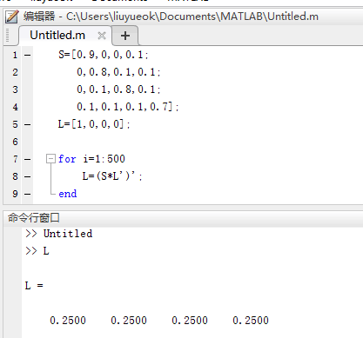

So the probability of the robot staying at each room is 0.25.

1. The probability is:

$$P=0.25×1+0.25×\frac{1}{3}+0+0=\frac{1}{3}$$