# Homework 4

**Task 1 Please generate samples of the odometry-based motion model (N=500)**

实现过程主要参照第五章的课件，sample产生的方法采用normal distribution，实现的工具是用matlab，下图是我生成的图：

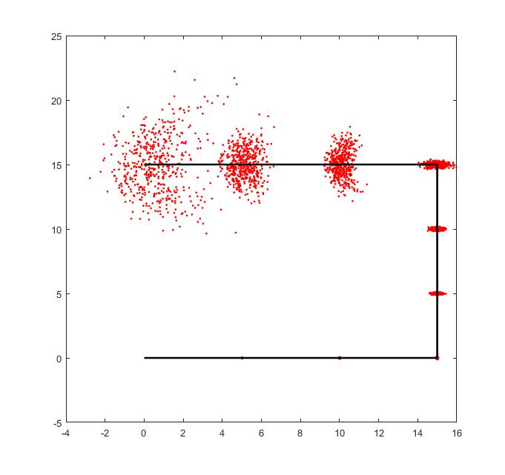

**My code: (matlab)**

Sample 采用正态分布，代码如下：

function [ randVal ] = sample( variance )

maxVal = variance;

minVal = -maxVal;

randVal = ((1/2)*sum(minVal + (maxVal-minVal).*rand(12,1)));

end

Odometry Motion Model代码实现如下：

function [ newX,newY,newTheta] = sample_motion_model( xT,x2T,aT )

%Simple odometry-based motion model.

%Argumentts are xT=(x,y,theta),

O_trans=sqrt((x2T(1)-xT(1)).^2+(x2T(2)-xT(2)).^2);

O_rot1=atan2(x2T(2)-xT(2),x2T(1)-xT(1))-xT(3);

O_rot2=x2T(3)-xT(3)-O_rot1

varianceVal = aT(1)*abs(O_rot1)+aT(2)*O_trans;

newRot1 =O_rot1+sample(varianceVal);

varianceVal = aT(3)*O_trans + aT(4)*(abs(O_rot1)+abs(O_rot2));

newRot_trans = O_trans + sample(varianceVal);

varianceVal = (aT(1)*abs(O_rot2)+aT(2)*O_trans);

newRot2 = O_rot2+sample(varianceVal);

newX = xT(1)+newRot_trans*cos(xT(3)+newRot1);

newY = xT(2)+newRot_trans*sin(xT(3)+newRot1);

newTheta = xT(3)+newRot1+newRot2;

end

主程序的code如下：

xs=zeros(500,1);

ys=zeros(500,1);

thetas = zeros(500,1);

xT_array = [0,0,0;5,0,0;10,0,0;15,0,0;

15,5,pi/2;15,10,pi/2;15,15,pi/2;

10,15,pi;5,15,pi;0,15,pi];

aT = [.0004;.0002;.0004;.0004];

for j=1:size(xT_array,1)-1

aT=aT*2;

for i=1:500 [xs(i),ys(i),thetas(i)]=sample_motion_model(xT_array(j,:),xT_array(j+1,:),aT);

end

plot(xs,ys,'r.');

hold on;

end

plot([0;15],[0;0],'k','LineWidth',2)

plot([15;15],[0;15],'k','LineWidth',2)

plot([15;0],[15;15],'k','LineWidth',2)

hold off;

**Task 2 Please generate samples of the velocity-based motion model for following cases (N=500).**

实验结果的截图如下：

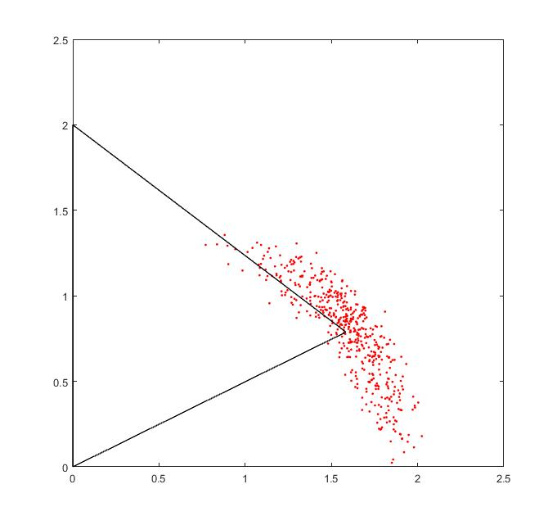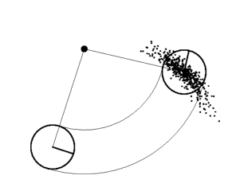

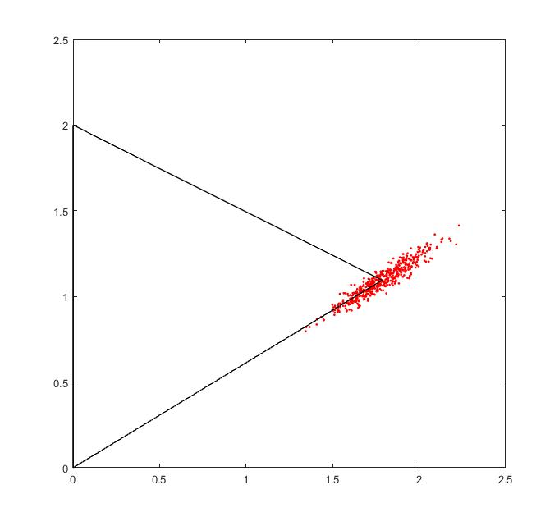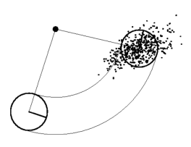

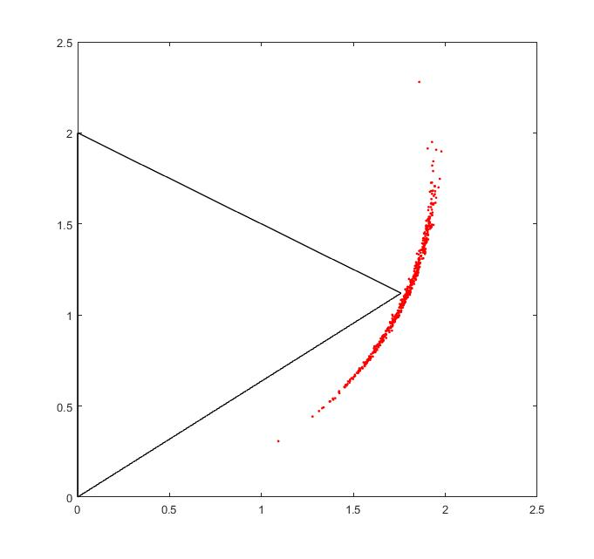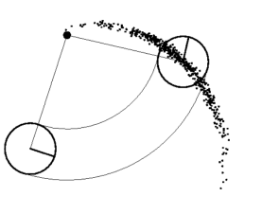

**My code: (matlab)**

Velocity-based Motion Model代码实现如下：

function [ newX,newY,newTheta] = sample_from_Velocity_Model( X,v,w,aT,t )

new_v=v+sample(aT(1)*abs(v)+aT(2)*abs(w));

new_w=w+sample(aT(3)*abs(v)+aT(4)*abs(w));

new_yj=sample(aT(5)*abs(v)+aT(6)*abs(w));

newX=X(1)-(new_v/new_w)*sin(X(3))+(new_v/new_w)*sin(X(3)+new_w*t);

newY=X(2)+(new_v/new_w)*cos(X(3))-(new_v/new_w)*cos(X(3)+new_w*t);

newTheta=X(3)+new_w*t+new_yj*t;

end

主程序的code如下：

xs=zeros(500,1);

ys=zeros(500,1);

thetas = zeros(500,1);

xT = [0,0,0];

aT = [.04;.006;.006;.4;0.4;.2];

v=1;

w=0.5;%v=w*r

t=0.6*pi;%8.7

for i=1:500

[xs(i),ys(i),thetas(i)]=sample_from_Velocity_Model(xT,v,w,aT,t);

end

plot(xs,ys,'r.');

axis([0 2.5 0 2.5])

hold on;

plot([0;0],[0;v/w],'k','LineWidth',1)

plot([0;mean(xs)],[v/w;mean(ys)],'k','LineWidth',1)

plot([0;mean(xs)],[0;mean(ys)],'k','LineWidth',1)

%line(xT_array(1,1:3),xT_array(4,1:3))

hold off;

**Task 3 Please generate the map-consistent probability model in the following situation.**

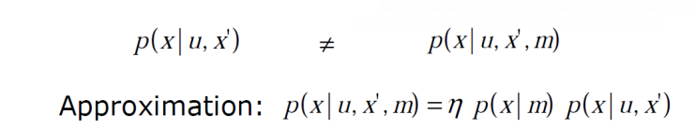

通过修改Task2的代码，得到如下的实验结果：

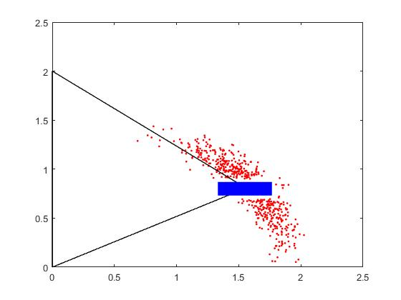

**My code: (matlab)**

Map-Consistent Motion Model代码实现如下：

function[ newX,newY,newTheta] = Map_Consistent_Motion_Model( X,v,w,aT,t )

[ newX,newY,newTheta] =sample_from_Velocity_Model(X,v,w,aT,t);

while (newX>=1.3&&newX<=1.8)&&(newY>=0.7&&newY<=0.9)

[ newX,newY,newTheta] =sample_from_Velocity_Model(X,v,w,aT,t);

end

end

主程序的源码如下：

xs=zeros(500,1);

ys=zeros(500,1);

thetas = zeros(500,1);

xT = [0,0,0];

aT = [.04;.006;.006;.4;0.4;.2];

v=1;

w=0.5;

t=0.6*pi;

for i=1:500

[xs(i),ys(i),thetas(i)]=Map_Consistent_Motion_Model(xT,v,w,aT,t);

end

plot(xs,ys,'r.');

axis([0 2.5 0 2.5])

hold on;

plot([0;0],[0;v/w],'k','LineWidth',1)

plot([0;mean(xs)],[v/w;mean(ys)],'k','LineWidth',1)

plot([0;mean(xs)],[0;mean(ys)],'k','LineWidth',1)

rectangle('Position',[1.34,0.74,0.42,0.12],'FaceColor','b','EdgeColor','b','LineWidth',2,'LineStyle','-');

hold off;