# Homework 5

11510424 刘悦

**Problem 1: Given the following observation models, please use importance sampling and resampling techniques to estimate the robot location.**

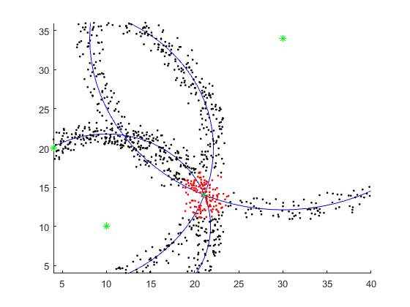

My code： written by matlab

function p=sample_point(landmark,a)

p=zeros(900,2);

r=sqrt((landmark(1)-a(1)).^2+(landmark(2)-a(2)).^2);

for i=1:900

deltat = i*pi/180;

x1 = landmark(1) + r*cos(deltat)-1.5+3*rand;

y1 = landmark(2) + r*sin(deltat)-1.5+3*rand;

p(i,1)=x1;

p(i,2)=y1;

end

rectangle('Position',[landmark(1)-r,landmark(2)-r,2*r,2*r],'Curvature',[1,1],'edgecolor','b');

hold on

end

landmark1=[10,10];

landmark2=[30,34];

landmark3=[4,20];

position=[21.1,14];

p1=[sample_point(landmark1,position);sample_point(landmark2,position);sample_point(landmark3,position)];

for ii =1: size(p1,1)

if norm(p1(ii,:)-position)<3

plot(p1(ii,1),p1(ii,2), 'r.');

else

plot(p1(ii,1),p1(ii,2), 'k.');

end

hold on

end

plot(landmark1(1),landmark1(2), 'g*');hold on

plot(landmark2(1),landmark2(2), 'g*');hold on

plot(landmark3(1),landmark3(2), 'g*');hold on

plot(position(1),position(2), 'g+');hold on

axis([4 40 4 36]);

**Problem 2: Given a map and the ultrasound sensor model, please use importance sampling and resampling techniques to estimate the robot location and path.**

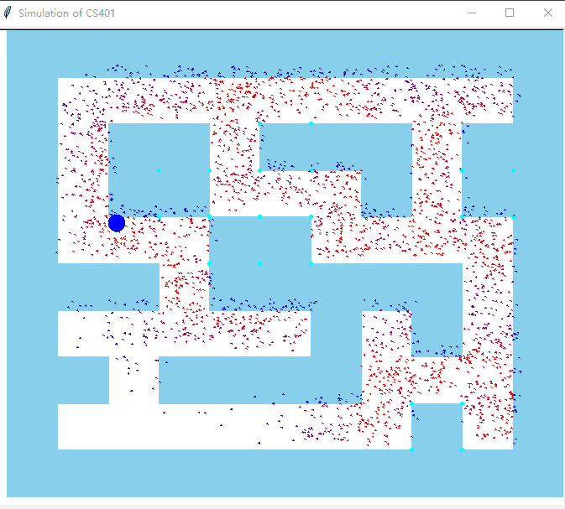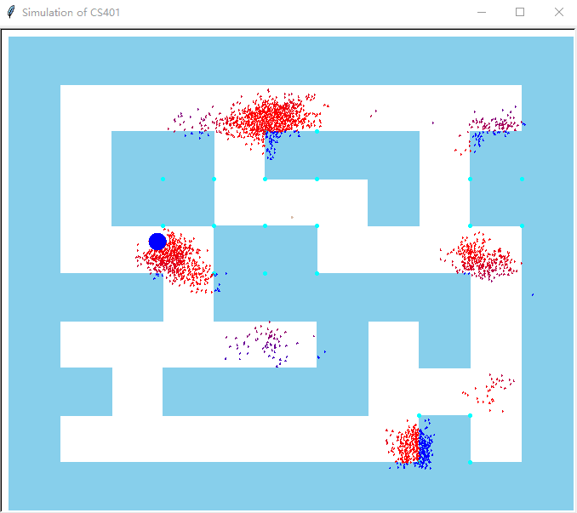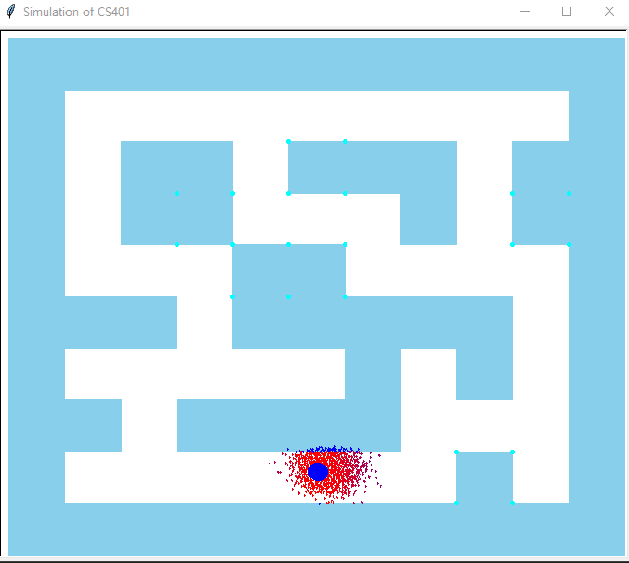

This code is written by Python3. The reference is <https://github.com/mjl/particle_filter_demo>。 I changed the map and add my own method of sample。