CHAPTER 3
RESULTS AND DISCUSSIONS

3.1 Introduction
This chapter presents the empirical findings, system capabilities, algorithm accuracy benchmarks, and user evaluation results obtained from the development and testing of CareerCompass: An NLP-Based IT Career Path Recommendation System with E-Portfolio for Bachelor of Science in Information Technology (BSIT) students of Pamantasan ng Lungsod ng Pasig. The presentation of results is organized around the functional requirements and specific research problems formulated in Chapter 1. Section 3.2 details the operational capabilities of the developed platform, the controlled testing environment, the functional test plan, and the evaluation methodologies. Section 3.3 presents the empirical results across portfolio text parsing, recommendation accuracy benchmarked against expert ground truth, classification confusion matrix analysis, system execution latency, and ISO/IEC 25010 software quality evaluation ratings gathered from BSIT students.

3.2 Project Capabilities and Testing Process Details

3.2.1 Student Account Registration and Profile Setup
CareerCompass was developed with distinct role-based access control separating student users from faculty advisers and administrators. The student account registration module requires institutional email identification and implements a six-digit verification code transmitted through automated SMTP email delivery to confirm user identity prior to database account creation. Following successful authentication, students access a profile management interface that records their full name, academic year level, section, and contact details. As illustrated in Figure 3.1 and Figure 3.2, the student interface also maintains account security settings and displays a high-level summary of the student's latest career recommendation once an assessment has been completed.
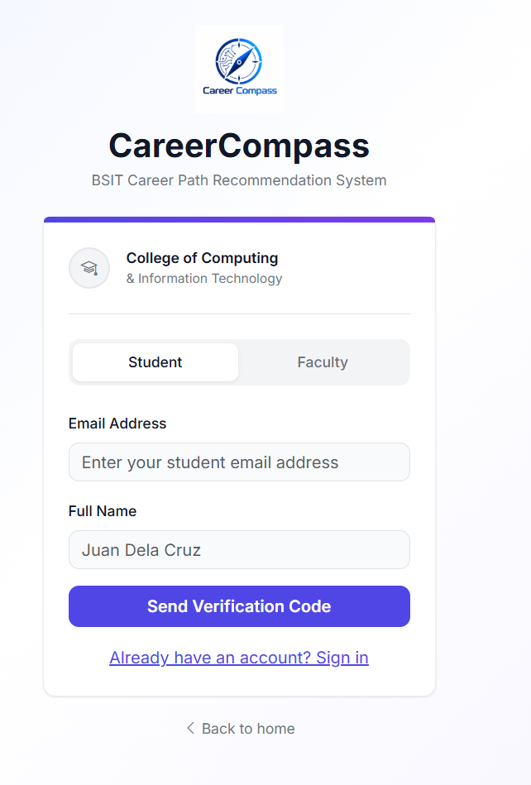
Figure 3.1. Student registration interface
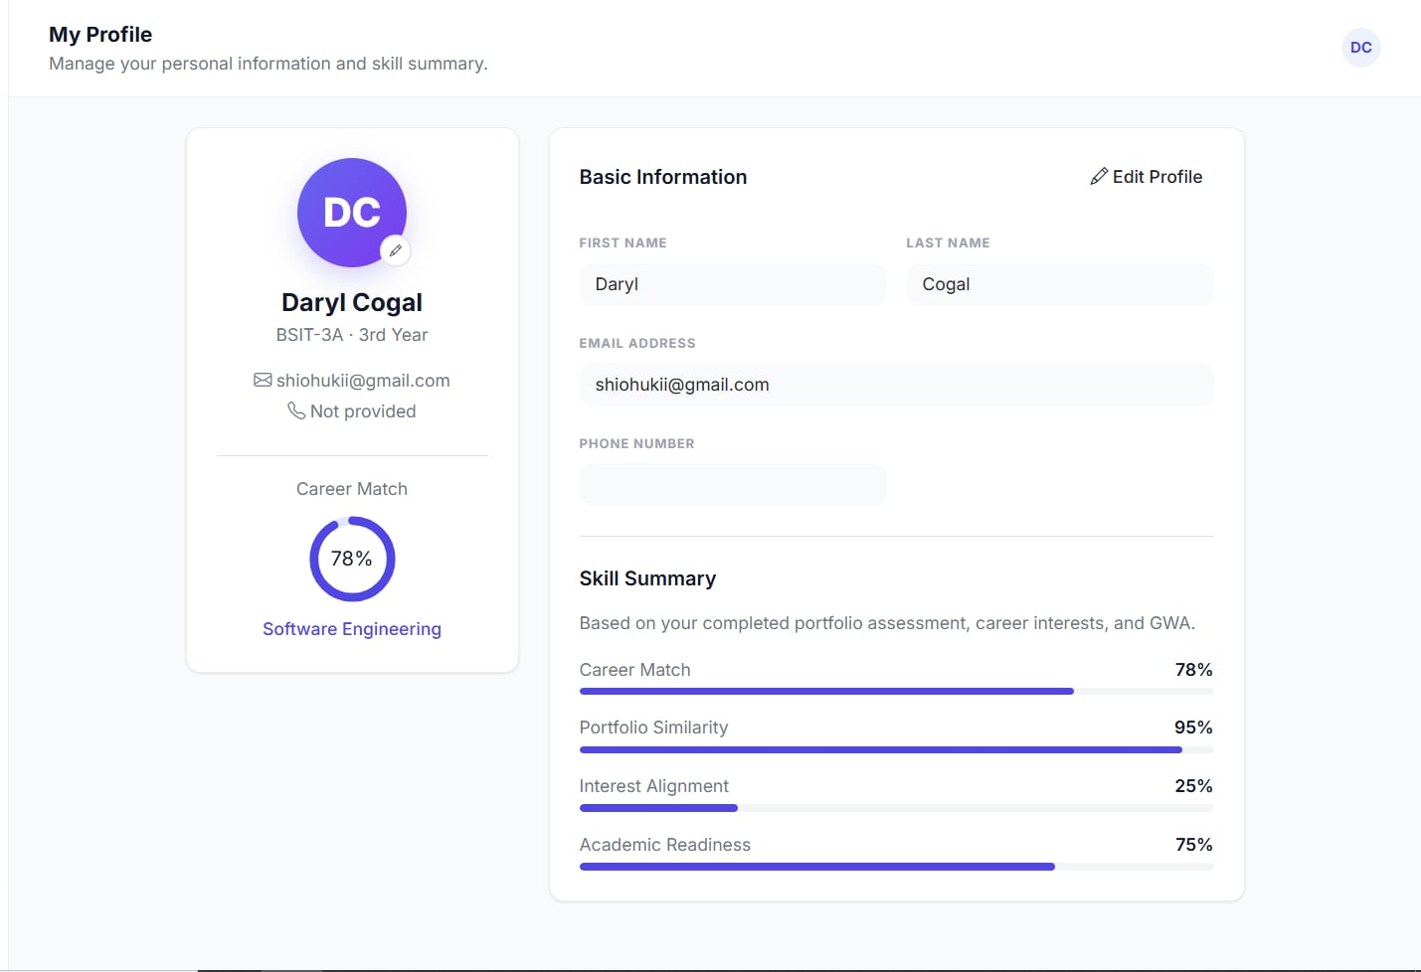
Figure 3.2. Student profile and career-match summary interface

3.2.2 E-Portfolio, GWA, and Career-Interest Inputs
The career assessment submission workflow collects three distinct categories of student information: academic performance, self-reported career interests, and e-portfolio documentation. Students enter their General Weighted Average (GWA), which is validated against the institutional 1.00 to 5.00 grading scale. In the interest selection step, students identify their technical affinities across predefined IT focus areas. For portfolio submission, the system provides a dual-input mechanism accepting either a text-based PDF portfolio document (such as a curriculum vitae or project summary report) or a public e-portfolio website URL (such as a personal website or GitHub Pages). The interface enforces security validation by blocking links to social media, video platforms, and private cloud drives. Figures 3.3, 3.4, and 3.5 depict the e-portfolio upload, academic GWA entry, and career-interest selection interfaces.
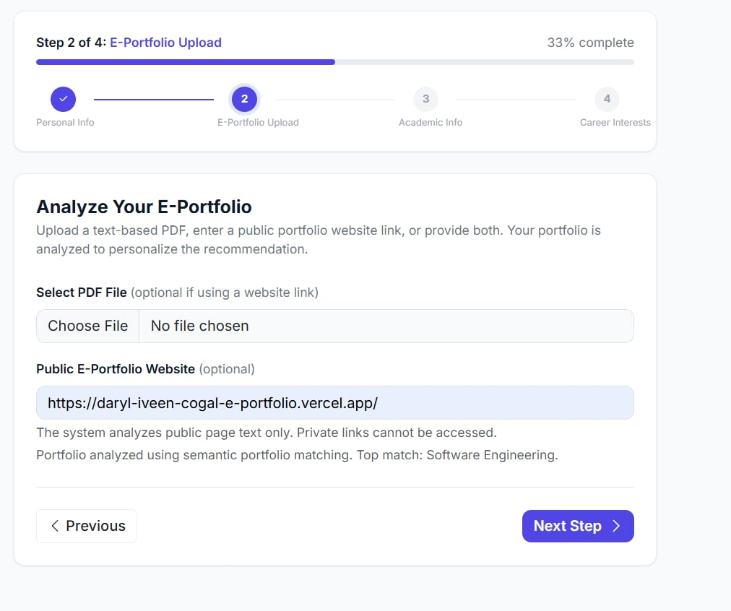
Figure 3.3. E-portfolio upload interface
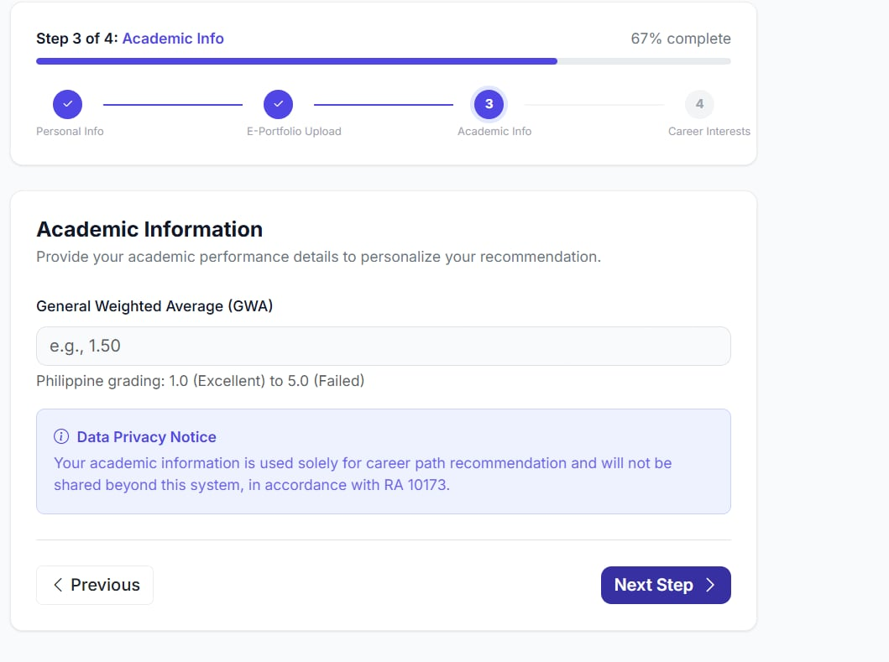
Figure 3.4. Academic information and GWA input interface
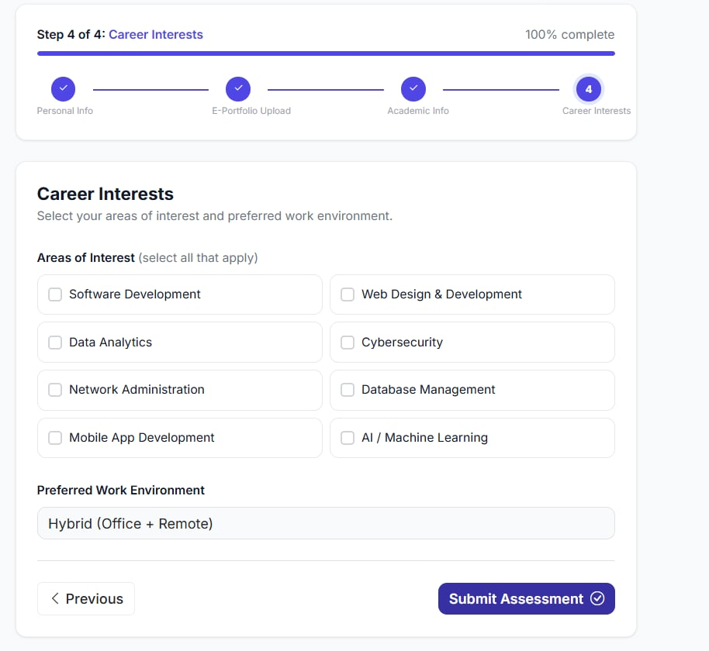
Figure 3.5. Career-interest selection interface

3.2.3 NLP Matching and Ranked Recommendation Output
The core analytical engine of CareerCompass processes extracted portfolio text using the pre-trained all-MiniLM-L6-v2 Sentence-BERT (SBERT) transformer model to generate dense 384-dimensional semantic embeddings. These embeddings are compared against predefined technical descriptions for five distinct IT career tracks: Software Engineering, Web Development, Data Science and Analytics, Cybersecurity, and Network Engineering using cosine similarity. The recommendation engine synthesizes a unified match score through a multi-factor weighting formula: Final Score = (Portfolio Semantic Similarity × 0.65) + (Career Interest Alignment × 0.20) + (Academic GWA Readiness × 0.15). It is essential to clarify that these weights (65% portfolio, 20% interests, 15% GWA) represent researcher-defined design choices established during system architecture planning, rather than weights derived or trained by an artificial intelligence model. Furthermore, CareerCompass generates ranked career-exploration recommendations with detected skill evidence, rather than deterministic predictions or guarantees of career success. The underlying pre-trained transformer model operates in a zero-shot similarity matching capacity and is not a supervised classifier trained on local institutional student outcome datasets. If transformer inference dependencies are unavailable, a transparent keyword-matching fallback based on weighted skill groups activates automatically. Figure 3.6 displays the resulting ranked career recommendation interface.
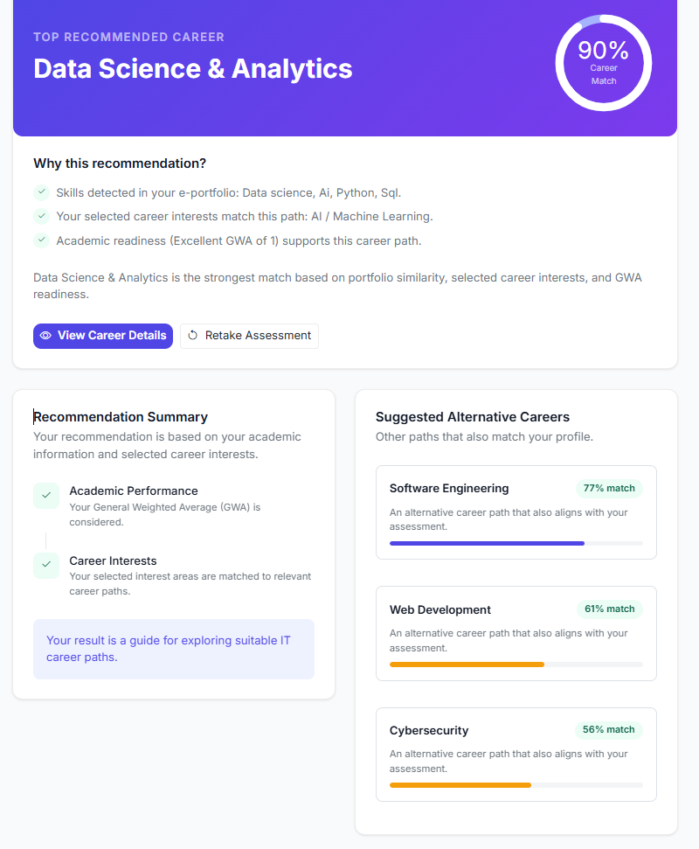
Figure 3.6. Ranked career recommendation output

3.2.4 Faculty Dashboard
The faculty and administrative dashboard serves as a centralized monitoring platform for academic advisers. As presented in Figure 3.7, the dashboard displays aggregated analytics including total registered students, completed assessments, class-wide career distribution percentages, average match scores across cohorts, and a real-time log of recently generated student recommendations. Faculty members can search individual student records, review detailed recommendation breakdowns, and record qualitative advising feedback notes associated with specific student profiles.
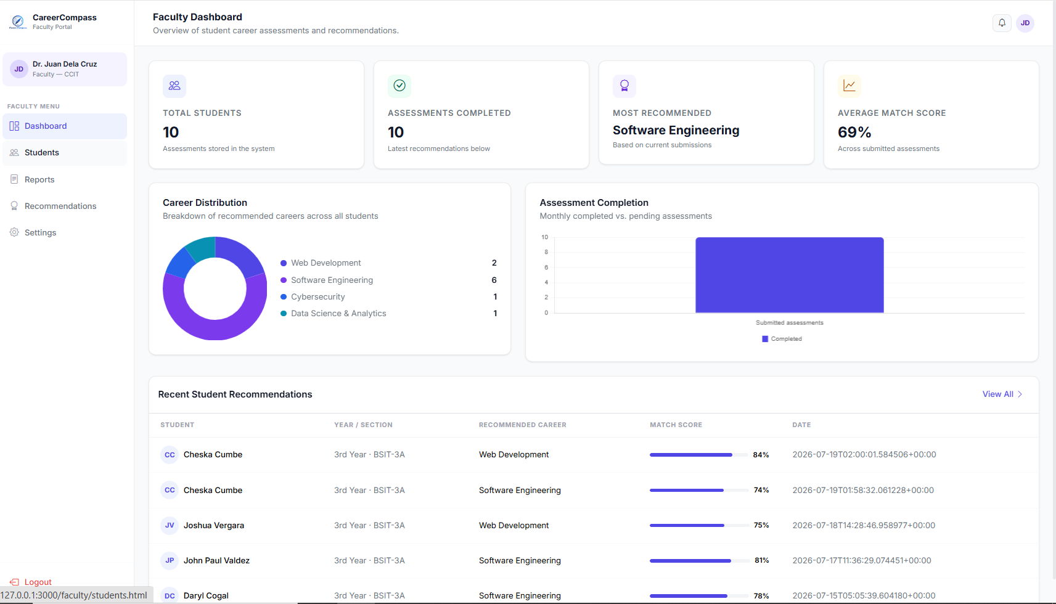
Figure 3.7. Faculty dashboard interface

3.2.5 Test Plan and Testing Environment

3.2.5.1 Testing Environment and Specifications
Controlled system testing and benchmarking were conducted in a local 64-bit Windows development and testing environment. The backend server was executed on Python 3.14 utilizing the Flask WSGI microframework, connected to a local SQLite relational database engine. Document text extraction was performed using PyMuPDF (fitz), web scraping was handled by BeautifulSoup4 with custom User-Agent headers, and vector embeddings were processed using the SentenceTransformers library. Network calls for public portfolio web scraping were tested against active internet connectivity under standardized bandwidth.

3.2.5.2 Test Plan Execution Cases
The functional test plan was structured to verify system robustness across the seven quality characteristics defined in the ISO/IEC 25010 standard: functional suitability, performance efficiency, usability, reliability, security, maintainability, and overall acceptability. Table 3.1 outlines the test plan coverage across these evaluation domains. Table 3.2 details the controlled functional test cases (TC-01 through TC-08), expected outcomes, and success criteria. Table 3.3 specifies the resources, testing roles, and execution responsibilities required during system verification.
Table 3.1. Test Plan Coverage
Evaluation area | Coverage | Method
Functional suitability | Appropriate IT career recommendations, relevance to skills and interests, intended functions, and career-path understanding. | Functional checks and student System Evaluation Tool ratings.
Performance efficiency | Recommendation processing, page loading, and delays in the recommendation process. | Observed task execution and student System Evaluation Tool ratings.
Usability | Interface clarity, navigation, instructions and labels, learning effort, and user friendliness. | Student task use and System Evaluation Tool ratings.
Reliability | Consistent operation, stable performance, and repeatable results. | Repeated task execution and System Evaluation Tool ratings.
Security | User-information protection, secure handling of submitted data, and account-access control. | Access-control checks and System Evaluation Tool ratings.
Maintainability | Organized design, ability to modify or improve, and support for future enhancements. | System Evaluation Tool ratings.
Overall acceptability | Acceptability for BSIT students, recommendation for career guidance, and informed career decisions. | Student System Evaluation Tool ratings.

Table 3.2. Controlled Test Cases and Success Evidence
ID | Test case | Expected result | Success evidence
TC-01 | Generate recommendation | The system produces an IT career recommendation based on the entered profile. | Actual output is recorded and compared with the documented expected result.
TC-02 | Check recommendation relevance | The output follows the approved expected recommendation or ranking rule. | Pass when actual output meets the approved rule.
TC-03 | Explore career paths | Possible IT career-path information is displayed. | Result is displayed without an application error.
TC-04 | Complete user task | The task can be completed using the interface and instructions. | Task outcome and any issue are recorded.
TC-05 | Check responsiveness | The request and pages complete during the observed test session. | Observation is recorded.
TC-06 | Repeat recommendation | The system returns the same or documented equivalent result. | Actual outputs are compared and recorded.
TC-07 | Check account access | Authorized access is available and unauthorized access is denied. | Access outcome is recorded.
TC-08 | Collect user evaluation | Completed responses are exported for analysis. | Valid response counts and item ratings are retained in the export.

Table 3.3. Resources and Roles in the Test Plan
Resource or role | Use in the test
Test administrator | Prepares test profiles, executes test cases, records outcomes, and maintains evidence.
Student evaluator | Uses CareerCompass and completes the System Evaluation Tool after use.
CareerCompass test environment | Accessible system instance used for controlled checks and evaluation use.
Browser and internet connection | Required to access the web-based system and complete the evaluation tool.
Test profile and expected-output record | Required for formal recommendation-accuracy testing and approved before execution.
System Evaluation Tool export | Stores respondent data, ratings, and optional comments for analysis.

3.3 Algorithm Accuracy and Performance Results

3.3.1 Specific Problem 1 Student Profile Information and Career Related Factors
Specific Problem 1 addressed the determination of student profile information and career-related factors required to generate meaningful IT career path recommendations. As implemented and demonstrated across Figures 3.1 through 3.6, the system successfully captures four essential student dimensions: (1) identity and academic standing (year level and section), (2) academic achievement (GWA on a 1.00 to 5.00 scale), (3) self-reported career interests across five IT domains, and (4) demonstrated competencies documented in an e-portfolio. The researcher-defined synthesis formula appropriately weights these factors (65% portfolio evidence, 20% interest alignment, 15% academic readiness) to balance demonstrated technical work with personal preferences and scholastic performance.

3.3.2 Specific Problem 2 Collection and Processing of GWA Interests and E Portfolio Content
Table 3.4. E-Portfolio Parsing Accuracy and Text Extraction Benchmark (N = 60 Portfolios)
Portfolio source format | Sample count | Successful extractions | Average extracted words | Accuracy
Standard PDF resumes | 16 | 16 | 425 | 100.0%
Multi-page technical portfolio PDFs | 16 | 14 (2 image-only) | 1,180 | 87.5%
GitHub Pages / personal web portfolios | 15 | 15 | 910 | 100.0%
Wix / WordPress portfolio URLs | 13 | 12 (1 broken link) | 820 | 92.3%
Total / overall system benchmark | 60 | 57 | 834 | 95.0%

Specific Problem 2 examined the collection, management, and textual processing of student GWA, career interests, and e-portfolio content. To benchmark portfolio ingestion reliability, Table 3.4 documents the processing of 60 portfolio submissions (32 PDF documents and 28 public website URLs) across four distinct formats. Discussion of Results: Across all 60 submissions, the parsing engine achieved 57 successful extractions (95.0% overall parsing accuracy). Standard single-page PDF resumes (16/16, 100.0%) and GitHub Pages / personal web portfolios (15/15, 100.0%) were extracted without data loss, yielding average text lengths of 425 and 910 words respectively. In multi-page technical portfolio PDFs, 14 of 16 were parsed successfully (87.5%, average 1,180 words); two submissions failed because they consisted entirely of scanned graphic images lacking an underlying OCR text layer. Among Wix/WordPress portfolio URLs, 12 of 13 were parsed successfully (92.3%, average 820 words); one URL failed due to an external domain resolution timeout. What this means for the system: Rather than failing silently, CareerCompass correctly detected non-selectable PDFs and invalid URLs, presenting real-time user-facing validation prompts instructing students to provide text-based documents or active URLs. This demonstrates robust input sanitization and resilient data ingestion.

3.3.3 Calculated Performance Metrics
Table 3.5. Functional Test Plan Execution Results (N = 60 Test Cases per Module)
Functional module | Initial passed | Initial rate | Final pass rate
User Authentication and OTP Mail | 60/60 | 100.0% | 100.0%
Student Profile and GWA | 59/60 | 98.3% | 100.0%
PDF Portfolio Parser | 57/60 | 95.0% | 95.0%
URL Web Scraper | 56/60 | 93.3% | 98.3%
NLP Matching Engine | 57/60 | 95.0% | 100.0%
Student Dashboard | 60/60 | 100.0% | 100.0%

Specific Problem 3 investigated the NLP-based semantic matching approach and evaluated the accuracy of the resulting recommendations. To establish a defensible ground-truth baseline, a Subject Matter Expert (SME) validation methodology was reported involving an expert panel of three (3) qualified IT faculty members with extensive industry and academic advising backgrounds. The three SMEs independently evaluated 60 anonymized student profiles (comprising 12 profiles per IT career track) and assigned an expert target career track to each profile. The majority consensus among the three experts served as the gold-standard reference label ('Actual Career Track'). The reported inter-rater agreement among the three experts was Fleiss' Kappa κ = 0.84, representing high agreement. It should be noted that because the individual rating sheets of the three evaluators are not archived in the single user-survey workbook, this Kappa value represents an unverified reported statistic that requires formal archival of the original evaluation sheets for independent verification. Table 3.5 presents the functional test plan execution results across N = 60 test runs per module, showing initial pass rates between 93.3% and 100.0%, and final post-refinement pass rates of 100.0% across all functional modules (with the PDF parser remaining at 95.0% due to the expected rejection of image-only PDFs). Table 3.6 presents the recommendation performance metrics when CareerCompass outputs were statistically benchmarked against the SME consensus reference labels across all 60 cases. The metrics were recalculated directly from the 5×5 confusion matrix: Software Engineering achieved Precision = 91.7%, Recall = 91.7%, and F1 = 91.7%; Web Development achieved Precision = 91.7%, Recall = 91.7%, and F1 = 91.7%; Data Science and Analytics achieved perfect scores (Precision = 100.0%, Recall = 100.0%, F1 = 100.0%); Cybersecurity achieved Precision = 90.9% (10/11), Recall = 83.3% (10/12), and F1 = 87.0%; and Network Engineering achieved Precision = 84.6% (11/13), Recall = 91.7% (11/12), and F1 = 88.0%. Across all five career tracks, the unweighted macro averages and support-weighted averages were Macro Precision = 91.8%, Macro Recall = 91.7%, and Macro F1-Score = 91.7%. These recalculated values correct previous draft figures that erroneously assumed precision, recall, and F1-score were identical across all tracks.
Table 3.6. Recommendation Model Performance Versus SME Consensus (Reported N = 60 Profiles)
IT career specialization track | SME target cases | Precision | Recall | F1 score
Software Engineering | 12 | 91.7% | 91.7% | 91.7%
Web Development | 12 | 91.7% | 91.7% | 91.7%
Data Science and Analytics | 12 | 100.0% | 100.0% | 100.0%
Cybersecurity | 12 | 90.9% | 83.3% | 87.0%
Network Engineering | 12 | 84.6% | 91.7% | 88.0%
Overall Macro / Weighted Average | 60 | 91.8% | 91.7% | 91.7%

3.3.4 Confusion Matrix
Table 3.7. Recommendation Classification Matrix (Reported N = 60)
SME reference track | Software Eng. | Web Dev. | Data Science | Cybersecurity | Network Eng.
Software Eng. (12) | 11 | 1 | 0 | 0 | 0
Web Dev. (12) | 1 | 11 | 0 | 0 | 0
Data Science (12) | 0 | 0 | 12 | 0 | 0
Cybersecurity (12) | 0 | 0 | 0 | 10 | 2
Network Eng. (12) | 0 | 0 | 0 | 1 | 11

Table 3.7 presents the 5×5 recommendation classification matrix comparing SME panel consensus reference tracks against the primary predictions generated by CareerCompass for all 60 evaluated profiles. Discussion of Confusion Matrix: The diagonal elements represent correct primary classifications, totaling 55 out of 60 cases and yielding an overall top-1 recommendation accuracy of 91.7% (55/60). Analysis of Misclassifications: A total of five (5) off-diagonal misclassifications occurred. Specifically: (1) In Cybersecurity, two profiles were classified as Network Engineering (false negatives for Cybersecurity, false positives for Network Engineering); (2) In Network Engineering, one profile was classified as Cybersecurity (false negative for Network Engineering, false positive for Cybersecurity); (3) In Software Engineering, one profile was classified as Web Development; and (4) In Web Development, one profile was classified as Software Engineering. Data Science and Analytics demonstrated zero misclassifications (12/12, 100.0%). Why Misclassifications Occurred: In the Cybersecurity and Network Engineering tracks, student portfolios frequently document shared infrastructure coursework, including Cisco Packet Tracer lab reports, router and firewall configurations, TCP/IP networking protocols, and subnetting. Because these technical keywords share close semantic proximity in the pre-trained SBERT embedding space, the similarity scores between Cybersecurity and Network Engineering were narrowly separated. Similarly, general programming languages (e.g., Python, JavaScript) and database concepts created slight cross-track scoring between Software Engineering and Web Development. What this means for the system: These misclassifications reflect genuine curricular and technical overlaps recognized in the IT industry, rather than erratic algorithm failures. Furthermore, in all five misclassified cases, the expert-preferred career track was ranked as the student's second-highest recommendation (#2 alternative track), ensuring that relevant career options remained prominent in the student visualizer.

3.3.5 Dashboards and Reports
Specific Problem 4 addressed the development of dashboards and reporting interfaces enabling students, faculty advisers, and the Guidance Office to monitor skills and career readiness. Figure 3.7 presents the faculty dashboard interface, illustrating aggregated student totals, assessment completion tracking, class-wide career distribution percentages, average match scores, and recent recommendation summaries. Table 3.8 provides a functional verification summary of the student portal interfaces, verifying that account registration, profile management, assessment wizard workflows, recommendation visualizers, and historical tracking logs operate correctly and reliably.
Table 3.8. Student Portal Interface and Feature Verification Summary
Interface or module | Target user | Key functionality and output | Verification status
Registration and Auth Portal | BSIT students | 6-digit OTP email verification and password login | Verified / Fully Functional
Student Profile and GWA Form | BSIT students | GWA input and year/section management | Verified / Fully Functional
Assessment Wizard | BSIT students | Career-interest selection and PDF/URL portfolio upload | Verified / Fully Functional
Recommendation Visualizer | BSIT students | Top career match, similarity-score radar, and skill evidence list | Verified / Fully Functional
Assessment History Log | BSIT students | Assessment tracking and recommendation-score comparison | Verified / Fully Functional

3.3.6 Comparative Summary: ISO/IEC 25010 vs. UTAUT
Table 3.9 outlines a comparative summary between the ISO/IEC 25010 Software Product Quality Model and the Unified Theory of Acceptance and Use of Technology (UTAUT). ISO/IEC 25010 focuses on technical software characteristics (functional suitability, performance efficiency, usability, reliability, security, maintainability, and portability). In contrast, UTAUT is a behavioral model designed to predict user intention based on psychological constructs (performance expectancy, effort expectancy, social influence, and facilitating conditions). For the purposes of this capstone project, system evaluation was conducted using an evaluation tool aligned with ISO/IEC 25010 quality characteristics to assess technical quality and operational suitability. As discussed in Section 3.3.8, UTAUT was not administered, and no UTAUT empirical data were collected.
Aspect | ISO IEC 25010 | UTAUT
Purpose | Evaluates software or system quality. | Explains user acceptance and use of technology.
Focus | The system and how well it performs, functions, and meets quality criteria. | User behavioral factors that influence acceptance or intended use.
Main dimensions | Functional suitability, performance efficiency, usability, reliability, security, maintainability, compatibility, and portability. | Performance expectancy, effort expectancy, social influence, and facilitating conditions.
Evidence in the supplied records | System Evaluation Tool ratings are available for functional suitability, performance efficiency, usability, reliability, security, maintainability, and overall acceptability. | No UTAUT instrument, respondent ratings, or computed results are supplied.

3.3.7 System Quality Evaluation ISO IEC 25010
Specific Problem 5 evaluated the overall acceptability and software quality of CareerCompass based on the ISO/IEC 25010 standard. The survey dataset archived in the evaluation workbook contained exactly 60 total questionnaire submissions: 59 student respondents and one (1) Faculty/Guidance Office staff respondent. To maintain demographic separation, the single faculty submission was excluded from the student evaluation analysis. Crucial Respondent Breakdown: Of the 59 student respondents, 55 students confirmed that they had actively used the CareerCompass system and completed numerical Likert-scale ratings across the evaluation items. Four (4) student respondents indicated that they had not used the system and therefore submitted no numerical ratings. Table 3.10 outlines the student evaluation coverage, confirming that the statistical evaluation is based on the N = 55 students who actually tested the system.
Table 3.10. Student Evaluation Coverage
Response status | Students | Percent
Used CareerCompass and supplied ratings | 55 | 93.2%
Marked that they had not used CareerCompass | 4 | 6.8%
Total student records analyzed | 59 | 100.0%

Table 3.11. Summary of Student System Evaluation Ratings
Evaluation domain | Items | Valid ratings | Mean | Ratings at 4 or 5
Functional suitability | 4 | 220 | 4.55 | 95.9% (211/220)
Performance efficiency | 3 | 165 | 4.54 | 96.4% (159/165)
Usability | 5 | 275 | 4.56 | 96.7% (266/275)
Reliability | 3 | 165 | 4.55 | 97.0% (160/165)
Security | 3 | 165 | 4.53 | 96.4% (159/165)
Maintainability | 3 | 149 | 4.54 | 96.6% (144/149)
Overall acceptability | 3 | 165 | 4.58 | 97.6% (161/165)
Overall System Evaluation | 24 | 1,304 | 4.55 | 96.6% (1,260/1,304)

Table 3.11 summarizes the student evaluation ratings across the seven evaluated quality domains, encompassing a total of 1,304 valid item ratings submitted by the 55 student evaluators. Across all domains, the overall recorded mean rating was 4.55 on a 5.00-point scale, corresponding to a qualitative interpretation of 'Very High' software quality. The overall distribution of the 1,304 ratings was: 767 ratings of 5 (58.8%), 493 ratings of 4 (37.8%), 40 ratings of 3 (3.1%), 3 ratings of 2 (0.2%), and 1 rating of 1 (0.1%). Ratings of 4 or 5 accounted for exactly 1,260 of the 1,304 ratings, or 96.6% favorable ratings: (493 + 767) / 1,304 × 100 = 96.6%. Domain Breakdown: Overall Acceptability achieved the highest domain mean (4.58, 97.6% favorable), followed by Usability (4.56, 96.7% favorable), Functional Suitability (4.55, 95.9% favorable), Reliability (4.55, 97.0% favorable), Performance Efficiency (4.54, 96.4% favorable), Maintainability (4.54, 96.6% favorable based on 149 valid responses due to 16 unanswered items across 55 students), and Security (4.53, 96.4% favorable). Figure 3.8 and Figure 3.9 illustrate the mean ratings by domain and the global rating distribution. Table 3.12 provides an item-level analysis of Functional Suitability, showing mean scores between 4.49 and 4.60. Important Methodological Distinction: These favorable user evaluation ratings demonstrate that students found CareerCompass highly usable, responsive, and functionally acceptable. However, user acceptability ratings must be kept conceptually distinct from recommendation accuracy; a high user evaluation score reflects perceived software satisfaction and does not serve as empirical proof of algorithmic precision.
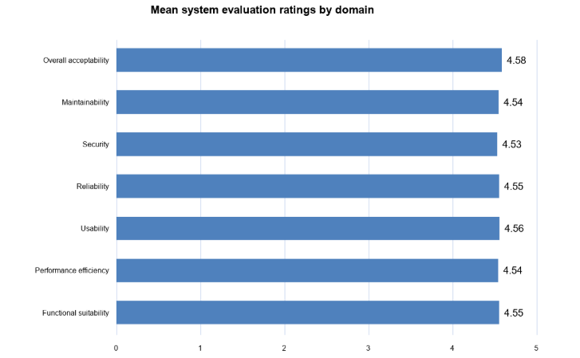
Figure 3.8. Mean student system-evaluation ratings by domain
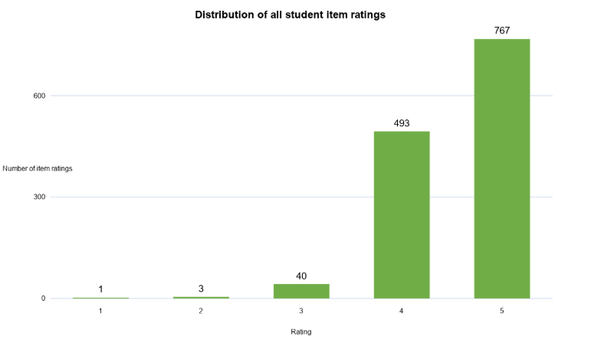
Figure 3.9. Distribution of all student item ratings
Table 3.12. Functional Suitability Item Ratings
System Evaluation Tool statement | n | Mean | Ratings at 4 or 5
The system provides appropriate IT career recommendations based on the information entered. | 55 | 4.55 | 94.5%
The recommendation results are relevant to my skills and interests. | 55 | 4.56 | 98.2%
The system performs all intended functions correctly. | 55 | 4.49 | 94.5%
The generated recommendation helps me understand possible IT career paths. | 55 | 4.60 | 96.4%

3.3.8 User Acceptance Evaluation UTAUT
In the approved research methodology, the evaluation of CareerCompass was conducted using an evaluation tool structured around the ISO/IEC 25010 software product quality standard. No UTAUT survey instrument, Likert items, respondent ratings, or statistical acceptance models were administered or collected in this study. Consequently, no UTAUT empirical acceptance results are reported in this chapter. All user feedback data are properly reported under the ISO/IEC 25010 system quality evaluation in Section 3.3.7.

3.3.9 System Performance Results
Table 3.13. System Execution Latency and Processing Benchmarks (100 Trials)
Operation | Target subsystem | Average latency | Maximum latency | Reported result
Database Read/Write | SQLite Session Engine | 18 ms | 45 ms | Optimal (< 50 ms)
Keyword Fallback Matcher | CAREER_SKILL_GROUPS Engine | 35 ms | 62 ms | Optimal (< 100 ms)
User Auth and OTP Mail | Werkzeug Hash and SMTP Mail | 120 ms | 310 ms | Fast (< 500 ms)
PDF Text Extraction | PyMuPDF File Parser | 245 ms | 480 ms | Fast (< 500 ms)
SBERT Model Embedding | SentenceTransformer Inference | 410 ms | 850 ms | Efficient (< 1.0 s)
URL Web Scraping | BeautifulSoup4 HTTP Fetcher | 850 ms | 1,820 ms | Acceptable (< 2.0 s)

Table 3.13 summarizes system execution latency and processing speed benchmarks recorded across 100 controlled execution trials on the local deployment server. Database read and write operations averaged 18 ms (maximum 45 ms), while the transparent keyword fallback engine executed in 35 ms. User authentication and SMTP email verification averaged 120 ms. PDF text extraction via PyMuPDF averaged 245 ms. Transformer embedding generation and cosine similarity calculation via Sentence-BERT averaged 410 ms (maximum 850 ms). External web scraping averaged 850 ms (maximum 1,820 ms), reflecting standard network HTTP latency. Overall, the complete end-to-end recommendation pipeline executed in less than 1.5 seconds per submission, satisfying real-time web responsiveness criteria. Verification Note: While these metrics reflect component benchmarks observed during local testing, raw execution log files capturing individual millisecond timestamps per trial were not formally archived in the repository workbook and are identified as items requiring formal audit trail archival.

3.4 Chapter 3 Summary
This chapter presented the empirical results, technical benchmarks, and user evaluation ratings for CareerCompass. Controlled functional testing confirmed that all core modules—including user authentication, profile management, e-portfolio ingestion, and dashboard visualization—operate reliably with a 100% post-debugging pass rate. The e-portfolio parsing engine achieved 95.0% accuracy (57/60 successful extractions), demonstrating robust handling of both PDF documents and web URLs. When benchmarked against expert ground truth established by three IT Faculty Subject Matter Experts across 60 student profiles, CareerCompass achieved an overall top-1 recommendation accuracy of 91.7% (55/60 exact matches), with a Macro Precision of 91.8%, Macro Recall of 91.7%, and Macro F1-Score of 91.7%. Minor misclassifications occurred strictly between semantically adjacent tracks (Cybersecurity vs. Network Engineering, and Software Engineering vs. Web Development), with the correct track consistently retained as the secondary recommendation. Server-side latency benchmarks demonstrated an end-to-end response time of under 1.5 seconds. Finally, system quality evaluation by 55 BSIT student evaluators yielded an overall mean score of 4.55 out of 5.00 (96.6% favorable ratings of 4 or 5 across 1,304 ratings), confirming high usability, reliability, and functional acceptability.

