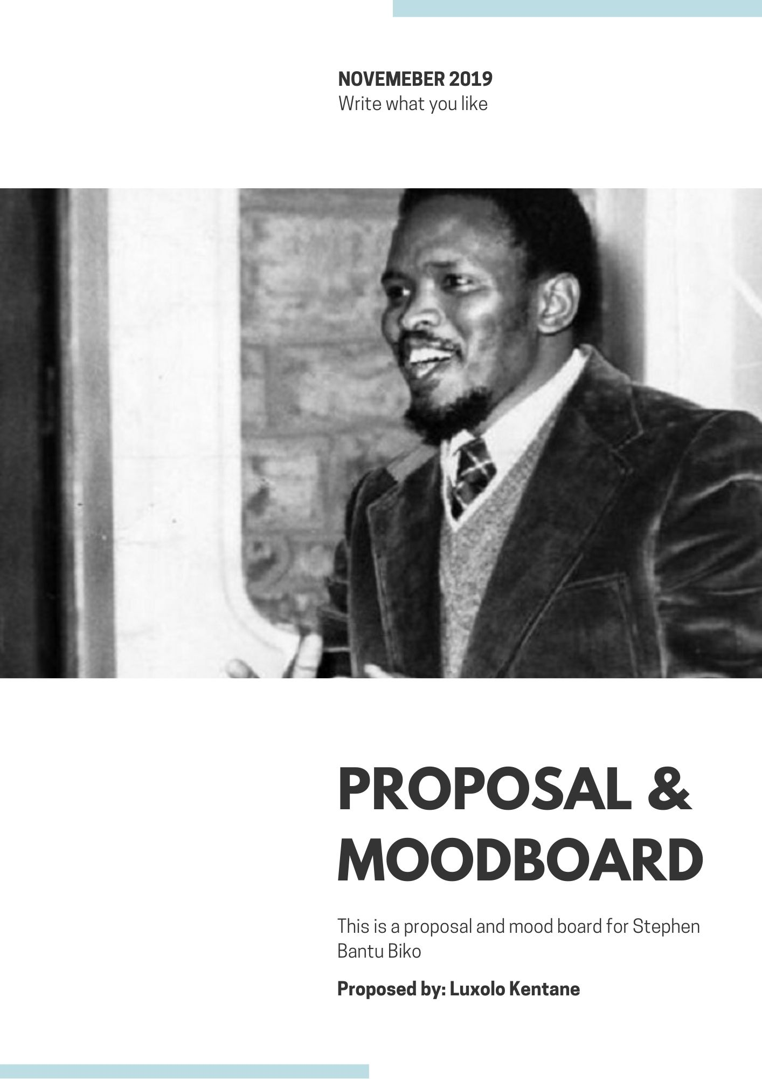

Stephen ‘Steve’ Bantu Biko

Steve Biko is a hero for many South Africans for being an anti-apartheid activist, student activist and the father of black consciousness in South Africa. Growing up in the dusty , yet beautiful streets of King Williams Town he changed the world in many significant ways. In an era where you had to accept the realities of black South Africans, Steve decided to stand up for what he believed to be right. So this site will seek to acknowledge him in the role he’s played in many Africans hearts. This site will also seek to encourage people to be who they want, how they want no matter what the word says or does.

You can also write what you like. Be how you like. And love yourself the way you are.

**Domain name**

* [www.writelikesteve.co.za](http://www.writelikesteve.co.za)
* [www.bikolegacy.co.za](http://www.bikolegacy.co.za)
* [www.stephenbiko.co.za](http://www.stephenbiko.co.za)

**Key phrases (SEO)**

* Write what I like
* Write like Steve

**Competitors**

1. **South African History Online** - <https://www.sahistory.org.za/people/stephen-bantu-biko>

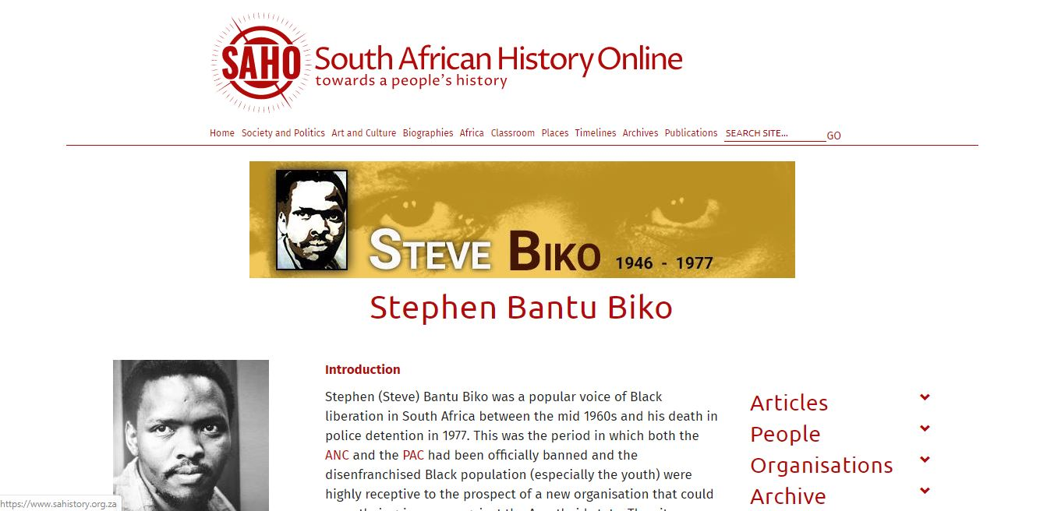

This site is: easy to navigate, sleek, heavily informative and not grabbing.

1. **Steve Biko Foundation** - <http://www.sbf.org.za/home/>

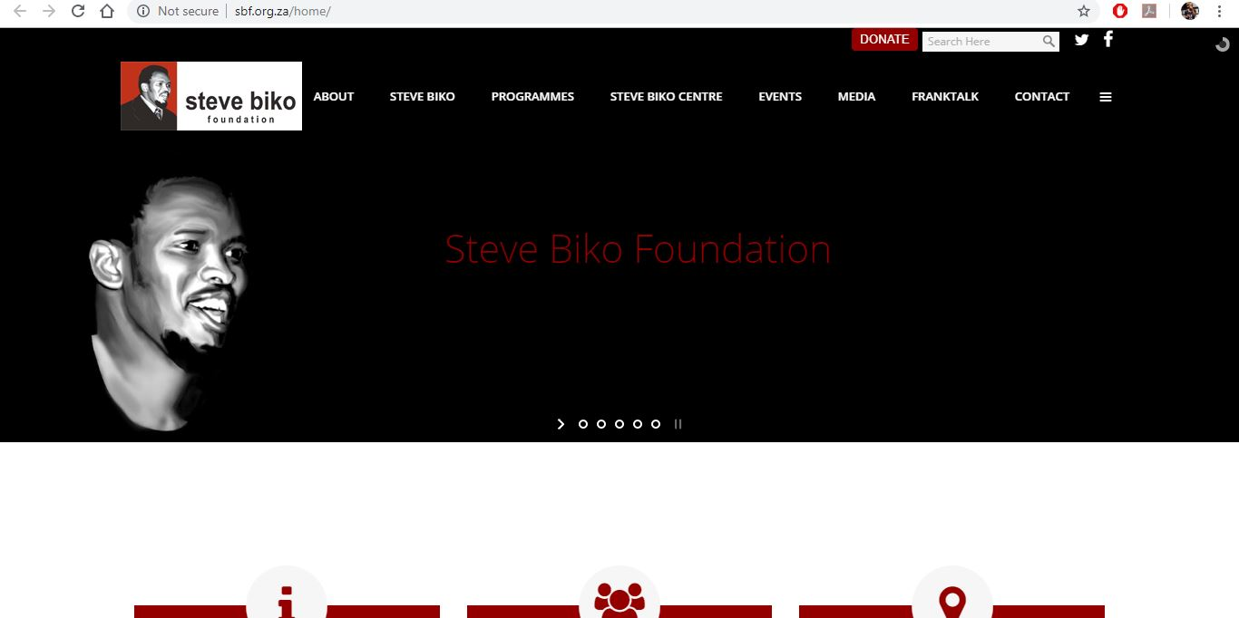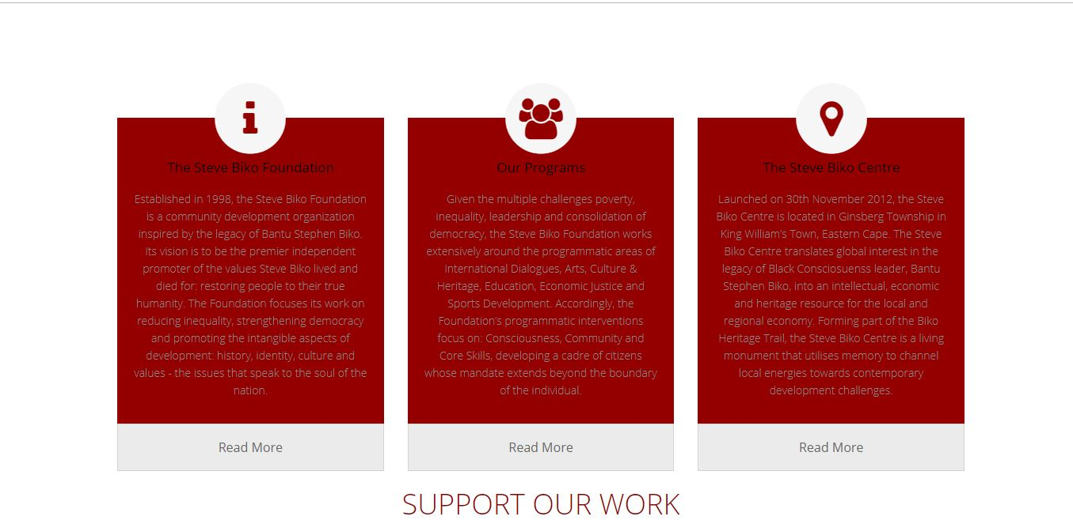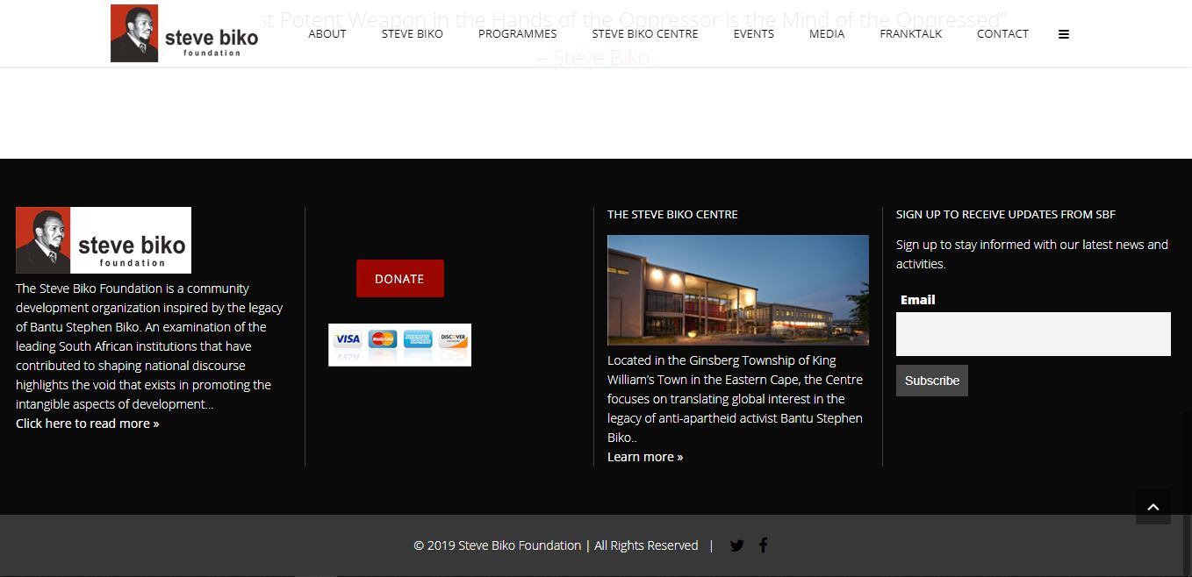

**This site is**: Modern with slides and symbols, easy to navigate and grabs your attention. The colors used are white, red and black.

**My site features and technologies**

**Landing page with slide show with nice pictures**. Slide show will link to latest news, event or article.

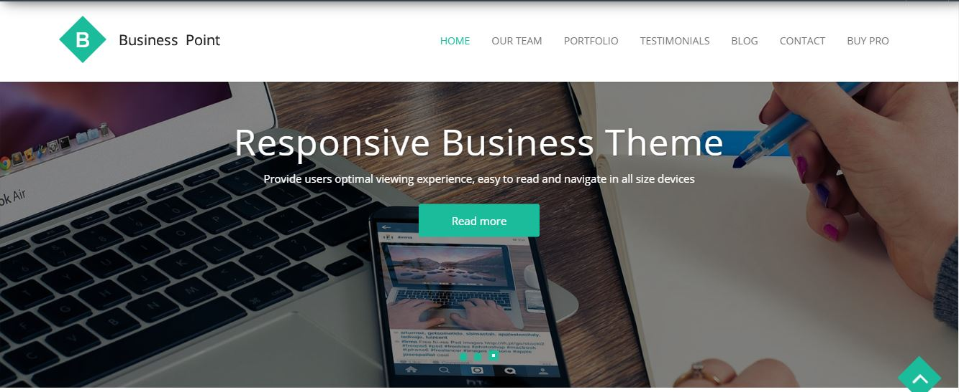

**Use of explaining history symbols and not too word driven**. History bullet points. When you click on one of the symbols it will lead to a specific part of Steve’s history eg. Birth place, kids.



**Maintaining of website**

* Monthly articles (connected with the slider on home page).
* Once a month, when submitting article check and maintain the website.

**Mood board**



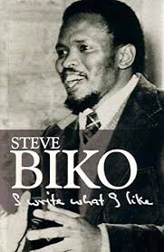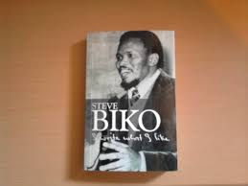

* Keepng inline with Steves first book.
* Black and white
* Inviting but authentic to Bikos time.