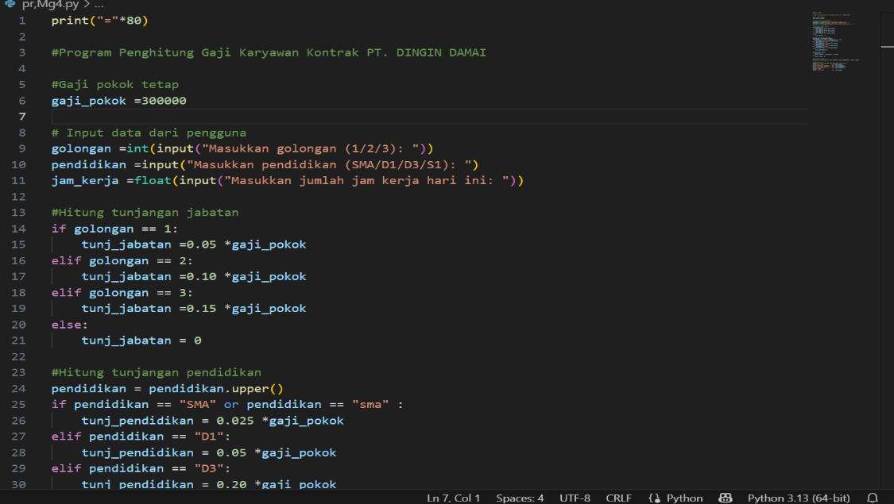PR.Dsara Permograman Mg.4

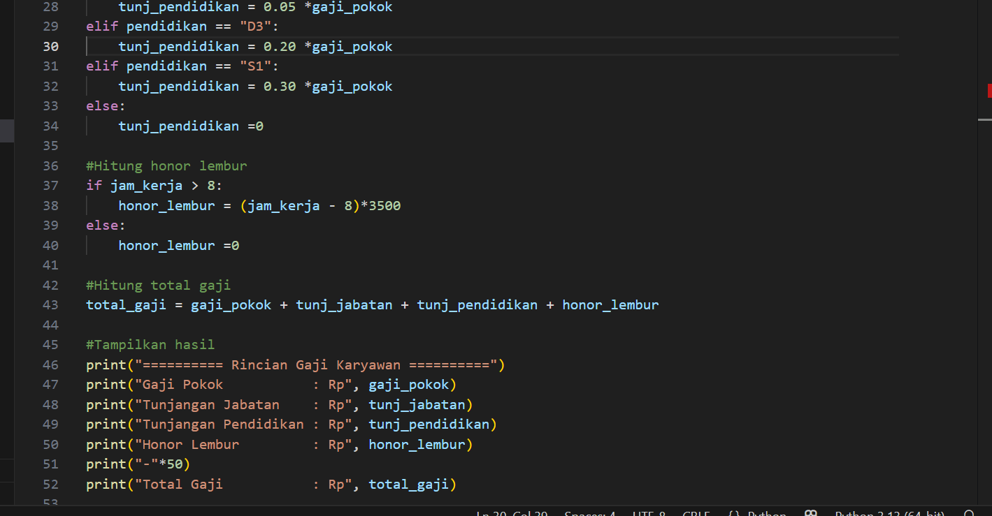

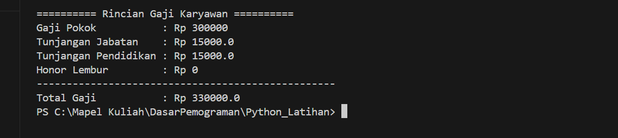

<https://github.com/LuxuriAcedia/FarisFHO.git>