**ASSIGNMENT 1 FRONT SHEET**

|  |  |  |  |
| --- | --- | --- | --- |
| **Qualification** | **BTEC Level 5 HND Diploma in Computing** | | |
| **Unit number and title** | Unit 06: Managing a Successful Computing Project | | |
| **Submission date** |  | **Date Received 1st submission** |  |
| **Re-submission Date** |  | **Date Received 2nd submission** |  |
| **Student Name** |  | **Student ID** |  |
| **Class** |  | **Assessor name** |  |
| **Student declaration**  I certify that the assignment submission is entirely my own work and I fully understand the consequences of plagiarism. I understand that making a false declaration is a form of malpractice. | | | |
|  |  | **Student’s signature** |  |

**Grading grid**

|  |  |  |  |  |  |  |
| --- | --- | --- | --- | --- | --- | --- |
| P1 | P2 | P3 | P4 | M1 | M2 | D1 |
|  |  |  |  |  |  |  |

|  |  |  |
| --- | --- | --- |
| **❒ Summative Feedback: ❒ Resubmission Feedback:** | | |
| **Grade:** | **Assessor Signature:** | **Date:** |
| **IV Signature:** | | |

Contents

I. Introduction 4

1. Scenario 5

II. SCOPE 5

1. Project Objectives. 5

**a)** **Expand the Green Zone community** 6

**b)** **Increase user awareness.** 6

**c)** **Security** 6

**d)** **Effectiveness** 6

**e)** **Performance** 6

2. Project deliverables. 6

III. Project plan. 7

1. Human Resources. 7

2 WBS and WBS dictionary. 8

a) WBS 9

b) WBS dictionary 10

3. Gantt Chart 12

4. Budget 15

5. Risk management 16

6. Quality Project 17

a. Plan 17

b. Do 18

c. Check 18

d. Act 18

7. Project Communication 18

IV. Qualitative and quantitative research. 23

1. Qualitative and quantitative research 23

a) Interview. 23

b. Focus Group. 25

c. Survey. 26

References 29

Table 1: Human Resources 6

Table 2: WBS Dictionary 11

Table 3: Cost 14

Table 4: Risk Plan 16

Table 5: Communication Log 22

Figure 1: Work Breakdown Structure of Project 8

Figure 2: Gantt Chart From 1/6 to 29/6 12

Figure 3: Gantt Chart from 30/6 to 27/7 12

Figure 4: Gantt Chart from 30/7 to 9/9 12

Figure 5: Gantt Chart from 12/9 to 15/10 13

Figure 6: Gantt Chart from 3/10 to 8/11 13

Figure 7: Statistics of health ministry. (Ministry, 2020) 26

# Introduction

# 

# II. SCOPE

COVID-19 is a major pandemic. It’s become more dangerous due to the increase of total cases and death case over the world. Vietnam is placed in the danger zone. When we have a very long border line with China where first case was found out. The most dangerous thing of COVID-19 is very easy to infection. Moreover, we have no specify vaccine for that virus and also have no many information about it exclude that it has few similiarities with SARS.

We have immediately researched and implemented a project that will help us to prevent the spread of this pandemic. This project name is .

Green Zone is an early warning application which has several function like:

* Let user be able to know immediately whether or not they have been in contact with infected person.
* The application will provide information on cases as well as localize high-risk places or vice versa.
* User can declare their health status through the program.

Green Zone is an application and it’s available for IOS and Android. Green Zone project is implemented within 6 months, so the time to open source code repository, license declaration time and release time of mobile versions is different, expecting user community and developer community. feel and join hands to find and fix errors as well as propose improvement idea. Estimate cost is more than 50.000$ and we need more than 10 people work for at least 3 weeks to finish this project.

Scale: it will be available in Hanoi in experiment time and other city after.

For now, Green Zone is not available for others platform exclude mobile device.

## 1. Project Objectives.

The developmental results of physical, financial, institutional, social, environmental or other development results that the project is expected to achieve.

**Quantitative**

Specific results include quantitative or qualitative criteria (for example, the total user will be raise to 1 million in 1 month.

**Qualitative**

Your results / goals must clearly identify the changes you desire to bring through project intervention.

1. **Expand the Green Zone community**

Green Zone has working like spider web patterns. Therefore, each user is an important chain for our system. Beside the information from ministry of health and other information channel. We also have to collect information from Green Zone’s user. We aim to 1 million users in first month.

1. **Increase user awareness.**

This pandemic is very dangerous. In addition to measures and actions what has been proposed by government departments and agencies, we need to increase our mental alertness and no cheating in declaring health.

1. **Security**

Because, this application collect so much information included information about location and travel itinerary from many people. So there will be hell if someone can steal our user information.

1. **Effectiveness**

We use Google Map API building the journey of infection and zoning the high risk area. Base on google API and user GPS, we hope the accurate rate is more than 90%.

1. **Performance**

All information are up to date as soon as possible for all Green Zone member. Each user health declare will be analyze and send to ministry of healthy quickly.

## 2. Project deliverables.

Technical and user documentation which will be given to the company.It include some graphical representations for ease of reference in the technical guide, diagrams showing movement of data through the system, and flowcharts describing how the system works.

* **User documentation**
* **Technical documentation**

# III. Project plan.

## Human Resources.

Human resources is the list of team member who has responsibility with project. It include management and recruitment. Human resources is the important stage of any organization or a project . Building an employer brand and company culture helps organization increase qualified candidates (42%), increase diverse candidates (35%), increase employee referrals (43%), and hire the right people (45%) (CultureIQ, 2020).

|  |  |  |
| --- | --- | --- |
| Team | Roles | Quantity |
| Project manager | + Manage team member  + Contact with other departments.  + Project analysis  + Divide the project to many part.  + Project monitoring | 1 |
| Business Analyst | + Research and propose solutions, ideas and features  + Provide improve. | 1 |
| Data analyst | + Analyze user data.  + Analyze pandemic data. | 1 |
| Designer | + Design user interface  + Design content for social media and marketing | 1 |
| Coder | + Code application function | 5 |
| Tester | + Test application function | 2 |
| Community Specialist | + Gather user feedback about app.  + Develop the community. | 1 |
| Marketing Specialist | + Create a content for marketing.  + Promote the app. | 1 |

Table 1: Human Resources

## 2 WBS and WBS dictionary.

Project will be implemented and developed in 6 months. In this project, we have 8 stage to do include:

1. Planning
2. Requirement Analyst
3. Designing.
4. Coding.
5. Testing.
6. Primary.
7. Secondary.
8. Installation and Maintenance.

### a) WBS

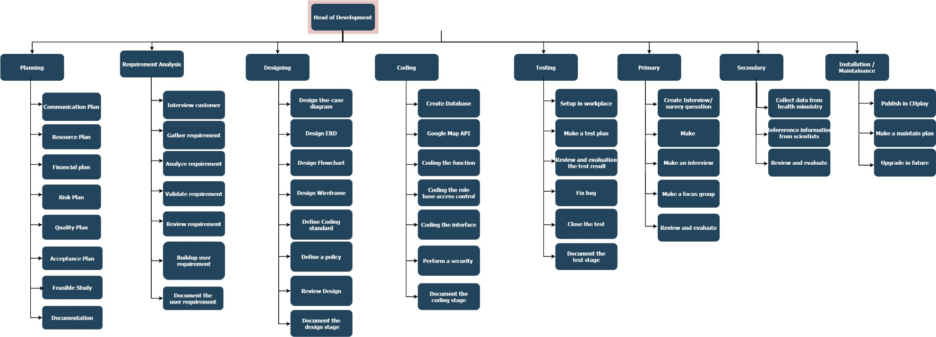

Figure 1: Work Breakdown Structure of Project

### b) WBS dictionary

|  |  |  |
| --- | --- | --- |
| **WBS Level 2** | **WBS Level 3** | **WBS Description** |
| Planning | Communication Plan | Schedule meetings as well as conversations during project completion. |
| Resources Plan | Make a list about labors and their responsibility. It include number of people for each role. Beside, we need to plan all other resources which will be used in project. |
| Financial Plan | List expenses and allocate costs appropriately. |
| Risk Plan | Plan all the risk can be happened then evaluted it and make solutions for each case |
| Quality Plan | Make a plan that includes goals and apply policies to ensure project quality. |
| Acceptable Plan | Make a necessary procedures and licenses to ensure the legality of the project. |
| Feasible Plan | Evaluate and review all the plan stage of project to identify feasibility of each part. |
| **Requirement Plan** | Interview Customer | Make an interview |
|  | Gather Requirement | Collect requirement and feedback from customer to analyze. |
| Analyze Requirement | Analyze the customer feedback to identify the main purpose of project. |
| Validate Requirement | Consider the feasibility of the customer requirements. |
| Review Requirement | Evaluate and review the user requirement in project team. |
| Buildup User Requirement | Complete the user requirement to start development deployment. |
| **Designing** | Design Use-case diagram | Make a use-case diagram base on the user requirement. |
| Design ERD | After analyze the user requirement make an entity relationship diagram for all entities which will be used in project |
| Design Flowchart | Design flowchart for each function in the project. |
| Design Wireframe | Design wireframe for user interface of application. |
| Define Coding Standard | Unified design and programming rules to make it easy to upgrade and maintain. |
| Design a policy | Make some rule which user can do or not. |
| Review Design | Review and evaluate the design stage. |
| **Coding** | Create Database | Buildup a database of application base on ERD. |
| Google Map API |  |
| Coding the function | Develop the function of application. |
| Coding the role base access control | Develop the role base access control/ account system for admin and normal user. |
| Coding the interface | Complete the user interface from the blueprints. |
| Perform a security | Contact the security parties or setup a protect shield for system. |
| **Testing** | Setup in workplace | Setup application in test environment. |
| Make a test plan | Make a test list and test plan. |
| Review and evaluate the test result | Review and evaluate the test result to find bug or which are not working right. |
| Fix bug | Fix bug left or complete the function if there is a function which not like user requirement |
| Close the test | Finish the test stage. |
| **Primary** | Publish in CH play | Upload apps to CH play for android operating. |
| Create survey question | Make survey form with appropriate question for user. |
| Make an interview | Interview few user to get their experience after use application. |
| Make focus group | Make an interview for group of people to collect their answer about app. |
| Review and evaluate the result | Review and evaluate the result of survey, interview and finish finding of research team. |
| **Secondary** | Collect data from health ministry | Collect data from health ministry to get statistics about pandemic. |
| Reference information from scientists | Interview or ask few scientists to get their opinion about app and this effect. |
| Review and evaluate the result | Review and evaluate the result. |

Table 2: WBS Dictionary

## 3. Gantt Chart

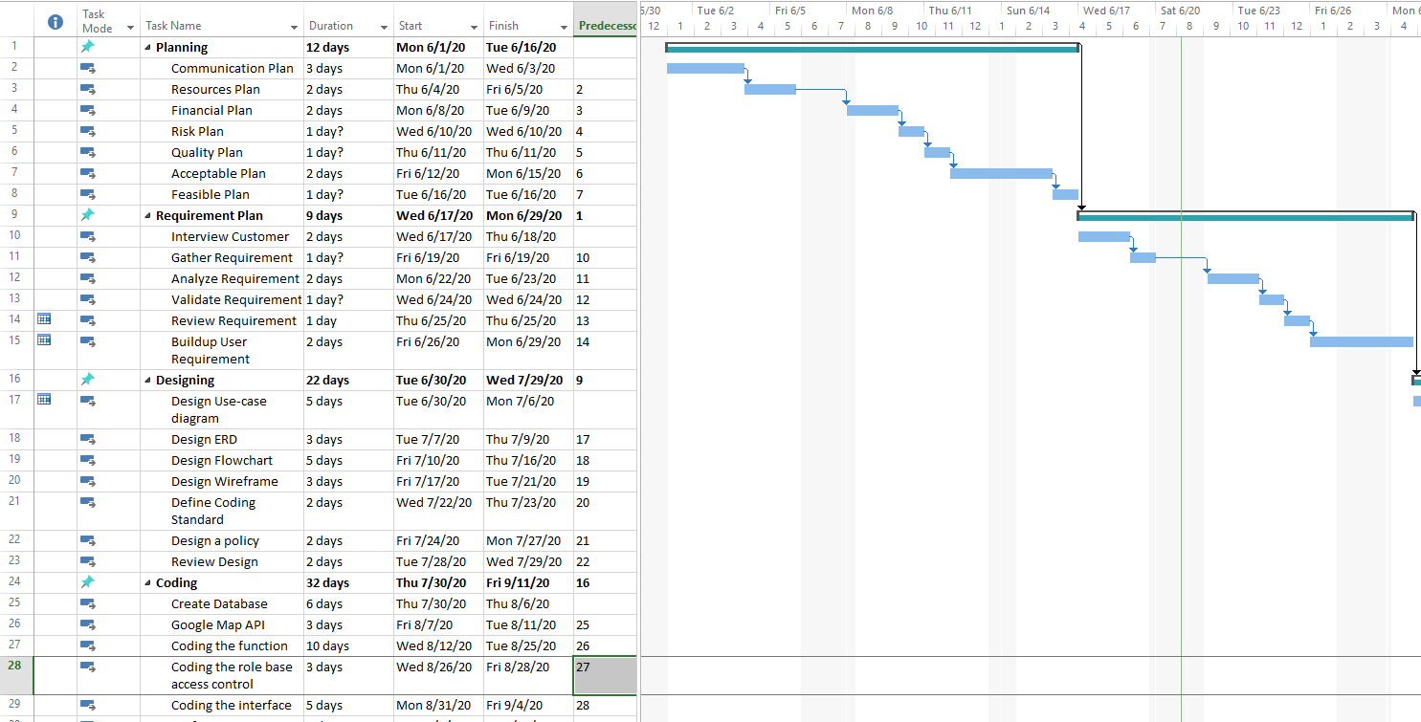

Figure 2: Gantt Chart From 1/6 to 29/6

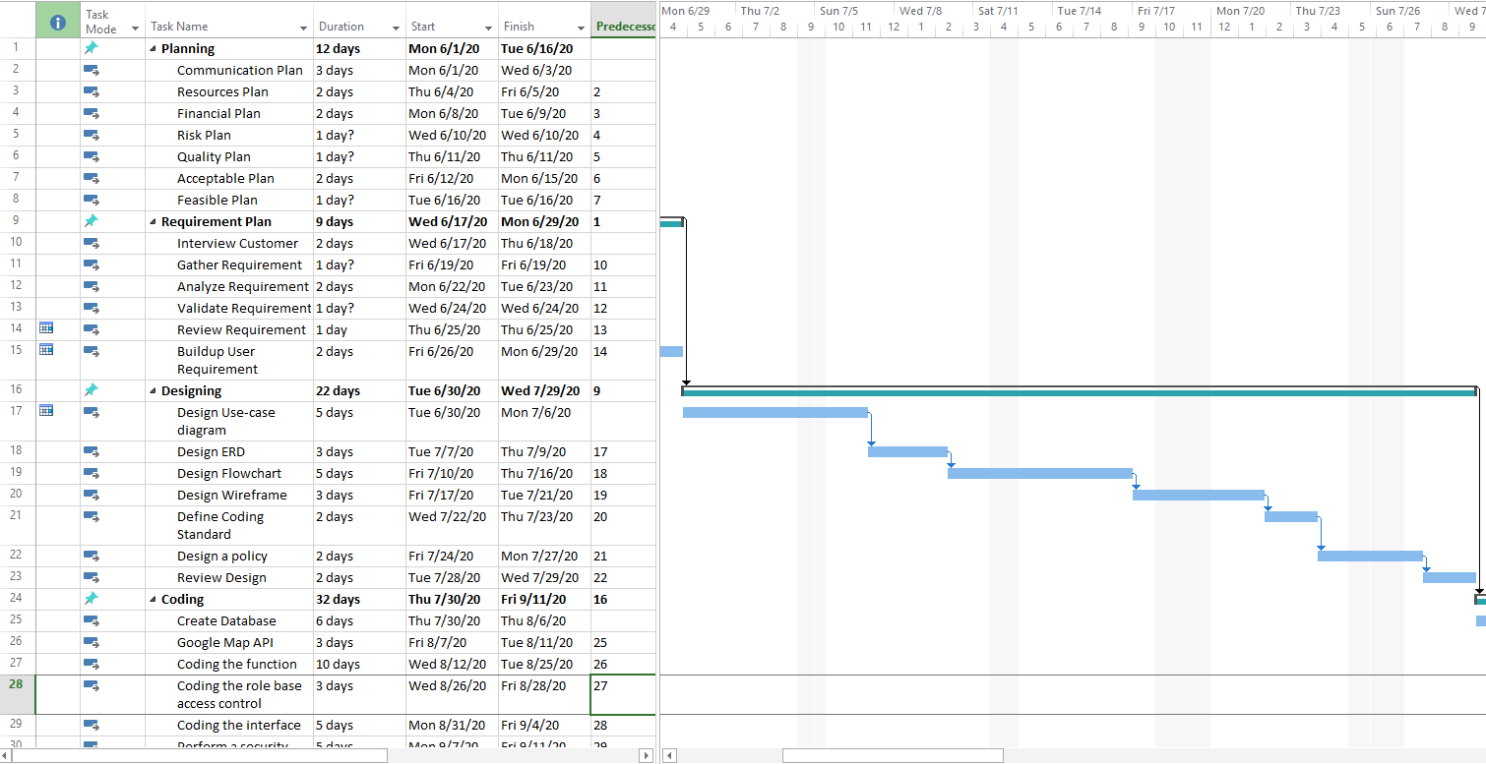

Figure 3: Gantt Chart from 30/6 to 27/7

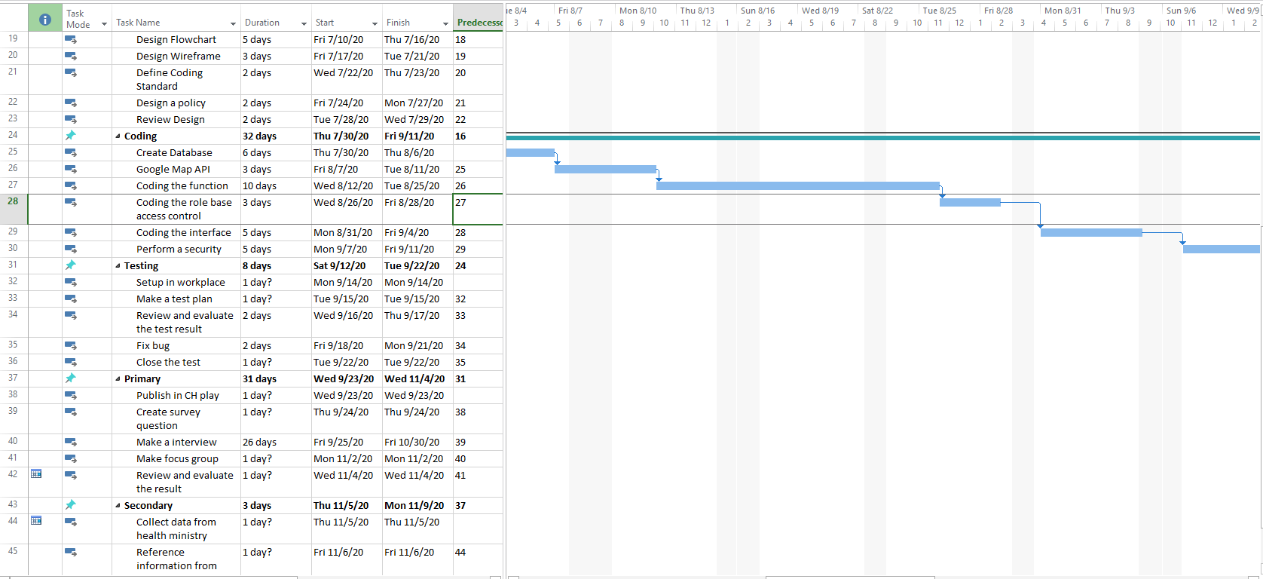

Figure 4: Gantt Chart from 30/7 to 9/9

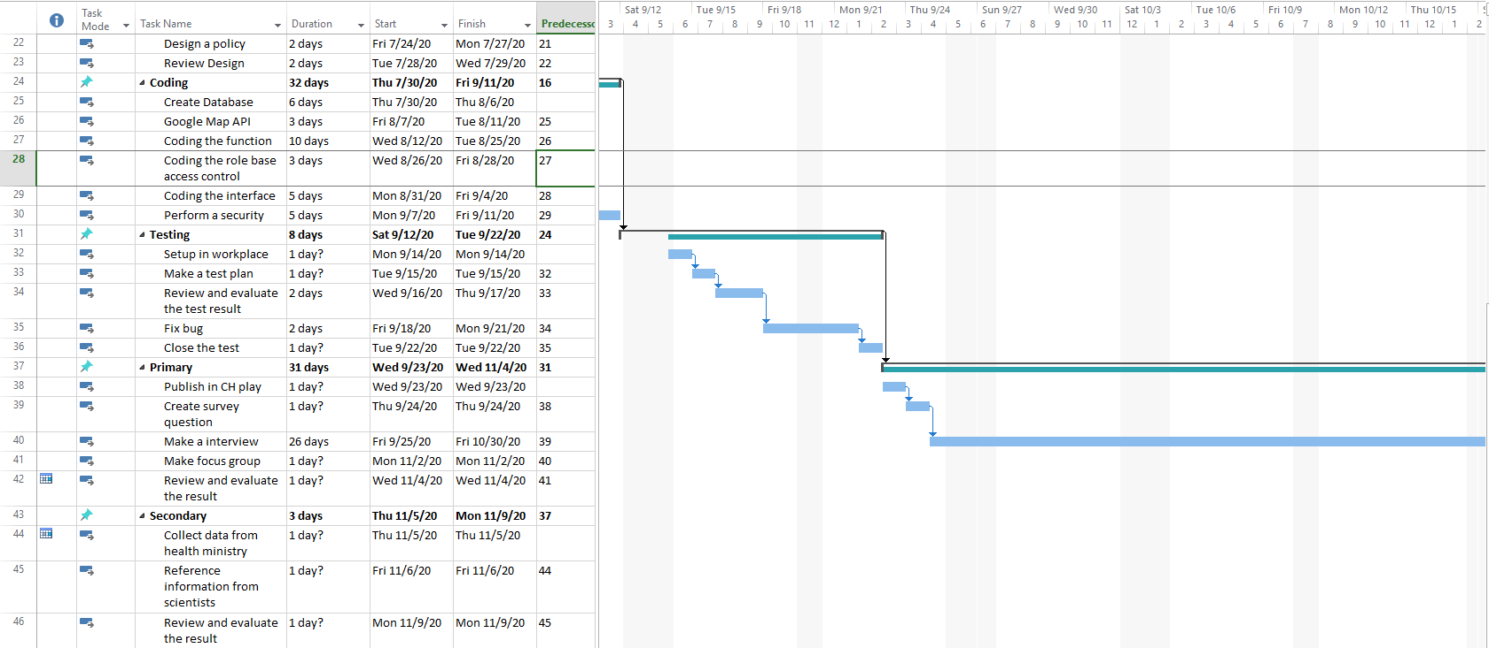

Figure 5: Gantt Chart from 12/9 to 15/10

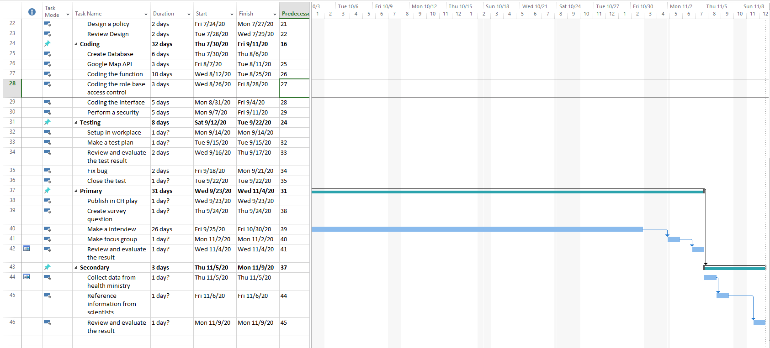

Figure 6: Gantt Chart from 3/10 to 8/11

## 4. Budget

Project can have project budgets that are several pages. Such projects often have a large number of costs associated with them, such as salary costs, development cost, and implement cost. The Project Budget itself is a dynamic document. It is continuously updated over the course of the project (Anon., 2020).

|  |  |  |  |
| --- | --- | --- | --- |
| **Project costs** | | **Percentage of overall budget** | **Budget** |
| Application/Licenses | | 6% | 3000$ |
| Staff cost | Data analyst | 3% | 1500$ |
| Coder | 10% | 5000$ |
| Designer | 3.2% | 1600$ |
| Tester | 3% | 1500$ |
| BA | 2.8% | 1400$ |
| Project manager | 4% | 2000$ |
| Marketing specialist | 2% | 1000$ |
| Total | 28% | 14000$ |
| Hardware | | 10% | 5000$ |
| Event | Interview | 3% | 1500$ |
| Meeting | 4% | 2000$ |
| Workshop | 9% | 4500$ |
| Total | 16% | 8000$ |
| Implement (Before and after project) | | 25% | 10000$ |
| Network | | 10% | 5000$ |
| Maintainance | | 10% | 5000$ |
| Marketing | | 10% | 5000$ |
| Total | | 50000$ | |

Table 3: Cost

## 5. Risk management

Risk management is the identification, evaluation and prioritization of risks followed by the rational and economical application of resources to minimize, monitor and control the probability of occurrence or impact of events. unfortunate events or to maximize the performance of opportunities. The goal of risk management is to ensure that this uncertainty does not divert the activities of the business goals.

|  |  |  |  |  |
| --- | --- | --- | --- | --- |
| Risk description | Type | Probability | Impact | Solution |
| Unreasonable cost allocation (Pay too much for one but other is lack of cost) | Budget risk/internal | Medium | High | Analyze and design clear and accurate cost for each work. |
| Lack of cost (Some hardware or application are more expensive than estimate,…) | Budget risk/ internal | Medium | High | Calling for investment.  Cut down on unnecessary expenses. |
| Overdue deadline | Time risk/ internal | High | Very High | Reasonable time calculation.  Proactively remind members to complete on time. |
| The transmission line is not stable | Technology risk / Resources | High | High | Use multiple lines to be able to change as needed.  Increase the registered bandwidth. |
| Out of date (Old version application, outdated hardware) | Technology risk | Low | Medium | Always up to date all the application and select the suitable hardware for project. |
| Limited communication  (Wrong understand or team member can’t talk to each other much. | Resources risk | Medium | Medium | Assign communicator of each team in the project.  Unify the project's standard projects. |
| Hardware error  (broken Server, broken components, …) | Technology risk / Resources risk | Medium | Very high | Planned routine maintenance.  Make Backup |
| Steal user data | Technology risk | High | Very High | Upgrade security system.  Rent some security engineers. |
| Fire house (Server room or staff room are fired,… ) | External / environment | High in summer  Low in other seasonal | Very High | Use early warning system for detect the fire as soon as possible.  Automatic fire extinguisher.  Always keep the temperature within the safe range. |
| Flood | External / environment | Low | Very High | Build good drainage system. |
| Errors of the program (  User cannot connect, login. Wrong information) | Technology | Medium | Very High | Make a test plan.  Ready to fix the error when there is feedback from the customer |

Table 4: Risk Plan

## 6. Quality Project

To ensure the design and development process go smoothly. Just like the application is completed in the best state before reaching the user. I have to follow quality assurance process in 4 steps.

### a. Plan

Project leader will divide this step into smaller parts base for our experience after analyze the user requirement. Firstly, We will analyze and classify user based on user requirements. To clearly, we will draw the use-case diagram. After identify the user. We will analyze about the entities which will use in the application and their relationship. Then design a suitable entity-relationship diagram for application. Secondly, our designer will try to design a site-map for application. Lastly, based on the components acquired in step 2, they will design wireframe applications. And to ensure that what you have analyzed is true to customer requirements. We need to let them know about what will we do. Note that, our customer sometime not a technician. So we need to talk with them and let them understand in the suitable way. We should not use so much confusing specialized terms.

### b. Do

In the Plan step, we have divided our application to many part to do. We also confirm with our customer about their requirement. In this step, we will continue to build an application base on which we get before. We can build a suitable database based on the ERD designed.

We also need to complete the user interface base on wireframe. Our developer also make some change to be more consistent as well as to add small details that the wireframe cannot indicate. The next work is connect the database to application and then completing functions for user objects based on use-case diagrams.

### c. Check

To ensure application will work well, we have to do many test. In this project, we would to do as many as possible test by assuming different cases. If there are still any error/bug, i will try to fix it. Depend on test result, we will make reviews and evaluate for identify weaknesses and strengths as well as advantages and disadvantages of the system.

### d. Act

After check step, Our team suggest improvements and upgrades in the future. Documentation of the main content of web development and design also makes maintenance easier. A quality project is not only perfect when it

It will be quality project if almost requirement of user are solved. There are not any bug or problem which direct affect to the user experience.

## 7. Project Communication.

Communication is the most important things of project success. In fact, according to the Project Management Institute (PMI), most project failures are due to communication issues. Project communication management ensures that does not happen (Anon., 2020). Project will be divided to many parts for many people. Each people have different work to do but it still a part of project. So when anyone begin their work, they need to communicate with other to ensure the synchronization. Beside, a member can ask for help when they got problem. Lastly, a project or each parts of project should be confirmed by all team member before begin.

|  |  |  |  |  |
| --- | --- | --- | --- | --- |
| **Date** | **Method** | **Type** | **Description** | **Responsible team member** |
| 01-06-2020 | Meeting | Project | Meet and introduce the participants in the project. | All member |
| 01-06-2020 | Discord / Zalo / Facebook | Project | Invite team member to discord channel and zalo/facebook group | Quoc Anh |
| 04-06-2020 | Meeting | Project | Project leader divide the project to parts for member.  Schedule a project. | All member |
| 08-06-2020 | Discord | Project | Project team willl discuss and allocation cost for each part of project. | All member |
| 10-06-2020 | Discord | Project | Discuss about risk and solution for each risk which can be happened. | Nam, Hoa |
| 16-06-2020 | Meeting | Project | Agree the plan steps of the project and start developing. | All member |
| 24-06-2020 | Face to face | Project | Review user requirement |  |
| 26-06-2020 | Meeting | Project |  |  |
| 12-07-2020 |  | Project |  |  |
| 17-07-2020 | Gmail | Project | Design team sends the blueprint to customers for preview and evaluation, comments. | Nam |
| 22-07-2020 | Discord | Project | The team members will agree on standards and regulations in the code including code convention, name convention, language, technology ... | All team member |
| 28-07-2020 | Meeting | Project | All team members will discuss and review all stages of the design before going into application development. | All Team member |
| 30/07/2020 | Discord | Project | Quoc Anh will discuss with user again to ensure that the design steps are according to user requirements. | Quoc Anh |
| 07/08/2020 | Gmail | Project | Sang will send email to Google API admin to request permission to use API in application. Besides, he also emailed the code team about how to use it. | Sang |
| 15/08/2020 | Discord | Project | Hoang got a problem with health report function. Form data can’t send to database so he need to work with Phuong to resolve it. | Phuong, Hoang |
| 22/08/2020 | Discord | Project | There are many problems when we try to sync code of Truong to the main application. | Truong |
| 27/08/2020 | Email | Project | Coder team will send a mail to the user to confirm the authorization of the accounts when using the program. | Quoc Anh |
| 02/09/2020 | Discord | Project | The coder and designer will discuss to revise and improve the user interface during development. | Quoc Anh , Sang, Nam |
| 12/09/2020 | Email | Project | Tuan will send an email to ask expert system security from BKAV for help. | Tuan |
| 17/09/2020 | Meeting | Project | All team member will discuss about the test case results. We also find bugs, reasons and plan solutions for each bug left. | All team member |
| 23/09/2020 | Face-to-Face | Project | QAnh, Hoa, Nam will making a present according to their work for the purpose of discussing the ways of project implement and project management can be met during the process | QAnh, Hoa,Nam |
| 24/09/2020 | Google Drive | Project | Nam will upload the presentation for the day 25/9/2020 to google drive folder | Nam |
| 27/09/2020 | Discord | Project | A team will demonstrate and analyzing the information provide for the day 25/9/2020 | All team member |
| 01/09/2020 | Discord | Project | Quoc Anh will be assigned Hoa and Nam to prepared a question for interviewing | All team member |
| 03/10/2020 | Face-to-Face | Project | Qanh and Nam will prepare some question related to group topic for planning and interviewing for the purpose of gathering customer feedback. They will need to find a suitable person who have experience and knowledge | Quoc Anh and Nam |
| 08/10/2020 | Google Drive | Project | A team member will discuss in brief on the interviewing collect answer for the day 8./10/2020 then upload to google drive folder | All team member |
| 16/10/2020 | Discord | Project | A team will discuss the way of how to meet the project objectives and the project budget during the whole of implementing to prevent project failed | All team member |
| 24/10/2020 | Email | Project | A team member will prepared and notify a group for the next interviewing with the professional project manager : Don will be scheduled on 3/11/2020 | All team member |
| 03/11/2020 | Face-to-Face/ Meeting | Project | A team member interview with Don to gather his information of get the good ways to get control strongly of the security and apply the API for the project | Phi Anh |
| 09/11/2020 | Face-to-Face | Project | Team member will prepare a survey question and find a group of people to gather their feedback from the project |  |
| 17/11/2020 | Discord | Project | A team will planning of project deadline finish will be schedule on 2/12/2020 | All team member |
| 29/11/2020 | Discord | Project | A team will discuss about how to apply API for the project and implement security for the project | All team member |
| 01/12/2020 | Face-to-Face | Project | Team member will make a presentation of analyzing the user feedback to Improve the ways of project implementing | All team member |

Table 5: Communication Log

# IV. Qualitative and quantitative research.

**Hypothesis.**

* Green Zone project help prevent the spread of coronavirus.
* Green Zone project helps easier to report health and health ministry can easier to collect information
* Green Zone project help people keep distance with the danger area so decrease the new case number.

## 1. Qualitative and quantitative research

### a) Interview.

Interview is one of the most reliability way to collect data from user. We have to invite atleast 4 -5 people to increase the accuracy. But due to the Corona pandemic, social gap policy has been implemented so we must to do it through skype or google meets. Age of interview participants from 20 to 65 years old. We choose the participant with the age range from young to old to receive answer from different generations. Because, depend on their age, they may have different point of view. To clarify more about advantages and disadvantages, our team has listed some questions. Question will focus on the experience and perspectives of people living in the epidemic area. Beside the available question, we will give them other question depend the development of conversation. There is questionnaire:

1. How often are you use Green Zone?
2. Is the information we provide accurate and helpful? Have it affect to you in a good way?
3. Will you send your health report through this app?
4. What do you think about this app?
5. Do you believe Green Zone will help prevent disease in Vietnam?
6. Are there any suggestion for our team to improve Green Zone project?

**Interviewee 1**

Interviewer: Hi, Sang

Sang: Hi.

Interviewer: How are you today?

Sang: I’m fine, thank you.

Interviewer: I knew that you have ever used Green Zone for 1 month, so can I ask you a few questions?

Sang: Of course.

Interviewer: How often are you use Green Zone?

Sang: I used it 4-5 times per day. I always use it to check the news about Corona.

Interviewer: Is the information we provide accurate and helpful?

Sang: Yes, it is. All the information which I have read is correct. It’s help me so much to know more about pandemic.

Interviewer: Have it affect to you in a good way?

Sang: Of course, I help me too much. I take care more about myself.

Interviewer: Will you send your health report through this app?

Sang: Yes, I will. I will send it anytime when I feel my health is not good or when I have any symptoms.

Interviewer: What do you think about this app?

Sang: It’s helpful, easy to use.

Interview: Do you believe Green Zone will help prevent disease in Vietnam?

Sang:

**Interviewee 2**

Interview: How often are you use Green Zone?

Nam: I often used Green Zone 1-2 hours per day

Interview: Is the information we provide accurate and helpful?

Nam: I feel those information you have provided is helpful for me to check the news of corona virus, exactly accurate with the statistic of number

Interview: Have it affect to you in a good way?

Nam: I thought that it be affected me in good ways.

Interview: Will you send your health report through this app?

Nam: Of course ,I will send my health report through your apps , if my health affected , I will find the ways to get a detection from examination on your apps.

Interview: What do you think about this app?

Nam: I feel it’s very convenient and helpful.

Interview: Do you believe Green Zone will help prevent disease in Vietnam?

Nam: Yes, according to some functions in this apps, Green Zone will recommend and signal all people from a dangerous zone and will prevent as soon as possible

Interview: Are there any suggestion for our team to improve Green Zone project?

Nam: I think overall the app is good with good service.

### b. Focus Group.

1. Are you affected by this pandemic?
2. What do you think if there is an application which help you find out and follow infection person journal? Is it helpful?
3. What will you do when you have contact with infection person? Will you send health report with this app?
4. How this app change your behavior?
5. Do you believe Green Zone will help limit disease in Vietnam after used it?
6. Which function do you expect to appear on app?

### c. Survey.

**Green Zone project help people change behavior and take more care about health.** According to the statistics from collecting data from social. We got some positive signal from people who do the survey and focus group about Green Zone project. People have changed their behaviors and they really take more care about their and family health. Almost people have sent their health report through Green Zone app. They also pay more attention to the symptoms that appear. According to the survey, Green Zone indirectly helped to make their lives healthier with some guide and article. For example: “Articles instructing to increase resistance or diet in epidemic season, …”.

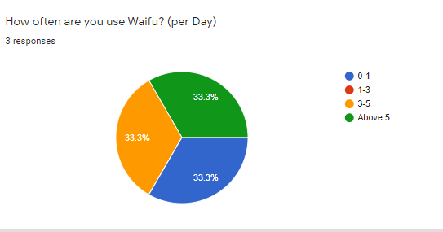

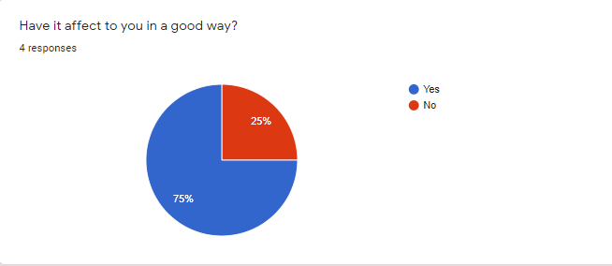

**Green Zone project helps easier to report health and health ministry can easier to collect information.** The increase in the number of people using the health reporting function will help the Ministry of Health get more information. Thereby it may be easier to manage and make appropriate policies. According to the collected data, 90% of users will send their health reports and relatives through the app.

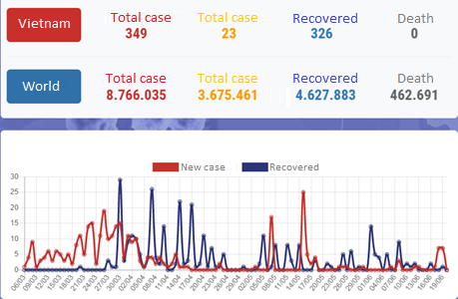

Figure 7: Statistics of health ministry. (Ministry, 2020)

**Green Zone project help prevent the spread of coronavirus.** In the fight against corona pandemic, besides the measures set by the government, the people's awareness is also a very important part. In the survey, the majority of users decided to use the software and recommend it to others. As mentioned at the beginning, each user is the chain of system, our software will be more and more effective when there are more users. According to the statistics of health ministry, till the time of this article, Vietnam had no new cases in the community for 63 days. All cases of entry have been quarantined (Anon., 2020). As Deputy Prime Minister Vu Duc Dam stated: "Living in Vietnam is the dream of many people around the world." Life in Vietnam has gradually returned to normal. All public utilities and schools have been reopened (Anon., 2020).

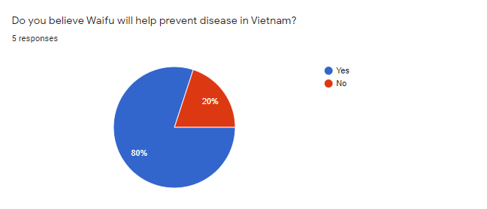

# References

Anon., 2020. *corporatefinanceinstitute.com.* [Online]   
Available at: https://corporatefinanceinstitute.com/resources/knowledge/finance/project-budget-overview/  
[Accessed 24 6 2020].

Anon., 2020. *NCOV.* [Online]   
Available at: https://ncov.moh.gov.vn/web/guest/-/thu-tuong-viet-nam-a-buoc-sang-trang-thai-binh-thuong-moi-

Anon., 2020. *wrike.com.* [Online]   
Available at: https://www.wrike.com/project-management-guide/faq/what-is-project-communication-management/

CultureIQ, 2020. *cultureiq.com.* [Online]   
Available at: https://cultureiq.com/blog/company-culture-employee-engagement-statistics/  
[Accessed 24 6 2020].

Ministry, H., 2020. *NCOV.* [Online].