**SCOPE**

COVID-19 is a major pandemic. It’s become more dangerous due to the increase of total cases and death case over the world. Vietnam is placed in the danger zone. When we have a very long border line with China where first case was found out. The most dangerous thing of COVID-19 is very easy to infection. Moreover, we have no specify vaccine for that virus and also have no many information about it exclude that it has few similiarities with sars.

**Purpose**

We have immediately researched and implemented a project that will help us to prevent the spread of this pandemic. This project name is Green Zone.

Blue zone is an early warning application which has several function like:

* Let user be able to know immediately whether or not they have been in contact with infected person.
* The application will provide information on cases as well as localize high-risk places or vice versa.
* User can declare their health status through the program.

Waifu is an application and it’s available for IOS and Android. Waifu project is implemented within 3 weeks, so the time to open source code repository, license declaration time and release time of mobile versions is different, expecting user community and developer community. feel and join hands to find and fix errors as well as propose improvement idea. Estimate cost is more than 50.000$ and we need more than 10 people work for at least 3 weeks to finish this project.

Scale: it will be available in Ha Noi in experiment time and other city after.

For now, Waifu is not available for others platform exclude mobile device.

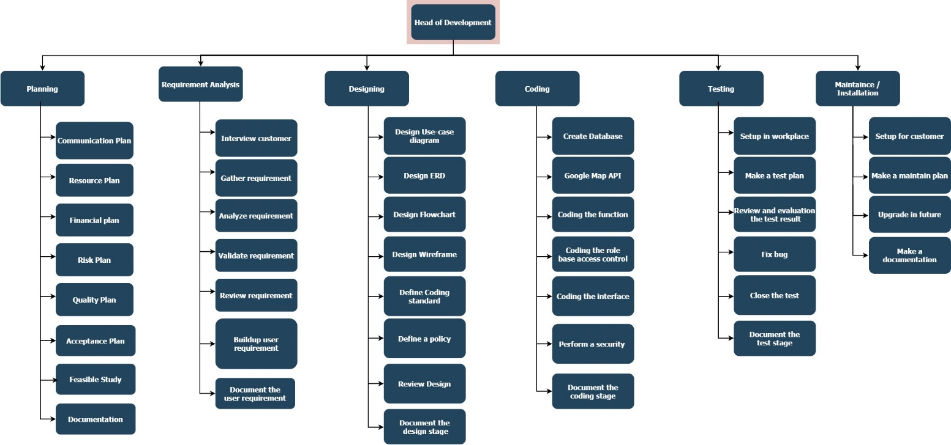

**Objective.**

The developmental results of physical, financial, institutional, social, environmental or other development results that the project is expected to achieve.

Quantitative

Specific results include quantitative or qualitative criteria (for example, the total user will be raise to 1 million in 1 month.

Qualitative

Your results / goals must clearly identify the changes you desire to bring through project intervention.

1. Expand the Waifu community

Waifu has working like spider web patterns. Therefore, each user is an important chain for our system. Beside the information from ministry of health and other information channel. We also have to collect information from Waifu’s user. We aim to 1 million users in first month.

1. Increase user awareness.

This pandemic is very dangerous. In addition to measures and actions what has been proposed by government departments and agencies, we need to increase our mental alertness and no cheating in declaring health.

1. Security

Because, this application collect so much information included information about location and travel itinerary from many people. So there will be hell if someone can steal our user information.

1. Effectiveness

We use Google Map API building the journey of infection and zoning the high risk area. Base on google API and user GPS, we hope the accurate rate is more than 90%.

1. Performance

All information are up to date as soon as possible for all blue zone member. Each user health declare will be analyze and send to ministry of healthy quickly.

**Human resources**

|  |  |  |
| --- | --- | --- |
| Team | Roles | Quantity |
| Project manager | + Manage team member  + Contact with other departments.  + Project analysis  + Divide the project to many part.  + Project monitoring | 1 |
| Business Analyst | + Research and propose solutions, ideas and features  + Provide improve. | 1 |
| Data analyst | + Analyze user data.  + Analyze pandemic data. | 1 |
| Designer | + Design user interface  + Design content for social media and marketing | 1 |
| Coder | + Code application function | 5 |
| Tester | + Test application function | 2 |
| Community Specialist | + Gather user feedback about app.  + Develop the community. | 1 |
| Marketing Specialist | + Create a content for marketing.  + Promote the app. | 1 |

**Cost**

|  |  |  |  |  |
| --- | --- | --- | --- | --- |
| **Type of cost** | **Project costs** | | **Percentage of overall budget** | **Budget** |
|  | Application/Licenses | |  | 3000$ |
|  | Staff cost | Data analyst |  | 1500$ |
| Coder |  | 5000$ |
| Designer |  | 1600$ |
| Tester |  | 1500$ |
| BA |  | 1400$ |
| Project manager |  | 2000$ |
| Marketing specialist |  | 1000$ |
| Total |  | 14000$ |
|  | Hardware | |  | 5000$ |
|  | Event | Interview |  | 1500$ |
| Meeting |  | 2000$ |
| Workshop |  | 4500$ |
| Total |  | 8000$ |
|  | Implement (Before and after project) | |  | 10000$ |
|  | Network | |  | 5000$ |
|  | Maintainance | |  | 5000$ |
|  | Marketing | |  | 5000$ |
|  | Total | |  | 50000$ |

**Risk management**

Risk management is the identification, evaluation and prioritization of risks followed by the rational and economical application of resources to minimize, monitor and control the probability of occurrence or impact of events. unfortunate events or to maximize the performance of opportunities. The goal of risk management is to ensure that this uncertainty does not divert the activities of the business goals.

|  |  |  |  |  |
| --- | --- | --- | --- | --- |
| Risk description | Type | Probability | Impact | Solution |
| Unreasonable cost allocation (Pay too much for one but other is lack of cost) | Budget risk/internal | Medium | High | Analyze and design clear and accurate cost for each work. |
| Lack of cost (Some hardware or application are more expensive than estimate,…) | Budget risk/ internal | Medium | High | Calling for investment.  Cut down on unnecessary expenses. |
| Overdue deadline | Time risk/ internal | High | Very High | Reasonable time calculation.  Proactively remind members to complete on time. |
| The transmission line is not stable | Technology risk / Resources | High | High | Use multiple lines to be able to change as needed.  Increase the registered bandwidth. |
| Out of date (Old version application, outdated hardware) | Technology risk | Low | Medium | Always up to date all the application and select the suitable hardware for project. |
| Limited communication  (Wrong understand or team member can’t talk to each other much. | Resources risk | Medium | Medium | Assign communicator of each team in the project.  Unify the project's standard projects. |
| Hardware error  (broken Server, broken components, …) | Technology risk / Resources risk | Medium | Very high | Planned routine maintenance.  Make Backup |
| Steal user data | Technology risk | High | Very High | Upgrade security system.  Rent some security engineers. |
| Fire house (Server room or staff room are fired,… ) | External / environment | High in summer  Low in other seasonal | Very High | Use early warning system for detect the fire as soon as possible.  Automatic fire extinguisher.  Always keep the temperature within the safe range. |
| Flood | External / environment | Low | Very High | Build good drainage system. |
| Errors of the program (  User cannot connect, login. Wrong information) | Technology | Medium | Very High | Make a test plan.  Ready to fix the error when there is feedback from the customer |

**Quality Project**

To ensure the design and development process go smoothly. Just like the application is completed in the best state before reaching the user. I have to follow quality assurance process in 4 steps.

**1. Plan**

I will divide this step into smaller parts base for my experience after analyze the user requirement. Firstly, I will analyze and classify user based on user requirements. To clearly, I will draw the use-case diagram. After identify the user. I will analyze about the entities which will use in the application and their relationship. Then design a suitable entity-relationship diagram for application. Secondly, i will try to design a site-map for application. Lastly, based on the components acquired in step 2, I will design wireframe applications. And to ensure that what you have analyzed is true to customer requirements. We need to let them know about what will we do. Note that, our customer sometime not a technician. So we need to talk with them and let them understand in the suitable way. We should not use so much confusing specialized terms.

**2. Do**

In the Plan step, we have divided our application to many part to do. We also confirm with our customer about their requirement. In this step, we will continue to build an application base on which we get before. We can build a suitable database based on the ERD designed.

We also need to complete the user interface base on wireframe. I also make some change to be more consistent as well as to add small details that the wireframe cannot indicate. The next work is connect the database to application and then completing functions for user objects based on use-case diagrams.

**3. Check**

To ensure application will work well, I have to do many test. In this project, I would to do as many as possible test by assuming different cases. If there are still any error/bug, i will try to fix it. Depend on test result, I will make reviews and evaluate for identify weaknesses and strengths as well as advantages and disadvantages of the system.

**4. Act**

After check step, I will suggest improvements and upgrades in the future. Documentation of the main content of web development and design also makes maintenance easier. A quality project is not only perfect when it

It will be quality project if almost requirement of user are solved. There are not any bug or problem which direct affect to the user experience.

**Hypothesis.**

* Waifu project help prevent the spread of coronavirus.
* Waifu project helps easier to report health and health ministry can easier to collect information
* Waifu project help people keep distance with the danger area so decrease the new case number.

Focus

**4. Qualitative and quantitative research**

**4.1 Interview**

Interview is one of the most reliability way to collect data from user. We have to invite atleast 4 -5 people to increase the accuracy. But due to the Corona pandemic, social gap policy has been implemented so we must to do it through skype or google meets. Age of interview participants from 20 to 65 years old. We choose the participant with the age range from young to old to receive answer from different generations. Because, depend on their age, they may have different point of view. To clarify more about advantages and disadvantages, our team has listed some questions. Question will focus on the experience and perspectives of people living in the epidemic area. Beside the available question, we will give them other question depend the development of conversation. There is questionnaire:

1. How often are you use Waifu?
2. Is the information we provide accurate and helpful? Have it affect to you in a good way?
3. Will you send your health report through this app?
4. What do you think about this app?
5. Do you believe Waifu will help prevent disease in Vietnam?
6. Are there any suggestion for our team to improve Waifu project?

1.

Participants 1

Interviewer: Hi, Sang

Sang: Hi.

Interviewer: How are you today?

Sang: I’m fine, thank you.

Interviewer: I knew that you have ever used Waifu for 1 month, so can I ask you a few questions?

Sang: Of course.

Interviewer: How often are you use Waifu?

Sang: I used it 4-5 times per day. I always use it to check the news about Corona.

Interviewer: Is the information we provide accurate and helpful?

Sang: Yes, it is. All the information which I have read is correct. It’s help me so much to know more about pandemic.

Interviewer: Have it affect to you in a good way?

Sang: Of course, I help me too much. I take care more about myself.

Interviewer: Will you send your health report through this app?

Sang: Yes, I will. I will send it anytime when I feel my health is not good or when I have any symptoms.

Interviewer: What do you think about this app?

Sang: It’s helpful, easy to use.

Interview: Do you believe Waifu will help prevent disease in Vietnam?

Sang:

Participant 2

Interview: How often are you use Waifu?

Nam: I often used Waifu 1-2 hours per day

Interview: Is the information we provide accurate and helpful?

Nam: I feel those information you have provided is helpful for me to check the news of corona virus, exactly accurate with the statistic of number

Interview: Have it affect to you in a good way?

Nam: I thought that it be affected me in good ways.

Interview: Will you send your health report through this app?

Nam: Of course ,I will send my health report through your apps , if my health affected , I will find the ways to get a detection from examination on your apps.

Interview: What do you think about this app?

Nam: I feel it’s very convenient and helpful.

Interview: Do you believe Waifu will help prevent disease in Vietnam?

Nam: Yes, according to some functions in this apps, Waifu will recommend and signal all people from a dangerous zone and will prevent as soon as possible

Interview: Are there any suggestion for our team to improve Waifu project?

Nam: I think overall the app is good with good service.

2. Focus

1. Where are you from?
2. Are you affected by this pandemic?
3. What do you think if there is an application which help you find out and follow infection person journal? Is it helpful?
4. What will you do when you have contact with infection person? Will you send health report with this app?
5. Do you believe Waifu will help prevent disease in Vietnam?
6. Which function do you expect to appear on app?

**Waifu project help people change behavior and take more care about health.** According to the statistics from collecting data from social. We got some positive signal from people who do the survey and focus group about Waifu project. People have changed their behaviors and they really take more care about their and family health. Almost people have sent their health report through Waifu app. They also pay more attention to the symptoms that appear. According to the survey, waifu indirectly helped to make their lives healthier with some guide and article. For example: “Articles instructing to increase resistance or diet in epidemic season, …”.

**Waifu project helps easier to report health and health ministry can easier to collect information.** The increase in the number of people using the health reporting function will help the Ministry of Health get more information. Thereby it may be easier to manage and make appropriate policies.