University Management System (UniConnect) - System Overview

Introduction
UniConnect is a modern, unified digital platform designed to streamline the complex administrative, academic, and financial operations of the university. It provides a tailored, intuitive experience for every member of the university ecosystem—Students, Academic Staff, Administrators, and Financial Officers.

The system is built on a secure, real-time cloud infrastructure, ensuring that data is always up-to-date, accessible from anywhere, and protected with enterprise-grade security.

Key Capabilities at a Glance
- For Students: A single hub for all academic and campus life needs. View results, pay fees, register for courses, and access welfare services without standing in queues.
- For Staff: Digital tools to manage teaching, grading, and research. Automated attendance tracking and streamlined mark entry reduce administrative burden.
- For Administration: Strategic oversight with real-time analytics. manage curriculum, users, and compliance from a central command center.
- For Finance (Bursar): Real-time financial reconciliation, automated fee tracking, and transparent auditing tools.

System Structure (User-Wise)
The following diagrams illustrate the robust feature set available to each user role.

1. Student Portal
Focus: Personal Academic Journey & Campus Services

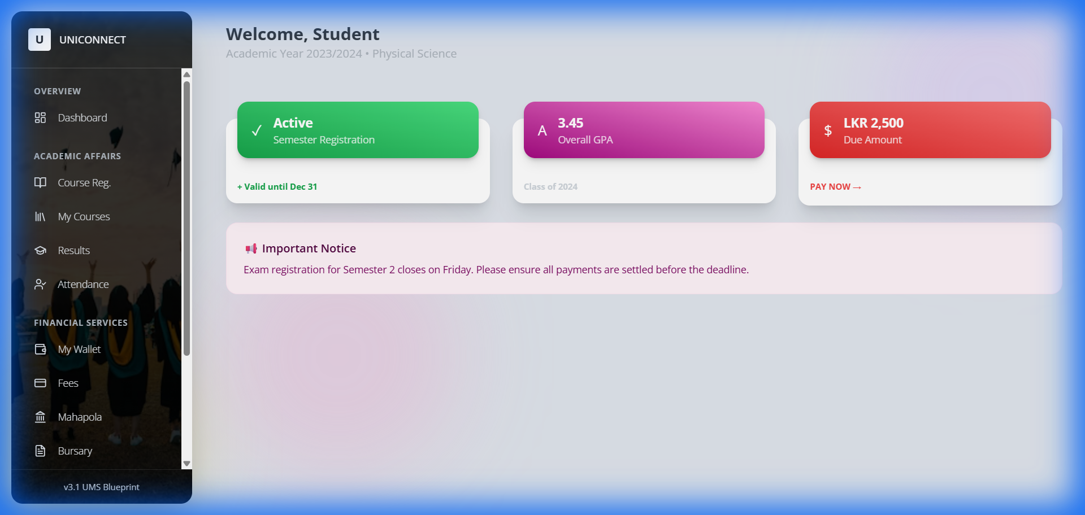

graph TD
Student[Student Services]
Student --> Overview[Overview]
Overview --> Dashboard[Personal Dashboard]
Student --> Academic[Academic Affairs]
Academic --> Reg[Course Registration]
Academic --> MyCourses[My Courses & Materials]
Academic --> Results[Exam Results & GPA]
Academic --> Attendance[Digital Attendance Record]
Student --> Finance[Financial Services]
Finance --> Wallet[Digital Wallet]
Finance --> Fees[Fee Payments]
Finance --> Mahapola[Mahapola Scholarship]
Finance --> Bursary[Bursary Management]
Student --> Welfare[Student Welfare]
Welfare --> Hostel[Hostel Allocation]
Welfare --> Health[Medical Centre]
Welfare --> Career[Career Guidance]

2. Academic Staff Portal
Focus: Teaching, Evaluation & Research

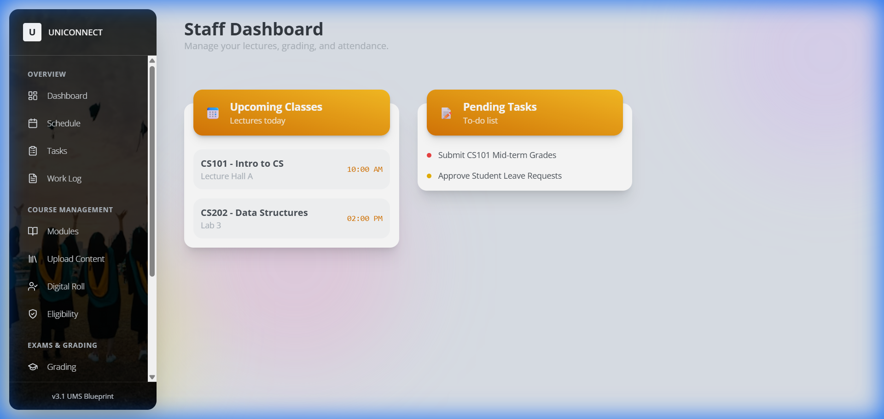

graph TD
Staff[Academic Staff]
Staff --> Overview[Overview]
Overview --> Dashboard[Staff Dashboard]
Overview --> Schedule[Teaching Schedule]
Overview --> Tasks[Admin Tasks]
Overview --> Log[Work Log]
Staff --> Courses[Course Management]
Courses --> Modules[Module Planning]
Courses --> Content[Upload Learning Materials]
Courses --> Attendance[Digital Roll Call]
Courses --> Eligibility[Exam Eligibility Checks]
Staff --> Exams[Exams & Grading]
Exams --> Grading[Final Grading]
Exams --> Marks[Enter Continuous Assessment]
Exams --> Plagiarism[AI Plagiarism Check]
Staff --> Research[Research & Impact]
Research --> Pubs[Publications Repository]
Research --> Grants[Grant Management]

3. Administration Portal (Registrar & VC)
Focus: Governance, Strategy & Operations

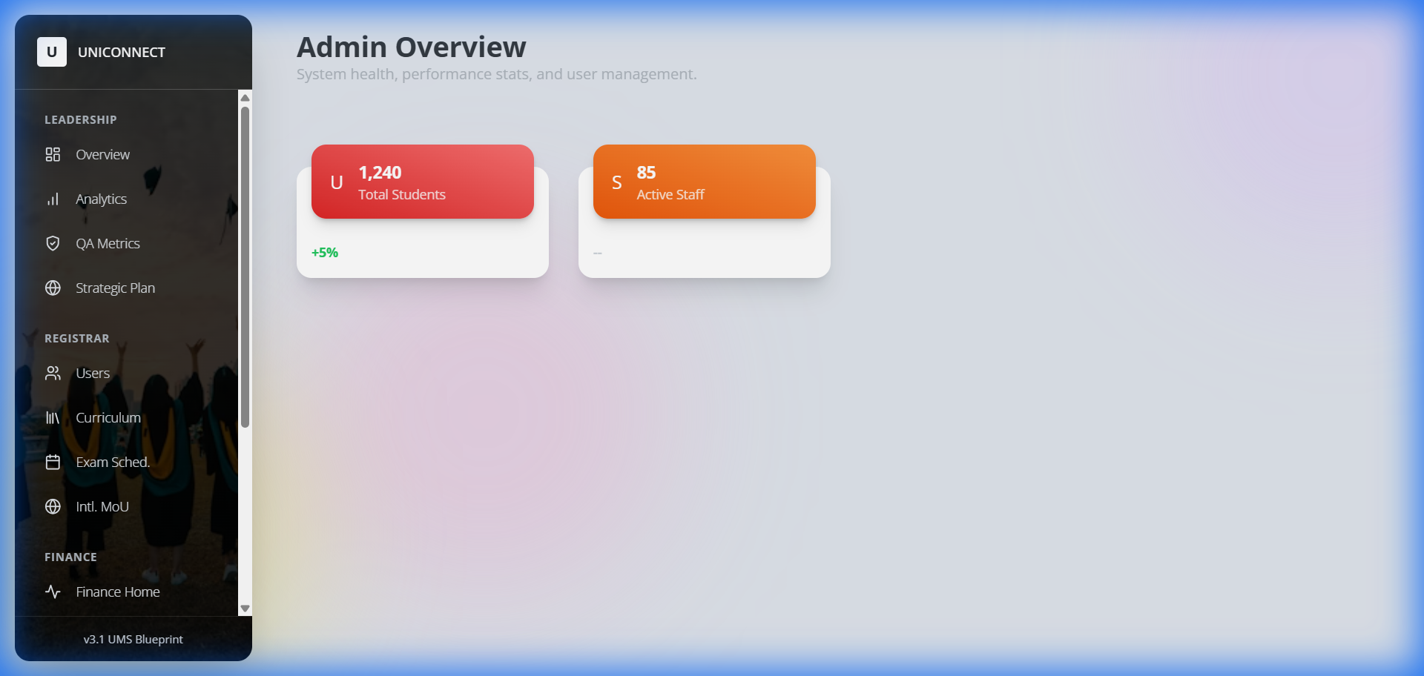

graph TD
Admin[Administration]
Admin --> Lead[Leadership & Strategy]
Lead --> Overview[Executive Overview]
Lead --> Analytics[University Analytics]
Lead --> QA[Quality Assurance]
Lead --> Plan[Strategic Planning]
Admin --> Reg[Registrar Operations]
Reg --> Users[User Management]
Reg --> Curr[Curriculum Development]
Reg --> Exams[Exam Scheduling]
Reg --> MOU[International MoUs]
Admin --> Fin[Finance Oversight]
Fin --> Fees[Fee Structures]
Fin --> Funds[Fund Allocation]
Fin --> Assets[Asset Management]
Fin --> Audit[Internal Audit]
Admin --> Sys[System]
Sys --> Settings[Configuration]

4. Bursar (Finance) Portal
Focus: Financial Integrity & Reconciliation

graph TD
Bursar[Bursar Office]
Bursar --> Fin[Financial Operations]
Fin --> Dashboard[Financial Overview]
Fin --> Reconcile[Daily Reconciliation]
Fin --> Payments[Verify Payments]
Fin --> Reports[Financial Reporting]

Role-Based Menu Explorer & Walkthroughs
This section describes exactly what a user sees and does in each menu option.

1. Student Portal Navigation
Primary Goal: Academic Success & Financial Clarity

Menu Section | Item | Action / Walkthrough
Overview | Dashboard | View: Check GPA, Semester Status, and Wallet Balance.<br>Action: Click widgets to jump to Results or Payments.
Academic | Course Reg. | Step 1: Browse open courses for the semester.<br>Step 2: Click "Enroll" on desired modules.<br>Step 3: System checks prerequisites > Confirms enrollment.
 | My Courses | View: List of active enrolled modules.<br>Action: Click a module to access learning materials, assignments, and announcements.
 | Results | View: Full academic transcript and GPA calculation.<br>Action: Download official semester reports (PDF).
 | Attendance | View: Check attendance percentage per module.<br>Alert: Flags if attendance drops below 80%.
Financial | My Wallet | View: Total balance, scholarship inflows, and payment outflows.<br>Action: Top up wallet via payment gateway.
 | Fees | View: Outstanding tuition or exam fees.<br>Action: Click "Pay Now" > Select Payment Method > Generates Receipt.
 | Mahapola | View: Scholarship installment status and history.<br>Action: Acknowledge receipt of funds.
 | Bursary | Action: Apply for financial aid > Upload Income Proof > Submit for Bursar review.
Welfare | Hostel | Action: Apply for accommodation > Select Room Type > View Allocation Status.
 | Health | Action: Book medical appointments > View digital medical history.
 | Career | Action: View job board > Book counseling sessions.

2. Academic Staff Navigation
Primary Goal: Efficient Teaching & Evaluation

Menu Section | Item | Action / Walkthrough
Overview | Dashboard | View: Upcoming Classes timeline and "To-Do" list (e.g., "Grade CS101").
 | Schedule | View: Weekly teaching timetable with room numbers.
 | Tasks | Action: View administrative tasks assigned by Dean/HoD > Mark as "Done".
 | Work Log | Action: Auto-generated log of teaching hours for payroll claims.
Courses | Modules | View: List of modules taught this semester.<br>Action: Select to manage specific course details.
 | Upload Content | Step 1: Select Module.<br>Step 2: Drag & Drop Lecture Slides/Notes.<br>Step 3: Publish to Student Portal.
 | Digital Roll | Step 1: Select Active Class.<br>Step 2: Display QR Code or Manually check students присутing.
 | Eligibility | View: Auto-generated list of students eligible for exams based on attendance.
Exams | Grading | Action: Input final letter grades for verified students > Submit to Exam Board.
 | Enter Marks | Action: Enter continuous assessment (assignment/mid-term) raw marks.
 | Plagiarism | Tool: Upload student assignment > AI scans against repository > Returns Similarity Report.
Research | Publications | Action: Log new research papers > Updates academic profile.
 | Grants | Action: Track grant utilization and detailed expenditure.

3. Administration Navigation (Registrar/VC)
Primary Goal: High-Level Oversight & Configuration

Menu Section | Item | Action / Walkthrough
Leadership | Overview | View: Campus pulse (Active Users, Financial Health, Critical Alerts).
 | Analytics | Tool: Interactive charts showing multi-year trends (Enrollment, Pass Rates).
 | QA Metrics | View: Compliance with UGC/Quality Assurance standards.
 | Strategic Plan | Action: Define and track long-term university KPIs.
Registrar | Users | Action: Create/Edit User Accounts > Reset Passwords > Assign Roles.
 | Curriculum | Action: Define new Degrees/Courses > Set Credits & Prerequisites.
 | Exam Sched. | Action: Create exam timetables > Allocate exam halls & invigilators.
 | Intl. MoU | Action: Manage partnerships with foreign universities.
Finance | Fee Tracking | View: Real-time monitor of fee collection rates across faculties.
 | Funds | Action: Allocate budget to departments.
 | Assets | Action: Inventory management (Buildings, Labs, Equipment).
 | Audit | Report: Generate system-wide activity logs for internal audit.
System | Config | Action: Set global variables (Academic Year, Semester Dates).

4. Bursar Navigation
Primary Goal: Financial Integrity

Menu Section | Item | Action / Walkthrough
Finance | Finance Home | View: Cash flow summary, Daily Collection, Pending Approvals.
 | Reconcile | Workflow: <br>1. System flags mismatched payments.<br>2. Bursar reviews bank feed vs system records.<br>3. Click "Reconcile" to force match or "Flag" to investigate.

Role Responsibility Matrix
This matrix clearly defines who is responsible for each core operation within the system.

Operational Area | Action | Student | Staff | Admin (Reg) | Bursar
Onboarding | Account Creation | Applies | Verifies Docs | Final Approval | -
Coursework | Enrollment | Initiates | Advises | Configures | -
 | Upload Content | Consumes | Uploads | - | -
 | Attendance | Checks | Marks | Monitors | -
Examinations | Scheduling | View | - | Creates | -
 | Grading | View | Enters | Publishes | -
Finance | Fee Payment | Pays | - | Sets Fees | Verifies
 | Scholarship | Receives | - | - | Disburses
 | Reconciliation | - | - | Audit | Executes
Welfare | Notifications | View | Send | Broadcast | -

Service Blueprint - Visual Evidence
Real-time snapshots of role-based workflows.

1. Student: Course Registration & Financials
Action: Browsing active modules and checking wallet balance.
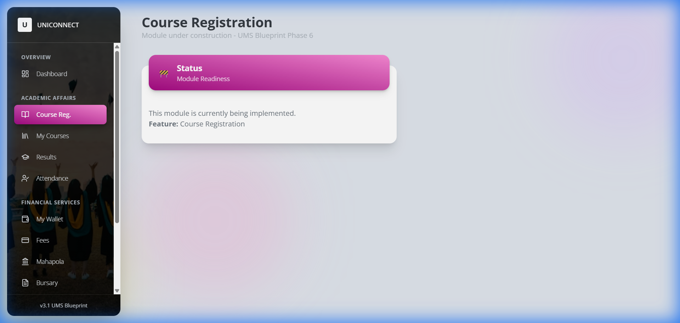
(Above: Student selects modules for the upcoming semester)

2. Staff: Academic Administration
Action: Managing modules and entering grades.
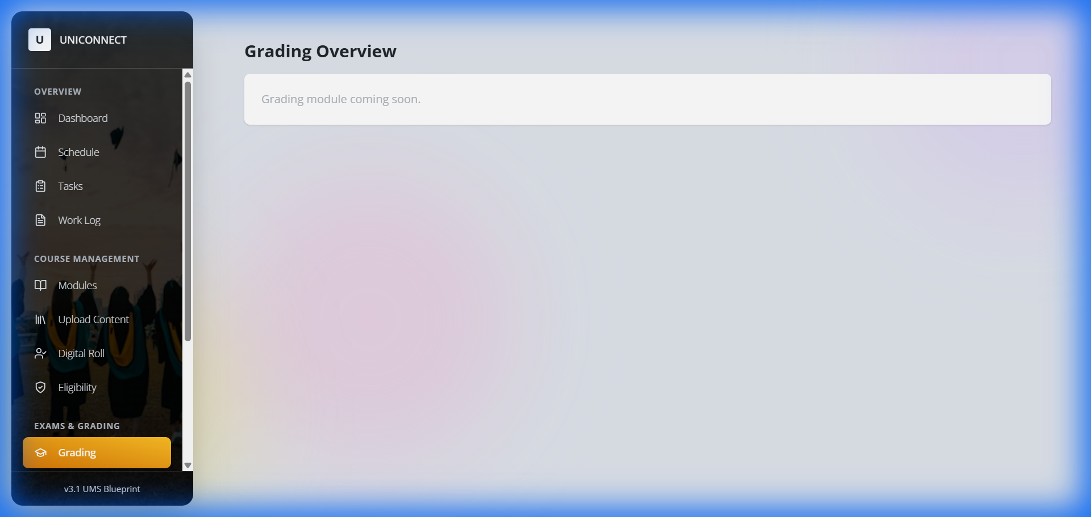
(Above: Interface for entering and finalizing student marks)

3. Admin: System Governance
Action: Managing user access and scheduling exams.
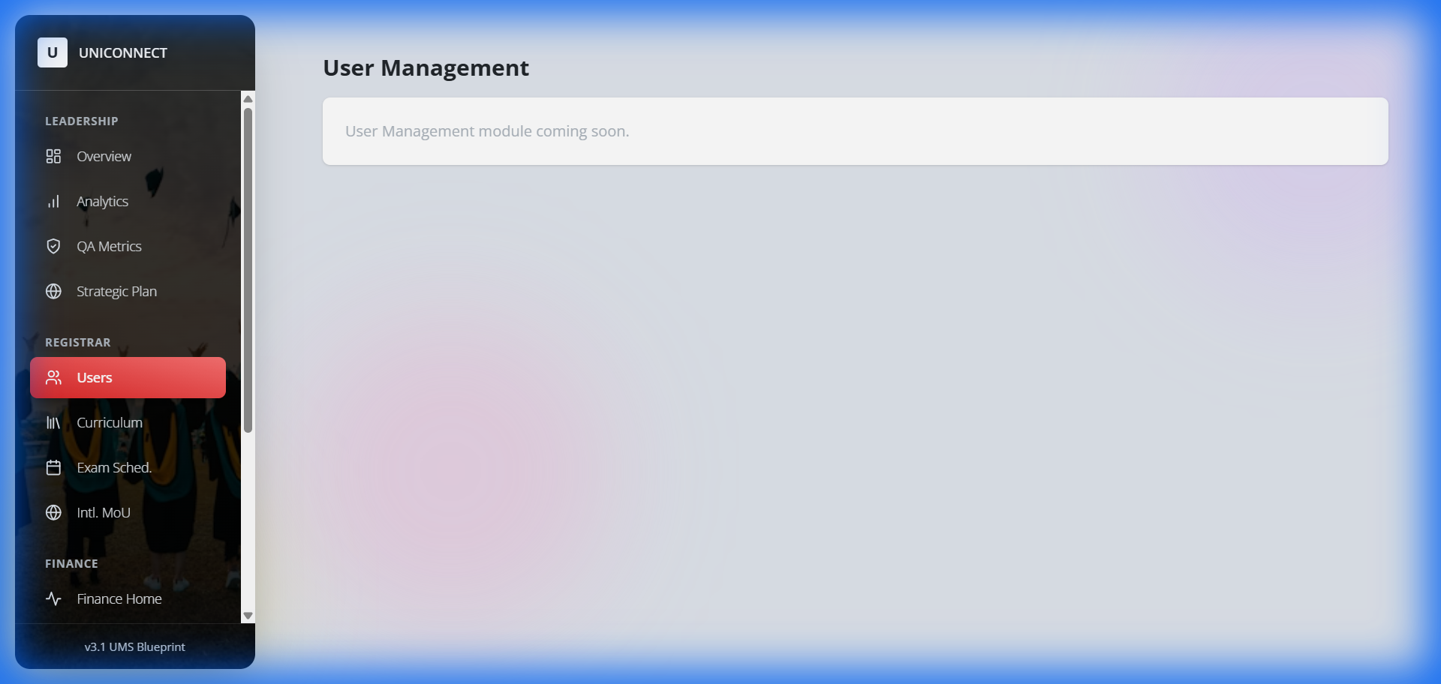
(Above: Registrar's view for verifying and managing student/staff accounts)

4. Bursar: Financial Reconciliation
Action: Verifying payments and auditing streams.
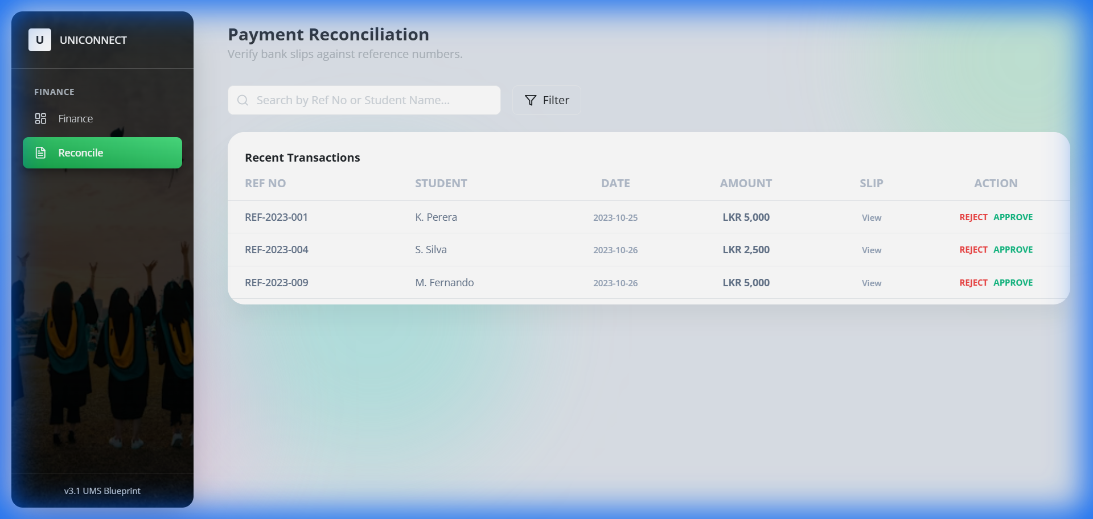
(Above: Active workspace for matching bank feeds with system receipts)

Interconnected Operational Workflows

Workflow 1: The "New Student" Lifecycle (Onboarding)
Goal: Move a user from an "Applicant" to an "Active Student".

- Student (External): Visits Portal > "Apply Now" > Fills Profile > Uploads NIC/A-Level Results.
- System: Creates "Provisional" account. Locked from Course Reg.
- Admin (Registrar): Receives "New Intake" Alert > Reviews Documents > Clicks "Approve".
- System: Unlocks Student Account > Generates Student ID > Sends Welcome Email.
- Student: Logs in > Sees "Complete Registration Payment" task.
- Student: Pays Registration Fee via Gateway.
- Bursar: Payment auto-verified (or manual checks).
- System: Status updated to "Active" > "Course Reg" menu unlocks.

Workflow 2: The "External Course" Application (Marketplace)
Goal: Allow a student to take an extra qualification (e.g., CIMA/MBA).

- Student: Navigation > My Courses > "Browse External Courses".
- System: Filters courses by Student's eligibility (e.g., Year 3 only).
- Student: Selects "MBA Foundation" > Clicks "Apply".
- Admin: "Curriculum" > Sees Application > Checks capacity > Approves.
- Student: Received "Offer Letter" notification > "Fees" menu updates.
- Student: Pays Module Fee (Installment 1).
- System: Auto-enrolls student in "MBA Foundation" module appearing in My Courses.

Request for Stakeholder Input
To ensure UniConnect fits your specific university culture, we need your input on:
- Approval Hierarchies: Who specifically signs off on new student intakes? (Dean vs Registrar?)
- Fee Structures: Are there specific installment plans for External Courses?
- Legacy Data: Do we need to migrate existing records?
- Custom Workflows: Are there unique departmental processes we should model?

