University Management System (UniConnect) - System Overview

Introduction
**UniConnect** is a modern, unified digital platform designed to streamline the complex administrative, academic, and financial operations of the university. It provides a tailored, intuitive experience for every member of the university ecosystem—Students, Academic Staff, Administrators, and Financial Officers.
The system is built on a **secure, real-time cloud infrastructure**, ensuring that data is always up-to-date, accessible from anywhere, and protected with enterprise-grade security.

Key Capabilities at a Glance
- **For Students**: A single hub for all academic and campus life needs. View results, pay fees, register for courses, and access welfare services without standing in queues.
- **For Staff**: Digital tools to manage teaching, grading, and research. Automated attendance tracking and streamlined mark entry reduce administrative burden.
- **For Administration**: Strategic oversight with real-time analytics. manage curriculum, users, and compliance from a central command center.
- **For Finance (Bursar)**: Real-time financial reconciliation, automated fee tracking, and transparent auditing tools.

System Structure (User-Wise)
The following diagrams illustrate the robust feature set available to each user role.

1. Student Portal
*Focus: Personal Academic Journey & Campus Services*
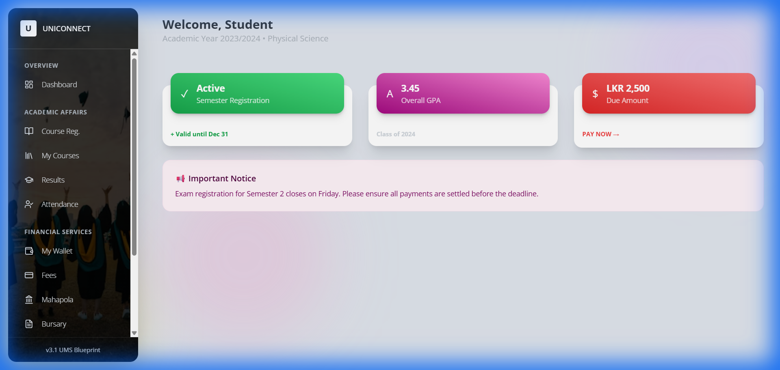
Student Dashboard
```mermaid
graph TD
Student[Student Services]
Student --> Overview[Overview]
Overview --> Dashboard[Personal Dashboard]
Student --> Academic[Academic Affairs]
Academic --> Reg[Course Registration]
Academic --> MyCourses[My Courses & Materials]
Academic --> Results[Exam Results & GPA]
Academic --> Attendance[Digital Attendance Record]
Student --> Finance[Financial Services]
Finance --> Wallet[Digital Wallet]
Finance --> Fees[Fee Payments]
Finance --> Mahapola[Mahapola Scholarship]
Finance --> Bursary[Bursary Management]
Student --> Welfare[Student Welfare]
Welfare --> Hostel[Hostel Allocation]
Welfare --> Health[Medical Centre]
Welfare --> Career[Career Guidance]
```

2. Academic Staff Portal
*Focus: Teaching, Evaluation & Research*
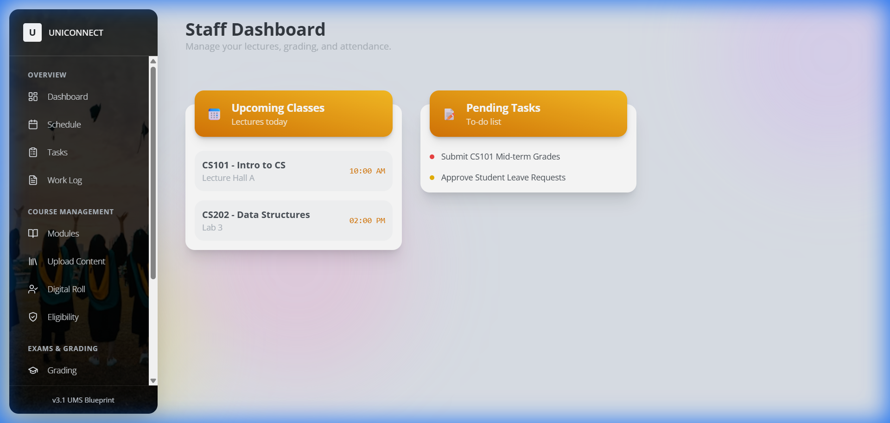
Staff Dashboard
```mermaid
graph TD
Staff[Academic Staff]
Staff --> Overview[Overview]
Overview --> Dashboard[Staff Dashboard]
Overview --> Schedule[Teaching Schedule]
Overview --> Tasks[Admin Tasks]
Overview --> Log[Work Log]
Staff --> Courses[Course Management]
Courses --> Modules[Module Planning]
Courses --> Content[Upload Learning Materials]
Courses --> Attendance[Digital Roll Call]
Courses --> Eligibility[Exam Eligibility Checks]
Staff --> Exams[Exams & Grading]
Exams --> Grading[Final Grading]
Exams --> Marks[Enter Continuous Assessment]
Exams --> Plagiarism[AI Plagiarism Check]
Staff --> Research[Research & Impact]
Research --> Pubs[Publications Repository]
Research --> Grants[Grant Management]
```

3. Administration Portal (Registrar & VC)
*Focus: Governance, Strategy & Operations*
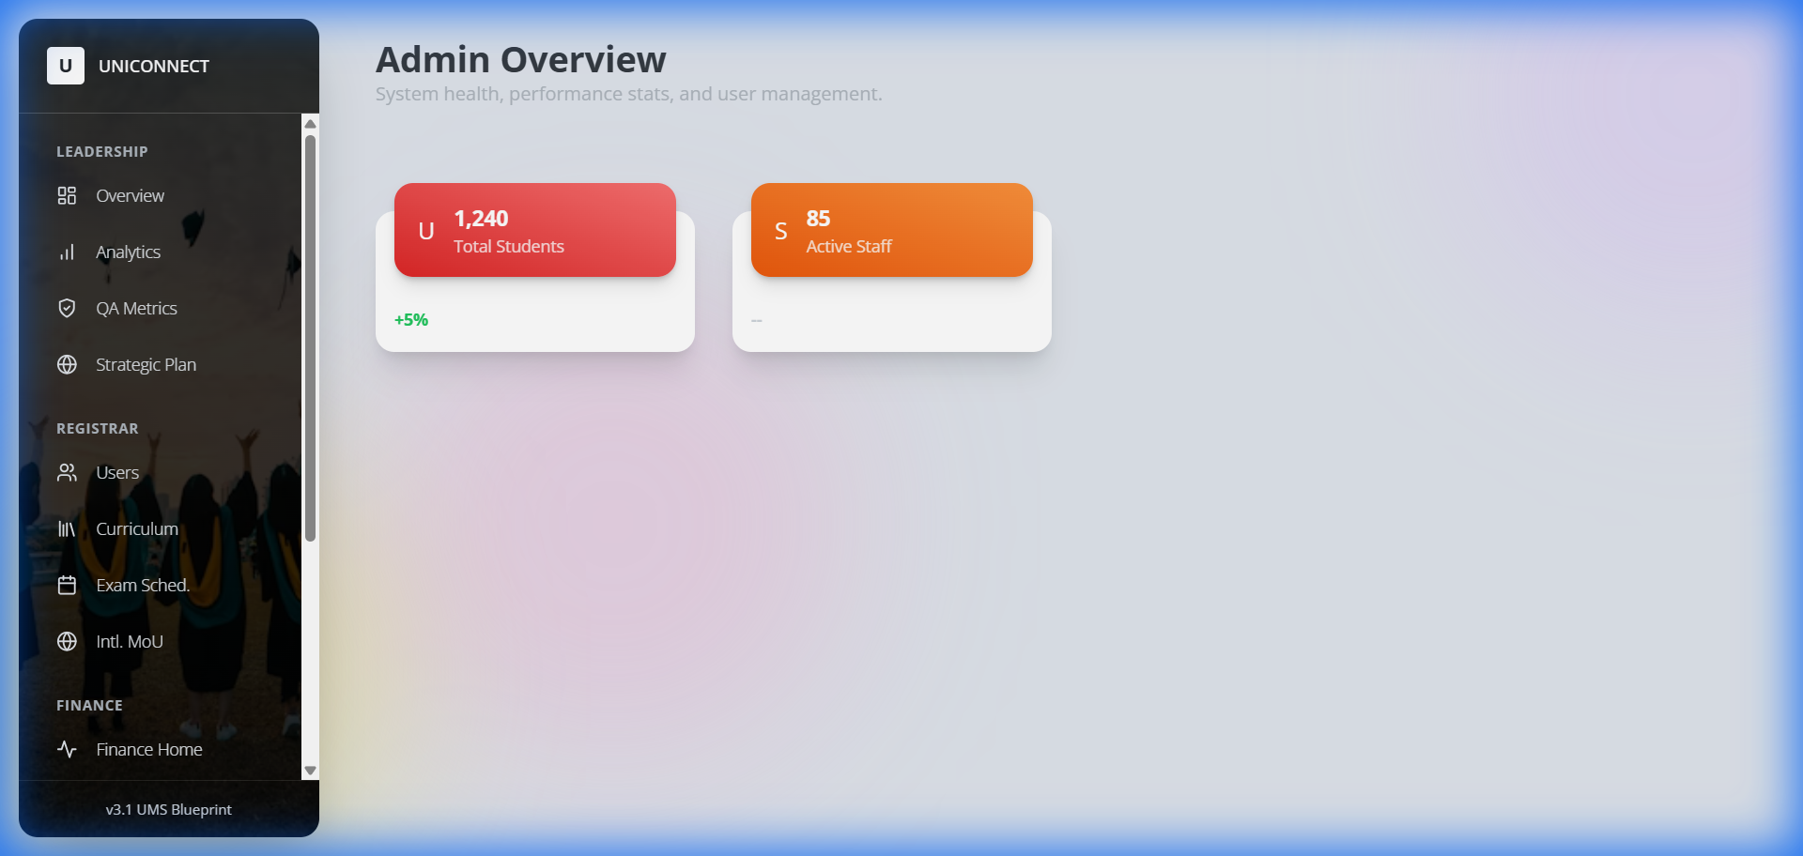
Admin Dashboard
```mermaid
graph TD
Admin[Administration]
Admin --> Lead[Leadership & Strategy]
Lead --> Overview[Executive Overview]
Lead --> Analytics[University Analytics]
Lead --> QA[Quality Assurance]
Lead --> Plan[Strategic Planning]
Admin --> Reg[Registrar Operations]
Reg --> Users[User Management]
Reg --> Curr[Curriculum Development]
Reg --> Exams[Exam Scheduling]
Reg --> MOU[International MoUs]
Admin --> Fin[Finance Oversight]
Fin --> Fees[Fee Structures]
Fin --> Funds[Fund Allocation]
Fin --> Assets[Asset Management]
Fin --> Audit[Internal Audit]
Admin --> Sys[System]
Sys --> Settings[Configuration]
```

4. Bursar (Finance) Portal
*Focus: Financial Integrity & Reconciliation*
```mermaid
graph TD
Bursar[Bursar Office]
Bursar --> Fin[Financial Operations]
Fin --> Dashboard[Financial Overview]
Fin --> Reconcile[Daily Reconciliation]
Fin --> Payments[Verify Payments]
Fin --> Reports[Financial Reporting]
```

Role-Based Menu Explorer & Walkthroughs
This section describes exactly what a user sees and does in each menu option.

1. Student Portal Navigation
*Primary Goal: Academic Success & Financial Clarity*
Menu Section | Item | Action / Walkthrough
**Overview** | **Dashboard** | **View**: Check GPA, Semester Status, and Wallet Balance.<br>**Action**: Click widgets to jump to Results or Payments.
**Academic** | **Course Reg.** | **Step 1**: Browse open courses for the semester.<br>**Step 2**: Click "Enroll" on desired modules.<br>**Step 3**: System checks prerequisites > Confirms enrollment.
 | **My Courses** | **View**: List of active enrolled modules.<br>**Action**: Click a module to access learning materials, assignments, and announcements.
 | **Results** | **View**: Full academic transcript and GPA calculation.<br>**Action**: Download official semester reports (PDF).
 | **Attendance** | **View**: Check attendance percentage per module.<br>**Alert**: Flags if attendance drops below 80%.
**Financial** | **My Wallet** | **View**: Total balance, scholarship inflows, and payment outflows.<br>**Action**: Top up wallet via payment gateway.
 | **Fees** | **View**: Outstanding tuition or exam fees.<br>**Action**: Click "Pay Now" > Select Payment Method > Generates Receipt.
 | **Mahapola** | **View**: Scholarship installment status and history.<br>**Action**: Acknowledge receipt of funds.
 | **Bursary** | **Action**: Apply for financial aid > Upload Income Proof > Submit for Bursar review.
**Welfare** | **Hostel** | **Action**: Apply for accommodation > Select Room Type > View Allocation Status.
 | **Health** | **Action**: Book medical appointments > View digital medical history.
 | **Career** | **Action**: View job board > Book counseling sessions.

2. Academic Staff Navigation
*Primary Goal: Efficient Teaching & Evaluation*
Menu Section | Item | Action / Walkthrough
**Overview** | **Dashboard** | **View**: Upcoming Classes timeline and "To-Do" list (e.g., "Grade CS101").
 | **Schedule** | **View**: Weekly teaching timetable with room numbers.
 | **Tasks** | **Action**: View administrative tasks assigned by Dean/HoD > Mark as "Done".
 | **Work Log** | **Action**: Auto-generated log of teaching hours for payroll claims.
**Courses** | **Modules** | **View**: List of modules taught this semester.<br>**Action**: Select to manage specific course details.
 | **Upload Content** | **Step 1**: Select Module.<br>**Step 2**: Drag & Drop Lecture Slides/Notes.<br>**Step 3**: Publish to Student Portal.
 | **Digital Roll** | **Step 1**: Select Active Class.<br>**Step 2**: Display QR Code or Manually check students присутing.
 | **Eligibility** | **View**: Auto-generated list of students eligible for exams based on attendance.
**Exams** | **Grading** | **Action**: Input final letter grades for verified students > Submit to Exam Board.
 | **Enter Marks** | **Action**: Enter continuous assessment (assignment/mid-term) raw marks.
 | **Plagiarism** | **Tool**: Upload student assignment > AI scans against repository > Returns Similarity Report.
**Research** | **Publications** | **Action**: Log new research papers > Updates academic profile.
 | **Grants** | **Action**: Track grant utilization and detailed expenditure.

3. Administration Navigation (Registrar/VC)
*Primary Goal: High-Level Oversight & Configuration*
Menu Section | Item | Action / Walkthrough
**Leadership** | **Overview** | **View**: Campus pulse (Active Users, Financial Health, Critical Alerts).
 | **Analytics** | **Tool**: Interactive charts showing multi-year trends (Enrollment, Pass Rates).
 | **QA Metrics** | **View**: Compliance with UGC/Quality Assurance standards.
 | **Strategic Plan** | **Action**: Define and track long-term university KPIs.
**Registrar** | **Users** | **Action**: Create/Edit User Accounts > Reset Passwords > Assign Roles.
 | **Curriculum** | **Action**: Define new Degrees/Courses > Set Credits & Prerequisites.
 | **Exam Sched.** | **Action**: Create exam timetables > Allocate exam halls & invigilators.
 | **Intl. MoU** | **Action**: Manage partnerships with foreign universities.
**Finance** | **Fee Tracking** | **View**: Real-time monitor of fee collection rates across faculties.
 | **Funds** | **Action**: Allocate budget to departments.
 | **Assets** | **Action**: Inventory management (Buildings, Labs, Equipment).
 | **Audit** | **Report**: Generate system-wide activity logs for internal audit.
**System** | **Config** | **Action**: Set global variables (Academic Year, Semester Dates).

4. Bursar Navigation
*Primary Goal: Financial Integrity*
Menu Section | Item | Action / Walkthrough
**Finance** | **Finance Home** | **View**: Cash flow summary, Daily Collection, Pending Approvals.
 | **Reconcile** | **Workflow**: <br>1. System flags mismatched payments.<br>2. Bursar reviews bank feed vs system records.<br>3. Click "Reconcile" to force match or "Flag" to investigate.

Role Responsibility Matrix
This matrix clearly defines who is responsible for each core operation within the system.
Operational Area | Action | **Student** | **Staff** | **Admin (Reg)** | **Bursar**
**Onboarding** | Account Creation | Applies | Verifies Docs | Final Approval | -
**Coursework** | Enrollment | **Initiates** | Advises | Configures | -
 | Upload Content | Consumes | **Uploads** | - | -
 | Attendance | Checks | **Marks** | Monitors | -
**Examinations** | Scheduling | View | - | **Creates** | -
 | Grading | View | **Enters** | Publishes | -
**Finance** | Fee Payment | **Pays** | - | Sets Fees | **Verifies**
 | Scholarship | Receives | - | - | Disburses
 | Reconciliation | - | - | Audit | **Executes**
**Welfare** | Notifications | View | Send | Broadcast | -

Service Blueprint - Visual Evidence
*Real-time snapshots of role-based workflows.*

1. Student: Course Registration & Financials
*Action: Browsing active modules and checking wallet balance.*
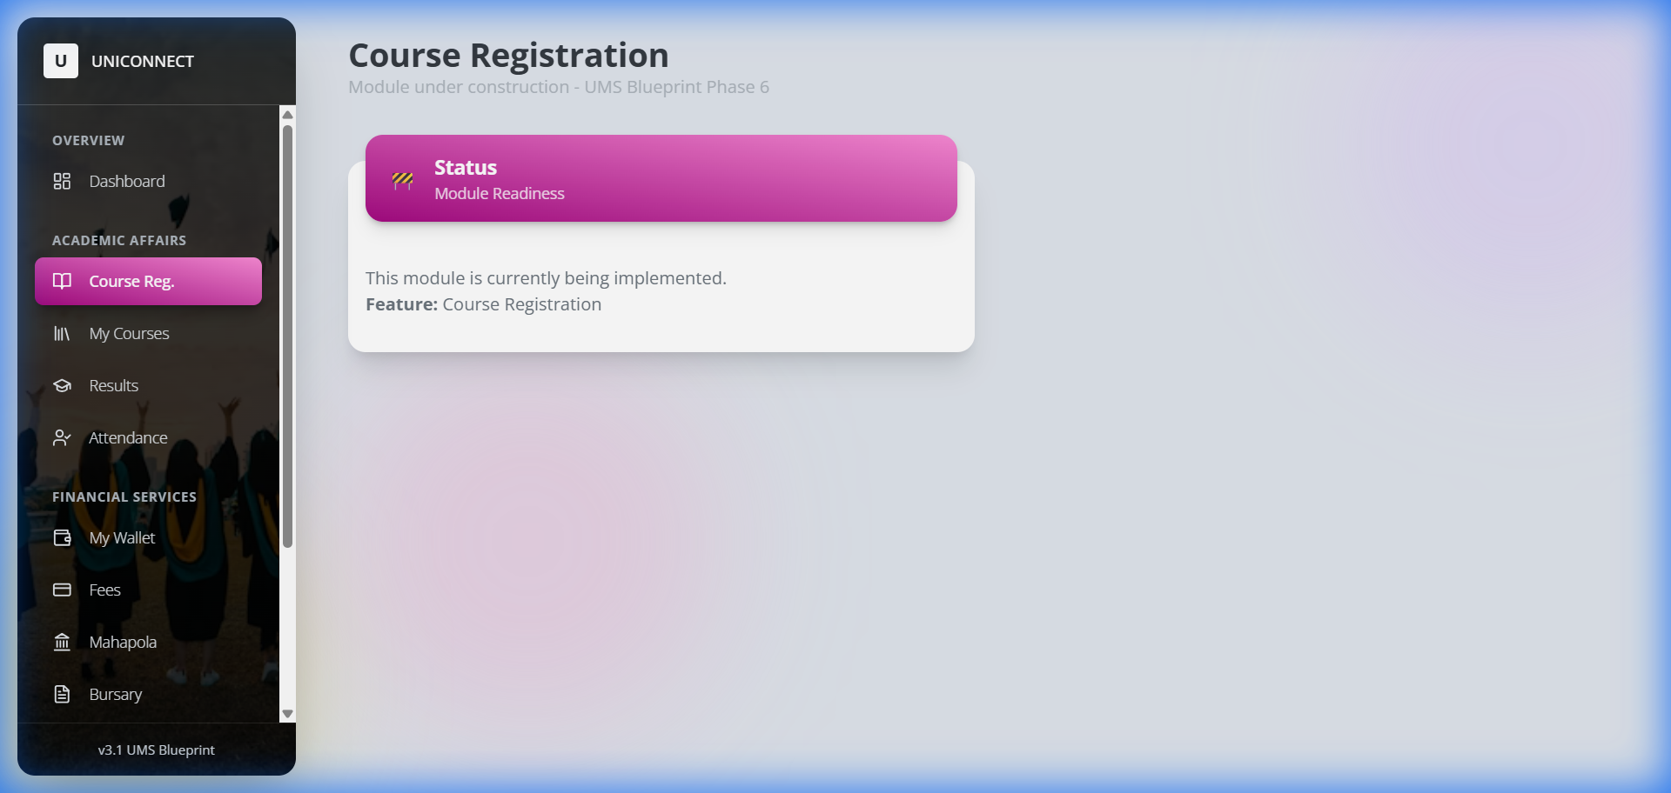
Student Course Registration
*(Above: Student selects modules for the upcoming semester)*

2. Staff: Academic Administration
*Action: Managing modules and entering grades.*
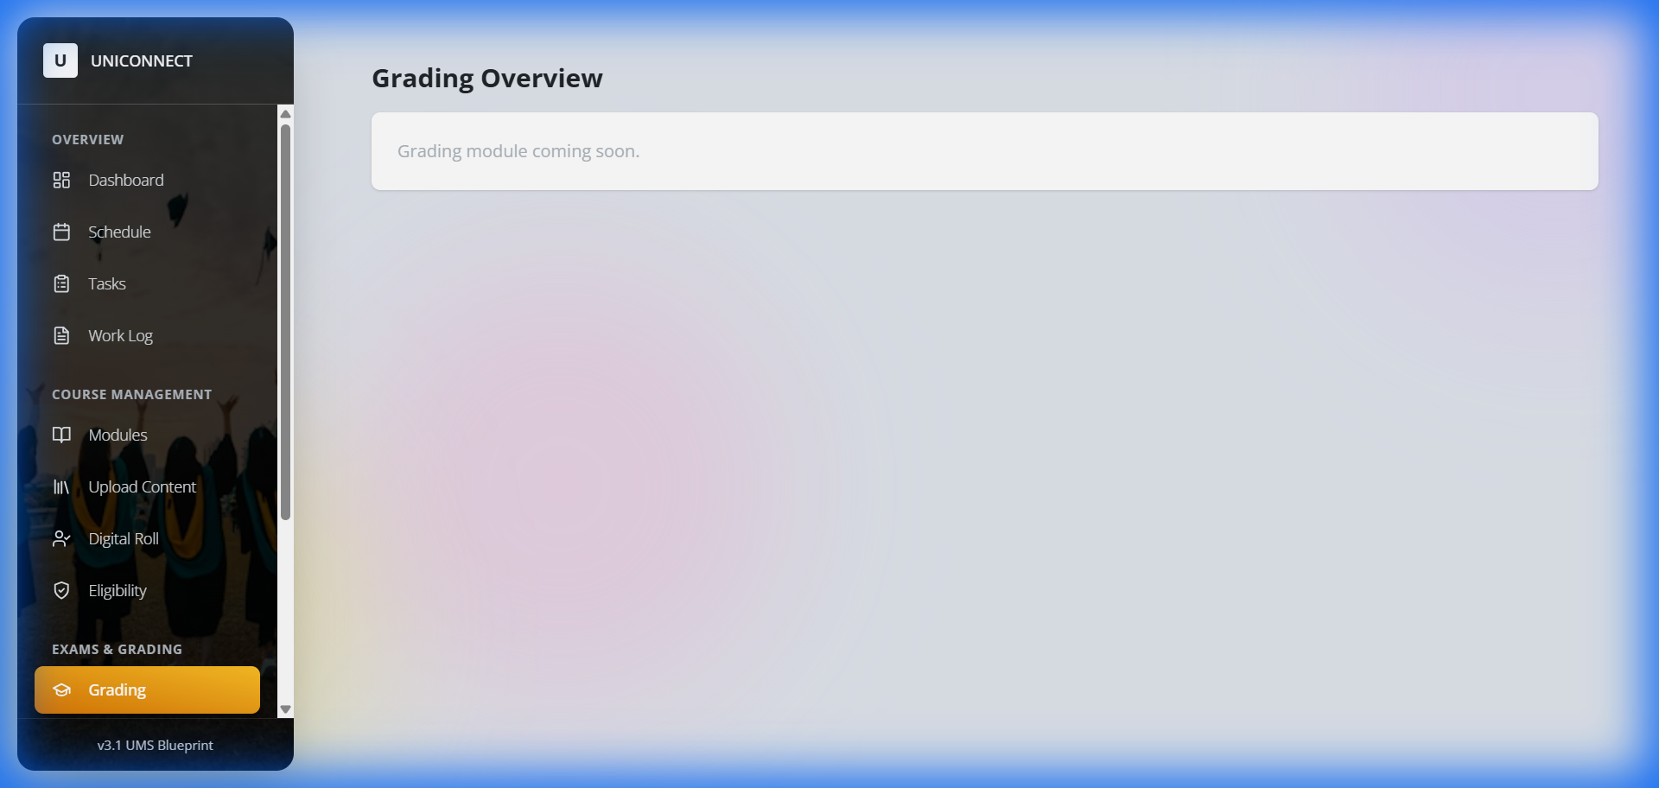
Staff Grading Portal
*(Above: Interface for entering and finalizing student marks)*

3. Admin: System Governance
*Action: Managing user access and scheduling exams.*
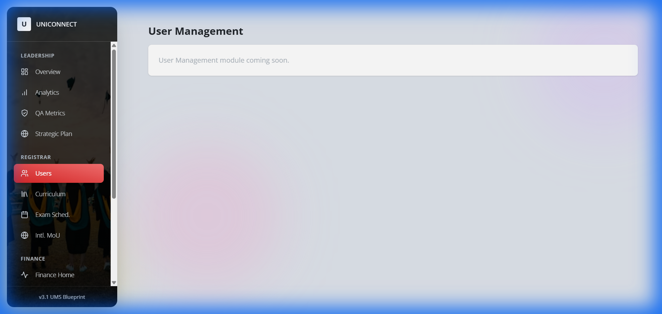
Admin User Management
*(Above: Registrar's view for verifying and managing student/staff accounts)*

4. Bursar: Financial Reconciliation
*Action: Verifying payments and auditing streams.*
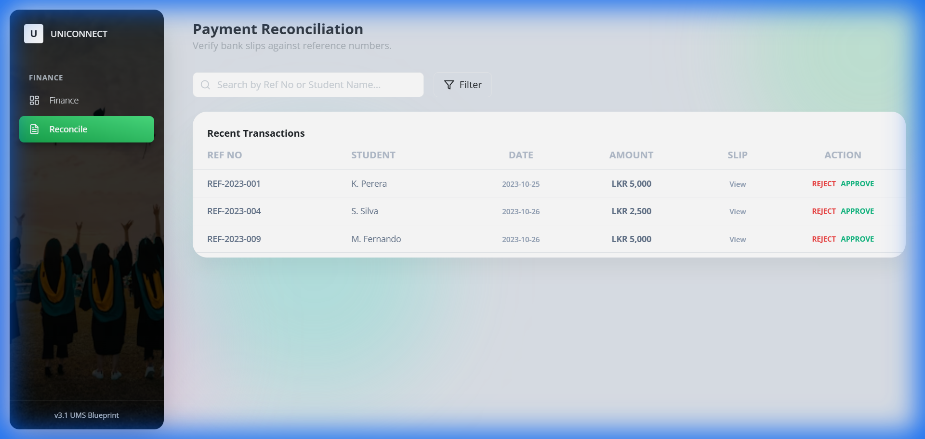
Bursar Reconciliation
*(Above: Active workspace for matching bank feeds with system receipts)*

Interconnected Operational Workflows

Workflow 1: The "New Student" Lifecycle (Onboarding)
**Goal**: Move a user from an "Applicant" to an "Active Student".
- **Student (External)**: Visits Portal > "Apply Now" > Fills Profile > Uploads NIC/A-Level Results.
2. **System**: Creates "Provisional" account. Locked from Course Reg.
3. **Admin (Registrar)**: Receives "New Intake" Alert > Reviews Documents > Clicks "Approve".
4. **System**: Unlocks Student Account > Generates Student ID > Sends Welcome Email.
5. **Student**: Logs in > Sees "Complete Registration Payment" task.
6. **Student**: Pays Registration Fee via Gateway.
7. **Bursar**: Payment auto-verified (or manual checks).
8. **System**: Status updated to "Active" > "Course Reg" menu unlocks.

Workflow 2: The "External Course" Application (Marketplace)
**Goal**: Allow a student to take an extra qualification (e.g., CIMA/MBA).
- **Student**: Navigation > **My Courses** > "Browse External Courses".
2. **System**: Filters courses by Student's eligibility (e.g., Year 3 only).
3. **Student**: Selects "MBA Foundation" > Clicks "Apply".
4. **Admin**: "Curriculum" > Sees Application > Checks capacity > Approves.
5. **Student**: Received "Offer Letter" notification > "Fees" menu updates.
6. **Student**: Pays Module Fee (Installment 1).
7. **System**: Auto-enrolls student in "MBA Foundation" module appearing in **My Courses**.

Request for Stakeholder Input
To ensure UniConnect fits your specific university culture, we need your input on:
- **Approval Hierarchies**: Who specifically signs off on new student intakes? (Dean vs Registrar?)
2. **Fee Structures**: Are there specific installment plans for External Courses?
3. **Legacy Data**: Do we need to migrate existing records?
4. **Custom Workflows**: Are there unique departmental processes we should model?

