SOFTWARE DEVELOPMENT PROJECT
Final Report

AgroAdvisor: an AI-assisted farm advisory platform that helps smallholder farmers prepare for severe weather

Prepared by:
[Student name]
[Student number]
Department of Computer Science & Information Technology
Sol Plaatje University

Submitted to:
Dr Silas Verkijika
Lecturer: Project (NPRJ740)
Department of Computer Science & Information Technology
Sol Plaatje University
24-26 Scanlan St, New Park, Kimberley, 8301

[Submission date]

Yellow-highlighted text marks details only the student can supply or evidence that has not been collected yet.

TABLE OF CONTENTS
EXECUTIVE SUMMARY 4
1. PROJECT CONTEXT 4
2. PROBLEM, PURPOSE AND SUCCESS CRITERIA 4
2.1 Problem Statement 4
2.2 Project Purpose 5
2.3 Success Criteria 5
3. SOLUTION OVERVIEW AND SCOPE 6
3.1 Solution Overview 6
3.2 Final Release Scope 6
3.3 Excluded and Deferred Capabilities 7
3.4 Known Limitations and Open Issues 7
4. SYSTEM REQUIREMENTS SPECIFICATION 7
4.1 Functional Requirements 7
4.2 Non-Functional Requirements 8
4.3 Business Rules 9
4.4 Acceptance Criteria for Included Requirements 9
5. SYSTEM DESIGN SPECIFICATION 10
5.1 Use Cases and Workflows 10
5.2 Architecture and Technology Stack 14
5.3 Key Design Decisions 15
5.4 Application Class Design 16
5.5 User Interface and Interaction 17
5.6 Data Design 20
5.7 Security, Privacy and Access Control 22
5.8 Deployment and Runtime Design 22
6. SYSTEM IMPLEMENTATION 23
6.1 Codebase and Repository Structure 23
6.2 Implementation of Core Capabilities 23
6.3 APIs and Integrations 24
6.4 AI/ML Component 24
7. VERIFICATION AND TESTING 24
7.1 Test Approach 24
7.2 Functional and Business-Rule Verification 25
7.3 Non-Functional and Security Verification 25
7.4 Defects and Known Issues 26
8. SYSTEM SETUP AND OPERATION 26
8.1 Prerequisites and installation 26
8.2 Environment configuration 26
8.3 Run commands 26
8.4 Seeding and demo accounts 27
9. SOLUTION EVALUATION 27
10. REFERENCES 27
11. APPENDICES 28
11.1 Appendix A: Source code repository 28
11.2 Appendix B: Deployed system 28
11.3 Appendix C: Supporting material 28

EXECUTIVE SUMMARY
Most food in South Africa is not grown by large commercial farms alone. Statistics South Africa counted 2,463,429 agricultural households in the 2022 census, and many of them farm on a small scale with little access to personal, timely advice (Statistics South Africa, 2022). Weather is the biggest risk they cannot control. In September 2026 the South African Weather Service and the Department of Agriculture both warned that a developing El Niño could bring heat, dry spells and storms in the 2026/27 season (South African Weather Service, 2026; Department of Agriculture, 2026).
AgroAdvisor is a web application for these farmers. A farmer saves a simple farm profile (location, size, crops and livestock). The system then reads the seven-day forecast for that exact place and turns it into plain advice and severe-weather warnings, for example what to do about heat at 35 °C or more, or frost at 2 °C or less, and when. It does not only display the weather. It also offers short reviewed video lessons, a private farm memory, and a community map where nearby farmers share short local notes.
The final system has a React and TypeScript client, a Hono API on a Cloudflare Worker, and Firebase Authentication and Cloud Firestore protected by Security Rules. Weather comes from Open-Meteo. Google Gemini identifies a crop or animal from a photo, and Azure Speech reads warnings aloud. The advice and risk engine is rule-based, using thresholds kept in a knowledge-base file.
Outcome: 16 of the 17 planned functional requirements are built, one (background push notifications) is not, and Microsoft sign-in is not enabled. The code builds and type-checks cleanly, 6 Firestore security-rule tests and 15 unit tests pass, and a live validation test behaved correctly. Performance has not been measured and the system has been assessed running locally, not on a public URL. These limits are listed in Known Limitations and Open Issues and the Solution Evaluation.

1. PROJECT CONTEXT
- Domain: agricultural advisory and climate-risk communication for smallholder and small-scale farmers in South Africa. The system combines weather forecasting data, simple agronomic rules and farmer-to-farmer knowledge sharing.
- Users: farmers only. There is one type of user. There are no administrator, buyer or other roles. Farmers use the system mostly on a phone, so the interface is mobile-first.
- Basis of the project: a general application domain. It is not built for one named organisation. The sample farmers in the database (demo-farmer-01 to demo-farmer-15) are invented for testing and are not real people.

2. PROBLEM, PURPOSE AND SUCCESS CRITERIA

2.1 Problem Statement
Small-scale farmers farm close to the weather. When a heatwave, frost, heavy rain or storm arrives without a warning they can act on, they lose crops and animals, and a household that grows part of its own food loses that food and the money spent on seed and feed. South Africa has about 2.46 million agricultural households (Statistics South Africa, 2022), but only about 40,000 commercial farming units (Statistics South Africa, 2017), so most farming households are small and do not have a private adviser.
The gap is advice, not data. Weather forecasts are widely available, but a number such as "37 °C" does not tell a farmer what to do for tomatoes or for chickens, or when. Public extension support is stretched: a study of the Eastern Cape found that 80.2% of the extension practitioners surveyed had no training in climate-change adaptation, and that farmers preferred personal channels (60.3%) over printed or broadcast ones (Makamane, 2023).
The risk is now rising. The World Meteorological Organization expects a strong El Niño in 2026/27 (World Meteorological Organization, 2026), and the 2015/16 El Niño cut South African maize prospects sharply (USDA Foreign Agricultural Service, 2016). Not every El Niño causes drought, but the warning is a reason to prepare early. Food inflation is currently low (Farmer's Weekly, 2026), so the argument for the system is resilience, not a price crisis: households that can grow part of their own food and protect it from the weather depend less on outside help.
A software solution is justified because the work is repetitive and local: the same forecast must be re-read every day against each farm's crops and animals. A program can do this for every farmer at no extra cost, in plain language, on the phone they already own.
Evidence note: the statements above come from the published sources in the References. The statement that many new small-scale farmers do not yet know how to farm well is a working hypothesis. [Add the findings of the farmer interviews here, or remove this sentence if no interviews were held.]

2.2 Project Purpose
The purpose is to help small-scale farmers protect their crops and animals from severe weather and to farm better, by turning a farm-specific seven-day forecast into clear, actionable advice and warnings, and by supporting them with short lessons, a private record of what worked, and local information from nearby farmers.

2.3 Success Criteria
ID | Success criterion | How it is verified
SC-1 | A farmer can register, sign in, save a farm profile and see advice for that farm on the dashboard. | Live use with a real account; unit tests for validation (Verification and Testing)
SC-2 | Severe weather (heat, frost, heavy rain, strong wind, storm) produces a warning that says what to do, when and why, using the documented thresholds. | Unit tests TC-U01 to TC-U09; warning pop-up screenshot
SC-3 | Each farmer can read and change only their own data, and community notes cannot be forged or reported twice. | Six Firestore rule tests; unauthenticated API checks
SC-4 | Invalid input is refused with a clear message and nothing wrong is saved. | Unit tests TC-U10 to TC-U15; live validation test
SC-5 | The project builds and type-checks cleanly and can be set up from the written instructions. | Client build, client and worker type checks (Verification and Testing)

3. SOLUTION OVERVIEW AND SCOPE

3.1 Solution Overview
AgroAdvisor is a mobile-first web application. A farmer signs in, saves a farm profile and lands on a dashboard that shows the farm name, the current weather, a seven-day outlook with a risk note for each day, and a warning icon whose colour shows the most serious expected event. Selecting the warning opens a short explanation of what to do, when and why, which can be read aloud. Other pages hold the farm profile, the Learn videos, the farm memory and the community map.
Figure 1 shows the system context: the farmer is the only user, and the system exchanges data with Firebase, Open-Meteo, Google Gemini, Azure Speech, YouTube and OpenStreetMap.
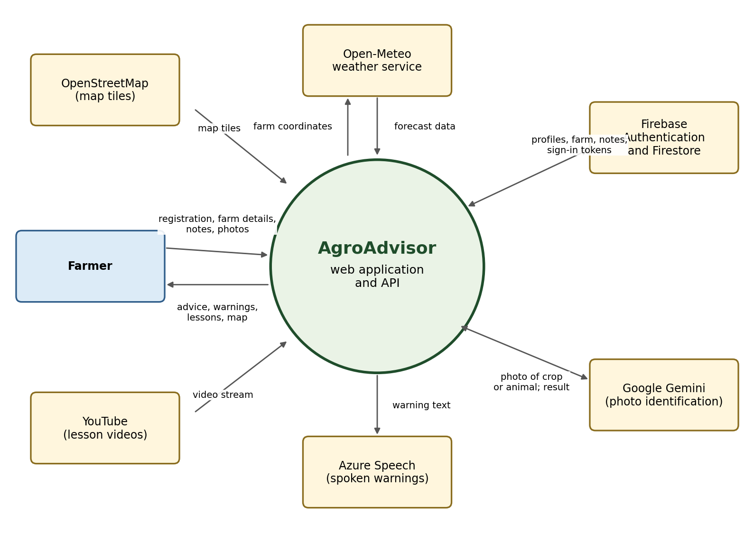
Figure 1: System context diagram

3.2 Final Release Scope
Included capability | What the farmer can do
Accounts | Register and sign in with email and password, or with Google.
Farm profile | Save one farm: name, nearest town, map location, size, crops, livestock and an optional photo. Identify a crop or animal from a photo. Estimate plot size by walking the boundary.
Weather advice | See current weather and a seven-day outlook interpreted for the farm.
Severe-weather warnings | See a coloured warning, a pop-up when the event is today or tomorrow, and hear it read aloud.
Learn | Watch reviewed video lessons by topic and mark them complete.
Farm memory | Record weather events, planting and what worked, with a weekly summary.
Community map | Add and see short local notes within 25 km, report another farmer's note, and remove your own.
Languages | Switch the interface between English, Afrikaans, isiZulu, Sesotho and Setswana.

3.3 Excluded and Deferred Capabilities
Capability | Status | Reason
Background push notifications when the app is closed (FR-17) | Deferred | Needs a Firebase service-account key held as a Worker secret. The code path for service-account tokens exists but was not exercised.
Microsoft sign-in | Deferred | The button exists, but the provider is not enabled because it needs an Azure app registration.
Month-by-month and seasonal advice | Deferred | The forecast source gives a seven-day horizon. Seasonal advice would need a seasonal-outlook data source and is planned, not built.
Crop suggestions for a farm | Deferred | Not yet approved as a feature.
Buyer, administrator or other roles | Excluded | The project serves farmers only.
Selling produce, payments, marketplace | Excluded | Outside the problem being solved.

3.4 Known Limitations and Open Issues
ID | Limitation or open issue | Effect
LIM-1 | The assessed system runs locally. No public URL has been deployed or tested. | Hosting behaviour on Cloudflare Pages and Workers is untested.
LIM-2 | No load-time or performance measurements were taken (NFR-07). | Performance claims are design targets only.
LIM-3 | Authenticated API calls were not tested with a scripted client. Browser testing from another origin was blocked by CORS, and the test tool hides the ID token. | Validation and error responses of the vision and speech routes are known from the code, not from measured calls.
LIM-4 | The wrong-password and login-error screens were not exercised in a live test during final testing. | Only the validation unit tests cover them.
LIM-5 | The client npm audit reports 5 high-severity findings that are not yet fixed. | A dependency update is needed before public release.
LIM-6 | Not every Learn video has been fully watched by the developer. [Confirm and record that each video was reviewed.] | Lessons are shown only when marked reviewed and published.
LIM-7 | Sample data (15 demo farmers and their community notes) is present in the database. | It must be deleted before real use. All IDs start with demo-.
LIM-8 | Advice is rule-based and covers only the crops and animals in the knowledge base. Photo identification can be wrong. | Farmers can always type a name instead.

4. SYSTEM REQUIREMENTS SPECIFICATION

4.1 Functional Requirements
Priority uses MoSCoW (M = Must, S = Should, C = Could). Release status is the state in the final release.
ID | Requirement | Priority | Release status
FR-01 | A farmer can register with full name, email and password and sign in with email and password. | M | Included
FR-02 | A farmer can sign in with a Google account. | S | Included (Microsoft deferred)
FR-03 | A farmer can create and edit one farm profile: name, nearest town, map location, size, crops, livestock with counts and an optional photo. | M | Included
FR-04 | A farmer can set the farm location by tapping the map or using the device location. | M | Included
FR-05 | A farmer can estimate plot size by walking the boundary. GPS points are not saved. | C | Included
FR-06 | A farmer can add a crop or animal by photo identification or by typing its name. | S | Included
FR-07 | The dashboard shows current weather next to the farm name. | M | Included
FR-08 | The system shows a seven-day outlook with an interpretation and risk note for each day. | M | Included
FR-09 | The system shows a severe-weather warning with what to do, when and why, and can read it aloud. | M | Included
FR-10 | The farm map shades nearby estimated temperatures. | C | Included
FR-11 | A farmer can browse reviewed and published video lessons by topic. | M | Included
FR-12 | A farmer can mark a lesson complete and it is saved in the farm memory. | S | Included
FR-13 | A farmer can record and delete weather, planting and success entries and see a weekly summary. | S | Included
FR-14 | A farmer can add a local observation within 25 km of the farm and see visible nearby notes. | S | Included
FR-15 | A farmer can report another farmer's note; a note is hidden after two different reports; the author can remove their own. | S | Included
FR-16 | A farmer can change the interface language. | S | Included
FR-17 | The system sends a background push notification when severe weather is forecast. | C | Deferred

4.2 Non-Functional Requirements
ID | Quality | Requirement | Verification
NFR-01 | Reliability | If the weather service or Worker is unavailable the dashboard shows a clear error with a retry and no wrong data. A failed forecast never changes saved data. | Code inspection; not tested live
NFR-02 | Availability | Uses managed services (Firebase, Cloudflare, Open-Meteo), so no server is maintained by the farmer. | Design review
NFR-03 | Security | A farmer can read and write only their own data (Security Rules). The Worker verifies the Firebase ID token on every request. Secrets are never in source code. | Rule tests; API checks (Verification and Testing)
NFR-04 | Security | Community notes carry no names. Rules limit note length, 25 km radius, one report per farmer per note and the report count. | Six rule tests
NFR-05 | Maintainability | Strict TypeScript, no 'any', Firestore access only through service modules, thresholds in one knowledge-base file, one shared API response helper. | Type checks
NFR-06 | Portability | Runs in any modern browser on phone or computer, with no app-store install. | Browser use
NFR-07 | Performance | Mobile-first, split build, map loaded only when needed. [No measured load time yet.] | Not yet measured
NFR-08 | Usability | Plain-language advice, 44 px touch targets, labelled controls, loading, empty and error states. | Screenshots; manual review
NFR-09 | Cost | Free tiers only: Firebase Spark, Cloudflare free, Open-Meteo. No Cloud Functions. | Design review

4.3 Business Rules
ID | Business rule | Enforced by
BR-01 | Each farmer has exactly one farm profile, stored under their own ID. | Firestore rules (farms/{ownerId})
BR-02 | A farm size must be greater than 0 and at most 10,000 hectares, and a farm needs a name. | Client validation and Firestore rules
BR-03 | Heat warning at 35 °C or more; frost warning at 2 °C or less; heavy rain at 50 mm, or 30 mm with 70% probability; strong wind at gusts of 60 km/h or more; storm for weather codes 95, 96 and 99. | Knowledge base (weather-risks.ts)
BR-04 | A warning pop-up is shown only when the event is today or tomorrow. | Advice engine
BR-05 | Only lessons marked both reviewed and published are visible. Farmers cannot write lessons. | Firestore rules
BR-06 | A community note must be within 25 km of the author's farm and no longer than 240 characters. | Firestore rules
BR-07 | A farmer cannot report their own note, and can report any note only once. | Firestore rules
BR-08 | A note becomes hidden when two different farmers have reported it. Only the author can delete it. | Firestore rules and transaction
BR-09 | A photo is accepted only as JPEG, PNG or WebP of at most 6 MB. A result with confidence 0.8 or higher is 'identified', 0.5 to 0.79 is 'uncertain', and lower is 'unknown'. | Worker vision route

4.4 Acceptance Criteria for Included Requirements
Requirement | Acceptance criterion
FR-01, FR-02 | Given valid details, the farmer reaches the dashboard. Given an empty or malformed email or a short password, an error is shown and no account is created.
FR-03, FR-04 | Given a valid name, town, size and location, the farm is saved and still shown after a reload.
FR-07, FR-08 | Given a saved farm location, the dashboard shows current weather and seven daily entries, or a clear error with retry.
FR-09 | Given a forecast with a value at or above a threshold, a warning with action, timing and reason is shown. Given a value just below, no warning is shown.
FR-11, FR-12 | Only reviewed and published lessons are listed. Completing a lesson adds an entry to the farm memory.
FR-14, FR-15 | A note outside 25 km is refused. A second report of the same note by the same farmer is refused. The second distinct report hides the note.

5. SYSTEM DESIGN SPECIFICATION

5.1 Use Cases and Workflows

Use case diagram
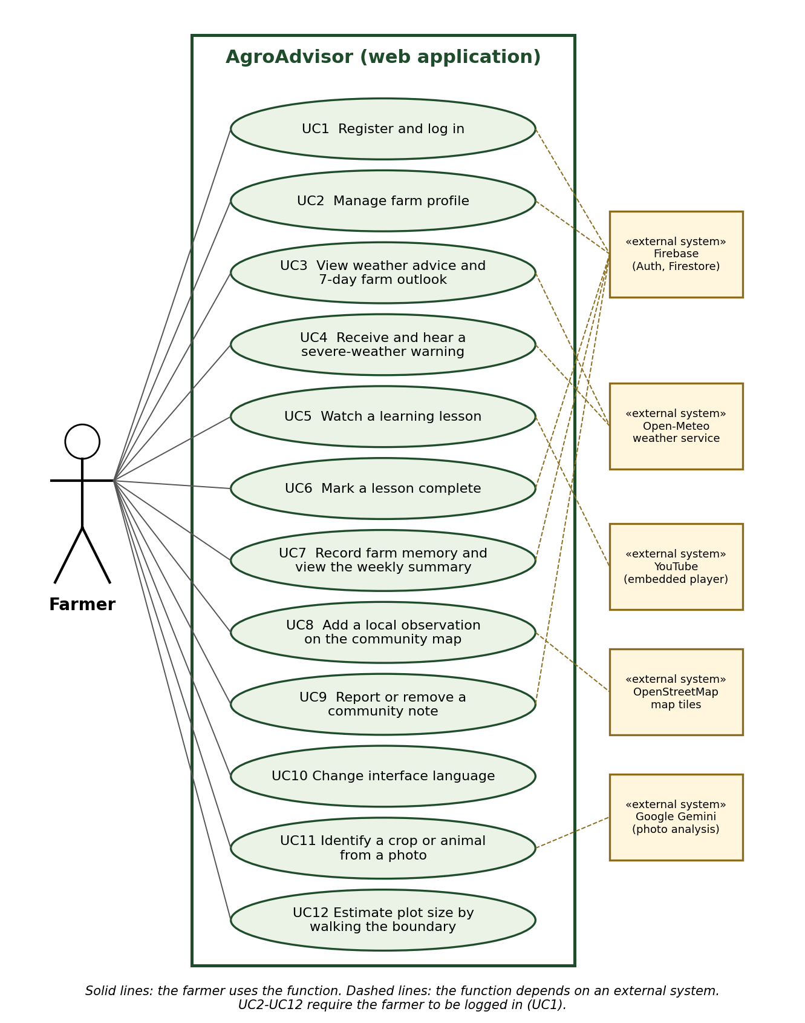
Figure 2: Use case diagram (the farmer is the only actor)

Workflow 1: view weather advice and warnings
The farmer opens the dashboard. The client asks the Worker for the forecast. If the request fails, an error with a retry is shown. If the forecast arrives, the advice engine compares it with the knowledge-base thresholds and shows advice, and a warning if a threshold is reached.
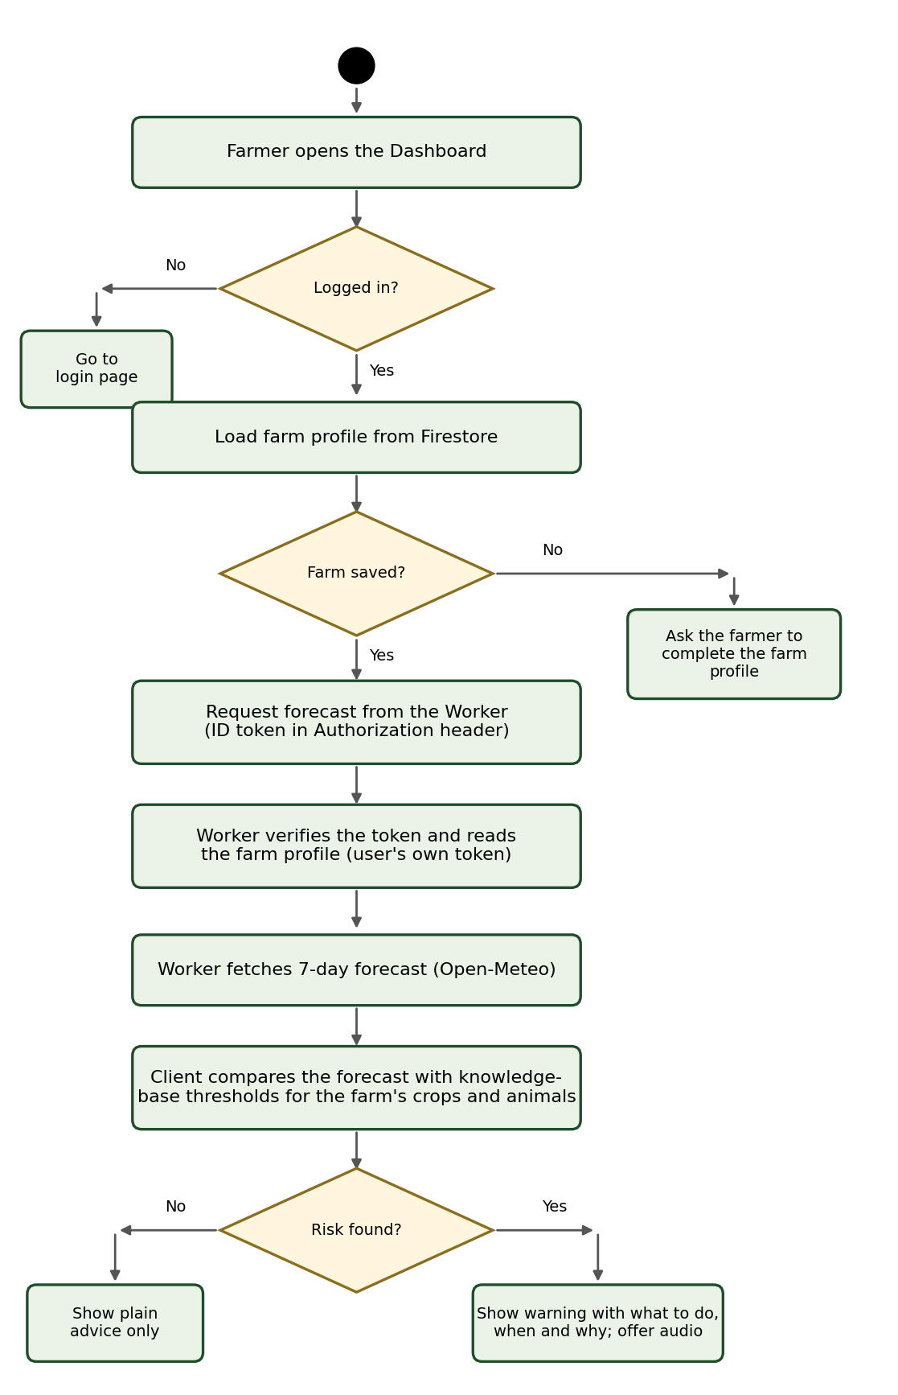
Figure 3: Activity diagram: view weather advice and warnings
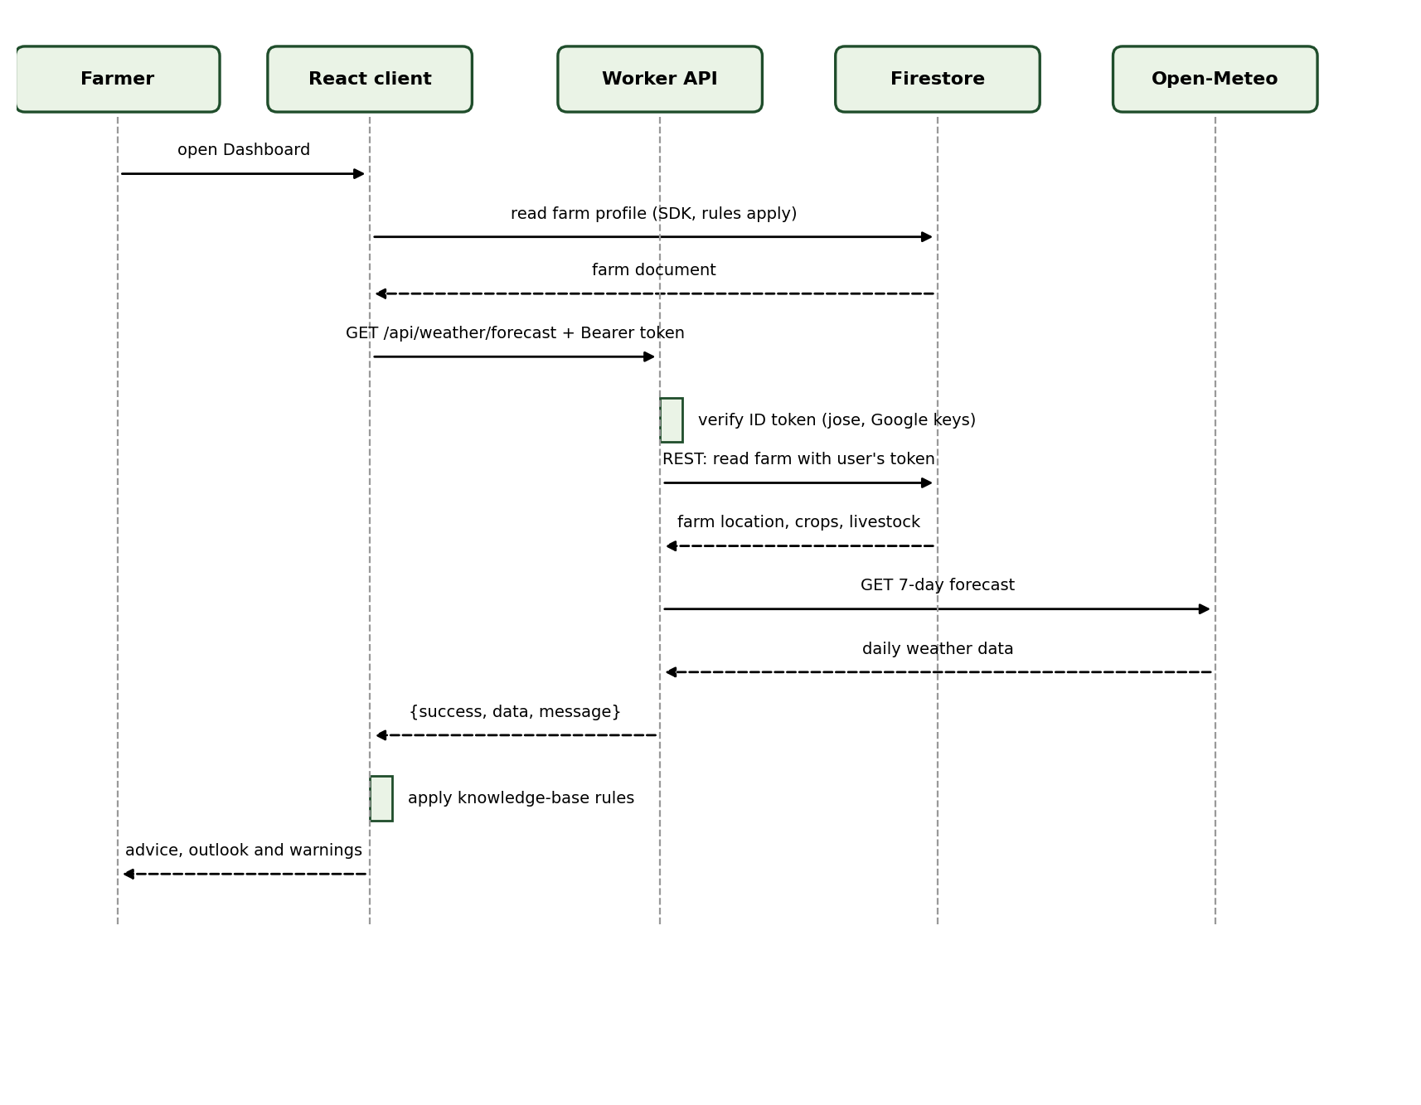
Figure 4: Sequence diagram: load farm weather advice

Workflow 2: report a community note
A farmer reports a note they believe is wrong. The rules refuse a report on the farmer's own note and a second report by the same farmer. The report and the count increase happen in one transaction, so either both are saved or neither is.
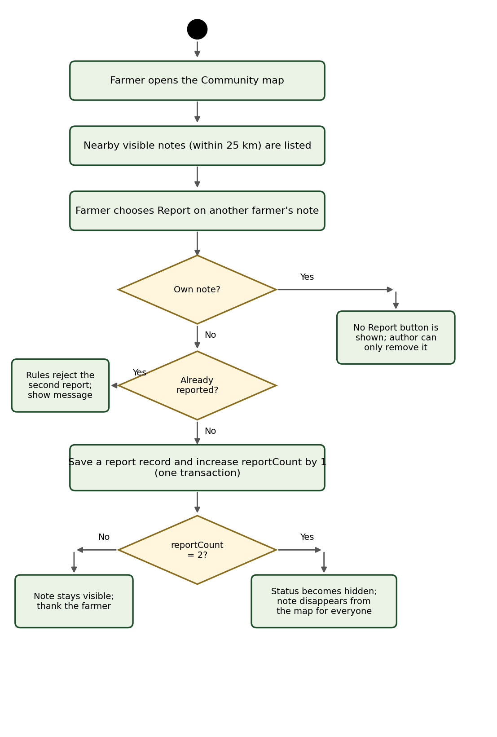
Figure 5: Activity diagram: report a community note
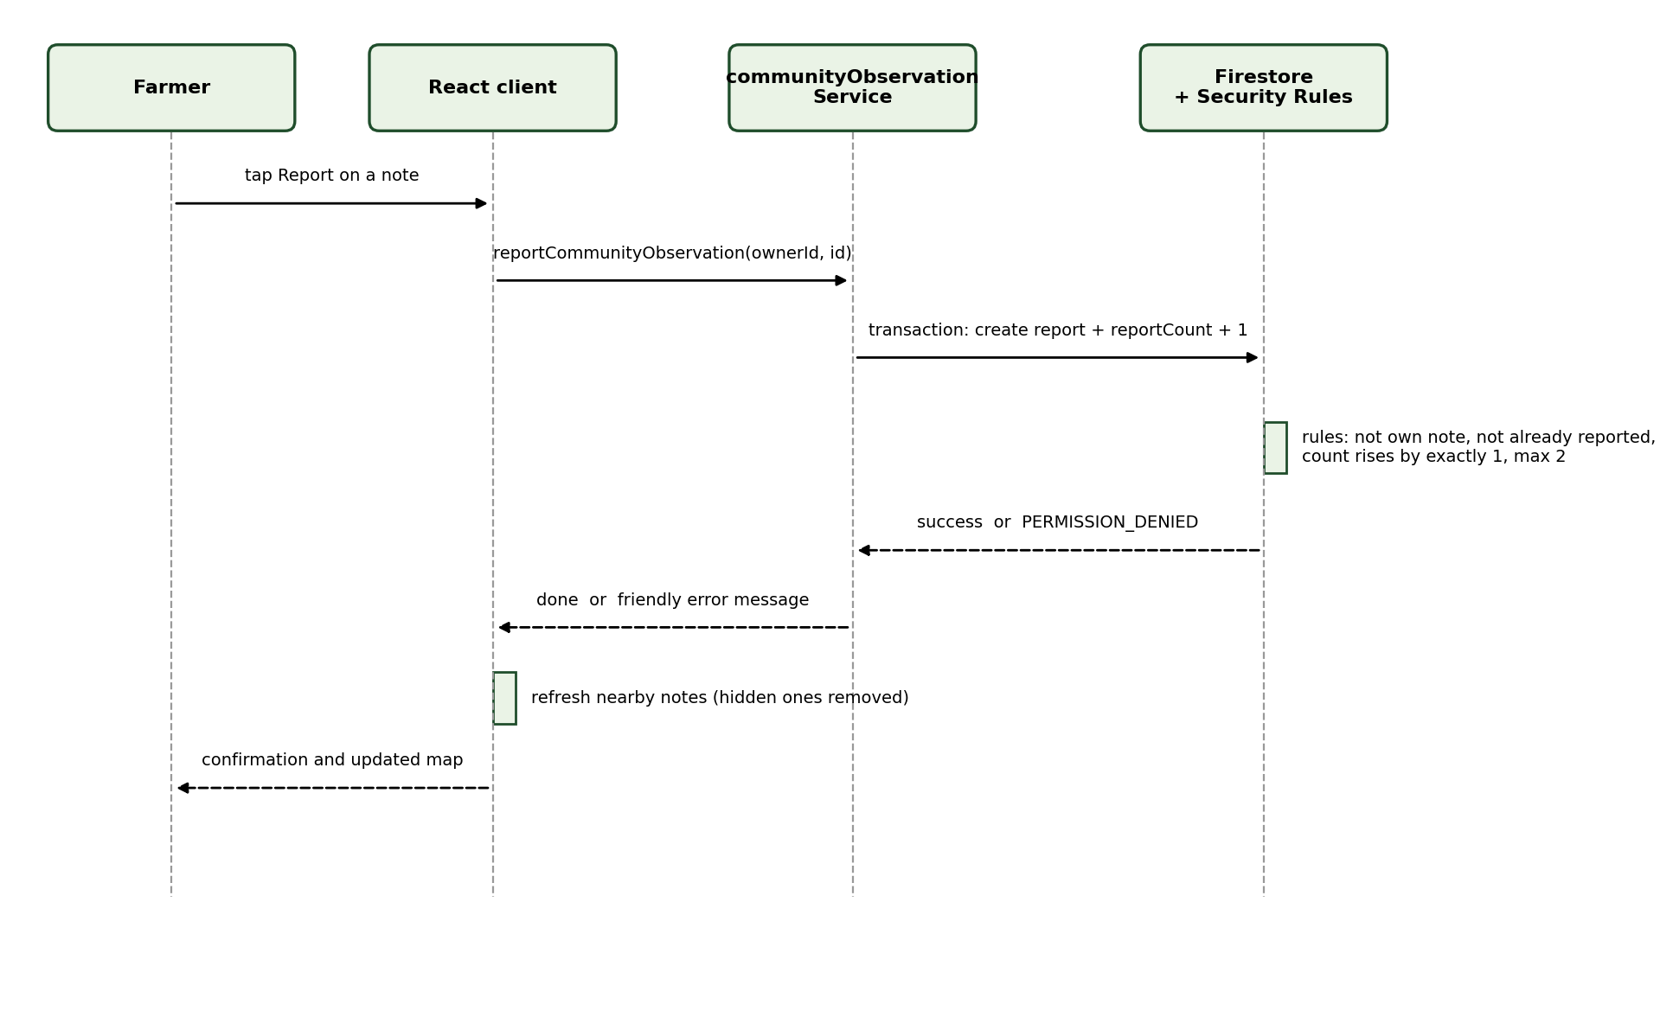
Figure 6: Sequence diagram: report a community note

State diagram
A community note is visible when created and hidden after two reports. It can be deleted by its author at any time.
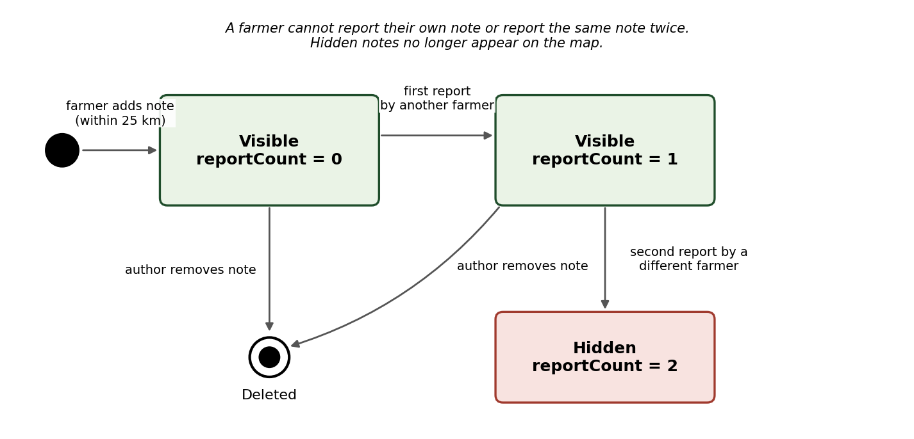
Figure 7: State diagram of a community note

5.2 Architecture and Technology Stack
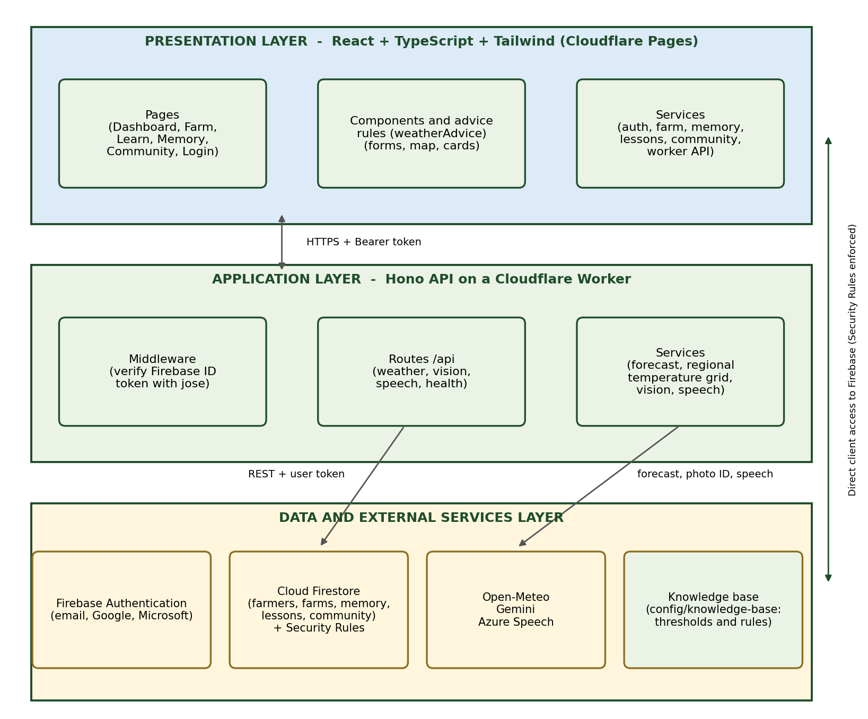
Figure 8: Logical architecture
Component | Responsibility
React client | Screens, input checking, advice rules, and reading and writing the farmer's own Firestore data through service modules.
Worker API (Hono) | Verifies the Firebase ID token, reads the farm with the farmer's token, fetches forecasts, identifies photos and creates speech. All routes are under /api and answer with { success, data, message }.
Firebase Authentication | Creates accounts and signs farmers in (email and Google).
Cloud Firestore and Security Rules | Stores data and decides who may read or write each document.
Knowledge base | Holds all agronomic thresholds with a comment explaining each rule and its reason.
External services | Open-Meteo (forecast), Google Gemini (photo identification), Azure Speech (spoken warnings), YouTube (lesson videos), OpenStreetMap (map tiles).

Component | Technology | Responsibility
Client | React 19, Vite 8, Tailwind CSS 4, React Router 8, TypeScript 7, react-leaflet | User interface and advice rules
Worker | Hono 4, jose 6, Wrangler 4, TypeScript (Cloudflare Workers runtime) | Authenticated API
Identity | Firebase Authentication (SDK 12) | Sign-in
Database | Cloud Firestore with Security Rules | Storage and access control
Weather | Open-Meteo forecast API (no key) | Forecast data
AI | Google Gemini (vision) | Photo identification
Speech | Azure Speech F0 (af-ZA, zu-ZA voices); browser voices for other languages | Spoken warnings
Testing | node:test, Firebase emulator, rolldown | Unit and rule tests

5.3 Key Design Decisions

Decision 1: the client reads and writes Firestore directly
Item | Detail
Context | Farmers need their own data fast, and the project must stay on free plans.
Options | (a) Route all data through the Worker; (b) call Firestore directly from the client protected by Security Rules.
Decision | Option (b).
Rationale | Security Rules enforce permissions on the server, so no client code has to be trusted, and no extra API is needed for simple reads and writes.
Consequences | Rules must be tested carefully, which is why six rule tests exist. Complex logic such as the report count had to be expressed as rules.

Decision 2: the Worker calls Firestore with the farmer's own token
Item | Detail
Context | The Worker needs the farm location to fetch a forecast.
Options | (a) Use a service account that can read everything; (b) forward the farmer's ID token to the Firestore REST API.
Decision | Option (b) for user requests. A service-account helper exists only for background work.
Rationale | The same Security Rules still apply, so the Worker can never read another farmer's farm.
Consequences | Each request needs a valid token, and background jobs need a service-account key (not yet configured).

Decision 3: a rule-based advice engine with a knowledge base
Item | Detail
Context | Advice must be explainable and safe for farmers.
Options | (a) Ask a language model for advice; (b) compare forecasts with fixed thresholds kept in a knowledge-base file.
Decision | Option (b). Gemini is used only to identify a photo.
Rationale | Thresholds are transparent, testable and can be changed in one place. Each rule has a comment giving its meaning and reason.
Consequences | Advice only covers the rules and crops that are written down.

Decision 4: Gemini only for photo identification, with manual fallback
Item | Detail
Context | Typing a crop or animal name is slow on a phone.
Options | (a) Typed names only; (b) photo identification with a typed fallback.
Decision | Option (b), with a model fallback list and a confidence rule.
Rationale | A photo is faster, and the confidence rule marks weak results as uncertain or unknown.
Consequences | It needs an API key and may be wrong, so the farmer can always edit or type the name.

5.4 Application Class Design
Figure 9 shows the main services and logic modules of the application, not only the data. Client services are the only code that touches Firestore. The advice engine reads the knowledge base. WorkerApi sends the farmer's token to the Worker. In the Worker, the authentication middleware guards every route, the routes call the worker services, and every route answers through the shared response helper.
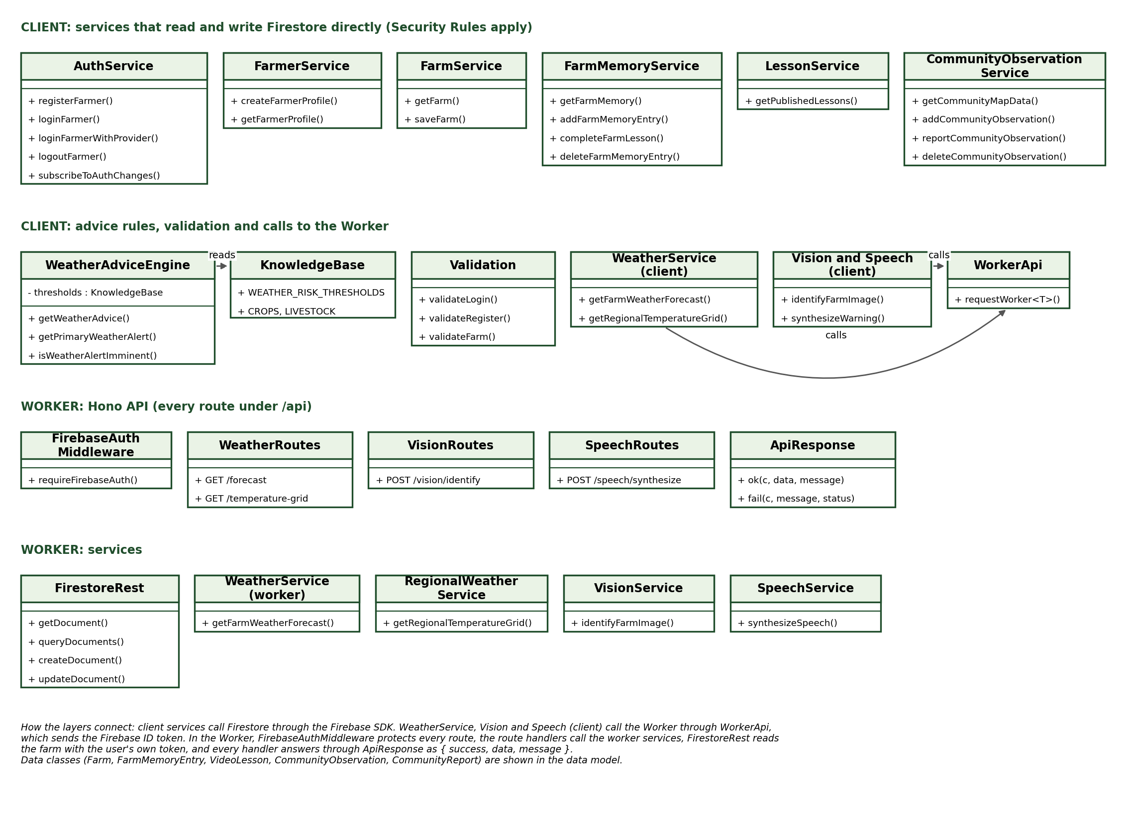
Figure 9: Application class diagram (client and Worker)
The data classes (farmer, farm, memory entry, lesson, community observation and report) are shown in the data model below.

5.5 User Interface and Interaction
Screen | User | Purpose | Action | Requirement
Login (Figure 10) | Farmer | Sign in | Enter email and password or choose Google | FR-01, FR-02
Farm validation error (Figure 11) | Farmer | Show that bad input is refused | Clear the name, enter size 0, press Save | BR-02
Dashboard (Figure 12) | Farmer | Core workflow and result: weather, outlook and warning | Open the dashboard | FR-07 to FR-09
Warning pop-up (Figure 13) | Farmer | Result: what to do, when and why | Open the warning | FR-09
Farm profile (Figure 14) | Farmer | Save the farm | Fill in and save | FR-03, FR-04

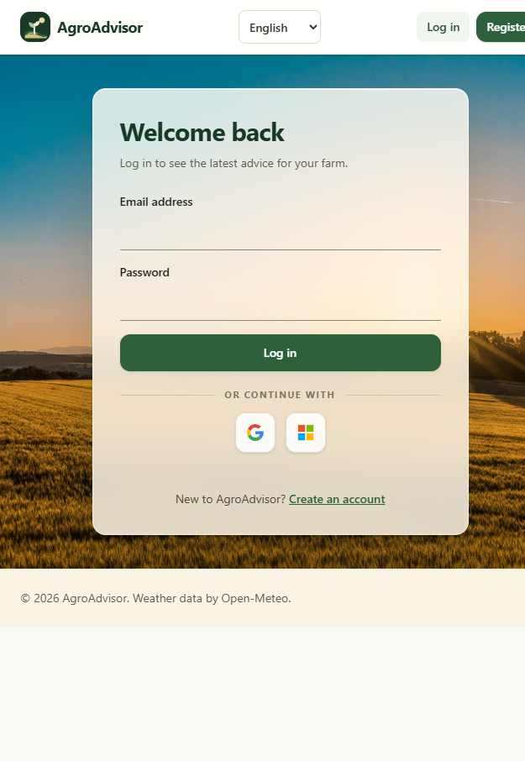
Figure 10: Login screen
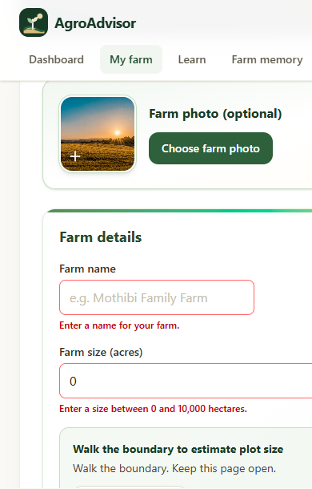
Figure 11: Validation state: the farm form refuses an empty name and a size of 0 (captured during the live test)
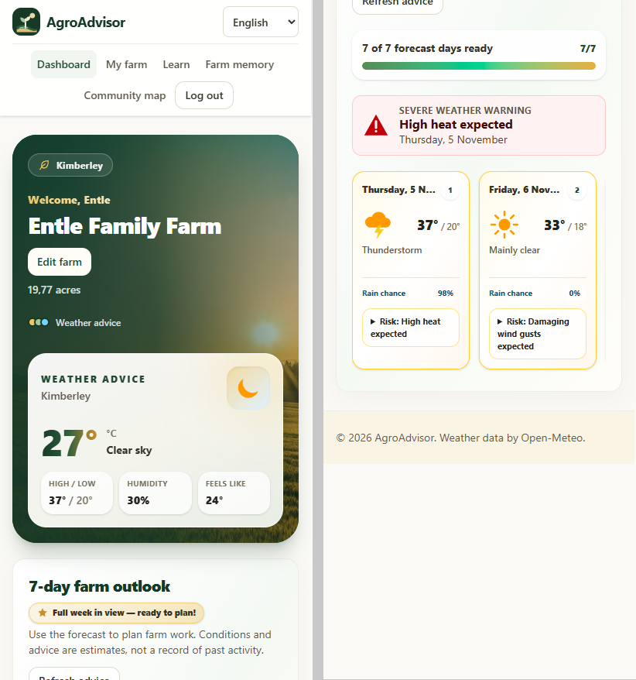
Figure 12: Dashboard: farm, weather, seven-day outlook and warning icon
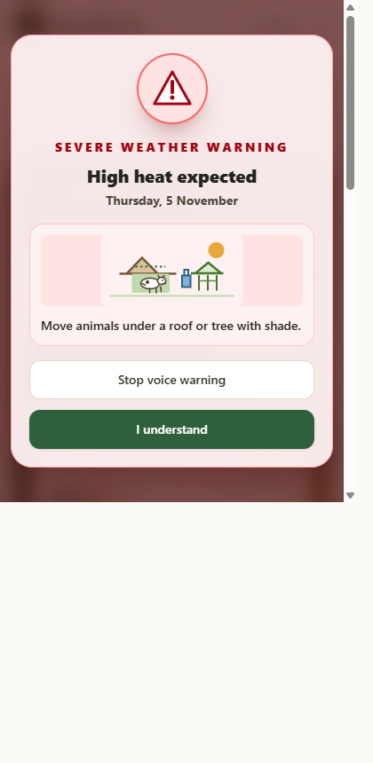
Figure 13: Result state: severe-weather warning pop-up
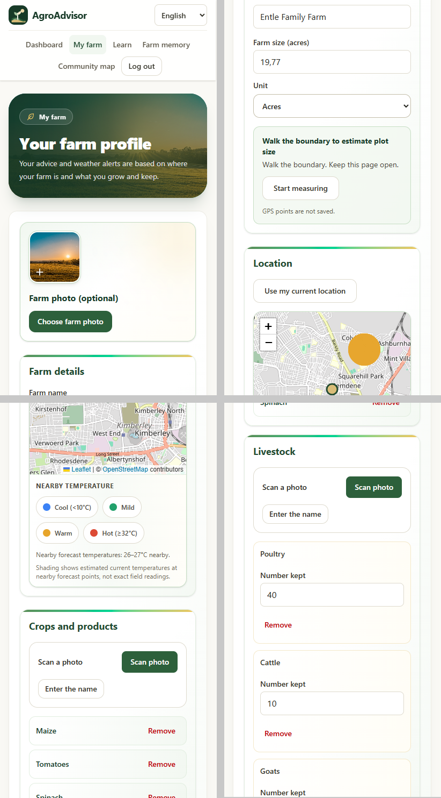
Figure 14: Farm profile

5.6 Data Design
Data is stored in Cloud Firestore. Figure 15 shows the entities and their relationships.
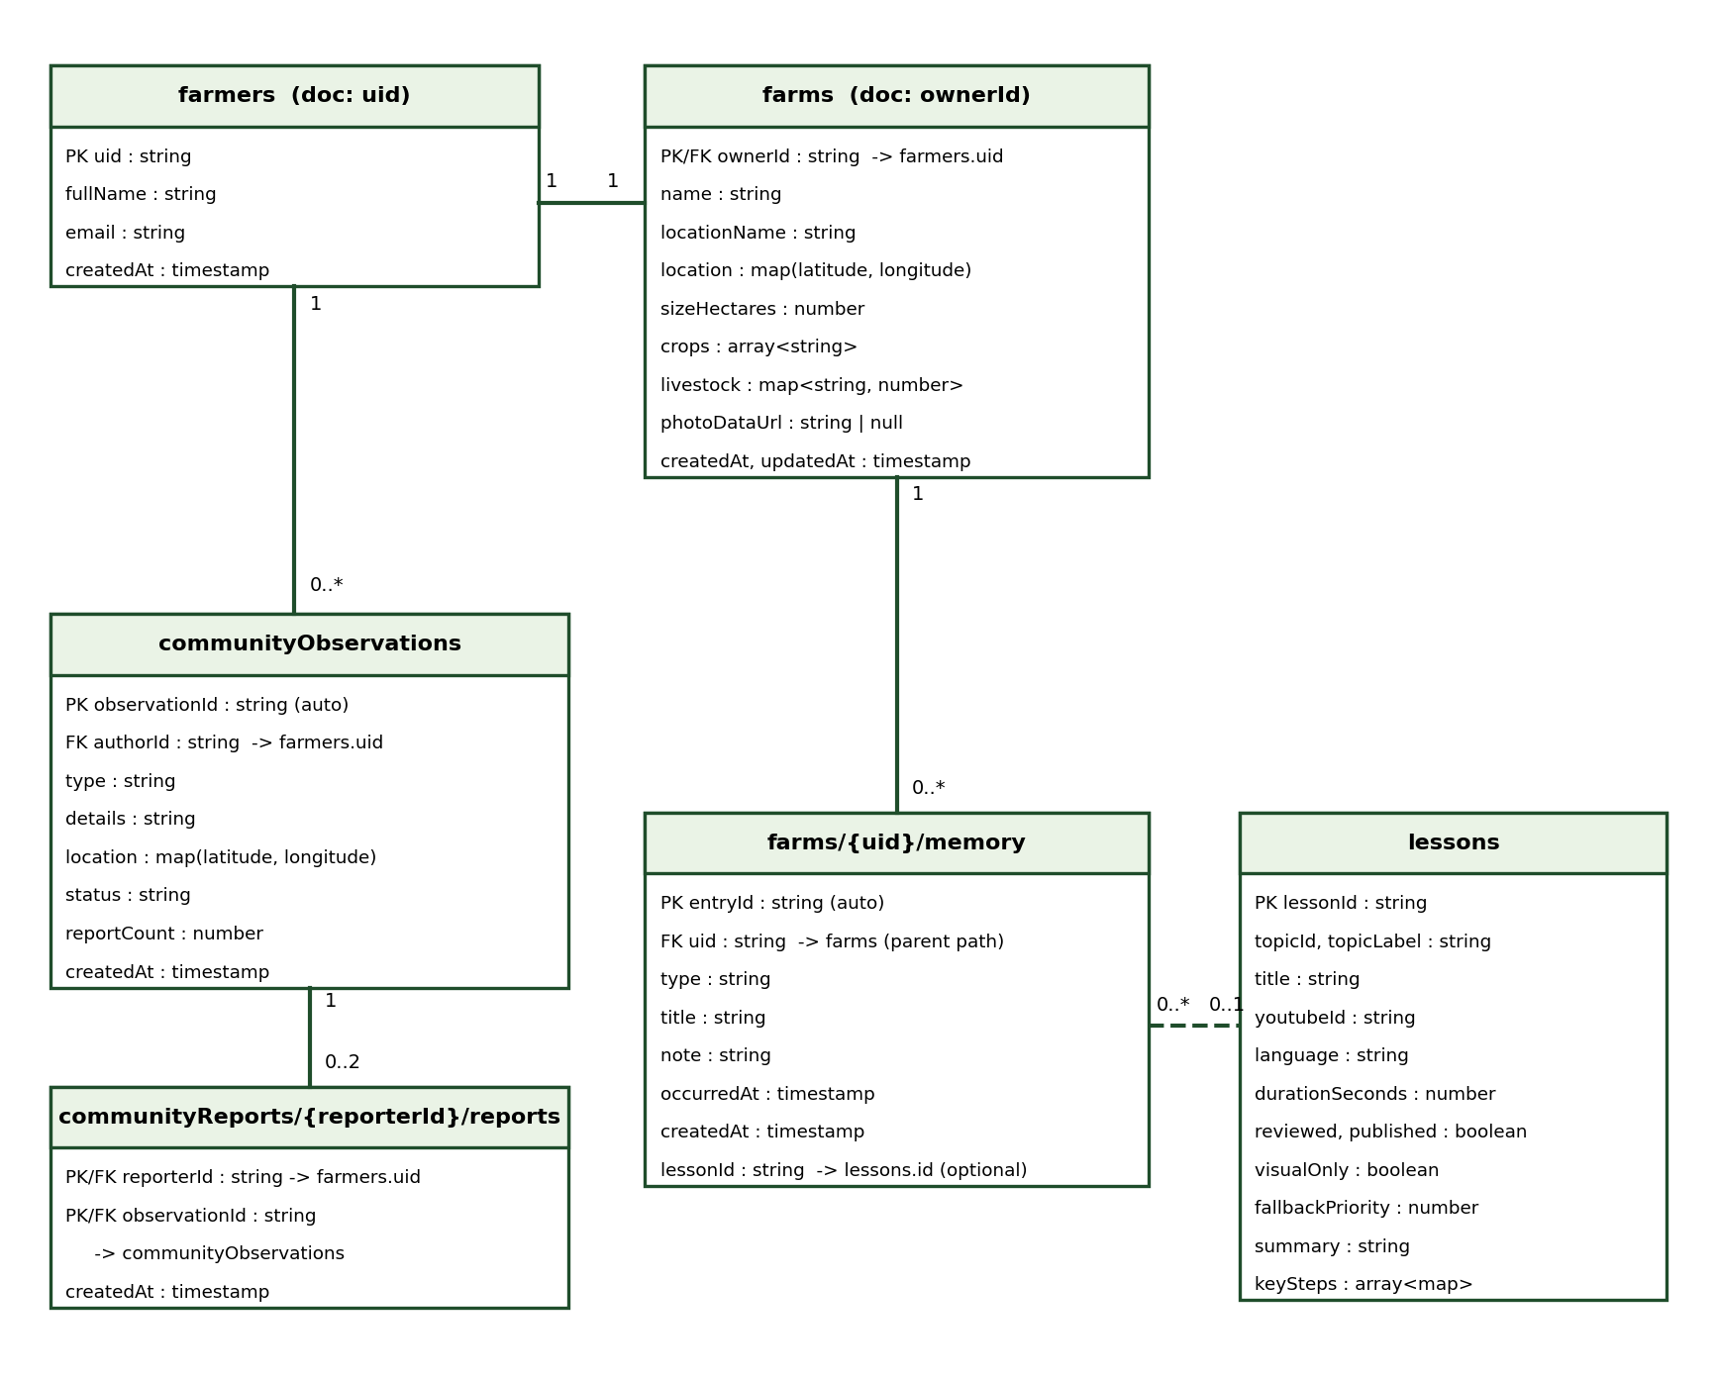
Figure 15: Data model
Collection / path | Key fields | Rules and limits
farmers/{uid} | uid, fullName, email, createdAt | Owner only. Email must match the account.
farms/{ownerId} | name, locationName, location, sizeHectares, crops, livestock, photoDataUrl, updatedAt | Owner only. Size above 0 and at most 10,000 ha. Name 1 to 80 characters.
farms/{uid}/memory/{entryId} | type, title, note, occurredAt, createdAt, lessonId | Owner only. Create or delete, no edit. Type is weather, planting, success or lesson. Date not in the future.
lessons/{lessonId} | topicId, title, youtubeId, language, reviewed, published, keySteps | Signed-in read of reviewed and published only. No writes by farmers.
communityObservations/{id} | authorId, type, details, location, status, reportCount, createdAt | Within 25 km of author's farm. Details at most 240 characters. Count 0 to 2.
communityReports/{reporterId}/reports/{observationId} | createdAt | Reporter only. One per note. Cannot be changed or deleted.

Integrity mechanisms: the farm and the farmer share one ID, so a farmer has one farm; the report action is a Firestore transaction that saves the report and increases the count together; rules check that the count rises by exactly 1 and never exceeds 2; the report document ID equals the note ID, so a duplicate report is impossible; and server timestamps stop the client from setting creation times.

5.7 Security, Privacy and Access Control
Authentication uses Firebase Authentication with email and password or Google. The Worker verifies the ID token with the jose library against Google's public keys, checking issuer and audience. There is a single role, the farmer.
Resource | Farmer (own data) | Another farmer | Not signed in
Farmer profile and farm | Read, write | No access | No access
Farm memory | Read, create, delete | No access | No access
Lessons (published) | Read | Read | No access
Community notes (visible) | Read, create, delete own | Read, report once | No access
Worker API (/api/weather, vision, speech) | Allowed with a valid token | Not applicable | 401 Unauthorized

Area | Risk | Implemented control
Data access | A farmer reads or edits someone else's farm | Firestore Security Rules on every collection; Worker uses the farmer's own token
API | Anonymous use of paid or limited services | Firebase ID token required; missing or invalid token returns 401
Community | Fake or repeated reports, abusive notes | One report per farmer per note, count rules, hide at two reports, no names, 25 km limit, length limit
Input | Oversized or wrong files and values | Photo type and 6 MB limit; size and length limits in rules; client and server validation
Secrets | Keys leaked in source code | Secrets only in .env and worker/.dev.vars (Wrangler secrets); example files hold placeholders
Cross-origin | Other websites calling the Worker | ALLOWED_ORIGIN setting limits browser origins
Privacy | Location exposure | GPS boundary points are not saved; community notes carry no names; farm data is private to the owner

5.8 Deployment and Runtime Design
The assessed system runs on one computer: the Vite development server for the client and the Wrangler development server for the Worker, with the Vite server forwarding /api requests to the Worker. Both talk to managed cloud services over HTTPS.
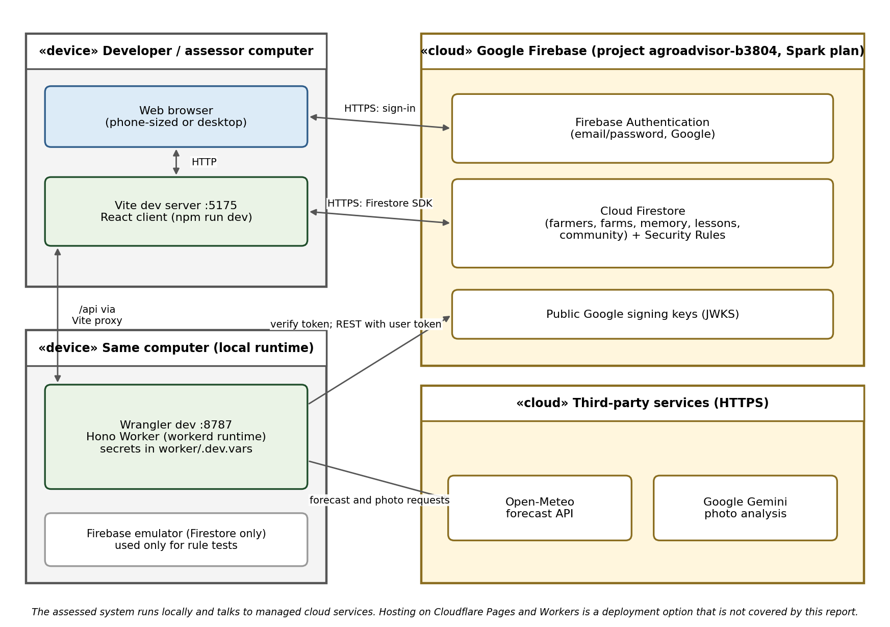
Figure 16: Deployment diagram

6. SYSTEM IMPLEMENTATION

6.1 Codebase and Repository Structure
Folder | Contents
client/ | React application: pages, components, hooks, services (all Firestore and Worker calls), types, translations, and tests.
worker/ | Hono Worker: routes, middleware, services and types under src/, with wrangler.toml and .dev.vars.example.
config/knowledge-base/ | Agronomic thresholds and rules for weather risks, crops and livestock, each with an explanatory comment.
firestore.rules and firestore.indexes.json | Security Rules and query indexes.
docs/ | Phase documents, diagrams and the scripts that build them.

6.2 Implementation of Core Capabilities
Capability | Requirement(s) | Main components
Sign-in and registration | FR-01, FR-02 | authService, validation module, Login and Register pages
Farm profile | FR-03 to FR-06 | farmService, Farm page, map picker, photo scan, plot walker
Weather advice and outlook | FR-07, FR-08 | Worker weather route and service, weather advice engine, Dashboard
Severe-weather warning | FR-09 | Advice engine, knowledge base, warning pop-up, speech route
Temperature map | FR-10 | Regional weather service, temperature-grid route
Learn and farm memory | FR-11 to FR-13 | lessonService, farmMemoryService, Learn and Memory pages
Community map | FR-14, FR-15 | communityObservationService, Community page, Firestore rules
Language | FR-16 | Translation files and language selector

6.3 APIs and Integrations
Integration | Use | Failure handling
Worker GET /api/weather/forecast | Farm forecast | 401 without a valid token; the client shows an error with a retry
Worker GET /api/weather/temperature-grid | Regional temperatures for the map | 401 without a token; the map still works without shading
Worker POST /api/vision/identify | Photo identification | 400 for a bad type, 413 for oversize, 503 if the service is not configured; the farmer can type the name
Worker POST /api/speech/synthesize | Spoken warning | 503 if not configured; the warning stays on screen as text
Open-Meteo | Weather data | A failed request returns an error response and nothing is cached as correct
Firebase Auth and Firestore | Accounts and data | Errors are shown to the farmer in plain language
YouTube and OpenStreetMap | Videos and map tiles | Loaded only when needed; a failure does not affect advice

No integration is mocked. Which of the failure responses above were measured is stated under Verification and Testing.

6.4 AI/ML Component
The only AI component is Google Gemini vision, used to identify a crop or animal from a photo. The Worker tries a list of models in order (gemini-3.1-flash-lite, gemini-3.5-flash-lite, gemini-3.6-flash) and returns a name with a confidence value. A confidence of 0.8 or more is 'identified', 0.5 to 0.79 is 'uncertain' and lower, or a non-farm picture, is 'unknown'. Limitations: the model can be wrong for similar plants or poor photos, it needs a network and an API key, and no accuracy figure has been measured. Fallback: the farmer can always type the name, and every identified item can be edited before saving. The advice and risk engine is not AI; it is rule-based so that every warning can be traced to a threshold.

7. VERIFICATION AND TESTING

7.1 Test Approach
Automated checks: the client production build, strict type checks for the client and the Worker, 15 unit tests for the advice and validation logic, and 6 Firestore Security Rule tests run against the Firebase emulator. Scripted API checks were made against the local Worker. Manual checks were made in a real browser. Items that were not run are labelled 'Not yet executed'. Nothing in this section is estimated.

7.2 Functional and Business-Rule Verification
Test ID | Requirement | Scenario | Type | Expected | Actual | Status
TC-U01 | FR-09, BR-03 | Temperature 35 °C | Unit | Heat warning | Heat warning raised | Pass
TC-U02 | BR-03 | Temperature 34.9 °C | Unit | No heat warning | None raised | Pass
TC-U03 | BR-03 | Temperature 2 °C | Unit | Frost warning | Frost warning raised | Pass
TC-U04 | BR-03 | Rain 50 mm, and 30 mm at 70% | Unit | Heavy-rain warning | Raised in both cases | Pass
TC-U05 | BR-03 | Gusts 60 km/h | Unit | Wind warning | Wind warning raised | Pass
TC-U06 | BR-03 | Weather codes 95, 96, 99 | Unit | Storm warning | Raised for each | Pass
TC-U07 | FR-08 | Missing (null) weather values | Unit | No crash, no false warning | No crash, none raised | Pass
TC-U08 | FR-09 | Several risks on one day | Unit | Most serious is primary | Correct order | Pass
TC-U09 | BR-04 | Event today, tomorrow, later | Unit | Pop-up only today or tomorrow | As expected | Pass
TC-U10 to U15 | FR-01, BR-02, SC-4 | Login, register and farm validation with invalid input | Unit | Error returned | Errors returned | Pass
TC-R01 | BR-07 | Same farmer reports one note twice | Rules | Second report refused | Refused | Pass
TC-R02 | BR-08 | Edit report count without a report | Rules | Rejected | Rejected | Pass
TC-R03 | BR-08 | Report without the count update | Rules | Rejected | Rejected | Pass
TC-R04 | BR-08 | Second distinct farmer reports | Rules | Note hidden | Note hidden | Pass
TC-R05 | BR-07 | Author reports own note | Rules | Refused | Refused | Pass
TC-R06 | NFR-03 | Another farmer deletes a note | Rules | Refused | Refused | Pass
TC-M01 | BR-02, SC-4 | Farm form: clear the name, size 0, press Save (live browser) | Manual | Both errors shown, nothing saved | 'Enter a name for your farm.' and 'Enter a size between 0 and 10,000 hectares.' shown; after reload the saved farm (Entle Family Farm, 8 ha) was intact | Pass
TC-M02 | FR-01 | Wrong password and Google sign-in error screens | Manual | Friendly error | - | Not yet executed
TC-M03 | FR-14 | Add note outside 25 km in the browser | Manual | Refused | - | Not yet executed

Thresholds are tested exactly (35 °C raises, 34.9 °C does not). Rule tests TC-R01 to TC-R06 are the six tests in client/tests/firestore.rules.test.mjs. Unit tests are in client/tests/logic.test.ts and run with 'npm run test:unit'.

7.3 Non-Functional and Security Verification
Test ID | Requirement | Check | Result | Status
TC-N01 | SC-5 | Client production build (npm run build) | Built successfully | Pass
TC-N02 | NFR-05 | Client strict type check (tsc -b) | No errors | Pass
TC-N03 | NFR-05 | Worker type check (npm run typecheck) | No errors | Pass
TC-S01 | NFR-03 | GET /api/health | 200, { success: true }, about 196 ms (single local request) | Pass
TC-S02 | NFR-03 | GET /api/weather/forecast with no token | 401 | Pass
TC-S03 | NFR-03 | GET /api/weather/forecast with an invalid token | 401 | Pass
TC-S04 | NFR-03 | POST /api/vision/identify, POST /api/speech/synthesize and GET /api/weather/temperature-grid with no token | 401 for each | Pass
TC-S05 | NFR-05 | Request to an unknown route /api/nothing | 404 | Pass
TC-S06 | NFR-03 | Authenticated requests with a valid token, and 400, 413 and 503 responses | - | Not yet executed
TC-P01 | NFR-07 | Dashboard load time on a slow mobile connection | - | Not yet executed

The 196 ms figure is one local request and is not a performance measurement.

7.4 Defects and Known Issues
Defects found while building and fixed: Google sign-in failed on 127.0.0.1 until that address was added to Firebase's authorised domains. Unresolved issues are listed in Known Limitations and Open Issues (LIM-1 to LIM-8).

8. SYSTEM SETUP AND OPERATION

8.1 Prerequisites and installation
- Node.js and npm. Java 17 (only for the Firestore rule tests).
- A Firebase project with Authentication (email/password and Google) and Cloud Firestore enabled. Add the dev address (localhost and 127.0.0.1) to the authorised domains.
- Install dependencies: run 'npm install' in client/ and in worker/.

8.2 Environment configuration
Copy the example files and fill in your own values. Never commit the real files.
File | Variable | Placeholder / purpose
client/.env | VITE_FIREBASE_API_KEY, VITE_FIREBASE_AUTH_DOMAIN, VITE_FIREBASE_PROJECT_ID, VITE_FIREBASE_STORAGE_BUCKET, VITE_FIREBASE_MESSAGING_SENDER_ID, VITE_FIREBASE_APP_ID, VITE_FIREBASE_VAPID_KEY (push, optional), VITE_WORKER_URL (empty locally) | your-firebase-web-config-value
worker/.dev.vars | FIREBASE_PROJECT_ID | your-project-id
worker/.dev.vars | ALLOWED_ORIGIN | http://localhost:5173
worker/.dev.vars | GEMINI_API_KEY | your-gemini-key (photo identification)
worker/.dev.vars | GOOGLE_SERVICE_ACCOUNT_EMAIL, GOOGLE_SERVICE_ACCOUNT_PRIVATE_KEY | service-account values for background work (not configured)
worker/.dev.vars | AZURE_SPEECH_KEY, AZURE_SPEECH_REGION | your-azure-speech-key and region (spoken warnings)

Check the exact variable names against client/.env.example and worker/.dev.vars.example, which list every required variable.

8.3 Run commands
Purpose | Command (folder)
Start the Worker | npm run dev (worker/), serves on http://127.0.0.1:8787
Start the client | npm run dev (client/); /api is forwarded to the Worker
Build the client | npm run build (client/)
Type-check | npx tsc -b (client/) and npm run typecheck (worker/)
Unit tests | npm run test:unit (client/)
Security rule tests | npm run test:firestore-rules (client/)

8.4 Seeding and demo accounts
The sample data is 15 demo farmers (IDs beginning demo-farmer-) with farms and community notes (IDs beginning demo-obs-). It was written to the database once, and can be deleted by that prefix. Demo logins: [Create or note one test account for the assessor and give the email and password to the supervisor separately. Do not put real passwords in this report.]

9. SOLUTION EVALUATION
Success criterion | Outcome | Evidence
SC-1 Register, sign in, save farm, see advice | Achieved | Live use with a real account; farm saved and still present after reload; validation unit tests pass. Microsoft sign-in is not enabled (Excluded and Deferred Capabilities).
SC-2 Warnings with what, when and why from documented thresholds | Achieved | Unit tests TC-U01 to TC-U09 pass; warning pop-up in Figure 13. Advice only covers rules in the knowledge base.
SC-3 Own-data access and community integrity | Achieved | Six rule tests pass; 401 for unauthenticated API calls. Authenticated API behaviour was not scripted (LIM-3).
SC-4 Invalid input refused | Achieved | Unit tests TC-U10 to TC-U15 and live test TC-M01. The login-error screens were not exercised live (LIM-4).
SC-5 Builds cleanly and can be set up | Partially achieved | Build and both type checks pass. Setup was documented but 5 npm audit findings remain and no public deployment was made (LIM-1, LIM-5).

Overall, the core purpose, interpreting a farm-specific forecast into warnings and advice, has been built and verified at the level shown. The remaining gaps are background push, seasonal advice, measured performance and public deployment.

10. REFERENCES
Department of Agriculture. (2026, September 2). El Niño advisory [Media statement]. https://www.nda.gov.za/images/Newsroom/Media%20Releases/2026/el-nino-advisory-2026-summer-season.pdf
Farmer's Weekly. (2026, August). SA food inflation at a 16-year low. https://www.farmersweekly.co.za/agri-news/south-africa/sa-food-inflation-at-a-16-year-low/
Farmers Mag. (2025, April). Best mobile apps for farmers in South Africa. https://farmersmag.co.za/2025/04/best-mobile-apps-for-farmers-in-south-africa/
Makamane, A. S. (2023). Capacity of extension and advisory services in supporting farmers to adapt to climate change in the Eastern Cape, South Africa [Doctoral thesis, University of the Free State]. http://hdl.handle.net/11660/12426
South African Weather Service. (2026, September 1). South African Weather Service statement on the 2026/27 El Niño [Media statement]. https://www.weathersa.co.za/api/wp/uploads/2026/09/SAWS-ENSO-Statement-002.pdf
Statistics South Africa. (2017). Census of commercial agriculture 2017: Financial and production statistics (Report No. 11-02-01). https://www.statssa.gov.za/publications/Report-11-02-01/Report-11-02-012017.pdf
Statistics South Africa. (2022). Women in agriculture: Six key facts (Census 2022). https://www.statssa.gov.za/?p=19824
USDA Foreign Agricultural Service, International Production Assessment Division. (2016, May). El Niño drought reduces 2015/16 corn prospects in South Africa. https://ipad.fas.usda.gov/highlights/2016/05/SouthAfricaElNino/index.htm
World Meteorological Organization. (2026). El Niño set to become very strong, raising risks of extreme weather in 2027. https://wmo.int/news/media-centre/el-nino-set-become-very-strong-raising-risks-of-extreme-weather-2027

11. APPENDICES

11.1 Appendix A: Source code repository
GitHub repository URL: [Paste the repository URL]
Release tag or commit: [Paste the tag or commit hash that was assessed]

11.2 Appendix B: Deployed system
No public deployment. The assessed system runs locally as described under System Setup and Operation.

11.3 Appendix C: Supporting material
- Phase 1, Phase 2 and Phase 3 documents (problem, requirements and models, GUI and data design).
- Test sources: client/tests/logic.test.ts and client/tests/firestore.rules.test.mjs.
- Knowledge base: config/knowledge-base/weather-risks.ts, crops.ts and livestock.ts.

