1. Write a program that accepts 'N' elements into an array but only adds them if they are not already present in the set. (enforcing "no duplicates" rule of set):
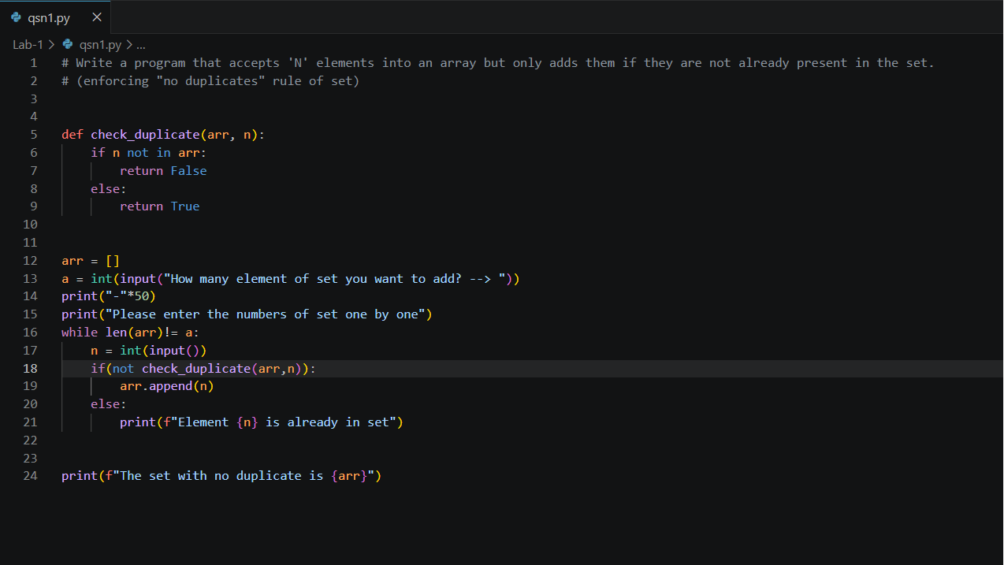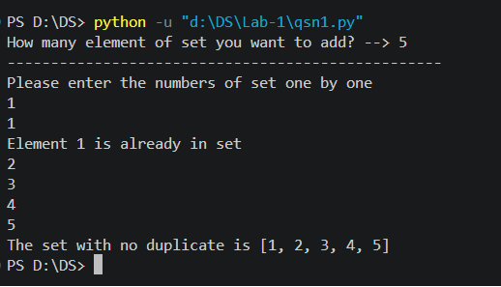

2. Create a function that return '1' if the element exists in the set and '0' otherwise.
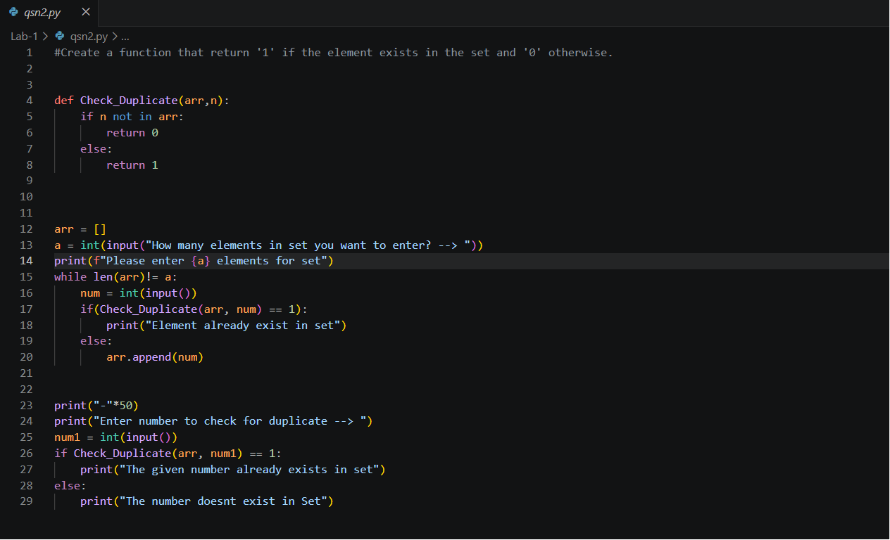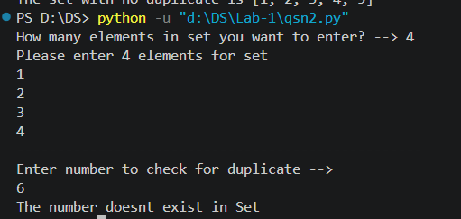

3. Write a program to simulate the set operations for the given two sets and perform the following operations.
a. Set Union
b. Set Intersection
c. Set Difference
d. Cartesian Product
e. Symmetric Difference
