A Structured Latent-Space Bayesian
Optimization Method for Aircraft Design with
Mixed Variables

Yi Lu1,2 , Yiyuan Ma1,2*, Zhonghua Han1,2
1 Northwestern Polytechnical University, 710072, Xi’an, People’s Republic of China.
2 Institute of Aerodynamic and Multidisciplinary Design Optimization, School of Aeronautics; also National Key Laboratory of Aircraft
Configuration Design.

*Corresponding author(s). E-mail(s): y.ma@nwpu.edu.cn;

Abstract
Aircraft conceptual design combines continuous geometric parameters with dis- crete, hierarchically activated configuration choices, creating high-dimensional, nonsmooth, and multimodal spaces that challenge sample-efficient optimization. Existing mixed-variable Bayesian optimization methods do not jointly represent ordinal relations, nominal similarities, and conditional activation, limiting cross- configuration knowledge transfer under expensive coupled aircraft analyses. This paper proposes structured latent-space Bayesian optimization (LSBO) for such mixed-variable problems. A structured variational autoencoder (VAE) maps dis- crete configurations to a continuous latent space. Performance-aware training, a VAE-informed Gaussian-process prior mean, activation masks, and decou- pled candidate generation align representation, prediction, and search with the objective. LSBO is evaluated on three mixed-variable benchmarks, a simplified analytical electric-aircraft model, and a complete mission-level multidisciplinary analysis (MDA) of a NASA X-57 aircraft. Relative to the second-best method, LSBO reduces mean final regret by 31.4%, 12.3%, and 11.0% on the benchmarks and by 39.9% on the analytical model. In the X-57 MDA case, LSBO improves on the random-forest Bayesian optimization baseline by 11.54% after normaliza- tion against the random-search gap. Ablation studies show final-best degradation of up to 9.01% when key components are removed. The results indicate that performance-aligned latent geometry and hierarchical validity improve sample efficiency in expensive mixed-variable aircraft design.

1

Keywords: latent-space Bayesian optimization; mixed-variable optimization;
variational autoencoder; aircraft conceptual design; multidisciplinary design
optimization

1 Introduction
Aircraft conceptual design establishes the overall layout and the feasible region for sub- sequent detailed design by integrating aerodynamics, structures, propulsion, energy storage, mass, control, and mission analysis. Many design variables are mixed and hier- archical: some are continuous, some encode ordered or nominal choices, and others are active only under particular configurations. An upper-level configuration can there- fore change the meaning, bounds, or activation of lower-level variables. For example, propulsor count is an integer, motor topology is categorical, battery parameters are continuous, and winglet variables are meaningful only when a winglet is selected. These dependencies create a nonuniform search space in which nominal labels may represent similar physical configurations and inactive variables should not affect predictions. Moreover, objective and constraint responses may be smooth within one configuration but discontinuous across configuration changes. Poor early configuration decisions may therefore restrict system-level improvements that cannot be recovered by later con- tinuous sizing. This structure is difficult to represent with a single fixed-dimensional vector and challenges both surrogate modeling and sequential sampling.
These difficulties are pronounced in electrified aircraft design because aerody- namic, structural, propulsion, and energy subsystems are tightly coupled. Afonso et al. [1] reviewed multidisciplinary design optimization (MDO) for sustainable aviation, while Abu Salem et al. [2] emphasized the coupling among aerodynamics, propulsion, battery sizing, and mission operation in electric aircraft. Ma and Elham [3] further showed how high-aspect-ratio wing design links aerodynamic efficiency to aeroelas- tic and structural constraints. Abdul-Kaiyoom et al. [4] reported that a system-level electric-aircraft formulation reduced total energy consumption by approximately 3% relative to sequential optimization. Van den Kieboom and Elham [5] reported that concurrent wing and high-lift-system optimization reduced fuel weight by 9.65%, com- pared with 9.20% for sequential optimization; the corresponding total-drag reductions were 28.7% and 25.0%, respectively. These results quantify the benefit of coupled opti- mization but do not resolve how mixed and conditionally active variables should be represented under expensive analysis.
Evolutionary algorithms can accommodate nonconvex mixed-variable spaces with- out differentiable models [6]. For a satellite-layout problem with 3888 possible configurations, Gamot et al. [7] reported that tag-based hidden-variable encoding explored approximately three times as many configurations as dimensional-variable encoding across 20 runs. Other representative approaches partition continuous, ordi- nal, and categorical variables [8] or combine dynamic grouping with distribution estimation [9]; these methods were evaluated on 34 mixed-variable optimization prob- lems against seven algorithms [8] and on 28 problems against eight algorithms [9], respectively. These studies demonstrate flexible treatment of heterogeneous variables,

2

but population-based search generally requires many expensive evaluations. Hierarchy is also commonly encoded through problem-specific chromosomes, variation opera- tors, grouping schemes, or post-sampling repair. Such mechanisms can preserve valid configurations, yet they do not construct a statistical representation through which observations from one configuration inform predictions for a related configuration. This limits their sample efficiency when each candidate invokes a multidisciplinary analysis.
Bayesian optimization (BO) reduces this evaluation burden by fitting a proba- bilistic surrogate and selecting new samples with an acquisition function [10]. The surrogate provides both a response estimate and predictive uncertainty, allowing the acquisition function to balance exploitation of promising regions against exploration of uncertain regions. This sequential use of information makes BO suitable when only a limited number of expensive evaluations is available. It has therefore been applied to aircraft design with multidisciplinary simulations and hidden constraints [11], including cases in which an analysis fails to return a valid objective or constraint value. Standard BO nevertheless assumes a fixed numerical input space and suffi- ciently regular responses. Integer and categorical choices violate conventional distance assumptions, while conditionally inactive variables can create duplicate or physically meaningless directions. Without structure-aware modeling, both Gaussian-process covariance and acquisition-function optimization may therefore be misleading [12, 13].
Kakkar et al. [14] recently applied multidisciplinary BO to a 116-dimensional gradient-free aerostructural wing problem. Their optimized laminar dry wing reduced fuel mass by 8.8% and increased the lift-to-drag ratio by 10.4% relative to an opti- mized turbulent dry wing, demonstrating the potential of BO for expensive aircraft design while retaining a continuous design space.
Mixed-variable BO addresses part of this problem. Saves et al. [12] developed a mixed-categorical Gaussian process (GP) kernel that models correlations among cat- egorical choices. With a 98-point training design, their exponential homoscedastic hypersphere kernel reduced the root-mean-square error on a 13,000-point cosine test set from 30.079 for a Gower-distance kernel to 1.882; on a cantilever-beam problem, it reduced the displacement error from 1.3858 cm to 0.1247 cm. In the multidisci- plinary design optimization of the DRAGON hybrid-electric aircraft, Saves et al. [13] combined a GP surrogate with partial least squares (PLS) to reduce the hyperpa- rameter dimension and reported a 4.1% reduction in single-mission fuel consumption. Bussemaker et al. [15] incorporated variable activation and architectural constraints into BO and achieved a thrust-specific fuel consumption (TSFC) comparable to that of the non-dominated sorting genetic algorithm II (NSGA-II) using 300 rather than 3250 evaluations. These methods improve mixed-variable search, but they do not explicitly learn a compact performance-relevant geometry for ordinal, nominal, and conditionally active variables together.
The remaining difficulty is representational because aircraft configuration variables are not interchangeable categorical labels. Ordinal variables, such as propulsor count, express ordered changes in level or scale. Nominal variables, such as propulsion topol- ogy or airfoil family, have no natural order but may exhibit nonuniform physical and

3

performance similarity. Conditionally active variables are meaningful only under spe- cific upper-level choices. These distinctions determine both what proximity means in the design space and whether a coordinate should contribute to a prediction. Treating all labels as equidistant loses ordinal and semantic relations; retaining inactive coor- dinates introduces artificial variation; and external repair alone may return a valid design while leaving the acquisition function unaware of equivalent or meaningless search directions. Existing mixed-categorical kernels [12, 13] learn correlations among categorical choices and reduce surrogate complexity, while hierarchical architecture BO [15] models variable activation and feasibility. Saves et al. [16] further formal- ized graph-structured hierarchical design spaces and associated kernels for mixed and conditionally active variables, including a green-aircraft BO application. These kernel- based formulations make hierarchy affect covariance directly, but they do not learn a compact objective-aligned latent geometry across all variable types. A suitable frame- work must therefore make hierarchy and performance relations affect latent distance, surrogate prediction, and candidate selection within one optimization loop.
Latent-space BO offers a route to this representation problem by mapping structured or high-dimensional inputs to a lower-dimensional continuous space. Gomez-Bombarelli et al. [17] used a variational autoencoder (VAE) with latent-space BO to identify a molecule with a logP value of 8.51, exceeding the maximum value of 8.25 in the training set. Griffiths and Hernandez-Lobato [18] increased the proportion of decoded samples classified as drug-like from below 5% to above 80%; across five independent runs, their best molecules reached the 100th percentile for one objective and above the 90th percentile for the remaining objectives. Tripp et al. [19] achieved an objective score of 27.84 with 500 samples, compared with the previous machine- learning best of 11.84 obtained with approximately 5000 samples. Moss et al. [20] further coupled representation learning, surrogate modeling, and candidate generation for structured domains. Collectively, these studies indicate that the latent represen- tation, surrogate, and sampling rule should be designed as one optimization system [20, 21].
In engineering optimization, Sridhara et al. [22] mapped nine attributes of 20 candidate materials to a two-dimensional VAE latent space and coupled it with topology-optimization examples containing more than one million degrees of free- dom. This illustrates the scalability of continuous latent representations for discrete engineering choices, although the learned geometry was not trained for BO response prediction.
These studies indicate that latent-space BO depends on whether the learned geometry supports surrogate modeling and candidate selection [19–21]. A standard VAE organizes samples through reconstruction and prior regularization, which pro- motes decodability but does not ensure that latent distance follows the objective response. Two configurations with similar encodings or geometry may have substan- tially different aerodynamic efficiency, propulsion-integration behavior, or mission energy, whereas configurations with different labels may exhibit similar performance and should share information. When a Gaussian-process kernel is applied directly to a reconstruction-oriented latent space, this mismatch affects both the predicted response and its uncertainty, and the acquisition function may allocate evaluations

4

to neighborhoods that are close for decoding but uninformative for optimization. For aircraft conceptual design, the latent space must also preserve ordinal relations and conditional activation so that inactive variables do not distort these neighbor- hoods. Performance-aware supervision should therefore shape the latent organization while retaining reconstruction fidelity and hierarchical validity. This motivates a representation learned for optimization rather than reconstruction alone.
This paper proposes latent-space Bayesian optimization (LSBO) for expensive aircraft conceptual design with mixed and hierarchical variables. LSBO encodes dis- crete configuration variables with a structured, performance-aware VAE, combines the latent code with active continuous variables, and fits a joint GP surrogate in that space. Validity masks and repair rules enforce conditional activation, while latent BO and a late-stage local refinement step generate candidates. Each candidate is evalu- ated by a multidisciplinary analysis (MDA), and the accumulated data periodically update both the representation and the surrogate.
The contribution is twofold. First, LSBO embeds ordinal relations, nominal con- figuration similarity, and conditional activation in a shared latent space. This avoids treating all discrete choices as equidistant labels and allows information to be trans- ferred across related configurations. Second, performance-aware training and refine- ment couple representation learning to the design objective, directing a limited MDA budget toward promising configuration-parameter neighborhoods. The method is eval- uated on three mixed-variable benchmarks and an X-57 distributed-electric-aircraft case against Random Search, a mixed-variable genetic algorithm (Mixed-GA), one-hot Gaussian-process Bayesian optimization (GP-BO), and a random-forest Bayesian opti- mization (RF-BO) baseline. Ablation studies isolate the effects of structured encoding, performance-aware training, and the VAE prior mean.
The remainder of this paper is organized as follows. Section 2 presents LSBO. Section 3 reports the benchmark and X-57 experiments, including ablation and aero- dynamic verification. Section 4 discusses the method and its scope. Section 5 concludes the paper.

2 Structured Latent-Space Bayesian Optimization Method
This section formulates LSBO for expensive aircraft conceptual design with hierar- chical mixed variables. The method maps structured discrete configurations into a performance-aware latent space, combines this representation with active continuous variables in a VAE-GP surrogate, and selects evaluations through joint acquisition optimization, discrete candidate screening, and local refinement.
Fig. 1 summarizes this workflow. Discrete configurations are encoded as structural and performance-aware latent variables and combined with active continuous variables in GP modeling and acquisition optimization. Each true evaluation then updates the representation, surrogate, and sampling policy, closing the optimization loop.

5

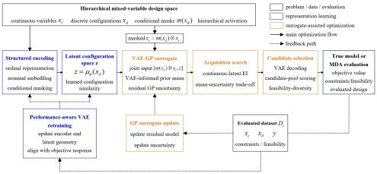

Fig. 1 Overall framework of LSBO for hierarchical mixed-variable optimization

2.1 Problem Definition and Hierarchical Mixed-Variable Structure
Let the aircraft conceptual design variables consist of a continuous design-variable vector xc and a discrete design-variable vector xd , where xc ∈ 耽p describes continu- ously adjustable parameters such as geometric dimensions, propulsion-system sizing, installation positions, and control settings, and xd = {dl ,..., dq } represents discrete configuration options such as propulsion architecture, airfoil family, and tail arrange- ment. The objective function f (xc , xd) is an expensive black-box function, typically obtained through multidisciplinary analysis or mission-profile simulation. The objec- tive of this work is to identify, within a given evaluation budget N , a design that satisfies the engineering constraints and minimizes the objective function. Formally, the problem is written as follows:
min f(xc , xd) (1)
xc,xd
s.t. xc ∈ Ωc (xd) , xd ∈ Ωd (2)
gj (xc , xd) ≤ 0, j = 1, . . . , ng (3)
where Ωd denotes the discrete design space, and Ωc (xd) is the valid domain of the con- tinuous design variables determined by the discrete design variables, describing the dependence of continuous variables on configuration choices. The function gj (xc , xd) denotes the j-th engineering constraint. In aircraft conceptual design, continuous vari- ables do not necessarily have the same physical meaning or valid range under all discrete configurations; therefore, this conditional dependence must be retained in the problem definition.
Discrete variables are classified as ordinal or nominal, while configuration- dependent activation is represented explicitly. Ordinal variables have ranked or

6

monotonic levels, such as the numbers of propulsors, blades, or energy modules. Nom- inal variables, including airfoil family, propulsion architecture, and tail arrangement, lack a natural order but may share performance characteristics. Hierarchical depen- dencies specify which lower-level variables are active under each upper-level choice; for example, propulsion architecture governs relevant layout variables, and wingtip geometry is inactive when no wingtip device is installed.
To describe the conditional validity of continuous variables under different discrete configurations, this work defines a conditional mask for continuous variables:
m(xd) ∈ {0, 1}p (4)
The i-th component of the mask is given by:
mi (xd ) = 0, if xc,i is inactive under xd (5)
mi (xd ) = 1, otherwise (6)
Before being passed to the surrogate model, the continuous design variables are expressed as:
xc = m(xd) ⊙ xc (7)
_
The mask indicates whether each continuous variable is physically meaningful under a given discrete configuration, thereby providing a unified description of hier- archical variables for subsequent structured embedding, surrogate modeling, and sampling decisions. The specific encoding, reconstruction, and surrogate-modeling procedures are detailed in the following subsections.

2.2 Structured VAE-Based Discrete Representation

2.2.1 Order-Preserving Representation for Ordinal Variables and Learnable Embedding for Nominal Variables
One-hot encoding maps discrete categories to mutually orthogonal vectors, making all categories equidistant and discarding semantic or structural similarity [23, 24]. This is restrictive for aircraft configurations: adjacent ordinal levels are related, and nominal choices such as airfoil families, tail arrangements, or propulsion architectures may exhibit similar aerodynamic, structural, or mission responses. Ignoring these relations limits cross-configuration information transfer in GP models under small evaluation budgets. Prior mixed-variable BO studies likewise show that categorical representations and correlation metrics affect surrogate accuracy and optimization performance [11, 12].
Accordingly, LSBO uses type-specific representations: order-preserving coordinates for ordinal variables, learnable embeddings for nominal variables, and conditional masks for configuration-dependent variables. Fig. 2summarizes these representations. Sections 2.2.1 and 2.2.2 define the embeddings and masks, respectively, before their use in surrogate modeling and candidate generation.

7

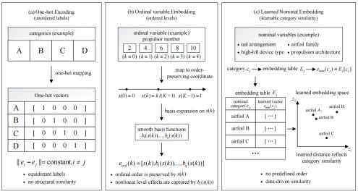

Fig. 2 Structured representation of ordinal and nominal configuration variables

For ordinal variables, this work adopts an order-preserving low-dimensional con- tinuous representation. For an ordinal variable with value index k ∈ {0,..., K __ 1} , the normalized order-preserving coordinate is defined as:
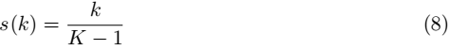
This coordinate maps discrete levels onto the interval [0, 1], allowing differences between levels to enter the subsequent surrogate model as continuous distances. Unlike one-hot encoding, the order-preserving coordinate explicitly retains the relative order among categories, keeping adjacent levels close in the embedding space while assigning larger distances to levels that are farther apart. This treatment has a clear engineer- ing interpretation in aircraft conceptual design. For example, changes in the number of propulsors or energy modules usually correspond to gradual variations in scale, mass, layout complexity, or system redundancy, rather than to mutually unrelated categorical transitions.
To enhance the ability of ordinal variables to represent nonlinear level effects, smooth basis functions can be introduced on top of the order-preserving coordinate:
eord (k) = [s(k), b1 (s(k)),..., bq (s(k))] (9)
where bl (•) denotes a smooth basis function. This extension does not alter the basic ordering constraint of the ordinal variable, but allows the surrogate model to cap- ture possible nonlinear response differences among levels. For example, increasing the number of propulsors from 2 to 4 and from 8 to 10 may not have the same effect on mission energy consumption, although both changes should still preserve the engi- neering order implied by an increasing propulsor count. In this way, ordinal variables

8

retain their ranked structure while allowing the surrogate to model nonlinear level effects, avoiding the treatment of ordinal values as independent unordered labels.
For nominal variables, this work uses learnable embedding layers to represent latent relationships among categories. Let the category value of the j-th nominal variable be
cj ∈ {1,..., Cj }. Its embedding is defined as:
enom (cj ) = Ej [cj] ∈ 耽dj (10)
where Ej ∈ 耽Cj ×dj is a learnable embedding matrix and dj is the embedding dimension. Since nominal variables have no natural ordering, no predefined distance relationship is imposed among categories. Instead, their latent similarities are learned in a data-driven manner. In aircraft configuration design, different airfoil families, propulsion architectures, or tail arrangements are unordered categories, but they may exhibit similar responses in terms of aerodynamic efficiency, structural penalty, propulsion integration, or mission energy consumption.
A learnable embedding vector is assigned to each nominal category and updated jointly through the VAE reconstruction loss and the performance-aware loss. The reconstruction loss encourages the embeddings to preserve the basic semantics of cat- egories within discrete configuration combinations, enabling the encoder to retain the original configuration information. The performance-aware loss further reorganizes the embedding space according to objective-function responses, so that categories with similar configuration-combination relationships or similar performance responses tend to have closer representations. As a result, nominal-variable embeddings not only sup- port discrete-configuration reconstruction, but also directly participate in learning objective-function correlations.
The embeddings of multiple discrete variables are then jointly fed into the encoder and mapped to a configuration latent variable z . In the VAE-GP joint surrogate, the GP kernel measures the design distance jointly determined by the continuous variables and the configuration latent variable. Thus, the effect of categorical vari- ables is expressed as configuration similarity in the latent space rather than as label differences in a predefined encoding space. Fig. 3 further summarizes the mapping process from structured embeddings of discrete configuration variables to the VAE- GP joint surrogate space, through which discrete-configuration similarity enters the GP kernel distance metric via the latent variable z. In this way, nominal variables participate in surrogate modeling and Bayesian optimization through learnable con- figuration similarity, enabling cross-configuration information transfer under limited samples.

2.2.2 Conditional Masks and Multi-Head Decoding Structure
Hierarchical dependencies make the validity of lower-level variables configuration- dependent. Propulsion architecture, for example, can activate or deactivate propulsor count, placement, and sizing variables, while wingtip geometry is irrelevant when no wingtip device is selected. Including inactive variables in encoding, reconstruction, or sampling introduces physically meaningless variation and can direct acquisition toward invalid designs. LSBO therefore applies conditional masks in the structured

9

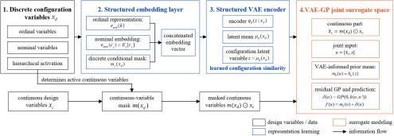

Fig. 3 Embedding flow from discrete configuration variables to the VAE-GP surrogate space

VAE and combines multi-head reconstruction with performance prediction to preserve configuration validity, recoverability, and optimization relevance.
For the j-th discrete variable, define the conditional mask mj (xd) ∈ {0, 1}. Here, mj = 1 indicates that the variable is active under the current configuration, whereas mj = 0 indicates that it is inactive. The masked embedding is defined as:
= mj (xd)ej (11)
where ej denotes the ordinal or nominal embedding of the j-th discrete variable. The valid embeddings are then concatenated and passed to the encoder to gener- ate the parameters of the latent-variable distribution. In this way, the latent space receives only physically meaningful discrete information under the current configura- tion, preventing inactive variables from perturbing the configuration representation. The conditional mask is also applied to the decoding reconstruction loss.
For variables deactivated by upper-level configurations, the corresponding cross- entropy reconstruction terms are not included. The reconstruction loss for discrete variables is expressed as:

cross-entropy loss This treatment allows the VAE to learn only the combination relationships among active configuration variables, without forcing the model to reconstruct categories that have no physical meaning under the current configura- tion. For continuous variables, analogous conditional relationships are introduced into subsequent surrogate modeling through continuous-input masks, so that deactivated continuous variables do not participate in the GP joint input or are fixed to valid values during the repair stage.
where J is the number 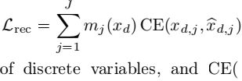· ) denotes the categor(ica
The structured VAE consists of an encoder, a latent-variable layer, a multi-head decoder, and a performance-prediction head. The encoder maps the conditionally masked discrete embeddings to the latent-distribution parameters µ and log σ2 , and

10

the configuration latent variable ≈ is obtained through reparameterization. The multi- head decoder assigns an independent classification branch to each discrete variable and outputs the corresponding category probabilities. Compared with a single decod- ing head, the multi-head structure preserves the value space and physical meaning of each discrete variable, avoiding the mixing of heterogeneous configuration variables such as airfoil family, propulsion architecture, and tail arrangement into a single clas- sification space. It also facilitates integration with conditional masks, allowing the reconstruction loss of inactive variables to be skipped locally.
The performance-prediction head hψ (≈) takes the latent variable ≈ as input and outputs a normalized prediction of the objective function. This prediction head does not replace true multidisciplinary analysis (MDA) evaluations or the GP surrogate; instead, it injects objective-function information into the latent space during VAE training. For aircraft conceptual design, it is not sufficient to ensure that discrete configurations can be encoded and decoded. More importantly, the distance relation- ships in the latent space should support subsequent surrogate modeling and sampling decisions. Therefore, the performance-prediction head guides the latent variables to be reorganized according to objective responses such as mission energy consumption, aerodynamic efficiency, or overall performance, so that configurations with similar performance obtain closer latent representations.
The multi-head decoder and the performance-prediction head constrain two com- plementary properties of the latent space. The reconstruction loss requires the latent variables to retain recoverable information about the original discrete configura- tions, enabling the decoder to reconstruct discrete designs that satisfy the variable domains and hierarchical rules. The performance loss requires the latent space to reflect objective-function responses, making it easier for configurations with similar performance to share information in the surrogate model. If only the reconstruction term is used, the latent space mainly serves category recovery and may fail to rep- resent performance similarity among configurations. If only the performance term is used, the latent space may weaken the preservation of original configuration infor- mation and hierarchical validity, reducing the stability of mapping latent variables back to valid discrete configurations. Through joint training with conditional masks, multi-head decoding, and performance prediction, this work balances configuration- information preservation with performance-response organization, so that the latent space is simultaneously decodable, physically valid, and optimizable.

2.3 Performance-Aware Latent-Space Training

2.3.1 Multi-Objective Loss Function
In expensive mixed-variable aircraft optimization, latent-space training should not only support discrete-configuration reconstruction, but also meet the requirements of subsequent surrogate modeling and sampling decisions. On the one hand, the latent variables should preserve sufficient configuration information so that discrete choices such as airfoil family, propulsion architecture, and tail arrangement can be decoded reliably. On the other hand, distance relationships in the latent space should, as

11

much as possible, reflect similarities in mission energy consumption or overall perfor- mance responses, so that the smoothness assumption of the GP kernel in this space is more consistent with the true optimization problem. Therefore, this work jointly trains the structured VAE using a multi-objective loss function, allowing the latent space to possess configuration recoverability, sampling feasibility, and performance discriminability.
The training objective of the structured VAE consists of four terms: the discrete reconstruction loss, maximum mean discrepancy (MMD) regularization, performance- prediction loss, and decoding-entropy regularization. It is written as
L = Lrec + βLMMD + γLperf — λHdec (13)
where Lrec is the sum of the cross-entropy losses over the multi-head discrete variables, with inactive variables skipped according to the conditional masks; LMMD regular- izes the aggregated posterior distribution toward the standard normal distribution; Lperf is the mean squared error between the output of the performance-prediction head and the normalized objective value; and Hdec is the entropy of the decoded categorical distributions, used to mitigate premature collapse of the decoder to a small number of categories in the early training stage. The coefficients β,γ, and λ control the weights of distributional regularization, performance supervision, and decoding-entropy regularization, respectively.
The standard VAE training objective typically includes a per-sample Kullback- Leibler (KL) divergence term that constrains the posterior distribution q φ (z|x) of each sample to be close to the prior distribution p(z) [25]. However, recent studies on VAE training dynamics and over-regularization have shown that overly strong latent- distribution constraints may force the posterior to approach the prior too closely, thereby weakening the ability of the latent variables to represent differences among input samples [26, 27]. Therefore, this work does not use the per-sample KL term as the main regularizer. Instead, MMD is adopted to match the aggregated posterior distribution,
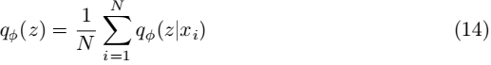
to the standard normal distribution p(z) = N(0, I). Similar ideas of distribution matching and regularization trade-off have been used in recent VAE improvements to alleviate over-regularization and insufficient information representation in the latent space [26, 27]. For the aircraft configuration optimization problem considered here, the number of discrete-configuration samples is limited, and differences among con- figurations are important for optimization. Applying strong pointwise regularization to every sample may compress latent differences among configurations and reduce the ability of the latent space to distinguish configuration categories and their combina- tions. In contrast, MMD constrains the latent-variable distribution at the sample-set level and imposes a milder restriction on individual configuration latent variables, thereby preserving structural differences among configurations while maintaining the ability to sample from the latent space.

12

The performance-prediction loss is a key difference between the proposed method and a standard reconstruction-oriented VAE. A standard VAE mainly learns a recon- structable representation of the input configurations, whereas LSBO further requires the latent space to represent objective-function similarity among configurations. Let the performance-prediction head be hψ (z) and the normalized objective value be y. The loss is defined as
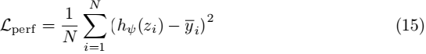
This term encourages neighboring configurations in the latent space to have sim- ilar objective values, thereby giving the distance metric used by the subsequent GP kernel a clearer optimization relevance. For aircraft conceptual design, this means that configurations with similar mission energy consumption, aerodynamic lift and drag characteristics, or propulsion-integration effects can share more information in surro- gate modeling, rather than establishing correlations only according to whether their discrete labels are identical.
From the perspective of metric learning, performance-aware training can be inter- preted as learning a task-dependent distance metric for discrete configurations. Let the latent means of two configurations xda and xdb be za and zb , respectively. Ideally, if the two configurations have similar objective-function responses, 聂za __zb 聂 should be small; if they belong to different performance regions, the latent-space distance should be larger. In this way, the smoothness assumption of a Matérn or radial basis function (RBF) kernel in the latent space becomes more consistent with the true optimization problem.
In expensive optimization problems, performance supervision is obtained from true evaluation samples accumulated progressively during the optimization process. Therefore, LSBO does not require a large amount of high-quality training data at the initial stage. In the early stage, the latent space is mainly shaped by struc- tural encoding. As more samples become available in the middle and later stages, the performance-prediction head continuously adjusts the latent-space organiza- tion, enabling BO to gradually shift from broad structural exploration toward the exploitation of high-quality configuration clusters.

2.3.2 Staged Annealing and Incremental Retraining
During staged training, the VAE first emphasizes discrete-configuration reconstruc- tion, allowing the latent space to establish a stable configuration mapping and ensuring that different variable types and hierarchical dependencies are encoded reliably. In the early stage of BO, the number of true evaluation samples is limited, and the samples usually do not sufficiently cover different configuration regions. If the performance- prediction loss is assigned a large weight too early, the latent space may be dominated by incidental performance differences in a small number of early samples and pre- maturely collapse toward local performance trends. Therefore, this work adopts a reconstruction-dominated objective in the early training stage and gradually increases the weight of the performance-prediction loss after the discrete-configuration map- ping becomes sufficiently stable. This strategy allows the latent space to gradually

13

transition from structure preservation to performance alignment while maintaining configuration recoverability.
As BO continuously obtains new samples, the VAE is incrementally retrained at fixed intervals. After a prescribed number of iterations, the newly evaluated samples are added to the training set, together with a certain number of randomly generated discrete configurations to maintain decoder coverage. The learning rate used for incre- mental retraining is lower than that used in the initial training stage, with the aim of adjusting the performance organization of the latent space rather than overwriting the learned structural representation.
This staged training and incremental updating mechanism is consistent with the sample-accumulation process of expensive BO. When early samples are scarce, struc- tural priors are first used to maintain the ability to sample from the latent space. As true performance data become available in the middle stage, the latent space is progressively calibrated. In the later stage, a clearer local geometry is formed around high-quality configurations. After each retraining step, historical discrete configura- tions are re-encoded, the joint input space is renormalized, and the GP surrogate is updated accordingly. This ensures that the VAE, GP, and acquisition function always use the same version of the latent-space coordinates. Fig. 4 summarizes the staged annealing and incremental retraining process: VAE training is dominated by configu- ration reconstruction in the early stage, the weight of the performance-prediction loss is then gradually increased, and the latent space and GP surrogate are periodically updated with new samples during BO iterations.

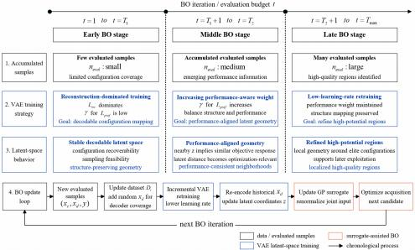

Fig. 4 Staged annealing and incremental retraining strategy for the performance-aware VAE

14

2.4 VAE-GP Joint Surrogate Model

2.4.1 Joint Input Space and Residual Modeling
After performance-aware training, the configuration latent variable and masked con- tinuous variables are combined in a joint BO input. Continuous variables describe local geometry and sizing, whereas discrete variables define the configuration context in which those parameters act. The surrogate must therefore resolve local contin- uous responses while transferring information among related configurations. LSBO achieves this with a VAE-GP surrogate whose kernel measures similarity in both the continuous and configuration-latent subspaces.
At iteration t, let the evaluated sample set be
Dt = {(xc,i , xd,i , yi)}1 (16)
where xc,i is the continuous design-variable vector of the i-th sample, xd,i is the corresponding discrete design-variable vector, and yi is the objective value obtained from the true evaluation. For each discrete design-variable vector xd,i , the structured VAE encoder outputs the mean of its latent variable:
zi = µϕ (xd,i) (17)
After applying the conditional mask to the continuous design variables, the masked continuous vector is concatenated with the discrete-configuration latent variable to form the joint surrogate input:
ui = [m(xd,i) ⊙ xc,i , zi] (18)
where m(xd,i) is the conditional mask for continuous variables determined by the discrete configuration. Through this joint input, the GP surrogate no longer models the objective function only in the original continuous-variable space, but learns the response surface in a space jointly formed by continuous variables and configuration latent variables.
To introduce the cross-configuration performance information learned by the VAE into the Bayesian optimization surrogate, this work constructs a VAE-GP joint surro- gate with a data-driven prior mean. The VAE performance-prediction head provides a prior estimate of the objective function from the discrete-configuration latent variable:
m0 (ui ) = hψ (zi) (19)
where hψ (zi) is the output of the VAE performance-prediction head. The GP does not directly fit the original objective value yi , but instead models the residual between the true evaluation and this prior estimate:
ri = yi − m0 (ui) (20)
The residual represents the local discrepancy not explained by the VAE, mainly arising from continuous geometric variables, local configuration differences, and limited-sample errors. This residual is assumed to follow a zero-mean GP:
δ (u) ∼ GP(0, k(u, u′)) (21)

15

The objective function can therefore be written as
f (u) = m0 (u) + δ(u) (22)
In prediction, if the residual GP gives predictive mean µGP (u) and standard
deviation σGP (u) at a joint input u, the predictive mean of the objective is
and the corresponding predictie(us)tandard(ud) eviation(ui)s (23)
σ (u) = σGP (u) (24)
pre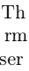iirtbcoiliz(i.iorsu, ncertainty-
The joint construction retains GP uncertainty while using the VAE prior mean to represent cross-configuration performance trends. The residual GP therefore focuses on local variation associated with continuous geometry, configuration-specific effects, and finite-sample error. Under limited evaluations, this division helps identify promising configuration clusters without replacing uncertainty-based exploration.

2.4.2 Acquisition Function and Joint Continuous-Latent Optimization
After the surrogate model is built, LSBO uses expected improvement (EI) as the acquisition function. For a minimization problem, the objective can be negated and converted into a maximization problem, or the improvement can be computed directly based on the current best objective value. EI balances the predictive mean and pre- dictive standard deviation: it favors regions with promising predicted performance while retaining the ability to explore uncertain regions. It is therefore one of the most widely used acquisition functions in Bayesian optimization [10].
Unlike direct enumeration in the original discrete space, LSBO first optimizes the acquisition function in the joint continuous space composed of continuous variables and latent variables, yielding a candidate continuous variable xc ∗ and a candidate latent point z ∗ . This continuous optimization process exploits the smooth GP posterior in the joint space and avoids optimizing the acquisition function directly in the original discrete space, whose combinatorial size can grow rapidly. The candidate latent point z ∗ is then decoded by the VAE to generate discrete candidate configurations.
This latent-first optimization strategy, in which the latent variables are opti- mized before being decoded into discrete configurations, transforms a complex discrete search into a continuous optimization problem that is more compatible with GP- based acquisition optimization. However, the mapping from latent variables to discrete configurations is not one-to-one, and a single decoding step may produce repeated configurations or configurations that violate hierarchical rules. Therefore, the decoded

16

result of ≈ ∗ is not accepted directly. Instead, ≈ ∗ is used as a candidate point for con- structing a discrete candidate pool, which is further screened together with historically high-performing configurations and randomly perturbed configurations.

2.5 Decoupled Discrete Candidate Selection and Local Refinement

2.5.1 Discrete Candidate Pool Generation and Composite Scoring
Because VAE decoding may generate repeated configurations or become overly con- centrated on the currently best categories, this work adopts a candidate-pool strategy for discrete-configuration selection. The candidate pool consists of three types of configurations: the deterministic decoding result of the candidate latent point ≈ ∗ , stochastic decoding results controlled by an annealing temperature, and historically high-performing configurations together with their local variants. The temperature is gradually reduced during the BO process, encouraging diverse exploration in the early stage and strengthening exploitation of high-quality regions in the later stage.
Each discrete candidate d in the pool is combined with the current continuous candidate and passed to the VAE-GP surrogate to obtain the predictive mean and uncertainty. Candidate scoring is used to select the discrete configuration for the next true evaluation from a limited number of discrete candidates. Its role is to convert the latent-space candidate point obtained from EI optimization into a hierarchical- rule-compliant and evaluation-worthy discrete design, and to further compare the exploitation potential of different candidates in the discrete space. The compos- ite score considers surrogate prediction, historical best quality, visit counts, recent repetition penalties, and historical feasibility rates. When the problem contains inter- pretable categorical similarity structures, proximity to historically high-performing configurations in the embedding space can also be incorporated. This design prevents discrete-configuration selection from relying solely on a single decoding result and instead balances surrogate information, historical evidence, and diversity constraints.
The composite score is summarized as
Q(d) = Qmodel (d) + Qhist (d) + Qdiv (d) + Qfeas (d) (25)
where Qmodel is derived from the predicted improvement potential of the current con- tinuous candidate and discrete configuration evaluated by the VAE-GP surrogate; Qhist uses the best historical performance of the same or similar discrete configura- tions; Qdiv penalizes configurations that have been visited too frequently in recent iterations, preventing premature concentration on local configurations; and Qfeas increases confidence in configurations with high historical feasibility rates. Through this scoring scheme, LSBO jointly incorporates surrogate-model recommendations, historical evaluation evidence, and engineering feasibility into discrete-configuration selection.

17

2.5.2 Local Continuous Refinement and Algorithmic Workflow
Once a discrete configuration exhibits stable potential during the BO stage, frequently switching to other discrete configurations may no longer be optimal. LSBO there- fore introduces a late-stage local refinement mechanism. Several high-quality discrete configurations are selected from the historical samples, and local perturbation and repair are applied to the continuous variables while keeping the discrete configura- tion fixed, so as to exploit the remaining continuous performance potential within the configuration.
The algorithmic workflow can be summarized as follows. Step 1 generates the ini- tial samples and performs the corresponding true function evaluations. Step 2 trains the structured VAE and obtains the latent representations. Step 3 builds a GP resid- ual model with a VAE-informed prior mean in the joint input space. Step 4 optimizes EI to obtain the continuous variables and the candidate latent point. Step 5 con- structs the discrete candidate pool through VAE decoding, local variants of historically high-performing configurations, and random supplementation. Step 6 selects the next discrete configuration using the composite score and repairs the continuous variables. Step 7 performs the true evaluation and updates the dataset. Step 8 periodically retrains the VAE and GP. Step 9 performs local refinement for high-quality discrete configurations in the later stage.

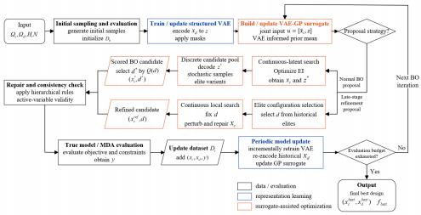

Fig. 5 Sequential optimization workflow of the proposed LSBO method

Fig. 5 summarizes the sequential loop: current evaluations update the struc- tured VAE and VAE-GP surrogate; joint acquisition optimization proposes a latent-continuous candidate; candidate-pool scoring, repair, and late-stage refinement determine the next valid evaluation. The resulting observation is then returned to the dataset.

18

LSBO couples three methodological functions: structure-aware latent encoding of hierarchical discrete variables, performance-aware surrogate modeling in the joint latent-continuous space, and budget allocation through candidate screening and local refinement. Together, these functions transfer information across related configu- rations while directing expensive evaluations toward promising configuration and continuous-parameter neighborhoods.

3 Numerical Experiments and Validation
LSBO is evaluated at three levels of increasing engineering fidelity. Controllable bench- mark functions isolate nominal, ordinal, and conditionally active structures under reproducible conditions. A simplified analytical electric-aircraft model then intro- duces physically interpretable coupling among configuration, geometry, propulsion, and mission energy. Finally, a complete mission-level MDA of the NASA X-57 Maxwell assesses the method in an expensive aircraft conceptual-design workflow.

3.1 Classical Mixed-Variable Benchmark Functions

3.1.1 Test Function Construction and Mathematical Motivation
Three mixed-variable benchmarks are constructed from the classical Ellipsoid, Hart- mann, and Ackley functions [28–30]. The Ellipsoid function represents a smooth anisotropic landscape, the Hartmann function provides low-dimensional multimodal- ity, and the Ackley function combines a broad basin with many local optima. Each parent function is extended with related configuration families, ordinal levels, configuration-dependent activation, and feasibility penalties. The resulting prob- lems isolate the structures that motivate LSBO while remaining inexpensive and reproducible.
The basic forms of the three classical parent functions are written as
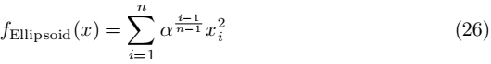

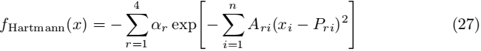

fAckley = __aexp 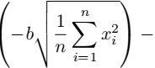 exp 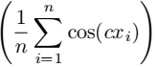 + a + exp (28)
where x = (x1 ,..., xn) is the continuous input; α controls Ellipsoid anisotropy; αr , Ari , and Pri are the standard Hartmann weights, scale coefficients, and centers; and a, b, and c are the Ackley parameters.

19

Based on these parent functions, the mixed-variable benchmarks are expressed in the unified form
F (xc , xd ) = fbase (T(xc , xd),θ (xd )) + P(xc , xd) (29)
where xc is the continuous design-variable vector, xd is the discrete design-variable vec- tor, T (·) denotes translation, rotation, scaling, or dimensional activation relationships jointly determined by nominal categories, ordinal variables, and conditionally active variables, θ(xd) denotes function parameters determined by the discrete configuration, and P (xc , xd) is the feasibility penalty term.
In the clustered Ellipsoid function, nominal families are introduced into the Ellip- soid function, with every two families grouped into a similar category cluster. Different clusters correspond to different continuous optimum centers, rotational coupling rela- tionships, and scaling coefficients. The ordinal variable adjusts the scaling coefficients in the Ellipsoid function, thereby changing the steepness of the response surface at different levels, while the conditionally active variable controls whether some contin- uous dimensions participate in the objective function. The overall response surface of this function is relatively smooth, but transferable similarity structures exist among different nominal categories. It is therefore mainly used to evaluate the algorithm’s cross-configuration knowledge transfer capability in a smooth mixed-variable space.
The hierarchical Hartmann function extends the six-dimensional Hartmann func- tion by introducing a nominal material variable, an ordinal variable, and a condition- ally active variable. The nominal material variable changes the locations and weights of local peaks, the ordinal variable adjusts the response intensity, and the conditionally active variable controls whether the last two continuous dimensions are active. This function simultaneously includes multimodal responses, hierarchical variable activa- tion, and feasibility penalties, and is mainly used to evaluate the search stability of the algorithm in a complex hierarchical mixed-variable space.
The clustered Ackley function extends the Ackley function by introducing nominal- family clusters and ordered roughness options. Different nominal families share similar but not identical continuous optimum centers and distortion directions. The roughness option changes the perturbation strength of local valleys, while the conditionally active variable controls whether some continuous dimensions participate in the objective function. This function exhibits stronger rugged multimodal characteristics and is mainly used to evaluate whether the algorithm can identify high-quality configuration clusters and concentrate sampling on promising regions in the later stage.

3.1.2 Compared Methods, Evaluation Budget, and Performance Metrics
The methods compared with LSBO include Random Search, Mixed-GA, One-hot GP-BO, and sequential model-based algorithm configuration (SMAC)-style RF-BO. Random Search serves as a model-free baseline and reflects the lower-bound per- formance of random sampling. Mixed-GA represents an evolutionary optimization method that can directly handle mixed variables. One-hot GP-BO represents a com- mon strategy in which discrete variables are expanded using one-hot encoding and

20

then modeled with a GP surrogate. SMAC-style RF-BO represents a strong baseline that handles categorical variables using a random-forest surrogate. Together, these methods form a comparison spectrum from model-free search to surrogate-assisted search.
All methods use the same budget of 120 true function evaluations and the same set of random seeds. Each problem is repeated over 50 random seeds to reduce the influence of randomness in individual optimization trajectories. The evaluation metrics include final regret, area under the convergence curve (AUC) regret, valid rate, and top-10 mean. Final regret measures the difference between the best-so-far value at the end of the budget and the reference optimum, and is used to evaluate final solution quality. AUC regret measures the cumulative area under the regret curve over the optimization process, and is used to evaluate sampling efficiency. Valid rate measures the proportion of feasible samples generated by an algorithm. Top-10 mean measures the average quality of the best 10% samples, reducing the risk of drawing conclusions from a single accidental optimum.

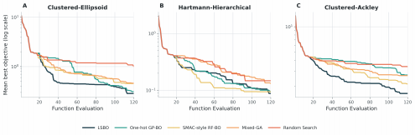

Fig. 6 Convergence curves on the mixed-variable benchmark functions

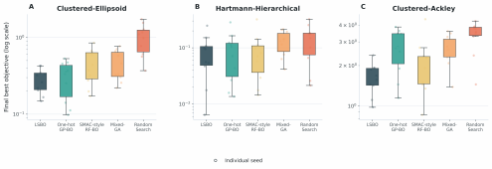

Fig. 7 Final regret distributions on the mixed-variable benchmark functions. Boxes show the interquartile range and median, and points denote individual random-seed outcomes.

21

3.1.3 Result Analysis
Figs. 6 and 7 compare convergence and final-regret distributions, respectively. LSBO obtains the lowest mean final regret on all three problems, reducing it relative to the second-best method by 31.4% on clustered Ackley, 12.3% on clustered Ellipsoid, and 11.0% on hierarchical Hartmann. Figs. 8–10 examine whether these mean gains are also reflected in pairwise reliability and target-reaching efficiency.

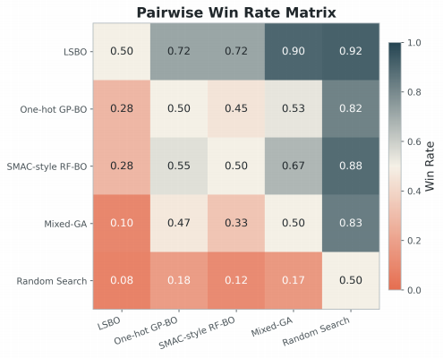

Fig. 8 Pairwise win-rate matrix on the mixed-variable benchmark functions

Each entry in Fig. 8 is the fraction of matched-seed runs in which the row method achieves lower final regret than the column method. Across the three problems, LSBO attains average win rates of 92% against Random Search, 90% against Mixed-GA, and 72% against both One-hot GP-BO and SMAC-style RF-BO. This consistency is compatible with the latent surrogate sharing observations across related configura- tions: each seed need not rediscover every categorical combination independently, so the ranking of promising regions is less sensitive to its early search path.
Fig. 9 reports the ECDF of the evaluations required to reach a problem-specific relative regret target. A curve closer to the upper-left indicates that a larger fraction

22

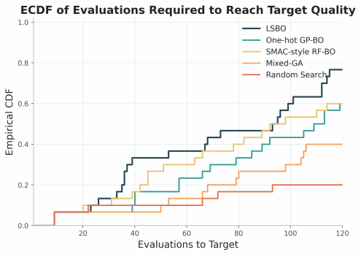

Fig. 9 Empirical cumulative distribution function (ECDF) of evaluations required to reach the target quality on the benchmark functions
of runs reaches the target with fewer evaluations. LSBO’s earlier rise shows that its final-regret advantage is accompanied by greater target-reaching efficiency. In model terms, structured distances allow a successful evaluation in one configuration to alter the GP posterior and acquisition values of related configurations, whereas one-hot or model-free search requires more direct observations to obtain the same directional evidence.

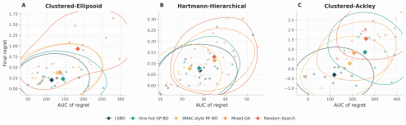

Fig. 10 Quality-efficiency trade-of across benchmark functions

23

Fig. 10combines final regret with the evaluation count required to reach the target. LSBO lies closest to the low-regret, low-cost region, showing that the improvement is not obtained by delaying exploitation until the end of the budget.
On clustered Ackley, LSBO obtains an AUC regret of 118.19, 37.1% below SMAC- style RF-BO (187.96), and a top-10 mean of 2.475, 18.2% below Mixed-GA (3.024). This is the case with the largest final-regret gain. Its repeated local valleys make direct continuous search sensitive to the selected category; grouping related categories in the latent space lets the GP pool evidence about basin quality before refining individual valleys.
On clustered Ellipsoid, LSBO achieves an AUC regret of 114.08, 12.2% below SMAC-style RF-BO, and a top-10 mean of 0.485, 22.3% below Mixed-GA. Because each within-configuration surface is smooth, the main difficulty is estimating transla- tions, rotations, and scales across categorical clusters. Learned embeddings preserve these partial similarities, giving the GP a more informative distance than equidistant one-hot categories.
On hierarchical Hartmann, LSBO reaches a mean final regret of 0.0688 and a top- 10 mean of 0.112, 11.0% and 32.8% below SMAC-style RF-BO, respectively. SMAC- style RF-BO nevertheless achieves lower AUC regret (23.63 versus 28.29). Its axis- aligned partitions can represent abrupt activation changes with little initial fitting, whereas LSBO requires enough observations to learn a useful latent geometry. This explains the tree model’s early advantage and LSBO’s better final exploitation, rather than implying uniform dominance by either surrogate.
The benchmark evidence supports a specific scope: LSBO is most useful when configurations share performance structure, inactive variables would otherwise distort distance, and sufficient sequential data are available to learn the latent geometry. These conditions also arise when airfoil, propulsion, tail, wingtip, and high-lift choices alter the valid continuous domain in aircraft conceptual design. The next case tests these mechanisms with coupled engineering responses.

3.2 Simplified Analytical Electric-Aircraft Model

3.2.1 Analytical Model Construction
Before the complete mission-level X-57 analysis, a simplified analytical electric-aircraft model provides a reproducible engineering test with interpretable couplings. It com- bines cruise efficiency, low-speed field performance, propulsion layout, high-lift devices, and wingtip devices in a mission-weighted equivalent-energy objective that balances cruise efficiency against takeoff and low-speed requirements.
The analytical model contains 10 continuous variables: aspect ratio, wing area, quarter-chord sweep angle, thickness ratio, taper ratio, root twist, propeller diame- ter ratio, propeller spanwise spacing, flap chord ratio, and winglet area ratio. It also includes five discrete variables: the number of propellers, propulsion layout, airfoil fam- ily, high-lift device type, and the presence or absence of wingtip devices. Among them, the number of propellers is treated as an ordinal variable, while propulsion layout, airfoil family, high-lift device type, and wingtip-device switch are treated as nominal

24

variables. Table 1 summarizes the variables and their domains. The National Advi- sory Committee for Aeronautics (NACA) designation is used for the corresponding airfoil families.
Table 1 Design variables of the simplified electric aircraft analytical model

Type | Variable group | Design variable | Domain
Continuous  Continuous | Wing geometry  Wing geometry | Aspect ratio  Wing area (m2 ) | [7.5, 14.5]  [10.2, 17.8]
Continuous | Wing geometry | Quarter-chord sweep (deg) | [0, 12]
Continuous | Wing geometry | Thickness-to-chord ratio | [0.09, 0.16]
Continuous | Wing geometry | Taper ratio | [0.35, 0.90]
Continuous | Wing geometry | Root twist angle (deg) | [-1, 4]
Continuous | Propulsion system | Propeller diameter ratio | [0.80, 1.25]
Continuous | Propulsion system | Propeller spanwise spacing | [0.30, 0.90]
Continuous | High-lift device | Flap chord ratio | [0.15, 0.32]
Continuous | Winglet | Winglet area fraction | [0.03, 0.12]
Ordinal | Propulsion system | Number of propellers | {2, 4, 6, 8}
Nominal | Propulsion system | Propulsion layout | {wingtip,  distributed}
Nominal | Wing  aerodynamics | Airfoil family | {NACA 63-412,  NACA 65-215,  NACA 4412,  NACA 23012, Clark-Y}
Nominal | High-lift device | High-lift device type | {none, plain flap, slotted flap}
Binary  nominal | Winglet | Winglet installation | {off, on}

Discrete choices condition the validity of several continuous variables. The propulsion layout governs spanwise-arrangement variables, the high-lift-device type activates flap geometry, and the wingtip-device switch activates wingtip geometry. The model therefore represents a hierarchical mixed-variable problem rather than an unconstrained concatenation of continuous and discrete coordinates.
The disciplinary calculations use conceptual-design relations for lift equilibrium, parabolic drag, induced drag, propulsion power, and low-speed performance [31–33]. Cruise energy follows from the required lift coefficient, drag polar, and propeller–motor efficiency; field energy depends on maximum lift, blown-lift augmentation, takeoff distance, and climb power. Airfoil choice modifies zero-lift drag, maximum lift, and structural weight; propulsion layout modifies blown lift and propulsive efficiency; and high-lift devices trade cruise drag and weight against low-speed performance. The model thus retains the principal aerodynamic–propulsive–weight couplings at low cost without replacing higher-fidelity analysis.

25

Configuration-dependent response terms assign different continuous optima to clusters defined by airfoil, propulsion, and high-lift-device compatibility. These terms preserve interpretable configuration couplings while introducing the multimodality needed to test transfer across related discrete designs.
The mission-weighted equivalent energy is defined as
Eeq (xc , xd ) = 0.62Ecr (xc , xd ) + 0.38Efld (xc , xd ) + R(xc , xd) (30)
where Ecr and Efld are the cruise and field-equivalent energy terms, respectively, and R is the configuration-dependent structured response term. The optimization problem is
min Eeq (xc , xd) (31)
xc,xd
s.t. xc ∈ Ωc (xd), xd ∈ Ωd , gj (xc , xd) ≤ 0, j = 1, . . . , 5 (32)
where the five gj terms impose limits on field stall speed, state-of-charge margin, field climb-power margin, takeoff distance, and wing loading. Constraint violations are returned to each optimizer through the same continuous penalty mapping.

3.2.2 Constraints, Compared Methods, and Experimental Settings
All methods use the same constraint limits and penalty mapping defined above, so their objective values and valid rates are directly comparable.
This case uses the same five methods as in Section 3.1 for comparison: LSBO, Ran- dom Search, Mixed-GA, One-hot GP-BO, and SMAC-style RF-BO. Each method is repeated over 20 random seeds, with an evaluation budget of 120 true analytical-model calls. All methods use the same initial sampling control variables, so that performance differences mainly arise from subsequent surrogate modeling and sampling strate- gies. The evaluation metrics include the final best mission-weighted equivalent energy consumption, final regret, AUC regret, valid rate, and top-10 mean.
Figs. 11 and 12 show convergence and final-value distributions for the analyti- cal aircraft problem. Across 20 seeds, LSBO obtains the lowest mean final regret of 523.22 Wh, 39.9% below SMAC-style RF-BO (870.26 Wh). Its mean final best value is 19978.20 Wh, compared with 20325.23 Wh for SMAC-style RF-BO, and is 4.10%, 3.94%, and 10.43% below One-hot GP-BO, Mixed-GA, and Random Search, respectively.
LSBO is not uniformly best early in the search because the initial data are insuf- ficient to align latent geometry with energy response. With additional evaluations, performance-aware retraining increases kernel correlation among configurations with similar energy, while conditional masks prevent inactive flap, wingtip, or propulsion variables from affecting GP length scales. The posterior can then distinguish promis- ing configuration families with fewer direct samples. Late-stage refinement fixes the selected discrete design and searches only its active continuous variables, explaining the stronger middle- and late-stage decrease in Fig. 11 and the lower final distribution in Fig. 12.
Figs. 13–15 examine matched-seed win rates, evaluations to a relative energy target, and sample organization, respectively.

26

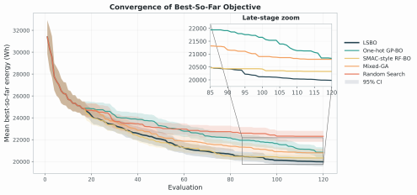

Fig. 11 Convergence of best-so-far energy on the simplified electric aircraft problem

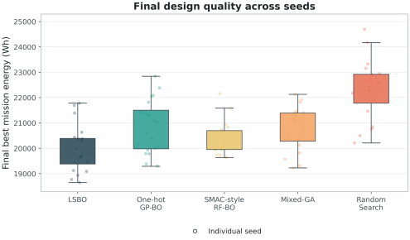

Fig. 12 Distribution of final best-so-far energy across random seeds. Boxes show the interquartile range and median, and points denote individual random-seed outcomes.

27

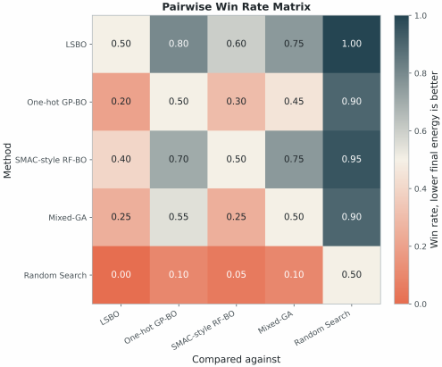

Fig. 13 Pairwise win-rate matrix on the simplified electric aircraft problem
Each entry in Fig. 13 is the fraction of matched-seed runs in which the row method obtains lower final energy than the column method. LSBO attains win rates of 100%, 75%, 80%, and 60% against Random Search, Mixed-GA, One-hot GP-BO, and SMAC-style RF-BO, respectively, showing a repeatable advantage rather than depen- dence on one favorable seed. In a one-hot GP, distinct categories are equidistant and cross-category covariance is limited; in LSBO, graded latent distances allow an infor- mative observation to update related configurations. Masking inactive coordinates also prevents seed-dependent values of irrelevant variables from perturbing covariance estimation. These effects reduce sensitivity to early trajectory differences. The smaller 60% win rate against SMAC-style RF-BO shows that tree-based partitioning remains competitive on this problem.
Fig. 14 shows the ECDF results for the number of evaluations required by each method to reach the relative energy target. This target is defined using the 80th percentile of the final solution quality achieved by LSBO, so the curves describe the probability that an algorithm reaches a relatively good design level within a given evaluation budget. A curve closer to the upper-left region indicates that more random

28

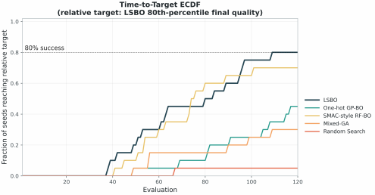

Fig. 14 ECDF of evaluations required to reach the relative energy target

seeds reach the target energy level with fewer evaluations. The results show that after 60 evaluations, LSBO reaches a success rate of 30%, tied with SMAC-style RF- BO for the highest value, and higher than One-hot GP-BO (5%), Mixed-GA (15%), and Random Search (0%). Under the total budget of 120 evaluations, LSBO achieves a final success rate of 80%, exceeding SMAC-style RF-BO (70%), One-hot GP-BO (45%), Mixed-GA (30%), and Random Search (5%). These results indicate that LSBO can not only enter low-energy design regions relatively early, but also maintain a higher target-reaching reliability at the end of the budget. The separation becomes clearer after initial sampling because the periodically updated encoder and GP can then reuse observations across related configurations. Before sufficient observations are available, this learned covariance offers little advantage; afterward, it reduces the direct evaluations needed to identify promising regions.

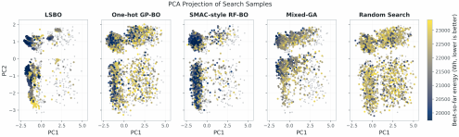

Fig. 15 Principal component analysis (PCA) projection of search samples on the simplified electric aircraft problem

29

Fig. 15 projects all mixed-variable samples onto a common two-dimensional PCA plane. For each method, a one-standard-deviation covariance ellipse is fitted to the top 10% lowest-energy samples. The LSBO ellipse area is 0.276, 74.8% below SMAC-style RF-BO (1.096) and 92.6% below One-hot GP-BO (3.720). Although a two-dimensional projection is only a diagnostic of the full search space, the concentration agrees with the surrogate mechanism. Performance-aware latent distances raise covariance within low-energy configuration families, so EI repeatedly samples their active continuous neighborhoods. One-hot encoding cannot express partial category similarity, produc- ing more dispersed high-quality samples; random-forest leaves define broader piecewise regions, which explains the intermediate concentration of SMAC-style RF-BO.
Across different metrics, the advantage of LSBO on the simplified analytical electric-aircraft model is mainly reflected in final solution quality and high-quality sample discovery. The top-10 mean of LSBO is 20219.42 Wh, which is 3.85% lower than that of the second-best SMAC-style RF-BO (21029.81 Wh). This indicates that LSBO does not rely only on a single accidental optimum, but continuously generates lower-energy candidates during the optimization process. In terms of AUC regret, LSBO is 1.60% lower than the second-best SMAC-style RF-BO, indicating that the two methods are relatively close in overall sampling efficiency, while LSBO performs better in final solution quality and the distribution of high-quality samples.
Taken together, the analytical case links the observed gain to three model proper- ties: graded covariance across related configurations, removal of inactive coordinates from the kernel input, and continuous refinement after discrete selection. The evi- dence supports these mechanisms under coupled aircraft responses without implying that LSBO must dominate during the data-sparse initial stage.

3.3 Complete Mission-Level MDA of the NASA X-57 Mod II

3.3.1 Problem Description and Experimental Settings
To evaluate LSBO in a realistic conceptual-design workflow, this section uses the NASA X-57 Mod II as the initial reference design and constructs a mission-level MDA optimization problem coupling geometry, propulsion, energy, and flight seg- ments. The Mod II configuration retains the Tecnam P2006T wing and replaces its two piston engines with electric cruise motors [34]. The design variables modify this reference geometry and permit candidate wingtip and leading-edge distributed- propulsion arrangements. Propulsor count, layout, size, and wing-relative position therefore interact with aerodynamic loading, propulsive efficiency, low-speed perfor- mance, and mission energy. Unlike the analytical case, the objective follows from configuration updates, coupled disciplinary analyses, mission integration, and fea- sibility checks. Fig. 16 shows the Mod II reference aircraft used to initialize the optimization model.
RCAIDE (Research Community Aircraft Interdisciplinary Design Environment) was used as the X-57 design-evaluation platform [35]. RCAIDE is an open-source Python framework for aircraft design, analysis, and optimization and extends the object-oriented, multifidelity approach developed in the Stanford University Aerospace

30


Fig. 16 Initial reference configuration of the NASA X-57 Mod II aircraft

Vehicle Environment (SUAVE) [36]. A common vehicle object integrates the air- frame, propulsors, motors, batteries, and energy network, while mission segments call modular geometry, weight, aerodynamic, propulsion–energy, and performance analyses. This architecture supports repeated aircraft-level evaluations and permits disciplinary methods to be replaced at different fidelity levels. Fig. 17 summarizes the X-57 evaluation workflow, from hierarchical design-variable interpretation and vehi- cle construction to coupled disciplinary analysis, mission evaluation, and feasibility checks.

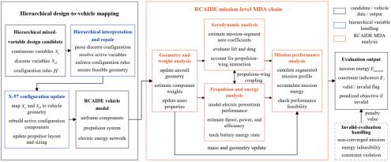

Fig. 17 RCAIDE-based multidisciplinary evaluation workflow for the X-57 hierarchical mixed- variable design problem

In the present analysis chain, geometry and weight modules update the wing, tail, wingtip geometry, and propulsor installation and estimate component masses. Aerodynamic models provide segment-level lift and drag and account for propeller- induced inflow in distributed-propulsion configurations [37, 38]. The electric energy network links the battery, motor, electronic speed controller, and propeller to com- pute thrust, power, and efficiency [39]. Mission analysis then integrates takeoff, climb,

31

cruise, descent, reserve, and return while updating atmospheric state, mass, and bat- tery energy. Total mission energy is the objective; solver non-convergence, insufficient energy, or constraint violation produces an invalid evaluation and a penalty.
The X-57 design space consists of 17 continuous variables and 7 discrete variables. The continuous variables cover wing planform, twist and dihedral, distributed- propulsor layout and sizing, high-lift-device geometry, tail position, and wingtip geometry. The discrete variables include the number of propulsors, propulsion layout, main-wing airfoil, number of propeller blades, tail arrangement, high-lift-device type, and wingtip installation state. Discrete configurations not only change the overall air- craft layout, but also alter the physical meaning or valid domain of some continuous variables. For example, the propulsion layout determines whether variables related to distributed propulsion are independently valid; the high-lift device determines whether flap parameters participate in mission-performance calculations; and the wingtip-device switch determines whether wingtip geometric variables are activated. Therefore, this problem exhibits typical hierarchical mixed-variable characteristics, including configuration selection, conditional variable activation, and propulsion-wing coupling.
The mission profile includes takeoff, initial climb, climb, cruise, descent, reserve, and return segments. If any mission segment fails to converge, or if the energy state or performance constraints are not satisfied, the design is recorded as an invalid sample and assigned a penalized objective value. The valid evaluation rate is also recorded to distinguish whether an algorithm obtains lower energy consumption by identifying high-quality feasible configurations or merely because of different proportions of failed samples. Table 2 lists the corresponding design variables and search domains.

3.3.2 Complete Mission-Level Comparison with Baseline Methods
The X-57 comparison uses the same five methods as in the previous two cases: LSBO, Random Search, Mixed-GA, One-hot GP-BO, and SMAC-style RF-BO. To control randomness, all methods use the same random seed and the same initial sample set. The evaluation budget is set to 100 initial samples and 300 optimization-stage evaluations, giving a unified total budget of 400 evaluations.
Fig. 18 shows the best-so-far mission energy trajectories of the five methods, and Fig. 19 further compares the top-k high-quality samples obtained by each method during optimization. Because complete mission-level MDA evaluations are expensive, this set of results is an engineering comparison under fixed initial samples and random seeds. Its main purpose is to examine differences in search behavior among different mixed-variable handling mechanisms within the same realistic mission-analysis chain. As shown in Fig. 18, under a total budget of 400 evaluations, LSBO obtains the lowest mission energy consumption of 23988.48 Wh. Compared with the second-best SMAC-style RF-BO result of 24241.24 Wh, LSBO reduces the mission energy by 252.76 Wh, corresponding to a 1.04% reduction in total mission energy. The reduc- tions relative to One-hot GP-BO, Mixed-GA, and Random Search are 1.20%, 6.08%, and 9.24%, respectively. Because the complete mission energy includes all mission segments, including cruise, climb, descent, reserve, and return, its absolute scale is large; directly measuring algorithmic differences as percentages of total energy can

32

Table 2 Design variables for the complete mission-level X-57 Maxwell MDA optimization

Type | Variable group | Design variable | Domain
Continuous  Continuous | Wing geometry  Wing geometry | Aspect ratio  Wing area (m2 ) | [6.0, 15.0]  [10.0, 20.0]
Continuous | Wing geometry | Quarter-chord sweep (deg) | [0.0, 5.0]
Continuous | Wing geometry | Thickness-to-chord ratio | [0.06, 0.15]
Continuous | Wing geometry | Taper ratio | [0.20, 1.00]
Continuous | Wing geometry | Root twist | [0, 5]
Continuous | Wing geometry | Tip twist | [-3, 3]
Continuous | Wing geometry | Dihedral | [0, 4]
Continuous | Tail and winglet | Horizontal-tail vertical offset | [0.80, 1.20]
Continuous | Tail and winglet | Winglet area fraction | [0.02, 0.15]
Continuous | Tail and winglet | Winglet cant angle | [30, 90]
Continuous | Distributed  propulsion | Propeller spanwise spacing ratio | [0.30, 0.90]
Continuous | Distributed  propulsion | Propeller diameter ratio | [0.70, 1.30]
Continuous | Wingtip propulsion | Wingtip propeller diameter | [1.40, 2.00]
Continuous | Wingtip propulsion | Wingtip propeller rotational speed | [2300, 3200]
Continuous | High-lift device | Flap chord ratio | [0.15, 0.35]
Continuous | High-lift device | Deflection angle | [5, 30]
Ordinal | Propulsion  architecture | Number of propellers | {2, 4, 6, 8, 10, 12}
Ordinal | Propulsion  architecture | Blade count | {2, 3, 4, 5}
Nominal | Wing aerodynamics | Airfoil family | {NACA 63-412, NACA 4412,  NACA 23012,  Clark-Y, NACA 65-215}
Nominal | Tail and winglet | Tail configuration | {conventional, T-tail}
Binary  nominal | Tail and winglet | Winglet installation | {off, on}
Nominal | Propulsion  architecture | Propulsion layout | {wingtip, leading- edge distributed}
Nominal | High-lift device | High-lift-device type | {none, plain flap, slotted flap}
Total number of design variables 24

33

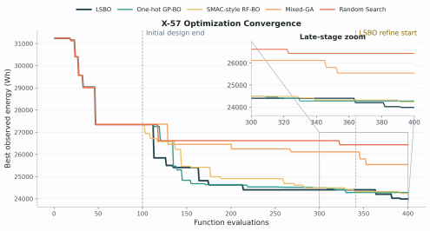

Fig. 18 Best-so-far mission energy histories of five optimization methods on the complete mission- level X-57 MDA problem

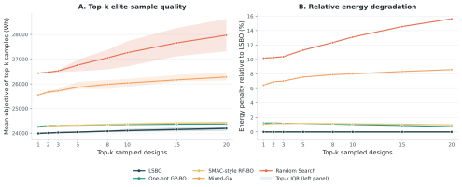

Fig. 19 Elite-set sample quality and relative degradation across X-57 optimization methods

34

therefore compress the apparent relative improvement among optimizers. The final best energy obtained by Random Search under the same budget is therefore used as a model-free search reference to assess the effective gain from surrogate-assisted search. This reference reflects the baseline level reachable on the MDA problem without using a surrogate model or mixed-variable structural information. Taking the energy gap between Random Search and SMAC-style RF-BO as the normalization baseline, the additional improvement of LSBO over SMAC-style RF-BO is 11.54% of that gap.
This gain is consistent with how the surrogate represents mixed-variable distance. One-hot encoding places distinct categories on equally separated coordinate axes regardless of performance similarity, whereas a random forest transfers information only through samples that share its piecewise partitions. LSBO instead evaluates covariance in the joint input u = [m(xd) ⊙ xc , z]. Conditional masking removes inac- tive coordinates, and performance-aware training places configurations with similar mission-energy responses closer in (z), increasing their GP kernel correlation. The VAE-informed mean supplies a configuration-level trend, leaving the residual GP to model local continuous effects and remaining discrepancy. EI can therefore rank can- didate neighborhoods using evidence shared across related configurations rather than relearning each category independently. The ablation results in Section 3.3.4examine these mechanisms separately.
The advantage emerges mainly after sufficient sequential observations have accu- mulated. The best initial value is 27344.98 Wh and falls to 24401.52 Wh after 240 BO evaluations, a 10.76% reduction. The final 60 local-refinement evaluations reach 23988.48 Wh; their 413.04 Wh gain accounts for 12.31% of the total improvement. Early observations are too sparse to determine configuration-level performance geom- etry reliably, so LSBO initially retains broad structural exploration. As the VAE and GP are updated, objective supervision improves the alignment between latent dis- tance and mission-energy response, while the residual GP reduces uncertainty within repeatedly supported neighborhoods. Candidate-pool scoring then favors configura- tions with both predicted improvement and historical evidence. Once a promising discrete design is identified, fixing xd during local refinement removes categorical switching and allocates the remaining evaluations to the smoother continuous sub- problem. This sequence explains why the benefit is larger in the middle and late stages than during initialization.
Fig. 19 measures elite-set sample quality using the mean mission energy of the top-k samples with the lowest mission energy among all valid evaluations for each method. The shaded bands in Fig. 19(a) denote the interquartile range (IQR) of the corresponding elite set. A lower value indicates a lower-energy group of high- quality feasible designs under the limited evaluation budget. LSBO remains the best- performing method over the entire range of k = 1 to 20. For example, at top-10, LSBO achieves a mean mission energy of 24102.32 Wh, which is 1.01% and 1.10% lower than those of One-hot GP-BO and SMAC-style RF-BO, respectively. When k is increased to 20, LSBO still maintains the lowest mean value of 24191.03 Wh, corresponding to reductions of 0.73% and 0.96% relative to One-hot GP-BO and SMAC-style RF-BO, respectively.

35

Because the above top-k relative reductions still use the complete mission energy as the reference scale, the numerical percentages can compress the differences among optimization methods in the high-quality sample region. To further characterize the gain of LSBO in high-quality sample density, Random Search is used as a model- free sampling reference. Taking top-10 as an example, if the top-10 mean energy gap between Random Search and SMAC-style RF-BO is used as the normalization baseline, the additional improvement of LSBO over SMAC-style RF-BO is equivalent to 9.29% of this baseline gap. For top-20, this proportion remains 6.65%. These results indicate that the advantage of LSBO does not arise from a single accidental optimum, but from more stable sample accumulation in high-quality feasible regions. The shared latent covariance and configuration-level prior improve multiple EI-selected candidates within related configuration–geometry neighborhoods, while local refinement increases sample density within the most promising neighborhood.

3.3.3 LSBO Optimization Results
Table 3 lists the best design identified by LSBO in the X-57 comparison experiment. The design adopts a leading-edge distributed-propulsion layout with 10 propulsors, a Clark-Y airfoil, two-bladed propellers, a conventional tail, plain flaps, and winglets.
Its continuous geometric features are characterized by a relatively high aspect ratio and a small sweep angle. The corresponding geometry-level outcome is visualized in Fig. 20 through symmetry-plane composite views of the initial reference configuration and the final LSBO-optimized configuration.

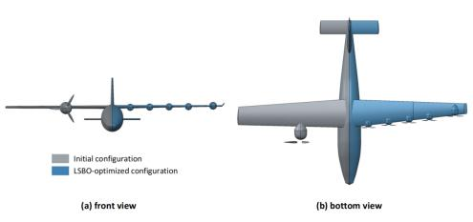

Fig. 20 Symmetry-plane composite comparison of the initial and LSBO-optimized X-57 configura- tions
In the optimization trajectory of this controlled comparison, the discrete config- uration combination corresponding to the final best design appears 32 times within

36

the 400 evaluations, with an average mission energy of 24393.35 Wh. This indi- cates that, as samples accumulate, LSBO can identify configuration neighborhoods with low-energy potential and continuously refine the continuous parameters within these neighborhoods. For hierarchical mixed-variable design problems such as the X- 57, different combinations of propulsion layout, airfoil, high-lift device, and wingtip device can change the valid domains of continuous variables and their performance- response relationships, thereby forming multiple discrete configuration clusters and corresponding local optima in the continuous-variable space. Therefore, the problem exhibits typical multimodal optimization characteristics, where different configuration pathways may lead to different low-energy local optima. The subsequent discrete- configuration clustering analysis further confirms this observation. Fig. 21 shows the energy evolution during the optimization process.

Table 3 Best X-57 design identified by LSBO in the controlled complete mission-level MDA comparison

Type | Variable group | Design variable | Optimal value
Continuous | Wing geometry | Aspect ratio | 11.780
Continuous | Wing geometry | Wing area | 11.596 m2
Continuous | Wing geometry | Quarter-chord sweep | 1.820 deg
Continuous | Wing geometry | Thickness-to-chord ratio | 0.1231
Continuous | Wing geometry | Taper ratio | 0.4817
Continuous | Wing geometry | Root twist | 2.233 deg
Continuous | Wing geometry | Tip twist | -0.907 deg
Continuous | Wing geometry | Dihedral | 1.177 deg
Continuous | Tail and winglet | Winglet area fraction | 0.0999
Continuous | Tail and winglet | Winglet cant angle | 45.662 deg
Continuous | Distributed  propulsion | Propeller spanwise spacing ratio | 0.3932
Continuous | Distributed  propulsion | Propeller diameter ratio | 0.8200
Continuous | High-lift device | Flap chord ratio | 0.1683
Continuous | High-lift device | Deflection angle | 13.449 deg
Ordinal | Propulsion  architecture | Number of propellers | 10
Ordinal | Propulsion  architecture | Blade count | 2
Nominal | Wing aerodynamics | Airfoil family | Clark-Y
Nominal | Tail and winglet | Tail configuration | conventional
Nominal | Propulsion  architecture | Propulsion layout | leading-edge  distributed
Nominal | High-lift device | High-lift device type | plain flap
Binary  nominal | Tail and winglet | Winglet installation | on

37

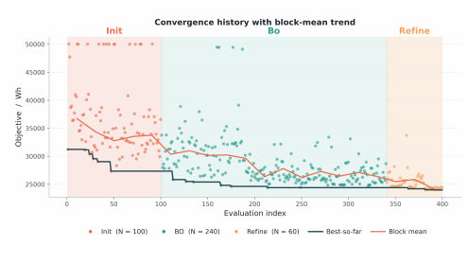

Fig. 21 Phase-wise best-so-far mission energy of LSBO
Fig. 21 separates pointwise evaluations, the best-so-far curve, and block means across the LSBO stages. Broad initial sampling produces many high-energy or penal- ized designs but supplies coverage of discrete configurations and active continuous domains. During BO, the declining block mean shows that improvement is distributed across successive candidates rather than confined to one favorable point.
This transition follows the model update mechanism. Initial samples establish structural reconstruction and a coarse GP posterior. As true mission energies are added, the performance loss reshapes z, the VAE-informed mean captures differ- ences among configuration families, and the residual GP learns local variation in the masked continuous coordinates. These updates increase posterior correlation among performance-related designs and sharpen EI discrimination between promising and low-potential neighborhoods. Candidate-pool scoring and repair prevent repeated or inactive-variable combinations from consuming the budget. The dense low-energy band in the final stage then results from solving a lower-dimensional continuous search with the selected configuration fixed, explaining both the reduced block mean and the late improvement in the best-so-far curve.

3.3.4 Ablation Study
To identify the individual contributions of the key LSBO components, three single- factor ablation variants are constructed while keeping the initial samples, evaluation budget, RCAIDE analysis chain, and other optimization settings unchanged: replacing the structured discrete encoding with one-hot representation, removing performance- aware training, and removing the GP prior mean provided by the VAE performance- prediction head. The full LSBO is used as the baseline. The ablation study focuses

38

on the sample-quality distribution during the BO stage and the ability to discover high-quality samples, rather than only comparing a single final best value, because expensive MDA optimization trajectories contain non-negligible randomness.
Table 4 summarizes the final best values and BO-stage statistics of the ablation variants. Removing structured encoding, performance-aware training, and the VAE- informed prior mean degrades the final best value by 935 Wh, 1785 Wh, and 2162 Wh, respectively. Relative to the baseline, the degradation ratios of the three ablation variants are 3.90%, 7.44%, and 9.01%, respectively.

Table 4 Ablation results on the X-57 MDA problem

Variant | Final best  (Wh) | Degradation  vs baseline  (%) | BO mean  (Wh) | BO top-10%  mean (Wh)
Full LSBO | 23988 | - | 27974 | 24341
w/o structured encoding | 24923 | +3.90% | 29594 | 25607
w/o performance- aware training | 25773 | +7.44% | 31746 | 26150
w/o VAE-informed prior mean | 26150 | +9.01% | 30655 | 26864

Removing structured encoding increases the BO-stage mean from 27974 Wh to 29594 Wh (5.79%) and the top-10% mean from 24341 Wh to 25607 Wh (5.20%). Under one-hot encoding, distinct categories are equidistant and ordinal proximity is lost. The GP kernel therefore cannot assign stronger covariance to structurally related configu- rations unless their similarity is rediscovered from objective observations. Structured embeddings retain these relations, allowing evidence from one configuration to update nearby configurations and improving the identification of low-energy regions.
Removing performance-aware training increases the BO-stage mean to 31746 Wh, 13.48% above the full LSBO and 7.27% above the structured-encoding ablation. Reconstruction alone organizes z for category recovery, not for smooth variation in mission energy. The stationarity assumption of the GP kernel can then place aero- dynamically dissimilar configurations close together or separate configurations with similar responses. The resulting posterior mean and uncertainty are less aligned with objective variation, which weakens the ranking of low-energy candidates by the acquisition function.
Removing the VAE-informed prior mean raises the BO-stage mean to 30655 Wh (9.59%) and causes the largest final-best degradation. With a zero-mean GP, the lim- ited observations must identify both the global performance offset among configuration families and local variation in the active continuous variables. The VAE-informed mean supplies the former trend, leaving the GP to learn a lower-amplitude resid- ual. This decomposition reduces small-sample estimation burden and supports later exploitation of the most promising configuration families.

39

To assess more than the final best value, the ablation is analyzed from four perspec- tives: BO-stage sample distribution, high-quality sample density, performance across different optimization stages, and sampling behavior. Figs. 23–26 present the ablation violin plots, top-k high-quality sample curves, ablation evidence matrix, and PCA visualization of sampling behavior, respectively.

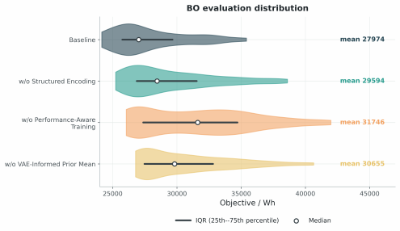

Fig. 22 Violin plots of BO-stage objective distributions in the X-57 ablation study

Fig. 22 compares the objective distributions of valid BO-stage samples. The full LSBO concentrates more probability mass in the low-energy region, whereas each ablation shifts the distribution toward higher values. The largest mean shift occurs without performance-aware training, consistent with a latent geometry that remains decodable but is poorly aligned with mission-energy variation. The shift caused by removing the prior mean shows that cross-configuration trends also affect the quality of routine BO proposals, rather than only the single best result.
Fig. 23 compares the quality of elite subsets selected from valid sequential-search samples generated by the full LSBO and the three ablation variants. Panel (a) reports the mean mission energy of the elite set over fractions from 5% to 50%, whereas panel (b) reports the corresponding energy penalty relative to the full LSBO. Lower values indicate more consistently high-quality samples. The baseline curve remains the lowest over the range of 5%-50%, indicating that the full LSBO does not merely find a single good sample, but maintains lower mean energy across a broad proportion of elite samples. Taking the top-10% samples as an example, removing structured encoding increases the mean energy from the baseline value of 24341 Wh to 25607 Wh, corresponding to a 5.20% increase; removing performance-aware training increases it to 26151 Wh, corresponding to a 7.44% increase; and removing the VAE-informed

40

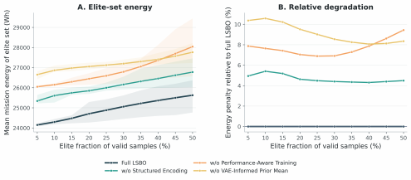

Fig. 23 Elite-set sample quality and relative degradation across LSBO ablation variants
prior mean increases it to 26864 Wh, corresponding to a 10.37% increase. Thus, all three modules improve the density of useful evaluations, with performance alignment and prior guidance contributing most strongly to sustained high-quality sample sets.

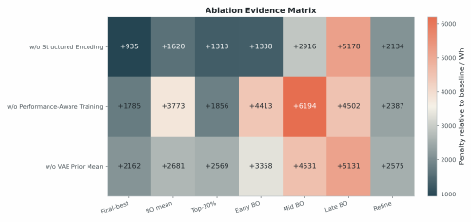

Fig. 24 Ablation evidence matrix showing performance degradation relative to the full LSBO base- line
Fig. 24 combines the final best value, BO-stage mean, top-10% sample quality, and stage-wise penalties relative to the full LSBO. The matrix separates the roles of the modules: performance-aware training has the largest effect on average BO-stage quality (13.48%), whereas the VAE-informed prior mean has the largest effect on the final best value (9.01%) and top-10% quality (10.37%). This pattern is consistent with performance supervision improving acquisition ranking throughout the search, while

41

prior guidance becomes particularly important when sparse late-stage observations must resolve small differences among promising configuration families.

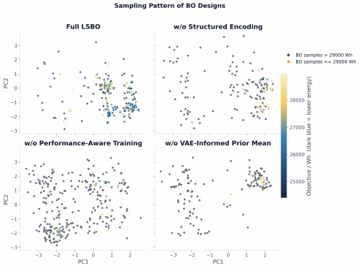

Fig. 25 PCA visualization of BO sampling patterns for diferent LSBO ablation variants

Fig. 25 examines the corresponding sampling behavior. For each method, the top 10% of valid BO-stage samples with the lowest objective values are selected, and the area of their one-standard-deviation covariance ellipse is computed in the PCA plane. A smaller area indicates a more concentrated distribution of low-energy sam- ples. The results show that the ellipse area of the baseline is 0.885. After removing structured encoding, the area increases to 3.492, approximately 3.95 times that of the baseline. After removing the VAE-informed prior mean, the area is 3.391, approxi- mately 3.83 times that of the baseline. After removing performance-aware training, the area is 0.973, representing a 9.94% increase over the baseline. The full LSBO there- fore organizes low-energy samples into a more compact configuration neighborhood. The substantially larger areas without structured encoding or prior guidance indicate weaker localization. By contrast, the performance-aware ablation has a similar ellipse area but a substantially worse objective distribution. Compactness alone is therefore not evidence of a useful latent region: performance supervision is needed to align the region with low mission energy.

42

Together, Figs. 21–25 support three complementary mechanisms: structured encoding defines meaningful cross-configuration covariance, performance-aware train- ing aligns that geometry with the objective response, and the VAE-informed mean separates global configuration trends from local GP residuals. Their combina- tion improves both the quality and concentration of feasible samples across the optimization trajectory.

3.3.5 Latent-Space Representation and Sensitivity Analysis
Sensitivity ranking and high-quality sample clustering are applied to the main opti- mization samples to interpret LSBO search behavior on the complete mission-level X-57 MDA problem. The former identifies which design variables dominate varia- tions in mission energy consumption, while the latter examines whether low-energy designs are concentrated around a single configuration or distributed across multi- ple competitive locally optimal regions. Together, these analyses assess whether the low-energy designs correspond to interpretable aircraft design patterns rather than isolated numerical optima of the black-box optimization process.
The sensitivity and clustering results show that the optimization difficulty of the X-57 problem arises from both continuous geometric variables and discrete con- figuration choices. The variable-importance analysis indicates that wing sizing and planform variables have dominant effects on mission energy consumption. PCA clus- tering of high-quality samples further shows that the low-energy region is not unique, but instead consists of multiple configuration modes. The best mode is concentrated around a configuration with 10 leading-edge distributed propulsors, a Clark-Y air- foil, two-bladed propellers, a conventional tail, plain flaps, and winglets. A secondary low-energy mode is mainly concentrated around configurations with six leading-edge distributed propulsors, a T-tail, plain flaps, and winglets, accompanied by different airfoil choices. Figs. 27 and 28 provide these interpretations from the variable level and configuration-cluster level, respectively.

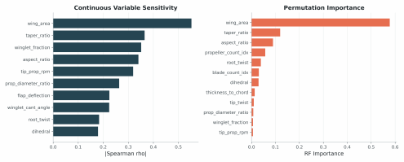

Fig. 26 Variable sensitivity rankings based on Spearman correlation

43

and permutation importance
Fig. 26 shows that both Spearman correlation and random-forest permutation importance identify wing area as the most influential factor, with a permutation importance of 0.578, followed by aspect ratio. This result is consistent with the basic relationships among wing loading, induced drag, and low-speed performance estima- tion in aircraft conceptual design [31–33]. Wing area mainly affects wing loading, low-speed lift requirements, and mission energy level, while aspect ratio is directly related to induced drag and cruise aerodynamic efficiency. Together, these two vari- ables determine the performance trade-off between low-speed and cruise segments for the electric aircraft. Variables such as taper ratio, propeller size, and the number of propellers also affect the optimization result, but their importance is lower than that of wing area and aspect ratio. This indicates that the X-57 optimization is not a sim- ple adjustment of a single geometric scale, but a coupled trade-off dominated by wing sizing and aerodynamic efficiency while also influenced by propulsion layout and local configuration choices.

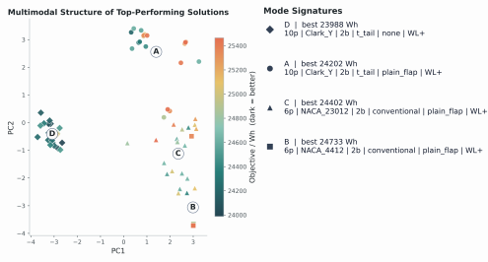

Fig. 27 Multimodal structure of top-performing X-57 designs in the mixed-variable feature space

Fig. 27 shows the multimodal structure of high-quality samples in the mixed- variable feature space. The best mode, denoted as C, corresponds to a configuration with 10 leading-edge distributed propulsors, a Clark-Y airfoil, two-bladed propellers, a conventional tail, plain flaps, and winglets, with a best value of 23988 Wh. Mode D is close to this configuration but uses a T-tail, while mode A corresponds to a sec- ondary low-energy region with six propulsors, a T-tail, and different airfoil choices. The separation of these modes in the PCA space indicates that the problem con- tains multiple locally favorable regions jointly formed by discrete configurations and continuous parameters. The value of LSBO lies in its ability to maintain exploration

44

across these modes while concentrating exploitation on the lowest-energy mode after sufficient samples have been accumulated.

3.3.6 High-Fidelity CFD Verification
To further examine the aerodynamic-prediction consistency of the RCAIDE analysis chain near the optimized design, the best X-57 design obtained by LSBO is selected for verification, and the trimmed cruise condition extracted from the RCAIDE mission profile is used as the external aerodynamic verification condition. The purpose of this verification is to compare the lift and drag levels predicted by different aerodynamic solvers under the same cruise condition, and to assess whether the MDA evaluation results at the conceptual design stage exhibit reasonable engineering consistency.
The verification condition uses the cruise parameters output by RCAIDE: flight altitude of 2442.06 m, freestream velocity of 54.05m/s, air density of 0.9626kg/m3 , Mach number of 0.1634, reference area of 11.596m2 , and angle of attack of 1.0439 deg. At this cruise point, RCAIDE predicts CL=0.7239 and CD=0.04175, corresponding to a lift of 12041.68 N and a drag of 694.44 N. The lift is approximately balanced with the aircraft weight.
First, the vortex lattice method (VLM) is used to independently verify the aero- dynamics of the X-57 configuration automatically exported from RCAIDE, with the calculation performed using OpenVSP, NASA’s open-source geometry modeling and aerodynamic analysis tool. At the same cruise angle of attack, VLM predicts CL=0.7052 and a lift of 11729.51N, differing from the lift predicted by the RCAIDE empirical method by approximately 2.6%. This indicates that the two low-order methods provide generally consistent predictions of the cruise lift level. For drag, VSPAERO predicts CD=0.02321 and a drag of 386.13 N, which differs from the RCAIDE result. This discrepancy mainly arises from differences in modeling assump- tions: VLM is based on a potential-flow assumption and generally does not directly resolve viscous drag, separation effects, or local installation interference, whereas the drag estimation in RCAIDE relies on empirical correction terms at the conceptual design stage. Therefore, the OpenVSP/VSPAERO and RCAIDE results are mainly used for cross-checking the cruise lift level and overall aerodynamic trends, while drag prediction still requires further assessment using higher-fidelity Reynolds-averaged Navier–Stokes (RANS) computational fluid dynamics (CFD).
Subsequently, a three-dimensional viscous RANS analysis is performed for the same cruise condition to provide high-fidelity aerodynamic verification, with the calculation conducted using STAR-CCM+, a commercial CFD software developed by Siemens. STAR-CCM+ provides capabilities for complex-geometry mesh gen- eration, turbulence-model solution, and post-processing, and is widely used for engineering-scale three-dimensional viscous flow simulations. Based on this platform, a three-dimensional external-flow model consistent with the RCAIDE cruise condi- tion is established. The computational domain, boundary conditions, and reference quantities are kept consistent with the RCAIDE cruise state. The aircraft surface is treated as a no-slip wall, while the far field is modeled using a velocity inlet, pressure outlet, and lateral far-field boundaries. A grid-independence test was first conducted using three successively refined meshes with a refinement ratio of r = 1.3. As reported

45

in Table 5, the fine-to-medium mesh differences are 0.23% for CL and 1.92% for CD ; therefore, the medium mesh was selected for the final RANS calculation as a practi- cal accuracy-cost compromise. Using the selected medium mesh, the converged RANS results give CL = 0.7276 and CD = 0.04002, corresponding to a lift of 12102.79 N and a drag of 665.67 N. Compared with RCAIDE, the lift and drag differences are 0.51% and 4.14%, respectively. The drag difference corresponds to an absolute coefficient difference of 0.00173 and is consistent with the different empirical and viscous-flow clo- sures used by the two models. It does not establish high-fidelity accuracy throughout the design space. However, the optimization comparison remains meaningful because every algorithm uses the same RCAIDE model, so common model-form bias does not preferentially benefit LSBO. The RANS result instead provides a local check that the final design has a comparable aerodynamic-force level; absolute performance claims remain subject to model-form uncertainty.
Table 6 summarizes the three aerodynamic predictions. VLM reproduces the lift level but underestimates drag because its potential-flow formulation omits viscous and installation effects. The three-dimensional RANS result is closer to RCAIDE for both quantities at the selected cruise point. Fig. 28 presents the surface pressure distribution of the optimized configuration under the cruise condition, illustrating the pressure characteristics on the wing, fuselage, and tail surfaces.

Table 5 Grid-independence test for the RANS simulation

Mesh | Number  of Cells | CL | Relative Change  from Medium  Mesh | CD | Relative  Change from Medium Mesh
Coarse mesh | 2267935 | 0.7225 | -0.70% | 0.04059 | +1.42%
Medium mesh | 3417726 | 0.7276 | Reference | 0.04002 | Reference
Fine mesh | 5181248 | 0.7293 | +0.23% | 0.03925 | -1.92%

Table 6 Aerodynamic validation results of the optimized X-57 design at the RCAIDE cruise condition

Method | CL | CD | Relative diference  in lift | Relative diference in drag
Empirical method | 0.7239 | 0.04175 | Reference | Reference
VLM | 0.7052 | 0.02321 | 2.59% | 44.40%
RANS | 0.7276 | 0.04002 | 0.51% | 4.14%

46

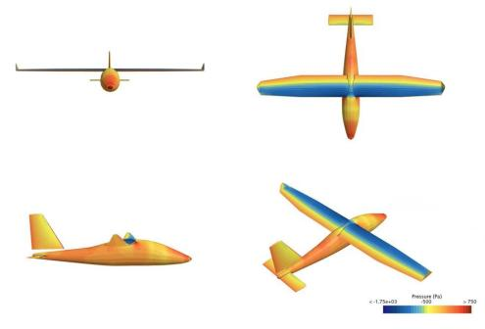

Fig. 28 High-fidelity CFD validation of the optimized X-57 design
At the selected cruise point, the 0.51% lift difference and 4.14% drag difference indicate that RCAIDE provides force levels suitable for the present conceptual-design comparison, subject to the local scope of the validation. OpenVSP predicts lower drag because VLM does not resolve viscous drag, installation drag, or local three- dimensional flow effects. However, its lift prediction remains useful as an auxiliary check of geometric aerodynamic trends. The agreement supports using RCAIDE as a common optimization evaluator, while final aerodynamic performance should still be reassessed with higher-fidelity analysis over additional operating points.

4 Discussion
4.1 Synergistic Efects of LSBO Components
LSBO couples representation, surrogate modeling, and budget allocation. The struc- tured VAE maps ordinal, nominal, and conditionally active choices to a common latent geometry, while masks prevent inactive coordinates from distorting GP distances. Per- formance supervision then aligns this geometry with mission-energy variation. The VAE-informed mean captures the global offset among configuration families, leaving the GP to model lower-amplitude local residuals in the active continuous variables. These roles are complementary: a decodable latent space need not be predictive, and a GP cannot exploit configuration similarity that is absent from its input geometry.

47

The ablation results support this division of roles. One-hot replacement weakens cross-configuration covariance; reconstruction-only training most strongly degrades average BO-stage sample quality; and removing the VAE-informed mean produces the largest loss in final solution quality. Candidate-pool scoring further limits dependence on a single decoded configuration, whereas late-stage refinement fixes the selected discrete design and solves a smoother continuous subproblem. The benefit there- fore emerges mainly after sufficient evaluations have shaped the latent geometry and residual GP, explaining the stronger middle- and late-stage gains.

4.2 Comparison with Existing Mixed-Variable Optimization Methods
Mixed-GA directly accommodates heterogeneous variables through population oper- ators but does not use a probabilistic surrogate to transfer evidence between evaluations. LSBO is therefore advantageous when each MDA call is expensive and the budget is too small for broad population search. This advantage is conditional: evolutionary search can remain preferable when evaluations are inexpensive or the response is too discontinuous for a useful surrogate.
One-hot GP-BO preserves category identity but represents distinct levels as orthogonal and equidistant, so its kernel cannot express graded similarity without direct observations. SMAC-style RF-BO handles categorical and hierarchical variables naturally and was competitive on hierarchical Hartmann, where axis-aligned parti- tions matched the response structure. LSBO instead learns configuration similarity and retains a continuous GP input for local refinement. It is most likely to improve on these baselines when responses are locally smooth within configurations and related configurations share transferable trends; when such relations are weak, the additional representation model may offer little benefit.
Existing studies provide complementary solutions. Mixed-categorical GP kernels model correlations among categories [12, 13], whereas hierarchical architecture BO emphasizes variable activation and feasibility [15]. Latent-space BO maps structured objects to continuous search spaces [18–21]. LSBO combines these concerns for aircraft configuration design: typed embeddings and masks define valid inputs, objective super- vision organizes latent distance, the VAE-informed mean supplies a configuration-level trend, and candidate screening with local refinement converts latent proposals into evaluable designs. The contribution is this coupled optimization loop rather than any individual component in isolation.

4.3 Applicable Problem Characteristics and Engineering Implications
LSBO is most applicable when discrete configurations have learnable similarities, dis- crete choices activate or redefine continuous variables, and true evaluations are scarce. Aircraft MDA exhibits all three features: adjacent propulsor counts or related air- foils can share response trends, layout choices control valid geometric variables, and each configuration requires continuous sizing. The method is less compelling when

48

categories are unrelated, hierarchy is absent, or sufficient evaluations are available to optimize every configuration independently.
For conceptual design, the practical benefit is a reduction in repeated within- configuration searches. Evidence from one evaluated configuration can update related latent neighborhoods, after which the remaining budget is concentrated on continuous refinement of supported candidates. This provides a traceable sequence from config- uration screening to parameter sizing, while the sensitivity and clustering analyses expose the design patterns associated with low mission energy.

4.4 Limitations
LSBO remains dependent on representative initial coverage and stable latent-space training. Sparse or imbalanced observations can bias the performance head, while strong noise can obscure the configuration similarities required by the GP. The present formulation is also limited to a single penalized objective; it does not explic- itly model constraint uncertainty or distinct simulation-failure modes. Finally, the expensive MDA comparison uses one controlled X-57-based case, and the RANS assessment checks one cruise point. The evidence therefore supports relative opti- mizer performance under a common evaluator, not universal algorithmic superiority or high-fidelity accuracy across the design space.

5 Conclusions
This paper develops LSBO for expensive hierarchical mixed-variable aircraft con- ceptual design. A structured VAE maps ordinal, nominal, and conditionally active configuration variables to a continuous latent space, while performance supervi- sion aligns latent distance with the objective response. A VAE-informed GP mean transfers configuration trends; masked joint inputs, candidate selection, and local refinement produce valid designs. The resulting framework couples representation learning, probabilistic modeling, and allocation of a limited MDA budget.
Across the clustered Ackley, clustered Ellipsoid, and hierarchical Hartmann bench- marks, LSBO reduces mean final regret by 31.4%, 12.3%, and 11.0%, respectively, relative to the second-best method, with pairwise win rates ranging from 72% to 92%. On the simplified analytical electric-aircraft model, it reduces mean final regret by 39.9% relative to SMAC-style RF-BO. Within 120 evaluations, LSBO reaches the rel- ative energy target in 80% of runs, compared with 70% for SMAC-style RF-BO and 45% for One-hot GP-BO. The benefit therefore persists under physical constraints and conditional activation.
In the controlled X-57-based MDA comparison, LSBO obtains 23988.48 Wh, 1.04% below the second-best SMAC-style RF-BO result. Relative to the Random-Search– SMAC-style-RF-BO energy gap, this improvement corresponds to 11.54%, and final continuous refinement contributes 12.31% of the total LSBO improvement. At top-10, the LSBO elite-set mean is 24102.32 Wh, 1.01% and 1.10% lower than One-hot GP- BO and SMAC-style RF-BO, respectively. This indicates a denser high-quality sample set rather than only a better optimum. The ablations clarify its source: removing

49

structured encoding increases the BO-stage mean by 5.79%, removing performance- aware training increases it by 13.48%, and removing the VAE-informed mean causes the largest final-best degradation of 9.01%. Without structured encoding or prior guidance, the low-energy PCA ellipse areas increase to 3.95 and 3.83 times that of LSBO, indicating weaker localization. Thus, meaningful cross-configuration covari- ance, objective-aligned latent geometry, and prior-guided residual modeling jointly improve sample quality under the common evaluation budget. At the selected cruise point, RANS differs from RCAIDE by 0.51% in lift and 4.14% in drag, providing a local aerodynamic check while leaving model-form uncertainty outside this condition unresolved.
Future work will extend LSBO to risk-aware constrained and multi-objective opti- mization, allowing trade-offs, constraint uncertainty, and distinct simulation-failure modes to guide candidate selection. Coupling low-order MDA with targeted high- fidelity analyses across additional operating conditions will assess robustness to sparse feasible regions, model-form uncertainty, and changing mission requirements.

Acknowledgements. This work was supported by the National Natural Science
Foundation of China (No. 52502451), the Natural Science Basic Research Plan in the Shaanxi Province of China (No. 2025CY-YBXM-083), and the Fundamental Research Funds for the Central Universities (No. G2024KY05104).
References
[1] Afonso F, Sohst M, Diogo C M A, et al: Strategies towards a more sustainable aviation: A systematic review. Progress in Aerospace Sciences, 2023, 137: 100878.
[2] Abu Salem K, Palaia G, Quarta A A: Review of hybrid-electric aircraft tech- nologies and designs: Critical analysis and novel solutions. Progress in Aerospace Sciences, 2023, 141: 100924.
[3] Ma Y, Elham A: Designing high aspect ratio wings: A review of concepts and approaches. Progress in Aerospace Sciences, 2024, 145: 100983.
[4] Abdul-Kaiyoom M A S, Yildirim A, Martins J R R A: Coupled aeropropulsive design optimization of an over-wing nacelle configuration. Journal of Aircraft, 2025, 62(1): 94-116.
[5] Li X, Chen X, Ding F, Li Z, Li J: Multidisciplinary design optimization of the first-stage waverider based on boost-glide flight trajectory. Aerospace Science and Technology, 2025, 160: 110033.
[6] Talbi E G: Metaheuristics for variable-size mixed optimization problems: A uni- fied taxonomy and survey. Swarm and Evolutionary Computation, 2024, 89: 101642.
[7] Gamot M, Balesdent M, Trémolet A, Melab N, Talbi E G: Hidden-variables genetic algorithm for variable-size design space optimal layout problems with

50

application to aerospace vehicles. Engineering Applications of Artificial Intelli- gence, 2023, 121: 105941.
[8] Gan G, Ye H, Dong M, Ye W, Wang Y: Three-partition coevolutionary differen- tial evolution algorithm for mixed-variable optimization problems. Engineering Applications of Artificial Intelligence, 2024, 133: 108263.
[9] Huang S, Wang Z, Ge Y, Wang F: A coevolutionary estimation of distribution algorithm based on dynamic differential grouping for mixed-variable optimization problems. Expert Systems with Applications, 2024, 245: 123122.
[10] Wang X, Jin Y, Schmitt S, Olhofer M: Recent advances in Bayesian optimization. ACM Computing Surveys, 2023, 55(13s): 1-36.
[11] Tfaily A, Diouane Y, Bartoli N, Kokkolaras M: Bayesian optimization with hidden constraints for aircraft design. Structural and Multidisciplinary Optimiza- tion, 2024, 67: 123.
[12] Saves P, Diouane Y, Bartoli N, Lefebvre T, Morlier J: A mixed-categorical correlation kernel for Gaussian process. Neurocomputing, 2023, 550: 126472.
[13] Saves P, Diouane Y, Bartoli N, Lefebvre T, Morlier J: High-dimensional mixed- categorical Gaussian processes with application to multidisciplinary design optimization for a green aircraft. Structural and Multidisciplinary Optimization, 2024, 67: 81.
[14] Kakkar S, Heinze W, Haupt M, et al: Aerostructural design of laminar and dry wings using multidisciplinary Bayesian optimization. Structural and Multidisci- plinary Optimization, 2026, 69: 202. https://doi.org/10.1007/s00158-026-04411- w.
[15] Bussemaker J, Saves P, Bartoli N, Lefebvre T, Nagel B: Surrogate-based opti- mization of system architectures subject to hidden constraints. AIAA AVIATION Forum and ASCEND, 2024.
[16] Saves P, Hallé-Hannan E, Bussemaker J, Diouane Y, et al: Modeling hier- archical spaces: a review and unified framework for surrogate-based archi- tecture design. Structural and Multidisciplinary Optimization, 2026, 69: 65. https://doi.org/10.1007/s00158-026-04249-2.
[17] Gómez-Bombarelli R, Wei J N, Duvenaud D, Hernández-Lobato J M, Sánchez- Lengeling B, Sheberla D, Aguilera-Iparraguirre J, Hirzel T D, Adams R P, Aspuru-Guzik A: Automatic chemical design using a data-driven continuous representation of molecules. ACS Central Science, 2018, 4(2): 268-276.
[18] Griffiths R R, Hernández-Lobato J M: Constrained Bayesian optimization for automatic chemical design using variational autoencoders. Chemical Science,

51

2020, 11(2): 577-586.
[19] Tripp A, Daxberger E, Hernández-Lobato J M: Sample-efficient optimization in the latent space of deep generative models via weighted retraining. Advances in Neural Information Processing Systems, 2020, 33: 11259-11272.
[20] Moss H B, Ober S W, Diethe T: Return of the Latent Space COWBOYS: Re-thinking the use of VAEs for Bayesian Optimisation of Structured Spaces. Proceedings of the 42nd International Conference on Machine Learning, 2025.
[21] Siivola E, Paleyes A, González J, Vehtari A: Good practices for Bayesian opti- mization of high dimensional structured spaces. Applied AI Letters, 2021, 2(2): e24.
[22] Sridhara S, Deodhare G G, Suresh K: A latent space approach to multi-material topology optimization. Structural and Multidisciplinary Optimization, 2026, 69: 54. https://doi.org/10.1007/s00158-025-04225-2.
[23] Mumtaz S, Giese M: Hierarchy-based semantic embeddings for single-valued and multi-valued categorical variables. Journal of Intelligent Information Systems, 2022, 58: 613-640.
[24] Gongora A E, Friedman C, Newton D K, Yee T D, Doorenbos Z, Giera B, Duoss E B, Han T Y J, Sullivan K, Rodriguez J N: Accelerating the design of lattice structures using machine learning. Scientific Reports, 2024, 14: 13703.
[25] Berahmand K, Daneshfar F, Salehi E S, Li Y, Xu Y: Autoencoders and their applications in machine learning: a survey. Artificial Intelligence Review, 2024, 57: 28.
[26] Ichikawa Y, Hukushima K: Learning Dynamics in Linear VAE: Posterior Collapse Threshold, Superfluous Latent Space Pitfalls, and Speedup with KL Annealing. Proceedings of AISTATS, 2024, PMLR 238: 1936-1944.
[27] Ko M, Yoo J: Generative autoencoder to prevent overregularization of variational autoencoder. ETRI Journal, 2025.
[28] Hansen N, Finck S, Ros R, Auger A: Real-Parameter Black-Box Optimization Benchmarking 2009: Noiseless Functions Definitions. INRIA Research Report RR-6829, 2009.
[29] Dixon L C W, Szegö G P: Towards Global Optimisation 2. North-Holland, 1978.
[30] Ackley D H: A Connectionist Machine for Genetic Hillclimbing. Kluwer Academic Publishers, 1987.
[31] Raymer D P: Aircraft Design: A Conceptual Approach. 6th ed. AIAA, 2018.

52

[32] Roskam J: Airplane Design. DARcorporation, 1985-2003.
[33] Gudmundsson S: General Aviation Aircraft Design: Applied Methods and Procedures. Butterworth-Heinemann, 2014.
[34] National Aeronautics and Space Administration: X-57 Maxwell Overview. NASA Armstrong Flight Research Center. Accessed 14 September 2026. (2018). https: //www.nasa.gov/centers-and-facilities/armstrong/x-57-maxwell/
[35] Clarke M A, Guidotti M, Shekar S S, Molloy A, Boggan C, Guerrero Y N: RCAIDE: A multidisciplinary analysis toolbox for aircraft design and flight simulation. Aerospace Science and Technology, 2026, 177: 112328. https://doi.org/10.1016/j.ast.2026.112328.
[36] Lukaczyk T W, Wendorff A D, Colonno M, Economon T D, Alonso J J, Orra T H, Ilario C: SUAVE: An Open-Source Environment for Multi-Fidelity Conceptual Vehicle Design. AIAA Aviation, 2015.
[37] Drela M, Youngren H: Athena Vortex Lattice. MIT, 2006.
[38] Miranda L R, Elliott R D, Baker W M: A generalized vortex lattice method for subsonic and supersonic flow applications. NASA CR-2865, 1977.
[39] Leishman J G: Principles of Helicopter Aerodynamics. Cambridge University Press, 2006.

53

