  CMPG 311 GROUP PROJECT PHASE 2 | Physical Design For The  TRADEROUTE LOGISTICS

Table of Contents
- Physical Data Model in Oracle
- Physical Data Model
- Database Objects
  - Tables
    - Initialisation
    - CLIENT
    - SORTING_HUB
    - PARCEL
    - PARCEL_STATUS
    - DRIVER
    - VEHICLE
    - ROUTE
    - ROUTE_ZONE
    - ROUTE_ASSIGNMENT
    - DELIVERY_EVENT
    - TARIFF_RATE
    - INVOICE
  - Sequences
  - Indexes
  - Triggers
  - Views
  - Data on Table
- Queries
  - Based on information requirements of company
  - Limitation of rows and columns
  - Sorting
  - LIKE, AND and OR
  - Variables and character functions
  - Round or trunc
  - Date functions
  - Aggregate functions
  - Group by and having
  - Joins
  - Sub-queries

1. PHYSICAL DATA MODEL IN ORACLE
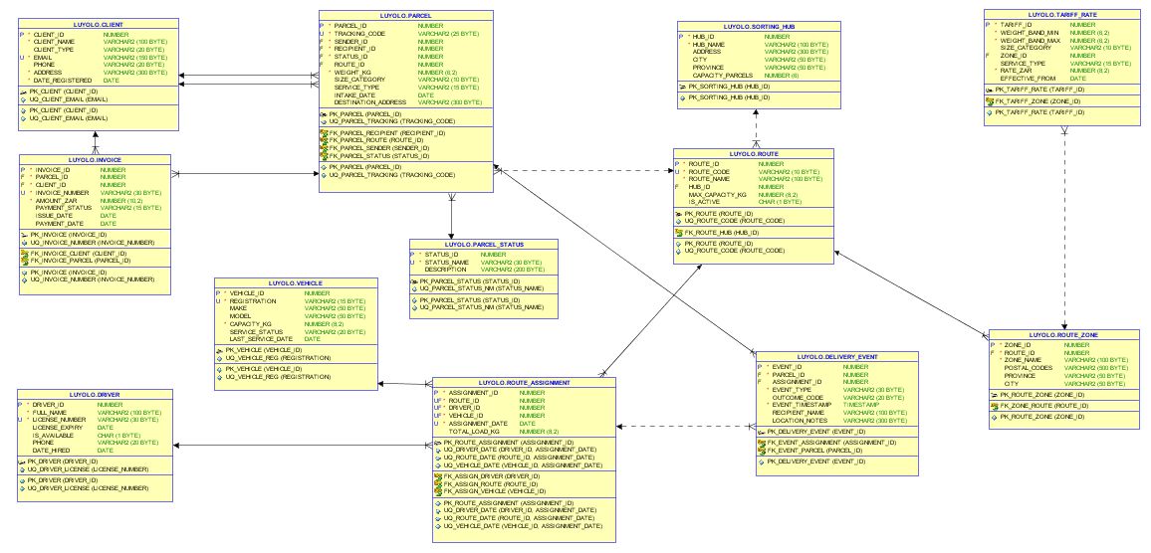
2. PHYSICAL DATA MODEL
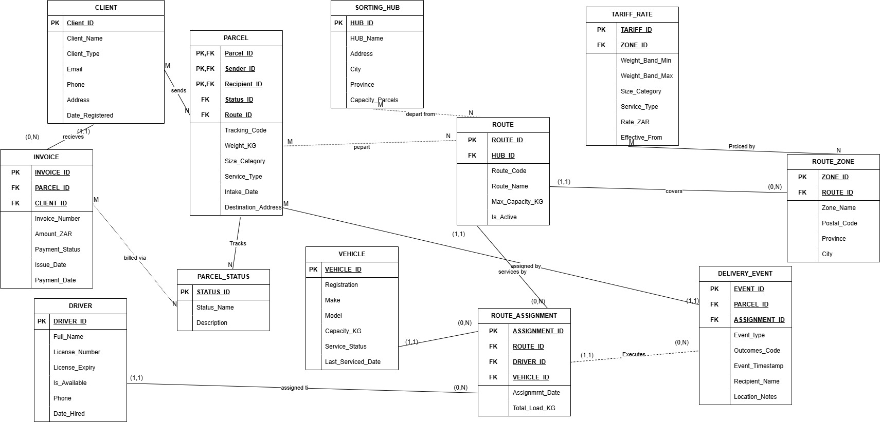
3. DATABASE OBJECTS
a) Tables
i) Initialisation (Drop Table and Sequences)
Remove references to dependent foreign keys, drop all current tables with cascade constraints:
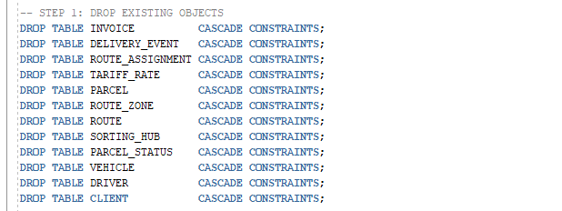
Remove any sequence that already exists:
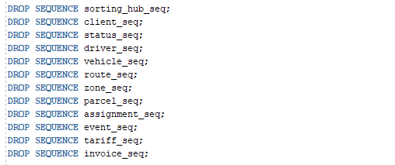
ii) CLIENT
Keeps a record of all client information, including package senders and recipients. The client_type must be one of three possible values—INDIVIDUAL, CORPORATE, or ECOMMERCE—according to a check constraint. To avoid repeated registrations, the email column is unique.
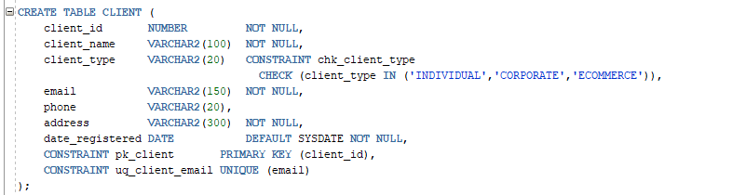

iii) SORTING_HUB
Maintains actual sorting hubs from which delivery routes are sent. The primary key is hub_id. Parcel capacity is always guaranteed to be positive by a check restriction.
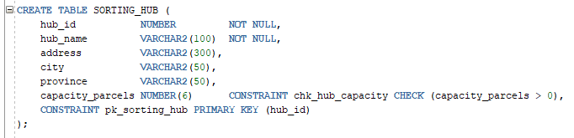

iv) PARCEL
The main table of operations. Every package has its own tracking code. Packages are linked to their sender and recipient by two foreign keys on CLIENT (sender_id and recipient_id). PARCEL_STATUS is linked to the status_id. Valid size_category and service_type values are enforced by check restrictions. Weight needs to be positive.
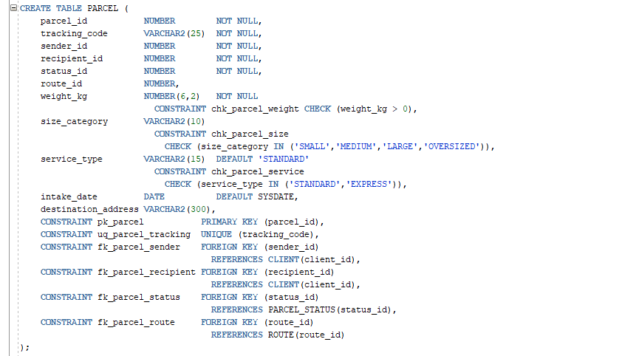

v) PARCEL_STATUS
A reference table that lists the acceptable status codes (such as RECEIVED, IN_TRANSIT, and DELIVERED) that a package may be allocated along its delivery lifespan. To avoid duplicate status codes, the status_name column contains a unique constraint.
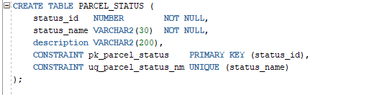

vi) DRIVER
Keep record of every delivery driver that TradeRoute Logistics employs. Only 'Y' or 'N' can be entered in the is available column. To avoid duplicating data, each motorist must have a distinct license number.
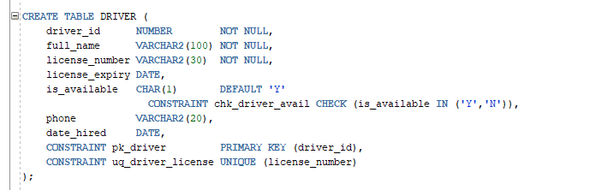

vii) VEHICLE
Maintains all the fleet's delivery cars. Service_status is restricted to OPERATIONAL, MAINTENANCE, or DECOMMISSIONED by a check constraint. The capacity_kg needs to always be positive. Each vehicle's registration number is distinct.
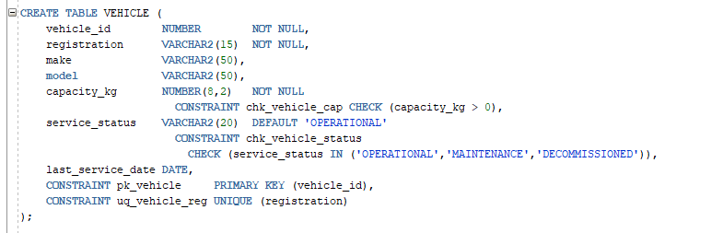

viii) ROUTE
Lists delivery routes with names. A foreign key on hub_id connects each route to a sorting hub. Each route has a unique route_code and is_active limits the value to 'Y' or 'N'.
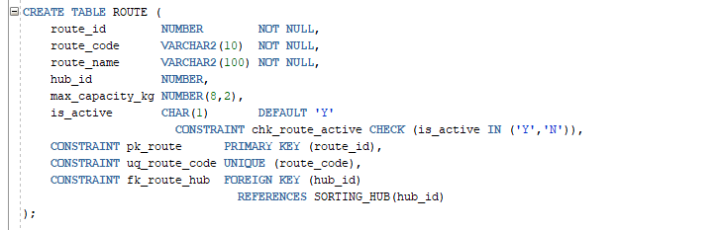

ix) ROUTE_ZONE
Connect delivery routes to geographic zones, such as postal codes and suburbs. A zone cannot exist without a parent route, making it a weak entity that depends on ROUTE. This reliance is enforced by the route_id foreign key.
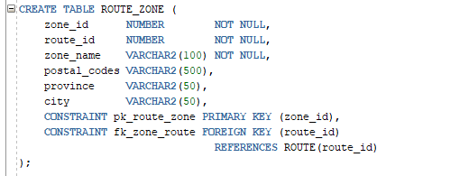

x) ROUTE_ASSIGNMENT
The many-to-many link between DRIVER, VEHICLE, and ROUTE is resolved by a bridge entity. The business requirements that a driver, vehicle, and route can only be assigned once per day are enforced by composite unique constraints on (driver_id, assignment_date), (vehicle_id, assignment_date), and (route_id, assignment_date).
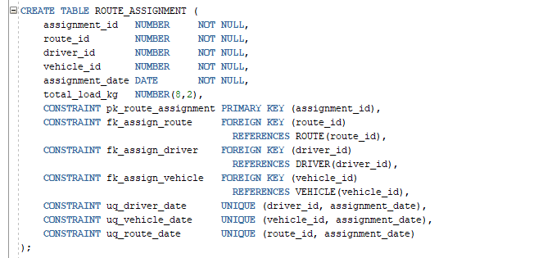

xi) DELIVERY_EVENT
Keeps a record of each delivery attempt for each package. Controlled vocabulary lists apply to the event_type and outcome_code columns. To record exact delivery timings, the event_timestamp uses Oracle's TIMESTAMP type, with SYSTIMESTAMP by default. To permit intake events prior to route assignment, the assignment_id is optional (NULL).
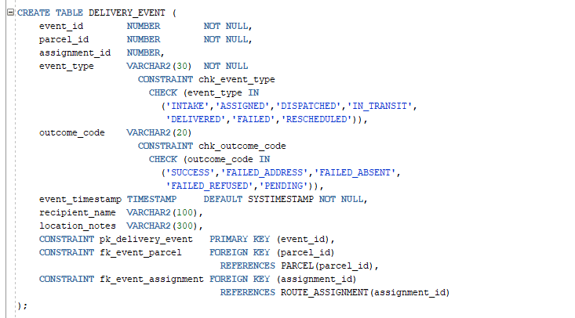

xii) TARIFF_RATE
Records the pricing schedule that is used to determine delivery fees. Weight_band_max is always bigger than weight_band_min because of a check restriction. Rate_zar needs to be positive. A tariff rate is associated with a particular delivery zone via the zone_id.
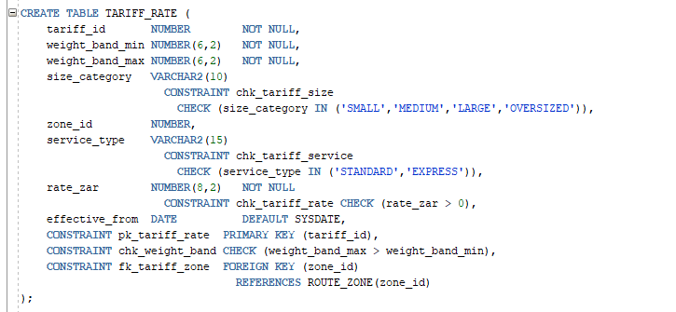

xiii) INVOICE
Keeps records of parcel billing information. The invoice number is distinct. Payment_status is limited to UNPAID, PAID, OVERDUE, or CANCELLED by a check constraint. There must be a positive amount_zar. Foreign keys parcel_id and client_id are both required.
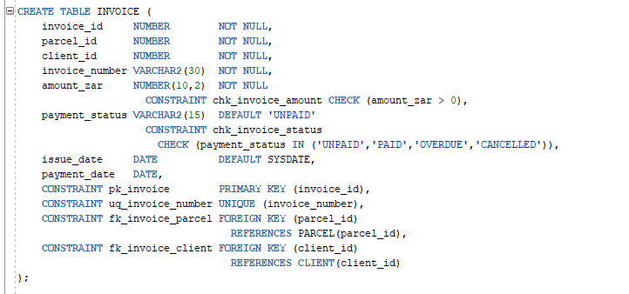
b) Sequences
Sequences are designed to automatically produce distinct primary key values for every table. Every sequence begins at 1 and increases by 1. To avoid sequence value gaps brought on by cached data being lost upon instance failure, NOCACHE is utilized.
For automatic primary key generation, create a single sequence for each table:
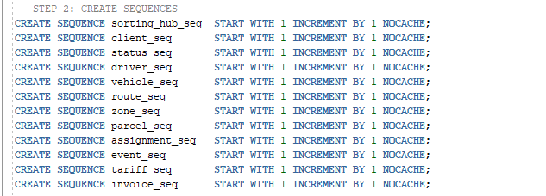

c) Indexes
To speed up row retrieval, indexes are built on frequently searched columns. The tracking_code column in PARCEL is a priority for indexing since it is the field that customers and operations personnel seek the most frequently. To facilitate date-range queries in operational reports, the assignment_date in ROUTE_ASSIGNMENT and the event_timestamp in DELIVERY_EVENT are indexed.

d) Triggers
Every table contains before-insert triggers designed to automatically fill the primary key from the matching sequence if no value is entered. This avoids primary key conflicts and removes the requirement for the application to manually manage ID generation.
The SORTING_HUB example trigger repeats the identical pattern across all 12 tables:
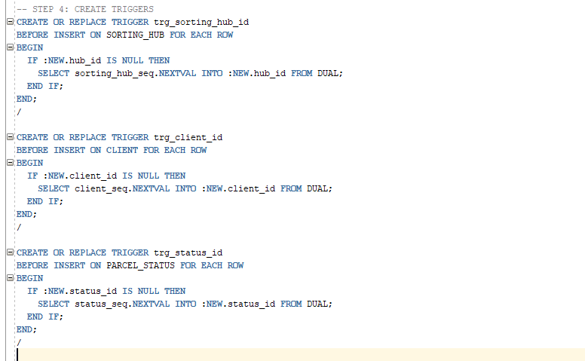
Note: The triggers for the remaining tables—trg_status_id, trg_driver_id, trg_vehicle_id, trg_route_id, trg_zone_id, trg_assignment_id, trg_event_id, and trg_tariff_id—follow the same pattern.

e) Views
To limit sensitive data access, streamline intricate multi-table searches, and offer pre-made result sets for operational reporting, four views were created. Because employees can query a view without having direct access to the underlying tables, views uphold the least privilege principle.
- VW_PARCEL_TRACKING:
- Combines parcel information, status, allocated route, and sorting hub to provide a comprehensive parcel tracking summary. Customer care representatives use it to respond to tracking inquiries without having access to raw tables.
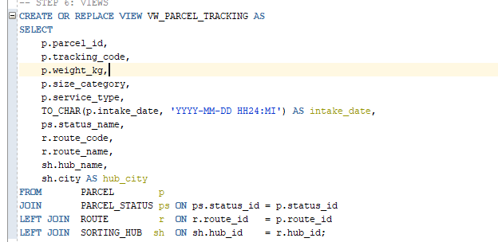
- VW_CLIENT_INVOICES:
- shows a detailed billing summary for each client by combining INVOICE, CLIENT, and PARCEL. This view allows finance workers to verify overdue amounts and payment status without having to write complicated joints.
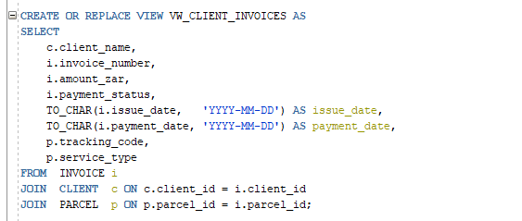
- VW_TODAYS_ROUTES:
- displays all of today's route assignments, including ROUTE, DRIVER, and VEHICLE. This view allows operations managers to identify which driver and vehicle are currently assigned to each route.
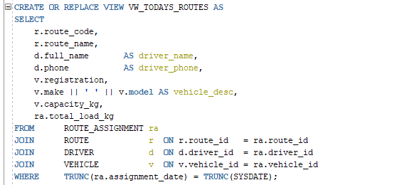
- VW_DRIVER_PERFORMANCE:
- creates a performance summary that displays the overall number of deliveries, successful deliveries, and unsuccessful attempts by aggregating delivery event results by drivers. used for performance evaluations by the operations manager.
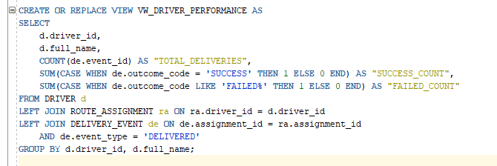

f) Data on Table
Each table is filled with actual records for TradeRoute Logistics operations by inserting sample data. Each table has a minimum of three INSERT statements:
PARCEL_STATUS & SORTING_HUB – Seed Data
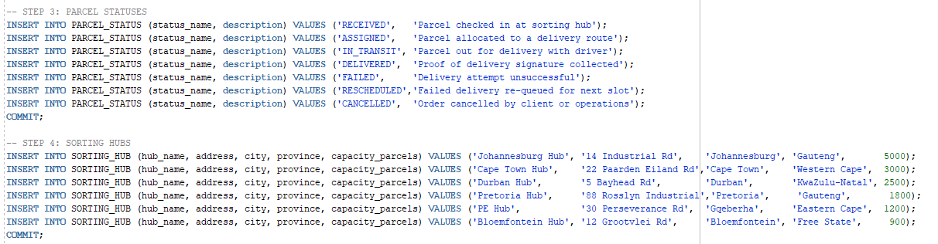
CLIENT – Sample Data
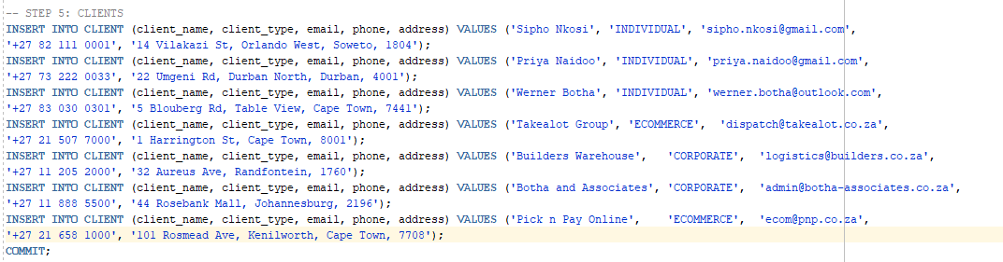
DRIVER – Sample Data
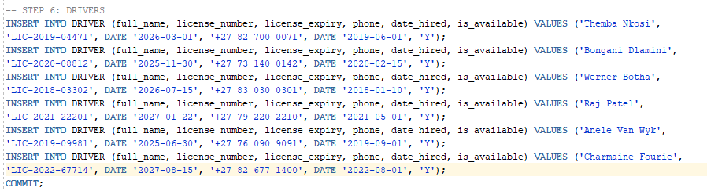
VEHICLE – Sample Data
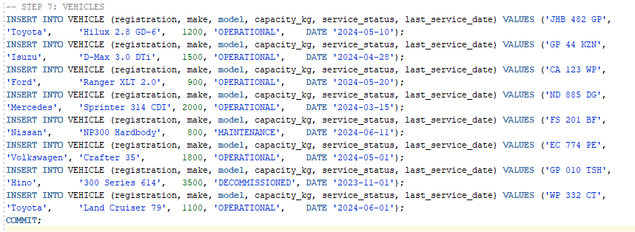
ROUTE & ROUTE_ZONE – Sample Data
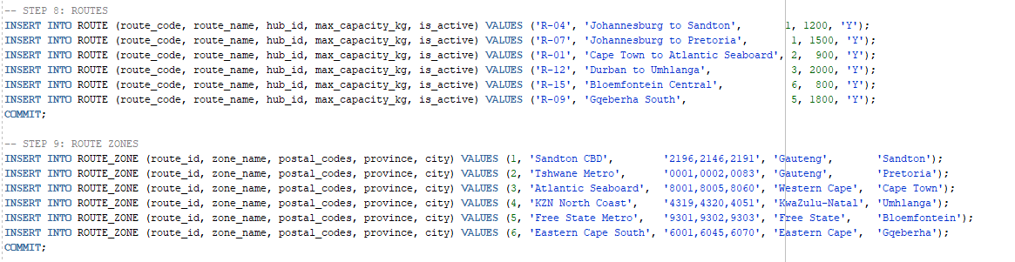
TARIFF_RATE – Sample Data
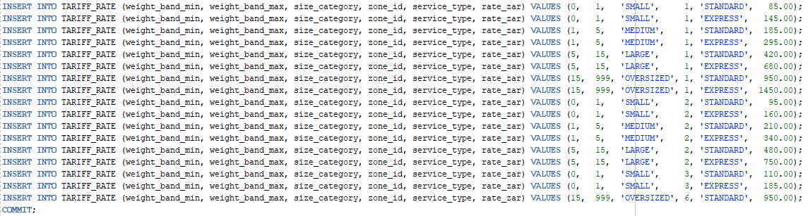
PARCEL & ROUTE_ASSIGNMENT – Sample Data
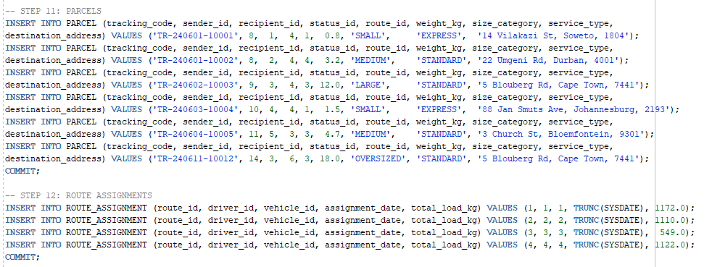
DELIVERY_EVENT & INVOICE - Sample Data
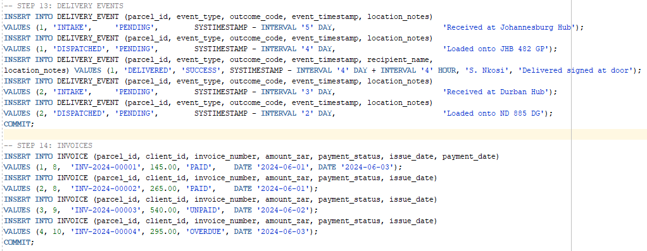

4. QUERIES

The TradeRoute Logistics database is subjected to the following SQL queries. Each query illustrates a necessary SQL method or responds to a particular information requirement of the business. Each inquiry is preceded by an explanation of the business purpose.
  - Based on information requirements of company
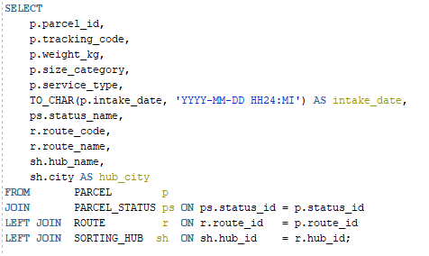

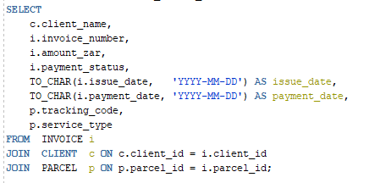
  - Limitation of rows and columns
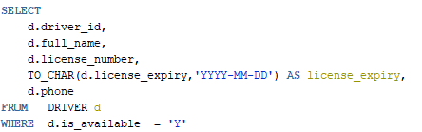

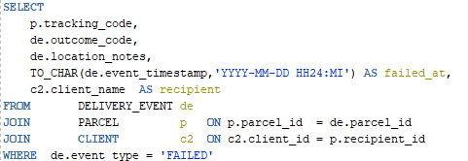
  - Sorting
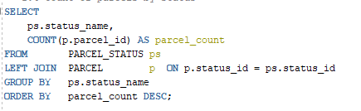

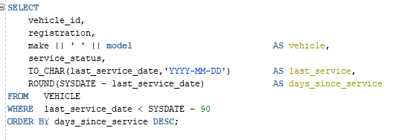
  - LIKE, AND and OR
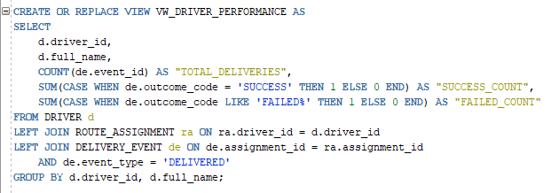

  - Variables and character functions
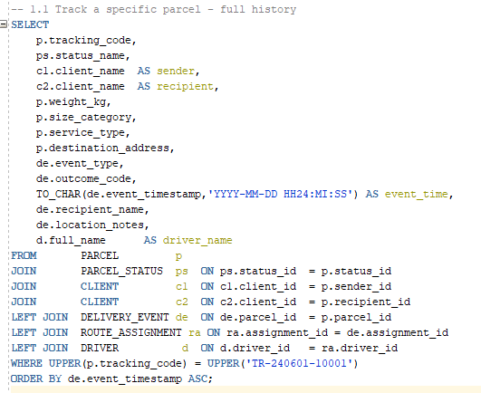

  - Round or trunc
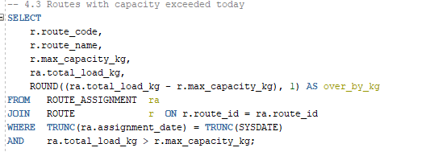

  - Date functions
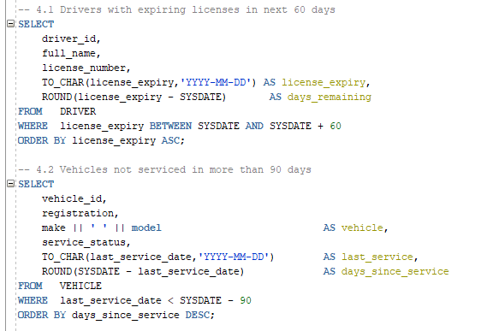

  - Aggregate functions
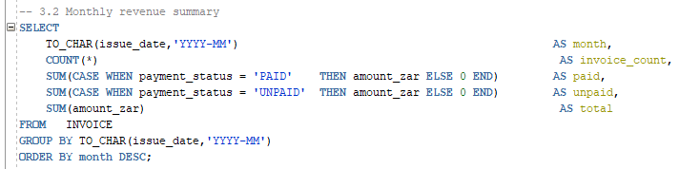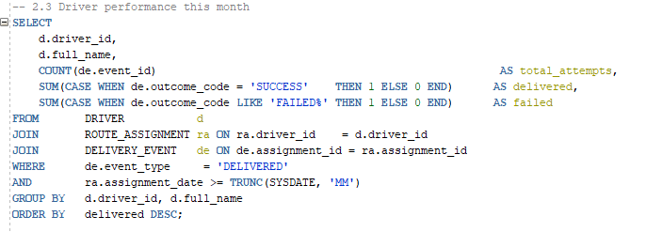

  - Group by and having
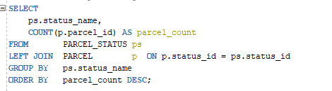

  - Joins
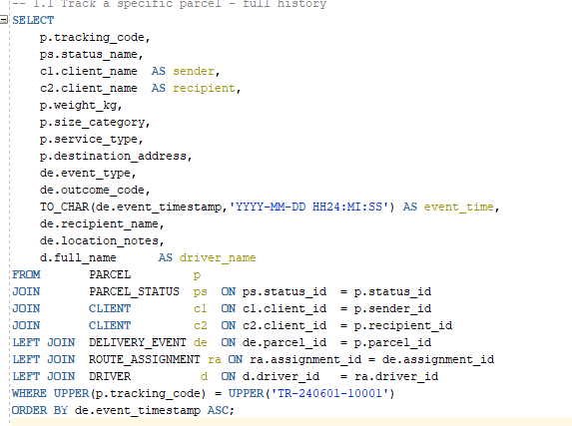
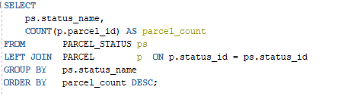

  - Sub-queries
