PIA_LRP.R

Usuario

2023-11-28

#LUZ ELENA RODRÍGUEZ PEQUEÑO  
#2070472  
#28/11/23  
#PIA  
  
  
# Importar ----------------------------------------------------------------  
  
setwd("C:/Repositorio_LR/Met_ES/codigos")  
climas <- read.csv("climas.csv", header = TRUE)   
head(climas)

## Tmax Tmin  
## 1 37.8 24.9  
## 2 38.8 18.6  
## 3 28.2 10.1  
## 4 19.5 11.6  
## 5 0.0 0.0  
## 6 33.8 20.8

# descriptivas ------------------------------------------------------------  
# medidad de tendencia central media, mediana, rango  
#Tmax  
mean(climas$Tmax) #28.65161

## [1] 28.65161

median(climas$Tmax) #32.3

## [1] 32.3

range(climas$Tmax) #0.0 39.3

## [1] 0.0 39.3

#Tmin  
  
mean(climas$Tmin) #16.53871

## [1] 16.53871

median(climas$Tmin) #18.6

## [1] 18.6

range(climas$Tmin) #0.0 39.3

## [1] 0.0 24.9

# medidad de dispersion desviacion estandar, varianza ---------------------  
#Tmax  
sd(climas$Tmax) #9.005068

## [1] 9.005068

var(climas$Tmax)#81.09125

## [1] 81.09125

#Tmin  
sd(climas$Tmin) #5.429775

## [1] 5.429775

var(climas$Tmin) #29.48245

## [1] 29.48245

# Grafica -----------------------------------------------------------------  
  
boxplot(climas$Tmax)

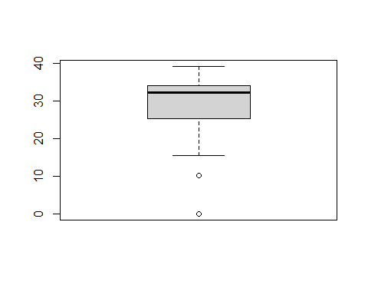

boxplot(climas$Tmin)

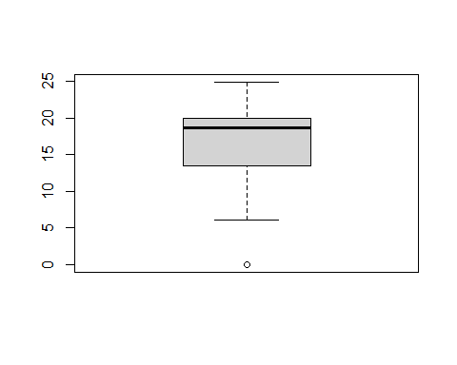

# Hipotesis ---------------------------------------------------------------  
  
#Tmax = 33 vs Tmin = 18.6  
#La temperaturas han incrmentado hasta 33 grados según la estación meteorologica de la facultad por lo que es una hipotesis alternativa   
  
  
# Procedimiento -----------------------------------------------------------  
  
t.test(climas$Tmax, mu = 33)

##   
## One Sample t-test  
##   
## data: climas$Tmax  
## t = -2.6886, df = 30, p-value = 0.0116  
## alternative hypothesis: true mean is not equal to 33  
## 95 percent confidence interval:  
## 25.34853 31.95470  
## sample estimates:  
## mean of x   
## 28.65161

#t = -2.6886, df = 30, p-value = 0.0116  
t.test(climas$Tmax, mu = 32.5)

##   
## One Sample t-test  
##   
## data: climas$Tmax  
## t = -2.3794, df = 30, p-value = 0.0239  
## alternative hypothesis: true mean is not equal to 32.5  
## 95 percent confidence interval:  
## 25.34853 31.95470  
## sample estimates:  
## mean of x   
## 28.65161

#t = -2.3794, df = 30, p-value = 0.0239  
t.test(climas$Tmax, mu = 32.6)

##   
## One Sample t-test  
##   
## data: climas$Tmax  
## t = -2.4413, df = 30, p-value = 0.02075  
## alternative hypothesis: true mean is not equal to 32.6  
## 95 percent confidence interval:  
## 25.34853 31.95470  
## sample estimates:  
## mean of x   
## 28.65161

#t = -2.4413, df = 30, p-value = 0.02075  
t.test(climas$Tmax, mu = 16.5)

##   
## One Sample t-test  
##   
## data: climas$Tmax  
## t = 7.5132, df = 30, p-value = 2.243e-08  
## alternative hypothesis: true mean is not equal to 16.5  
## 95 percent confidence interval:  
## 25.34853 31.95470  
## sample estimates:  
## mean of x   
## 28.65161

#t = 7.5132, df = 30, p-value = 2.243e-08  
  
  
# Recapibilidad -----------------------------------------------------------  
  
#Guardar la prueba t en un objeto llamado "prueba"  
prueba <- t.test(climas$Tmax, mu =33)  
  
#Conocer el p-value  
prueba$p.value #0.01159886

## [1] 0.01159886

# Conocer los grados de libertad   
prueba$parameter #df

## df   
## 30

30

## [1] 30

# Conocer intervalos de confianza   
prueba$conf.int #0.95

## [1] 25.34853 31.95470  
## attr(,"conf.level")  
## [1] 0.95

# Correlación -------------------------------------------------------------  
cor.test(climas$Tmax, climas$Tmin)

##   
## Pearson's product-moment correlation  
##   
## data: climas$Tmax and climas$Tmin  
## t = 8.3631, df = 29, p-value = 3.225e-09  
## alternative hypothesis: true correlation is not equal to 0  
## 95 percent confidence interval:  
## 0.6928424 0.9207906  
## sample estimates:  
## cor   
## 0.8407716

#t=8.3631, df = 29, p-value = 3.225e-09  
# cor 0.8407716   
#¿Es significativa la correlación?  
# Si porque es mayor que 0.5 por lo que no se puede rechazar  
  
#estadisticas descriptivas  
mean(climas$Tmax) #28.65161

## [1] 28.65161

mean(climas$Tmin) #16.53871

## [1] 16.53871

sd(climas$Tmax) # 9.005068

## [1] 9.005068

sd(climas$Tmin) #5.429775

## [1] 5.429775

var(climas$Tmax)#81.09125

## [1] 81.09125

var(climas$Tmin) #29.48245

## [1] 29.48245

# Grafica -----------------------------------------------------------------  
  
plot(climas$Tmax, climas$Tmax, xlab = "Tmx",   
 ylab = "Tmin", pch = 19)

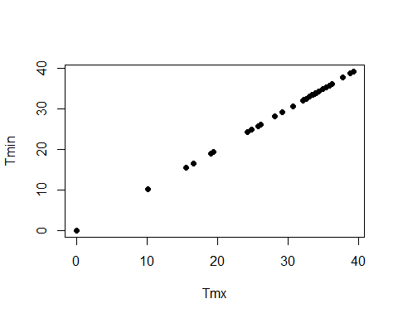

# R Lineal ----------------------------------------------------------------  
  
climas.lm <- lm (climas$Tmax ~ climas$Tmin)  
  
climas.lm # obtenemos el valor de alfa y beta

##   
## Call:  
## lm(formula = climas$Tmax ~ climas$Tmin)  
##   
## Coefficients:  
## (Intercept) climas$Tmin   
## 5.590 1.394

summary(climas.lm) # obtenemos la significancia

##   
## Call:  
## lm(formula = climas$Tmax ~ climas$Tmin)  
##   
## Residuals:  
## Min 1Q Median 3Q Max   
## -10.4456 -2.8527 0.2487 2.8256 9.4096   
##   
## Coefficients:  
## Estimate Std. Error t value Pr(>|t|)   
## (Intercept) 5.5903 2.8978 1.929 0.0635 .   
## climas$Tmin 1.3944 0.1667 8.363 3.22e-09 ***  
## ---  
## Signif. codes: 0 '***' 0.001 '**' 0.01 '*' 0.05 '.' 0.1 ' ' 1  
##   
## Residual standard error: 4.959 on 29 degrees of freedom  
## Multiple R-squared: 0.7069, Adjusted R-squared: 0.6968   
## F-statistic: 69.94 on 1 and 29 DF, p-value: 3.225e-09

climas$yprima <- 5.590 + 1.394*climas$Tmax  
climas$estimados <- climas.lm$fitted.values