Thesis Title
Subheading, if any

LAB University of Applied Sciences
Type here your degree.
Type here the graduation year.
Type here your Firstname and Lastname.
Statement about using AI
The author of this thesis, Firstname Lastname, did not use any AI tools during the preparation of the thesis.
OR
The author of this thesis, Firstname Lastname, used the following AI tools during the preparation of the thesis:
AI tool name A
Purpose of use:
Explanation of the use of the tool:

AI tool name B
Purpose of use:
Explanation of the use of the tool:

Responsibility
The author of this thesis, Firstname Lastname, takes full responsibility for the content of this thesis and has reviewed and edited the content generated by the possible use of AI tools. The author has saved all discussions with AI applications during the thesis process. Thus, the extent of the author’s own work and the use of AI can be verified if necessary.
The authenticity of this thesis has been checked with the Turnitin similarity checking software.

 |  | Abstract
Author(s)  Firstname Lastname | Type of publication  Thesis, UAS | Published in (year)  20xx
Author(s)  Firstname Lastname | Number of pages  xx
Title of the publication
Title of the Thesis
Subheading, if any
Degree, Field of Study

Commissioning organization (if the thesis is commissioned by another party)

Abstract
Type the abstract text here …
Keywords
keyword, keyword, keyword

Contents
1 Introduction 1
2 Second main section 2
2.1 First subsection 2
2.1.1 Subsection of first subsection 2
2.1.2 Second subsection of subsection 2
2.2 Second subsection 2
3 Third main section 3
3.1 First subsection 3
3.2 Second subsection 3
4 Fourth subsection 4
4.1 First subsection 4
4.2 Second subsection 4
4.3 Third subsection 4
5 Summary and discussion 5
References 6

Appendix 1. Appendix title
Appendix 2. Appendix title

- What does your test suite actually test?
my test suite primarily verifies the core functionality and reliability of the four basic arithmetic functions within the mylib module. Specifically, it tests:
- Standard Operations: It verifies that add, subtract, multiply, and divide return the mathematically correct results when provided with valid numerical inputs.
- Edge Cases & Error Handling: It specifically targets the division function to ensure that when 0 is passed as a divisor, the program actively throws a descriptive error (ZeroDivisionError) rather than silently failing or returning Infinity.
- Test Lifecycle (Hooks): It utilizes before() and after() hook functions to test the execution of code before the entire test suite begins and after it concludes, which is demonstrated via console logging.
- Crucial Code Snippets and Explanations
  - Snippet 1: Testing the Exception
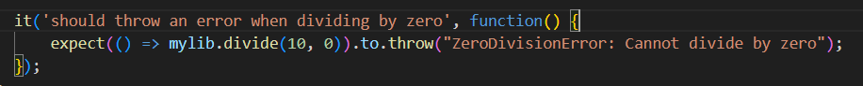
This test case uses Chai's expect assertion style to verify the error handling. Crucially, the function call mylib.divide(10, 0) is wrapped inside an anonymous arrow function () => .... If it were not wrapped, the error would be thrown immediately during execution, crashing the test. The .to.throw() assertion then intercepts the error from the arrow function and validates that the error message exactly matches the expected string.

  - Snippet 2: Handling Zero Division
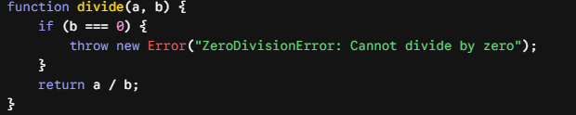
This snippet shows the implementation of the divide function. Before performing the actual division, it checks if the divisor b strictly equals 0. If it does, it explicitly throws an Error object. This prevents JavaScript from executing the mathematical division by zero (which would evaluate to Infinity) and ensures the application handles invalid operations predictably.
- Problems or Limitations of the Approach
While the current solution meets the basic requirements, it has the following limitations:
- Lack of Type Checking: Because JavaScript is dynamically typed, the module does not validate whether the inputs are actual numbers. For instance, mylib.add("5", 3) would return the string "53" instead of the number 8.
- Floating-Point Precision Issues: JavaScript has inherent limitations with floating-point arithmetic (e.g., 0.1 + 0.2 does not exactly equal 0.3). The current library does not implement any rounding or precision correction mechanisms.
- Limited Test Coverage: Currently, there is only one test case per mathematical operation. For a production-grade library, the test suite should be expanded to include negative numbers, extremely large values, and decimal inputs to ensure broader robustness.

References
Act 123/20XX.
Organisation’s name. 2026. Title of the article on the organisation’s website. Retrieved on day month year. Available at https://webaddress
Surname, A., Surname, B. & Surname, C. 2022. Title of book. Location of publisher: Name of publisher.
Surname, D. 2023. Title of book. Audiobook. Location of publisher: Name of publisher.
Surname, E. & Suname, F. 2020. Title of journal article. Name of journal. Volume/Issue (e.g., Vol. 13 (8)), page numbers. Available at DOI 10.3390/jrfm13080166
Surname, G. 2024. Title of article in a compilation. In Surname, H. (Ed.) Title of compilation. Location of publisher: Name of publisher, page numbers of the article (e.g., 171-190).
Title of publication 2025. Location of publisher: Name of publisher.

