

Tribhuvan University
Faculty of Humanities and Social Sciences

Online Food Ordering System for Cafe
A Project Report

Submitted to
Department of Computer Application
Shahid Smarak College

In partial fulfillment of the requirements of the Bachelors in Computer Application

Submitted by
Name: Luzan Maharjan
TU Registration no: 6-2-262-5-2019
September, 2022

Under the Supervision of
Mr. Himal Raj Gentil


Tribhuvan University
Faculty of Humanities and Social Sciences
Shahid Smarak College

Supervisor’s Recommendation

I hereby recommend that this project prepared under my supervision by LUZAN MAHARJAN entitled “ONLINE FOOD ORDERING SYSTEM OF CAFE” in partial fulfillment of the requirements for the degree of Bachelor of Computer Application is recommended for the final evaluation.

…………………
SIGNATURE
Mr. Himal Raj Gentil
SUPERVISOR
Shahid Smarak College
Kirtipur, Nayabazar


Tribhuvan University
Faculty of Humanities and Social Sciences
Shahid Smarak College

LETTER OF APPROVAL

This is to certify that this project prepared by LUZAN MAHARJAN entitled “ONLINE FOOD ORDERING SYSTEM OF CAFE” in partial fulfillment of the requirements for the degree of Bachelor in Computer Application has been evaluated. In our opinion it is satisfactory in the scope and quality as a project for the required degree.

………………….  Mr. Himal Raj Gentil  Supervisor  Shahid Smarak College  Kirtipur, Nayabazar | ………………….  Mr. Sanjay Jnawali  Coordinator  Shahid Smarak College  Kirtipur, Nayabazar
………………….  Internal Examiner | ………………….  External Examiner
Acknowledgement

My earnest appreciation to the Supervisor Mr. Himal Raj Gentil for directing me all through the arranging and advancement period of the framework. Without his vital role and direction, I would not have achieved the last phase of the improvement.
I would like to thank my close peers and classmates for being supportive and encouraging throughout the project development journey here in Shahid Smarak College. My sincere gratitude goes to Shahid Smarak College for providing the platform where I was able to cherish and nurture my compassion and improve my technical skills. Much appreciation to Shahid Smarak College for great support and all necessary academic materials that has taught me great helpful academic as well as life lessons.
Finally, yet importantly, I would like to thank my family. Their endless support has been unconditional. Their hopes and faith on me had me keep going even when the days were challenging.

Yours Sincerely,
Luzan Maharjan

Abstract

The world is changing thanks to the enormous growth of Information and Communication Technology. E-commerce Site is looking to develop a state of online food ordering system which is able to track customer details and make helpful history. The goal of Online Food Ordering System is to mechanize the prevailing manual system by the assistance of computerized equipment’s and developed computer application, fulfilling their needs in order that their valuable data/information may be hold on for an extended period with simple retrieving and handling of the identical. Online Food Ordering System is the system used by a small cafe to provide services such as online ordering as well as delivery. It is also designed to provide better and quick services to the customers. This system helps to save your time and attract the new and existing customers. This system also helps as a marketing scope for the cafe. This system has its own delivery system. It doesn’t use third party applications for delivery services so this system is fully trust worthy and reliable.

Table of Contents

1. Chapter 1 Introduction 1
1.1. Introduction to the Proposed project 1
1.2. Problem Statement 1
1.3. Objectives 1
1.4. Scope and Limitation 2
1.5. Report Organization 2
2. Chapter 2 Background study and Literature Review 3
2.1. Background study 3
2.2. Literature review 5
3. Chapter 3 System Analysis and Design 6
3.1. System Analysis 6
3.1.1. Requirement Analysis 8
3.1.2. Feasibility Analysis 9
3.1.3. Data Modeling (ER-Diagram) 10
3.1.4. Process Modeling (DFD) 11
3.2. System Design 12
3.2.1. Architectural Design 12
3.2.2. Database Schema Design 13
3.2.3. Interface Design 18
3.2.4. Physical DFD 19
4. Chapter 4 Implementation and Testing 20
4.1. Implementation 20

4.1.1. Tools used 21
4.1.2. Implementation Details of Modules 23
4.2. Testing 24
4.2.1. Test Cases for Unit Testing 27
4.2.2. Test Cases for System Testing 27
5. Chapter 5 Conclusion and Future Recommendation 28
5.1. Lesson Learnt/ Outcome 28
5.2. Conclusion 28
5.3. Future Recommendation 29
References 31
Appendix 38

Table of Figures

Figure 1: Himalayan Java Home Page 3
Figure 2: Himalayan Java About Page 4
Figure 3: Himalayan Java Contact Page 4
Figure 4: Starbucks Home Page 5
Figure 5: Starbucks Menu Page 5
Figure 6: Waterfall Model 6
Figure 7: Admin Use Case 7
Figure 8: User Use Case 8
Figure 9: Gannt Chart 9
Figure 10: ER-Diagram of Jhhigu:cafe 10
Figure 11: Context level DFD 11
Figure 12: DFD level 1 11
Figure 13: Two Tier Architecture 12
Figure 14: Database Schema of Jhhigu:cafe 13
Figure 15: Home Page of Jhhigu:cafe (Interface Design) 15
Figure 16: Gallery Page of Jhhigu:cafe (Interface Design) 15
Figure 17: Menu Page of Jhhigu:cafe (Interface Design) 16
Figure 18: Review Page of Jhhigu:cafe (Interface Design) 16
Figure 19: Login Page of Jhhigu:cafe (Interface Design) 17
Figure 20: Registration Page of Jhhigu:cafe (Interface Design) 17
Figure 21: About Page of Jhhigu:cafe (Interface Design) 18
Figure 22: Admin Dashboard Page of Jhhigu:cafe (Interface Design) 18
Figure 23: Physical DFD of Jhhigu:cafe 19
Figure 24: Home Page of Jhhigu:cafe 32
Figure 25: Menu Page of Jhhigu:cafe 33
Figure 26: Gallery Page of Jhhigu:cafe 33
Figure 27: Review Page of Jhhigu:cafe 33
Figure 28: About Page of Jhhigu:cafe 34
Figure 29: Order Page of Jhhigu:cafe 34
Figure 30: Search Page of Jhhigu:cafe 34
Figure 31: Cart Page of Jhhigu:cafe 35
Figure 32: Login Page of Jhhigu:cafe 35
Figure 33: Registration Page of Jhhigu:cafe 36
Figure 34: Admin dashboard Page of Jhhigu:cafe 36
Figure 35: Add products Page of Jhhigu:cafe 37
Figure 36: Accounts Page of Jhhigu:cafe 37
Figure 37: Placed Order Page of Jhhigu:cafe 38

List of Tables
Table 1: Register page test case 24
Table 2: Login page test case for user 25
Table 3: Login page test case for admin 25
Table 4: Search page test case 26
Table 5: Add products page test case 26
Table 6: Shopping cart page test case 27

Chapter 1 Introduction
  - . Introduction of Proposed project
These days internet has played a vital role to access lots of things i.e., physical object as well as virtual object. With the help of growing web applications, it is now easier to buy and sell anything from anywhere to anybody. For this semester’s project, I’ve concluded in developing “Online Food Ordering System for a Cafe”.
Although there are lots of food delivery system in Nepal but we are developing our own online ordering as well as delivery system. With the help of this system, customers don’t require to access other third-party delivery system. This system also includes cafeteria website, user account as well as admin account. Cafeteria website will be aided as marketing.
  - . Problem Statement
Due to various food ordering system in Nepal, it is harder for customers to choose the third-party food ordering system which have following traits.
- Consuming lots of time.
- Third party food ordering system is expensive to use.
- Cannot be always trust worthy.

  - . Objectives
- Easy to use for both Customer(ordering) as well as Cafe Administrator (visible flow of data).
- Also, will be helpful in regard to the Marketing, since everyone these days do have internet access on their fingertips.
- Remove the human error as well as miscalculations.
- Trustworthy delivery system for the customers.

  - . Scope and limitation
Scope
- Easier system to use for any age group.
- Reliable for customers since, we are owning our own ordering as well as delivery system.
Limitation
- Tracking of food delivery isn’t available.
- This system doesn’t focus on cafeteria inventory system.
- This system can’t specify the time consumed during the delivery.
  - . Report Organization
This report document contains five chapters including this chapter. Chapter two defines and describes Background Study and Overview of related existing systems and their pros and cons. Chapter three presents the System Analysis and Design including Requirement Analysis and Feasibility Analysis. Chapter four presents the Implementation, Testing and debugging are explained. In Chapter five, Conclusion, Limitations and Future Enhancement are briefly explained.

Chapter 2 Background study and Literature Review
2.1. Background study
To research about this project, I went to the cafe named “Jhhigu:cafe” and interviewed the cafe owner. The owner then stated about the present situation of his cafe. This cafe doesn’t have its own online ordering as well as food delivery system.
2.2. Literature review
Although there are lots of third-party delivery system, it is much more viable to have own ordering as well as delivery system for the customers. For this cafe customers satisfaction is the prior thing, that’s the reason why this cafe owner came up with an idea of developing its own system. It also protects the customers information being handed to third-party.
Himalayanjava.com
Himalayan Java Coffee Beans are grown locally and are roasted to perfection in the ideal Himalayan air. It is then packaged immediately and rushed off to our outlets which ensures we deliver the best coffee experience possible for all of our customers.[1]
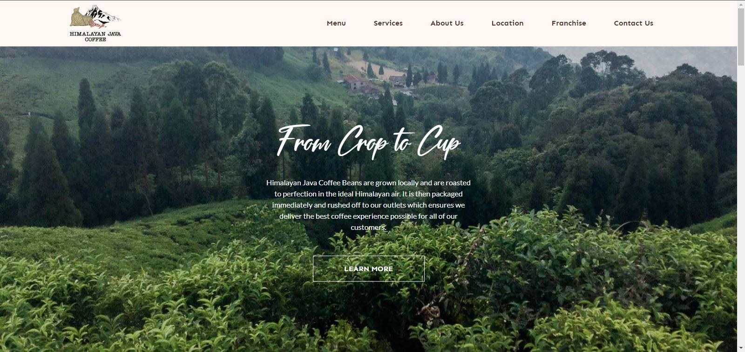
Figure 1: Himalayan Java Home Page
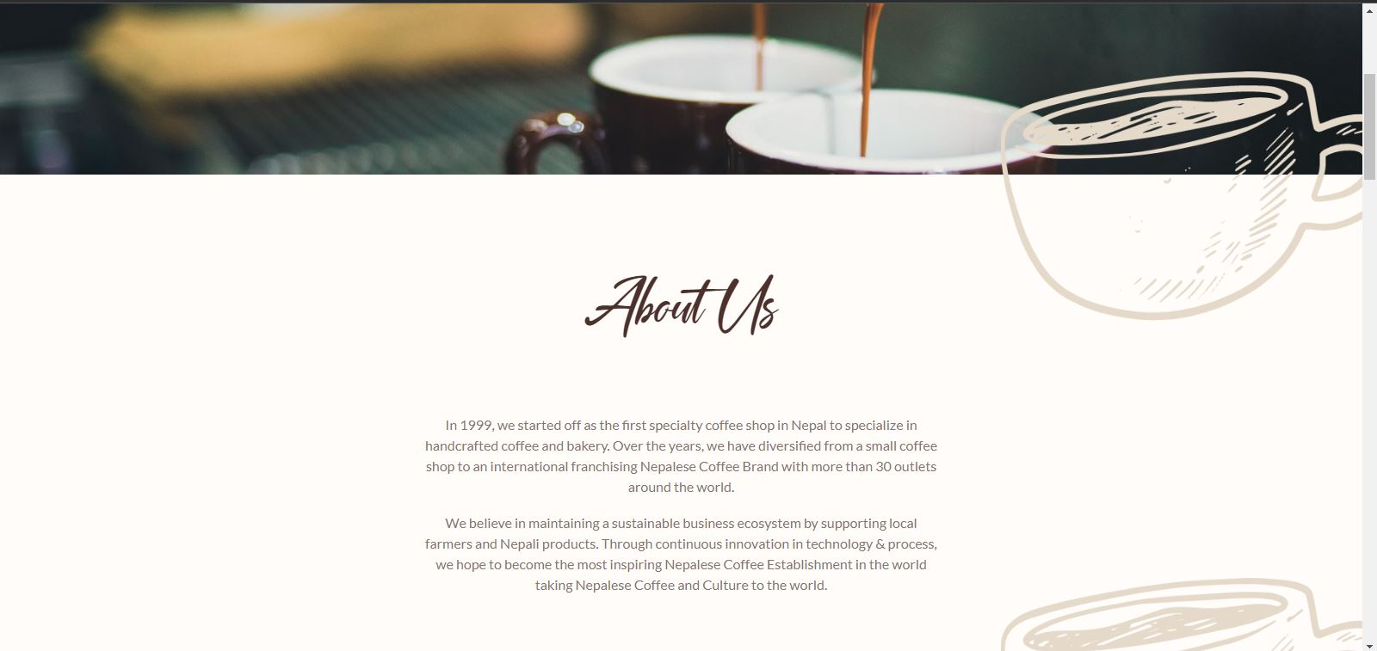
Figure 2: Himalayan Java About Page

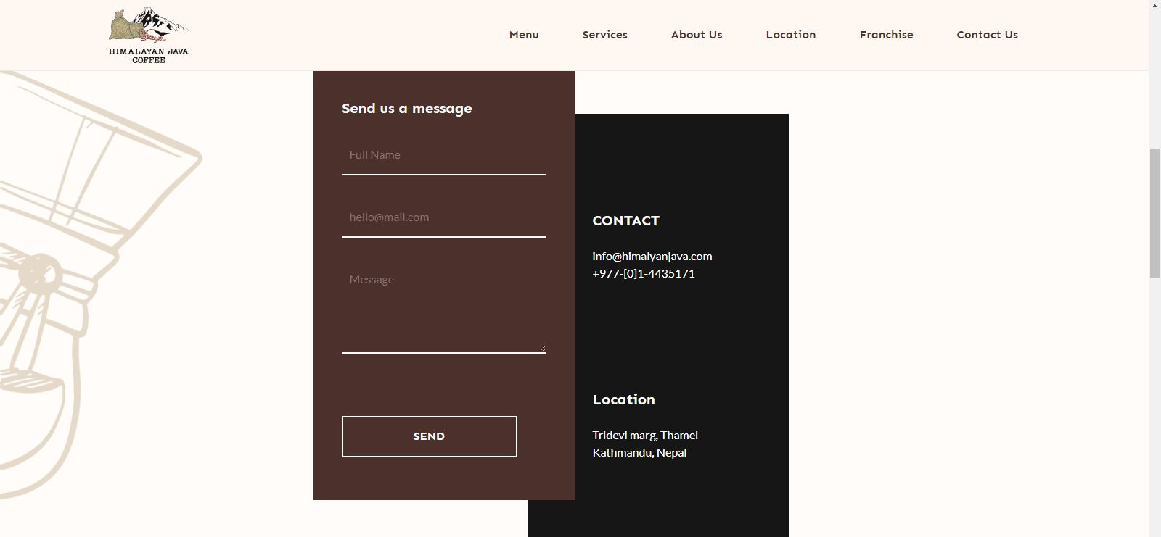

Figure 3: Himalayan Java Contact Page

Starbucks.com
Starbucks Corporation is an American multinational chain of coffeehouses and roastery reserves headquartered in Seattle, Washington. It is the world's largest coffeehouse chain. As of November 2021, the company had 33,833 stores in 80 countries, 15,444 of which were located in the United States. [2]
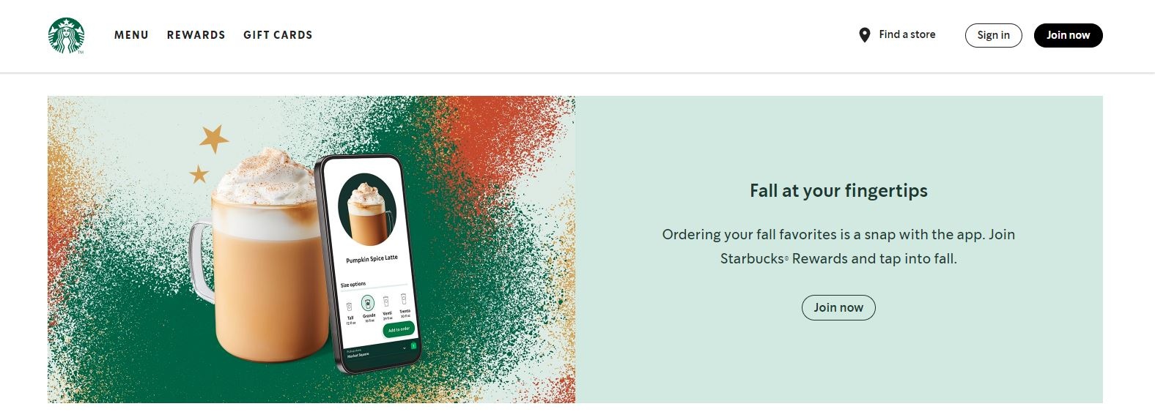
Figure 4: Starbucks home page
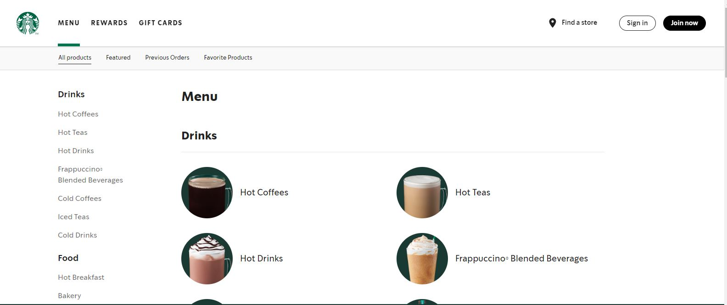
Figure 5: Starbucks menu page

Chapter 3 System Analysis and Design
3.1. System Analysis
Systems analysis is the process by which an individual (s) studies a system such that an information system can be analyzed, modeled, and a logical alternative can be chosen. Systems analysis projects are initiated for three reasons: problems, opportunities, and directives. The process by which systems are developed can be described by the systems development life cycle. This is the initial phase for any software being developed in waterfall software development model.[3]
This system will be following the waterfall software development methodology [4]. As shown in the figure below, we will be developing the system in five different phases.
- Analysis
- Design
- Implementation
- Testing
- Maintenance
In this methodology, while working in one phase another phase isn’t touch before completing previous one. While jumping into another phase we should go thoroughly about the previous phase, which helps to understand the system.
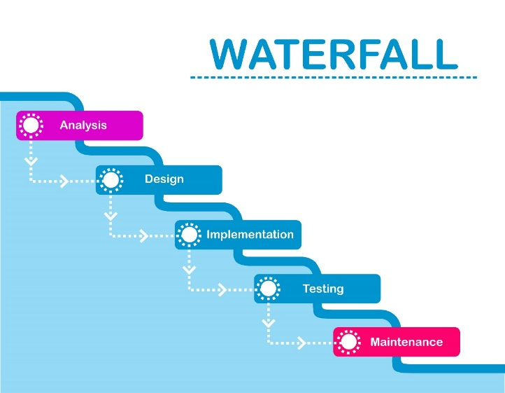
Figure 6: Waterfall Model
3.1.1. Requirements Analysis
This system needs the following functional and non-functional requirements.
- Functional requirements.
- Customer can order food as well as delivered as quickly as possible.
- This system includes search engine for the customer.
- Admin can view the information of the user when the user orders food.
- Admin have full control over the menu, create new menu, delete menu as well as put the menu out of stock.
A use case is a methodology used in system analysis to identify, clarify and organize system requirements. The use case is made up of a set of possible sequences of interactions between systems and users in a particular environment and related to a particular goal. The method creates a document that describes all the steps taken by a user to complete an activity.[5]

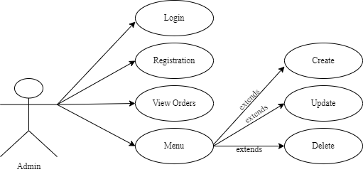
Figure 7: Admin Use Case
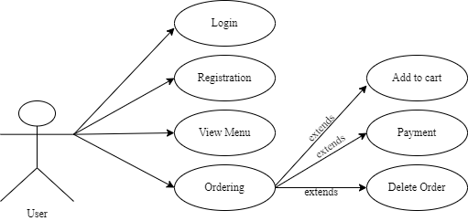
Figure 8: User Use Case

- Non-Functional requirements.
- Availability
This system is available through online. The users can easily access anytime, anywhere just through a smartphone or a PC and an internet connection.
- Security
The user’s information isn’t shared to others. Only authorized users can access the system with username and password.
- Performance
This system is designed for smooth performance with good optimization and good response.
- Reliability
This system will be reliable for the users. The system will run 24/7.

3.1.2. Feasibility Analysis
A feasibility study is simply an assessment of the practicality of a proposed project plan or method. This is done by analyzing technical, economic, legal, operational and time feasibility factors.[6]
Following feasibilities were studied before building the system:
- Technical Feasibility:
In order to design this system, it uses existing technologies, software and hardware so there are no technological difficulties in building this system.
- Economic Feasibility:
This system doesn’t require extra software and hardware i.e., it uses open-source technologies. So, there is no extra cost rather than internet.
- Operational Feasibility:
This system uses simple technologies to design. So, it is user friendly.
- Schedule Feasibility:
This assessment is the most important part for project success; after all, a project will fail if not completed on time.
In this project, Gantt Chart is used for Schedule feasibility study.
Gantt Chart
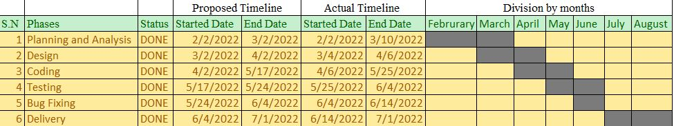Figure 9: Gantt Chart
In the above Gantt Chart, it shows the start and finish dates of the project elements such as planning and analysis, design, coding, testing, bug fixing, delivery. It clearly shows that the project started from February 2 and ended on August 1. It almost took 6 months to complete the whole project.
3.1.3. Data Modeling (ER-Diagram)
ER Diagram stands for Entity Relationship Diagram, also known as ERD is a diagram that displays the relationship of entity sets stored in a database. In other words, ER diagrams help to explain the logical structure of databases. ER diagrams are created based on three basic concepts: entities, attributes and relationships.[7]
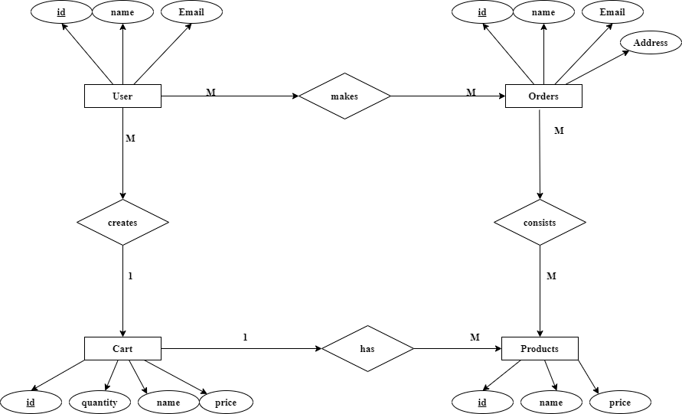
Figure 10: ER-Diagram of Jhhigu:cafe
3.1.4. Process Modeling (DFD)
A Data Flow Diagram (DFD) is a graphical representation of the “flow” of data through an information system, modeling its process aspects. Often it is a preliminary step used to create an overview of the system that can later be elaborated. DFDs can also be used for the visualization of data processing (structured design) and show what kind of information will be input to and output from the system, where the data will come from and go to, and where the data will be stored. It does not show information about the timing of processes or information about whether processes will operate in sequence or in parallel.[8]

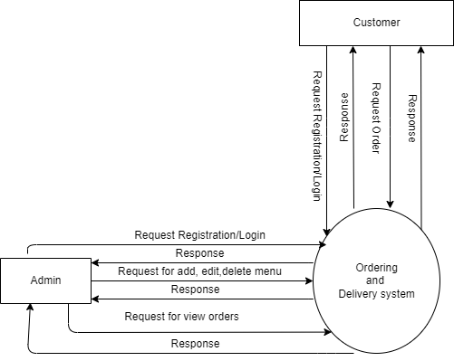
Figure 11: Context Level DFD

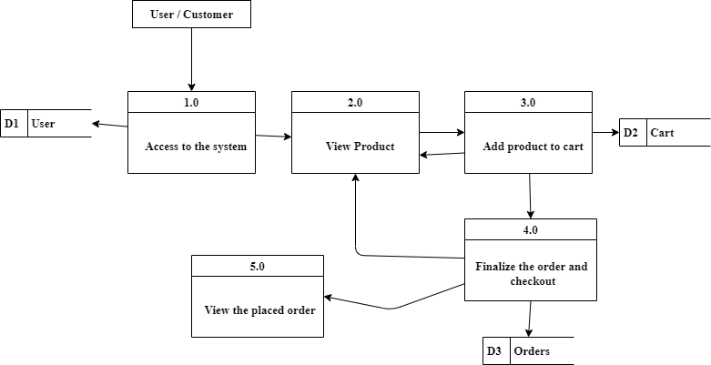
Figure 12: DFD Level 1

3.2 System Design
System Design is the process of designing the architecture, components, and interfaces for a system so that it meets the end-user requirements. System Design for tech interviews is something that can’t be ignored! Almost every IT giant whether it be Facebook, Amazon, Google, or any other ask various questions based on System Design concepts such as scalability, load-balancing, caching, etc. in the interview. This specifically designed System Design tutorial will help you to learn and master System Design concepts in the most efficient way from basics to advanced level.[9]
3.2.1 Architectural Design
This phase of design will be planning the architecture of the application. There will be in some cases a separation of the user interface and data. The business layer will be totally independent and not embedded in the views of the website. Data will be stored in an SQL database. To query the database and code behind for server-side scripting will be in PHP. The other business objects will have their own layer. The architecture of the application is shown in the figure below:
Presentation Logic

Business Logic

Database Driver

Tire Boundary

Database

Figure 13: Two Tier Architecture
3.2.2 Database Schema Design
A database schema is the skeleton structure that represents the logical view of the entire database. It defines how the data is organized and how the relations among them are associated. It formulates all the constraints that are to be applied on the data. A database schema defines its entities and the relationship among them. It contains a descriptive detail of the database, which can be depicted by means of schema diagrams. It’s the database designers who design the schema to help programmers understand the database and make it useful.[10]

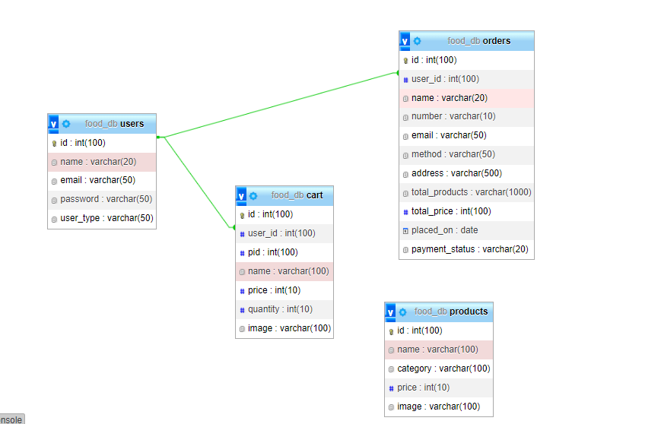
Figure 14: Database Schema Design of Jhhigu:cafe

3.2.3 Interface Design
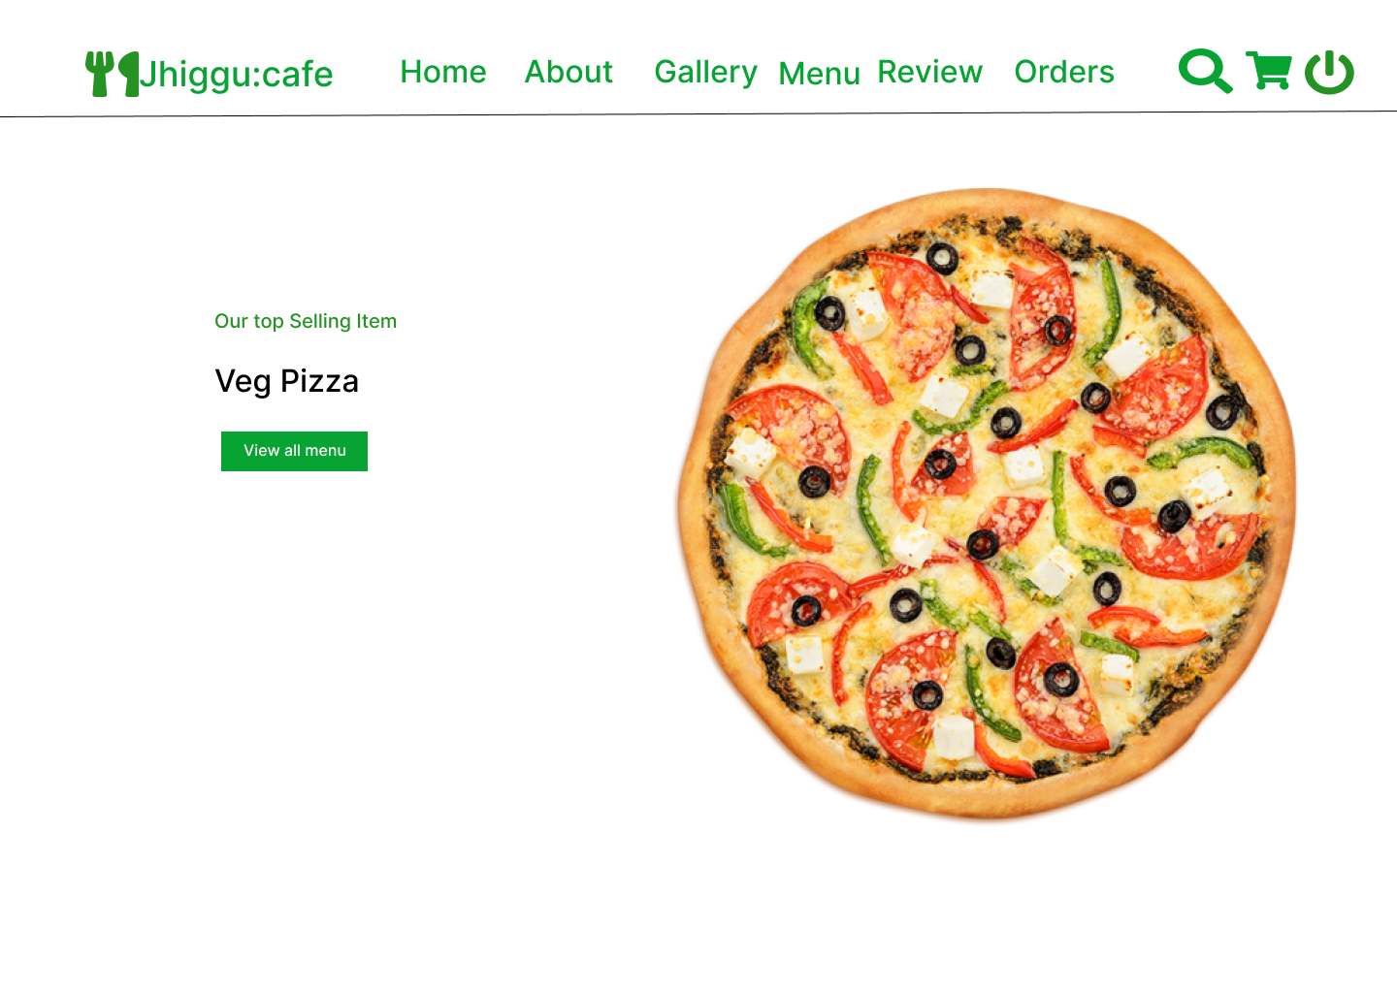
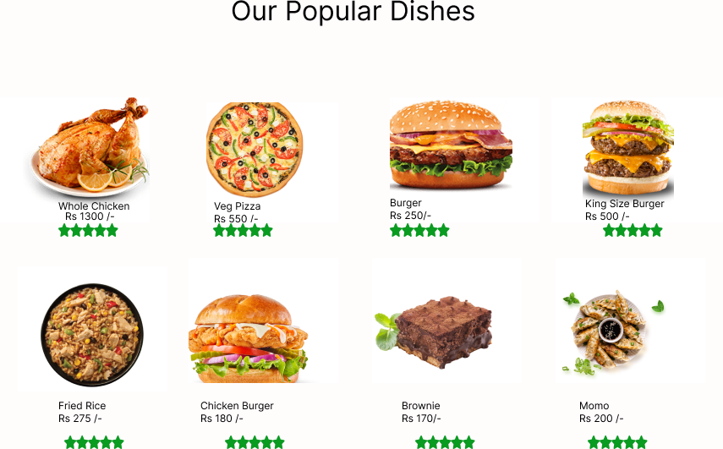
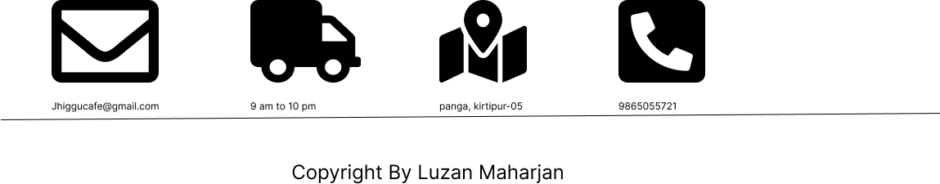
Figure 15: Home page of Jhiggu:cafe(Interface Design)
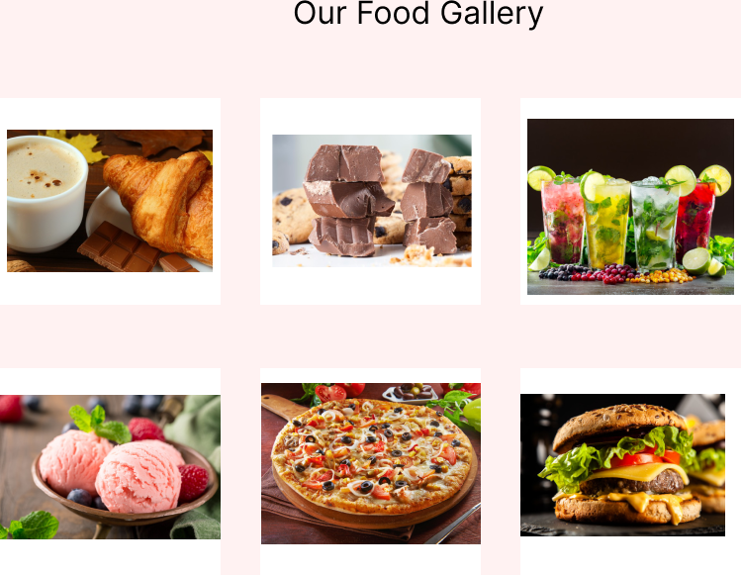
Figure 16: Gallery page of Jhiggu:cafe(Interface Design)
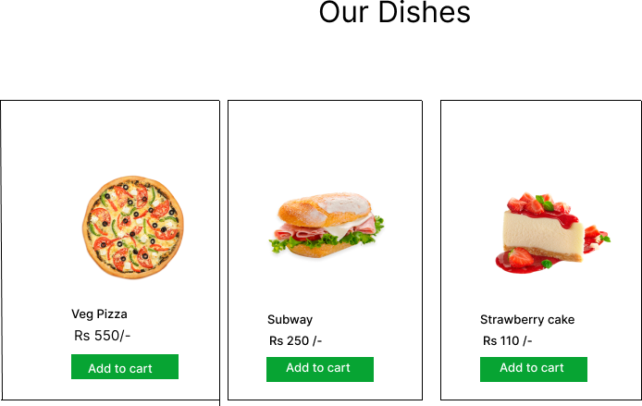
Figure 17: Menu Page of Jhiggu:cafe (Interface Design)

Figure 18: Review page of Jhiggu:cafe(Interface Design)
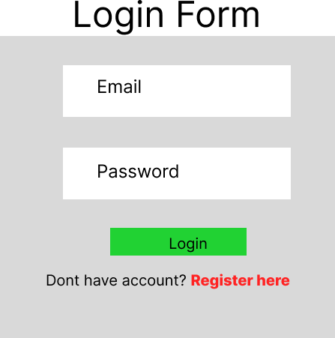
Figure 19: Login Page of Jhiggu:cafe (Interface Design)
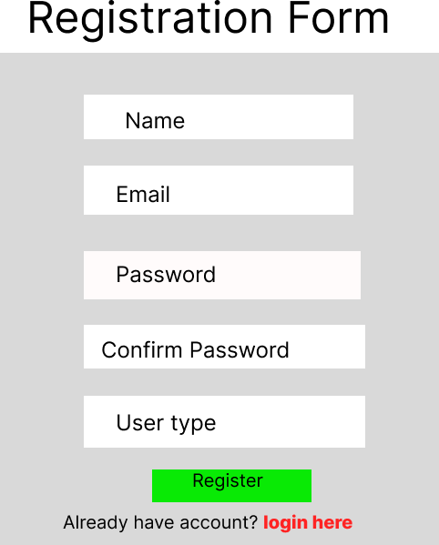
Figure 20: Registration Page of Jhiggu:cafe (Interface Design)
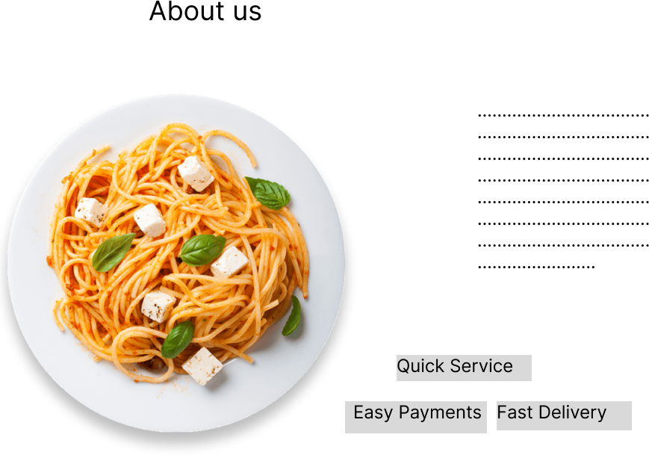
Figure 21: About Page of Jhiggu:cafe (Interface Design)
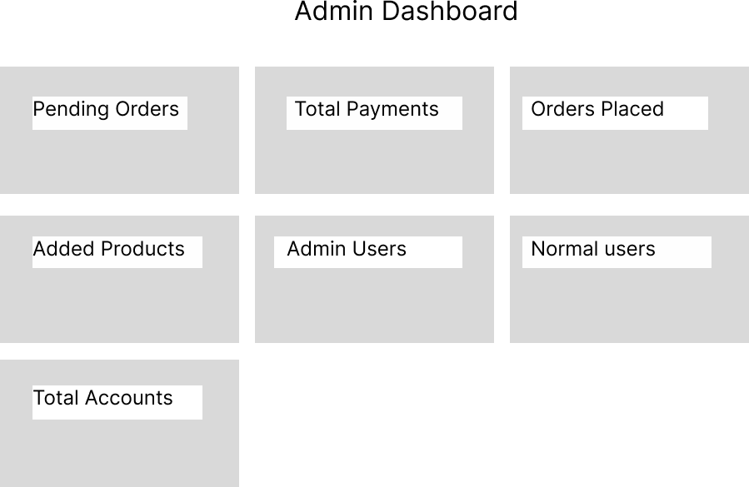
Figure 22: Admin Dashboard Page of Jhiggu:cafe (Interface Design)

3.2.4. Physical DFD

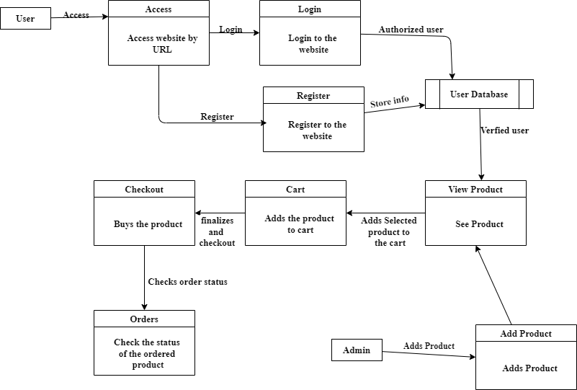

Figure 23: Physical Level DFD of Jhiggu:cafe
Physical data flow diagram shows how the data flow is implemented in the system. Physical DFD is more specific and closer to implementation.

Chapter 4: Implementation and Testing
4.1 Implementation
Implementation includes user notification, user training, installation of hardware, installation of software onto production computers, and integration of the system into daily work processes. This phase continues until the system is operating in production in accordance with the defined user requirements.[11]
4.1.1Tools Used
The various system tools that have been used in developing both the frontend and backend have been discussed in this chapter.
FRONT END
HTML, CSS, JavaScript, Font awesome, Figma and PHP.
HTML
The Hyper Text Markup Language or HTML is the standard markup language for documents designed to be displayed in a web browser.[12]
CSS
Cascading Style Sheets (CSS) is a style sheet language used for describing the presentation of a document written in a markup language.[13]
JavaScript
JavaScript is a lightweight, interpreted programming language. It is designed for creating network-centric applications. It is complimentary to and integrated with Java. JavaScript is very easy to implement because it is integrated with HTML. It is open and cross-platform.[14]
Figma
Figma is the designing tool used to design the interface of the following project.

PHP
The PHP Hypertext Preprocessor (PHP) is a programming language that allows web developers to create dynamic content that interacts with databases. PHP is basically used for developing web-based software applications. This tutorial helps you to build your base with PHP.[15]
Font Awesome
Font Awesome is the Internet's icon library and toolkit, used by millions of designers, developers, and content creators.[16]

BACK END
The back end is implemented using MySQL which is used to design database.
MySQL
MySQL is the most popular Open-Source Relational SQL database management system. MySQL is one of the best RDBMS being used for developing web-based software applications.[17]
4.1.2 Implementation Details of Modules
After the design was made and the problems arising from the design process were clarified and dealt with, it was time to start implementing the application. Implementing application this scale requires lots of resources and explaining the whole implantation process will not be clarified in this paper. However major important aspects in the implementation will described. Some modules of the shopping websites are listed below:
- Header: It shows the name of the cafe. The navbar is used in order to provide links to other pages.
- Register Form: It is used to register new users to the website. It contains the text field like email, username, password and confirm password. The information entered is further stored to be used in the login page.
mysqli_query($conn, "INSERT INTO `users`(name, email, password, user_type) VALUES('$name', '$email', '$cpass', '$user_type')") or die('query failed');
$message[] = 'registered successfully!';
- Login Form: It is used to provide the user the gateway to website. It uses data like username and password from register form to authenticate the user and give further access.
$row = mysqli_fetch_assoc($select_users);
if($row['user_type'] == 'admin'){
$_SESSION['admin_name'] = $row['name'];
$_SESSION['admin_email'] = $row['email'];
$_SESSION['admin_id'] = $row['id'];
header('location:dashboard.php');
}elseif($row['user_type'] == 'user'){
$_SESSION['user_name'] = $row['name'];
$_SESSION['user_email'] = $row['email'];
$_SESSION['user_id'] = $row['id'];
header('location:home.php');
}
- Menus: It shows the food items available in the cafe.
<?php
$select_products = mysqli_query($conn, "SELECT * FROM `products`") or die('query failed');
if(mysqli_num_rows($select_products) > 0){
while($fetch_products = mysqli_fetch_assoc($select_products)){
?>
- Cart: It displays the quantity of products and the prices of the products to be bought by the user.
<?php
$select_cart_number = mysqli_query($conn, "SELECT * FROM `cart` WHERE User_id = '$user_id'") or die('query failed');
$cart_rows_number = mysqli_num_rows($select_cart_number);
?>
- Checkout: It is to verify the details before finalizing the order.
mysqli_query($conn, "INSERT INTO `orders`(user_id, name, number, email, method, address, total_products, total_price, placed_on) VALUES('$user_id', '$name', '$number', '$email', '$method', '$address','$total_products', '$cart_total', '$placed_on')") or die('query failed');
$message[] = 'order placed successfully!';
mysqli_query($conn, "DELETE FROM `cart` WHERE user_id = '$user_id'") or die('query failed');
- Search: It searches the items you wish to order.
<?php
if(isset($_POST['submit'])){
$search_item = $_POST['search'];
$select_products = mysqli_query($conn, "SELECT * FROM `products` WHERE name LIKE '%{$search_item}%'") or die('query failed');
if(mysqli_num_rows($select_products) > 0){
while($fetch_product = mysqli_fetch_assoc($select_products)){
?>
- Admin Module: It provides information to the admin. It provides information like user detail, Admin can add, edit or remove products.
4.2. Testing
Testing is done to check the behavior of a complete and fully integrated software product based on the software requirement specification document. For the application or website to be deployed it has to be tested. Hence test cases will be written to test this application. They are many types of tests to be carried out on a web application from performance, functionality, database loading time, response time, server time handling, user's actions and many others. We will not carry out all types of tests for the application considering the time scale to present this project. Hence performance check related to upload time, memory usage will be part of a future test. We will focus the test cases on functionality, security and performance So that various types of testing procedures were performed in order to check the working mechanism and correctness of the system.
4.2.2 Test Case for Unit Testing
Register page test case
ID | Test Case Description | Test Data | Expected Result | Actual Result | Pass/Fail
1 | User enters an invalid email | Email: luzangmail.com  Password:0706 | **  Invalid email** | As expected, | Pass
2 | User enters a wrong password | Email: luzan@gmail.com  Password:0706  Confirm password:1111 | **Password didn’t match | As expected, | Pass
3 | User enters valid email and password | Email: luzan@gmail.com  Password: 0706 | Logged into login page | As expected, | Pass
Table 1: Register page test case
Login Page Test Case for User
ID | Test Case Description | Test Data | Expected Result | Actual Result | Pass/Fail
1 | User enters a wrong email | Email: luz@gmail.com  Password:0706 | **  The email is not found** | As expected, | Pass
2 | User enters a wrong password | Email: luzan@gmail.com  Password:1515 | **Password is incorrect** | As expected, | Pass
3 | User enters valid email and password | Email: luzan@gmail.com  Password: 0706 | Logged into Home page | As expected, | Pass
Table 2: login page test case for user
Login Page Test Case for Admin
ID | Test Case Description | Test Data | Expected Result | Actual Result | Pass/Fail
1 | Admin enters a wrong email | Email: luz@gmail.com  Password:0706 | **  Incorrect Email or Password** | As expected, | Pass
2 | Admin enters a wrong password | Email: luzan@gmail.com  Password:1515 | **  Incorrect Email or Password** | As expected, | Pass
3 | Admin enters valid email and password | Email: luzan@gmail.com  Password: 0706 | Logged into Admin page | As expected, | Pass
Table 3: login page test case for admin
Search Page Test Case
ID | Test Case Description | Test Data | Expected Result | Actual Result | Pass/Fail
1 | User enters a product name | burger | Displays the product details | As expected, | Pass
2 | User enters a wrong information | book | No result found | As expected, | Pass
Table 4: search page test case
Add Products Page Test Case
ID | Test Case Description | Test Data | Expected Result | Actual Result | Pass/Fail
1 | Admin does not upload the picture | Name: burger  Price:120 | Please fill all the information | As expected, | Pass
2 | Admin enters product name, price and image | Name: burger  Price:120  Image: burger.png | Product added successfully | As expected, | Pass
Table 5: Add products page test case
Shopping Cart Page Test Case
ID | Test Case Description | Expected Result | Actual Result | Pass/Fail
1 | User again adds the product to the cart | **  Product already added** | As expected, | Pass
2 | User deletes the product from the cart | **  Your cart is empty ** | As expected, | Pass
3 | User provides details and quantity correctly | Checkout successful | As expected, | Pass
Table 6: Shopping cart page test case
4.2.2 Test Case for System Testing
- Verify that all the specified fields are present on the registration page.
- Verify that for better user interface dropdowns, radio buttons and checkboxes, etc. fields are displayed wherever possible instead of just textboxes.
- Verify that clicking submits button after entering all the required fields, submits the data to the server.
- Verify that not filling the optional fields and clicking the submit button will still send data to the server without any validation error.
- Check validation on the date and email fields (only valid dates and valid email Ids should be allowed.
- Check validation on numeric fields by entering alphabets and special characters.

Chapter 5 Conclusion and Future Recommendations
5.1. Lesson Learnt/ Outcome
When the project is completed, the users will be able to order different varieties of food just by staying home. After registering, user can view and buy different food items through web browser. User can easily add and remove from the cart.
5.2. Conclusion
My goal was to create an application where the cafe has its own ordering as well as delivery system. The current application has fulfilled these goals. I followed the specifications strictly but enhanced some of the features when there was need for it to be done. With the goals achieved the basis of the application and this project has been achieved. Building this web application has been challenging and enriching because throughout the project I learnt a lot about PHP, JavaScript, Figma and understand what it takes to build a fully functional website. There have been challenges especially when it came to backend and making sure to make application responses in a predictable. Careful planning made the job easier because we had to carefully think about the type of architecture, the design, the database types to use and what type of business object to create. When this was done, implementation was started.
Choosing PHP for this project is because it is very simple and easy to use, compared to another scripting language, this is widely used all over the world. It is Open source; we can freely download and use it. And it is platform independent as well.
5.3. Future Recommendations
Here is what can be added in the future on this website to increase its usability, user experience and portability of the website. It will need more time and resources for all these to be done but is still very realistic and possible to achieve.
- Add payment gateways,
- Add categories for foods,
- Add preview of cafe, foods,
- Add customer review section,
- Add own delivery users account,
- Add profile panel to update the user data
- Add edit profile data
- Add Change password

References
[1] himalayan Java. (n.d.). Himalayan Java. https://www.himalayanjava.com/
[2] Starbucks Coffee Company. (n.d.). Starbucks. https://www.starbucks.com/
[3] waterfall model. (n.d.). [Jpg]. Waterfall Model. https://agilewolfs.com/what-is-waterfall/
[4] Barrier, T. (2003). System analyis. System Analyis, 1. https://www.sciencedirect.com/topics/computer-science/system-analysis#:~:text=Systems%20analysis%20is%20the%20process,problems%2C%20opportunities%2C%20and%20directives.
[5] Bridges, J. (2021, October 8). What Is a Feasibility Study? How to Conduct One for Your Project. Project Manager. https://www.projectmanager.com/training/how-to-conduct-a-feasibility-study
[6] Gannt Chart. (n.d.). Gannt Chart. https://www.gantt.com/
[7] Peterson, R. (2022, August 25). Entity Relationship (ER) Diagram Model with DBMS Example. Guru99. https://www.guru99.com/er-diagram-tutorial-dbms.html
[8] Barrier, T. (2003). System analysis. System Analysis, 1. https://www.sciencedirect.com/topics/computer-science/system-analysis#:~:text=Systems%20analysis%20is%20the%20process,problems%2C%20opportunities%2C%20and%20directives.
[9] GeeksforGeeks. (2021, November 15). System Design Tutorial. https://www.geeksforgeeks.org/system-design-tutorial/
[10] Brush, K. (2020, February 14). use case. SearchSoftwareQuality. https://www.techtarget.com/searchsoftwarequality/definition/use-case
[11] DBMS - Data Schemas. (n.d.). Tutorialspoint. https://www.tutorialspoint.com/dbms/dbms_data_schemas.htm
[12] System Development Lifecycle (SDLC) | Michigan Tech Information Technology. (n.d.). Michigan Technological University. https://www.mtu.edu/it/security/policies-procedures-guidelines/information-security-program/system-development-lifecycle/
[13] Wikipedia contributors. (2022, August 8). HTML. Wikipedia. https://en.wikipedia.org/wiki/HTML
[14] Wikipedia contributors. (2022b, August 20). CSS. Wikipedia. https://en.wikipedia.org/wiki/CSS
[15] Javascript Tutorial. (n.d.). Tutorialspoint. https://www.tutorialspoint.com/javascript/index.htm
[16] PHP Tutorial. (n.d.). Tutorialspoint. https://www.tutorialspoint.com/php/index.htm
[17] font awesome. (n.d.). Fontawesome. https://fontawesome.com/
[18] MySQL Tutorial. (n.d.). Tutorialspoint. https://www.tutorialspoint.com/mysql/index.htm
[19] Figma: the collaborative interface design tool. (n.d.). Figma. Retrieved September 14, 2022, from https://www.figma.com/

Appendix
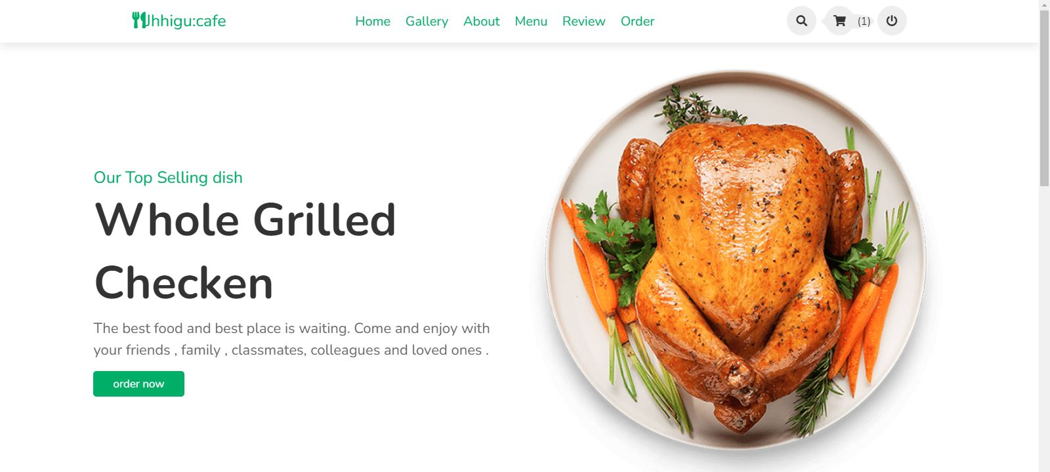
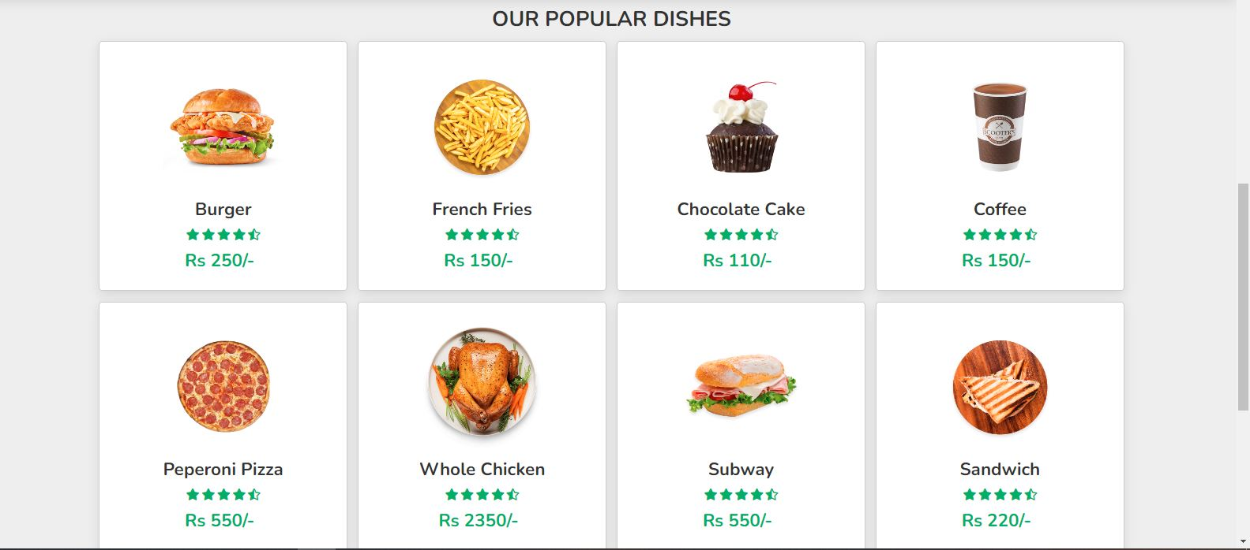
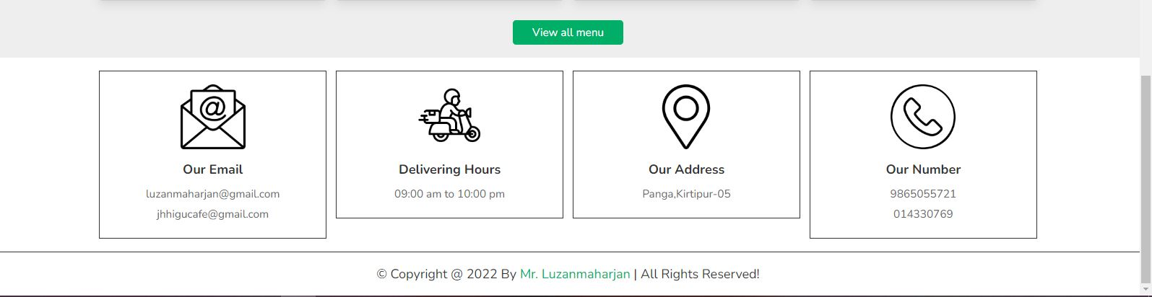
Figure 24: Home page of Jhiggu:cafe
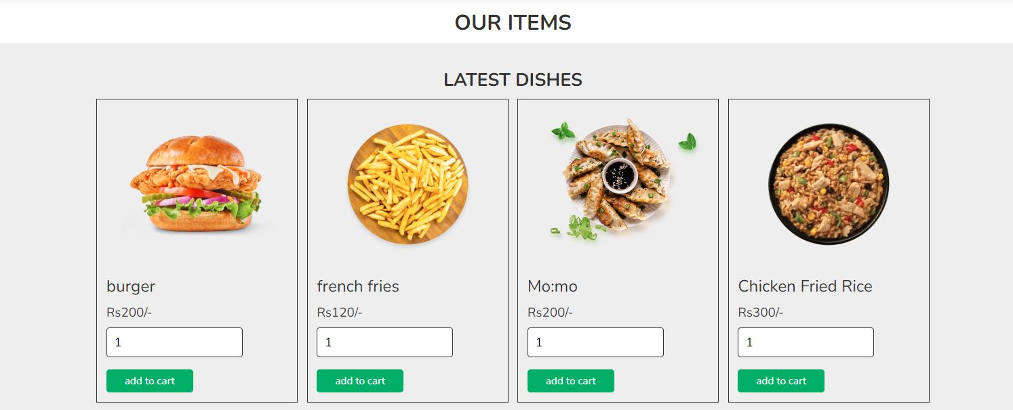
Figure 25: Menu page of Jhiggu:cafe
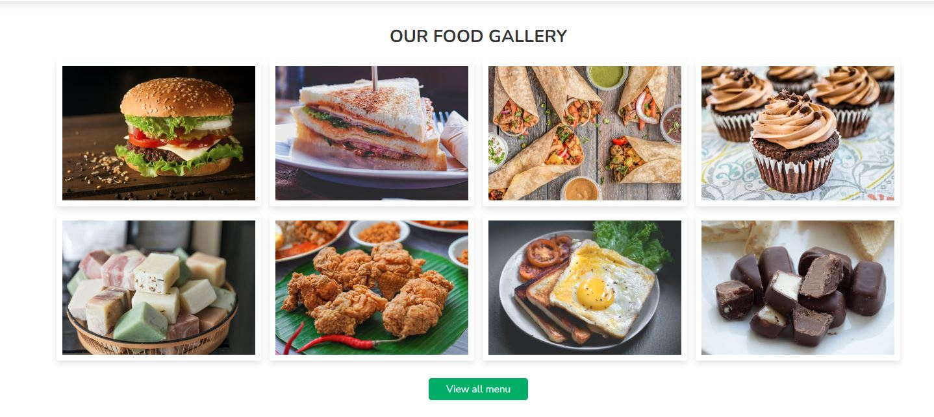
Figure 26: Gallery page of Jhiggu:cafe
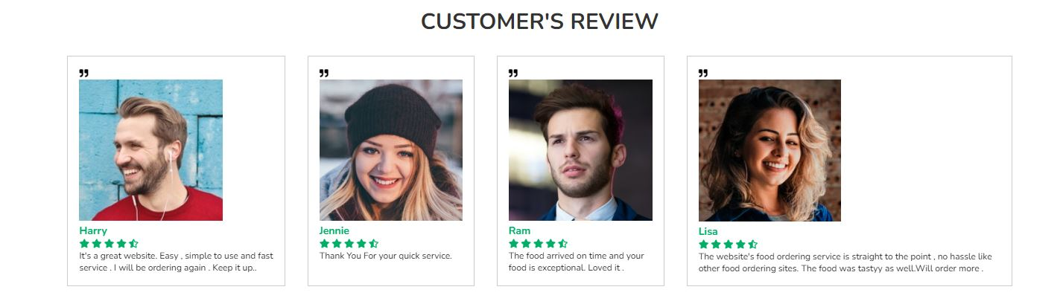
Figure 27: Review page of Jhiggu:cafe
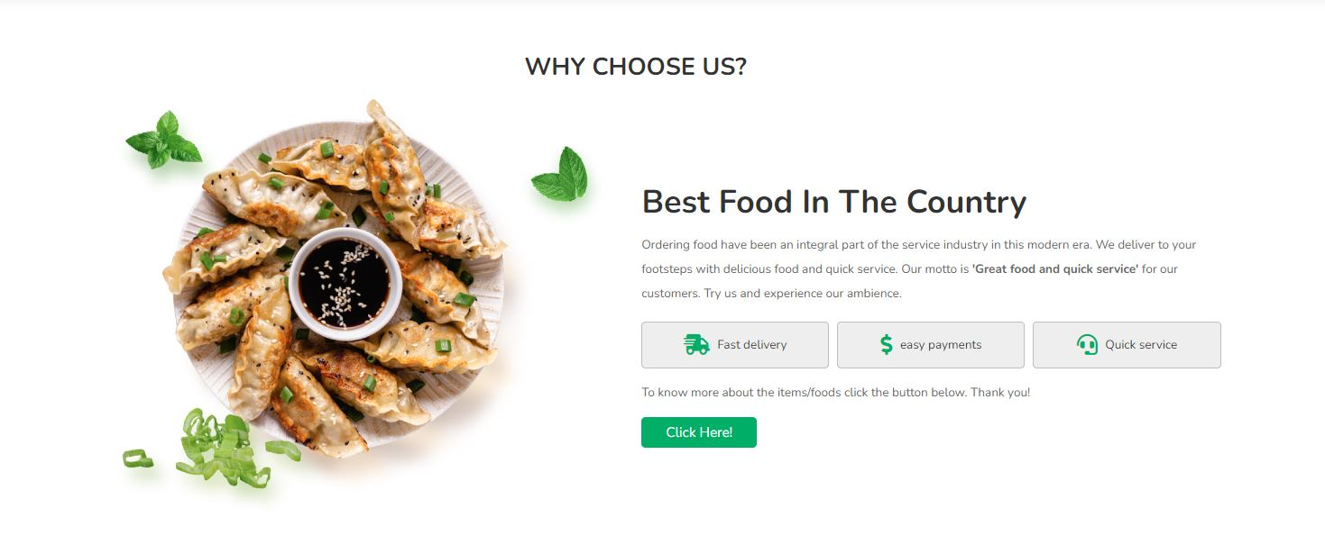
Figure 28: About page of Jhiggu:cafe
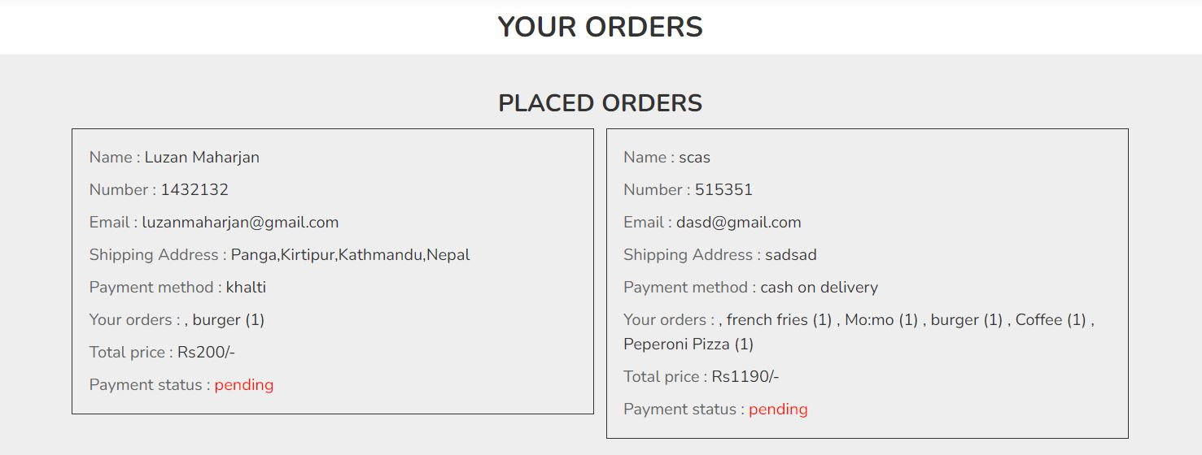
Figure 29: Orders page of Jhiggu:cafe
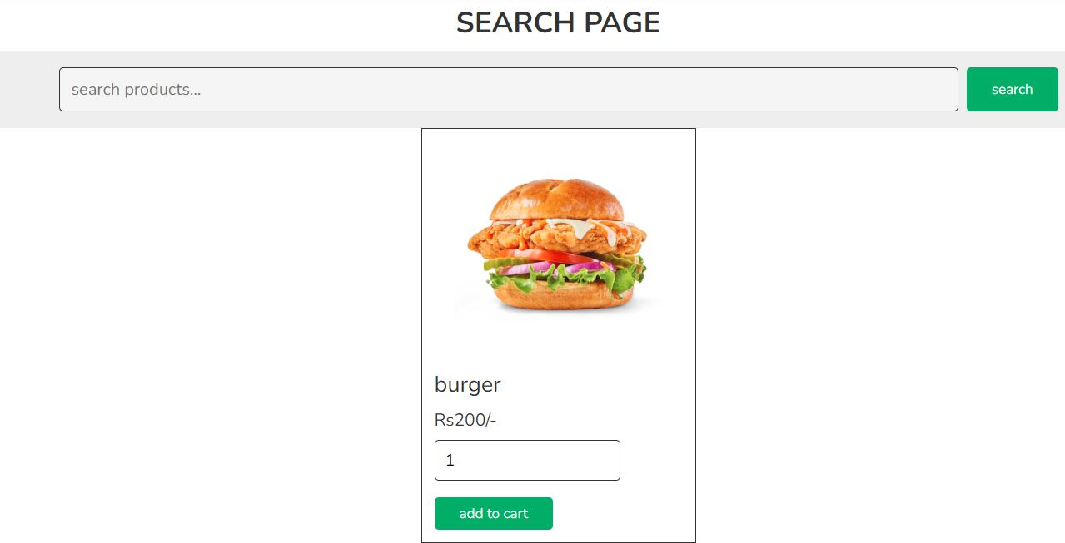
Figure 30: Search page of Jhiggu:cafe
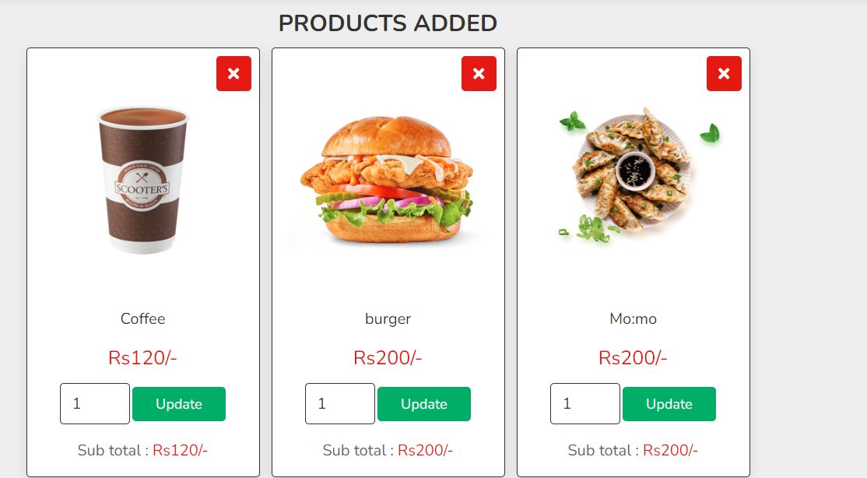
Figure 31: Cart page of Jhiggu:cafe

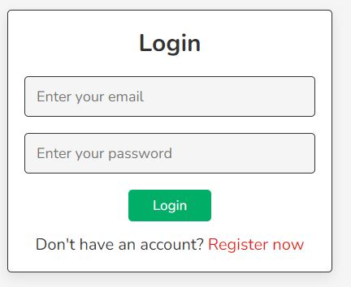
Figure 32: Login page of Jhiggu:cafe
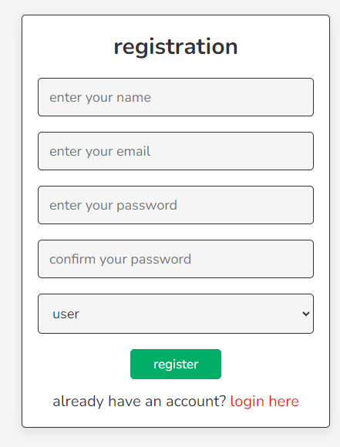
Figure 33: Registration page of Jhiggu:cafe
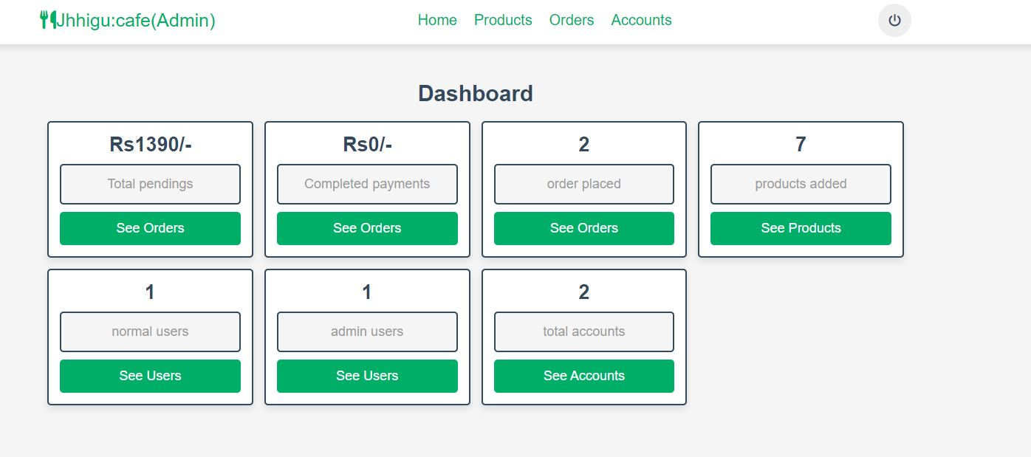
Figure 34: Admin Dashboard page of Jhiggu:cafe
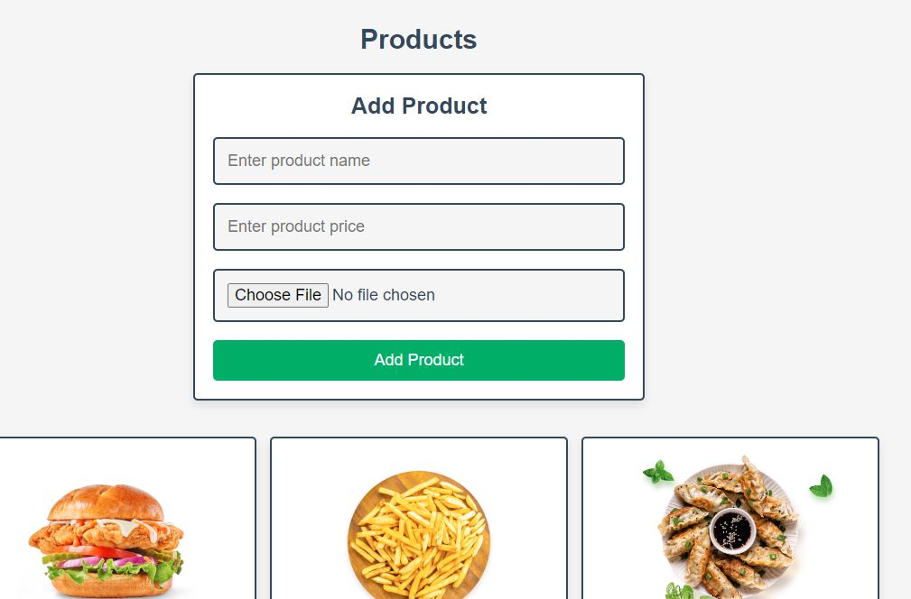
Figure 35: Add products page of Jhiggu:cafe
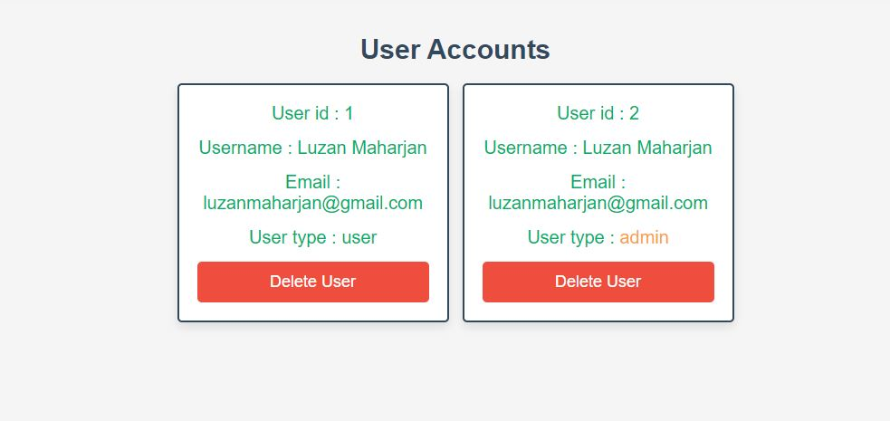
Figure 36: Accounts viewing page of Jhiggu:cafe
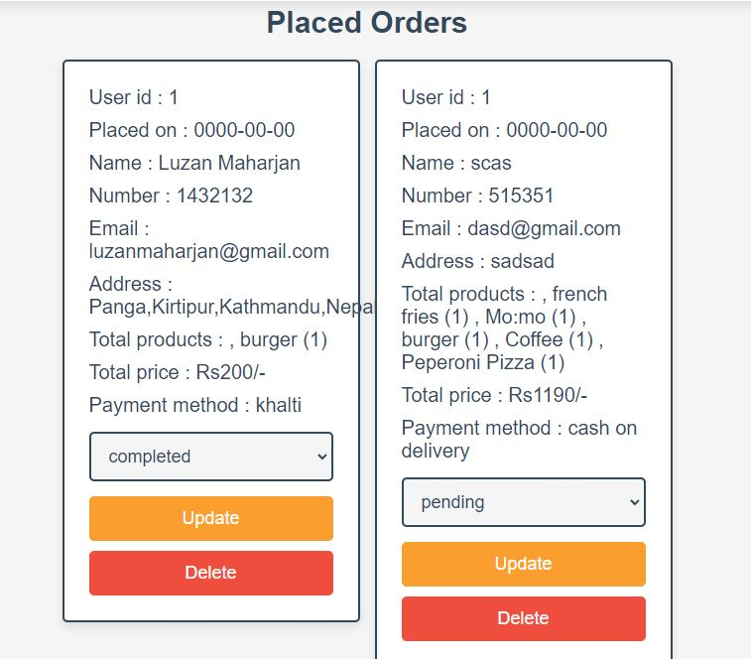
Figure 37: Placed Orders page of Jhiggu:cafe

