

Faculty of Mechanical Engineering and Mechatronics

Project Report on Building a Production Simulation in Factory I/O

Project Topic No. 2:
Production and Sorting

Building an automated production, sorting, and storage system; representing a fictional but complete industrial process

eXtended Reality (xR)
Summer Semester 2026

Group Members:

Tobias Unger; Matr.-Nr. 67328; unto1011@h-ka.de
Jeremy Zolk; Matr.-Nr. 77913; zoje1011@h-ka.de
Max Hinderer; Matr.-Nr. 106313; hima1030@h-ka.de
Yasmine Gafsi; Matr.-Nr. 105991; gaya1011@h-ka.de
Felix Faaß; Matr.-Nr. 106472; fafe1012@h-ka.de
Kilian Kutzer; Matr.Nr. 73124; kuki1011@h-ka.de
- Declaration of Independent Work
We hereby declare on our honor that we, Tobias Unger, Jeremy Zolk, Max Hinderer, Yasmine Gafsi, Felix Faaß, and Kilian Kutzer, have independently prepared the submitted project work entitled “Project Report on Building a Production Simulation in Factory I/O - Project Topic No. 2: Production and Sorting” without external assistance and have not used any sources or aids other than those indicated.
All passages of the work that have been taken, either verbatim or in substance, from other works have been clearly identified in each case, with proper reference to the original source.

Karlsruhe, the 28th of June 2026
signatures:

Tobias Unger ____________________________

Jeremy Zolk ____________________________

Max Hinderer ____________________________

Yasmine Gafsi ____________________________

Felix Faaß ____________________________

Kilian Kutzer ____________________________

- Declaration on the Use of AI Tools

The project work, including the design of the simulation and the control programming, was carried out without the use of AI-generated solutions. Likewise, this report’s content was prepared independently by the authors. AI-assisted writing tools were used only to support the finalization of the report by helping with translation and language refinement. Their use was limited to improving the clarity and readability of the text.
- Table of Contents
I. Declaration of Independent Work II
II. Declaration on the Use of AI Tools III
III. Table of Contents IV
IV. List of Figures V
1 Project Description 1
1.1 Project Simulation with Factory I/O 1
1.1.1 Software Factory I/O 1
1.1.2 Software Control I/O 1
1.2 Description of the assigned Project Topic No. 2: Production and Sorting 2
1.2.1 Project Task and Intention 2
1.2.2 Required additional Assets to Fulfill 4
2 Literature Sources 6
Appendix 7
A1. Original Description of Project Topic No. 2: Production and Sorting 7
A2. Overview of the Trello board used for Project Organization by the group 8
A3. Overview of the Production Plant 9
A4. Control I/O logic demonstrating the dynamic pairing mechanism via AND gates and internal memory bits. 10
A5. Control I/O snippet showing the gap detection timers and the dynamic merge logic 11
A6. Process logic for the Gap detection and Merge Process of correctly assembled products into gaps between packages on main conveyor belt 12
A7. Control I/O logic for evaluating the vision sensor value and starting the corresponding warehouse transfer 13

- List of Figures
Figure 1: Process logic of the given task No. 2: Production and Sorting. The workflow illustrates the separation and combination of products and packages in the industrial plant. 3
Figure 2: Overview of the developed Production Plant in Factory I/O 6
Figure 3: Setup of the two 3-axis Pick & Place robots at the end of the color-sorted supply conveyors. 7
Figure 4: The main assembly station featuring the 2-axis portal robot and pneumatic clamping mechanisms. 8
Figure 5: Flow-control logic utilizing the 'InCycle' bit to halt supply conveyors during the assembly state machine execution. 9
Figure 6: The initial identification station featuring the conveyor scale and the RFID writing 10
Figure 7: Control I/O logic demonstrating the evaluation of the analog weight signal and the execution of the RFID write command. 11
Figure 8: The Quality Control (QC) Vision Sensor with its detection radius and the pneumatic Pusher unit at the merging station. Visible are also the diffuse sensors for gap detection (right) and for checking if a product lies properly in front of the pusher. 12
Figure 9: Assembler (right) with lane continuation to lower Remover Box for unassembled lids, Merging Station (center) with lane continuation to upper Remover Box for bases without assembled lid and Main Conveyor Belt (left) 13
Figure 10: Assembled Product passes underneath mechanically elevated Pivot Arm Sorter 4 in deflected position without being affected 14
Figure 11: The last pivot arm in main conveyor belt movement direction (pivot arm 4) is diverted by default in order to move cardboard boxes off the main conveyor belt which might not have been sorted out correctly before (as a result of errors in the RFID reader) 15
Figure 12: RFID readers with their detection radius along the sorting section for cardboard boxes; vertical diffuse sensor trigger RFID readers; horizontal sensors at chute conveyor entries check successful product removal from the main conveyor 16
Figure 13: Overview of the Packaging Station: Assembled products arrive on the lower conveyor belt. A 3-axis Pick & Place robot picks them up and places them into one of three stackable boxes according to their color. 17
Figure 14: Internal Control I/O state variables for the packaging station. The ColorBox variables store the color of the product assigned to each stackable box position, and the CounterBox variables store the number of products in each box. The OldColorBox and OldCounterBox variables preserve the previous state during box replacement. 18
Figure 15: Control I/O command logic for moving one of the three stackable boxes into the central Pick & Place drop-off position. The MoveToBox signals are converted into short conveyor movement commands and are only enabled when no other box movement is active. 19
Figure 16: Storage of pallets containing products of different colors in dedicated storage compartments, including an individual counter for the stored products; right: Staple Box Packing Station 20
Figure 17: Counter logic for updating the number of stored products by color 21
Figure 18: Control I/O logic for moving boxes through the storing area until the correct transfer position is reached 22
Figure 19: Emergency Stop button, warning light and alarm siren next to an access door to the production area. Opening the door in case of a working production side triggers the same effect as an emergency stop. 23
Figure 20: Stack Light at the product assembling station, representing the operating state of the 2-axis Pick&Place assembly robot 24
Figure 21: Handrails and Safeguards around product sorting station 24
Figure 22: Elevated catwalk above the production area, built from Platforms and reached via Stairs 25

Project Description
The following paragraph shall give an overview about the project that the given report is about. The project aims to build a fictional, but completely working simulation of an automated production, sorting, and storage system, resembling the complete industrial process. The simulation is realized with Factory I/O, a software framework with an integrated tool to build industrial PLC controls.

Project Simulation with Factory I/O
This project utilizes two software tools from the Factory I/O ecosystem. Factory I/O provides a three-dimensional environment for simulating industrial processes, while Control I/O is used to create and test the corresponding control logic. Together, they form a platform for developing and validating automated systems in a virtual environment.

Software Factory I/O
Factory I/O is a 3D simulation software for industrial automation developed by Real Games. The software is used to create virtual factory environments in which automated production and logistics processes can be designed, visualized, and tested.
The software provides a library of industrial components such as conveyor belts, sensors, actuators, elevators, storage systems, and robotic handling devices. These components can be combined to create complete production lines and material handling systems. In addition to custom layouts, Factory I/O also includes a number of predefined industrial scenarios that can be used for training and experimentation [1].
Factory I/O can be connected to various automation platforms and control systems. For example, it supports communication with physical and virtual PLCs and Modbus devices The software also includes a physics engine and real-time visualization, which allow the behavior of industrial processes to be represented and observed during operation [1].
In this project, Factory I/O was used to model and simulate the production, sorting, and storage process. No physical connection was implemented. The simulation environment made it possible to evaluate the implemented control logic and the interaction of sensors, actuators, and material flow without the need for physical equipment.

Software Control I/O
Control I/O is the control environment integrated into Factory I/O. It allows automation logic to be created and executed directly within the simulation, making it possible to operate virtual production systems without connecting an external PLC [2].

The software is based on graphical function block programming [2]. Instead of writing code, control logic is created by connecting blocks that represent inputs, outputs, logical operations, timers, counters, and other control functions. Since Control I/O is directly linked to the Factory I/O simulation, the effects of changes in the control program can immediately be observed in the virtual process [3]. This makes it suitable for testing automation concepts and verifying process sequences during development.
Compared to professional PLC programming environments, Control I/O offers a more limited set of functions and focuses on ease of use rather than advanced engineering capabilities [4]. For example, dedicated memory bits are not available, which can make the implementation of more complex control structures more challenging. In addition, the graphical programming approach provides only limited possibilities for structuring and modularizing larger programs. As a result, the software is mainly intended for educational purposes and smaller automation projects, where the emphasis lies on understanding and implementing control logic rather than developing industrial-scale software solutions [4].
In this project, Control I/O was used to implement the control logic for the production and sorting process. The software coordinated the interaction between sensors and actuators and thereby controlled the overall sequence of operations within the simulation.

Description of the assigned Project Topic No. 2:
Production and Sorting

Project Task and Intention
The core objective of this project is the conceptualization and implementation of a fully automated production, sorting, and warehousing system using the Factory I/O simulation environment. The system is designed to simulate a realistic, end-to-end industrial process that handles both pre-packaged goods and raw materials for product assembly.
The process flow begins with the continuous, randomized introduction of cardboard packages of varying sizes onto a primary conveyor belt. In parallel, a secondary supply system consisting of six individual conveyors provides product bases and lids in three distinct colors (blue, green, and metal). The manufacturing stage involves the automated assembly of these components, ensuring that each lid is matched with a base of the identical color. Once a product is successfully assembled, it is merged onto the main conveyor belt. A critical challenge at this stage is the collision-free integration of the new products into the existing flow of cardboard packages.
Following the merging process, the routing logic diverges. The cardboard packages are identified and sorted by size before being routed to designated storage zones. Simultaneously, the assembled products are directed to a packaging station, where they are palletized into staple boxes. Finally, these loaded boxes are sorted by product color and transferred to specific warehouse sections.
This process logic is visualized in the diagram shown in Figure 1. The original description of the project topic and task can be found in Appendix A1.

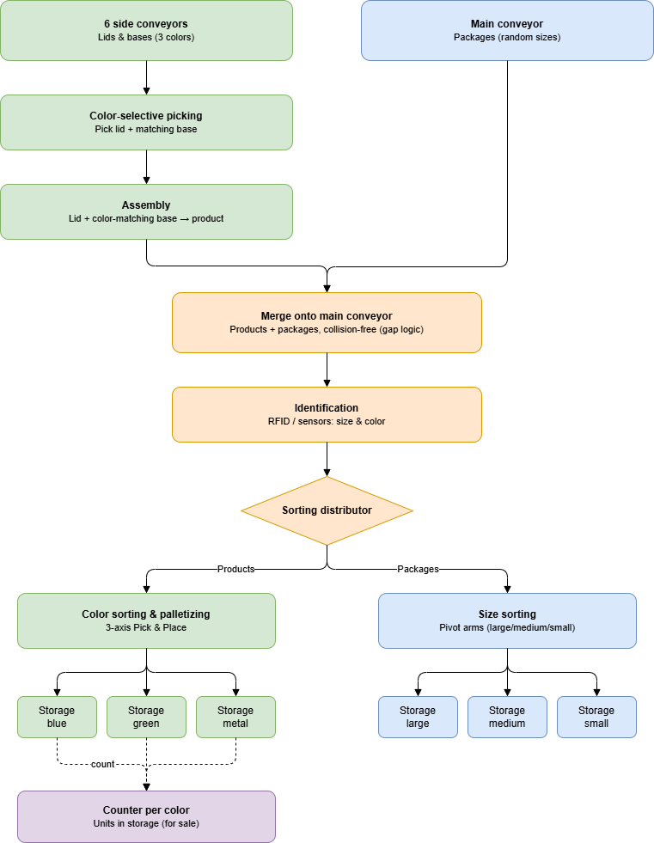
Figure 1: Process logic of the given task No. 2: Production and Sorting. The workflow illustrates the separation and combination of products and packages in the industrial plant.

Required additional Assets to Fulfill
Beyond the fundamental material flow, the simulation must satisfy several operational and safety criteria to mimic a genuine industrial facility. The entire plant is required to operate autonomously, driven by the underlying Control I/O logic.
To facilitate production monitoring, the system incorporates digital counters that provide a real-time overview of the inventory, displaying the exact quantity of products manufactured for each color. Furthermore, a comprehensive safety and control infrastructure is mandatory. This includes the implementation of a centralized electrical control cabinet equipped with master switches for power, start, stop, and reset functions. To ensure a safe environment for virtual workers and visitors, Emergency Stop switches must be decentralized and accessible at every workstation, while stack lights continuously provide clear visual feedback regarding the operational state of the machinery.

Literature Sources

[1] | Real Games, "Factory I/O Features - Design and simulate," 2006. [Online]. Available: https://factoryio.com/features.
[2] | Real Games, "About Control I/O," 2006-2024. [Online]. Available: https://docs.factoryio.com/controlio/.
[3] | Real Games, "Control I/O Drivers," 2006-Present. [Online]. Available: https://docs.factoryio.com/manual/drivers/control-io/.
[4] | Real Games, "Starter Edition - Factory I/O," 2006 - Present. [Online]. Available: https://factoryio.com/starter-edition.
[5] | Real Games, "Factory I/O Next-Gen PLC Training," 2006. [Online]. Available: https://realgames.co/.

Appendix
- Original Description of Project Topic No. 2: Production and Sorting
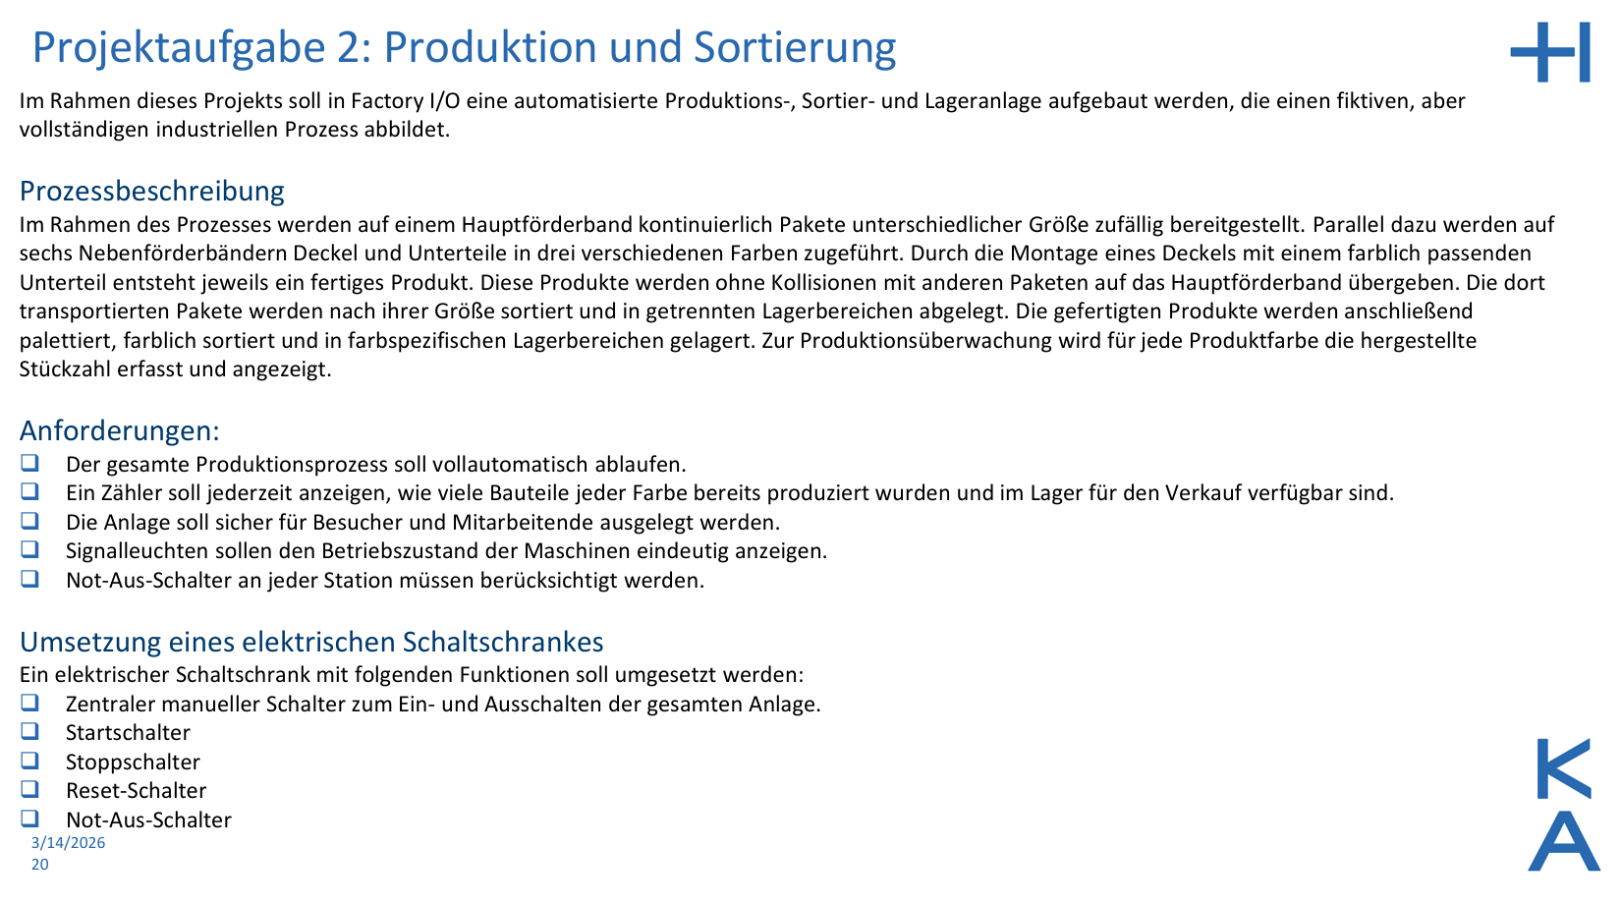
- Overview of the Trello board used for Project Organization by the group

