Objet SOP

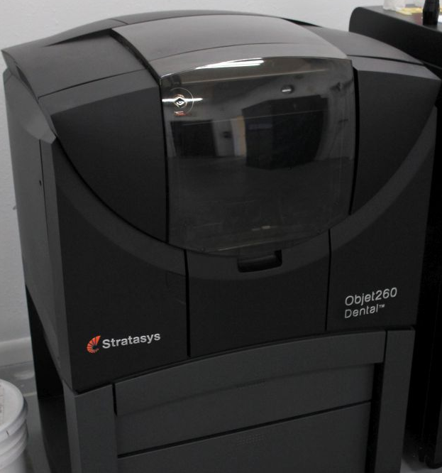

This SOP is meant only for those who have been previously trained by proficient members of TSD’s CAM team. The Objet is a very expensive and sophisticated piece of equipment that should not be utilized by the inexperienced.

The Objet does not have direct network access and is connected to another networked PC via an A B switch. (Note: Since the premature demise of the networked PC, a new PC with the nesting software was setup without network access. Now all stl files must be transferred via thumb drive.)

\*Daily maintenance must be run on Objet prior to use. If you are not trained in maintenance, you are not trained in operation of this printer\*

Step 1. Choose and load necessary stl files onto a thumb drive for transfer.

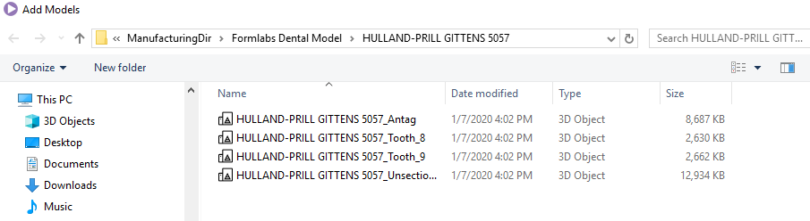

\*Solid = unsectioned (sic) model – Full & Quad = all files – always print all dies\*

Step 2. Transfer said files to Nesting PC connected to Objet. Use the folder on the desktop and create a new folder with the correct date / tray number.

Step 3. Nest the files per the Objet users guide chapter 5 attached to the Objet in the Equipment Trello board.

Step 4. Check for correct tray position, UV temp via labels, and overall Objet function prior to starting the job.

Step 5. Start the job on nesting PC. Switch to Objet onboard PC to start the job on the Objet.

Step 6. Upon completion, remove the tray to scrape parts (except for dies and soft tissue) into power washer.

Step 7. Thoroughly clean parts with power washer. Remove and inspect. Rinse and repeat until completely clean. Wash dies and soft tissue by hand. Verify fit of all parts prior to moving them on to next step. All dies and soft tissue go in a baggy marked with the case number per supervision.

If you have questions about anything, stop and ask. Verify proper fit, cleanliness, and final quality of the models prior to allowing any of them to leave the CAM area. All dies go in small baggies with the case number written on the bag.