TSD  Print Room Training

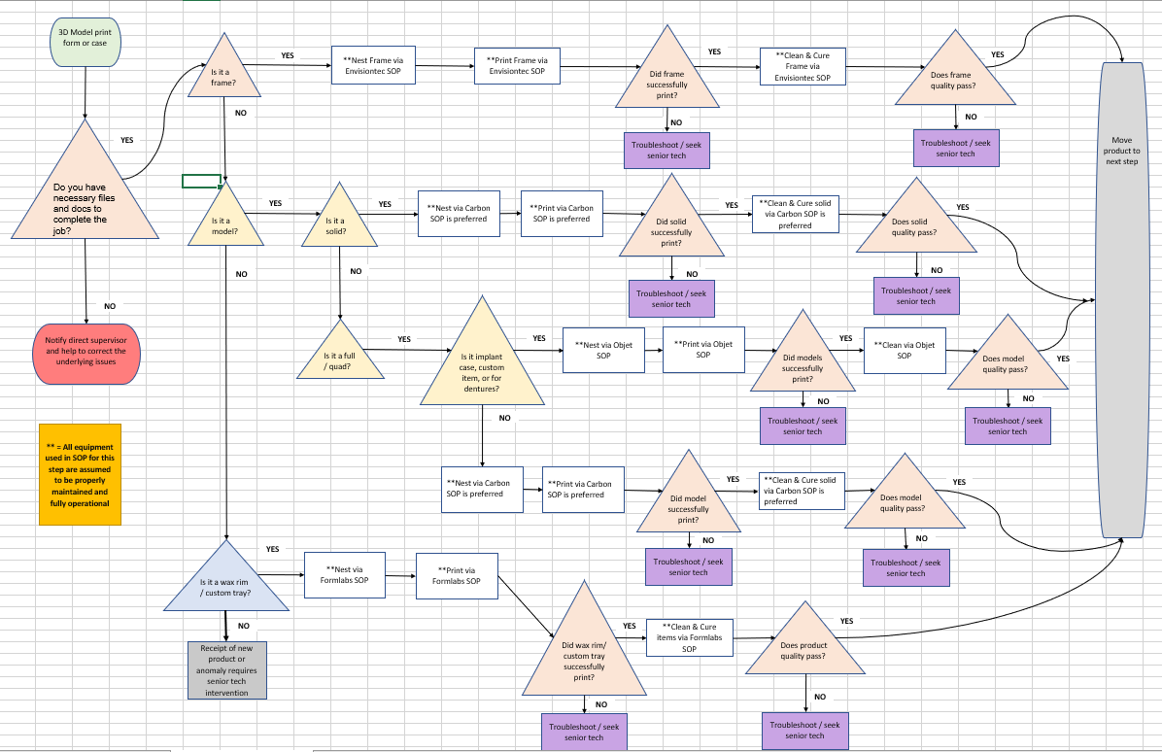

Table of Contents

Preface …………………………………………………………………………………………………………… 3
Overview………………………………………………………………………………………………………… 6
Formlabs………………………………………………………………………………………………………… 12
Basic Carbon………………………………………………………………………………………………….. 18
Intermediate Carbon……………………………………………………………………………………… 28
Advanced Carbon…………………………………………………………………………………………… 32
Basic Objet…………………………………………………………………………………………………….. 40
Intermediate Objet………………………………………………………………………………………… 52
Basic Envisiontec……………………………………………………………………………………………. 63
Intermediate Envisiontec………………………………………………………………………………. 74
Summary……………………………………………………………………………………………..……….. 85

Preface

The intent of this document is to help guide you through the live training in the TSD 3D Print Room.
While we have documentation on our processes, it would be naïve to think we could adequately encapsulate all of the knowledge necessary to function in our lab efficiently without experiencing live training and practice of all applied principles. With that in mind, it is highly recommended that trainees take notes and ask relevant questions during training.
This complete training used to be scheduled for five 8hr workdays, but it became obvious very quickly that the short duration made the training too concentrated and resulted in poor knowledge retention amongst participants.
Below is a copy of the five day orientation and training plan that was originally implemented:

Fab Print Room Orientation

This document outlines the necessary steps for those who are to be trained on 3D printers in the TSD FAB PRINT ROOM. This training plan must completed prior to gaining authorization to operate and maintain our various TSD 3D printers. This orientation plan does not implicitly grant authorization to members who satisfactorily complete it. It only allows said team members to be designated as authorized operators of specific printers as seen fit by our leadership.
Day 1
Background and Basics
MIT 3D Print Video
Physical Orientation in TSD FAB 3D Print Room
General talking points –
Basic flow of print jobs in and out of our room
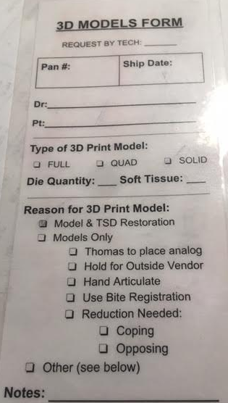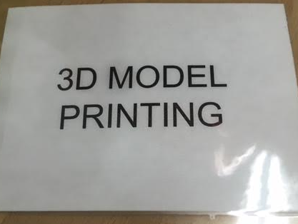
Kinds of prints –
Models
Wax Rims
Custom Trays
Emax / PFM crowns
Frames
Surgical guides / jigs
Night guards
Dentures

Introduction to each printer type and make in our room
FFF - Creality CR10
SLA - Formlabs Form3
SLA - envisionOne cdlm
Jetted Material - Stratasys Objet
SLA - Carbon M2

Overview of processes of each printer
Creality CR10 – Design, nest/convert, print
Formlabs Form3 – Nest, print, post process / cure
Carbon M2 – Nest, print, post process / cure
envisionOne cdlm – Nest, print, post process / cure
Stratasys Objet – Nest, print, post process

Basic terminology
Supports and associated dimensions / variables
Base / raft and associated dimensions / variables
Materials and associated characteristics
Quiz
Day 2
Detailed Training on simple post processing / curing
Clean as you go process fundamentals
Formlabs Form3
Carbon M2
Stratasys Objet
envisionOne cdlm
Quiz
Day 3
Basic daily maintenance / upkeep on printers / machines
Utilizing maintenance and equipment board basics
Formlabs Form3
Carbon M2
Stratasys Objet
envisionOne cdlm
Clean as you go process review
Weekly maintenance / upkeep on printers / machines
Formlabs Form3
Carbon M2
Stratasys Objet
envisionOne cdlm
Quiz
Day 4
Basic setup, nesting, and misc.
Formlabs Form3
Carbon M2
Stratasys Objet
envisionOne cdlm
Creality CR10
Clean as you go process review
Common defects and mitigation
Proper documentation of defects and troubleshooting efforts
Quiz
Day 5
Live run and final test.
Envisiontec cdlm and/ or Objet certification tests upon management request.

While this method might still be used for new hires coming directly to the 3D print lab as a permanent work center, it will not be used for cross training those in other work centers due to the poor retention cited previously.
The new training will be more “hands on” practicum that put the trainee in realistic scenarios with problems to overcome. This happens with new hires during the course of their normal work day, but it must be created in a memorable state for those cross training. The intent with the new training is to fully immerse the trainee to seal in the knowledge juices we’d like to keep while keeping everything simple enough to allow for maximum long term retention.

Formlabs
We utilize Formlabs form3B printers for custom trays and wax rims. Below is the flow chart for these products.
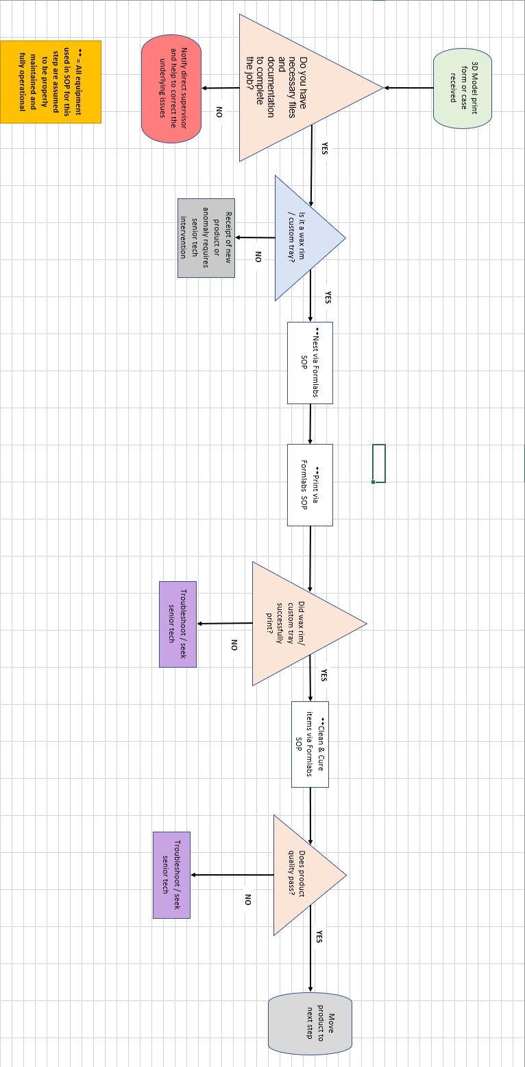

SOP for Formlabs Custom trays and Wax Rims By:
Katherine Lala
Nesting: software is PreForm (blue butterfly)
− when the dialog box opens pick the printer of choice − resin is Custom Tray
− layer thickness set to fastest print 200 microns
− apply

− drag and drop files from the windows directory \dima Print Cast
− Orient print with the intaglio surface away from the plate (so that minimal supports get on it.)

− if there are a fewer than five prints lay them flat to the plate as above
− if there are more than that, stand them nearly vertical to the plate distal side to plate (with a slight tilt with the intaglio side away from the plate) as above
− Supports:
− Check for and supports on the intaglio surfaces. Remove if necessary.
− Layout All
− Check the slices.
− Save file as month-day-70(2/3)-#-initials
− Check printability
− use the Orange Printer button to send to the printer.
− Remove the resin tank and while holding upside down give it a left right shake. Put it back.
− Open the vent on resin tank
− check the plate (clean and proper position)
− in the tiger mix the resin
− verify that you have the correct file and hit print on the printer. Follow prompts.
− remove plate
− at the processing station use the super bendy black handle scraper to remove the prints
− place them in the dirty IPA for 280 seconds in the ultrasonic
− blow out between supports and print

− raft type = Mini rafts
− no raft labels
− density = 1.00
− touchpoint size = 0.30mm
− internal supports off
− Auto-Generate All
− For easier visibility select the model. It will turn blue and the supports will be green.

Printing:
Removal and Curing:

− place in clean IPA for 280 seconds
− give a light blow off and air dry for 30 minutes
− 30 minutes in the Accu-Cure
− remove supports and clean up with clippers

formlabs reference https://dental.formlabs.com/indications/custom-trays-guide

