Part 1: Embodied Noticing
Tool 1 — Water & Wastewater Systems Reasoning
Scenario: The Super Pit (Fimiston Open Pit), Kalgoorlie-Boulder, Western Australia
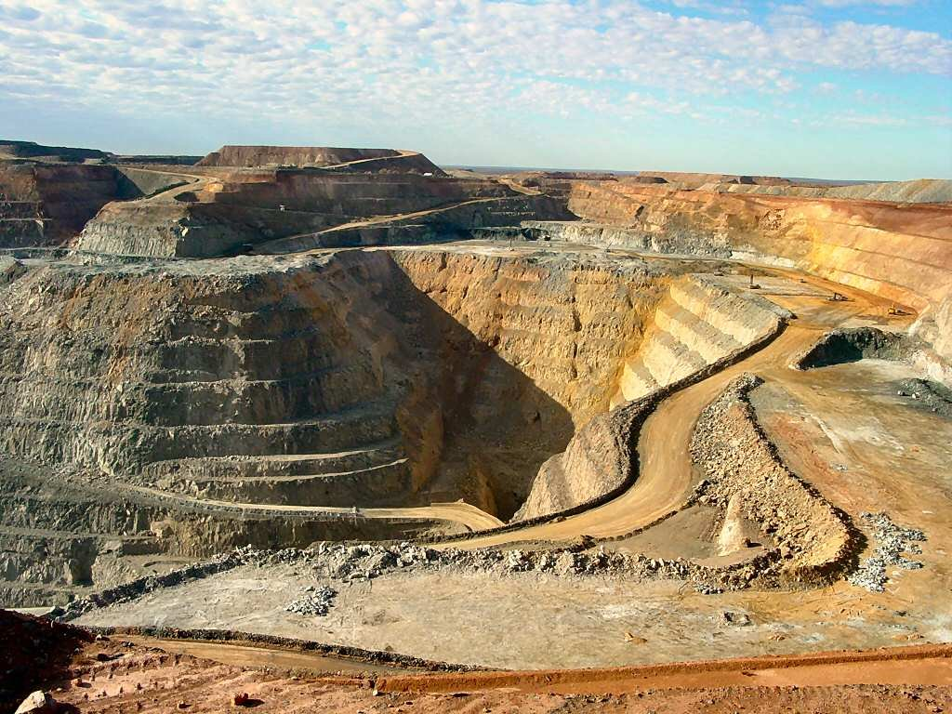
Figure 1. The Super Pit (Fimiston Open Pit), Australia's largest open-cut gold mine, located on the south-eastern edge of Kalgoorlie-Boulder, Western Australia.

Observations (What I See)
- A large open-cut pit with multiple tiered bench roads spiralling down to the pit floor, with heavy machinery visible operating at several levels simultaneously — indicating a large, active workforce present on site at all times.
- The surrounding landscape is visibly arid — dry, reddish-brown soil with sparse vegetation — suggesting the region receives little rainfall and has limited natural surface water resources.

Inferences (What I Think Might Be Happening)
- Given the remote, arid location approximately 600 km east of Perth, all potable water for the on-site workforce is likely piped in over a significant distance or extracted from deep groundwater borefields — neither of which is visible in the image but would be essential infrastructure.
- The scale of the operation and the number of tiered benches suggest a workforce of hundreds to over a thousand people on site, implying a continuous and substantial daily domestic water demand for drinking, sanitation, cooking, and hygiene.

Explicit Unknown
- It is unclear how much of the site's potable water supply is sourced from groundwater borefields versus piped municipal supply from Kalgoorlie-Boulder, and how the reliability or availability of each source changes seasonally or during drought conditions.

Engineering Question
How much potable water must be delivered daily to the Super Pit to meet the domestic needs of its on-site workforce, and how does that demand change under the site's extreme summer temperatures?

