Assignment-1:

Tried the Phishing quiz but was trapped in some of the questions.

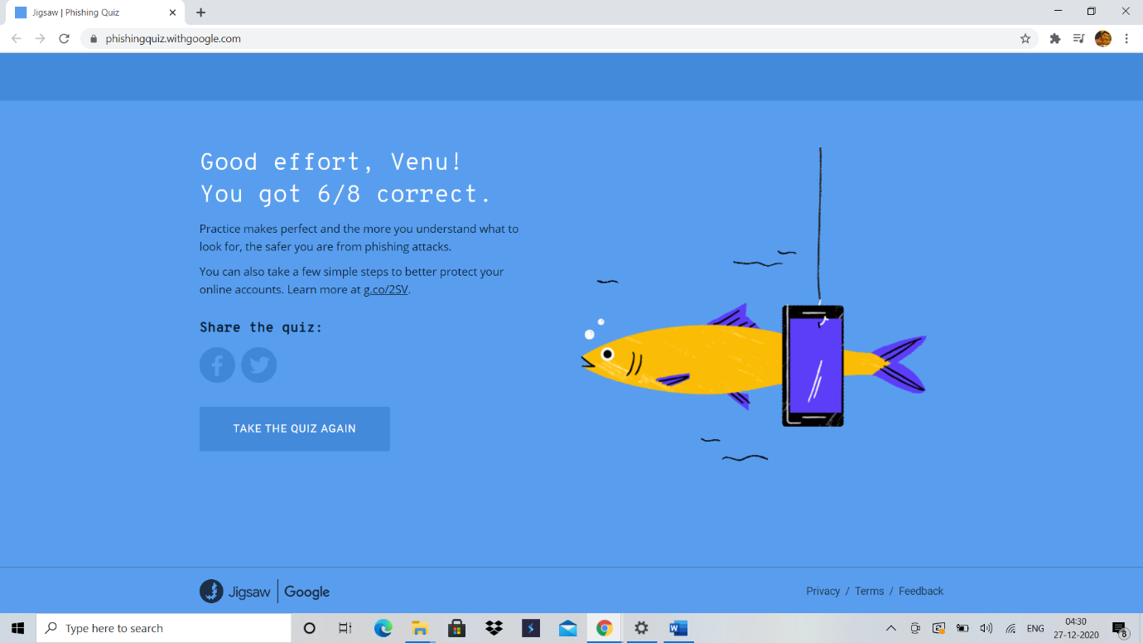

Assignment -2:

Checked my Instagram password strength.

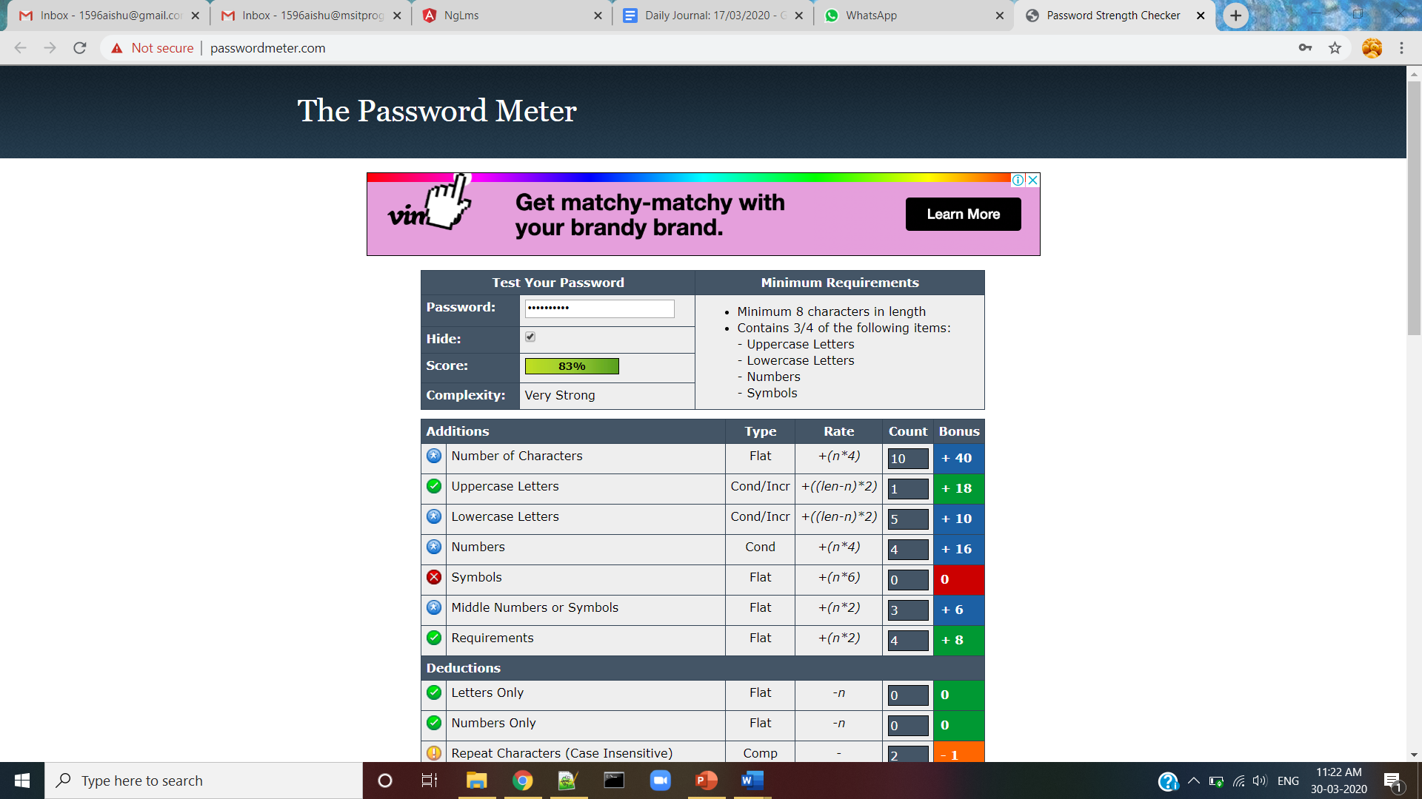

Assignment -3:

Submitted the ppt of poster.

Assignment -4:

All the softwares are upto date.