Assignment -1:

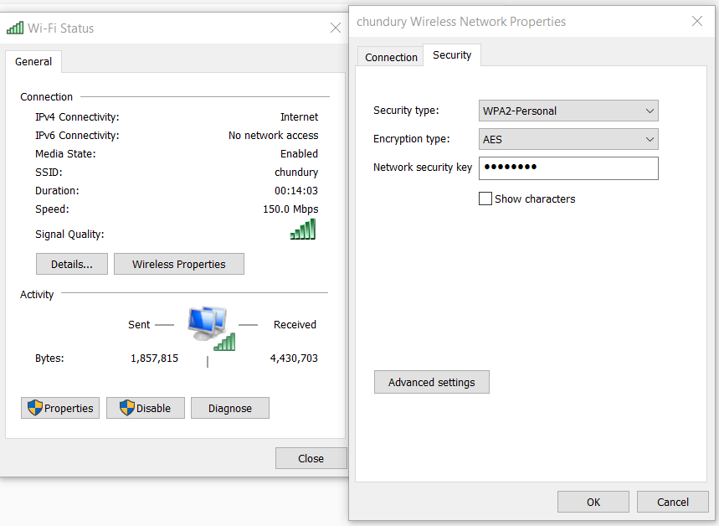

Changed the default SSID to a different name, enable WPA2 and set a security key. Firewall is also enabled.

Assignment -2:

Host based intrusion detection system - Suricata / Snort

A host-based IDS is an intrusion detection system that monitors the computer infrastructure on which it is installed, analysing traffic and logging malicious behaviour.

Snort is an example of host-based intrusion detection system, which is a packet sniffer that monitors network traffic in real time, checking each packet closely to detect a dangerous payload or suspicious anomalies. It can be used as a monitoring device, and analyse the traffic.