Assignment -1:

AES tool is a symmetric encryption algorithm. It allows encryption and decryption with secret key and key size. This generates an encypted cipher text based on the secret key given.

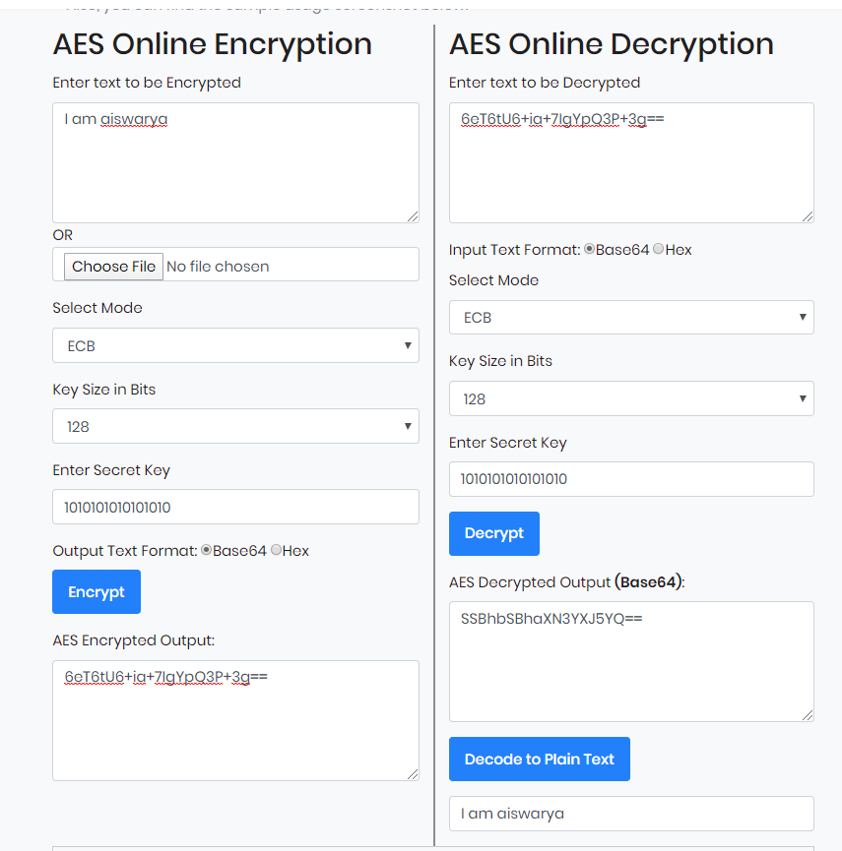

Assignment -2:

Keybase is a software which allows us to chat with friends in a safe encypted manner. It allows us to keep a filesystem with private, public and team folders. It provides a feature of encrypting and decrypting text. It supports wallet access and Git push.

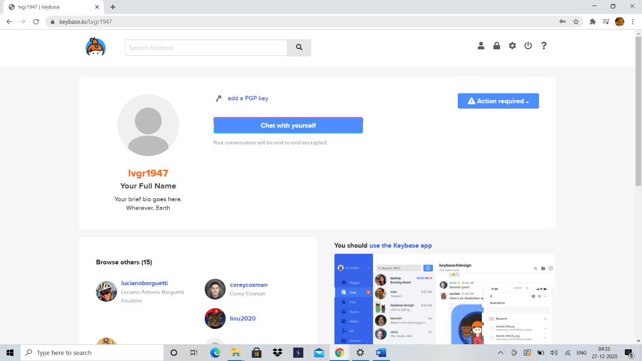

Assignment -3:

When the website is safe, the website's server uses a certificate to prove the website's identity to browsers. Certificate from trusted devices.

