**目前构造的需求本体可能有以下情况**

1：领域实体相互连接

Hotscripts.com Clone

We are in need of a portal like hotscripts.com. An online admin is automated to run the site. It approve new additions, manage forums and manage ads. site has mysql database with PHP scripts.

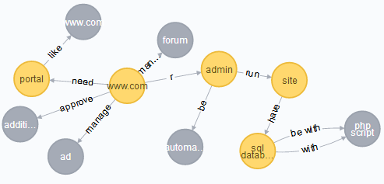

2.领域实体通过路径推传递关联

Chat application

I need an application. Users will search flats that posted by agent. Customer initiate the chat. Customer can chat with agent . You should have experience in PHP. And you should have Duration.

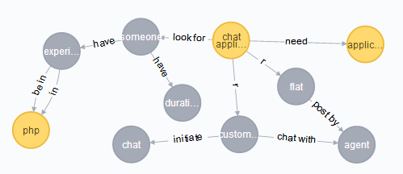

3.领域实体没有直接关联

challenge

A full blown web site for the Get Fit-Stay Fit Challenge. I have a detailed outline of what I need, so email me an I\\\\\\\'ll send it. I will need a good database to handle entrants in the challenge. Oracle is probably the best option. I also need great graphics to get and maintain consumer interest. Millions of people will see this site, plus thousands of businesses, so it has to be good.

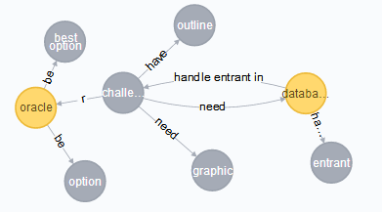

**实体关系抽取存在的问题**

1.一些干扰词影响句子识别，比如this

2.无法确定指代关系，It具体指前文哪个实体

3.由于都是从单句中抽取三元组，导致前后句中两个本该相关的实体关系缺失。

4.复杂句子中包含多个三元组，经常丢失部分信息

**目前的一些构想**

1.对于两个相关的领域实体，不必得出实体之间的确切关系，而是以相关度进行描述。最后的第三层领域知识空间由领域实体和领域实体之间的相关度构成。

2.在比较理想的情况下，采用表示学习进行关系路径推理。

3.考虑是否利用上skill标签信息。每个需求都有若干个标签，每个标签都有自己的所属的大类别。可以通过分析这些skill标签之间的相关性，从而得出各个领域之间的关联。（比如，哪些skill经常被同时需求，用户需求经常横跨哪几个领域。）