**PRAKSA**

Luka Vuletić

**Booking system**

Rijeka, 2015.

Revision History

|  |  |  |  |
| --- | --- | --- | --- |
| **Date** | **Version** | **Description** | **Author** |
| 27.04.2015 | 1.0 |  | Luka Vuletić |

Table of Contents

1. INTRODUCTION 4

2. GENERAL OVERVIEW 4

2.1 Technologies used 4

2.2 General description 4

2.3 Development plan 4

3 FUNCTIONAL SPECIFICATIONS 4

4 REQUIREMENTS 5

5 DATA MODELS 5

5.1 ER Diagram 5

6. ANALYSIS MODELS 6

6.1 Use case 6

6.2 Sequence diagram 7

1. INTRODUCTION

In this document will be described in detail the web application for booking apartments.

1. GENERAL OVERVIEW
   1. Technologies used

Booking system is a web based application constructed using Phalcon PHP framework, MySQL database engine, Google Maps and Nginx web server.

* 1. General description

The booking application will allow the visitors to search through a plethora of geographical locations of which each offers a diverse set of apartments for rent. The specifications of each apartment unit is customizable by either the owner of the said unit or the website administrator.

Visitors to the site can search for a specified apartment unit but in order to read all available information about it, including location, price, photo gallery and other features. If the apartment is currently reserved, an expiration date is also showed, if not, the user can book a reservation for a specified number of people and for a specified amount of time.

* 1. Development plan

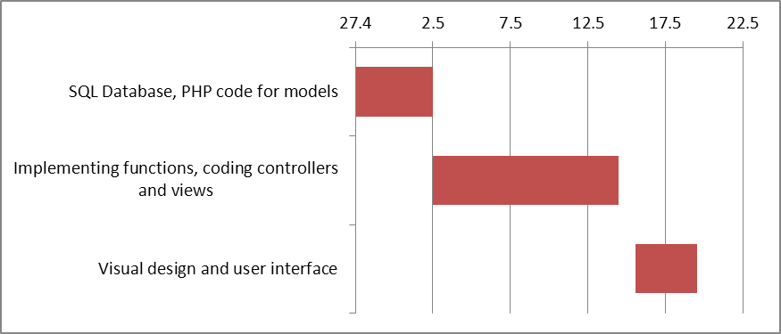

1. FUNCTIONAL SPECIFICATIONS

The following are the mayor system functions:

-a login screen for visitors to sign in in order to gain access to advanced features of the application

-a list of all available apartments

-clicking on a link would bring up a detailed apartment description with a photo gallery and a feature list

-a search function which allows both users and visitors to search through the apartment database using specified queries

-a sorting option which includes several possible criteria

-a register button for creating new users with a maximum of one user per email address

-a tab for changing languages

-an embedded google map which can be clicked on to load a proper google map interface

-a form for apartment reservation

1. REQUIREMENTS

The booking system can run on most operating system, it has been tested on all major web browsers(Firefox, IE, Chrome, Opera and Safari) and it has not encountered a problem.

Of the technologies used the minimum versions required are:

-Nginx 1.7.0

-MySQL 5.5

-PHP 5.4.3

1. DATA MODELS
   1. ER Diagram

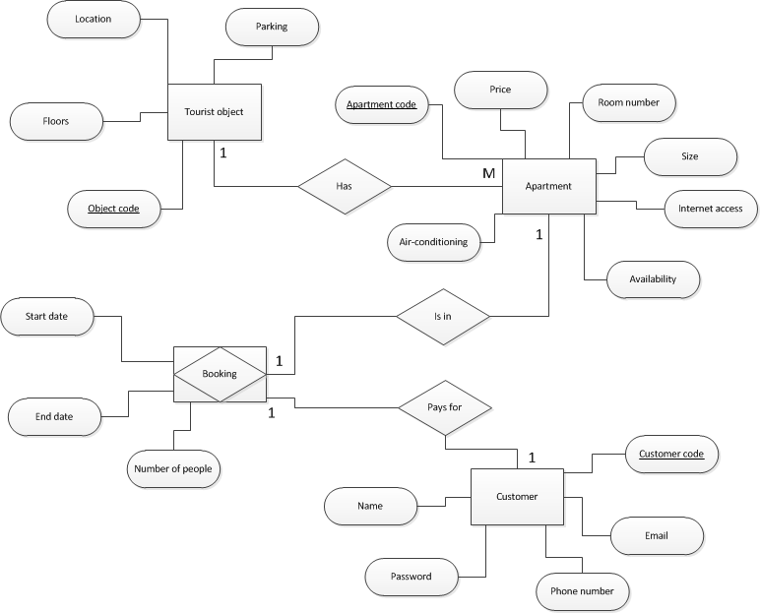

* 1. Database model diagram

-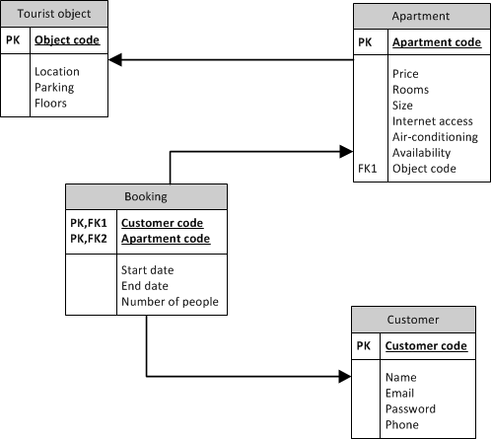

# 6. ANALYSIS MODELS

## 6.1 Use case

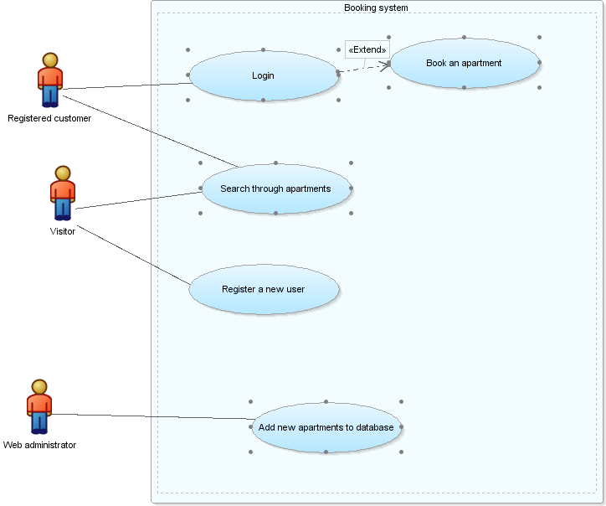

## 6.2 Sequence diagram

