Low-Level Design (LLD)

Appointment Booking SaaS for Clinics, Salons & Fitness Trainers

Document | Value
Product working name | BookEase (placeholder; branding TBD)
Classification | Internal — confidential
Backend | Java 17+, Spring Boot 3.x
Frontend | React 18+ (SPA)
Primary DB | PostgreSQL (recommended) or MySQL 8
Auth | JWT (Bearer), role + tenant scoped
Version | 1.1
Date | 2026-04-05
Status | Approved

Document control & approvals

Role | Name | Action | Date
Prepared by | Product / Engineering | Draft & technical content | 2026-04-05
Approved | **Nagendra** | Approved | 2026-04-05
Approved | **Ravi Nalla** | Approved | 2026-04-05

*Signatures (optional hard copy):* _________________________ (Nagendra) _________________________ (Ravi Nalla)

1. Purpose & scope

This LLD describes how the system is built: modules, data model, APIs, security boundaries, key workflows, and deployment units. It applies one reusable product to multiple business types—clinics, salons, and fitness trainers—without separate codebases per vertical.

Out of scope for v1 LLD detail: Native mobile apps (responsive web only), advanced CRM, inventory, full EMR/clinical records depth.

1.1 Target client segments (same platform)

Segment | Typical use | Configuration (no code fork)
**Clinics** | Doctor/consultation slots, follow-ups, tests | Services = visit types; staff = doctors; customer notes for clinical context (non-EMR)
**Salons** | Hair, spa, beauty services | Services = menu items; staff = stylists; categories = packages
**Fitness trainers / studios** | PT sessions, classes, diet consults | Services = session types; staff = trainers; duration = slot length

All segments share: public booking link, calendar, staff calendars, payments, reminders, subscription billing for the business tenant.

1.2 Reusable platform principles

- Single Spring Boot + React codebase; differences are tenant configuration (services, staff, hours, branding, slug URL), not separate deployments per vertical.
- Tenant isolation via clinic_id (generic “business” tenant key—name is historical; represents any subscribed business).
- Extensible metadata: service category, description, and optional JSON fields on clinic or service (future) for vertical-specific labels without schema forks.
- Super Admin manages all tenants regardless of segment; analytics can filter by optional business_type enum on clinics if product adds it later.

1.3 Compliance & data handling (high level)

- PII (name, phone, email) encrypted in transit (TLS); at-rest encryption per cloud DB policy.
- Audit for super-admin and sensitive actions (audit_logs).
- Clinics may impose stricter policies later (e.g. consent text on booking); v1 keeps notes as configurable fields with access restricted to tenant staff roles.

2. Actors & Responsibilities

Actor | Role in system | Primary surfaces
**Customer** | Browse public booking link, book/cancel/reschedule, pay, profile | React public routes
**Business Admin** | Onboard org, staff, services, hours, payments; manage bookings | React dashboard
**Staff** | Own calendar; may confirm/complete appointments (configurable) | React dashboard (subset)
**Super Admin** | SaaS operator: tenants, subscriptions, suspend, global analytics | React admin console
**System** | Cron jobs: reminders, subscription webhooks, reconciliation | Spring `@Scheduled`, queues (optional)

3. Logical architecture
The diagram below combines multi-vertical reuse (clinics, salons, fitness) with the technical runtime: React, edge hosting, Spring Boot, data stores, and integrations.
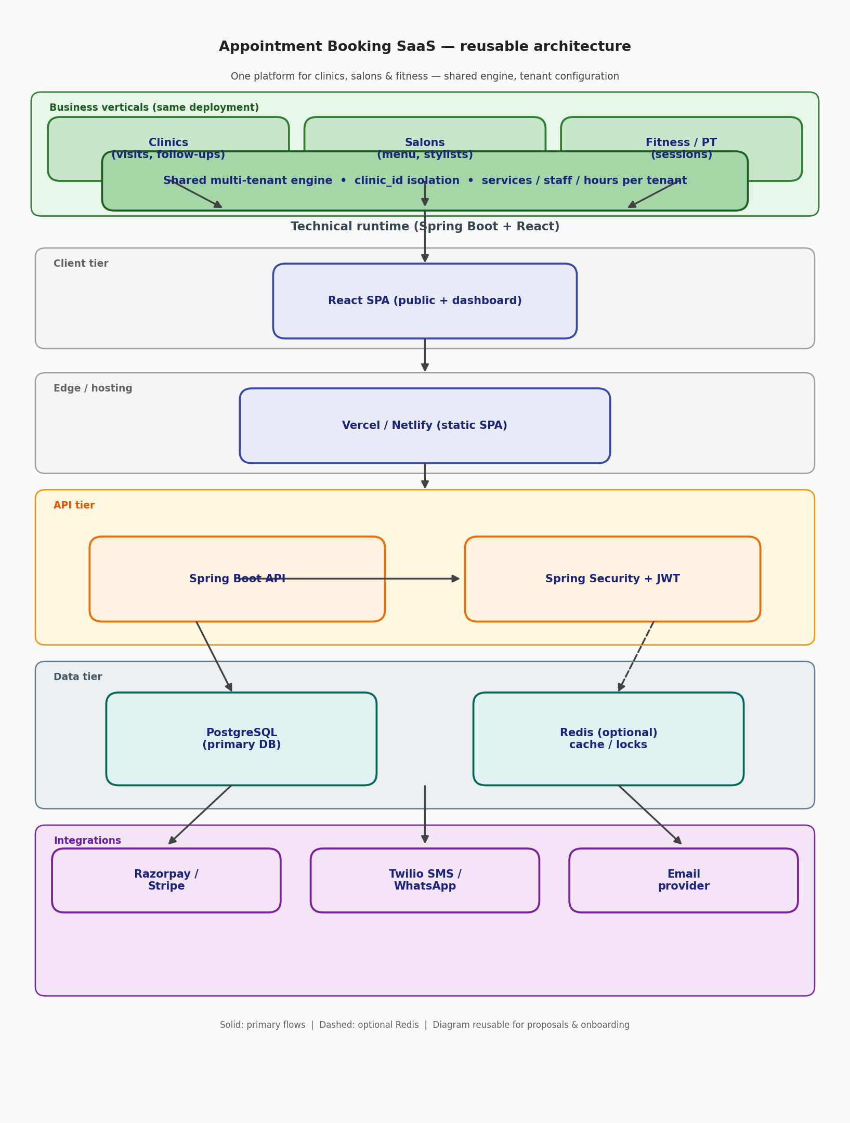

3.1 Multi-vertical reuse (business view)

*Same deployment serves all client types; configuration differentiates experience.*

3.2 Technical architecture (runtime)

Embedded diagram (DOCX export): The generated architecture-diagram.png combines §3.1 (vertical reuse) and §3.2 (technical tiers) for reuse in proposals and stakeholder packs.

Multi-tenancy model: *Row-level* isolation: every business-scoped row carries clinic_id (tenant id). API layer resolves clinic_id from JWT claims for ADMIN/STAFF; CUSTOMER tokens may be scoped to customer_id + allowed clinic_id for booking flows. SUPER_ADMIN bypasses tenant filter with explicit audit.

4. Backend Module Map (Spring Boot)

Module / package | Responsibility
`config` | Security, CORS, OpenAPI, Jackson, timezone
`security` | JWT filter, `UserDetailsService`, method security, password encoder
`domain` | JPA entities, enums (`Role`, `AppointmentStatus`, `PaymentStatus`, …)
`repository` | Spring Data JPA repositories
`service` | Business logic, transactions, domain services
`web` | REST controllers, DTOs (request/response), validation (`@Valid`)
`integration` | Razorpay/Stripe clients, SMS/WhatsApp adapters
`job` | Scheduled reminders, stale booking cleanup
`exception` | Global handler, error codes

Suggested base package: com.bookease (replace with your final brand).

5. Frontend Module Map (React)

Area | Responsibility
`src/app` or `src/routes` | React Router: public booking, auth, dashboard, super-admin
`src/features/auth` | Login, register, token storage, refresh (if implemented)
`src/features/booking` | Slot picker, service selection, checkout
`src/features/dashboard` | Today’s list, KPIs, calendar
`src/features/staff` | CRUD staff, working hours
`src/features/services` | CRUD services, categories, pricing
`src/features/customers` | List, profile, notes, history
`src/features/settings` | Clinic profile, holidays, breaks, notification prefs
`src/features/billing` | Subscription status, plan, Razorpay portal links
`src/features/admin` | Super-admin-only UI
`src/api` | Axios/fetch client, interceptors (JWT), typed DTOs
`src/components` | Shared UI (layout, tables, forms, calendar)
`src/hooks` | `useAuth`, `useClinic`, `useDebounce`, etc.

State: React Query (TanStack Query) for server state; lightweight context for auth/session. UI: Tailwind CSS or MUI per your brief.

6. Database Low-Level Design

6.1 Core Entities & Relationships

- User ↔ optional link to Staff or standalone Customer profile.
- Clinic (tenant) 1—* Staff, *—* Service, *—* Appointment.
- Appointment links Customer (user or guest), Staff, Service, Clinic.
- Payment links Appointment (or Subscription invoice for SaaS billing).

6.2 Table Specifications (PostgreSQL-oriented)

users

Column | Type | Constraints / Notes
id | UUID PK
email | VARCHAR(255) | UNIQUE where not null
mobile | VARCHAR(20) | UNIQUE where not null; E.164 normalized in app
password_hash | VARCHAR(255) | BCrypt
name | VARCHAR(200)
role | VARCHAR(32) | ADMIN, STAFF, CUSTOMER, SUPER_ADMIN
status | VARCHAR(32) | ACTIVE, SUSPENDED, PENDING
created_at, updated_at | TIMESTAMPTZ

clinics

Column | Type | Notes
id | UUID PK | tenant id
business_name | VARCHAR(255)
slug | VARCHAR(100) | UNIQUE, URL segment `.../c/{slug}`
business_type | VARCHAR(32) | optional: CLINIC, SALON, FITNESS, OTHER — for analytics & onboarding templates
address, city | TEXT / VARCHAR
timezone | VARCHAR(64) | IANA e.g. `Asia/Kolkata`
working_hours_json | JSONB | structured weekly hours
subscription_plan | VARCHAR(32) | BASIC, STANDARD, PREMIUM
subscription_status | VARCHAR(32) | TRIAL, ACTIVE, PAST_DUE, CANCELLED
razorpay_customer_id | VARCHAR(128) | nullable
created_at, updated_at | TIMESTAMPTZ

clinic_users (membership: which user belongs to which clinic + role at clinic level)

Column | Type | Notes
clinic_id | UUID FK
user_id | UUID FK
clinic_role | VARCHAR(32) | CLINIC_ADMIN, STAFF
PK | (clinic_id, user_id)

staff

Column | Type | Notes
id | UUID PK
clinic_id | UUID FK
user_id | UUID FK nullable | if staff logs in
display_name | VARCHAR(200)
specialization | VARCHAR(255)
working_hours_json | JSONB | override clinic default
active | BOOLEAN | default true

services

Column | Type | Notes
id | UUID PK
clinic_id | UUID FK
name | VARCHAR(255)
category | VARCHAR(100)
duration_minutes | INT | CHECK > 0
price_cents | BIGINT | integer money
tax_rate_bps | INT | basis points (100 = 1%)
description | TEXT
active | BOOLEAN

appointments

Column | Type | Notes
id | UUID PK
clinic_id | UUID FK
customer_id | UUID FK → users | or separate `customers` if you split
staff_id | UUID FK
service_id | UUID FK
start_at | TIMESTAMPTZ | UTC stored; UI converts with clinic TZ
end_at | TIMESTAMPTZ | derived: start + duration (+ buffer in app)
status | VARCHAR(32) | REQUESTED, CONFIRMED, CANCELLED, COMPLETED, NO_SHOW
payment_status | VARCHAR(32) | UNPAID, PENDING, PAID, REFUNDED
source | VARCHAR(32) | ONLINE, MANUAL
notes | TEXT | internal
customer_notes | TEXT | preferences / conditions
version | INT | optimistic locking optional

payments

Column | Type | Notes
id | UUID PK
clinic_id | UUID FK
appointment_id | UUID FK nullable
amount_cents | BIGINT
currency | CHAR(3) | INR default
mode | VARCHAR(32) | ONLINE, CASH, UPI_RECORDED
gateway | VARCHAR(32) | RAZORPAY, STRIPE
gateway_order_id | VARCHAR(255)
gateway_payment_id | VARCHAR(255)
status | VARCHAR(32) | CREATED, AUTHORIZED, CAPTURED, FAILED, REFUNDED
raw_payload_json | JSONB | audit
created_at | TIMESTAMPTZ

blocked_slots (breaks / holidays / manual blocks)

Column | Type | Notes
id | UUID PK
clinic_id | UUID FK
staff_id | UUID FK nullable | null = whole clinic
start_at, end_at | TIMESTAMPTZ
reason | VARCHAR(255)

notifications (outbox pattern optional)

Column | Type | Notes
id | UUID PK
appointment_id | UUID FK
channel | VARCHAR(32) | SMS, EMAIL, WHATSAPP
template | VARCHAR(64)
scheduled_at | TIMESTAMPTZ
sent_at | TIMESTAMPTZ nullable
status | VARCHAR(32) | PENDING, SENT, FAILED
payload_json | JSONB

audit_logs (super-admin & sensitive actions)

id, actor_user_id, clinic_id nullable, action, entity_type, entity_id, metadata_json, created_at

6.3 Indexes (minimum)

- clinics(slug) UNIQUE
- appointments(clinic_id, start_at)
- appointments(staff_id, start_at)
- appointments(customer_id, start_at DESC)
- payments(appointment_id)
- blocked_slots(clinic_id, staff_id, start_at)

6.4 Consistency Rules

- Booking transaction: validate slot, insert appointments with status per rules (e.g. REQUESTED vs CONFIRMED), prevent overlap via DB exclusion constraint or SELECT ... FOR UPDATE on staff row + application check (simpler v1: transactional read + insert with unique composite trick is hard for ranges—prefer pessimistic short lock or serializable isolation for booking path only).

7. API Low-Level Design

7.1 Conventions

- Base path: /api/v1
- JSON UTF-8; dates ISO-8601 in UTC with Z or explicit offset
- Errors: { "code": "SLOT_TAKEN", "message": "...", "details": {} }
- Pagination: ?page=0&size=20&sort=startAt,desc
- Idempotency: Idempotency-Key header on POST /payments/orders and booking POST (recommended)

7.2 Authentication

Method | Path | Description
POST | `/auth/register` | Customer or clinic signup (body distinguishes flow)
POST | `/auth/login` | Returns JWT access token (+ optional refresh)
GET | `/auth/me` | Current user profile + memberships

JWT claims (example): sub (user id), roles, clinic_id (for tenant users), typ (access/refresh).

7.3 Clinic (tenant) — ADMIN

Method | Path | Description
POST | `/clinics` | Create clinic (onboarding)
GET | `/clinics/{id}` | Detail (authorize membership)
PUT | `/clinics/{id}` | Update profile, timezone, working hours
GET | `/clinics/slug/{slug}` | Public metadata for booking page

7.4 Staff

POST | `/clinics/{clinicId}/staff` | Add staff
GET | `/clinics/{clinicId}/staff` | List
PUT | `/clinics/{clinicId}/staff/{staffId}` | Update
DELETE | `/clinics/{clinicId}/staff/{staffId}` | Soft-delete

7.5 Services

POST | `/clinics/{clinicId}/services` | Create
GET | `/clinics/{clinicId}/services` | List (public subset for booking)
PUT / DELETE | `.../services/{id}` | Manage

7.6 Slots & Appointments

GET | `/clinics/{clinicId}/availability` | Query params: `staffId`, `serviceId`, `from`, `to` → available slots
POST | `/clinics/{clinicId}/appointments` | Book (customer) or manual (admin) — body flag `source`
GET | `/clinics/{clinicId}/appointments/today` | Dashboard
GET | `/clinics/{clinicId}/appointments` | Filter by range, status
POST | `/appointments/{id}/cancel` | Policy: time window
POST | `/appointments/{id}/reschedule` | New slot + conflict check
PATCH | `/appointments/{id}/status` | CONFIRMED / COMPLETED / NO_SHOW (authorized roles)

7.7 Blocked time

POST | `/clinics/{clinicId}/blocks` | Create break/holiday
GET | `/clinics/{clinicId}/blocks` | List range

7.8 Payments

POST | `/payments/orders` | Create Razorpay/Stripe order for appointment
POST | `/payments/verify` | Verify signature / capture
POST | `/webhooks/razorpay` | Subscription + payment events (raw verify signature)
GET | `/clinics/{clinicId}/payments/reports` | Monthly revenue (aggregated)

7.9 Super Admin

GET | `/admin/clinics` | All tenants, filters
PUT | `/admin/clinics/{id}/status` | SUSPEND / ACTIVE
GET | `/admin/metrics` | MRR, active count, signups
GET | `/admin/audit` | Paginated audit

8. Critical Workflows (Sequence-Level)

8.1 Public booking (3 steps)

1. GET services + clinic by slug.
2. GET availability for chosen staff/service/date.
3. POST appointment + optional POST payment order → client completes gateway → POST verify → update payment_status and appointment.status.

8.2 Reminder job

1. Cron every N minutes: select appointments where start_at in [now+55m, now+65m] and reminders not sent.
2. Enqueue or send SMS/email/WhatsApp via provider.
3. Record notifications row; mark sent.

8.3 SaaS subscription (Razorpay)

1. On onboarding completion, create Razorpay customer + subscription for plan.
2. Webhook updates clinics.subscription_status.
3. If PAST_DUE or CANCELLED, optionally set clinics feature flags (e.g. disable new bookings).

9. Slot Generation Algorithm (LLD)

Inputs: staffId, service.duration_minutes, clinic.working_hours_json, staff.working_hours_json (override), existing appointments, blocked_slots, slot step (e.g. 15 min).

Steps:

1. Resolve effective working windows for the day in clinic timezone, convert to UTC for comparison.
2. Generate candidate starts: t = dayStart; t += step until t + duration <= dayEnd.
3. Exclude any candidate overlapping an appointment (same staff_id) or blocked interval.
4. Optionally apply buffer between appointments (config per clinic/service).
5. Return list of ISO timestamps for UI.

Auto-assign staff: If customer selects “any available,” iterate staff list and pick first staff with a free slot at chosen time (same overlap rules).

10. Security LLD

Topic | Approach
Passwords | BCrypt with strength 10+
JWT | Short-lived access (15–60m); refresh token in httpOnly cookie if used
CSRF | SameSite cookies if cookie-based auth; for SPA + Bearer header, rely on CORS allowlist
Tenant isolation | Service layer always filters by `clinic_id` from JWT; never trust client-supplied clinic id alone
Super admin | Separate role; all mutations logged to `audit_logs`
Webhooks | Verify Razorpay/Stripe signatures with raw body
PII | Minimize logs; mask mobile in non-audit logs

Spring Security: Resource server JWT; method-level @PreAuthorize on admin routes.

11. Non-Functional Requirements

NFR | Target
Availability | 99.5% MVP
API p95 latency | < 300 ms read, < 800 ms write (excluding gateway)
Concurrency | Booking path must be race-safe under duplicate clicks
Backups | RDS automated backups + PITR
Timezone | All persistence UTC; presentation per `clinic.timezone`

12. Error Code Catalog (sample)

Code | HTTP | When
`AUTH_INVALID` | 401 | Bad token
`FORBIDDEN` | 403 | Wrong tenant/role
`VALIDATION_ERROR` | 400 | Bean validation
`SLOT_UNAVAILABLE` | 409 | Overlap
`APPOINTMENT_NOT_CANCELLABLE` | 409 | Policy
`PAYMENT_VERIFICATION_FAILED` | 400 | Bad signature
`SUBSCRIPTION_INACTIVE` | 402 | Feature gated

13. Deployment LLD

Component | Suggested
API | Docker on EC2/ECS or Render
DB | RDS PostgreSQL
Frontend | Static build on Vercel/Netlify; `VITE_API_BASE_URL` env
Secrets | AWS SSM / environment variables
CI/CD | GitHub Actions: test → build image → deploy

Health: GET /actuator/health (secured or public liveness as per policy).

14. Testing Strategy (LLD)

- Unit: slot algorithm, pricing/tax, status transitions
- Integration: @SpringBootTest with Testcontainers (Postgres) for repositories & booking transaction
- Contract: OpenAPI generated from controllers or maintained spec
- E2E: Playwright/Cypress against staging for booking funnel

15. Folder Structure (Reference)

Backend (Maven)

src/main/java/com/bookease/
BookingSaaSApplication.java
config/
security/
domain/
repository/
service/
booking/
payment/
notification/
web/
dto/
controller/
integration/
razorpay/
job/
src/main/resources/
application.yml
db/migration/ (Flyway/Liquibase)

Frontend

src/
main.tsx
routes/
features/
api/
components/
lib/
public/

16. Traceability to Product Features

Product feature | LLD anchors
One product, clinics + salons + fitness | §1.1–1.2, §3.1, optional `business_type` on `clinics`
3-step booking | §8.1, §7.6 availability + appointment
Multi-staff calendars | `staff`, `appointments`, slot algorithm
Manual + approve flow | `status` REQUESTED/CONFIRMED; PATCH endpoint
Razorpay | §7.8, webhooks, `payments`
Reminders | §8.2, `notifications`
Super admin | §7.9, `audit_logs`, tenant status
Onboarding wizard | Clinic create + staff + services + hours APIs in sequence

17. Revision history

Version | Date | Author | Changes
1.0 | 2026-04-05 | Product/Tech | Initial LLD
1.1 | 2026-04-05 | Product/Tech | Document control; approvals (Nagendra, Ravi Nalla); multi-vertical reuse; §1.1–1.3; §3.1–3.2; optional `business_type` on `clinics`; DOCX diagram scope clarified

*End of document.*

