1.Open Docker Desktop and make sure it’s running.

2.Pull the Gitea Docker image:

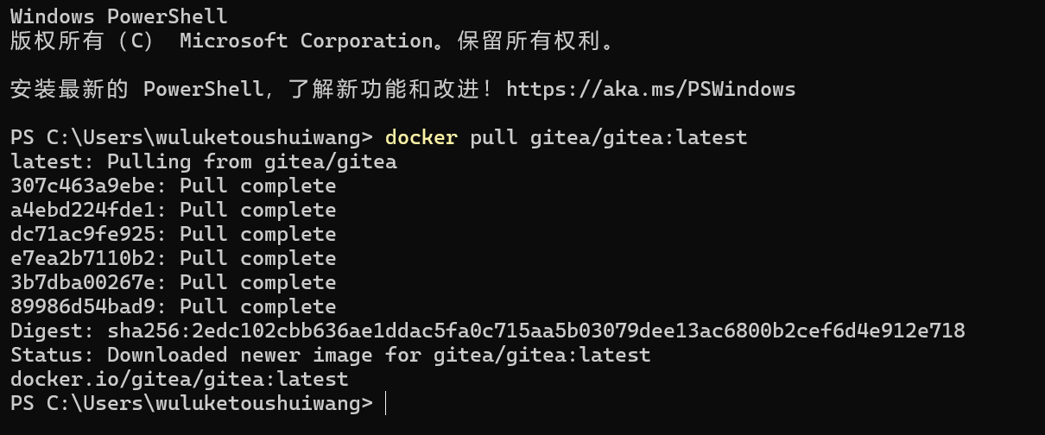

Create directories for persistent data (so your repos survive container restarts):

mkdir -p ~/gitea/{data,config}

2.Run the Gitea container:

docker run -d --name gitea -p 3000:3000 -p 222:22 -v C:\Users\wuluketoushuiwang\gitea\data:/data gitea/gitea:latest

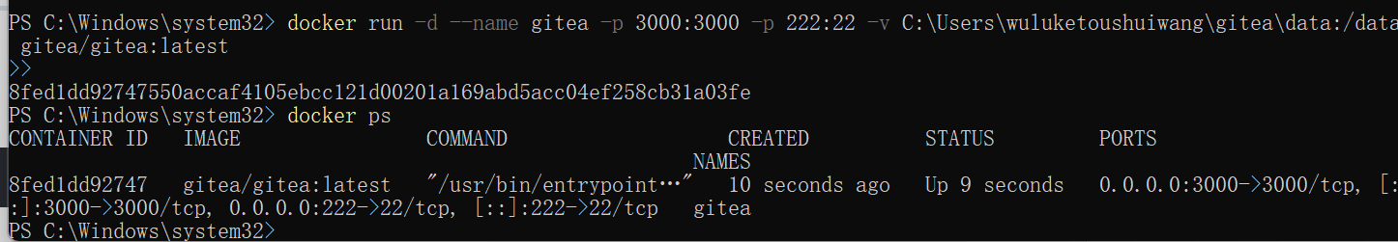

3. Open browser: <http://localhost:3000>

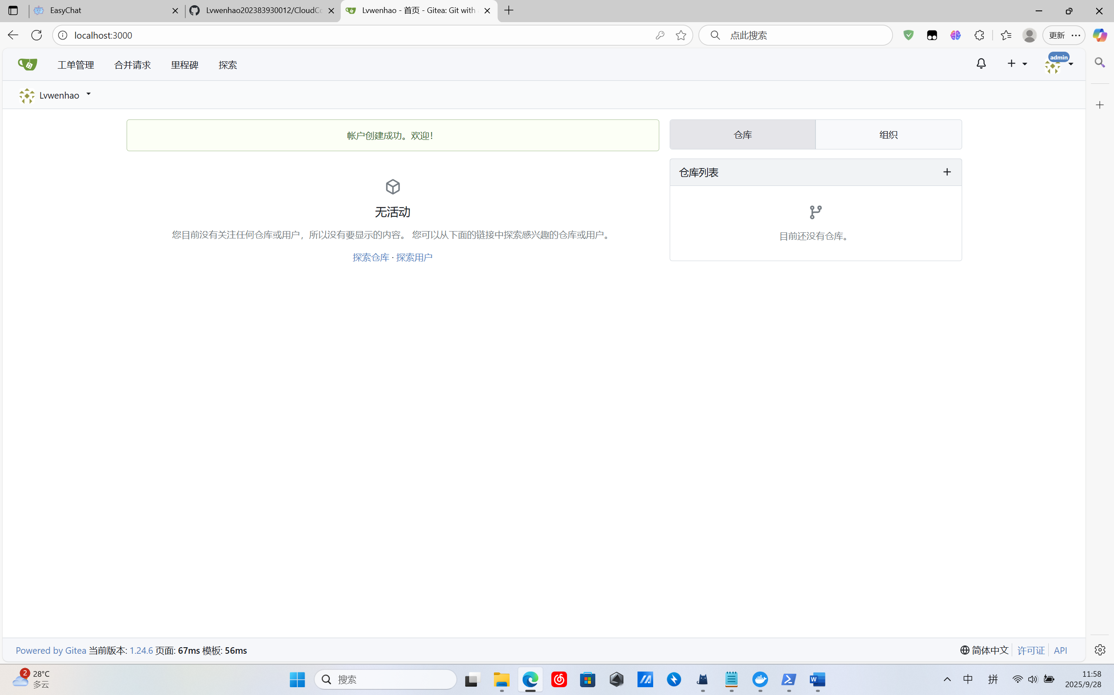

1. It support LFS

In docker edit config file

docker exec -it gitea /bin/sh vi /data/gitea/conf/app.ini

[server]

LFS_START_SERVER = true

We can find this on website

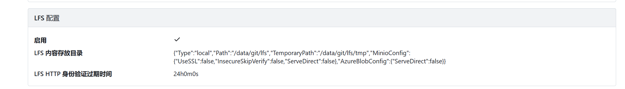

1. First create a repository on gitea

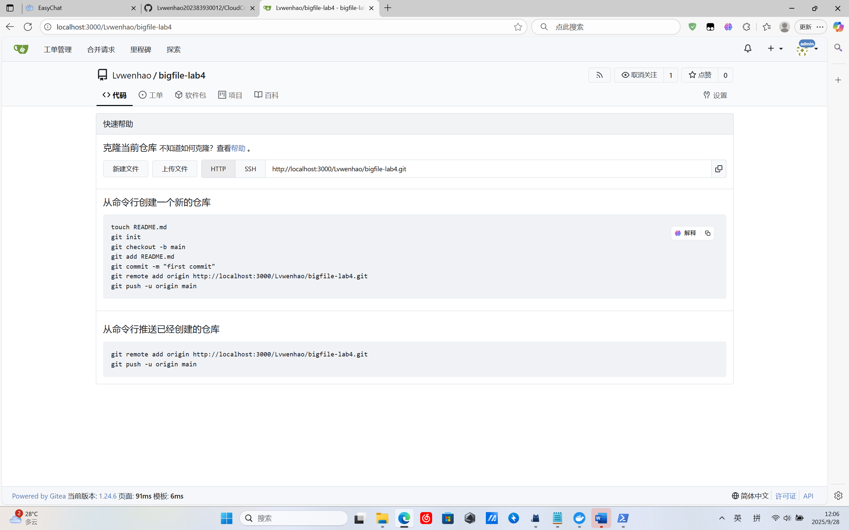

Then clone it on docker

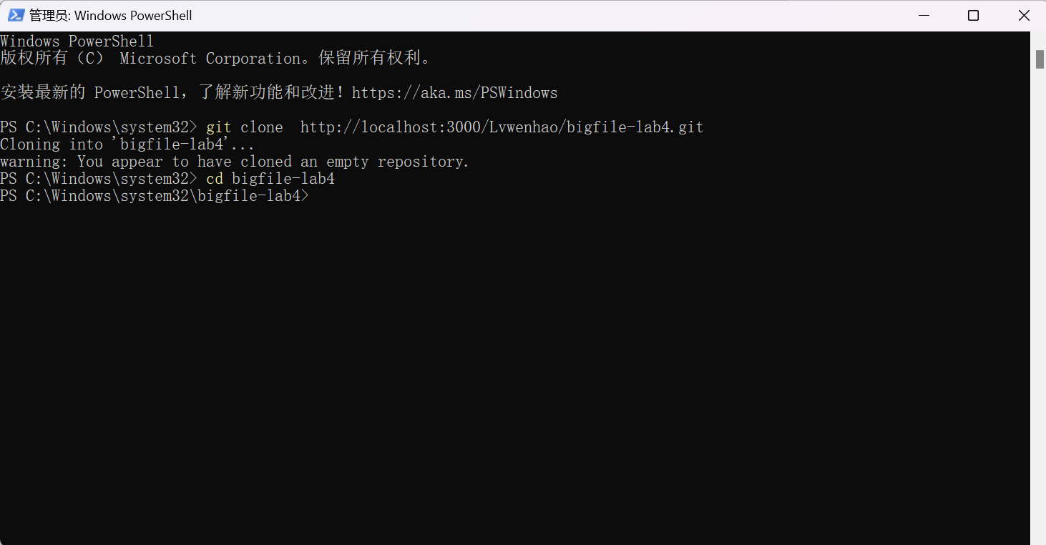

And create this bigfile and commit it to my repository

