Download Istio

1. 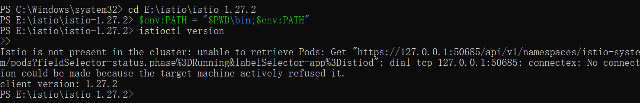

Install Istio

1. Install Istio using the demo profile, without any gateways:

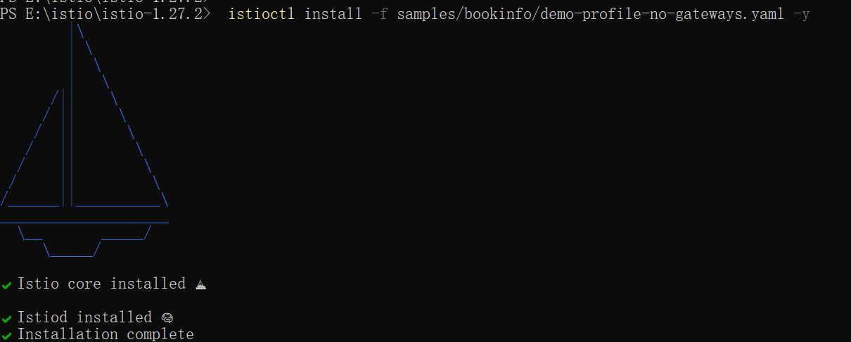

1. Add a namespace label to instruct Istio to automatically inject Envoy sidecar proxies when you deploy your application later:



Install the Kubernetes Gateway API CRDs

1. Install the Gateway API CRDs, if they are not already present:

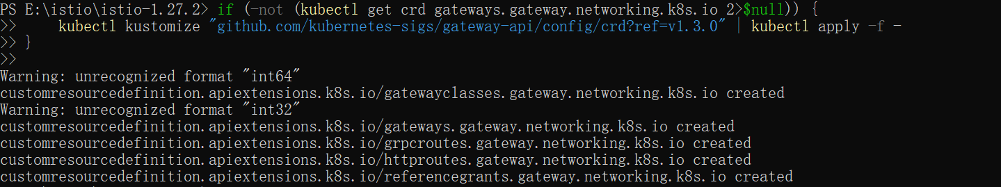

Deploy the sample application

1. Deploy the Bookinfo sample application:

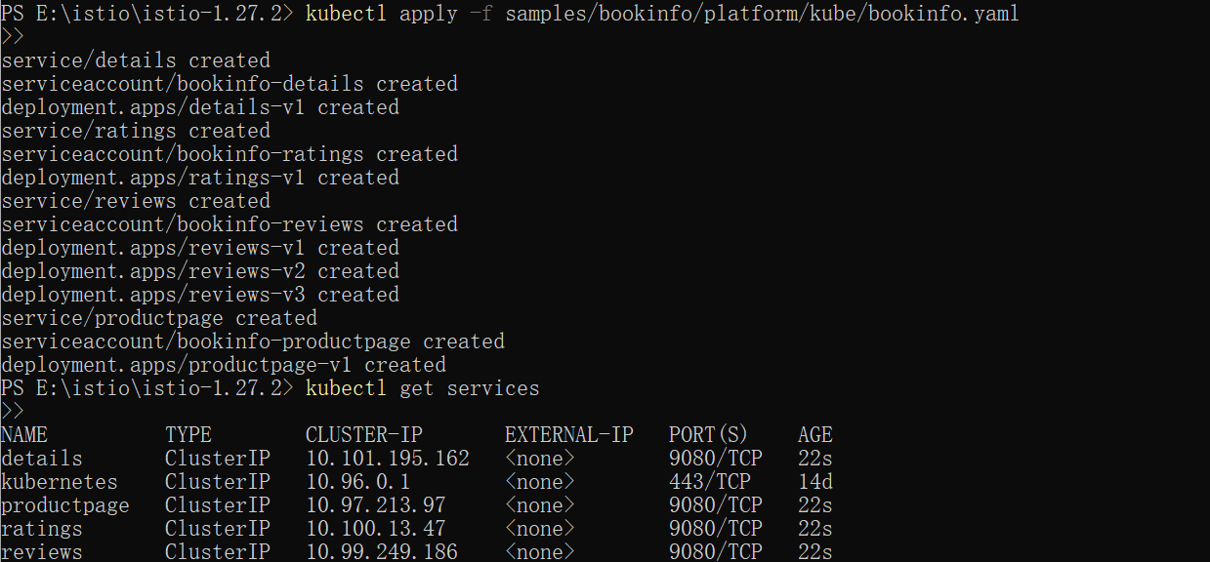

1. Validate that the app is running inside the cluster by checking for the page title in the response:



Open the application to outside traffic

1. Create a Kubernetes Gateway for the Bookinfo application:



1. Change the service type to ClusterIP by annotating the gateway:



Access the application

1. 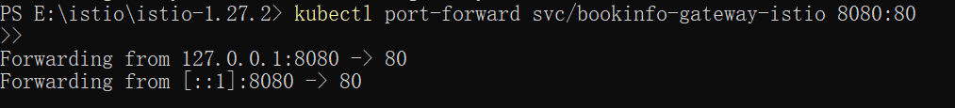
2. 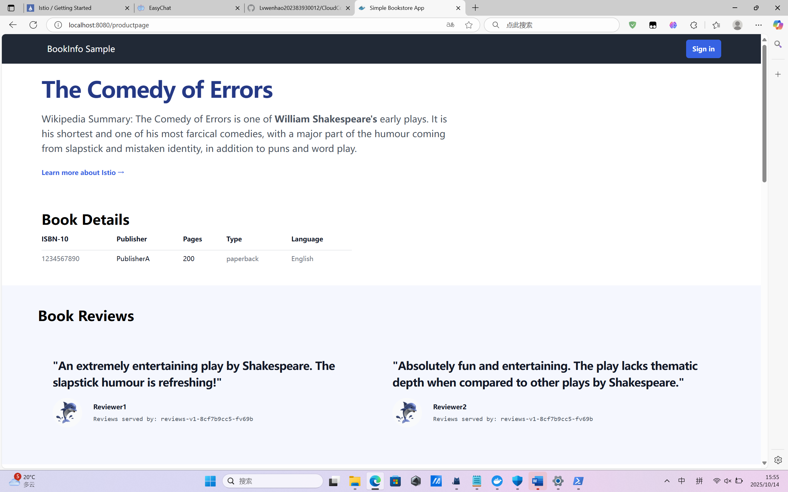

View the dashboard

1. Install Kiali and the other addons and wait for them to be deployed.

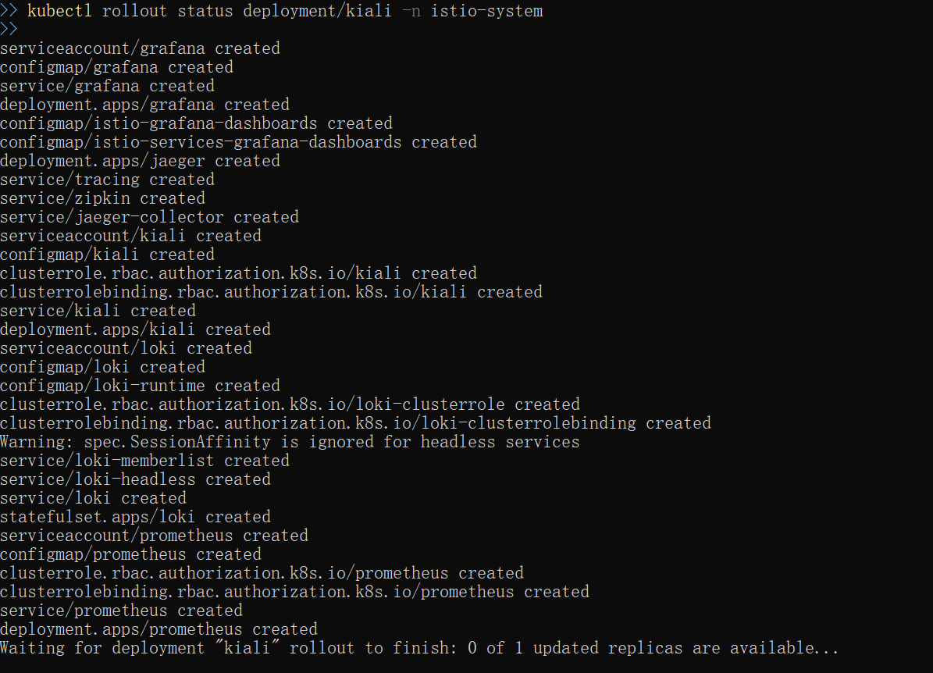



1. 