Start the application services

1. Deploy your application using the kubectl command:
2. Confirm all services and pods are correctly defined and running:
3. To confirm that the Bookinfo application is running, send a request to it by a curl command from some pod, for example from ratings:

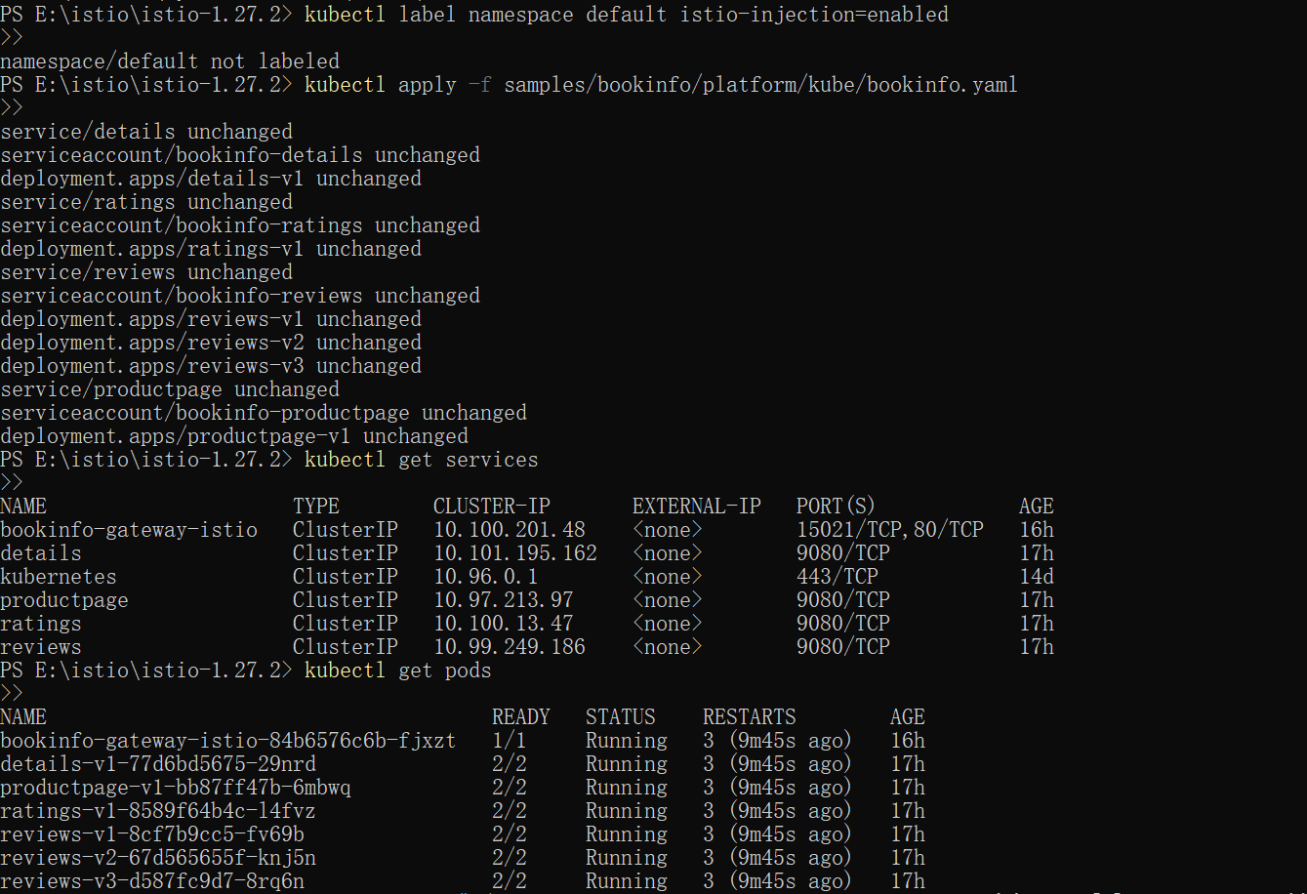

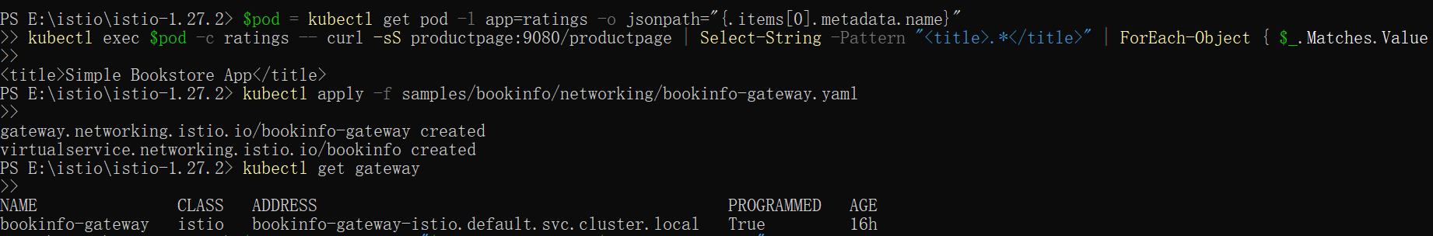

Ingress Gateways

1. 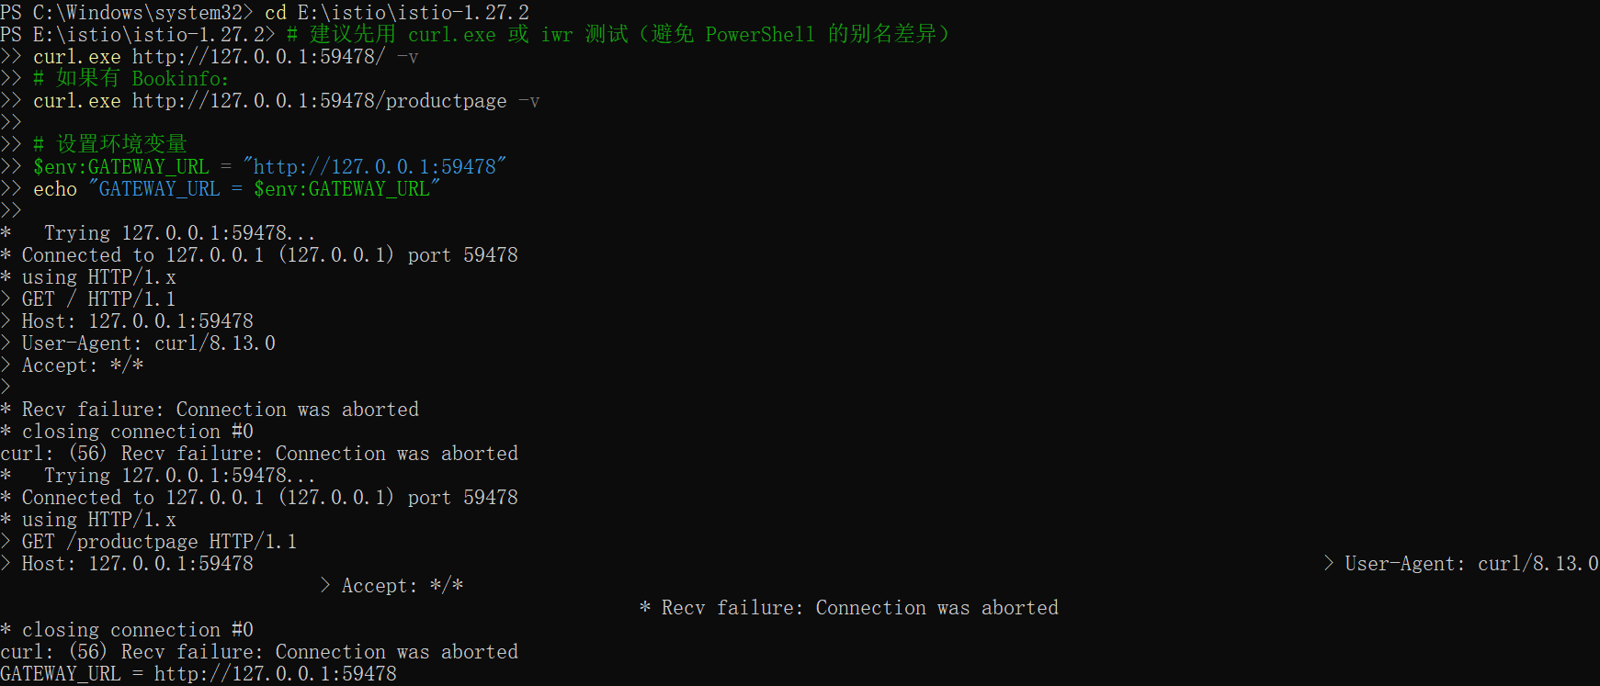
2. 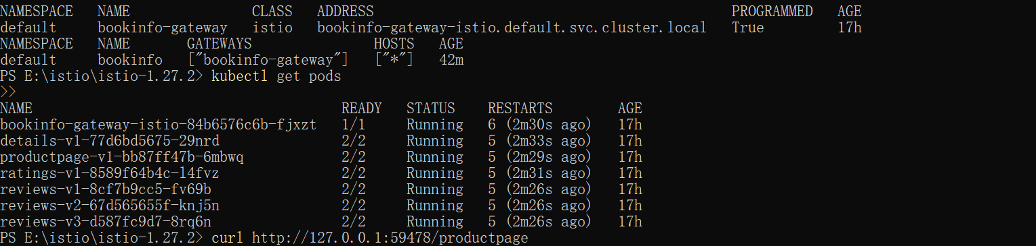
3. 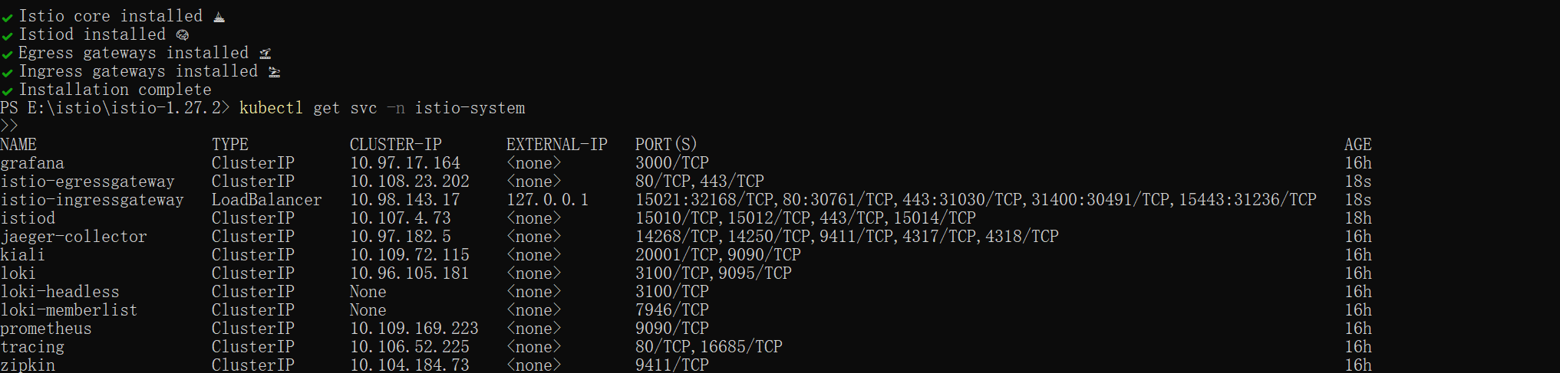
4. Create a gateway for the Bookinfo application:
5. Set GATEWAY_URL:

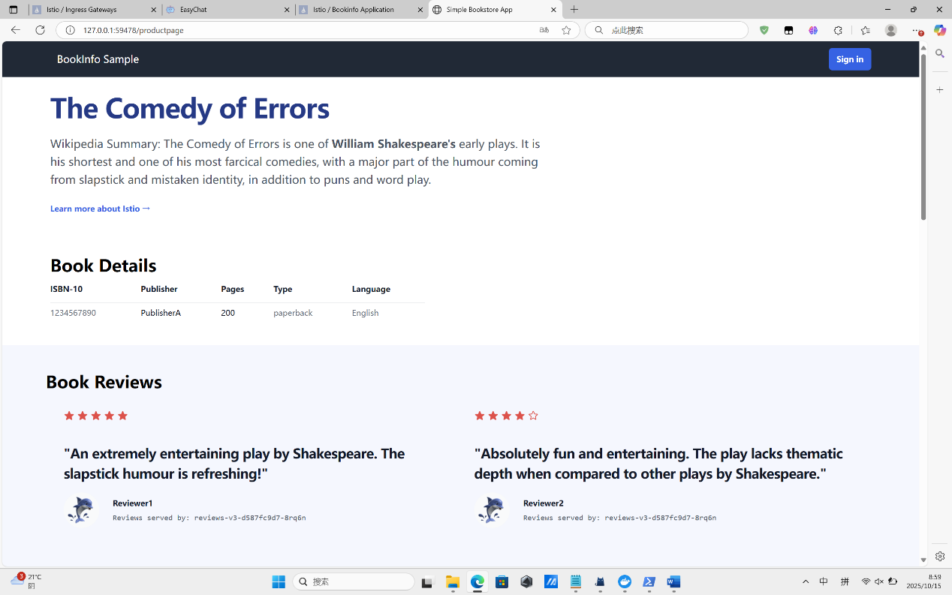

Request Routing

1. Run the following command to create the route rules:

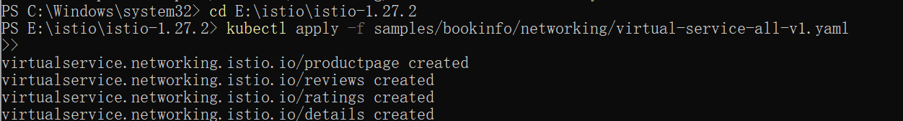

1. Run the following command to enable user-based routing:



1. 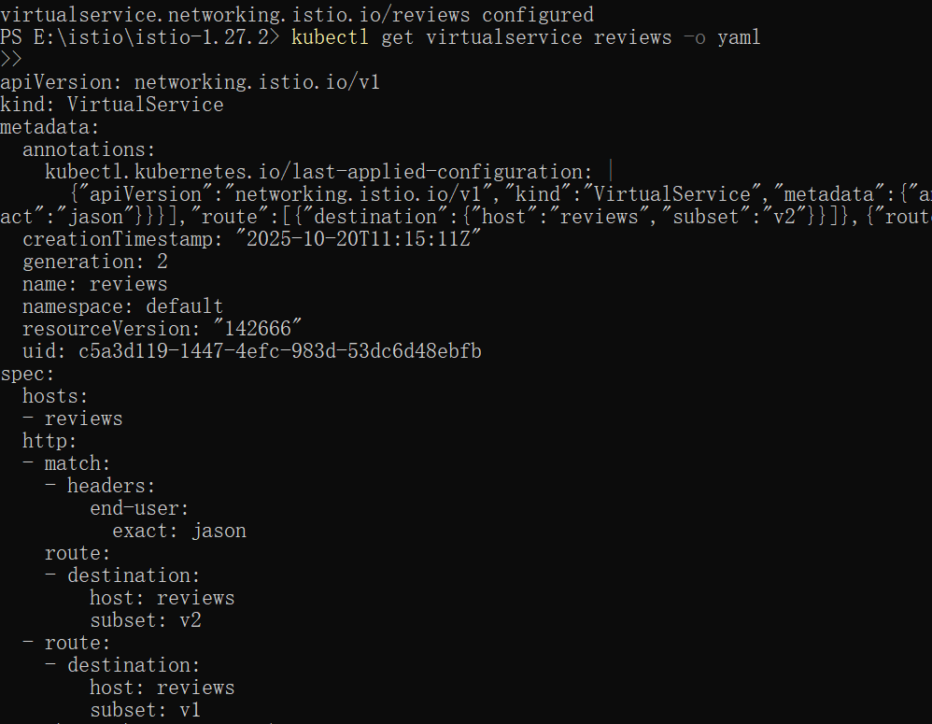
2. 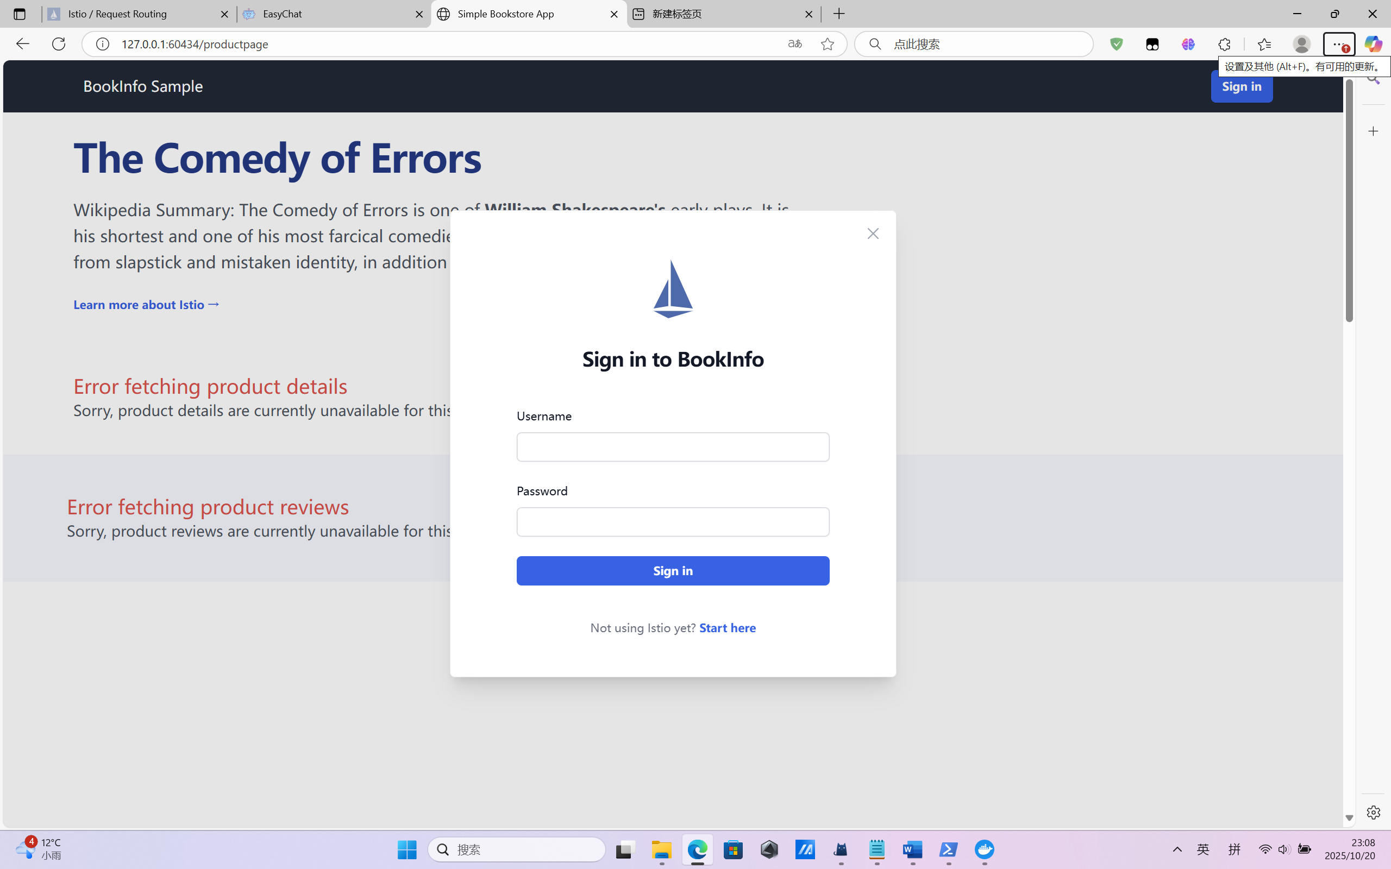
3. 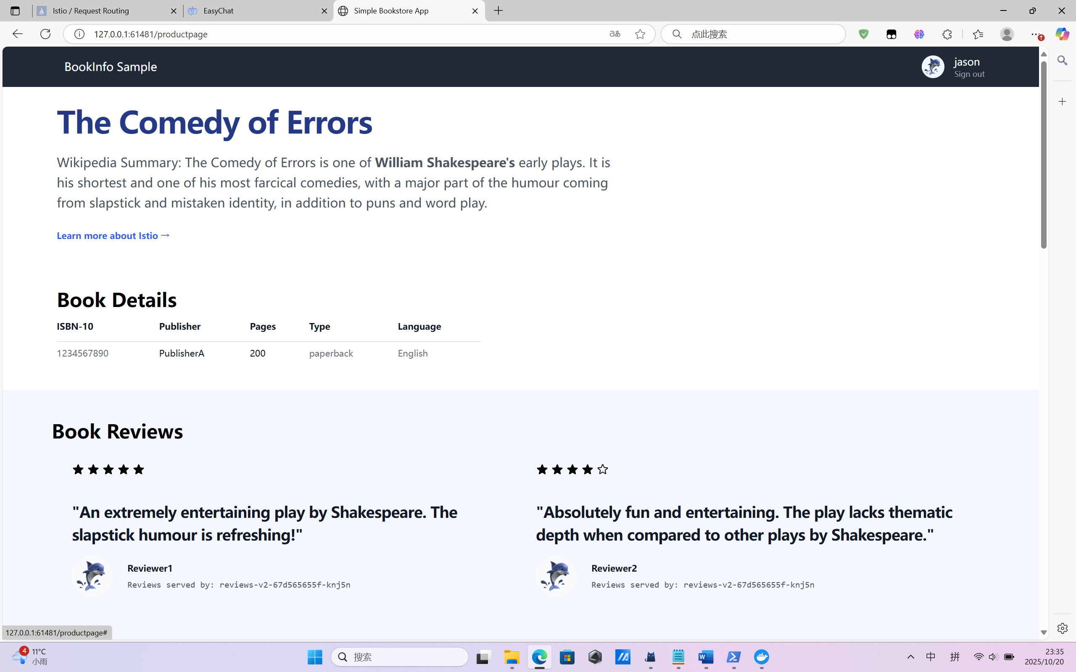
4. 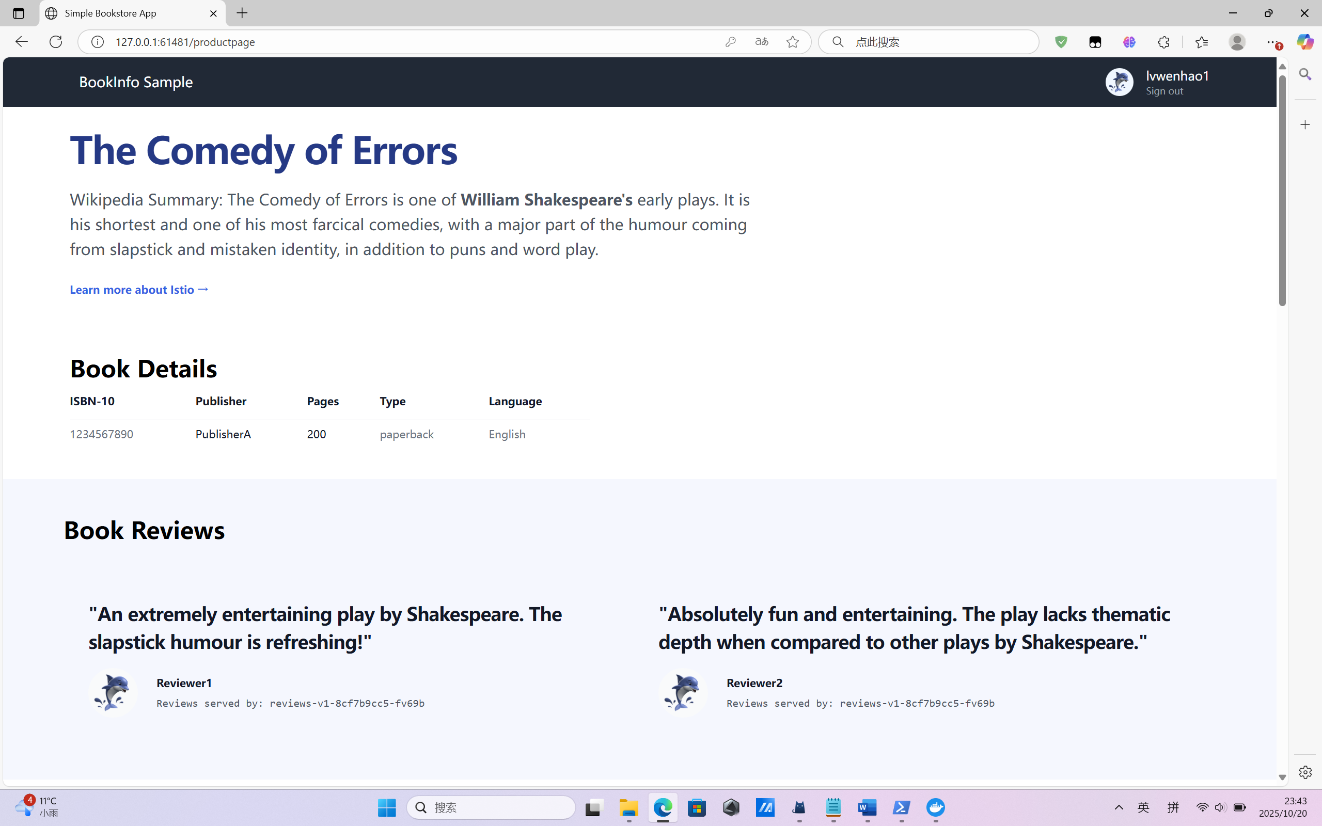

Fault Injection

1. Create a fault injection rule to delay traffic coming from the test user jason.
2. Confirm the rule was created:

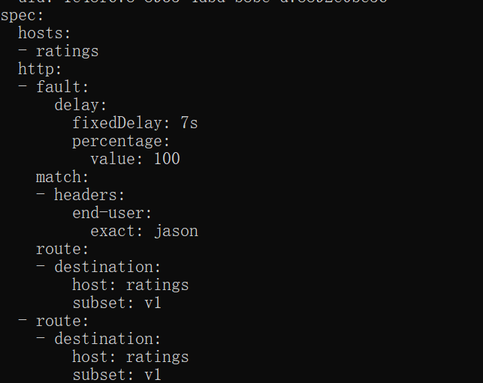

1. Login as Jason after 7s the website reload and the review disappear

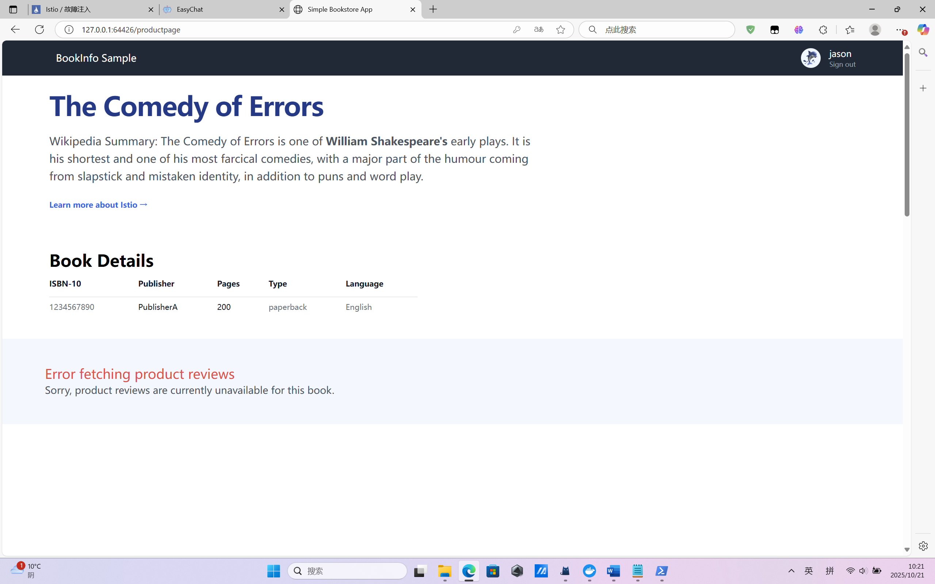

1. 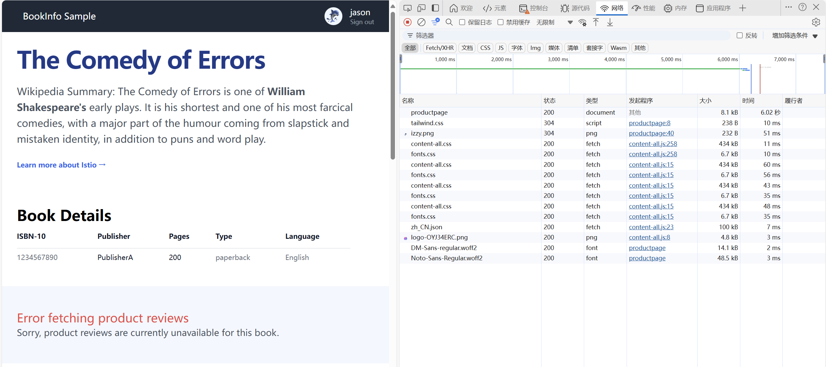
2. Injecting an HTTP abort fault

Create a fault injection rule to send an HTTP abort for user :Jason

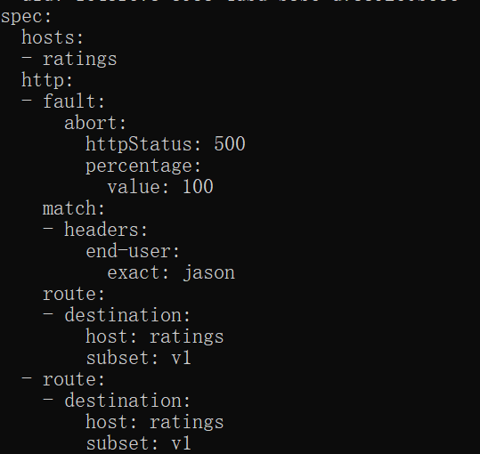

1. 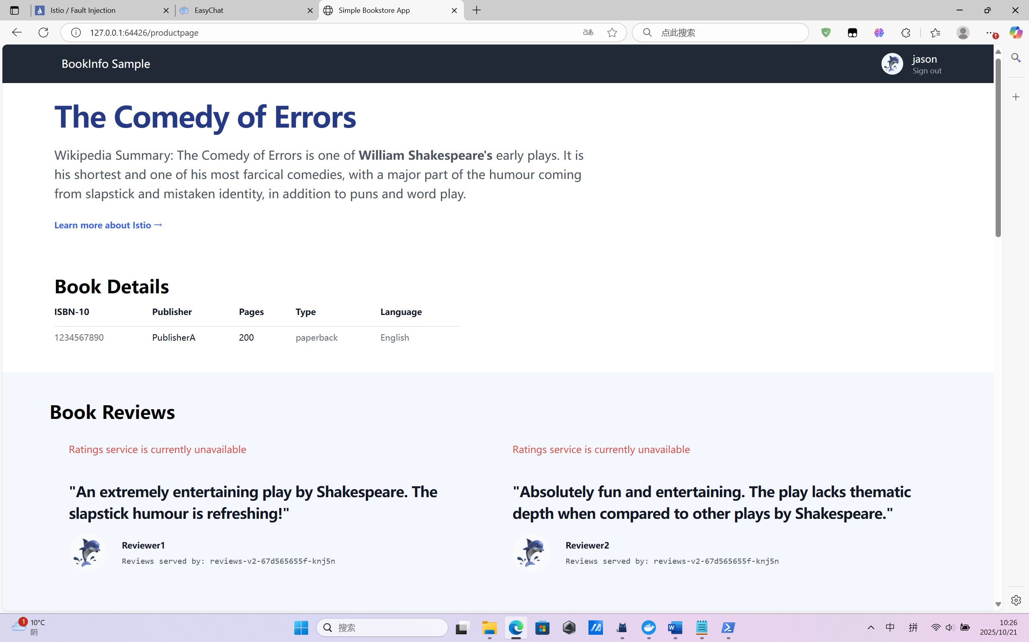

We can see the webpage now has the review but don’t have ratings when logging in Jason

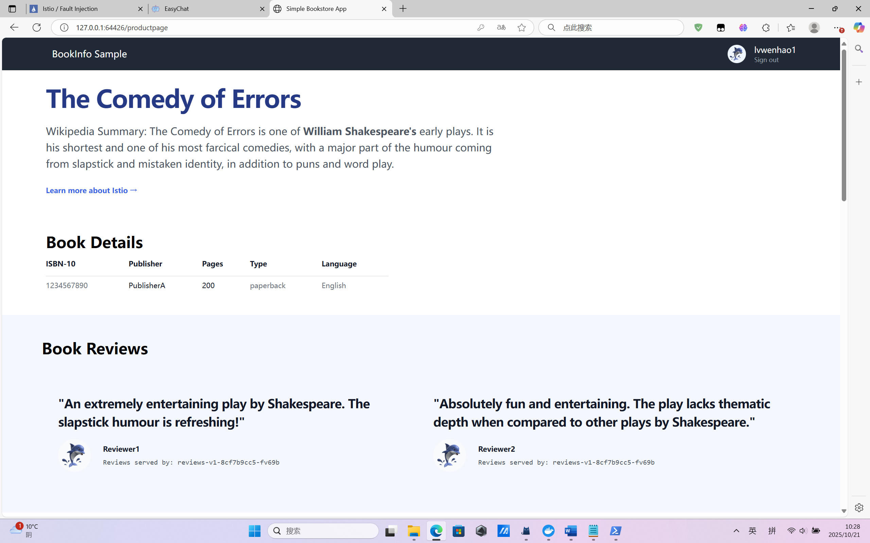

This is the page when we log in as Lvwenhao1

Traffic Shifting

1. Transfer 50% of the traffic from reviews:v1 to reviews:v3 with the following command:
2. 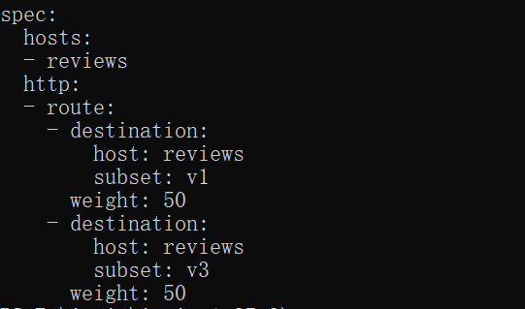
3. 
4. 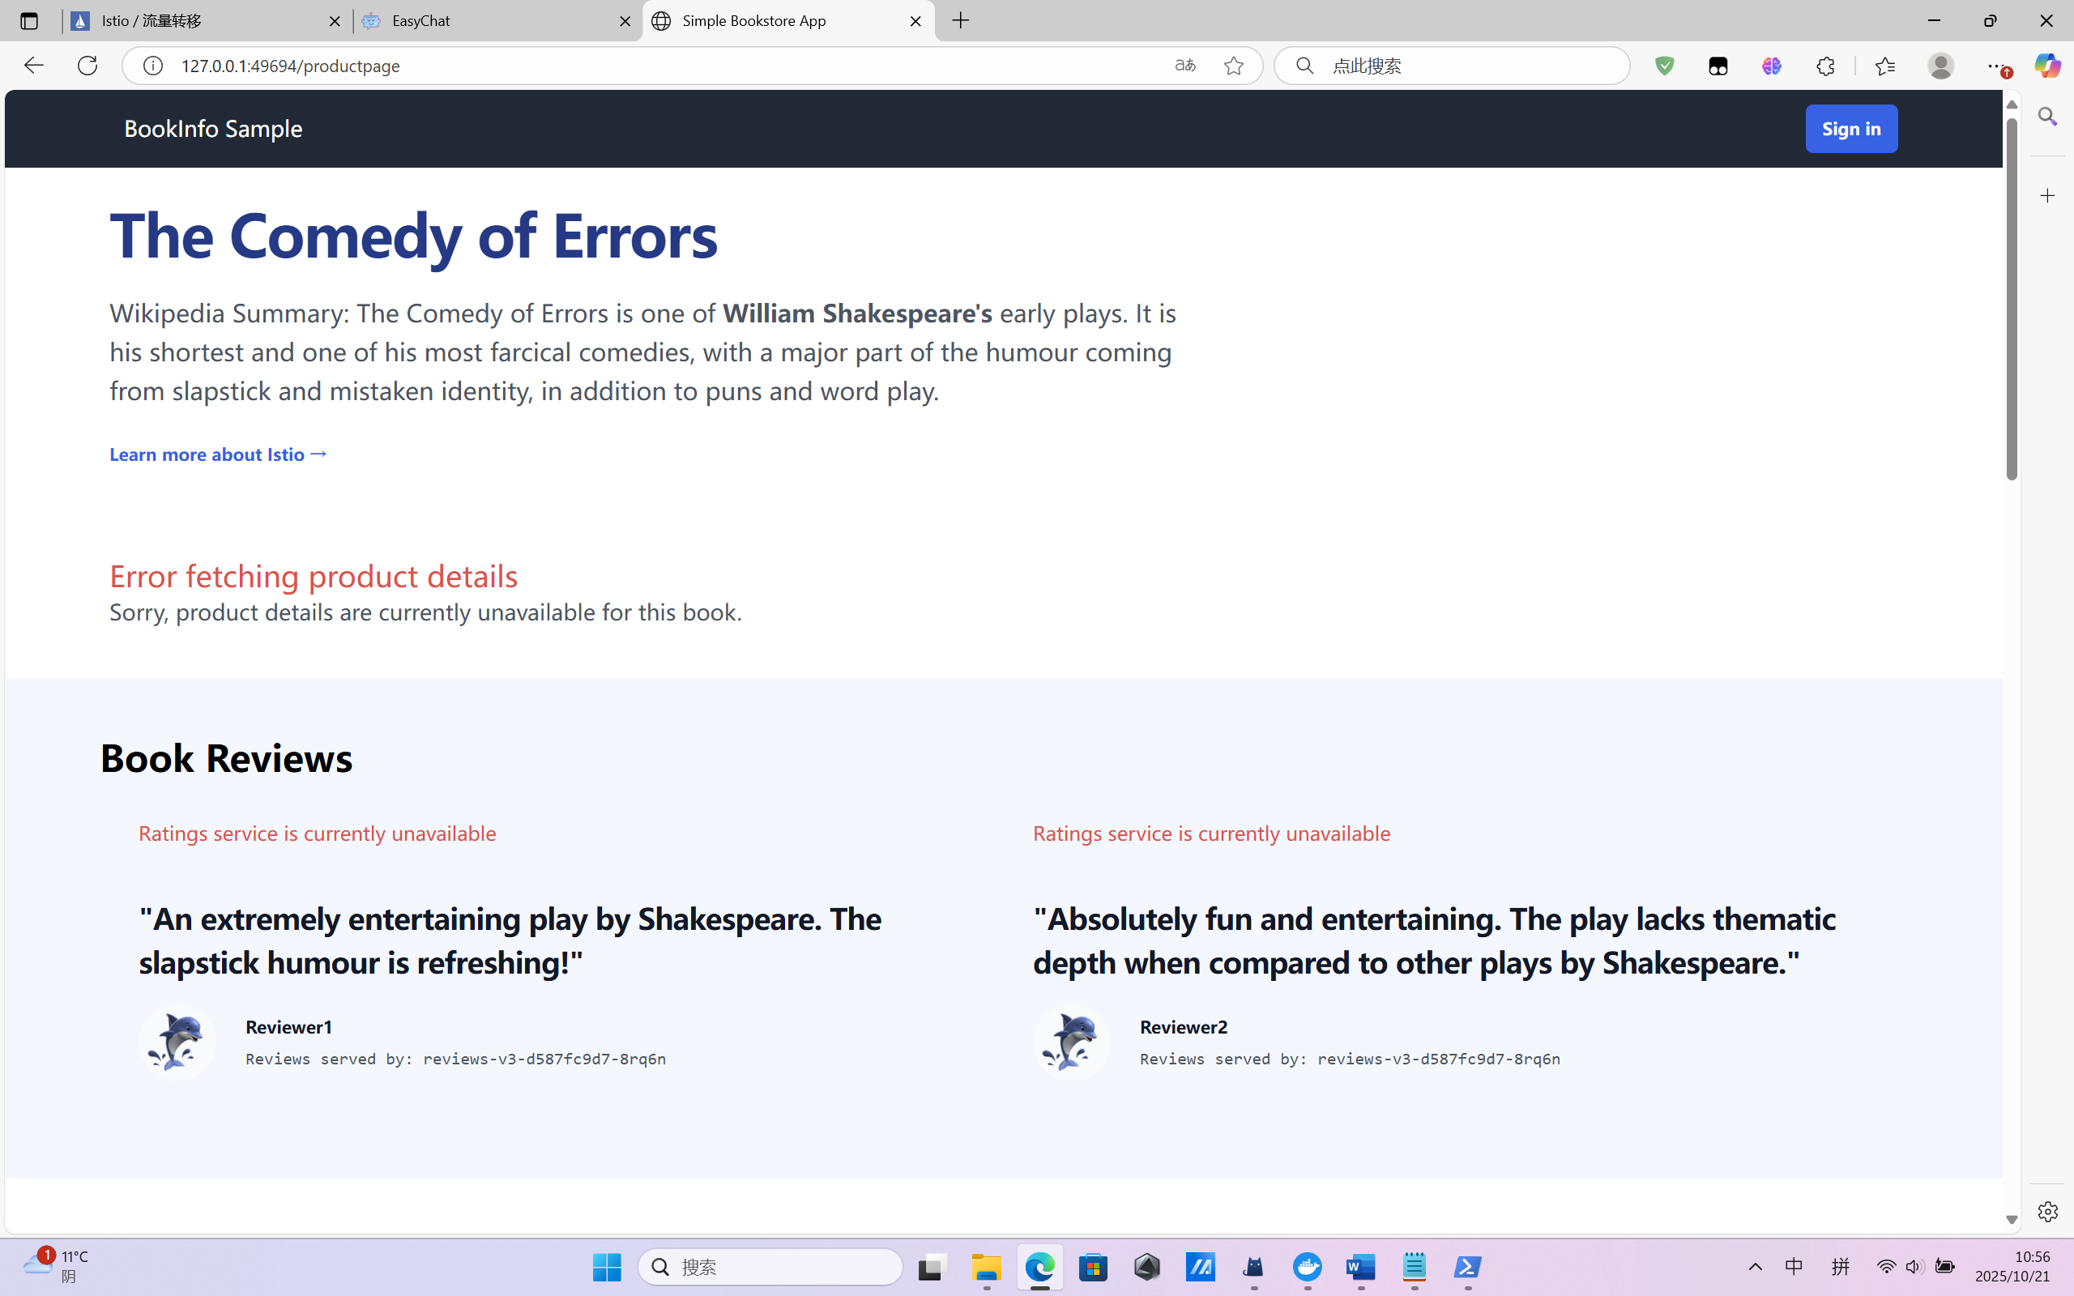

Circuit Breaking

1. Start the [httpbin](https://github.com/istio/istio/tree/release-1.27/samples/httpbin) sample.
2. Create a destination rule to apply circuit breaking settings when calling the httpbin service:

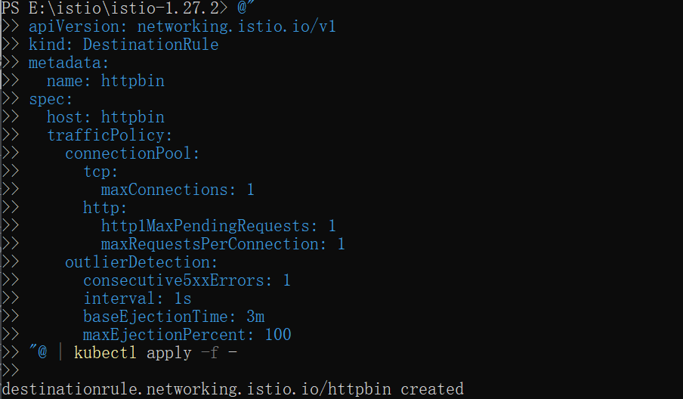

1. 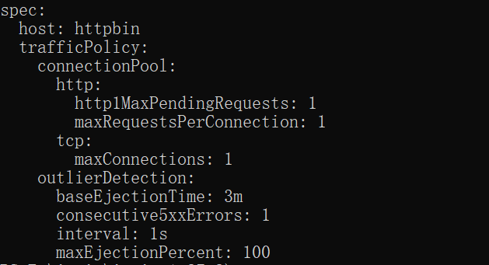
2. Create a client to send traffic to the httpbin service. The client is a simple load-testing client called fortio. Fortio lets you control the number of connections, concurrency, and delays for outgoing HTTP calls. You will use this client to “trip” the circuit breaker policies you set in the DestinationRule.
3. Inject the client with the Istio sidecar proxy so network interactions are governed by Istio.

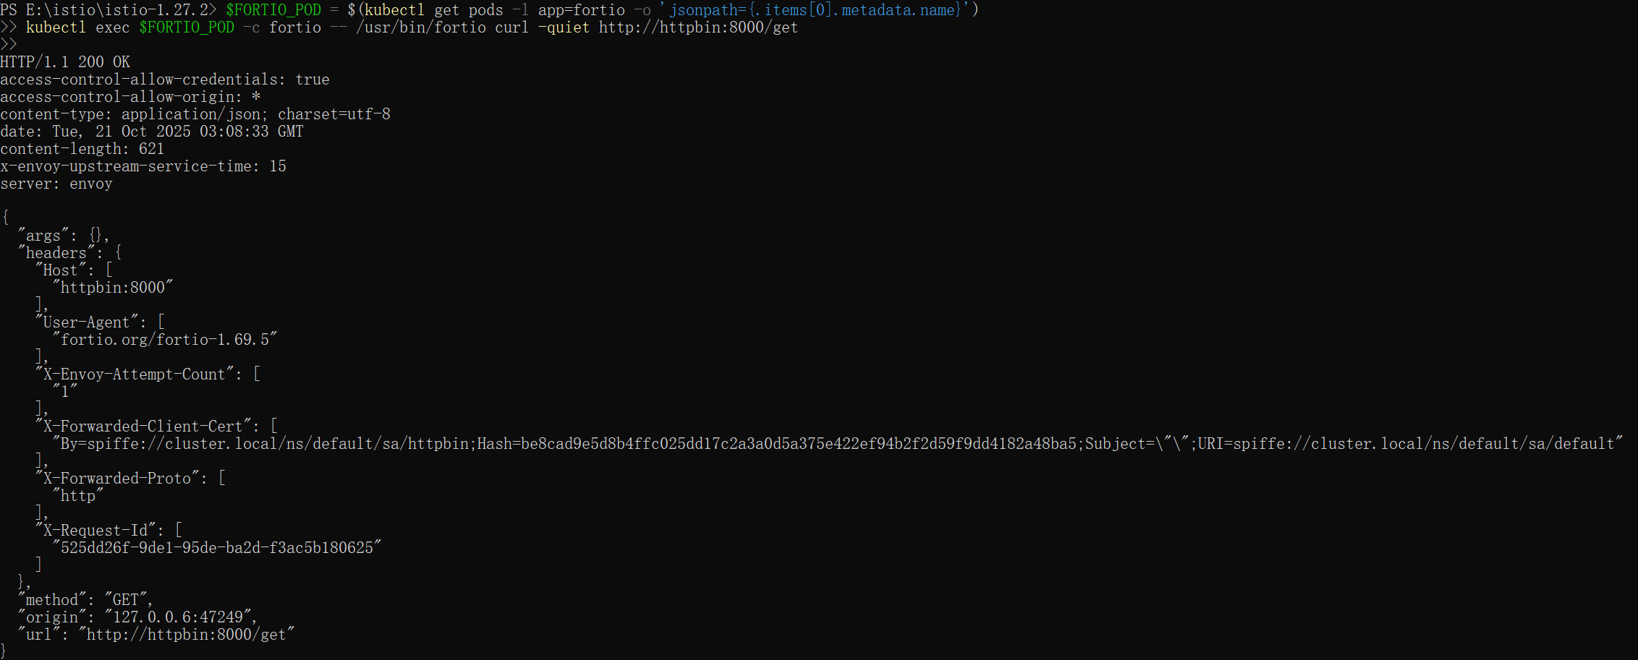

1. Call the service with two concurrent connections (-c 2) and send 20 requests (-n 20):

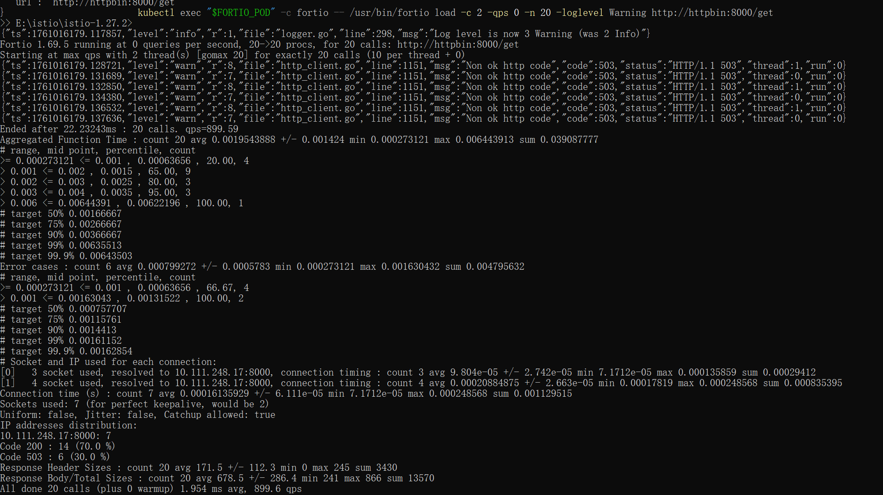

1. Bring the number of concurrent connections up to 3:

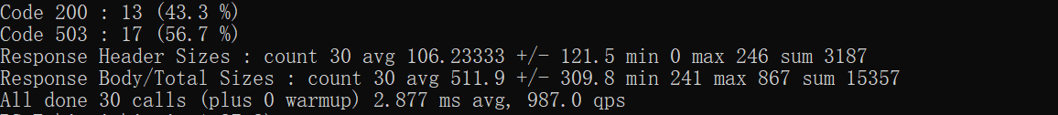

1. Query the istio-proxy stats to see more:

