Installing Knative Functions
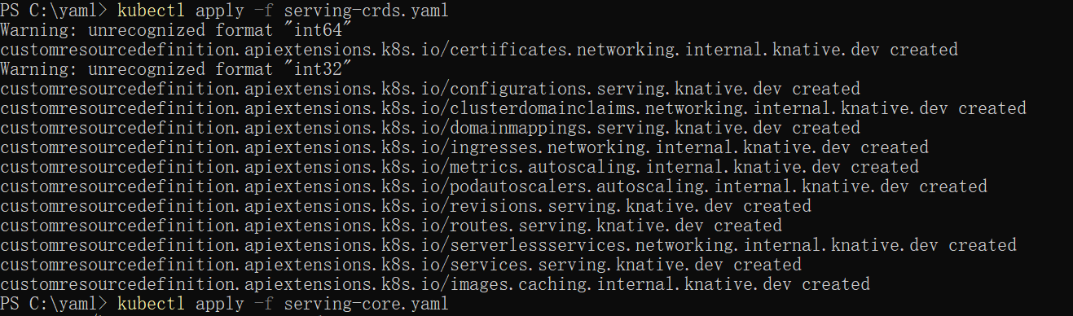
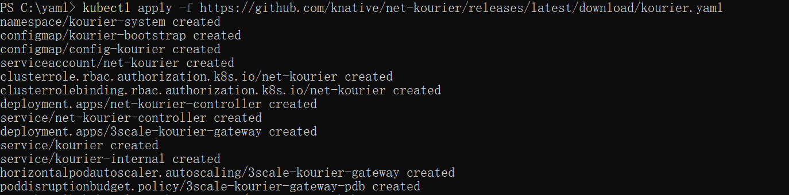
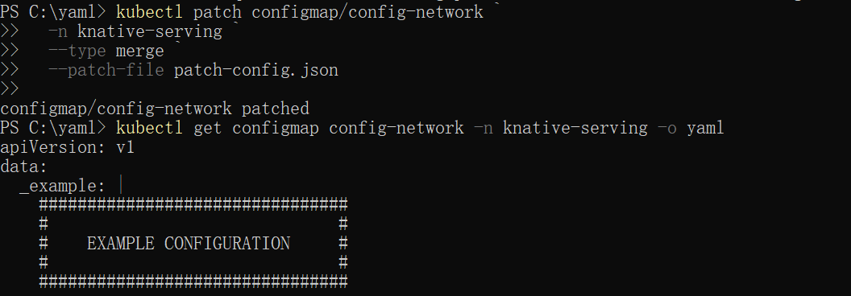
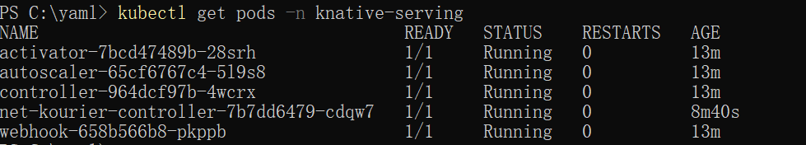
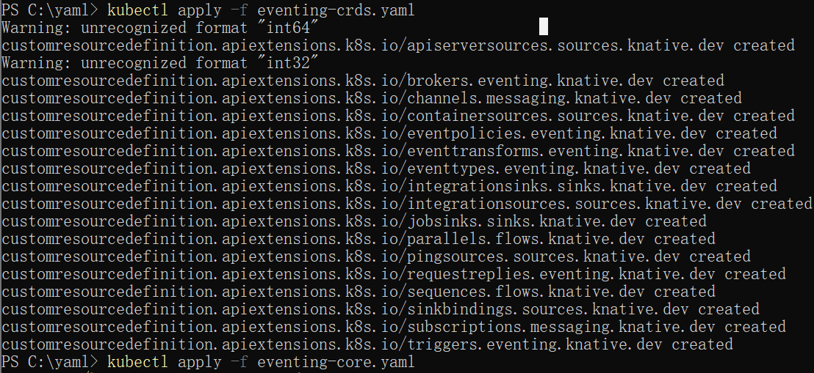
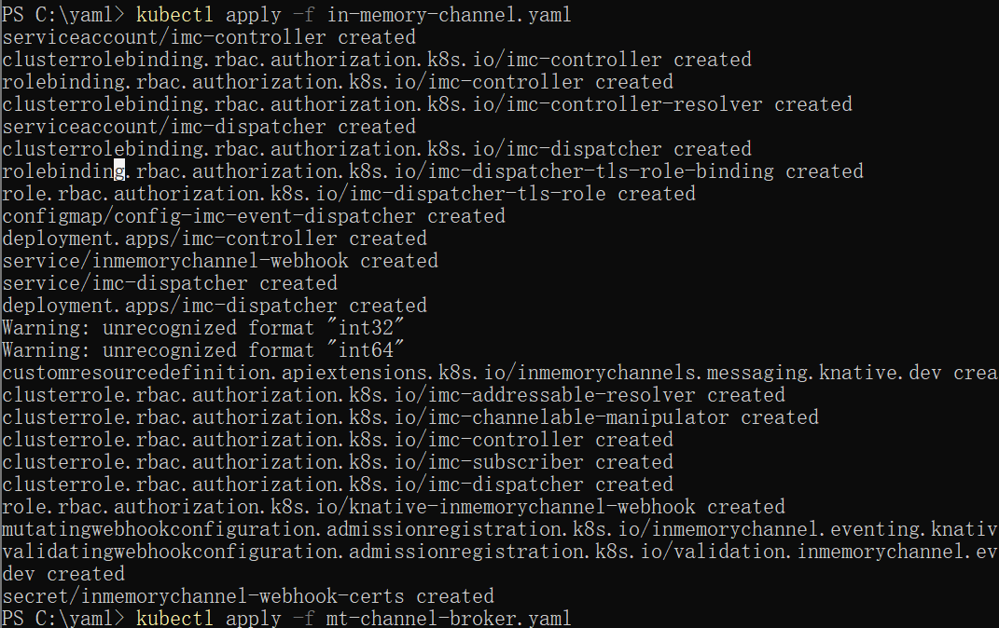
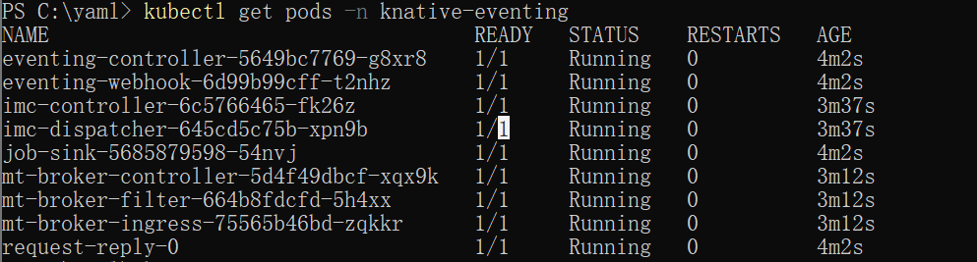
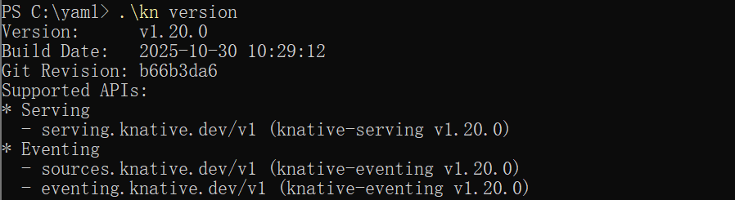
Installing Knative Functions
- Run func from a container image.
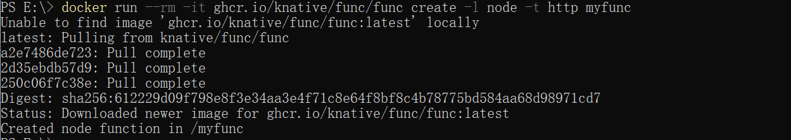
- Installing the kn func CLI plugin
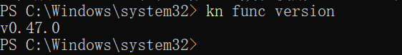
Creating a function
1.
Running a function
- Run the function locally, by running the command inside the project directory:
- 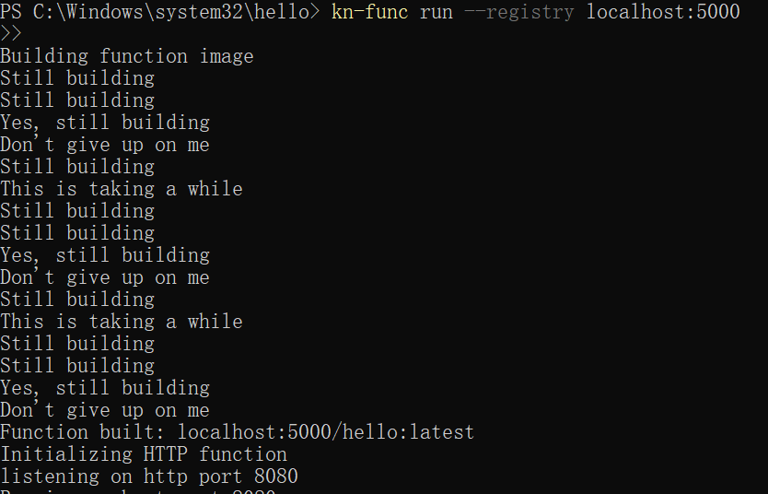
Deploying a Knative Service
- Copy the following YAML into a file named hello.yaml:
- Install the knative service and Deploy the Knative Service by running the command:
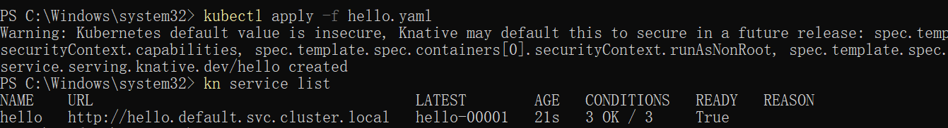
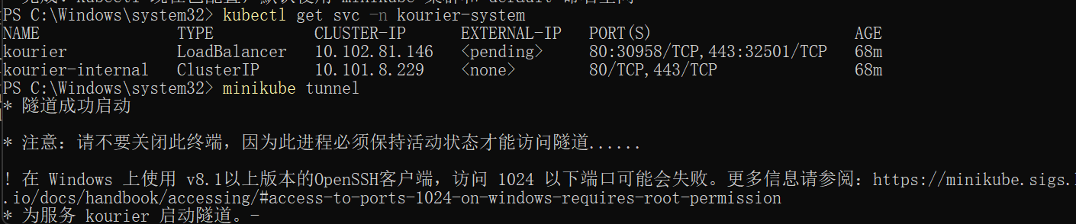
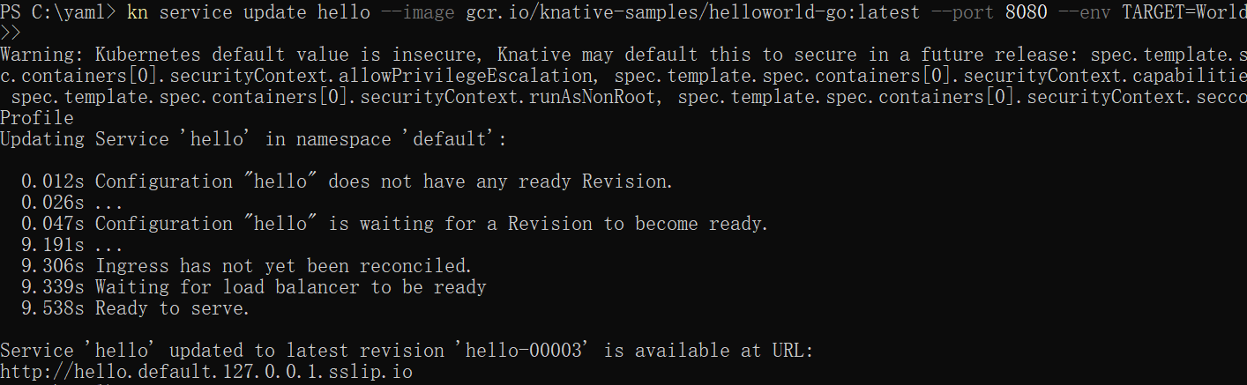
Autoscaling
- View a list of Knative Services by running the command:
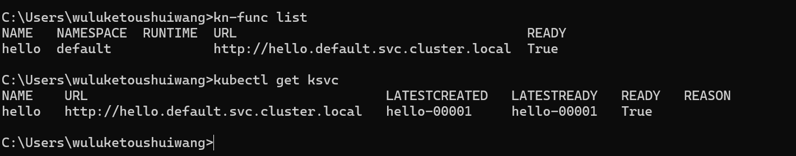
- Access your Knative Service by opening the previous URL in your browser or by running the command:
- Watch the pods and see how they scale to zero after traffic stops going to the URL:
Traffic splitting
- Instead of TARGET=World, update the environment variable TARGET on your Knative Service to greet "Knative" instead.
- Split the traffic between the two Revisions:
