- Install and configure KServe on a local Kubernetes cluster (Minikube)
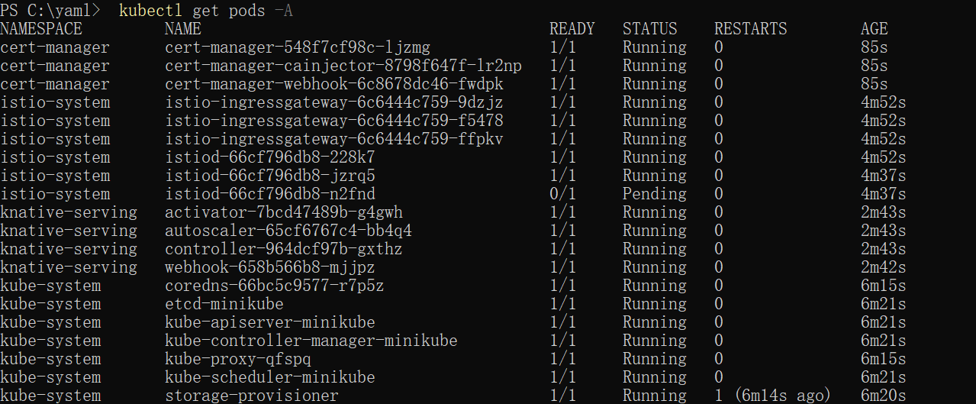
- 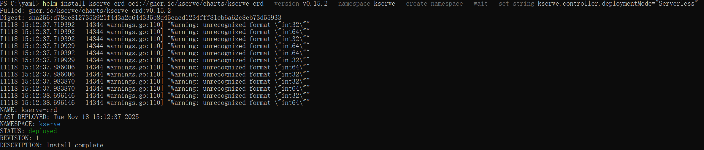
- 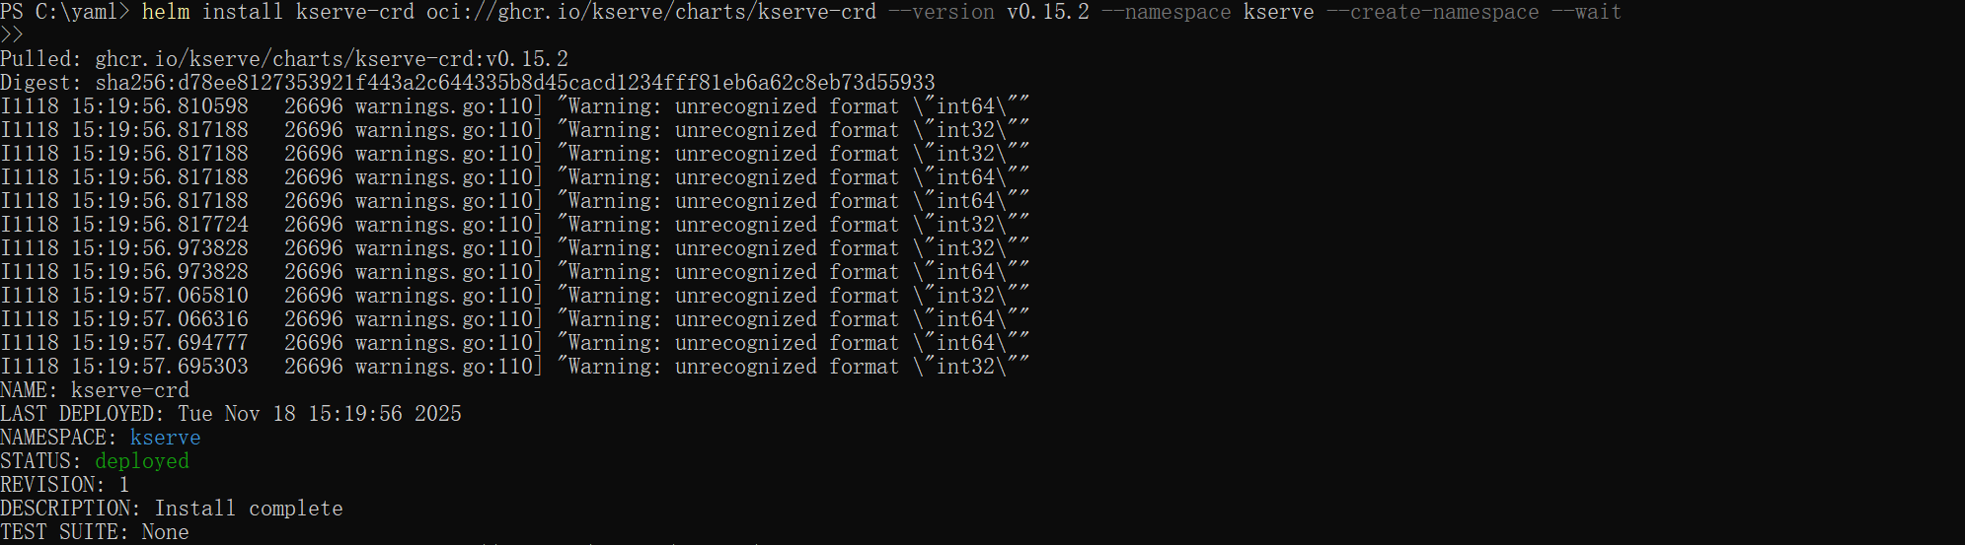
- 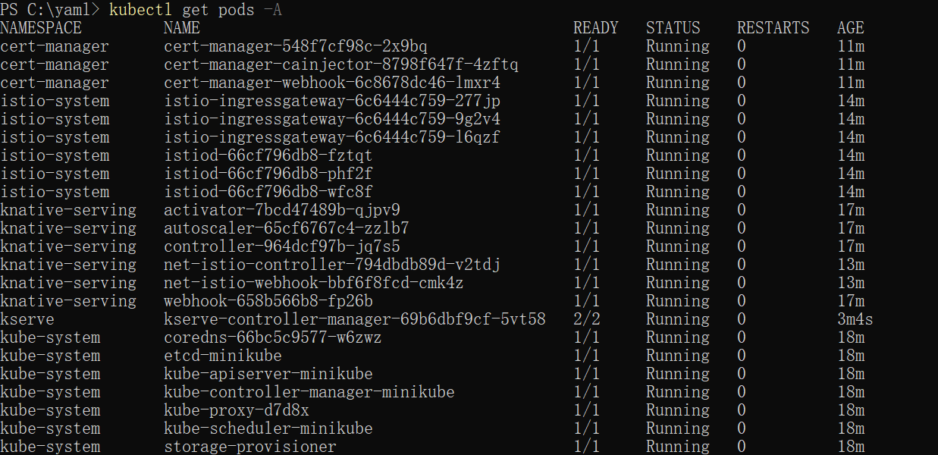
- 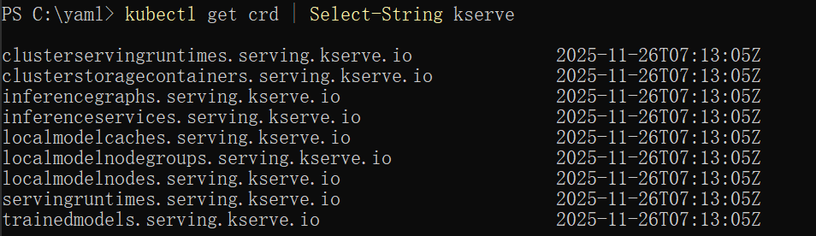
Create an InterferenceService
- 