**Cellular Economics**

**Questions of the TD on resource allocation – January 2024**

Léa Wagner, Olivier Borkowski, Matthieu Jules

# Model 1: cell-free

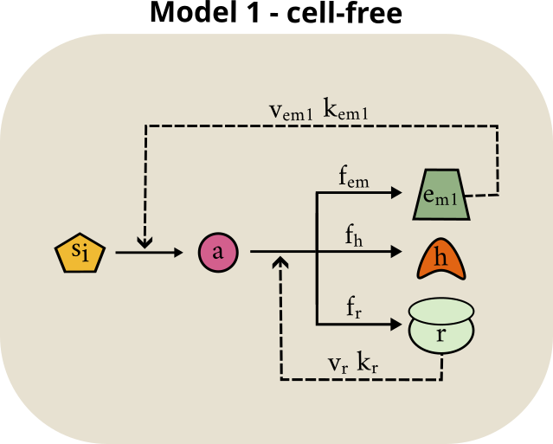

As depicted above, the cell is made of only five coarse-grained molecular components:

an internalized substrate 𝑠𝑖

* a species 𝑎 representing energy
* a pool of ribosomes 𝑟
* a pool of housekeeping proteins ℎ
* a pool of enzymes for metabolism 𝑒𝑚1

The total energy available to the cell must be divided between the tasks of producing 𝑟, ℎ and 𝑒𝑚1. This is represented in the model by the parameters 𝑓𝑅, 𝑓𝐻 and 𝑓𝑒𝑚1, which represent the proportion of energy allocated to the production of 𝑟, ℎ and 𝑒𝑚1 respectively.

Ribosomes produce 𝑟, ℎ and 𝑒𝑚1 according to a Michaelis Menten law:

Similarly, the metabolic enzymes 𝑒𝑚1 enable the regeneration of energy 𝑎 according to a Michaelis Menten law:

* 1. **Write the system of differential equations describing this model.**
  2. **Using the graph below, we will describe the effects of variations in the proportions of each species produced.**

**a) Describe the effects on the system of a variation in the ribosome fraction. What happens when no ribosomes are neoformed? What happens when only ribosomes are produced?**

**b) Describe the effects on the system of a variation in the metabolic enzymes fraction. What happens when no metabolic enzymes are neoformed? What happens when only metabolic enzymes are produced?**

**c) Describe the effects on the system of a variation in the housekeeping proteins fraction. What happens when no housekeeping proteins are neoformed? What happens when only housekeeping proteins are produced.**

* 1. **Using the graph below, what species can be absent from the initial conditions without the system collapsing? Which species are essential to initialize the model?**
  2. **Describe the different types of resources present in this system (for catabolism or anabolism).**

**1.5) Why does the concentration of some species never decrease? Which classical biological phenomenon is not considered by this simplified model?**

**1.6) In all the above cases, the system eventually reaches a stage where nothing more is produced. Why?**

# Model 2 – *in vivo*

Let's consider now a slightly more complicated system to represent a cell in vivo. Unlike cell-free, this cell is constrained by a membrane.

The cell must internalize its substrate (𝑠*i*) from the surrounding environment using transport enzymes (𝑒𝑡).

This compartmentalization gives rise to density constraints. Based on experimental data, we assume that the cell maintains a constant mass density and volume. That means the cell mass (equal to the sum of all components) is proportional to the growth rate.

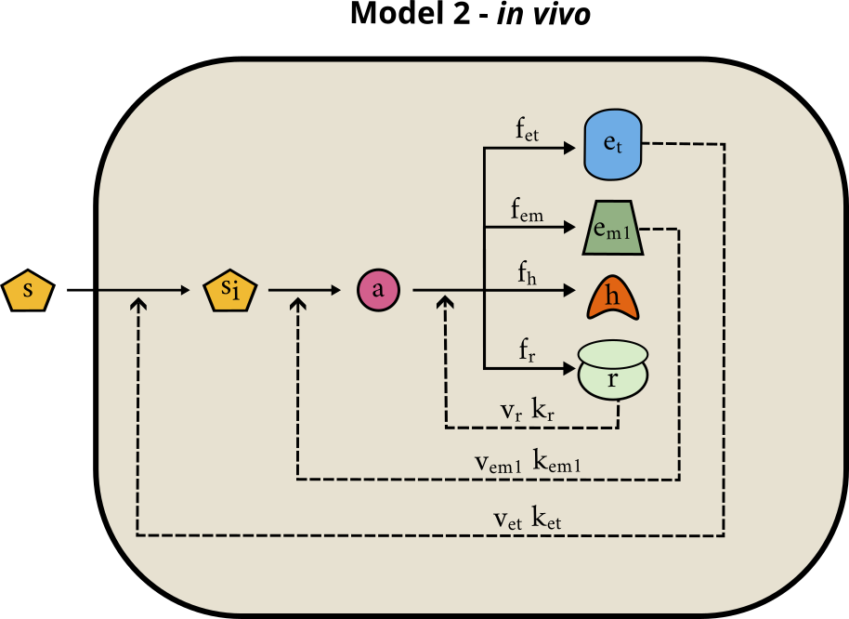

**Questions**

**2.1) Write the system of differential equations describing this model. Add a term to account for dilution that takes the growth rate into account.**

**2.2) Using the graph below, we will describe the effects of variations in the proportions of each species produced.**

**a) Describe the effects on the system of a variation in the ribosome fraction. What happens when no ribosomes are neoformed? What happens when only ribosomes are produced?**

**b) Describe the effects on the system of a variation in the metabolic enzymes fraction. What happens when no metabolic enzymes are neoformed? What happens when only metabolic enzymes are produced?**

**c) Describe the effects on the system of a variation in the housekeeping proteins fraction. What happens when no housekeeping proteins are neoformed? What happens when only housekeeping proteins are produced?**

**d) Describe the effects on the system of a variation in the transporter fraction. What happens when no transporter is neoformed? What happens when only transporters are produced?**

**2.3) Why is the concentration of $r$, $h$, $em1$ and $et$ constant at a given moment, when there is still energy?**

**2.4) Find an expression for the cell growth rate 𝜇 (think mass conservation and combine the differential equations).**

**2.5) Using the graph below, see how 𝜇 changes when you increase the richness of the substrate 𝑆.**

**2.5) Using the graph below, find some optimal ratios $f_{r}$, $f_{h}$, $f_{em1}$, $f_{et}$, $f_{si}$, $f_{a}$ to maximize the growth rate (more than 1.0).**

# Model 3 - *in vivo* with two metabolic pathways

Let's consider now a slightly more complicated system to represent a cell in vivo. In cells, several metabolic pathways are encoded in the genome and can be activated depending on the environment. Here we show:

* an expensive but highly efficient metabolic pathway (**em1**)
* an inexpensive but not very efficient metabolic pathway (**em2**)

|  |
| --- |
|  |

As depicted above, the cell is made of the following species:

* an external substrate 𝑠
* an internalized substrate 𝑠𝑖
* a species 𝑎 representing both protein precursors and energy
* a pool of ribosomes 𝑟
* a pool of housekeeping proteins ℎ
* a pool of enzymes for metabolism 𝑒𝑚1 and 𝑒𝑚2
* a pool of enzymes for transport 𝑒𝑡

The actions of 𝑟, 𝑒𝑚1, 𝑒𝑚2 and 𝑒𝑡 are modelled by a Michaelis-Menten function as before.

**3.1) Which of the metabolic pathways could correspond to 𝑒𝑚1 and 𝑒𝑚2 based on their characteristics?**

**3.2) Using the graph below, explore the circumstances in which 𝑒𝑚1 is more favorable than 𝑒𝑚2 and vice versa by varying the parameters.**