FULL LEGAL NAME | LOCATION (COUNTRY) | EMAIL ADDRESS | MARK X FOR ANY NON-CONTRIBUTING MEMBER

Statement of integrity: By typing the names of all group members in the text boxes below, you confirm that the assignment submitted is original work produced by the group (excluding any non-contributing members identified with an “X” above).
Team member 1
Team member 2
Team member 3

Use the box below to explain any attempts to reach out to a non-contributing member. Type (N/A) if all members contributed.
Note: You may be required to provide proof of your outreach to non-contributing members upon request.

- On top left of your screen click on File →Download → Microsoft Word (.docx) to download this template
- Upload the template in Google Drive and share it with your group members
- Delete this page with the requirements before submitting your report. Leaving them will result in an increased similarity score on Turnitin.

Keep in mind the following:
- Make sure you address all the questions in the GWP assignment document published in the Course Overview.
- Follow the “Submission requirements and format’ instructions included in each Group Work Project Assignment, including report length.
- Including in-text citations and related references is mandatory for all submissions. You will receive a ‘0’ grade for missing in-text citations and references, or penalties for partial completion. Use the In-Text Citations and References Guide to learn how to include them.
- Additional writing aids: Anti-Plagiarism Guide, Academic Writing Guide, Online Writing Resources.
- To avoid an increase in the Turnitin similarity score, DO NOT copy the questions from the GWP assignment document.
- Submission format tips:
  - Use the same font type and size and same format throughout your report. You can use Calibri 11, Arial 10, or Times 11.
  - Do NOT split charts, graphs, and tables between two separate pages.
  - Always include the axes labels and scales in your graphs as well as an explanation of how the data should be read.
- Use the LIRN Library for your research. It can be accessed via the left navigation pane inside the WQU learning platform.
- Carefully read Academic Policy on the use of AI explaining how the use of AI tools is restricted and regulated. Severe penalties apply for excessive and improper use of AI

The PDF file with your report must be uploaded separately from the zipped folder that includes any other types of files. This allows Turnitin to generate a similarity report.

Part 1
Q1
- The paper used quantitative data (time series data), primarily sourced from Yahoo Finance for the period of 12 December 2009 to 1 January 2020. The data includes opening price, highest price, lowest price, closing price, number of transactions (volume) and adjusted close price. This data was extracted for iShares MSCI Chile ETF (ECH), iShares MSCI Brazil ETF (EWZ), iShares Core S&P 500 ETF (IVV).
The technical indicators in the paper are derived through Pandas Technical Analysis Library (Pandas TA). This is a toolkit (from Pandas package) that has customizable technical indicators, utility functions and candlestick patterns. These expanded the feature set to 216 indicators, in addition to the above 6 from Yahoo Finance.

- The importance of using these indicators is that it provides more diverse features used for analyzing different factors of market trends and improving predictive power of the derived model. The indicators extract useful patterns such as market momentum, volatility, trend direction, and investor sentiment, that are not immediately visible from the raw data. Thus, transforming financial time series data (which is usually noisy) into structured signals allows predictive models to be more accurate with stock price forecasts. Selecting the most relevant indicators reduces computational costs and reduces issues of overfitting, making the model more robust and adaptable to dynamic market conditions, in this case volatile emerging markets.
Q2
- The iShares Core S&P 500 ETF (IVV) is a large capitalization, passive equity ETF managed by BlackRock under its iShares brand. It is designed to track the performance of the S&P500 Index. It was launched on 15 May 2000 with the intent to offer broad exposure to the 500 largest U.S. companies, picked according to market capitalization, this includes blue-chip stocks like Apple, Microsoft and Amazon. As an ETF, it has a low expense ratio (of 0.03%), is efficient and tax-friendly, thus appeals to long-term portfolio holding.
On 15 July 2025, IVV’s net asset value (NAV) is $625.28, with a 52-week range of $498.79 - $628.90, this indicates growth over the year. The fund has over $582 billion in assets under management (AUM). It has a Morningstar 5-star rating and a Gold Analyst rating confirming strong performance, liquidity and cost efficiency.
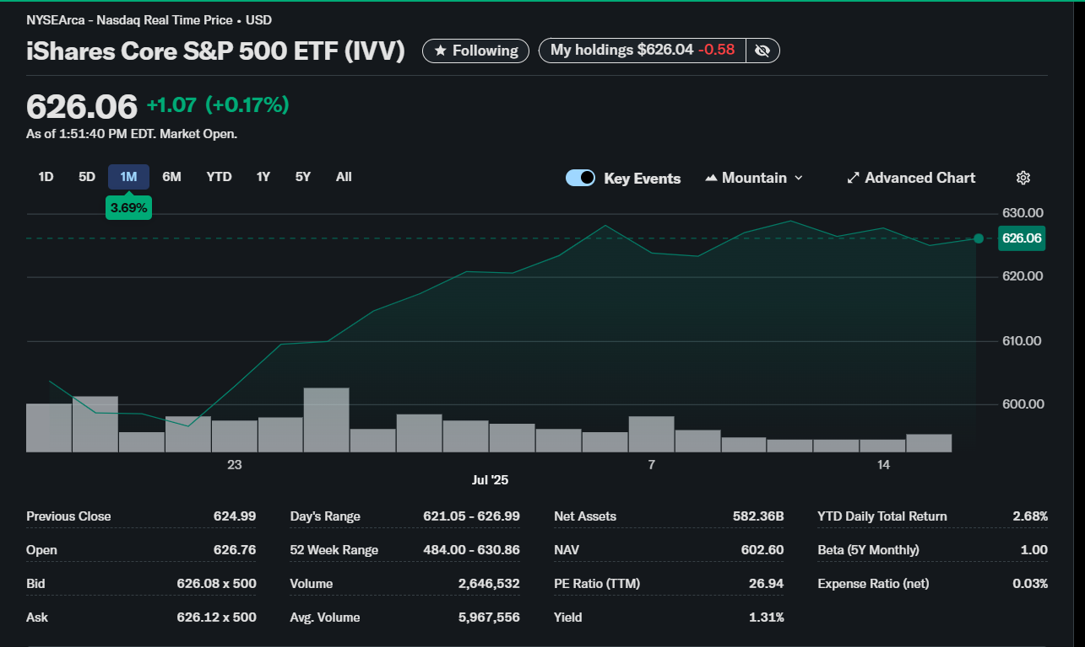
The last 1 month figure above shows a steady growth with moderate volatility. Its closing price fluctuates between $620-$630 implying upward growth in the U.S. large-cap market. The fund averages between $616-$617, with intraday volume between 2-5 million shares, thus there is liquidity in the market with trader and investor engagement. Over the past year, the ETF had a positive total return of 10%-11.5%, including dividends, which corresponds to the S&P500 returns (benchmark). The ETF offers diversification across multiple sectors like technology, finance, health care, and consumer goods.

- The authors run a classification problem as the aim is to predict the direction of the stock price movement, rather than predicting the future price. There are only two directions considered, a “1” implies that the stock opening price is strictly going up otherwise a “-1” is assigned to indicate current stock opening price either equal or less than previous day’s opening price. This form of prediction is more stable and robust than actual prediction of price. The cumulative movement of this metric is shown in figure 3, where IVV has a higher increase than the other two ETFs. Predicting the future price the stock would have turned the problem into a regression problem.
Other examples of classification variable include:
- Percentage Threshold Movement, which uses the percentage change calculated against the threshold to categorize the movement into 2 cases:
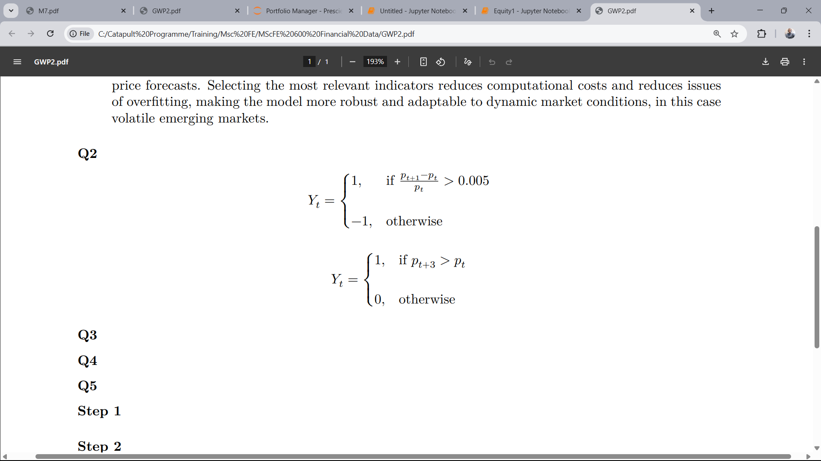

Where “1” is assigned if the percentage change is above 5% (subjective threshold), and “-1” assigned if not.
- Multi-day Direction, which is the same as the “next-day direction” metric from the paper, but over a longer period (here, 3 days).
Q3
- 2. Data
- Problem Analysis
- Exploratory Data Analysis
- Data Processing
- Model Construction
- Model Evaluation
- Interpretation

- 3. Methodology
- Feature Selection Techniques
  - Low Variance
  - Chi-Squared

